PropLed: A Blockchain - based Real Estate market

Ghayathri J

*Sri Sai Ram Institute of Technology,*

*Chennai, T.N. India.*

*Email*[*: ghayathri.it@sairamit.edu.in*](:%20ghayathri.it@sairamit.edu.in)*.*

Jaideep R.P., Vijay G , Yogesh Mudaliar V,

*Sri Sai Ram Institute of Technology, Sri Sai Ram Institute of Technology, Sri Sai Ram Institute of Technology, Chennai, T.N. , India* . *Chennai, T.N., India. Chennai, T.N., India.*

*Email:* [*i6it061@sairamtap.edu.in*](mailto:i6it061@sairamtap.edu.in) *Email:* [*i6it053@sairamtap.edu.in*](i6it053@sairamtap.edu.in) *Email*[*: i6it003@sairamtap.edu.in*](:%20i6it003@sairamtap.edu.in)

.

***Abstract***—Global real estate (RE) investments account more than twice the size of the stock market. Yet the number of investors in RE are much lower, because of the liquidity and global access. Tenants, owners, and investors are barely satisfied in the current system. In this paper, the goal is to try out the employment of blockchain in RE market and represent the facilities it can give to the RE market. The research to date leads to the following conclusions: Blockchain technology and smart contracts can sort out the classical issues that RE is facing with, and they offer much more meaningful tools for a game theoretic stable-priced market.

***Index Terms***—Blockchain technology, Commercial Real Estate, Algorithm based Stable token.

# 1. Introduction

RE investment is considered one of the safest options for investing. For that we have: it provides security to investors and is a hedge against inflation (money inflation). It is also a physical asset that is excellent for portfolio diversification, and can be non-volatile and essentially risk-free over a long period of time. RE investment is available to everyone as opposed to for experts only.

## 1.1. REs markets

|  |
| --- |
|  |

Real estate sector in India is expected to reach US$ 1 trillion by 2030. By 2025, it will contribute 13 per cent of the country’s GDP. Real Estate stock in India is expected to reach 3.7 million square feet in 2019, with addition of 200 million square feet during the year. Emergence of nuclear families, rapid urbanisation and rising household income are likely to remain the key drivers for growth in all spheres of real estate, including residential, commercial and retail. Rapid urbanisation in the country is pushing the growth of real estate. More than 70 per cent of India’s GDP will be contributed by the urban areas by 2020. Indian real estate increased by 19.5 per cent CAGR from 2017 to 2028.

Real estate attracted around Rs 43,780 crore (US$ 6.26 billion) of investments in 2019. The retail segment in Indian realty attracted private equity investments of around US$ 1 billion in 2019. Real estate attracted around US$ 14 billion of foreign private equity (PE) between 2015 and Q3 2019. First REIT raised Rs 4,750 crore (US$ 679.64 million) and was launched earlier in 2019 by the global investment firm Blackstone and realty firm Embassy group.

1.2. RE market drawbacks

RE with over 200 trillion USD is the single largest asset class globally. However, the way business with this asset class is carried out is not just complicated, but also costly, non-transparent and highly inefficient. Most importantly, RE investments are even more out of bounds for ordinary people. RE investments are dominated by either institutional investors or by ultra-high-net-worth individuals. This restrictive access prevents ordinary people to profit from growing returns on RE investments. For owners of RE, the value of their RE often serves as a security for unforeseen eventualities. However, it is no liquid wealth. To access the wealth ’trapped’ in their RE, owners either have to sell off their equity in it or take recourse to some financial vehicle which secures their equity release.

In addition to these drawbacks, Commercial RE (CRE) industry has been slow and problematic to innovate its core business processes. Today, commercial brokers and other middlemen are struggling hard with old-fashioned technology, data sharing mechanism, inefficient cash flow management, real-time performance data, and so forth. These drawbacks lead to collusion and side effects for tenants, owners and investors.

In accordance to IBISWorld, the global CRE industry revenue totals $3385 trillion and this indicates how competitive the market is in the fierce condition that CRE is operating within the narrow boundaries of prices, sales, lease rates, and also when previous transactions and valuations that are kept secret by market players.

1.3. Blockchain technology

Blockchain is a shared database technology whose well known application has been to support Bitcoin digital cryptocurrency. It works with linked databases that update

digital record books continuously. Smart contracts are also another concept that means: a work be done and be audited automatically without the existence of middlemen. In smart contracts, codes are laws and two parties in a transaction agreed on its content.

Blockchain and smart contracts introduce a new set of tools and framework to create a new generation of markets where supply and demand is equipped with a secure commercial transaction, and also with such various commercial rules and without the need for a central mediator sector. Historically, as like as online markets that have just altered many traditional stores and systems, blockchain and smart contracts will lead to a new type of peer-2-peer market that is able to destabilize current running markets.

The usage of blockchain can be permissioned or permissions in that there is a trusted or trust less network respectively. The necessity for using permissioned and permission less blockchains are shown in Fig. 1 [27]. As this figure shows, blockchain is used when multiple entities write to a shared database. If entities are unknown or want anonymity, then a permission less blockchain is preferred. Otherwise, when they need trust, they desire a permissioned blockchain.

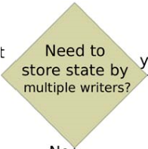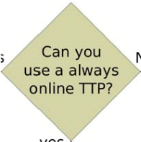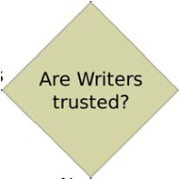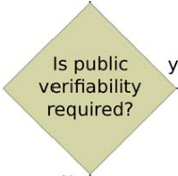

Figure 1. The needs for using blockchain

In a technical view, a blockchain is a public ledger that records chronologically all new transactions requesting a new upload or modification. Figure 2 shows a Ledger and blockchain and their relation. It shows that ledgers can be figured as a history of all transactions that happened up to now. World state, as a database, holds the current values of different fields, and for this manner, blockchain is a transaction log that records all the changes that determine the world state.

Figure 2. Ledger and its subsections

Due to its nature for storing transaction’s log and history, blockchain broadly can be used for asset management (trade processing and settlement) even when there is no trust between seller and buyer or any other members in the network.

# 2. State of the Art, Literature Review, and Opportunities

In fact like other markets, digitized world enhance mobility, efficiency and transparency for one of the largest global asset categories, namely RE. Due to the drawbacks that centralized databases are facing, the emerge of blockchain technology is able to be present and solve some of these radical issues in RE. Blockchain as a decentralized one offers the following benefits, Blockchains make tokenisation business models and economies possible–This is fundamental to tokenizing RE . The liquidity problem has always been the biggest problem of RE. Tokenization democratizes ownership of assets to split assets into tokens that are stored on the blockchain. People in different geographies and tax brackets now have access to attractive investment opportunities that they previously would not.

* Transparency and Trust: Blockchain-based applications and businesses are by design transparent in their transactions and building trust. The possibility of frauds and ownership dispute can be almost eliminated with the high degree of transparency. Data and transaction records cannot be manipulated or tampered with. This makes blockchains ideal for trust-free transactions.
* P2P transactions: Blockchains provide P2P transactions a big thrust because by design they eliminate intermediaries.
* Cost reduction: The current process of ownership transfer can take months due to the various parties involved and the need to verify the documentation during various stages, usually with the assistance of a lawyer. The blockchain technology will be able to address this issue by deleting the middle parties.
* Smart contracts: A transaction using a smart contract is completed entirely between the buyer and the seller (or renter and landlord) and has no human interaction. Transactions can be done in far less time with far less chance of fraud. Computer protocols check the legitimacy of the transaction and no agreement can be completed until all of the terms are met.
* Integrity and Security: The decentralized nature of the Blockchain technology ensures that records stored on it can’t be changed or controlled by a single source, thus it provides security against malicious attacks such as hacking.
* Property Title: Title insurance has grown to be up to $15 billion per year by ensuring buyers that their property is clear of old liens and debts. Every municipality has their own specific method for storing assets’ data. With the usage of blockchain, considerable amount of time and money would be saved and, and it could eliminate the need for title insurance. It is also possible to store information about construction, damages and improvements to the title.

Applying blockchain in the realm of RE transactions and land/title registries has drawn a considerable attention and support from governments such as North America, Europe, Dubai and Japan all of which are economic giants. This simply means that the CRE world is potential to embrace a faster, better and more affordable way of taking its action. Forbes noted three areas that blockchain has the ability to improve regarding the RE market, multiple listing service (MLS) property data, title records, and transactions.

As such effective projects, Ethereum is a blockchain based platform where people will get easy access to easily invest, hold, buy or sell RE.

All we do here in this paper is to present a model to benefit all parties involved in the RE and be secure against the mentioned problems. Issues like being resistant to devaluation of investments (inflation and deflation), having a stable price, and gaining interests and revenue are also of paramount importance to demonstrate in this paper.

The rest of the paper is structured as follows: In the next section, literature Review, and opportunities are reviewed and the goal of the present paper is stated. Then we offer a theory that is possible to accept after the emergence of the blockchain and smart contacts. Making this offer leads to giving a discussion in the subsequent section. Additionally, features and facilities that out presented method can provide is explained. In last section, recapping the issue and viewpoint, we come up with a conclusion. 3. Theory development

## 3.1. Technical issues and solution

As discussed, using blockchain and smart contract can help having a secure and easier investment in RE market. All that said, the technical issues are left unexplained. As a classical issue, when it comes to” supply and demand”, it leads the price to fluctuate; it is not a good idea for stable price tokens at all.

Over the centuries, human being used fiat or real assets like gold as means of bartering goods. Both of them are problematic in regards of time. Fiat currency is not trustworthy in long term and, neither is gold in the near term (Fig 4, 5). That means that one can witness the devaluation of fiat or gold in long or near term respectively. As the value of money has an effective connection with” purchasing power” we draw our diagrams in respect with purchasing power.

Feature 1:

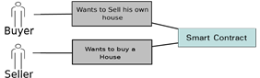

Figure 9. The RE entities

Feature 2:

The seller will create an account in our ledger and verify their assets as the eligible criteria. Then the asset will be included in the list of properties that are to be bidden. When the allotted slot for the asset comes online, the sellers will be able to see the asset and decide their motive on it. As the bid goes every bidding needs ether to raise their bid. The highest bid will be the buyer of the asset and the bid will be closed. On the completion the asset will be renamed from the seller to buyer.



Figure 11. Owner-Tenant connection

As of seller, account will be created to enter into ledger. Ether will be given to the buyer with considerable amount. Buyer will be able to see the list of available assets on the ledger screen. The buyers will be able to see all the details available on the property. Then the buyers will bid for their desired asset mentioned in the ledger. Then the one of the bidders can be chosen by the seller based on his/her willingness and the buyer will obtain the property, and on the completion the property will be renamed.

# 4. Discussion

## 4.1. Facilities and innovation

In this platform, with blockchain, STO represent fractional ownership of real property. Firstly, all the RE assets are to be digitalised in order to to neglect frauds or duplicate land to be digitalised it is done by government officials using their authority to view and add land as a block in the RE block chain.

Until an owner is willing to sell his or her land no one can initiate to buy/sell the land. Once the sellers report to send his/her asset the N no. of buyers can come to buy the land and provide their details and they can discuss with buyer about their willingness and price of the land.

As it is purely based on seller’s choice to whom he/she wants tov sell their land. And after some negotiations and investigation the buyer can gain trust over the property and can pay for it using mode of payment as preferred by the seller. And within the seconds user can be the owner the seller gives the transaction permission automatically the buyer gets registered with the property he/she willing to buy.

## 4.2. Implementation

In the contemporary world, the digitalization is important breakthrough that moves our society towards the world where a sustainable future awaits. In that world, the digitization of real estate and asset businesses plays a vital role. Mostly assets and plots are being sold by the realer in hand to hand contract way with brokerage and many other intermediators. So that a lot of money is being wasted as a token for intermediates. To overcome such difficulties and to initiate digitization, this work of property ledger using blockchain is created. The digitization of property is a challenging task to work because of several scammers generating fake documents and making business with those documents. Initially all the sellers who are to sell an asset in our ledger will go through a series of verification to check the right documents are given based on the assets registered in gazette. Then the seller is given an ID to enter into the ledger, which was created by the team. The which is to be sold is put into a block and along with seller, several buyers will be added. The buyers will also be verified. The ledger will allow the users in the block to bid on the asset which is to be sold. The seller will choose a buyer with high bid value and the asset will be sold to the buyer. As every process is progressed in block chain, there will be no alterations and changes made to the bid. As for the bidding process, it uses Ethereum blockchain as ledger to process all bidding and addition of users. Ethereum uses ether as it’s cryptocurrency. We use solidity as backend to process all the bidding requests.

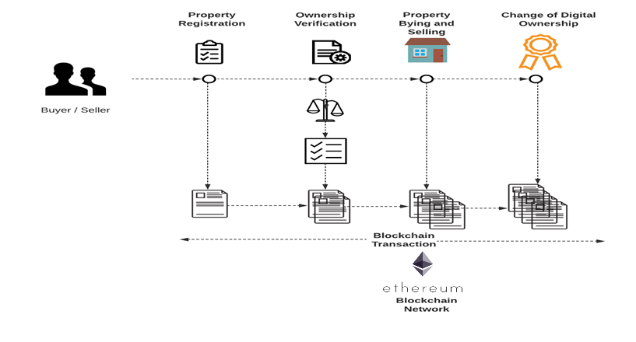

Figure 17. Architecture

# 5. Conclusion

We discussed that this is possible to provide liquidity to RE market and remove middlemen– classical issues in RE. For this, blockchain technology helps fulfill this plan by harnessing smart contracts.

Also multiple benefits including de-risked asset with a stable price token in RE market is implemented that can be protected against manipulative actions of market bubbles. Other benefits will be process integrity, network reliability and longevity, faster transactions and lower transaction costs. To this matter, the shown system can benefit tenants, owners and investors all in a better way. And also, with an STO-like nature it can assure investors to budget on their future purposes.

# References

1. Blockchain -based Real Estate market : one method for applying Blockchain technology in Commercial Real Estate Market
2. ”Global Real Estate Market Outlook” 2 Apr 2019, https://www.cbre.com/research-and-reports/2017-Global-RE-MarketOutlook.
3. ”Council Post: Developments And Adoption Of Blockchain In The U.S. Federal Government. ”, Jan 2018,

https://www.forbes.com/sites/forbestechcouncil/2018/01/25/ developments-and-adoption-of-blockchain-in-the-u-s-federalgovernment/#427d2b893d99.

1. ”Blockchain in Europe”, Feb 2018, https://hackernoon.com/blockchain-in-europe-b914cf1a9ea1.
2. ” Dubai’s land registry is world’s first to embrace Blockchain”, 2017, http://www.property-report.com/detail/-/blogs/dubai-s-land-registry-isworld-s-first-government-entity-to-embrace-blockch-13.
3. Tech in Asia, ”Connecting Asia’s startup ecosystem”, Oct 2017, http://www.techinasia.com/japan-financial-blockchain-adoption.
4. IBISWorld, ”Industry Market Research, Reports, and Statistics”, https://www.ibisworld.com/industry-trends/global-industryreports/real-estate-renting/commercial-real-estate.html.
5. Max Crowdfund, ”Dominium Whitepaper”, 2018, https://dominium.me.
6. Aassio, ”aassio whitepaper”, 2018, https://aass.io/.
7. Iotokens, ”iatokens Whitepaper”, 2018, https://www.iatokens.com/.
8. ”Three ways blockchain technology will revolutionize real estate in 2019”, Nov 2018, https://www.forbes.com/sites/forbesrealestatecouncil/2018/11/15/threeways-blockchain-technology-will-revolutionize-real-estate-in-2019/.
9. ”Blockchain Technology to Resolve Real Estates Problems”, Jul 2018, https://blockchain.wtf/2018/07/industry-impacts/enterprise/realestate/.
10. aasio, ”aasio Whitepaper”, 2018, https://aass.io/.

|  |  |  |
| --- | --- | --- |
| [15] Agentmile, ”Agentmile https://www.agentmile.com/. | Whitepaper”, | 2018, |
| [16] properbuz, ”properbuz https://www.properbuz.com/. | Whitepaper”, | 2018, |

1. Smartreality, 2018, ”http://www.smartrealty.io”.
2. Osborne, Martin J.; Rubinstein, Ariel. A Course in Game Theory. Cambridge, MA: MIT. p. 14. ISBN 9780262150415, 1994.
3. Mobo, ”Mobo Whitepaper”, 2018, https://www.mobu.io.
4. Agric, ”Agric Whitepaper”, 2018,http://agric.online.
5. Chellecoin, ”Chellecoin Whitepaper”, 2018, http://www.chellecoin.com.
6. Habibicoin, ”Habibicoin Whitepaper”, 2018, https://habibicoin.io.
7. Brickvest, ”The global real estate liquidity platform”, 2019 , https://brickvest.com/.
8. Skyline, ”Real Estate Investment Meets Artificial Intelligence”, 2018, https://www.skyline.ai/.
9. proportunity, ”New York Creative Marketing Solutions - Upportunity”, 2018, https://proportunity.co/.
10. Rex, ”A marter Way to Buy and Sell Homes”, https://www.rexchange.com/.
11. Wagenaarm. 2018, Blockchain Decision Tree. steemKR. Accessed March 2019.
12. James, Febin John, ”How to Validate If Your Ideas Need a

Blockchain”, 2018, https://devopedia.org/types-of-blockchains.

1. ”A Blockchain Platform for the Enterprise hyperledgerfabricdocs master documentation”, 2018, https://hyperledgerfabric.readthedocs.io.
2. makerdao, ”Makerdao whitepaper”, 2018, https://makerdao.com/.
3. Ampleforth, ”Ampleforth whitepaper”, 2018, https://www.ampleforth.org/.
4. Kowala, ”Kowala whitepaper”, 2018, https://www.kowala.tech/.