Sliding Tile Puzzle 8 and 16 tiles using DFS

Problem:
A sliding puzzle challenges a player to slide the numbers into the adjacent space along certain routes to reach the final configuration. The pieces to be moved may consist of tiles of numbers. But in this particular job we are coding in order to find the solution path consisting of al the directions that the space will travel to reach the final state.
A typical and simple example may be given as:
Initial State Final State
1 2 3 1 2 3 1 2 3
4 5 6 - > 4 5 6 - > 4 5 6
0 7 8 7 0 8 7 8 0
which has got a one step answer by one move.
Sliding puzzles are always two-dimensional in nature. The main purpose of this problem is to find the moves and the paths opened up by each move within the two-dimensional matrix.
Solution:
This program’s main functions are to create child nodes and hence, the tree and applying the DFS search method onto the tree in order to find the series of moves made by the space. The space can go in 4 directions: Up, Down, Right, Left.
To facilitate our decision on whether the space can travel any direction we consider and create the nodes surrounded with -1, when we encounter -1 when we are exploring for the state space for any particular direction then we can assume that we cannot create a child node for that direction.

-1 -1 -1 -1 -1
-1 1 2 3 -1
-1 4 5 6 -1
-1 -1 -1 -1 -1

Code snippets and logic used:

The initial state is taken from the user, made as the root node and is used to create all the child nodes from that root node(initial state) to the final state as the leaf nodes. This created tree is stored in an array of objects with links to the child and parent nodes.
The function “int CreateChildNodes()” are called for each parent to create all the nodes possible and returns the index of the next node to be created inside the array

static int CreateChildNodes(Node[] Array,Node Parent,Node Goal,int NextIndex)//creation of child nodes for all the 4 directions
{
int Index=NextIndex;
if(CheckUpDirection(Parent))//check for up direction
{
Array[Index]=new Node(Parent.State,Parent.BlankXcoordinate,Parent.BlankYcoordinate,Index,Parent.OwnIndex,'U');
ExchangeUp(Array[Index]);//exchange the coordinates of blank space
Array[Index].BlankXcoordinate--;//change the x coordinates
Array[Index].ManhattanDistance=CalculateManhattanDistance(Array[Index],Goal);

boolean cond=CompareNodes(Array[Index],Array[Parent.ParentIndex]);

if(cond==false)
{
Array[Index]=null;//--Index;

}
else
{
PrintNode(Array[Index]);
++Index;

}
}

The above code snippet creates the child node for up direction, and similarly the child nodes for left, right and down are created by other functions:

up
1 0 3
4 2 5
6 7 8
left | right

1 2 3 1 2 3 1 2 3
0 4 5 <- 4 0 5 -> 4 5 0
6 7 8 6 7 8 6 7 8
|

1 2 3
4 7 5
6 0 8

down

We check for each parent node whether the child node can be created for a particular direction:

static boolean CheckLeftDirection(Node Obj)
{
if (Obj.State[Obj.BlankXcoordinate][Obj.BlankYcoordinate-1]==-1)
{
return false;//cannot go left
}
else
{
return true;//can go left
}

}
The above snippet shows checking of the left direction. Similarly we check for each of the 4 directions.

If a child node can be created for any parent then we create the child node and exchange the co ordinates of the space and swap the number traveling with the space using the below function:

static void ExchangeLeft(Node Obj)//exchange the x and y coordinate for blank space
{
Obj.State[Obj.BlankXcoordinate][Obj.BlankYcoordinate]=Obj.State[Obj.BlankXcoordinate][Obj.BlankYcoordinate-1];
Obj.State[Obj.BlankXcoordinate][Obj.BlankYcoordinate-1]=0;

}

After creating the tree with all the child nodes, we call upon the function “void ApplyDFS” function to find the solution path from the root initial state to the final state.

ApplyDFS((ObjectArray,Goal,count)//Call DFs method to find solution path

Then, we apply the DFS search method for traversing the tree created right from the root node. We send the Object Array consisting of al the child nodes in an array, Goal state to compare whether we have reached the leaf node or not and count( variable which consists of the number of nodes created).

The below code snippet shows the application of dfs search method recursively:

static void ApplyDFS(Node[] Array,Node Goal,int j,int cc)//Apply dfs recursively
{
if(!(CompareNodes(Array[j],Goal)))
{
while(!(CompareNodes(Array[j],Goal)))
{
if(Array[j].Child1Index>0)
{
PrintNode(Array[j]);
ApplyDFS(Array,Goal,j,cc);
}
else if(Array[j].Child2Index>0)
{
PrintNode(Array[j]);
ApplyDFS(Array,Goal,j,cc);
}
else if(Array[j].Child3Index>0)
{
PrintNode(Array[j]);
ApplyDFS(Array,Goal,j,cc);
}
else if(Array[j].Child4Index>0)
{
PrintNode(Array[j]);
ApplyDFS(Array,Goal,j,cc);
}
}
}
else System.exit(0);
}

We send the count (variable containing the maximum number of nodes in the tree) and the ObjectArray containing the array of all the child nodes.
Here, we are making use of recursive call to ApplyDFS function which will keep finding the next child node for a particular parent node.

The node structure will be having : Child1Index, Child2Index, Child3Index, Child4Index which holds the index values of all the child nodes created for a particular parent node.
If there is no child for a particular direction then that corresponding variable will be maintained 0.

Child1Index: Index of Up Child
Child2Index: Index of Down Child
Child3Index: Index of Left Child
Child4Index: Index of Right Child

The node class structure is:

class Node
{
public int OwnIndex,ParentIndex,BlankXcoordinate,BlankYcoordinate,Child1Index,Child2Index,Child3Index,Child4Index;
public char Direction='\0';
public int State[][]=new int[5][5];
public Node()
{
}

public Node(int[][] values,int X, int Y,int Index, int Parent,char Dir)
{
for(int i=0;i<5;i++)
{
for(int j=0;j<5;j++)

{
State[i][j]=values[i][j];
}
}

BlankXcoordinate=X;
BlankYcoordinate=Y;
ParentIndex=Parent;
Direction=Dir;
}
}
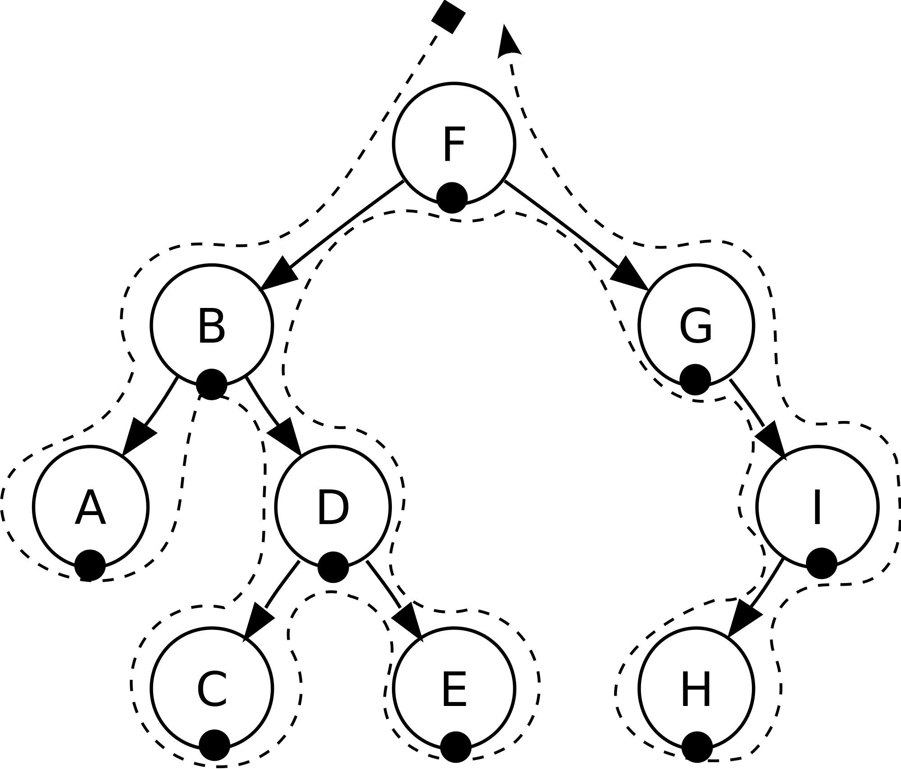

For example the if the user inputs the initial state as 1 2 3
4 0 5
6 7 8

The child nodes created will be output on the screen along with the root node:

TileSliding Puzzle for 8 and 16 tiles using DFS:---

Enter your option
1.3*3
2.4*4

1
Enter the Initial List
1
2
3
4
5
6
7
8
0

The root node is:

Navigation of space:

1 2 3
4 5 6
0 7 8

The child nodes created are:

Navigation of space: U
1 2 3
0 5 6
4 7 8

Navigation of space: R
1 2 3
4 5 6
7 0 8

Navigation of space: U
0 2 3
1 5 6
4 7 8

Navigation of space: R
1 2 3
5 0 6
4 7 8

Navigation of space: U
1 2 3
4 0 6
7 5 8

Navigation of space: R
1 2 3
4 5 6
7 8 0

Navigation of space: D
1 2 3
0 5 6
4 7 8

Navigation of space: R
2 0 3
1 5 6
4 7 8

Navigation of space: U
1 0 3
5 2 6
4 7 8

Navigation of space: D
1 2 3
5 7 6
4 0 8

Navigation of space: R
1 2 3
5 6 0
4 7 8

Navigation of space: L
1 2 3
0 5 6
4 7 8

Navigation of space: U
1 0 3
4 2 6
7 5 8

Navigation of space: D
1 2 3
4 5 6
7 0 8

Navigation of space: R
1 2 3
4 6 0
7 5 8

Navigation of space: L
1 2 3
0 4 6
7 5 8

------The solution path is:---------
Node Visited:
1 2 3
4 5 6
0 7 8

To

Node Visited:
1 2 3
4 5 6
7 0 8

TO

Node Visited:
1 2 3
4 5 6
7 8 0

After displaying all the child nodes we display the route of the space in all the directions possible in order to reach the final state along with the direction taken in every node along the solution path.

------The solution path is:---------
Node Visited:
1 2 3
4 5 6
0 7 8

To

Node Visited:
1 2 3
4 5 6
7 0 8

TO

Node Visited:
1 2 3
4 5 6
7 8 0

The same carries over for 16 tile puzzle, and the only change that we make is the number of indices for the matrix in each node. Also, the same logic is applied for 4*4 as that of 3*3 keeping indices and using the 4*4 matrices.

The DFS search method will be applied for the created tree structure.

The final state will be:

-1 -1 -1 -1 -1 -1
-1 1 2 3 4 -1
-1 5 6 7 8 -1
-1 9 10 11 12 -1
-1 13 14 15 0 -1
-1 -1 -1 -1 -1 -1

If we compile the code and execute with the input:

1 2 3 4
5 6 7 8
9 10 11 12
0 13 14 15

The output can be seen is:

TileSliding Puzzle for 8 and 16 tiles using DFS:---

Enter your option
1.3*3
2.4*4

2
Enter the Initial List
1
2
3
4
5
6
7
8
9
10
11
12
0
13
14
15
The root node is:

Navigation of space:
1 2 3 4
5 6 7 8
9 10 11 12
13 0 14 15

The child nodes created are:

Navigation of space: U
1 2 3 4
5 6 7 8
9 0 11 12
13 10 14 15

Navigation of space: R
1 2 3 4
5 6 7 8
9 10 11 12
13 14 0 15

Navigation of space: L
1 2 3 4
5 6 7 8
9 10 11 12
0 13 14 15

Navigation of space: U
1 2 3 4
5 0 7 8
9 6 11 12
13 10 14 15

Navigation of space: R
1 2 3 4
5 6 7 8
9 11 0 12
13 10 14 15

Navigation of space: L
1 2 3 4
5 6 7 8
0 9 11 12
13 10 14 15

Navigation of space: U
1 2 3 4
5 6 7 8
9 10 0 12
13 14 11 15

Navigation of space: R
1 2 3 4
5 6 7 8
9 10 11 12
13 14 15 0

Navigation of space: U
1 2 3 4
5 6 7 8
0 10 11 12
9 13 14 15

Navigation of space: U
1 0 3 4
5 2 7 8
9 6 11 12
13 10 14 15

Navigation of space: D
1 2 3 4
5 6 7 8
9 0 11 12
13 10 14 15

Navigation of space: R
1 2 3 4
5 7 0 8
9 6 11 12
13 10 14 15

Navigation of space: L
1 2 3 4
0 5 7 8
9 6 11 12
13 10 14 15

Navigation of space: U
1 2 3 4
5 6 0 8
9 11 7 12
13 10 14 15

Navigation of space: D
1 2 3 4
5 6 7 8
9 11 14 12
13 10 0 15

Navigation of space: R
1 2 3 4
5 6 7 8
9 11 12 0
13 10 14 15

Navigation of space: L
1 2 3 4
5 6 7 8
9 0 11 12
13 10 14 15

Navigation of space: U
1 2 3 4
0 6 7 8
5 9 11 12
13 10 14 15

Navigation of space: D
1 2 3 4
5 6 7 8
13 9 11 12
0 10 14 15

Navigation of space: R
1 2 3 4
5 6 7 8
9 0 11 12
13 10 14 15

Navigation of space: U
1 2 3 4
5 6 0 8
9 10 7 12
13 14 11 15

Navigation of space: D
1 2 3 4
5 6 7 8
9 10 11 12
13 14 0 15

Navigation of space: R
1 2 3 4
5 6 7 8
9 10 12 0
13 14 11 15

Navigation of space: L
1 2 3 4
5 6 7 8
9 0 10 12
13 14 11 15

******************The solution path is:***********

Navigation of space: R
1 2 3 4
5 6 7 8
9 10 11 12
13 0 14 15

TO

Navigation of space: R
1 2 3 4
5 6 7 8
9 10 11 12
13 14 0 15

TO

Navigation of space: R
1 2 3 4
5 6 7 8
9 10 11 12
13 14 15 0

