**Q1.**

**MapReduce**

**Problem Statement**

Here, we have chosen the stock market dataset on which we have performed map-reduce operations. Following is the structure of the data. Kindlyfind the solutions to the questions below.

Data Structure

1. Exchange Name

2 Stock symbol

3. Transaction date

4. Opening price of the stock

5. Intra day high price of the stock

6. Intra day low price of the stock

7. Closing price of the stock

8. Total Volume of the stock on the particular day

9. Adjustment Closing price of the stock

Field Separator – comma

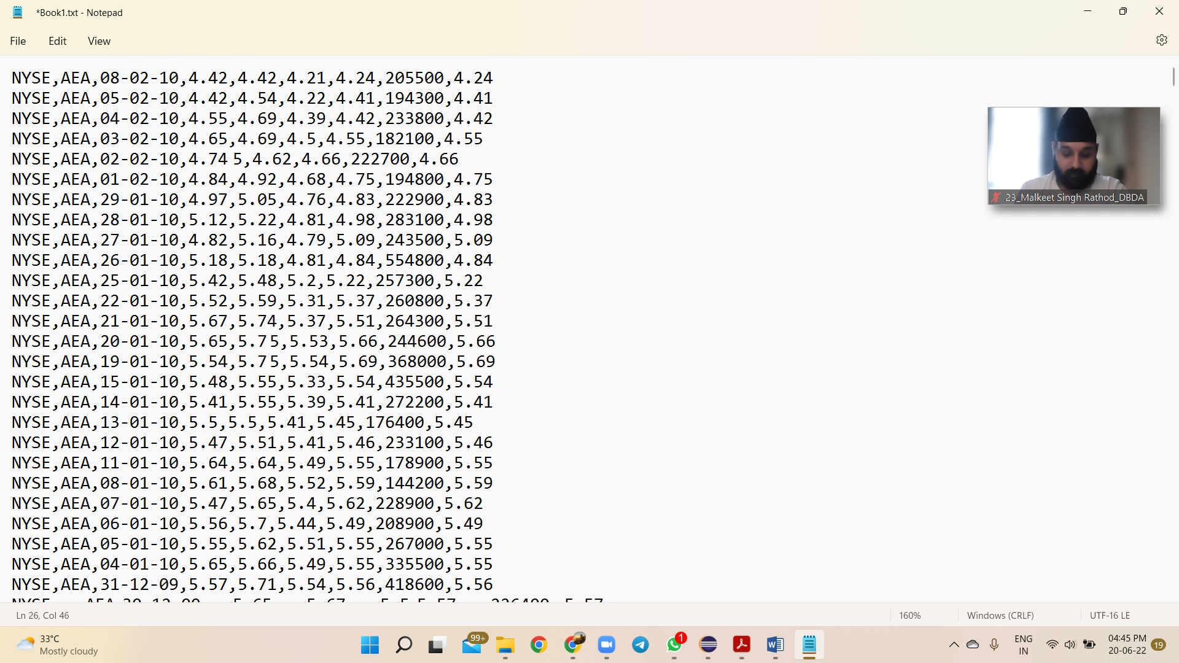

**Question 2 : Find all time High price for each stock**

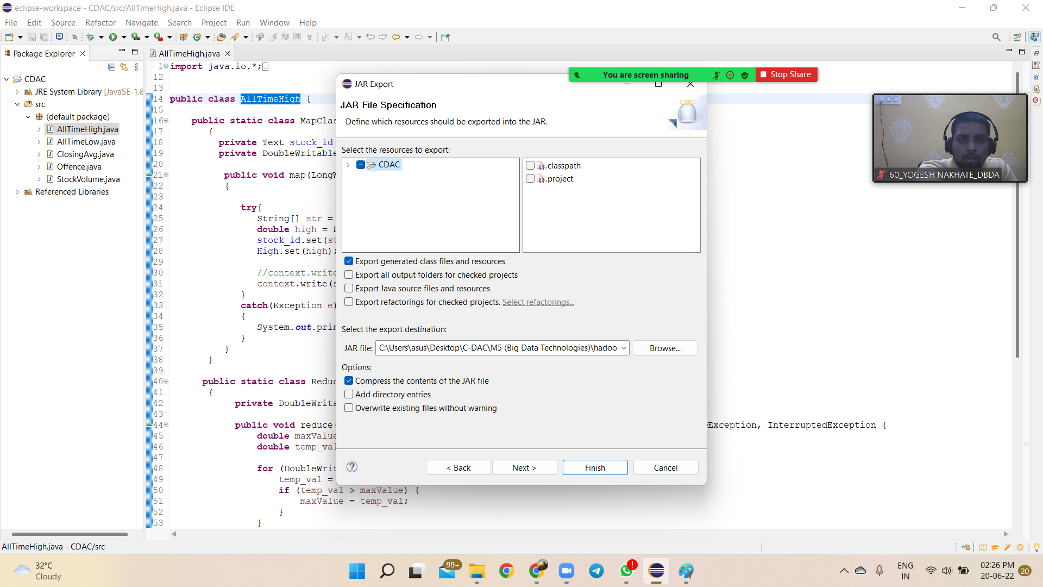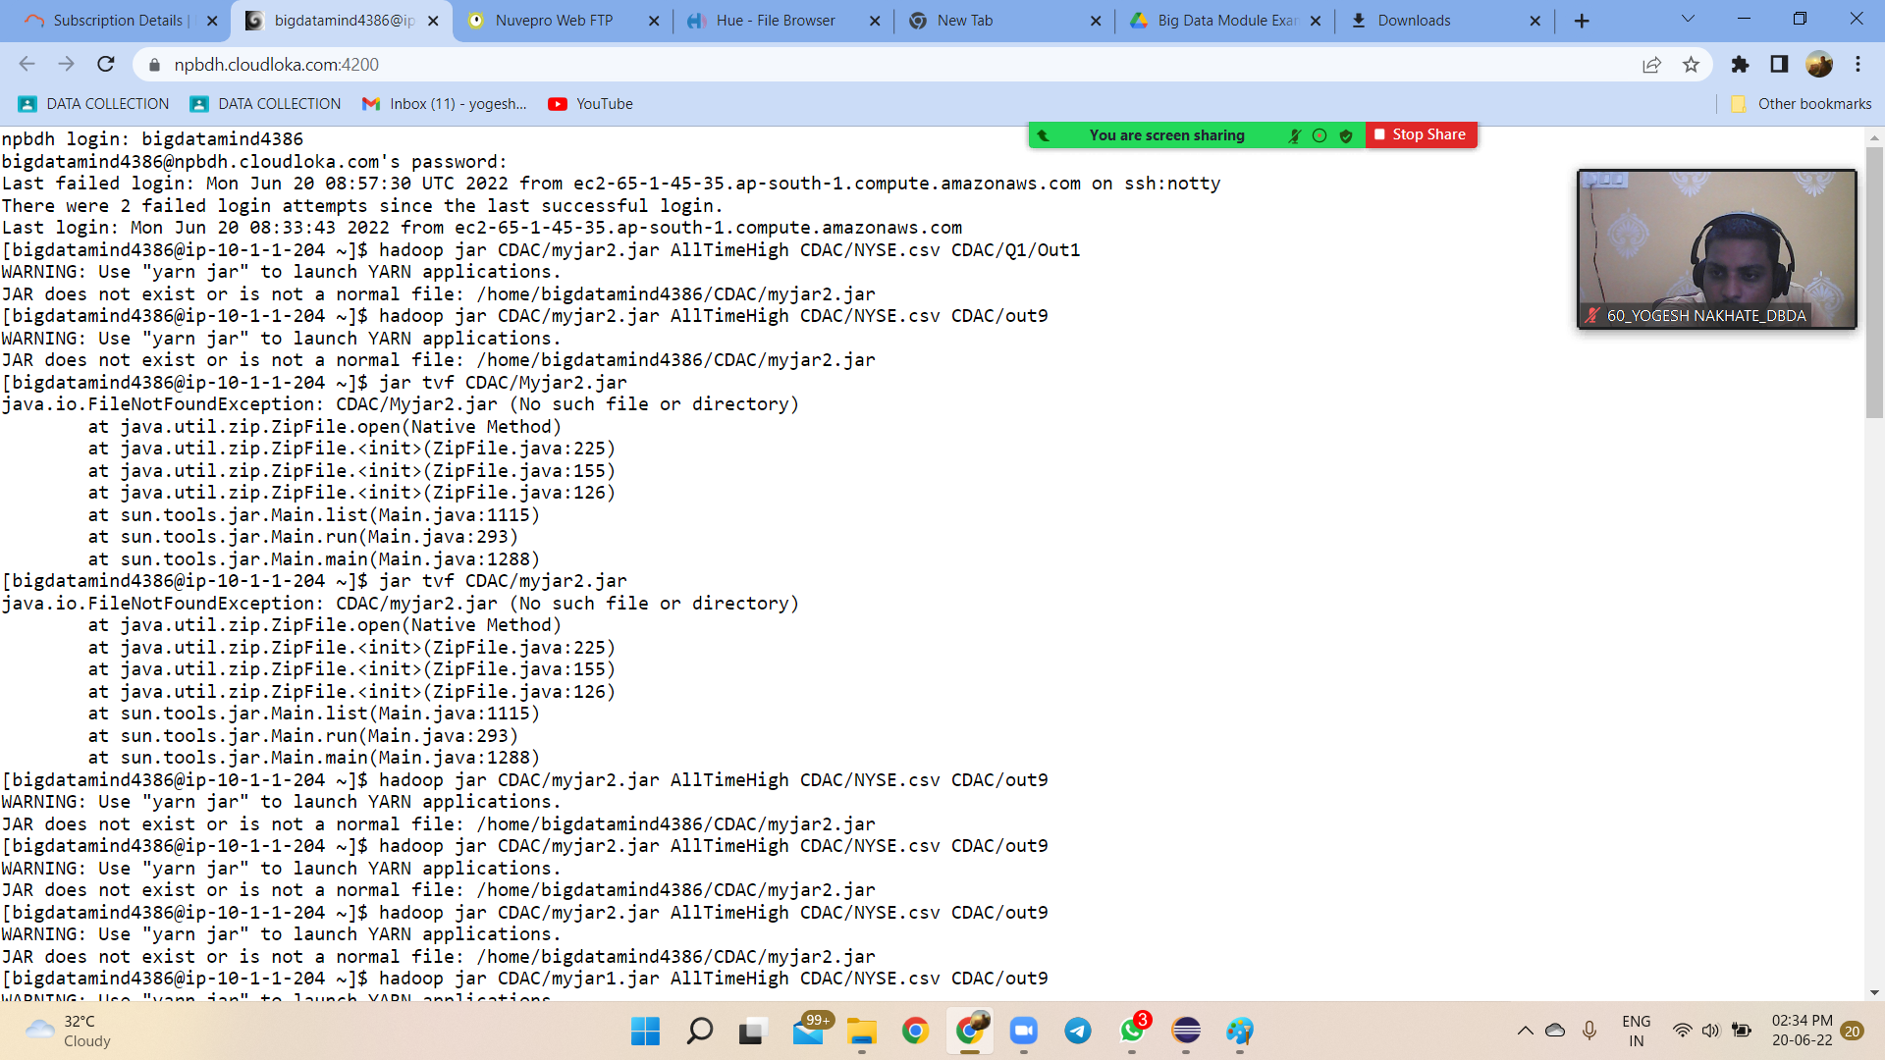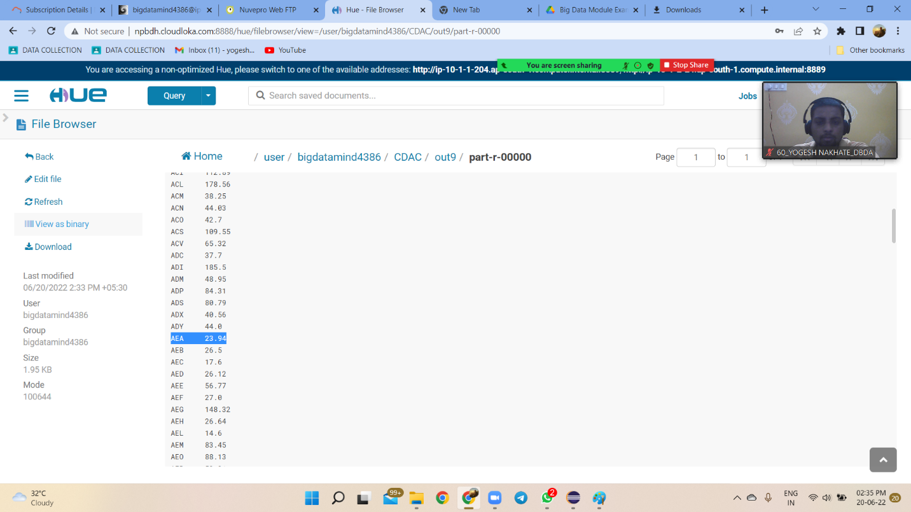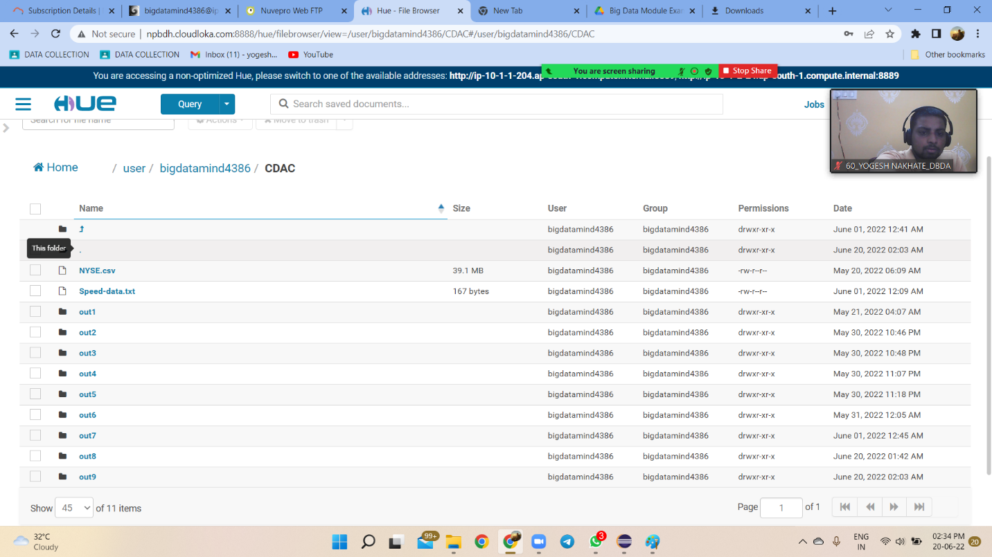

**Hive**

Please find the customer data set.

cust id

firstname

lastname

age

profession

