# Homeo

## Overview

The project we’ve decided on for the group assignment is a simple, modern room booking website where users can view, book, and host not only the trending rooms but also the traditional ones as required. After multiple brainstorming and with a group poll, we came up with ‘Homeo’ for our website’s name which primarily aims to spread a familiar and nostalgic tone.

We’ve built this website with the intention of making listing and finding homes simple and accessible widely. With a variety of categorized rooms to choose from, the targeted audience and users are meant for more than just the youngsters. It’s meant to be a platform for not only Nepalese but also international travelers which helps with a much smoother renting and payment system. The travelers get to experience a cultural-rich experience with lots of options to choose from and within budgets. With hopes of making people feel at home, the team has worked relentlessly on this project—with proper design, development and integration, it has become a success.

Git has been used by every member to the best of their abilities and for this project we have decided to use Visual Studio Code as our default text editor. GitHub served as the best platform to open up a repository and collaborate with our team members.

## Team Roles

This team project assigned to us, from the module ‘Code Management with VCS’, consists of 6 individual members. Each member has been assigned a crucial role for the proper development and completion of this project. Our members and roles assigned have been represented as follows:

|  |  |  |
| --- | --- | --- |
| **Team Members** | **IDs** | **Roles & Contributions** |
| Yogesh Pant |  | Team Lead + Front-end Developer |
| Rikesh Adhikari | 24046835 | Front-end Developer + Bug Fixes + Git |
| Arjan Regmi | 24046715 | Front-end Developer + Bug Fixes + Git |
| Aaditya Pudasaini |  | Front-end Developer + Git Manager |
| Jasun Maharjan |  | Content Manager |
| Shirbhooshan Razopadhyay | 24046885 | UI/UX Designer + Documentation |

## Git activities

After opening a repository in GitHub, using git helped in the integration of the website development process. Many git commands have helped us familiarize ourselves with not only GitHub but also the Command Line Interface (CLI). Few of the git commands we’ve used are shown in detail below along with proper evidence:

1. git push

1. git pull

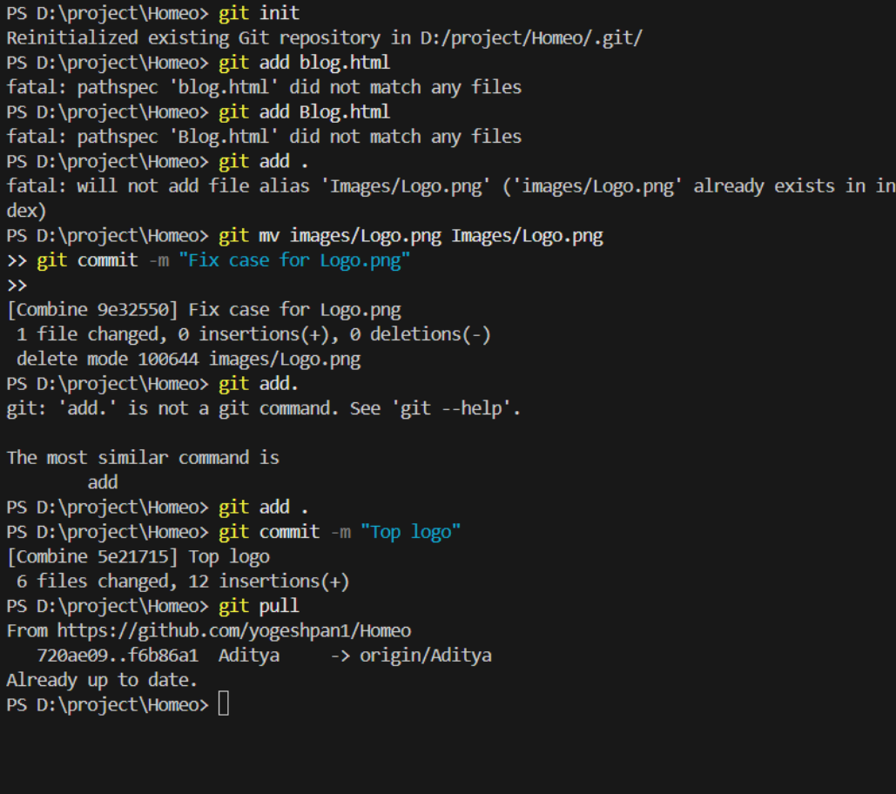

1. Git clone

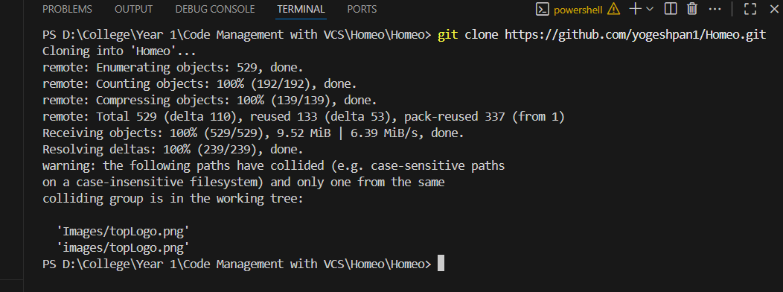

1. Git merge

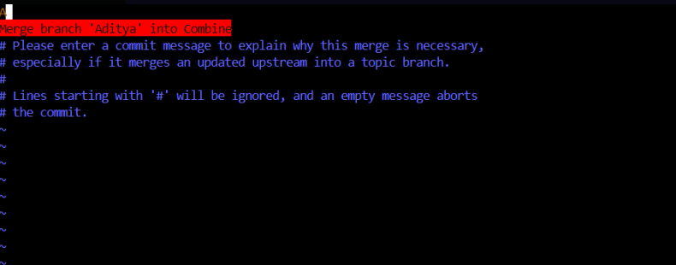

1. Git log

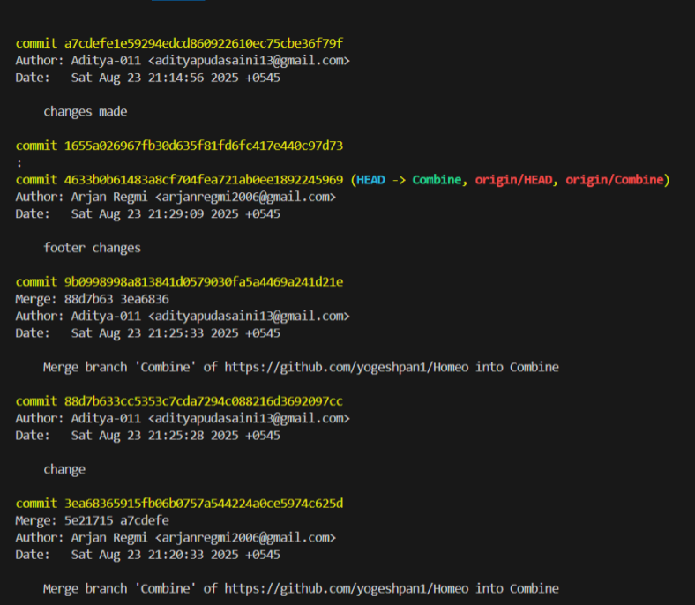

1. Git branch

1. Git log –graph

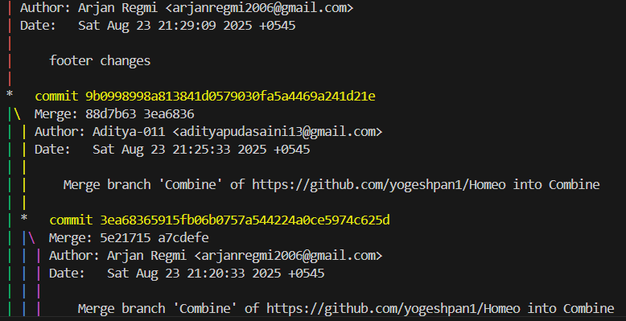

1. Git branch graph

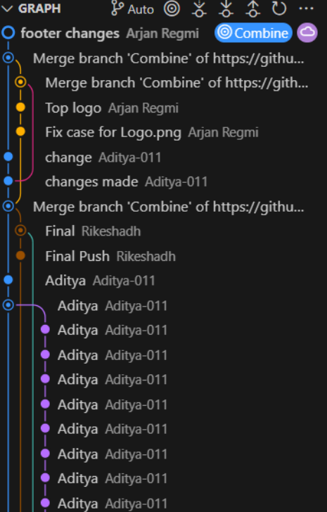

1. Merge conflict screenshot

1. Contributions from GitHub Insight

As shown above, it goes to say how important using git is. Having practical knowledge of using the Command Line Interface for accessing and updating the dataset is very important, especially for collaborative use.

## Merge conflict documentation

We encountered very few merge conflicts due to strategic and methodological analysis beforehand. However, despite being careful we were not fully able to prevent merge conflicts. One example of a conflict we encountered is shown below:

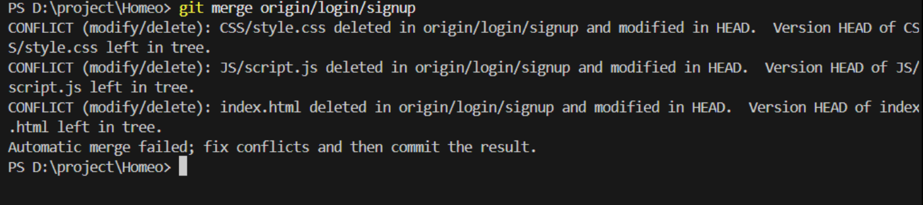

Before merging, the programmer must take proper caution and must be prepared for any conflict messages. It normally happens when we are trying to merge files that have been differently modified or when we try to merge files of a branch to another where the files have been deleted or replaced. Throughout our project, we made use of multiple branches so that files can be uploaded in a proper format without collision later. To prevent any merge conflicts, we made sure that we only edited files as per required and not in rash behavior.

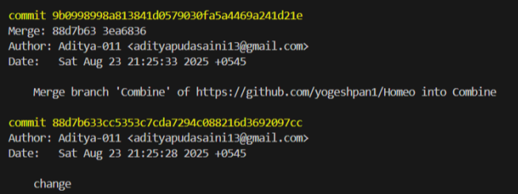

We made little but timely steps when merging everything into a single default branch, e.g. main. During times that we did encounter merge conflicts, we properly studied the error messages in terminal to get a proper understanding of where we should show attention to. As such we were able to properly minimize the conflicts and solve them accordingly.

## Team Contributions

Before designing and developing the website, we carefully researched the true intent of this project. As such we decided it to look modern and simple with a very limited yet strong color palette. After careful methodological analysis, the design was made and while so the roles for website development were assigned. The design first was made in Figma, and each member was allocated a page to work on and to replicate it according to the design. To make it easier and less time-consuming, the development was collaboratively worked on and below is the allocation in more detail.

|  |  |
| --- | --- |
| **Team Members** | **Allocation** |
| Yogesh Pant | About us & Portfolio pages |
| Rikesh Adhikari | Home & Host pages + Logo + Debugging + Fixes |
| Arjan Regmi | Blog & Login/Signup pages + Debugging + Fixes |
| Aaditya Pudasaini | Individual room pages, fixes + Git Managing |
| Jasun Maharjan | Room pictures + room details |
| Shirbhooshan Razopadhyay | Website design + Footer, Readme, & Minor changes, Documentation |

## Reflection on Git usage

Through this assignment & coursework we learned the true value of using git for our projects. It is undoubtedly a game changer when it comes to good practice while coding. It helps us properly review our modifications, store our code remotely, compare the older and newer file versions and helps us return to previous versions if necessary. Not only is it able to show us our progress, it also best supports a collaborative effort using branches and with the merging commands.

Through git, backup and recovery has become more applicable and easier. GitHub in this case has also helped us to build the pillar for collaborative use. We have used git in almost every step of the development & integration processes. It also served as a great introduction to using Command Line Interfaces (CLI), and it has proved to be easy to learn. Being able to modify and have commit messages has made our code more manageable and consistent. It’s made us more aware of what the next step of the process can be, and it’s been much easier to work in a team. The advantage of using git is that it enables offline work, due to which we were able to have a backup and code in our own spaces. When we encountered merge conflicts, few of our solutions included reverting the versions to minimize the conflicts and allow for proper debugging. Being able to look at the previous versions also helped us to understand our past mistakes.