**SafetyCheck Android Application**

**Submitted By:**

**YogeshPandey  
ASU ID: 1209374189**

SafetyCheck is an android application which pulls earthquake alerts and friends information from server and notify user whenever there has been new alert detected. The user can also view the earthquake and its impacted area on map. It also shows friends that may have been impacted by this earthquake.

I have used some some Android SDK APIs to build this application. This document will walk through all those functionalities.

The server for this application is running at 52.32.136.81:8080

**MainActivity with Sliding Tab panel**

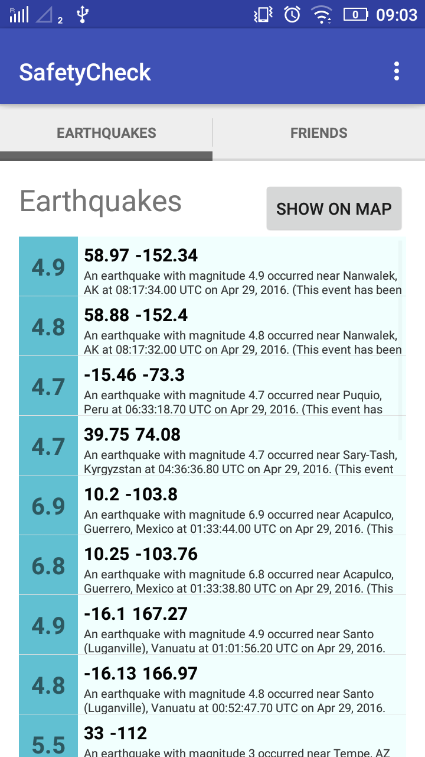 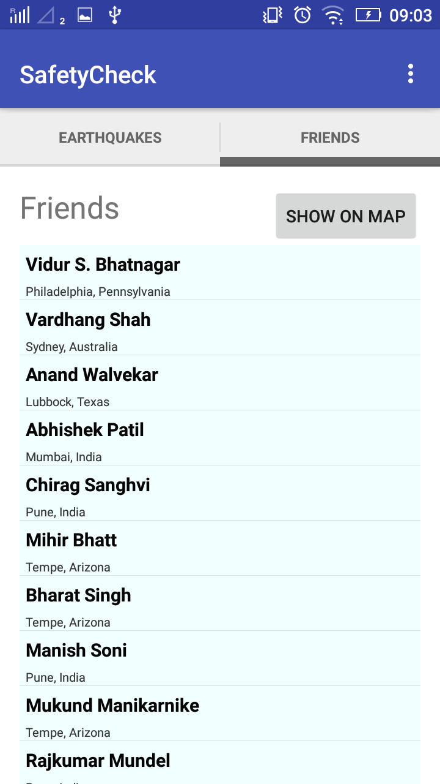  
  
User can either swipe or touch tab header to move across tabs.

It is making use of SectionsPagerAdapter and PlaceholderFragment to inflate either R.layout.list_earthquake or R.layout.list_friends based on user tab selection.

**Map Activity - Map All Earthquakes**

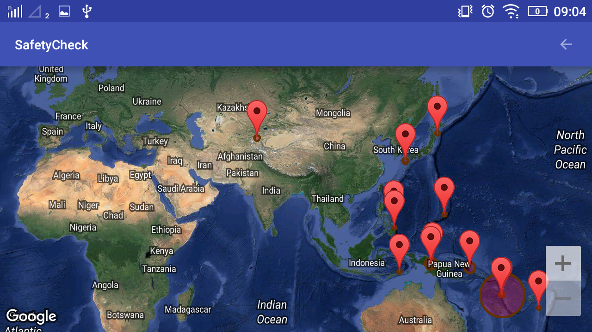  
  
When user touches “SHOW ON MAP” button under earthquakes tab, it creates an intent to MapActivity to show all earthquakes with their impacted area on world map. You can also view more details of Earthquake if you touch the marker.

**MapActivity – Map All Friends  
  
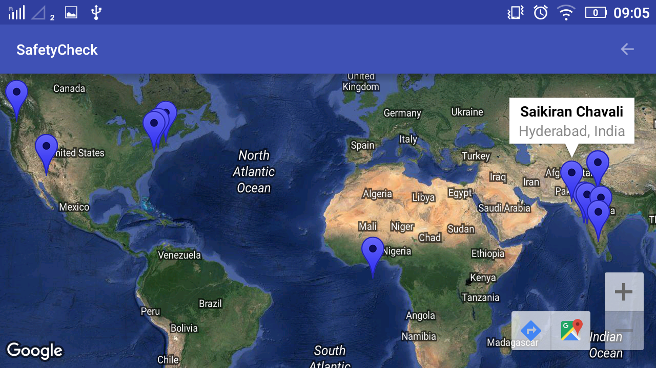**

When user touches “SHOW ON MAP” button under Friends tab, it creates an intent to MapActivity to show all friends on world map. You can also view your friends name if you touch on marker.

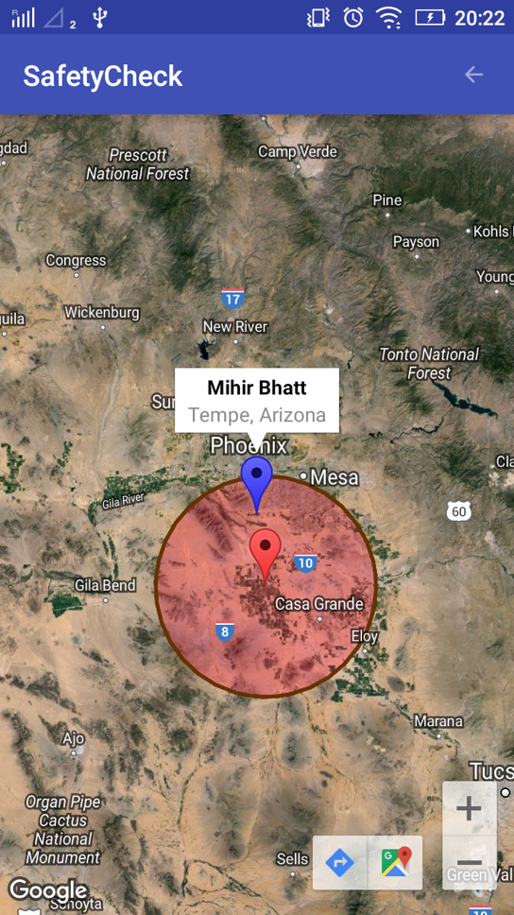

**Fetch Earthquakes using EarthquakeReceiver and EarthquakeService:**

EarthquakeReceiver which extends **BroadcastReceiver** class, is periodically triggered by the AlarmManager (every 3mins) to start EarthquakeService.

This **intent service** pulls earthquakes data from server and notify user if there has been any new earthquake. This process keeps running in background even if the application is closed.

**Notification:**

Whenever a new earthquake alert is encountered by EarthquakeService, it generates a notification for the user with earthquake details. If user opens this notification it launches the MapActivity showing earthquake impacted area.

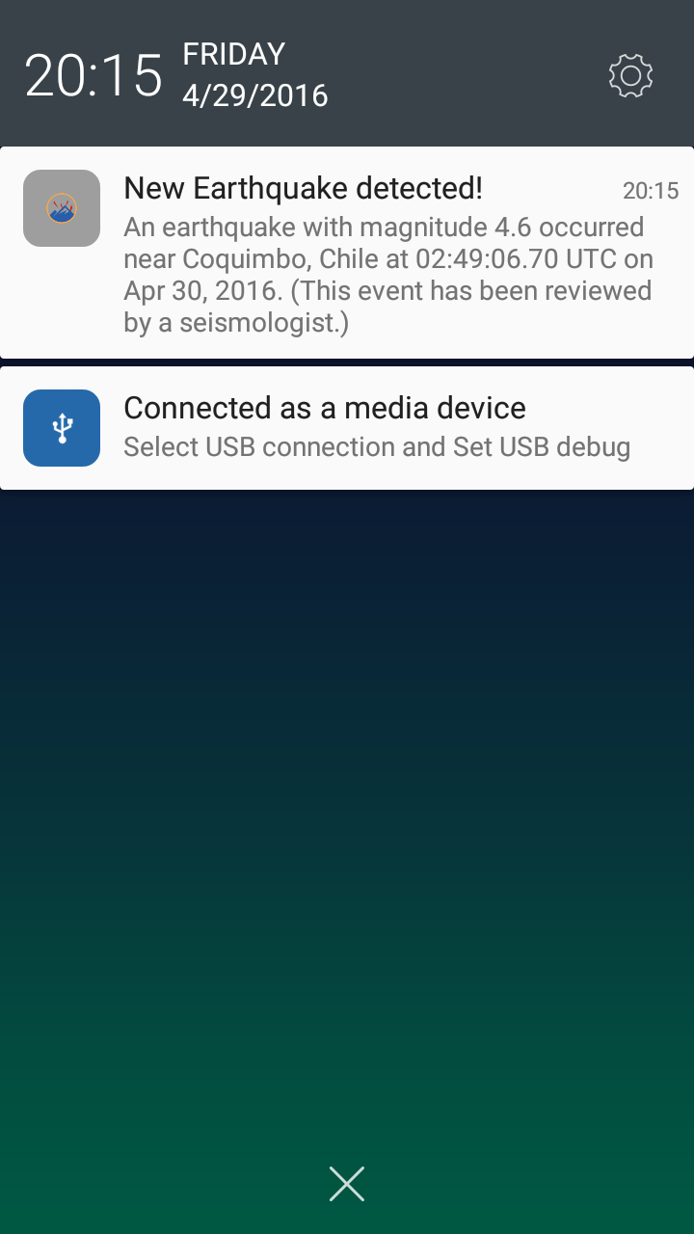

To Demo Notification:

* Go to <http://52.32.136.81:8080/SafetyCheckWeb/earthquakes.html>
* Try insert a dummy earthquake using Add button on right top

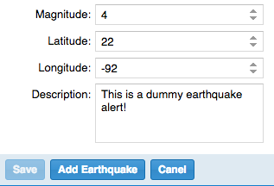

* You should be able to see earthquake notification within 3 mins

**EarthquakeContentProvider:**This application also make use of content provider to access EarthquakeTable. This design will allow other applications also to access EarthqaukeTable

Classes Used to support Content Provider:

* EarthquakeContentProvider
* EarthquakeContract
* EarthqaukeDBHelper

**Future Scope:**

* Allow add contacts from user.
* Fetch Weather alerts
* Setting preference to allow customization of frequency to check for alerts