Bachelor of Computer Application

PROJECT REPORT

Platform for blue-collar workers

By
Sumit Bind
(ECC2014012)
(413008)

Yogesh Kumar Pandey
(ECC2014001)
(413007)

Advisor:
Dr. Varun Agrawal
DEPARTMENT OF COMPUTER APPLICATION



Ewing Christian College, Prayagraj

Gaughat, Prayagraj Uttar Pradesh: 211003

April 2023
DECLARATION

We declare that this written submission represents our ideas in our own words, and where others' ideas or words have been included, we have adequately cited and referenced the original sources. We also declare that we have adhered to all principles of academic honesty and integrity and have not misrepresented or fabricated or falsified any idea/data/fact/source in our submission. We understand that any violation of the above will be a cause for disciplinary action by the Institute and can also evoke penal action from the sources that have thus not been properly cited, or from whom proper permission has not been taken when needed.

- Sumit Bind ECC2014012 Signature

- Yogesh Kumar Pandey ECC2014001 Signature

Date: ______________

Department of Computer Application [BCA]
Ewing Christian College, Prayagraj

Certificate

This is to certify that the project entitled “Platform for hiring Blue-Collar Workers” is the bonafide work carried out by Sumit Bind (ECC2014012) and Yogesh Kumar Pandey (ECC2014001), student of BCA, Ewing Christian College, Prayagraj during the year 2023, in partial fulfilment of the requirement for the award of the degree of Bachelor of Computer Application.

Examiner-1 Examiner-2 Name of Advisor

Dr. Varun Agrawal

Dr. Anil kr. Singh
Coordinator

ACKNOWLEDGEMENTS

The success and outcome of this project required a lot of guidance from many people and we are extremely fortunate to have got this all along the completion of our project work. Whatever we are able to do is because of their guidance.
We would like to express our sincere thanks to our respected course coordinator Dr. Anil Kumar Singh for giving us an opportunity to work in this project.
We would also like to thank our guide Dr. Varun Agrawal, without whose guidance this project would not be a success. Finally, we would like to show our sincere gratitude to all our teachers, friends and our family members who have helped us directly or indirectly in every means to complete this project.

Sumit Bind (ECC2014012)
Yogesh Kumar Pandey
(ECC2014001)
ABSTRACT

This project aims to solve the problem faced by blue-collar workers in accessing job opportunities due to a lack of education and limited digital resources. The platform, built using React and Firebase, provides an easy-to-use interface for both employers and workers. The app offers a database of registered blue-collar workers which employers can search and filter based on their location and type of work. Additionally, employers can directly contact potential employees via the app itself. For blue-collar workers, the app offers a wide range of job opportunities, along with details about potential employers such as reviews and ratings. The platform aims to bridge the gap between blue-collar workers and employers and provide better job opportunities for the workers. The methodology involves a registration and login interface for employers to post job openings and search for workers. Further improvements can be made to verify both parties involved in the hiring process. By investing in digital media, this platform aims to provide a solution to the problem of unemployment and poverty among blue-collar workers in India.

HOME PAGE

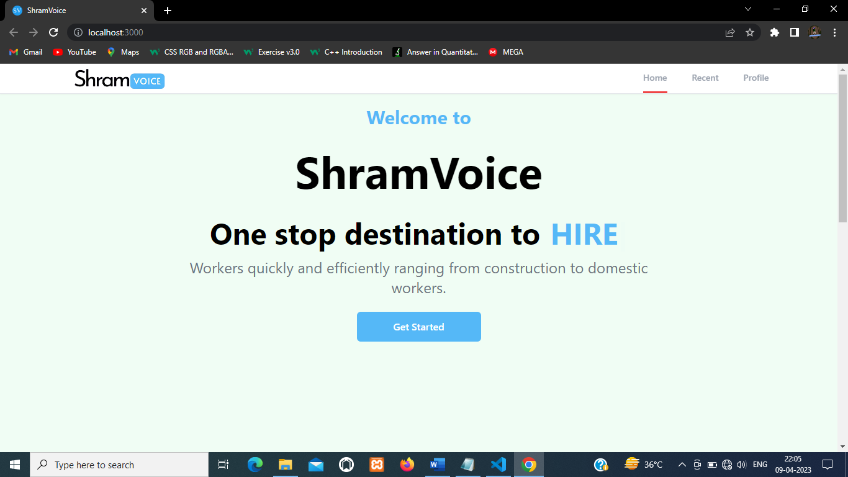

CONTENT

Chapter 1. Introduction…………………………………...……...…… 9
  - Brief Overview of work
  - Objective and Scope
Chapter 2. Project Modules…………………………………………... 11
  - Registration and Login
2.1.1 Update Profile
  - Post Requirements
2.2.1 Update/Delete Requirements
  - Search Workers
  - Add Workers
Chapter 3. Project Description……………………………......……… 14
3.1 Overview of Blue-Collar Industry
3.2 Key Features and Functionalities
Chapter 4. Analysis…………………………………………………... 17
4.1 System Analysis
4.2 On-Site Observation
4.3 Questionnaires
4.4 Problem Analysis
Chapter 5. Feasibility Study……………………………………......... 19
5.1 Technical Feasibility
5.2 Economic Feasibility
5.3 Operational Feasibility
Chapter 6. Development Methodology................................................. 21
Chapter 7. System Design……………………………………………. .23
7.1 Use Case Diagram
7.2 Activity Diagram
7.3 ER Diagram
Chapter 8. Technologies Used………………………………………... 26
8.1 About Visual Studio Code
8.2 About React.js
8.3 About Tailwind CSS
8.4 About Firebase

Chapter 9. Implementation………………………………………...... 29
9.1 Coding
9.2 User Interface
9.3 Test Cases and Result
Chapter 10. Activity Chart……………………….………………...... 45
Chapter 11. Conclusion……………………………………………… 46
Chapter 12. Future Scope of the Project…………….……………..... 47
Chapter 13. Bibliography……………………………………………. 48

CHAPTER 1: INTRODUCTION

This project aims to develop a medium for hiring blue collar workers. This platform will make it easy for potential employers to get in touch and hire the workers as per their requirement. This will make hiring process smooth. Blue-collar jobs are typically classified as involving manual labour and compensation by an hourly wage. Some fields that fall into this category include construction, manufacturing, maintenance, and mining.

1.1 Brief Overview of work

For decades, blue collar workers have been facing a major challenge: a lack of education and limited digital resources. This has resulted in them being unable to access job opportunities that require technical knowledge or even find the right kind of job for their skillset. However, the good news is that technology can be used to solve this problem. This web app built using React and Firebase aims to provide blue collar workers with better job opportunities and makes it easy for employers to hire them easily.

The app will have an intuitive interface which will make it easy for employers to search through the database of blue-collar workers and find ones who are suitable for their job requirements. Furthermore, they will be able to contact the worker directly via the app itself, making it a convenient solution for both parties. On the other hand, blue collar workers will have access to a wide range of jobs on offer through this application. They can filter their search based on location, type of work etc., allowing them to find jobs more suited for their needs easily. In addition, they can also view details about potential employers such as reviews from past employees and ratings from other sources before applying for any position.
Finally, the app will help bridge the gap between blue collar workers and potential employers by providing an easy-to-use platform where both parties can interact directly with each other without having any technical knowledge or expertise required from either side.

1.2 Objective and Scope

There are several problems faced by blue collar workers in India. These problems can include a lack of social security, insufficient access to education, and low wages. Additionally, these workers are often required to work long hours for low pay. This can lead to health problems, such as obesity and heart disease, and a decreased quality of life. Due to the lack of available digital mediums, many of these workers have had difficulty finding work. This has led to increased levels of unemployment and poverty among blue collar workers in India. In order to address this problem, it is essential to invest in digital media. This platform will ensure that the employer and workers get in touch with minimal efforts. Further improvements can be done to verify both parties involved in the whole process.

CHAPTER 2: PROJECT MODULES

The main objective of this project is to provide a dedicated online platform for blue-collar industry. And this platform has necessary functions and features that will promote smooth working for basic requirements.
This will also minimize the efforts of both the individuals involved. It will eliminate the need for person-to-person network for seeking the required services, hence will eliminate the traditional methods.

- The platform contains all the necessary information that the users need to identify the existence of the individuals involved.
- This app contains registration, post requirements, fetching data from worker database features. At last, there is functionality of adding workers to database.

2.1 Registration and Login

Employer Registration is a process by which an employer creates an account on platform to access the services provided by the platform. This process typically involves providing personal information such as name, email address, and phone number, and password.

Employer Login is the process of accessing the platform by an employer who has previously registered on the platform. This involves entering the email and password associated with their account to gain access to the platform's features and services. Once an employer has logged in, they can post or list jobs and search for registered workers.

2.1.1 Update Profile
Under this feature, user gets permission to edit and save changes to their profile after logging in to their existing account.

2.2 Post Requirements

This module allows employers to post job openings for blue-collar workers. The module provides an interface for employers to describe the job requirements and responsibilities, along with other descriptions.
To post a job, an employer must log in to their account on the platform and navigate to the job posting module. From there, they can provide all the necessary information about the job, such as the job title, location, job description, required skills, and pay. They can also set the deadline for applications and specify any other relevant details.
The job posting module is essential because it provides a centralized location for employers to post job openings and attract qualified blue-collar workers. This saves time and resources for both employers and workers by eliminating the need for physical job postings or classified ads. Furthermore, the module allows employers to easily manage their job postings.
Once a job is posted, it becomes visible to all the users who visit the platform. Workers can view the job details and call if they meet the requirements. The job posting module ensures that job seekers are aware of available job openings and provides a straightforward application process.

2.2.1 Update/Delete Requirements
This feature allows authenticated users to view and alter their previously posted requirements. They can delete the posted listing.

2.3 Search Workers

The Worker Database Search and Filtering module in the Blue-Collar Hiring platform is designed to help employers search for suitable workers based on specific criteria. The module allows employers to search through a database of registered workers and filter them based on various parameters such as location and job type.
When an employer logs in to the platform, they can navigate to the worker search page and follow the instructions to find related data to the job they are looking to.
For example, if an employer is looking for a construction worker in Lucknow, they can enter "construction" and select "Lucknow" as the location filter. This will display a list of registered workers in the construction field who are in Lucknow.
The module provides a simple and intuitive interface that makes it easy for employers to find suitable workers quickly and efficiently.
Overall, the Worker Database Search and Filtering module is a crucial component of the Blue-Collar Hiring platform, as it allows employers to find and hire the right workers for their job openings with minimal effort and time.

2.4 Add Workers

The Worker Registration module is a crucial part of the Blue-Collar Hiring platform that allows workers to register on the platform. This module enables to create workers profile, add their work experience, and other details that will help them in securing job opportunities.
The worker registration module typically consists of a form that includes fields such as the worker's name, contact details, work experience, and job preferences.
Once the registration form is submitted, the information is stored in the platform's database. The platform's search and filtering algorithm will analyse the worker's details and make them available to employers searching for workers with a specific skillset or experience.
The important note here is that not everyone can add workers data as this part is nowhere in the applications interface. One needs the have direct link to the module to access this feature.
Overall, the Worker Registration module is a critical component of the Blue-Collar Hiring platform as it creates a database of skilled workers, enabling employers to search for qualified candidates and workers to find suitable job opportunities.
CHAPTER 3: PROJECT DESCRIPTION

This project is being built for the industry that currently lacks the online presence. This is a project for those involved in manual works such as construction. Due to digital absence, they still look for the works by traditional means. They largely depend on middle-man for all their communication with the employer.
This project was chosen to tackle this problem. The website will contain all the necessary details about the confidentiality of the listed persons. The website will provide an interface for the service providers. The website will allow the costumer to get in touch with the personnel attached to the respective service provider.

3.1 Overview of The Blue-Collar Industry:

The Blue-Collar industry refers to jobs that require manual labour and involve tasks that are often physically demanding. These jobs are typically categorized by hourly wage compensation and may not require formal education beyond high school. Some common fields that fall under the Blue-Collar category include manufacturing, construction, mining, maintenance, and transportation.
In many countries, including India, the Blue-Collar industry employs a significant portion of the workforce. However, blue-collar workers face several challenges that can impact their quality of life. These challenges include a lack of access to education, limited opportunities for job growth, low wages, and a lack of social security. Blue-collar workers often work long hours for low pay, which can lead to health problems such as obesity and heart disease. The lack of available digital resources and job opportunities in the Blue-Collar industry can lead to increased levels of poverty and unemployment among these workers.
However, the good news is that technology can help to address some of these issues. Digital platforms can help connect potential employers with blue-collar workers who are looking for work. This platform can help provide blue-collar workers with better job opportunities, making it easier for them to find work that is better suited to their skillset and needs. Additionally, technology can help to improve the safety and working conditions of blue-collar workers. For example, sensors and automation can help to reduce the physical strain associated with manual labour. This can lead to a safer work environment and a decreased risk of work-related injuries.
Overall, the Blue-Collar industry plays a significant role in the global economy. While workers in this industry face several challenges, technology can help to address some of these issues by providing better job opportunities and improving working conditions.

3.2 Key Features and Functionalities:

This Platform is designed to provide a user-friendly and efficient interface for both employers and workers. Here are some of the key features and functionalities of the platform:

- Employer Registration and Login: Employers can register and create their accounts on the platform, which will allow them to post job openings, search, and filter through the database of workers, and contact potential candidates.
- Job Posting Module: The job posting module allows employers to post job openings on the platform, providing details such as job title, location, work hours, and required skills. Employers can also specify the application deadline and the number of positions available.
- Worker Database Search and Filtering: The platform features a search and filtering module that allows employers to search through the database of registered workers based on their location, type of work, experience level, and other relevant criteria.
- Worker Registration: The platform provides a separate registration interface for workers, wherein their profiles can be created.
- OTP Verification: To ensure the authenticity of employers, the platform requires users to verify their contact information through a one-time password (OTP) sent to their registered phone number.
- Worker Profile Preview: Workers' profiles on the platform provide a preview of their skills and experience
- Direct Contact with Workers: The platform allows employers to contact workers directly through the app, enabling them to discuss job requirements, negotiate wages, and schedule interviews.
- Data Security and Privacy: The platform ensures the security and privacy of users' data through various measures, such as encryption, secure data storage, and access controls.
- User-friendly Interface: The platform features a user-friendly interface that makes it easy for employers and workers to navigate and use the various functionalities of the platform.

CHAPTER 4: ANALYSIS

Analysis is detailed study of various operations performed by a system and their relationships within and outside of the system. Analysis is a management technique, which helps us in designing a new system, or improvement of the existing system a key question is what must be done to solve the problem? One aspect of analysis is defining the boundaries of the system and determining the benefit of the system. During analysis, data are collected on the available files, decision points transactions handle by the present system.

The process of developing a hiring platform for blue-collar workers involves conducting a thorough analysis of the needs of both the employers and the workers. This analysis is crucial for ensuring that the platform meets the requirements of the target audience and provides a seamless user experience.
There are several methods of analysis that can be used in this process, including system analysis, on-site observation, questionnaires, and problem analysis.

4.1 System Analysis:

System analysis involves identifying the existing systems and processes related to hiring blue-collar workers. This includes analyzing the current job market, the types of jobs available, the skill sets required, and the methods used by employers to hire workers. It also involves studying the current digital platforms available for blue-collar workers and identifying the gaps and limitations of these platforms. The insights gained from system analysis help in identifying the features and functionalities required in the new platform.

4.2 On-Site Observation:

On-site observation involves visiting job sites and observing the working conditions, the skills required for different types of jobs, and the challenges faced by workers in their daily work. This helps in understanding the real-world challenges faced by blue-collar workers and in identifying the features that can be added to the platform to address these challenges.
4.3 Questionnaires:

Questionnaires can be used to gather information from both employers and workers about their needs and expectations from a hiring platform. This includes gathering information about the types of jobs and workers required, the level of technical expertise needed, and the user experience expected from the platform. Questionnaires help in gaining a broader perspective on the requirements of the target audience and in identifying the key features and functionalities required in the platform.

4.4 Problem Analysis:

Problem analysis involves identifying the challenges faced by blue-collar workers in finding jobs and by employers in hiring workers. This includes identifying the reasons behind the limited digital resources available to blue-collar workers and the challenges faced by employers in finding the right candidates for their jobs. The insights gained from problem analysis help in identifying the features and functionalities required in the platform to address these challenges.
Overall, a combination of these analysis methods can provide a comprehensive understanding of the needs and challenges of the target audience, and help in developing a platform that meets their requirements and provides a seamless user experience.

CHAPTER 5: FEASIBILITY STUDY

The feasibility of a project can be ascertained in terms of technical factors, economic factors, or both. A feasibility study is documented with a report showing all the ramifications of the project. Preliminary investigation and need of identification analysis helps us very much in determining whether the proposed system is feasible or not. In this phase, every alternative should be defined and then each one evaluated which gave me important information about the system feasibility.
Feasibility study is an essential step in the development of any project. It determines whether a project is feasible or not by evaluating its technical, economic, and operational aspects. Here is a feasibility study for the platform for hiring blue-collar workers:

5.1 Technical Feasibility:

Technical feasibility refers to the ability of the process to take advantage of the current state of the technology in pursuing further improvement. The technical capability of the personnel as well as the capability of the available technology should be considered. Technology transfer between geographical areas and cultures needs to be analyzed to understand productivity loss (or gain) due to differences. During study of technical feasibility, we mainly investigated that:

Technical feasibility determines whether the technology used in the project is feasible or not. The platform for hiring blue-collar workers is built using React.js and Firebase, which are modern and widely used technologies. Both technologies have strong documentation and community support, making it easy to find solutions to any technical issues that may arise. Additionally, the platform has been designed to be scalable and adaptable, ensuring that it can accommodate any changes in the future.

5.2 Economic Feasibility:

Economic feasibility evaluates whether the project is financially viable or not. This involves the feasibility of the proposed project to generate economic benefits. A benefit-cost analysis and a breakeven analysis are important aspects of evaluating the economic feasibility of new industrial projects. The platform for hiring blue-collar workers is economically feasible, as it has a low startup cost and can generate revenue through advertisements, sponsorships, and commission-based models. Additionally, the platform can potentially reduce the cost of hiring blue-collar workers by providing a centralized platform for employers to find qualified workers, thereby reducing the need for expensive recruitment agencies.

5.3 Operational Feasibility:

During the operational feasibility analysis, we investigate that the operating requirements of the proposed system is feasible or not. We analyze mainly is there any resistance for the proposed system related to the operating requirements?
Operational feasibility assesses whether the project can be implemented within the existing organizational structure. The platform for hiring blue-collar workers is operationally feasible, as it has been designed to be user-friendly and easy to use for both employers and workers. The platform's intuitive interface and efficient search algorithms allow employers to find the right candidate quickly and easily, while workers can easily search for suitable jobs based on their location, type of work, and other parameters. Additionally, the platform's verification process ensures that both employers and workers are legitimate, minimizing the risk of fraud and other issues.

CHAPTER 6: DEVELOPMENT METHODOLOGY

Introduction:
Agile development methodology was employed for the development of the platform aimed at hiring blue collar workers. The project spanned over a period of 4 months. Agile methodology was chosen due to its iterative and collaborative approach, which allowed for flexibility and adaptability to changing requirements and market demands.

Development Process:
The Agile development process consisted of several key stages:
Project Planning: The team conducted an initial project planning phase where the product backlog was created. The backlog included all the features, user stories, and tasks required for the development of the platform.
Sprints: The development process was divided into multiple sprints.
Continuous Integration and Testing: Continuous integration was employed to ensure that code changes were regularly integrated into the main branch and tested for functionality and quality.
Collaboration and Communication: Collaboration and communication were key elements of the Agile methodology. We had regular discussions to ensure that the platform was aligned with the expectations. Any changes or modifications were accommodated in subsequent sprints.
Incremental Development: The Agile approach allowed for incremental development, with each sprint delivering a potentially shippable product increment.

Results:
The use of Agile methodology for the development of the blue-collar worker hiring platform yielded several positive outcomes:
Flexibility: Agile allowed the team to be adaptable to changing requirements.
Collaboration and Communication: Agile fostered a collaborative and communicative environment. This helped in identifying and resolving issues promptly and ensured that the project progressed smoothly.
Quality and Stability: Continuous integration and testing ensured that the platform was stable and of high quality, with bugs being caught and fixed early in the development process. This resulted in a reliable and robust platform.
Incremental Development: The incremental development approach helped in identifying and addressing any potential issues early on, minimizing risks and ensuring a successful product.

Conclusion:
The Agile development methodology was effective in developing the blue-collar worker hiring platform. It provided flexibility, collaboration, and incremental development, resulting in a high-quality product that met our expectations. The iterative approach allowed for regular adjustments, ensuring that the final product was optimized and aligned with demands. Overall, Agile methodology proved to be a successful approach for the development of the platform.

CHAPTER 7: SYSTEM DESIGN

7.1 Use Case Diagram:

ONLINE PORTAL

Register

Login

Employer
Post Requirement

Admin
Worker Database Search

Manage Profile

Other User

Browse Recent Listings

Add Worker Profile

7.2 Activity Diagram:

Start

Registration

Login

Authentication

Check

Post Requirement
Manage Profile
Find Worker

Update

Update Profile
Delete

Logout

End

7.3 Entity Relationship Diagram:

number
address
userName

userRef

Listing
City
1
N
description

Has
Post
contact
email
uid
address

N
1
N
name
Search
1
experience
Users
Workers
N
pinCode
name
timestamp
workerType
location

Add
number

1

Admin

user
password

CHAPTER 8: TECHNOLOGIES USED

IDE used: Visual Studio Code
LANGUAGES: HTML, CSS, JAVASCRIPT
FRAMEWORKS: Tailwind CSS
DATABASE: Firebase

8.1 About Visual Studio Code:

VS Code is a popular integrated development environment (IDE) that is widely used for software development. It offers a range of features and tools that make coding easier and more efficient. In this report, we will discuss how you used VS Code for your blue-collar hiring platform project.
One of the advantages of using VS Code for this project development is Improved productivity. VS Code's features and tools can help you write code more quickly and accurately, improving your overall productivity.

8.2 ABOUT REACT.JS:

React.js is a powerful JavaScript library that is widely used for building interactive user interfaces for web applications. Its popularity is due to its ability to efficiently manage complex and dynamic views in web applications.
For this project on blue-collar hiring platform, React.js have been an excellent choice due to its ability to handle complex user interfaces and dynamic data.
One of the key benefits of using React.js is its component-based architecture. With React, you can create reusable UI components that can be used across different parts of the application. This allows for a more modular and scalable approach to web development.
React.js also provides excellent performance optimizations, such as its Virtual DOM (Document Object Model) feature. This feature helps to reduce the number of actual DOM manipulations, which can be time-consuming and slow down the application's performance.
In addition to its performance and scalability benefits, React.js has a large and supportive community that provides a wealth of resources and libraries that can be used to enhance the development process.
Overall, using React.js for this project have been a wise choice, as it provides a solid foundation for building dynamic and scalable user interfaces with excellent performance optimizations.

8.3 About Tailwind CSS

Tailwind CSS is a utility-first CSS framework that provides a set of pre-designed CSS classes that can be used to style your web pages. In the project on blue-collar hiring platform, we have used Tailwind CSS to style the user interface and create a consistent look and feel across all pages of the platform.
One of the key benefits of using Tailwind CSS is its ability to speed up the development process. With its extensive library of pre-designed CSS classes, you can quickly style your web pages without having to write custom CSS code from scratch. This saves time and allows you to focus on other aspects of your platform.
Another advantage of Tailwind CSS is its flexibility. You can customize the framework to match your specific design requirements by adding or removing CSS classes, modifying colours and fonts, and adjusting other settings. This makes it easy to create a unique and visually appealing user interface that meets the needs of your users.
Tailwind CSS also helps to improve the performance of your platform by keeping the size of your CSS files small. Instead of writing custom CSS code that may include unused styles, you can use Tailwind CSS to only include the necessary styles that are required for each page of your platform.
Overall, using Tailwind CSS in this project has helped to speed up the development process, create a visually appealing user interface, and improve the performance of your platform. Its pre-designed CSS classes, flexibility, and ability to keep CSS file sizes small make it a valuable tool for building responsive and efficient web applications.

8.4 About Firebase:

Firebase is a Backend-as-a-Service (Baas). It provides developers with a variety of tools and services to help them develop quality apps, grow their user base. It is built on Google’s infrastructure. Firebase is categorized as a NoSQL database program, which stores data in JSON-like documents.
Using Firestore as the backend database for blue-collar hiring platform has enabled to build a scalable and flexible platform that can meet the needs of users. It provides real-time synchronization, powerful querying, and easy integration with other Google Cloud services, making it a valuable tool for your platform's success.
Key Features:
- It supports authentication using passwords, phone numbers, Google, Facebook, Twitter, and more. The Firebase Authentication (SDK) can be used to manually integrate one or more sign-in methods into an app.
- Data is synced across all clients in real-time and remains available even when an app goes offline.

CHAPTER 9: IMPLEMENTATION

9.1 Coding:

Index.html

<!DOCTYPE html>
<html lang="en">
<head>
<meta charset="utf-8" />
<link rel="icon" href="%PUBLIC_URL%/favicon.ico" />
<meta name="viewport" content="width=device-width, initial-scale=1" />
<meta name="theme-color" content="#000000" />
<meta
name="description"
content="Web site created using create-react-app"
/>
<link rel="apple-touch-icon" href="%PUBLIC_URL%/logo192.png" />

<link rel="manifest" href="%PUBLIC_URL%/manifest.json" />

<link
rel="stylesheet"
href="https://unpkg.com/leaflet@1.8.0/dist/leaflet.css"
integrity="sha512-hoalWLoI8r4UszCkZ5kL8vayOGVae1oxXe/2A4AO6J9+580uKHDO3JdHb7NzwwzK5xr/Fs0W40kiNHxM9vyTtQ=="
crossorigin=""
/>

<title>ShramVoice</title>
</head>
<body>
<noscript>You need to enable JavaScript to run this app.</noscript>
<div id="root"></div>
</body>
</html>

Home.jsx

const Home = () => {
return (
<Fragment>
<Hero/>
<About/>
<Footer/>
</Fragment>
)
}

SignUp.jsx

export default function Verif() {
const [otp, setOtp] = useState("");
const [ph, setPh] = useState("");
const [name, setName] = useState("");
const [email, setEmail] = useState("");
const [password, setPassword] = useState("");
const [loading, setLoading] = useState(false);
const [showOTP, setShowOTP] = useState(false);
const [user, setUser] = useState(null);
const auth = getAuth();

const handleSignUp = () => {
// Run onSignUp() function here
onSignup()
console.log('Signing up with name:', name, 'phone number:', ph, 'email:', email, 'password:', password);
}

const [nameError, setNameError] = useState("");
const [emailError, setEmailError] = useState("");
const [passwordError, setPasswordError] = useState("");

const validateInputs = () => {
const isValidName = /^[a-zA-Z ]+$/.test(name);
if (!isValidName) {
setNameError("Name can only contain letters and spaces");
} else {
setNameError("");
}

const isValidEmail = /^[a-zA-Z0-9._%+-]+@[a-zA-Z0-9.-]+\.[a-zA-Z]{2,}$/.test(email);
if (!isValidEmail) {
setEmailError("Invalid email address");
} else {
setEmailError("");
}
const isStrongPassword = /^(?=.*\d)(?=.*[a-z])(?=.*[A-Z])(?=.*[^a-zA-Z0-9])(?!.*\s).{8,}$/.test(password);
if (!isStrongPassword) {
setPasswordError("Password must be at least 8 characters long and contain at least one lowercase letter, one uppercase letter, one number, and one special character");
} else {
setPasswordError("");
}

if (isValidName && isValidEmail && isStrongPassword) {
handleSignUp();
} else {
// Show an error message to the user
console.log('Validation error: Please check your inputs');
}
}

const handleNameChange = (event) => {
setName(event.target.value.trim());
}

const handleEmailChange = (event) => {
setEmail(event.target.value.trim());
}

const handlePasswordChange = (event) => {
setPassword(event.target.value.trim());
}

function onCaptchVerify() {
if (!window.recaptchaVerifier) {
window.recaptchaVerifier = new RecaptchaVerifier(
"recaptcha-container",
{
size: "invisible",
callback: (response) => {
onSignup();
},
"expired-callback": () => {},
},
auth
);
}
}

function onSignup() {
setLoading(true);
onCaptchVerify();

const appVerifier = window.recaptchaVerifier;

const formatPh = "+" + ph;

signInWithPhoneNumber(auth, formatPh, appVerifier)
.then((confirmationResult) => {
window.confirmationResult = confirmationResult;
setLoading(false);
setShowOTP(true);
toast.success("OTP sent successfully!");
})
.catch((error) => {
console.log(error);
setLoading(false);
});
}

async function onOTPVerify() {
setLoading(true);
try {
const res = await window.confirmationResult.confirm(otp);
console.log(res);
setUser(res.user);
onRegister();

setLoading(false);
} catch (err) {
console.log(err);
setLoading(false);
}
}

async function onRegister() {
setLoading(true);
try {
const userCredential = await createUserWithEmailAndPassword(
auth,
email,
password
);

updateProfile(auth.currentUser, {
displayName: name,
});

console.log(userCredential);
const user = userCredential.user;
const docRef = await addDoc(collection(db, "users"), {
name,
email,
phoneNumber: ph,
uid: user.uid,
timestamp: serverTimestamp(),
});
console.log("Document written with ID: ", docRef.id);

toast.success("User registered successfully!");
setLoading(false);
} catch (error) {
console.log(error);
setLoading(false);
}
}

SignIn.jsx

export default function SignIn() {
const [showPassword, setShowPassword] = useState(false);
const [formData, setFormData] = useState({
email: "",
password: "",
});
const { email, password } = formData;
const navigate = useNavigate();
function onChange(e) {
setFormData((prevState) => ({
...prevState,
[e.target.id]: e.target.value,
}));
}
async function onSubmit(e) {
e.preventDefault();
try {
const auth = getAuth();
const userCredential = await signInWithEmailAndPassword(
auth,
email,
password
);
if (userCredential.user) {
navigate("/profile");
}
} catch (error) {
toast.error("Bad user credentials");
}
}

Profile.jsx

export default function Profile() {
const auth = getAuth();
const navigate = useNavigate();
const [changeDetail, setChangeDetail] = useState(false);
const [listings, setListings] = useState(null);
const [loading, setLoading] = useState(true);
const [formData, setFormData] = useState({
name: auth.currentUser.displayName,
email: auth.currentUser.email,
});
const { name, email } = formData;
function onLogout() {
auth.signOut();
navigate("/");
}
function onChange(e) {
setFormData((prevState) => ({
...prevState,
[e.target.id]: e.target.value,
}));
}
async function onSubmit() {
try {
if (auth.currentUser.displayName !== name) {
//update display name in firebase auth
await updateProfile(auth.currentUser, {
displayName: name,
});

// update name in the firestore

const docRef = doc(db, "users", auth.currentUser.uid);
await updateDoc(docRef, {
name,
});
}
toast.success("Profile details updated");
} catch (error) {
toast.success("Profile details updated");
}
}
useEffect(() => {
async function fetchUserListings() {
const listingRef = collection(db, "listings");
const q = query(
listingRef,
where("userRef", "==", auth.currentUser.uid),
orderBy("timestamp", "desc")
);
const querySnap = await getDocs(q);
let listings = [];
querySnap.forEach((doc) => {
return listings.push({
id: doc.id,
data: doc.data(),
});
});
setListings(listings);
setLoading(false);
}
fetchUserListings();
}, [auth.currentUser.uid]);
async function onDelete(listingID) {
if (window.confirm("Are you sure you want to delete?")) {
await deleteDoc(doc(db, "listings", listingID));
const updatedListings = listings.filter(
(listing) => listing.id !== listingID
);
setListings(updatedListings);
toast.success("Successfully deleted the listing");
}
}
function onEdit(listingID) {
navigate(`/edit-listing/${listingID}`);
}

export default Home

Offers.jsx

export default function Offers() {
const [listings, setListings] = useState(null);
const [loading, setLoading] = useState(true);
const [lastFetchedListing, setLastFetchListing] = useState(null);
useEffect(() => {
async function fetchListings() {
try {
const listingRef = collection(db, "listings");
const q = query(
listingRef,
where("offer", "==", true),
orderBy("timestamp", "desc"),
limit(8)
);
const querySnap = await getDocs(q);
const lastVisible = querySnap.docs[querySnap.docs.length - 1];
setLastFetchListing(lastVisible);
const listings = [];
querySnap.forEach((doc) => {
return listings.push({
id: doc.id,
data: doc.data(),
});
});
setListings(listings);
setLoading(false);
} catch (error) {
toast.error("Could not fetch listing");
}
}

fetchListings();
}, []);

async function onFetchMoreListings() {
try {
const listingRef = collection(db, "listings");
const q = query(
listingRef,
where("offer", "==", true),
orderBy("timestamp", "desc"),
startAfter(lastFetchedListing),
limit(4)
);
const querySnap = await getDocs(q);
const lastVisible = querySnap.docs[querySnap.docs.length - 1];
setLastFetchListing(lastVisible);
const listings = [];
querySnap.forEach((doc) => {
return listings.push({
id: doc.id,
data: doc.data(),
});
});
setListings((prevState)=>[...prevState, ...listings]);
setLoading(false);
} catch (error) {
toast.error("Could not fetch listing");
}
}

ForgotPassword.jsx

export default function ForgotPassword() {
const [email, setEmail] = useState("");

function onChange(e) {
setEmail(e.target.value);
}

async function onSubmit(e) {
e.preventDefault();
try {
const auth = getAuth();
await sendPasswordResetEmail(auth, email);
toast.success("Email was sent");
} catch (error) {
toast.error("Could not send reset password");
}
}

Findworker.jsx

export default function Findworker() {
const [myCollection, setMyCollection] = useState("");
const [workerType, setWorkerType] = useState("");
const [pincode, setPincode] = useState("");
const [data, setData] = useState([]);
const [isLoading, setIsLoading] = useState(false);

const handleFetchData = async () => {
if (!myCollection) {
alert("Please select a city");
return;
}

if (!workerType) {
alert("Please select a Worker");
return;
}

if (!/^\d{6}$/.test(pincode)) {
alert("Please enter a valid 6-digit pincode");
return;
}
setIsLoading(true);
let q = collection(db, myCollection);
if (workerType !== "") {
q = query(q, where("workerType", "==", workerType));
}
if (pincode !== "") {
q = query(q, where("pinCode", "==", pincode));
}
const querySnapshot = await getDocs(q);
const fetchedData = [];
querySnapshot.forEach((doc) => {
fetchedData.push(doc.data());
});
setData(fetchedData);
if (fetchedData.length === 0) {
alert("Sorry, we do not have any available workers in your area with the provided Pincode. Please try again with the Pincode of your nearest area");
}
setIsLoading(false);
};

const collections = [
{ value: "Prayagaraj", label: "Prayagaraj" },
{ value: "Kanpur", label: "Kanpur" },
{ value: "Lucknow", label: "Lucknow" },
];

const workerTypes = [
{ value: "Construction Worker", label: "Construction Worker" },
{ value: 'Plumber', label: 'Plumber' },
{ value: 'Electricion', label: 'Electricion' },
{ value: 'Welder', label: 'Welder' },
{ value: 'Carpenter', label: 'Carpenter' },
{ value: 'Painter', label: 'Painter' },
{ value: 'Bricklayer', label: 'Bricklayer' },
{ value: 'Cook', label: 'Cook' },
{ value: 'Maid', label: 'Maid' },
];

Header.jsx

import { useEffect, useState } from "react";
import { useLocation, useNavigate } from "react-router-dom";
import { getAuth, onAuthStateChanged } from "firebase/auth";
export default function Header() {
const [pageState, setPageState] = useState("Sign in");
const location = useLocation();
const navigate = useNavigate();
const auth = getAuth();
useEffect(() => {
onAuthStateChanged(auth, (user) => {
if (user) {
setPageState("Profile");
} else {
setPageState("Sign in");
}
});
}, [auth]);
function pathMatchRoute(route) {
if (route === location.pathname) {
return true;
}
}

9.2 User Interface:

Home Page

Recent Page

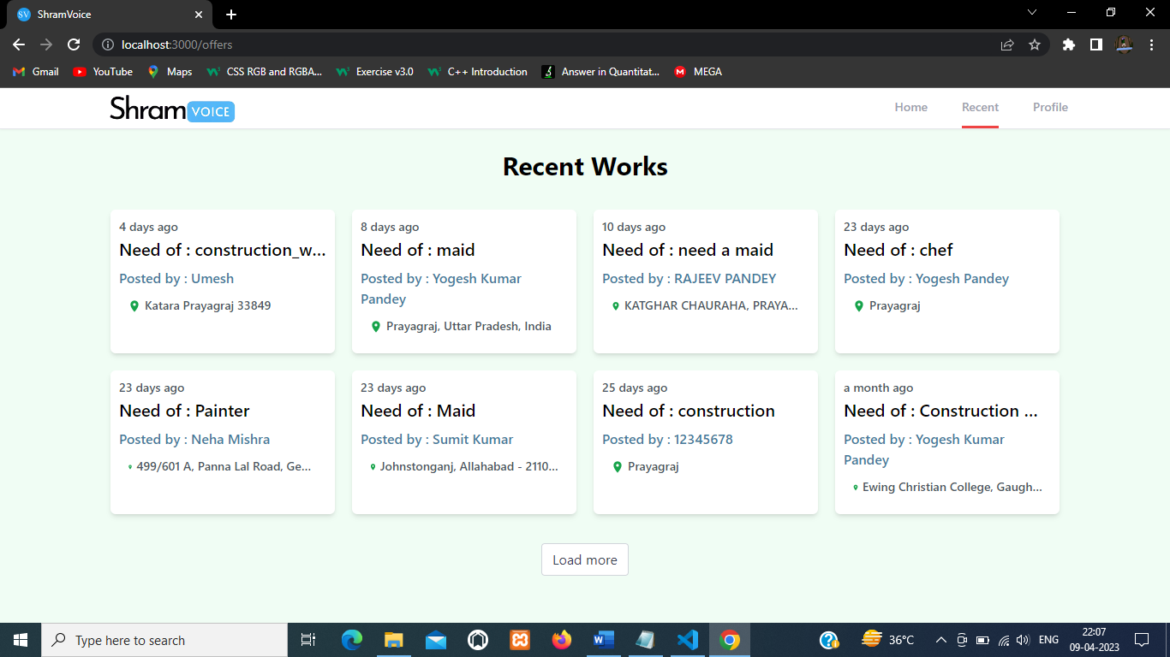

SignUp Page

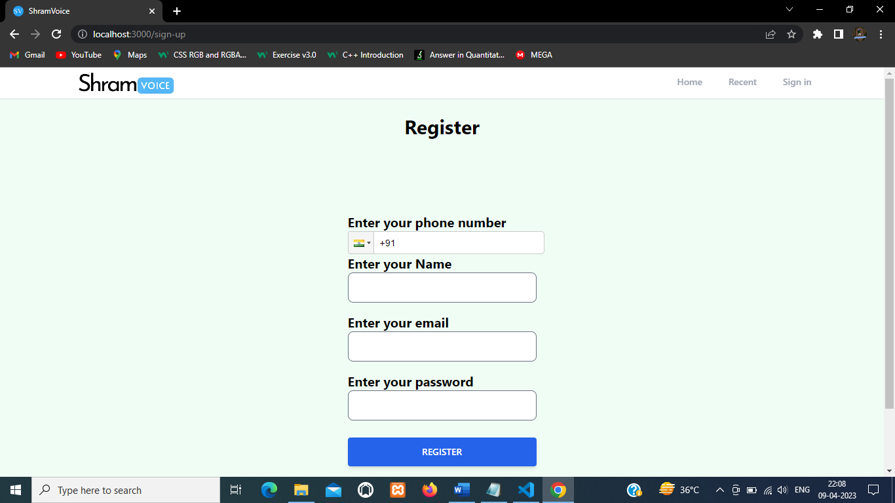

SignIn Page

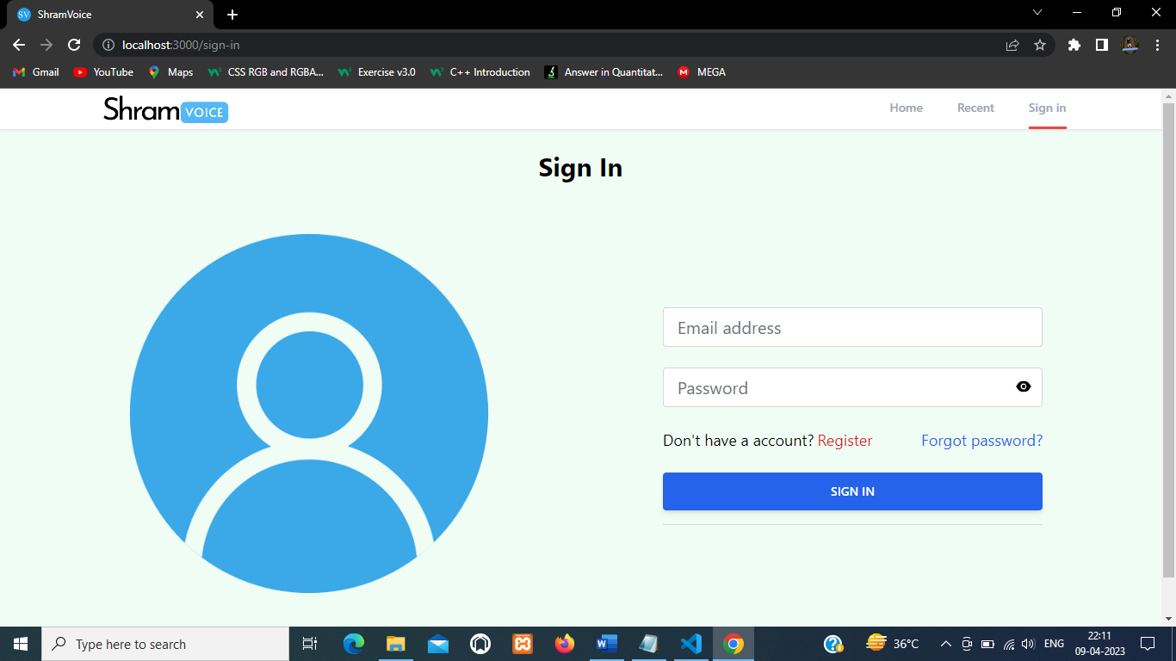

Profile Page

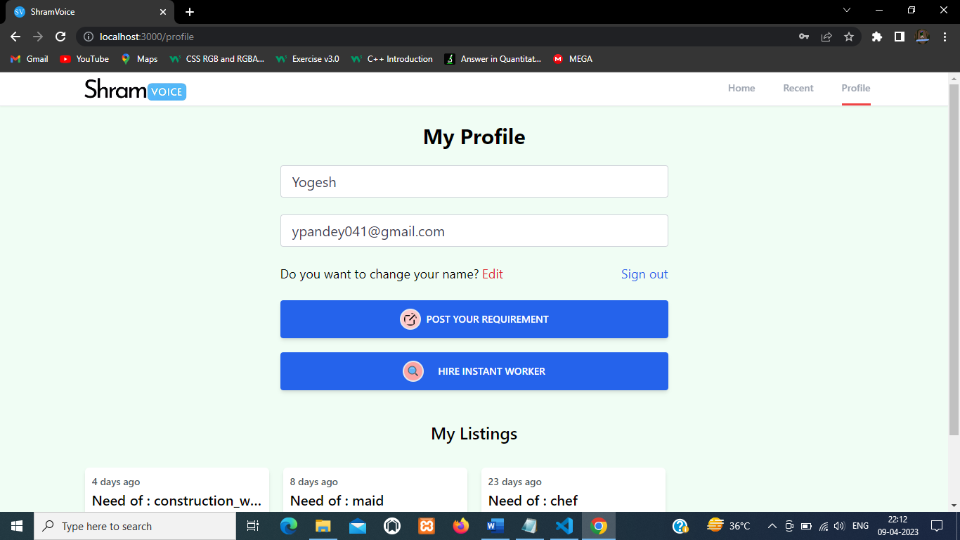

Post Your Requirement

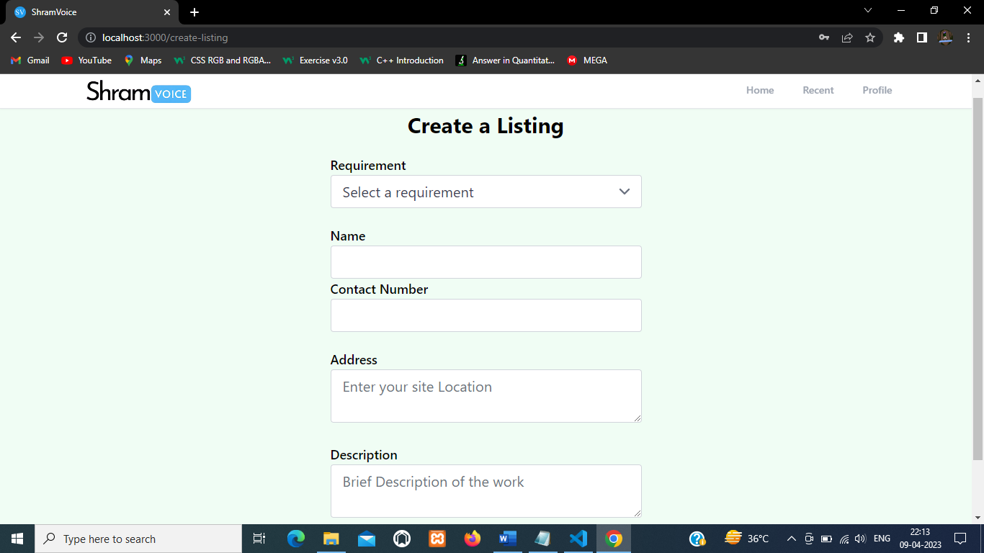

Find Worker

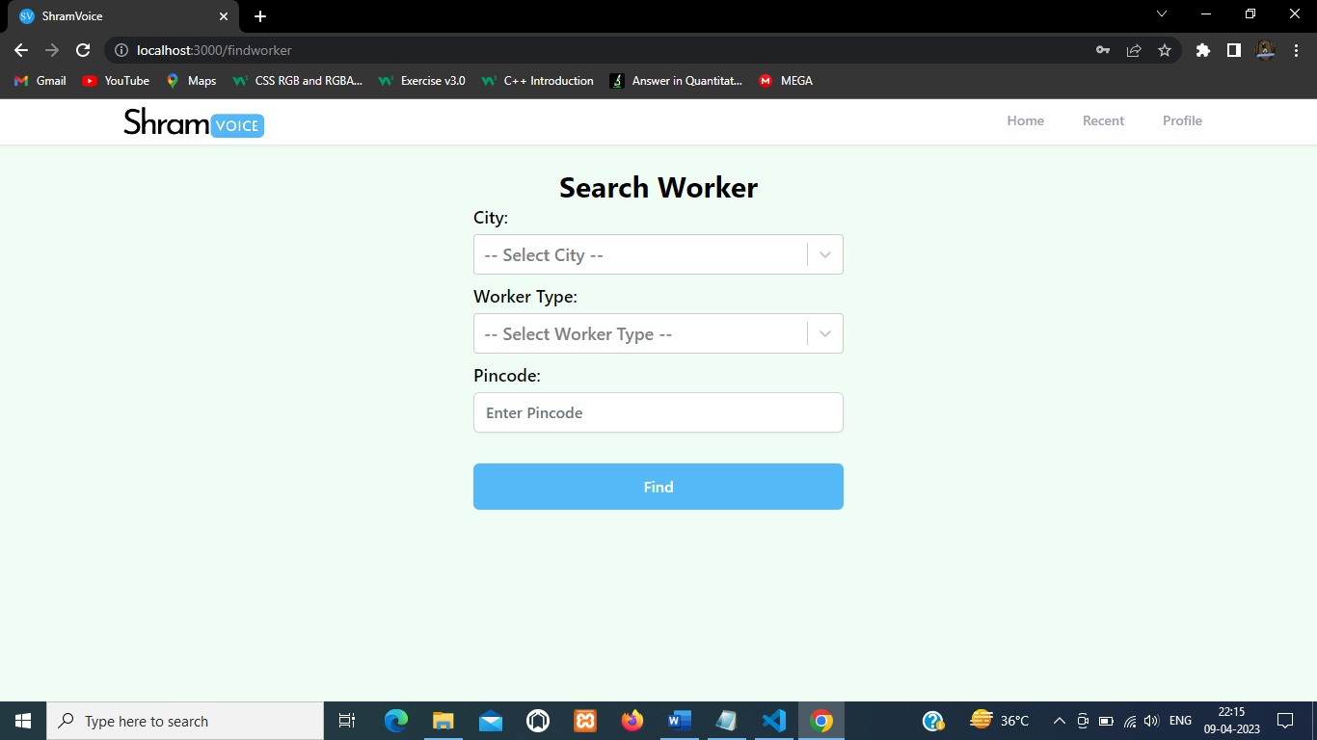

Listing Page

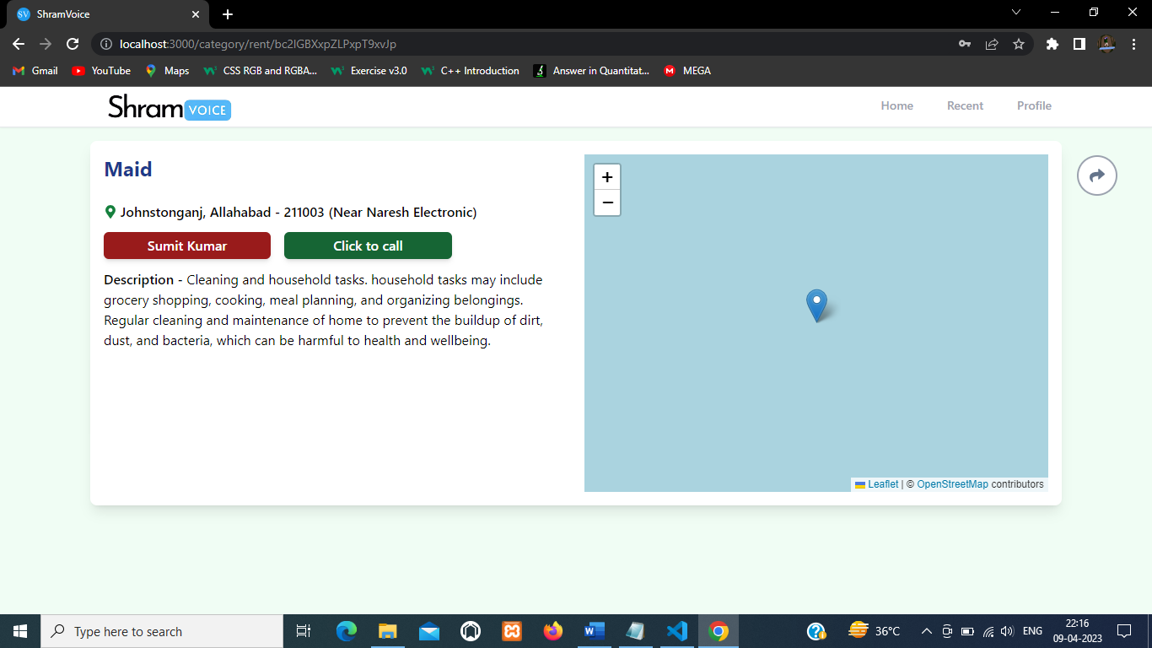

Admin Login

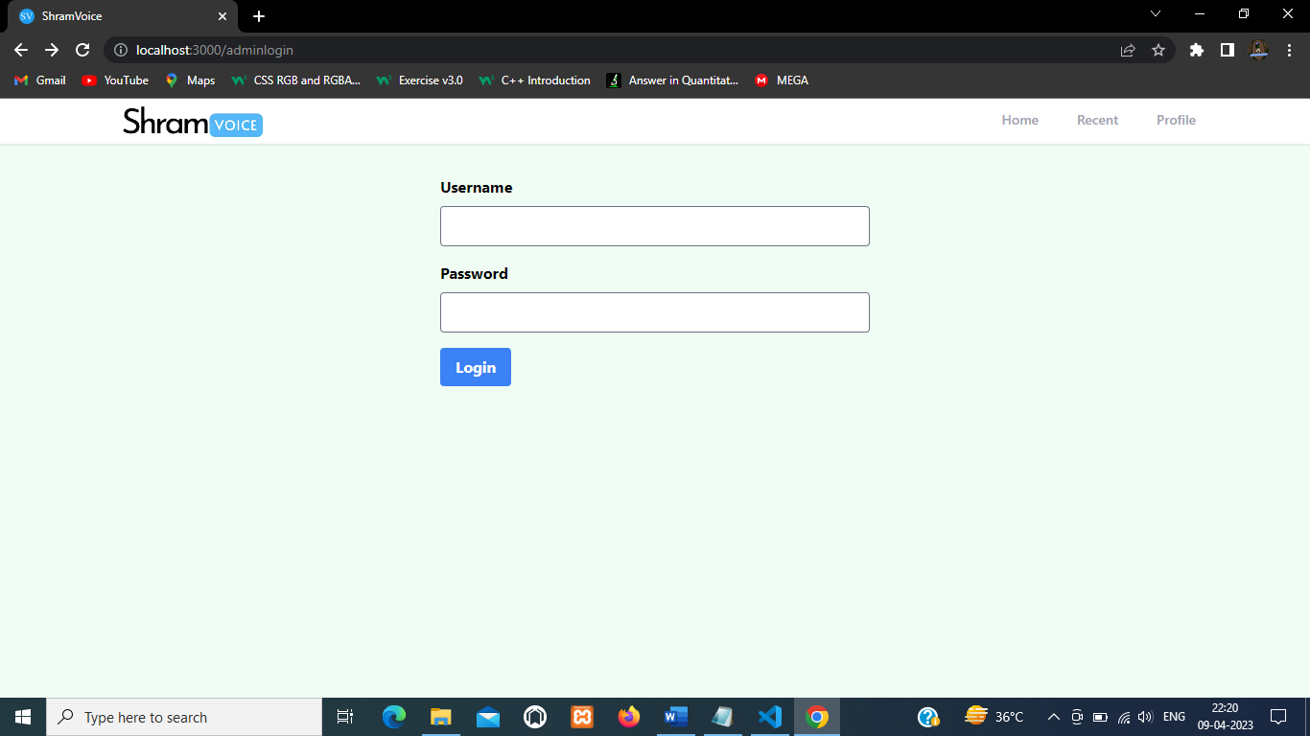

Add Worker

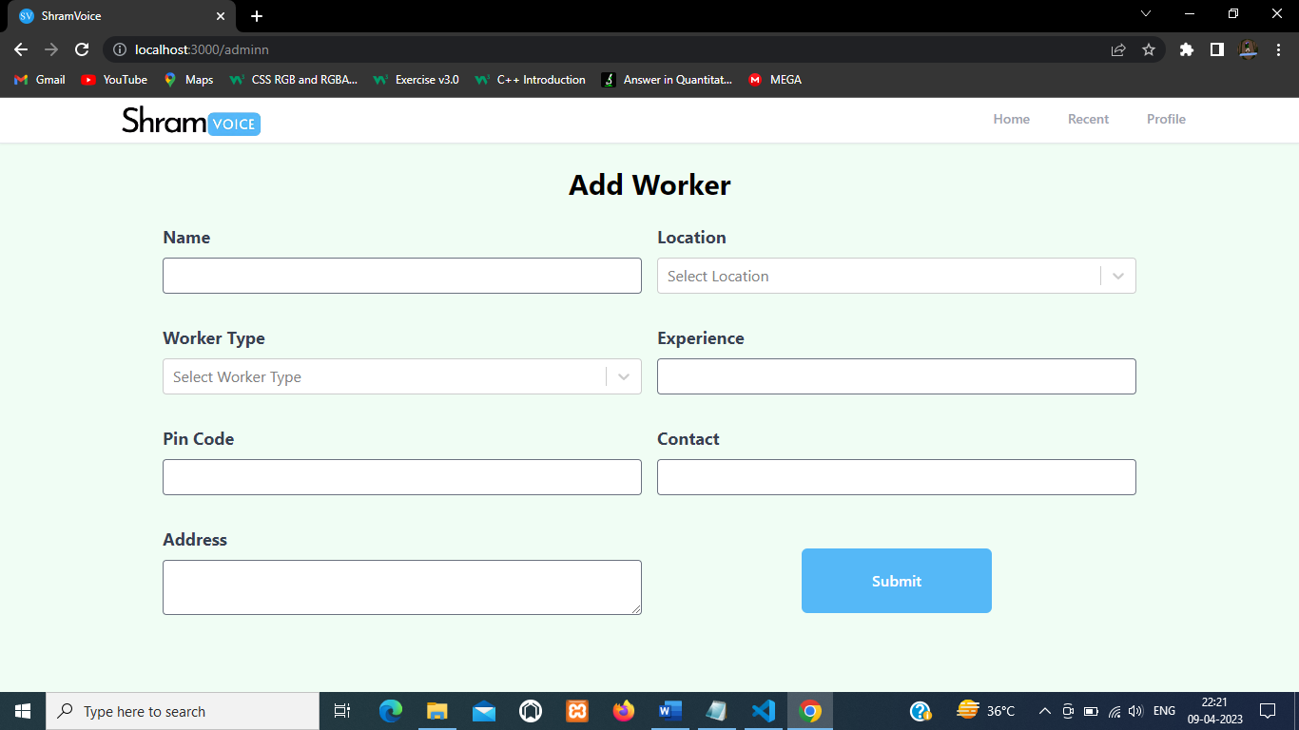

9.3 Test Cases and Result:

Test Scenario | Test Data | Expected Result | Actual Result
Register New Employer | Information of Employer to be  Added | Successfully Register New Employer | As Expected
Login to Existing Account | Employer Enter Valid Data | Successfully Login | As Expected
Post Requirement for  Employer | Fill Required Details | Successfully Added | As Expected
Fetching from Worker  Database | Fill Required Details | Successfully Fetch Data | As Expected
Update Existing Listings | Fill Fresh Details | Successfully Updated | As Expected
Delete Listings | Click Delete Icon | Successfully Deleted | As Expected

CHAPTER 10: ACTIVITY CHART

Activity Code | Name of Activity | Duration of Activity
1. | Analysis | 20 DAYS (05-01-23)  TO (25-01-23)
2. | Designing | 24 DAYS (02-02-23)  TO (26-02-23)
3. | Coding | 32 DAYS (28-02-23) TO (31–03-23)
4. | Documentation | 9 DAYS (01-04-23)  TO (09-04-23)

TOTAL 85 DAYS

CHAPTER 11: CONCLUSION

In conclusion, the development of the Blue-Collar Hiring platform is a significant step towards revolutionizing the hiring process for blue-collar workers. The platform offers a robust solution to the various challenges experienced in the blue-collar industry, including the lack of a centralized platform for hiring and the difficulty in matching suitable candidates to job requirements.

The project was developed using agile methodology, which allowed for iterative development and frequent collaboration with stakeholders to ensure that the final product met their expectations. The use of modern technologies such as React.js, Tailwind CSS, and Firebase ensured that the platform was responsive, fast, and scalable.

The feasibility study conducted on the project indicated that the platform was technically feasible, economically viable, and operationally feasible. The platform's potential for revenue generation was also analysed and found to be promising, with various monetization strategies available, including job posting fees and subscription-based models for employers.
The future scope of the project is vast, with potential for growth and expansion into other geographical regions and industries. The addition of new features such as machine learning algorithms for job matching and integration with other HR software could further enhance the platform's usability and efficiency.

Overall, the Blue-Collar Hiring platform is a step towards creating a more equitable and efficient hiring process for blue-collar workers, and it has the potential to transform the blue-collar industry.

CHAPTER 12: FUTURE SCOPE OF THE PROJECT

The future scope of the project for the Blue-Collar Hiring platform is extensive. Here are some potential areas for expansion and improvement:

- Integration with AI and Machine Learning: The platform can be enhanced with AI and Machine Learning algorithms to improve the job matching process, worker profiling, and automated screening of applicants.
- Mobile Application: With the increasing use of smartphones, creating a mobile application can improve the accessibility of the platform for both workers and employers.
- Integration with social media: Integrating the platform with social media platforms like Facebook, Twitter, and LinkedIn can increase the reach of the platform and help employers find the right candidates.
- Partnership with Training Institutes: Partnering with training institutes and vocational schools can provide a pool of skilled workers to the platform and enhance the quality of the workforce.
- Expanding Geographical Reach: Expanding the platform's geographical reach to other countries and regions can help in creating a diverse pool of workers and increase opportunities for workers and employers.
- Improved User Interface and User Experience: Continuously improving the user interface and user experience can make the platform more user-friendly and attractive to both workers and employers.
- Integration with Gig Economy: The platform can also explore the integration with the gig economy, providing opportunities for workers to take up short-term assignments and freelance work.
- In summary, there are several avenues for growth and improvement for the Blue-Collar Hiring platform in the future. By implementing some of these strategies, the platform can attract more users, expand its reach, and become a go-to platform for hiring blue-collar workers.

CHAPTER 13: BIBLIOGRAPHY

The resources referred during the development of this project are as follows-

- HTML, CSS from https://www.w3schools.com/
- JavaScript from https://developer.mozilla.org/
- https://tailwindcss.com/docs/
- React from https://react.dev/learn
- https://firebase.google.com/docs
- Other Sources – YouTube.com

