**Experiment 3**

**Aim** - Understanding the concept the threat modeling with an exercise using microsoft threat

modeling tool

**Theory**- Threat Modeling (TM) is a structured approach used in information security and software development to identify potential security threats and vulnerabilities in a system or application. The goal of threat modeling is to proactively assess security risks and take appropriate measures to mitigate or eliminate these threats before they can be exploited by attackers.

**Importance of Threat Modeling:**

* Risk Reduction: Threat modeling helps in identifying and prioritizing potential risks, allowing organizations to focus their efforts on the most critical security issues.
* Early Detection: It enables the identification of security flaws during the design phase, reducing the cost and effort required to fix them later in the development lifecycle.
* Security by Design: By integrating security considerations from the beginning, threat modeling promotes a "security by design" approach.
* Compliance: Many regulatory frameworks and standards require organizations to conduct risk assessments and implement security controls, making threat modeling essential for compliance.

**Process of Threat Modeling:**

The process of threat modeling typically involves the following steps:

* Scope Definition: Clearly define the boundaries of the system or application being assessed. Identify its components and external dependencies.
* Threat Identification: Enumerate potential threats that the system may face. This can be done using various techniques, such as brainstorming, threat libraries, past incident analysis, etc.
* Asset Identification: Identify the critical assets, data, and functionalities that need protection.
* Attack Surface Analysis: Analyze the potential entry points (attack surfaces) that attackers could use to exploit vulnerabilities.
* Threat Analysis: Assess the threats identified in Step 2 and understand their impact on the system, including how they might exploit the vulnerabilities.
* Mitigation Planning: Develop and prioritize strategies to address the identified threats. This could involve selecting and implementing security controls, re-architecting certain aspects, or adding security layers.
* Risk Assessment: Evaluate the residual risks after implementing the mitigation strategies.
* Review and Iterate: Review the threat model with stakeholders, gather feedback, and iterate on the model to improve its accuracy and effectiveness.

**Limitations of Threat Modeling:**

* Assumption-based: Threat modeling relies on assumptions about potential threats, and these assumptions may not always align with real-world attack scenarios.
* Expertise and Resources: It requires knowledgeable security experts and time to conduct thorough threat modeling exercises.
* Complexity: For large and complex systems, threat modeling can become challenging and time-consuming.
* Scope and Context: Defining the scope and context accurately can be difficult, which may lead to missing certain threats or assets.
* Dynamic Environment: Threats and vulnerabilities evolve over time, so the threat model may become outdated without regular updates.
* False Sense of Security: Over-reliance on threat modeling might give a false sense of security, as it cannot guarantee that all possible threats have been identified.

**Steps to Solve Threats Identified:**

To address the threats identified during threat modeling, the following steps are typically taken:

* Selection of Security Controls: Determine the most appropriate security controls to mitigate each threat. This could include encryption, access controls, intrusion detection systems, etc.
* Implementation: Implement the chosen security controls into the system or application.
* Testing and Validation: Thoroughly test the implemented controls to ensure they function as expected and do not introduce new vulnerabilities.
* Monitoring: Continuously monitor the system to detect and respond to any emerging threats or incidents.
* Updates and Patching: Keep the system and all its components up to date with security patches and updates.
* Education and Awareness: Educate users and stakeholders about security best practices to minimize human error-related risks.
* Feedback Loop: Maintain a feedback loop from incidents and ongoing security assessments to continuously improve the threat modeling process and the security posture of the system.

**Methodologies of threat modeling:**

* STRIDE: STRIDE is a threat modeling methodology developed by Microsoft. It focuses on identifying threats based on six categories: Spoofing, Tampering, Repudiation, Information Disclosure, Denial of Service, and Elevation of Privilege. For each category, the model considers the potential threats, their impact, and possible countermeasures.
* DREAD: DREAD is a threat modeling framework used to assess risks by assigning scores to different aspects of a threat. The acronym stands for Damage potential, Reproducibility, Exploitability, Affected users, and Discoverability. Each category is scored from 0 to 10, with higher scores indicating higher risks.
* PASTA: Process for Attack Simulation and Threat Analysis (PASTA) is a threat modeling methodology that incorporates concepts from security risk management and attack patterns. It emphasizes a risk-centric approach and uses seven steps, including defining objectives, creating an application profile, identifying threats, creating attack models, and prioritizing threats.
* TARA: Threat Agent Risk Assessment (TARA) is a threat modeling approach that centers around the identification and prioritization of threat agents or adversaries. It involves understanding the motivations, capabilities, and potential actions of different threat agents and how they might target a system.
* OCTAVE: Operationally Critical Threat, Asset, and Vulnerability Evaluation (OCTAVE) is a threat modeling methodology designed for organizations to assess information security risks. It considers business processes, assets, threats, and vulnerabilities to develop a risk profile and recommends security controls.
* Trike: Trike (also known as the Microsoft TRIKE methodology) is a structured threat modeling approach that combines the best elements of various existing methodologies. It aims to be flexible and comprehensive, accommodating different threat modeling needs based on the project's size and complexity.
* VAST: Visual, Agile, and Simple Threat (VAST) modeling is a lightweight approach to threat modeling, emphasizing simplicity and ease of use. It involves creating visual representations of the application and potential threats, making it accessible to a broader range of stakeholders.
* LINDDUN: LINDDUN stands for Linkability, Identifiability, Non-repudiation, Detectability, Disclosure of information, Unawareness, Non-compliance, and DoS (Denial of Service). It is a comprehensive checklist-based threat modeling methodology that covers a wide range of security aspects.

**Tools for thread modeling:**

* Microsoft Threat Modeling Tool (MTMT): Developed by Microsoft, this tool is widely used for creating and analyzing threat models. It helps in identifying potential threats, vulnerabilities, and security controls within a system. The tool integrates with Visual Studio and Azure DevOps, making it suitable for software development teams.
* OWASP Threat Dragon: Threat Dragon is an open-source threat modeling tool by OWASP. It allows users to create and visualize threat models using a data-flow-based approach. The tool is web-based and provides collaboration capabilities, making it useful for distributed teams.
* Eclipse Papyrus for Real-Time Security (Papyrus-RT): While primarily a UML modeling tool for real-time and embedded systems, Papyrus-RT can be extended to support threat modeling. It allows the creation of UML-based threat models and system designs.
* IriusRisk: IriusRisk is a commercial threat modeling platform that helps organizations identify, assess, and mitigate security risks during the software development lifecycle. It supports various threat modeling methodologies and offers integration with popular development tools.
* Pytm: Pytm is an open-source Python-based threat modeling framework that enables users to create and manage threat models in code. It follows the "Pytm" language, allowing threat models to be version-controlled and integrated into development pipelines.
* Seaweed Threat Modeling Tool: Seaweed is an open-source threat modeling tool that employs a graphical interface to create threat models using the STRIDE methodology. It offers simplicity and ease of use for teams that prefer a straightforward approach to threat modeling.
* ThreatModeler: ThreatModeler is a comprehensive commercial threat modeling platform that automates the threat modeling process. It supports various threat modeling methodologies and helps organizations efficiently analyze and manage security risks.

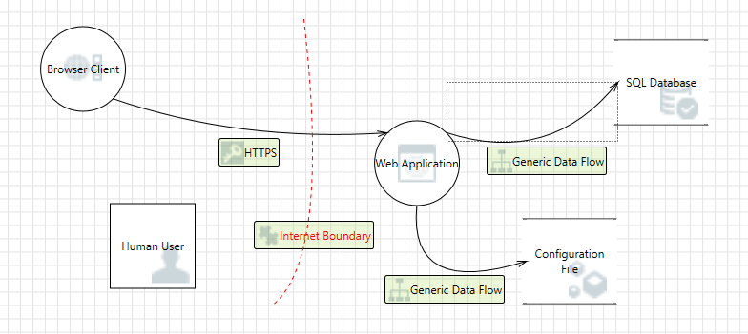

**Conclusion**:In conclusion, the threat modeling exercise using the Microsoft Threat Modeling Tool was instrumental in enhancing the security posture of the system. It provided valuable insights into potential threats, vulnerabilities, and risk prioritization. By incorporating security measures early in the development lifecycle, we are better equipped to build a robust and secure application.