HIGH-LEVEL DESIGN
Resume Screening
System architecture for AI-assisted resume-to-JD screening
Item | Detail
Document | HLD v1.0
Product version | 7.1
Status | Baseline: describes the delivered system
Date | 16 October 2026
Author | Solution Architect: [TBD]
Related documents | PRD v7.1, LLD v1.0, Deployment and Local Run Guide v7.1

Contents

Tip: If the contents list is empty, right-click it in Word and choose Update Field.

1. Introduction and purpose
This HLD describes the shape of the Resume Screening system: its components, how requests and data flow between them, the technology choices, integrations and non-functional design. It is intended for architects, tech leads and the platform team. Field-level schemas, API contracts and algorithms are in the LLD.
The system implements the PRD goal: classify each resume against each JD as Best Fit, Close to JD or Not Fit, prove skills from project details, and enforce an infrastructure-domain gate and a JD-keyword gate before anyone is shortlisted.

2. System architecture overview
Resume Screening is a thin-server, rich-client web application deployed as a single Node.js process on the customer's own server (bare metal, VM or Docker).
- Browser (rich client): reads uploaded files, builds the analysis prompt, sends resumes in batches, normalises the AI reply, enforces the screening gates, renders results and builds PDF/CSV/text exports. Each user's workspace is kept in browser localStorage.
- Server (thin): handles sign-in, sessions and user administration, serves the pages, and acts as an authenticated proxy to the LLM provider so the provider key never reaches the browser. It does not store resumes or results.
- LLM provider: an external chat-completions API. Default is OpenRouter routing to NVIDIA Nemotron 3 Ultra; Anthropic, Groq, Sarvam AI or a self-hosted OmniRoute gateway can be selected by configuration.
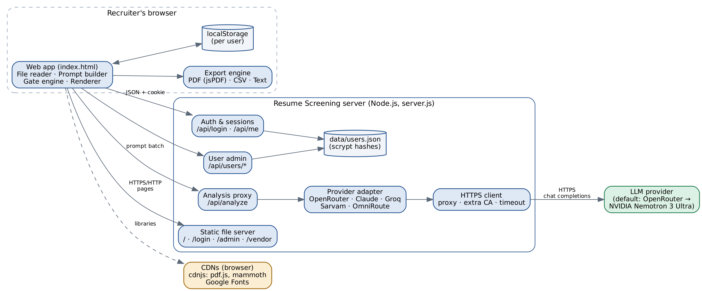
Figure 1. Component architecture

2.1 Key architectural decisions
Decision | Choice | Rationale
Where AI keys live | Server only; browser calls /api/analyze | Keys must not be exposed to users or the network; enables proxy/certificate handling in one place.
Where gates run | Browser, after normalisation | Deterministic rules applied to the AI's structured output; same code for the hosted and local editions; no server state needed.
Results storage | Browser localStorage per user | No candidate data at rest on the server; simplest compliant default. Trade-off: no cross-device history.
Server dependencies | None (Node.js standard library only) | Easy install in restricted networks; small attack surface; no npm install.
Provider abstraction | Single adapter with per-provider profile | Provider switch by AI_PROVIDER; OpenAI-style providers share one code path.
Sessions | In-memory map + HttpOnly cookie | Single instance; restart simply requires sign-in again.

3. Major components and responsibilities
Component | Responsibility | Key interactions
Web app (index.html) | Workspace UI, file ingestion, prompt building, batching, result normalisation, gate engine, rendering. | Calls /api/me, /api/analyze, /api/test-connection; reads/writes localStorage; uses export engine.
File reader | Extract text from PDF (pdf.js), DOCX (mammoth.js), TXT/MD (File API). | Libraries lazy-loaded from cdnjs in the browser.
Gate engine | Recompute domain verdict from the project table; apply domain and keyword rules; cap or reject; record reasons. | Runs on every assessment and on example data.
Export engine | PDF (jsPDF + AutoTable, vendored), CSV, plain-text report. | Reads current results from state.
Sign-in page (login.html) | Sign-in and forced password change. | /api/login, /api/change-password, /api/me.
Admin page (admin.html) | Create users, reset passwords, change roles, delete users; change own password. | /api/users endpoints (admin only).
Router (server.js) | Route requests; enforce authentication, forced password change and admin role. | All handlers.
Auth and sessions | Verify scrypt hashes, throttle failures, issue and expire session tokens. | users.json store; cookie header.
User store | Load/save users.json atomically (temp file + rename, mode 600). | Auth, user admin.
Analysis proxy | Validate request, call provider, extract and parse JSON, map errors to codes. | Provider adapter.
Provider adapter | Build provider-specific request (headers, body, reasoning, JSON mode), retry without unsupported optional parameters. | HTTPS client.
HTTPS client | Outbound requests with CONNECT proxy tunnelling, proxy auth, extra CA, timeout, abort. | LLM provider.
Diagnostics | Test connection per depth option; translate network/API errors into fixes. | Provider adapter, HTTPS client.
Static server | Serve pages (with signed-in user injected) and vendored scripts. | Router.

4. Data flow overview
A typical screening run, at a high level:
- The recruiter adds JDs and resumes. Text is extracted in the browser; nothing is uploaded yet.
- For each JD, resumes are grouped into batches (default 3 for OpenRouter) and a prompt is built containing the fit rules, the project-evidence rules, the domain-check rules and the keyword-gate rules, plus the JD and the batch of resumes.
- The browser posts the prompt to /api/analyze. The server checks the session, calls the configured provider through the adapter, and returns the parsed JSON (or a coded error).
- The browser normalises each assessment (types, enums, limits), then the gate engine applies the domain gate and keyword gate and records reasons.
- Results are rendered, saved to localStorage for that user, and can be exported to PDF, CSV or text.
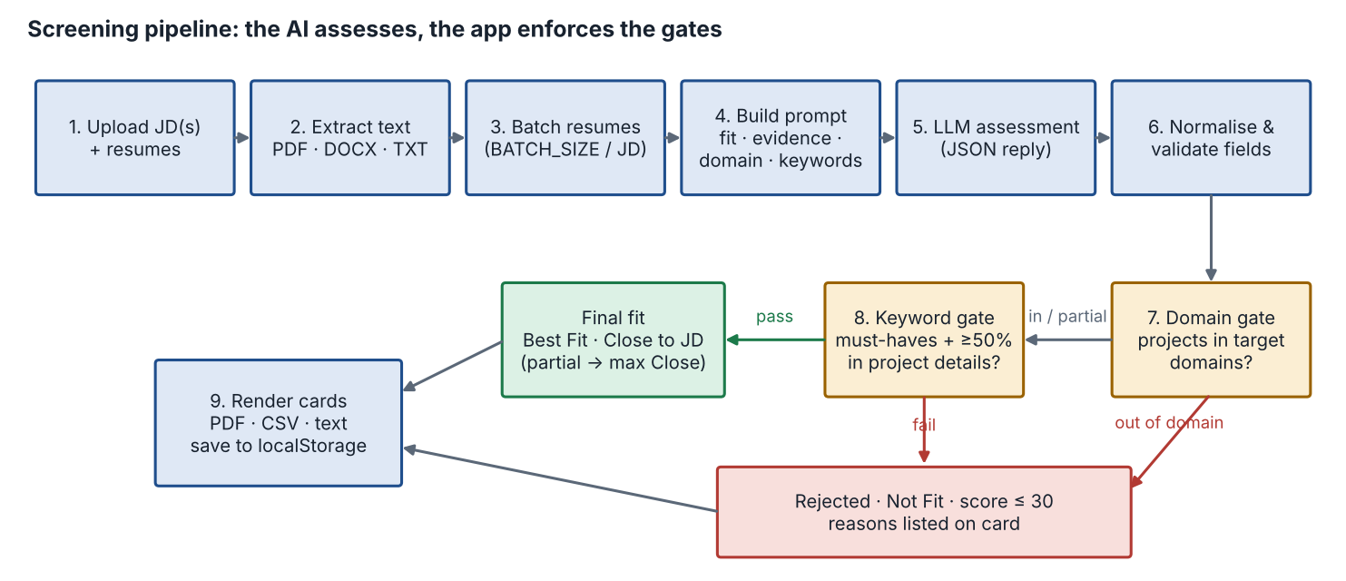
Figure 2. Screening pipeline
Note: Both gates are always evaluated; a resume can be rejected for its domain, its keywords or both. The diagram shows them in sequence for readability.

4.1 Data classification
Data | Where it lives | Handling
Resume and JD text | Browser memory and localStorage; in transit to the AI provider | Not written to server disk or logs; trimmed to size limits.
Assessment results | Browser localStorage (per user) | Cleared by Clear all; exported files are user-managed.
User accounts | Server data/users.json | Salted scrypt hashes; file mode 600; back up.
Sessions | Server memory | Random 256-bit tokens; expire after SESSION_HOURS; lost on restart.
AI provider key | Server environment (.env) | Never sent to the browser.

5. Technology stack
Layer | Technology
Server runtime | Node.js 18+ (tested on 20/22); standard library only: http, https, tls, crypto, fs.
Front end | Plain HTML, CSS and JavaScript (no framework); IBM Plex Sans/Mono and Bricolage Grotesque fonts.
Document parsing (browser) | pdf.js 3.11.174, mammoth.js 1.6.0 (cdnjs, lazy-loaded).
PDF export (browser) | jsPDF 2.5.1 + jsPDF-AutoTable 3.8.2, vendored in public/vendor.
Persistence | JSON file for users; browser localStorage for workspaces.
AI | OpenRouter → nvidia/nemotron-3-ultra-550b-a55b (default); Anthropic Messages API; Groq, Sarvam AI and OmniRoute chat completions.
Packaging | Zip with start.sh/start.bat; Dockerfile (node:20-alpine) and docker-compose.yml with a named volume for data.
Optional edge | Nginx reverse proxy for HTTPS and an extra password layer.

6. Integration points
System | Endpoint | Auth | Nature
OpenRouter (default) | POST https://openrouter.ai/api/v1/chat/completions | Bearer key | Sync HTTPS, JSON; reasoning {effort, exclude}; JSON mode; optional provider.require_parameters
Anthropic | POST https://api.anthropic.com/v1/messages | x-api-key, anthropic-version | Sync HTTPS, JSON
Groq | POST https://api.groq.com/openai/v1/chat/completions | Bearer key | Sync HTTPS; reasoning_effort; include_reasoning=false
Sarvam AI | POST https://api.sarvam.ai/v1/chat/completions | api-subscription-key + Bearer | Sync HTTPS; reasoning_effort
OmniRoute | POST {OMNIROUTE_BASE_URL}/chat/completions | Optional Bearer | Sync HTTP(S) to self-hosted gateway; never proxied when local
Corporate proxy | HTTPS_PROXY (CONNECT) | Optional Basic | Tunnel for outbound provider calls
cdnjs, Google Fonts | Browser fetches | None | Static libraries and fonts

7. Non-functional design

7.1 Security
- Authentication on every page and API except /login, /api/login, /api/logout and /api/health.
- Default admin/admin forced to change at first sign-in; password policy (8+ chars, not 'admin').
- Throttling: 10 failed sign-ins per client address per 15 minutes.
- Session cookie: HttpOnly, SameSite=Strict, Secure when SECURE_COOKIE=true; JSON-only POST bodies (CSRF mitigation together with SameSite).
- Role checks on the server for all admin operations; last administrator protected.
- Static file serving restricted to the public folder (path traversal check); pages sent with X-Frame-Options: DENY.
- Provider key only in server environment; outbound TLS verified (extra CA supported, never disabled).

7.2 Performance and capacity
- Each AI request carries a batch of resumes (default 3 with OpenRouter); a 50-resume screen against one JD is about 17 requests, run sequentially per JD.
- Server work per request is negligible; latency is dominated by the model (Thorough depth on Nemotron 3 Ultra can take minutes).
- Request body cap 2 MB; outbound timeout 600 s (configurable).
Assumption: Capacity targets were not specified. The design assumes one team (tens of users) on a single instance. Horizontal scaling would need a shared session store and a shared user store.

7.3 Availability and operations
- Single process; restart via service manager (systemd/PM2) or Docker restart policy.
- Accounts persist in users.json (Docker named volume rs-data); sessions do not survive restarts.
- Health endpoint /api/health for monitoring; console logs for user-account changes and AI errors (no resume content logged); last sign-in time is stored per user.

7.4 Privacy and compliance
- No candidate data at rest on the server.
- Candidate text is sent to the configured AI provider; operators should require non-logging providers in OpenRouter privacy settings and confirm candidate consent terms.

8. Deployment view
Option | Topology | Notes
Single machine | Browser → Node.js on 127.0.0.1:3000 | Default HOST; one user.
Team server | Browsers → Node.js on 0.0.0.0:3000 (firewalled to office subnet) | systemd or PM2.
Docker | Browsers → container :3000; volume rs-data:/app/data | docker compose up -d --build.
With HTTPS | Browsers → Nginx :443 (TLS, optional basic auth) → Node.js 127.0.0.1:3000 | SECURE_COOKIE=true; proxy_read_timeout 600s.

9. Assumptions and constraints
- Assumption: single-instance deployment for one recruitment team; no high-availability requirement.
- Assumption: recruiters use current desktop browsers with access to cdnjs and Google Fonts.
- Assumption: the LLM follows the JSON contract well enough; the client tolerates missing or invalid fields and the gates do not reject when data is missing (Not verified).
- Constraint: text-based PDFs only; scanned resumes need pasted text.
- Constraint: results are per browser; moving machines or clearing browser data loses them unless exported.
- Constraint: provider limits (context, reply size, rate limits) bound batch size; defaults chosen per provider.

