LOW-LEVEL DESIGN
Resume Screening
Module, API, data and algorithm specifications
Item | Detail
Document | LLD v1.0
Product version | 7.1
Status | Baseline: matches the delivered code
Date | 16 October 2026
Author | Solution Architect: [TBD]
Code base | server.js (618 lines), public/index.html (902), admin.html (188), login.html (111)

Contents

Tip: If the contents list is empty, right-click it in Word and choose Update Field.

1. Introduction
This LLD details every component named in the HLD at a level an engineer can implement or modify from. It covers the server modules in server.js, the browser modules in public/index.html, login.html and admin.html, the data models, the API contracts, the screening-gate algorithms, error handling and configuration. It matches the delivered code at version 7.1.

1.1 Source layout
Path | Contents
server.js | Config loader, HTTPS client, user store, sessions, throttling, router, auth and admin handlers, provider adapter, analysis proxy, diagnostics, static server.
public/index.html | Main app: state, storage, file ingestion, prompt builder, batching and run loop, normalisation, gate engine, renderers, exports.
public/login.html | Sign-in and forced password change.
public/admin.html | User administration.
public/vendor/ | jspdf.umd.min.js (2.5.1), jspdf.plugin.autotable.min.js (3.8.2).
data/users.json | User accounts (created on first start).
.env / .env.example | Configuration (section 8).
Dockerfile, docker-compose.yml, start.sh, start.bat | Packaging and start-up.

2. Server modules (server.js)

2.1 Config loader
Reads .env (simple KEY=VALUE, comments and quotes stripped) without overriding variables already in the environment, then derives constants: provider profile P, tiers, limits, gate settings. Resolution of AI_PROVIDER: explicit value (claude is an alias of anthropic), else first provider whose key is set in the order OpenRouter, OmniRoute, Groq, Anthropic, Sarvam, else openrouter.

2.2 Provider profiles
Provider | Endpoint (default base) | Tiers: default / complex / quick | Max tokens | Batch
openrouter | openrouter.ai/api/v1/chat/completions | Nemotron 3 Ultra; effort medium / high / low | 16000 | 3
omniroute | localhost:20128/v1/chat/completions | auto / auto / auto; no effort | 8000 | 2
groq | api.groq.com/openai/v1/chat/completions | gpt-oss-120b, gpt-oss-120b, gpt-oss-20b; medium / high / low | 8000 | 2
anthropic | api.anthropic.com/v1/messages | claude-sonnet-4-5, claude-opus-4-5, claude-haiku-4-5 | 16000 | 4
sarvam | api.sarvam.ai/v1/chat/completions | sarvam-105b; default / high / low | 16000 | 4
Each profile defines name, keyVar, url, headers(key), extra (provider-specific body fields), effortStyle (openrouter → reasoning:{effort,exclude:true}; otherwise reasoning_effort), tiers, maxTokens, batchSize, and keyOptional (OmniRoute).

2.3 HTTPS client
Function | Specification
proxyFor(url) → URL|null | Returns the proxy from HTTPS_PROXY/HTTP_PROXY unless the host is local (localhost, 127.x, ::1, host.docker.internal) or matches NO_PROXY (exact, suffix or *).
postJson(url, headers, body, signal) → {status, ok, json, text} | POSTs JSON. With a proxy: CONNECT tunnel (Basic auth from URL credentials), then TLS with SNI and optional extra CA. Timeout REQUEST_TIMEOUT_MS; aborts on signal. Never throws on HTTP errors; throws on network errors with code (ECONNREFUSED, PROXY_AUTH, PROXY_REFUSED, ETIMEDOUT…).
explainNetError(e, host) → string | Maps network error codes to a plain-language fix (DNS, firewall, proxy, proxy auth, certificate inspection → EXTRA_CA_CERTS, timeout). OmniRoute-specific message when the local gateway is down.

2.4 User store, sessions and throttling
Function | Specification
hashPassword(pw, salt?) → {salt, hash} | scrypt(pw, 16-byte random salt hex, keylen 64) → hex.
checkPassword(pw, user) → bool | Recompute scrypt and compare with timingSafeEqual.
loadUsers() / saveUsers(users) | Read data/users.json; write to .tmp with mode 600 then rename (atomic). Creates admin/admin with mustChangePassword=true if the file is missing or empty.
createSession(username) → token | 32 random bytes hex; stored with expiry now + SESSION_HOURS.
sessionUser(req) → {token, user}|null | Reads cookie rs_session; drops expired sessions and sessions whose user no longer exists.
endSessionsFor(username, exceptToken?) | Deletes all of a user's sessions (used on password change, reset, delete).
tooManyFailures(ip) / recordFailure(ip) | Map ip → {count, until}; window 15 minutes; limit 10.
cookieHeader(token, maxAge) | rs_session=…; Path=/; HttpOnly; SameSite=Strict; Max-Age=…[; Secure].

2.5 Router and handlers
route(req, res) evaluates rules in order:
- Public: GET /api/health, POST /api/login, GET /login (redirects to / if signed in and not forced to change), POST /api/logout.
- Require session, else 401 JSON (signed_out) for /api/* or 302 to /login.
- GET /api/me and POST /api/change-password are allowed even when the user must change password.
- If mustChangePassword: 403 must_change_password for APIs, 302 to /login?change=1 for pages.
- /api/users/* → handleUsers (admin only); POST /api/analyze → analyze; POST /api/test-connection (admin only).
- GET / → index.html with <!--RS_USER--> replaced by window.RS_USER={…}; GET /admin (admin only) → admin.html; other GETs → static files under public/ (traversal blocked).

2.6 Provider adapter and analysis proxy
Function | Specification
callAI(tier, prompt, maxTokens, signal, opts) | Anthropic: {model, max_tokens, temperature, system, messages:[user]}. OpenAI-style: {model, max_tokens, temperature, messages:[system,user], response_format:{type:'json_object'} if JSON_MODE, reasoning, …extra}. Normalises HTTP 200 bodies that contain error and no choices into failures. On 400/422 mentioning response_format, a provider extra, or reasoning, disables that option (process-wide for JSON mode; per tier for effort/extras) and retries; up to 4 attempts.
replyOf(data) → {text, truncated} | Anthropic: join text blocks; truncated if stop_reason=max_tokens. OpenAI-style: choices[0].message.content (string or parts), <think>…</think> removed; truncated if finish_reason=length.
parseJsonLoose(text) | Whole text as JSON; else the first fenced code block; else first { to last }.
apiErrorMessage(r) | error.message, error string, detail string/array, or message; otherwise 'HTTP n from host (not from the provider…)'.
openRouterHint / omniHint(r, msg) | Appends fixes for 401, 402 credits, 404 no endpoints / privacy policy, 429 rate limits, 408/502/503 upstream failures (OpenRouter); key, model and no-provider hints (OmniRoute).
analyze(req, res) | Validates key and prompt; selects tier; aborts upstream when the client disconnects; maps failures to codes (section 7); returns {result, model, usage}.
testConnection(req, res) | For each tier sends 'Reply with exactly this JSON: {"ok":true}' (20 tokens for Anthropic, 2000 for reasoning models); stops at the first network error; returns per-tier status, message and latency, plus API host, proxy and extra-CA flags.

3. Browser modules

3.1 index.html
Module / function | Specification
State and storage: load(), save() | state = {jds[], cvs[], results, activeJd, filter, tier}. Key resumescreening.v1.<username>. Saved example results are refreshed from the built-in example on load.
File ingestion: fileToText(file), addFiles(files, kind) | PDF via pdf.js (worker script loaded in the main thread), line reconstruction from text-item y-positions; DOCX via mammoth.extractRawText; TXT/MD via file.text(); .doc rejected. The first real upload replaces example items of that kind.
batches(cvs) | Trims each resume to 14,000 chars; groups up to MAX_BATCH (from /api/me batchSize) and ≤ 50,000 chars per batch; assigns R1…Rn.
buildPrompt(jd, batch) | Role, fit definitions, evaluation rules, DOMAIN CHECK (TARGET_DOMAINS), PROJECT EVIDENCE CHECK, KEYWORD GATE (KEYWORD_MIN_COVERAGE), JD (≤ 20,000 chars), resumes, and the JSON contract (section 4.3).
run() | For each JD and batch: POST /api/analyze; on success normalise each assessment and call applyGates; on error record a coded failure; stop the whole run on fatal codes (auth, key, network, rate limit, signed out). Results replace state.results only if at least one assessment returned.
Normalisation | Enum checks (fit, gap_nature, evidence_strength, usage), clamping (score 0–100), arrays coerced to strings, limits (3 strengths, 3 projects per keyword, 8 domain projects), domain_check default 'Not verified'.
applyGates(a) | Section 5.
Renderers: renderResults, card, domainBlock, evidenceBlock | Tabs per JD, tiles and filters, gate summary lines, cards with reject banner, domain table, keyword-gate header and evidence table.
Exports: buildPdf, toCsv, toMarkdown | PDF: A4, cover block, per-JD counts, ranking table (fit, score, years, domain, keyword gate, counts), per-candidate details with domain and evidence tables, footer page x of y; non-Latin-1 characters mapped (e.g. ₹ → Rs.). CSV: UTF-8 with BOM.
Clear all | Two-click confirmation (4 s window); aborts an active run and marks it cleared so late results are discarded.
Diagnostics UI | Admin-only Test connection button; error box shows the mapped message plus details.

3.2 login.html and admin.html
- login.html: sign-in form → POST /api/login; if mustChangePassword, shows the change form pre-filled with the current password; ?change=1 re-opens it for an existing session.
- admin.html: lists users (role select, status pill, last sign-in), create form with password generator (12 chars from an unambiguous alphabet), reset row (copies the new password to the clipboard), two-click delete, and own-password form. Receives window.RS_USER from the server.

4. Data models
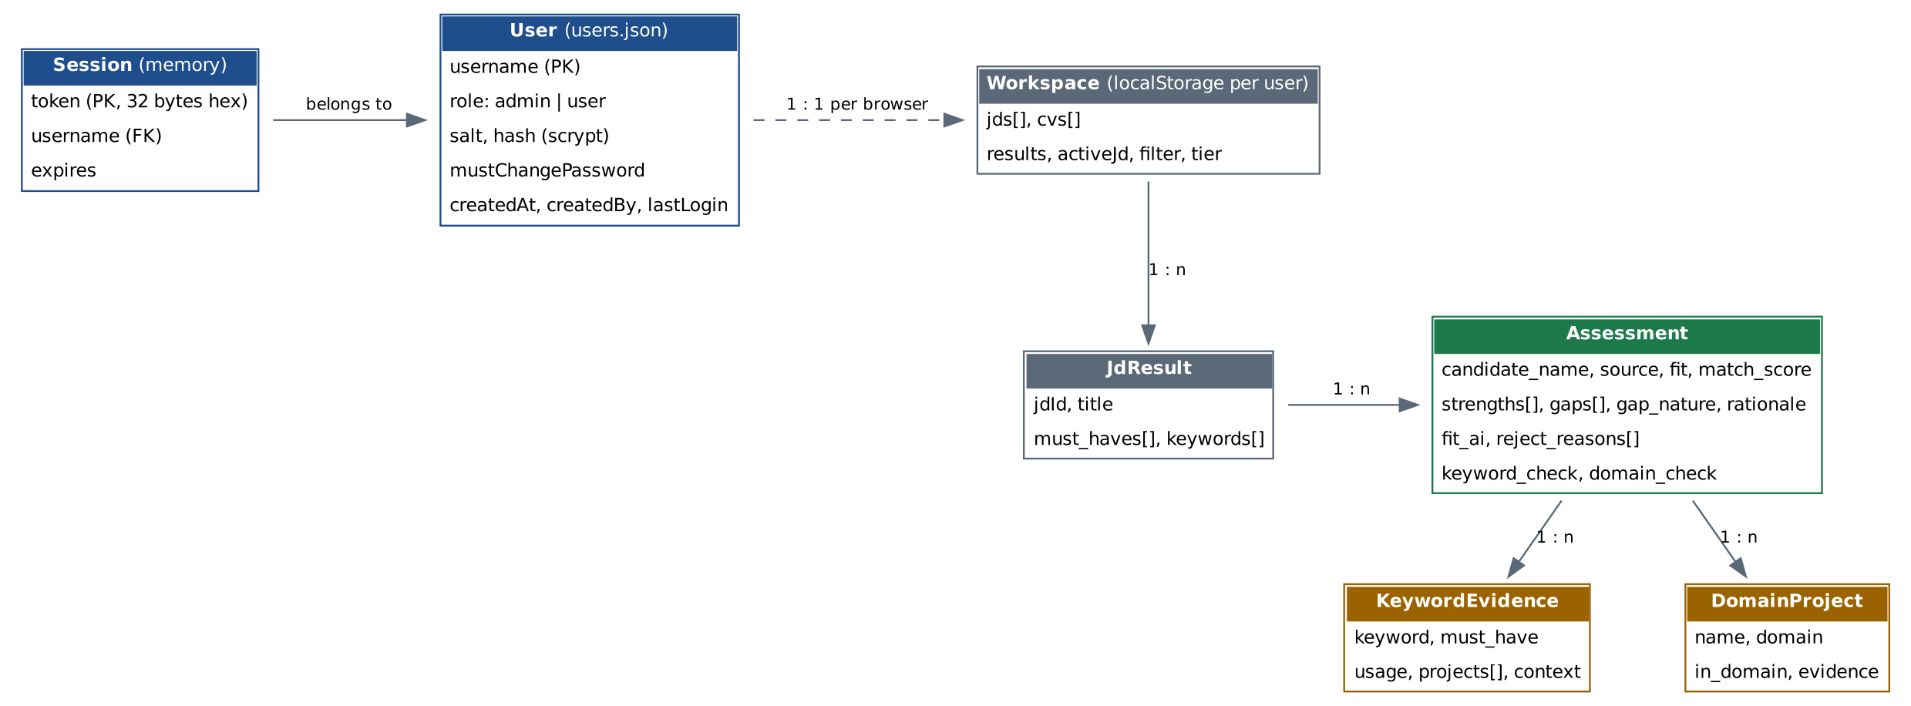
Figure 1. Data model

4.1 users.json
Field | Type | Constraints | Description
users[].username | string | 3–32, [A-Za-z0-9._-], unique (case-insensitive) | Login name (primary key)
users[].role | enum | admin | user | Authorisation role
users[].salt | hex string | 32 chars | scrypt salt
users[].hash | hex string | 128 chars | scrypt(password, salt, 64)
users[].mustChangePassword | boolean |  | Forces change at next sign-in
users[].createdAt | ISO date |  | Creation time
users[].createdBy | string | optional | Admin who created the user
users[].lastLogin | ISO date | optional | Last successful sign-in

4.2 Browser workspace (localStorage)
Field | Type | Description
jds[] / cvs[] | {id, title, text, example?, collapsed, loading?} | Inputs; text after extraction.
results | {example, ranAt, jds: JdResult[]} | Last run (or example).
activeJd, filter, tier | number, string|null, enum | UI state.
JdResult | {jdId, title, must_haves[], keywords[], assessments[]} | One per JD.

4.3 AI response contract (per batch)
{
"must_haves": ["label", ...], // 3-7 JD must-haves
"keywords": ["label", ...], // 6-10 JD keywords
"assessments": [{
"resume_id": "R1", "candidate_name": "Full Name",
"fit": "Best Fit|Close to JD|Not Fit", "match_score": 0-100, "years_relevant": number|null,
"must_haves_met": [...], "must_haves_missing": [...],
"strengths": ["2-3 items"], "gaps": [...], "gap_nature": "None|Trainable|Fundamental",
"rationale": "one sentence",
"evidence_strength": "Strong|Moderate|Weak", "evidence_summary": "one sentence",
"domain_check": { "projects": [{ "name", "domain", "in_domain": bool, "evidence" }],
"primary_domain", "domain_verdict", "domain_reason" },
"project_evidence": [{ "keyword", "must_have": bool,
"usage": "Hands-on|Supporting|Mentioned only|Not found",
"in_skills_section": bool, "projects": [...], "context": "<=25 words" }]
}]
}

4.4 Normalised assessment (after gates)
Field | Type | Description
fit, match_score | enum, int | Final values after gates.
fit_ai, rationale_ai | enum, string | AI's original rating and rationale.
fit_before_domain | enum|undefined | Set when a gate changed the fit (shown as 'skills alone would rate').
reject_reasons[] | string[] | One entry per failed rule.
domain_rejected, keyword_rejected | boolean | Which gate rejected.
keyword_check | {verdict, covered, total, coverage, must_total, must_missing[]} | Keyword gate result (verdict Passed | Failed | Not verified).
domain_check.domain_verdict | enum | Recomputed: In domain | Partially in domain | Out of domain | Not verified.

5. Screening gate algorithm
applyGates(a) runs once per assessment, after normalisation. It is deterministic and does not trust the AI's own verdict labels.
applyGates(a):
if a.fit_ai is undefined: a.fit_ai = a.fit; a.rationale_ai = a.rationale
reasons = []
# Domain gate
d = a.domain_check; n = len(d.projects); k = count(p.in_domain)
if n > 0: d.domain_verdict = (k == 0) ? "Out of domain" : (2k >= n ? "In domain" : "Partially in domain")
elif verdict not recognised: d.domain_verdict = "Not verified"
if DOMAIN_FILTER and verdict == "Out of domain":
reasons += "no projects in the target domains (mainly <primary>)"; prepend gap
# Keyword gate
ev = a.project_evidence
if ev not empty:
covered = count(usage in {Hands-on, Supporting}); must = ev where must_have
missing = must where usage not in {Hands-on, Supporting}; pct = round(100*covered/len(ev))
pass = (missing empty) and (pct >= KEYWORD_MIN_COVERAGE)
a.keyword_check = {verdict: pass ? Passed : Failed, ...}
if KEYWORD_GATE and not pass: reasons += missing-must-haves and/or coverage reason; prepend gap
else: a.keyword_check.verdict = "Not verified" # never rejects on missing data
# Outcome
if reasons: fit = Not Fit; score = min(score, 30); gap_nature = Fundamental
rationale = "Rejected: " + reasons + (fit_ai != Not Fit ? " On skills alone ... " + fit_ai)
elif DOMAIN_FILTER and verdict == Partially in domain and fit == Best Fit:
fit = Close to JD; score = min(score, 69); prepend gap "Only k of n projects ..."
if fit != fit_ai: a.fit_before_domain = fit_ai

6. Sequence diagrams
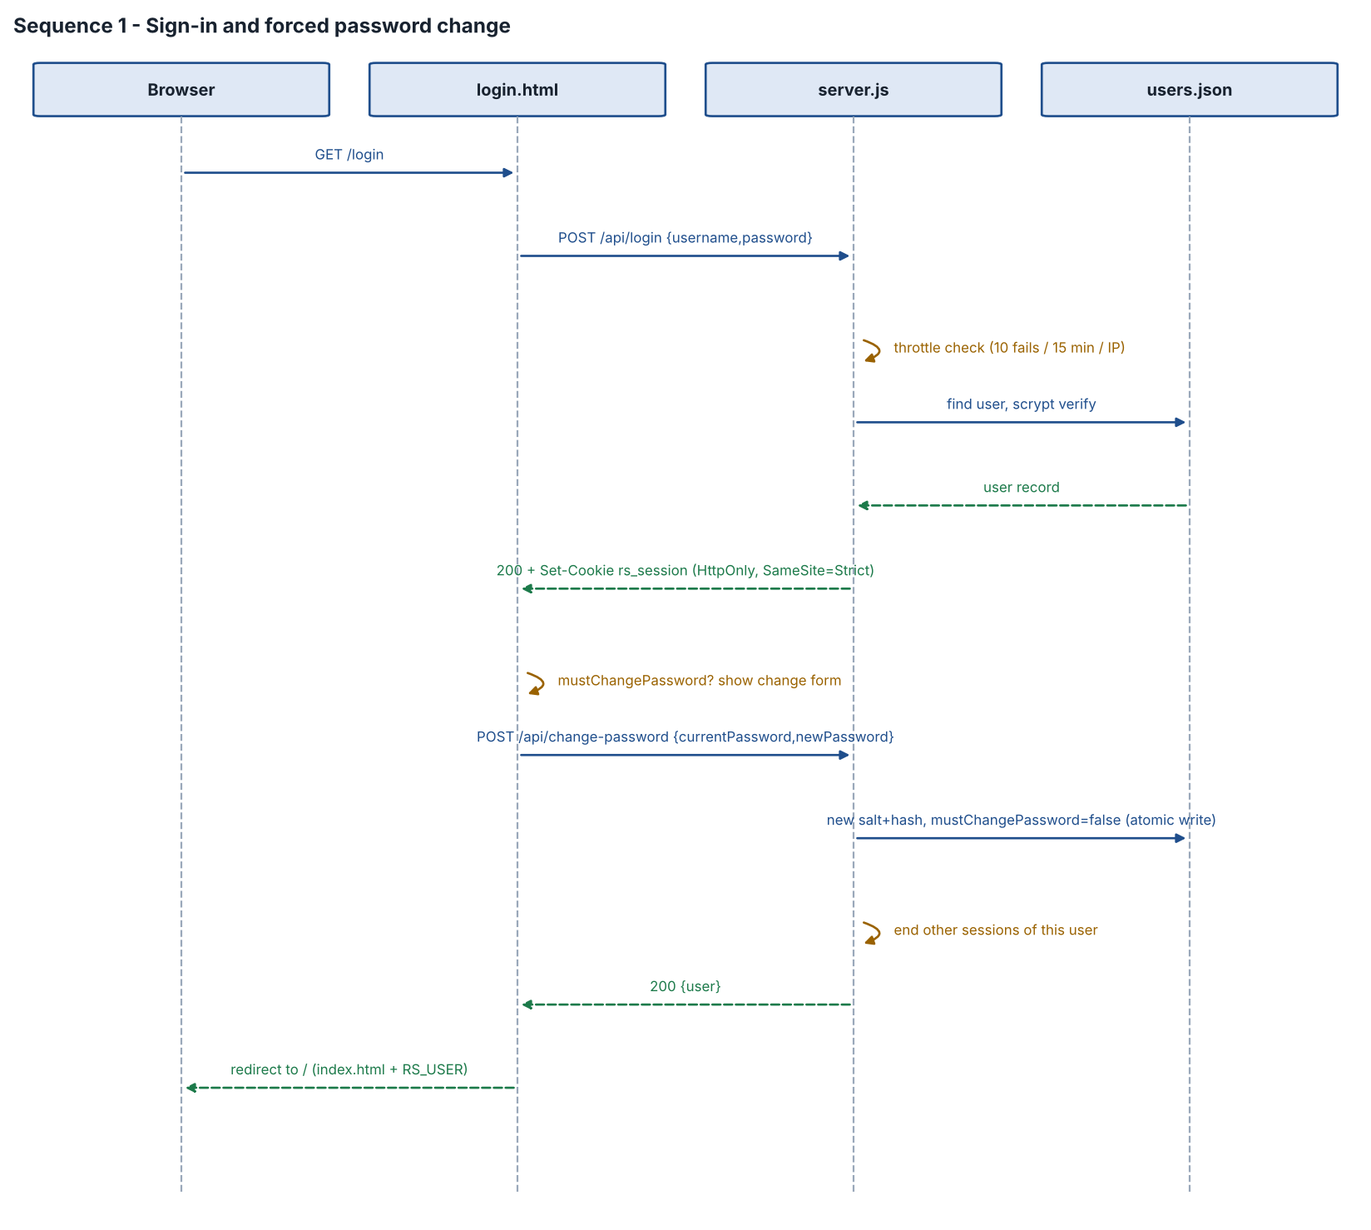
Figure 2. Sign-in and forced password change
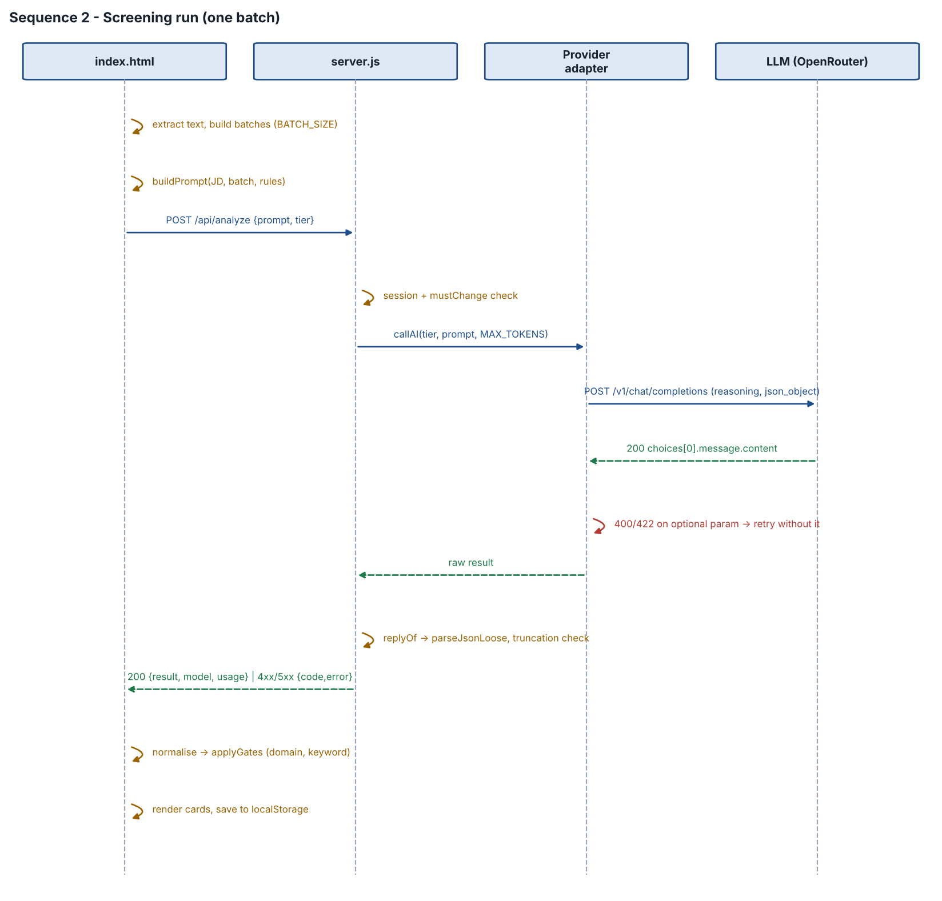
Figure 3. Screening run (one batch)
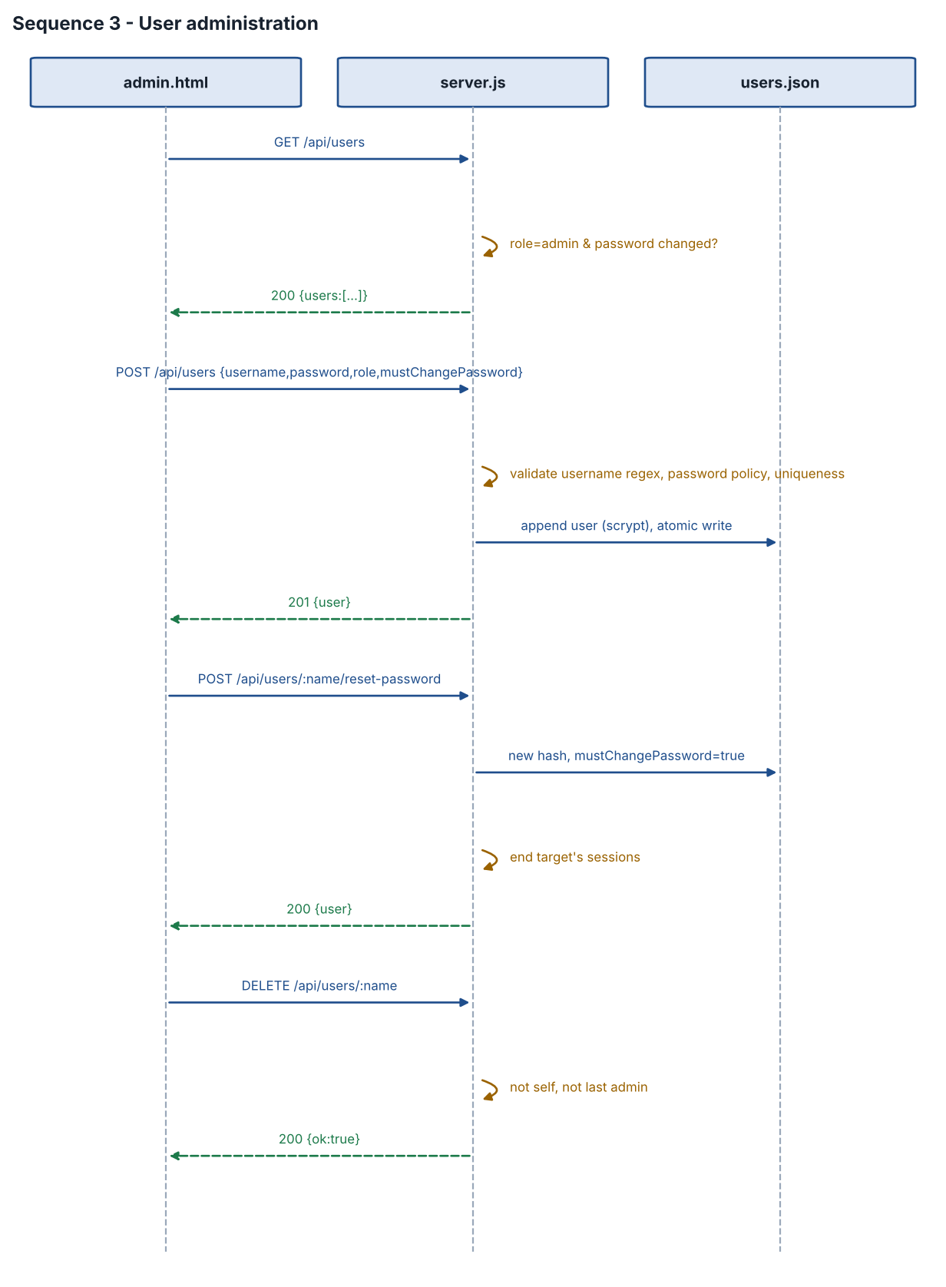
Figure 4. User administration

7. API contracts
All request and response bodies are JSON. POST requests must send Content-Type: application/json. Error bodies: { "code"?: string, "error": string }. Authenticated requests carry the rs_session cookie.
Method | Path | Auth | Request | Response
GET | /api/health | None | – | 200 {ok:true}
POST | /api/login | None | {username, password} | 200 {user} + Set-Cookie · 401 wrong credentials · 429 throttled · 400 bad body
POST | /api/logout | None | – | 200 {ok:true}; cookie cleared
GET | /api/me | User | – | 200 {user, apiKey, provider, keyVar, models, batchSize, targetDomains, domainFilter, keywordGate, keywordMinCoverage}
POST | /api/change-password | User | {currentPassword, newPassword} | 200 {user} · 400 wrong current / policy
GET | /api/users | Admin | – | 200 {users:[publicUser]}
POST | /api/users | Admin | {username, password, role, mustChangePassword} | 201 {user} · 400 validation · 409 exists
POST | /api/users/:name/reset-password | Admin | {password} | 200 {user} · 400 policy · 404
POST | /api/users/:name/role | Admin | {role} | 200 {user} · 400 last admin · 404
DELETE | /api/users/:name | Admin | – | 200 {ok:true} · 400 self / last admin · 404
POST | /api/analyze | User | {prompt, tier: default|complex|quick} | 200 {result, model, usage} · coded errors (section 7.1)
POST | /api/test-connection | Admin | {} | 200 {ok, apiHost, proxy, extraCa, results:[{tier, model, ok, status, message, ms}]}
publicUser = {username, role, mustChangePassword, createdAt, lastLogin}. Admin endpoints also return 403 if the caller is not an administrator or has not yet changed their password.

7.1 Error codes
code | HTTP | Meaning / client behaviour
signed_out | 401 | No or expired session → redirect to /login.
must_change_password | 403 | Change password first.
invalid_request | 400 | Malformed body or missing prompt.
prompt_too_large | 413 | Body over 2 MB or provider context exceeded.
no_api_key | 500 | Provider key not configured; run stops.
auth_error | 401/403 | Provider rejected the key; run stops.
rate_limited | 429 | Provider rate/quota (incl. TPM text, rate_limit_exceeded); run stops; hint to lower BATCH_SIZE/MAX_TOKENS.
model_error | 404/4xx | Unknown model or no endpoint.
invalid_json | 502 | Reply not parseable (or json_validate_failed); batch marked failed, run continues.
truncated | 502 | Reply cut at MAX_TOKENS; hint to raise it or reduce batch.
network_upstream | 502 | Server could not reach the provider; message from explainNetError; run stops.
upstream_error | 502/5xx | Other provider failure; batch marked failed.

8. Configuration
Variable | Default | Purpose
AI_PROVIDER | openrouter | openrouter | omniroute | groq | anthropic | sarvam
OPENROUTER_API_KEY / _MODEL / _BASE_URL | – / nvidia/nemotron-3-ultra-550b-a55b / https://openrouter.ai/api | OpenRouter settings
OPENROUTER_REQUIRE_PARAMETERS | false | Route only to providers supporting all sent parameters
OPENROUTER_SITE_URL / _APP_NAME | http://localhost:3000 / Resume Screening | Attribution headers
ANTHROPIC_*, GROQ_*, SARVAM_*, OMNIROUTE_* | – | Keys, base URLs and models for alternative providers
MODEL_STANDARD / _THOROUGH / _FAST | provider default | Model per depth option
EFFORT_STANDARD / _THOROUGH / _FAST | medium / high / low (OpenRouter) | Reasoning effort per depth option
MAX_TOKENS, BATCH_SIZE | per provider (16000, 3 for OpenRouter) | Reply cap; resumes per request (1–8)
TEMPERATURE, JSON_MODE | 0.2, true | Sampling; JSON response format
TARGET_DOMAINS | Storage,Networking,Security,Cloud,Semiconductors,IoT,Virtualization,Infrastructure | Domain gate list
DOMAIN_FILTER | true | false = report-only
KEYWORD_GATE, KEYWORD_MIN_COVERAGE | true, 50 | Keyword gate on/off and threshold (0–100)
PORT, HOST | 3000, 127.0.0.1 | Listen address
DATA_DIR, SESSION_HOURS, SECURE_COOKIE | data, 12, false | Accounts folder; session life; cookie Secure flag
HTTPS_PROXY, NO_PROXY, EXTRA_CA_CERTS | – | Outbound network
REQUEST_TIMEOUT_SECONDS | 600 | Per-request timeout to the provider

8.1 Fixed limits in code
Limit | Value | Location
Request body | 2 MB | server.js MAX_BODY
Resume text per item | 14,000 chars | index.html MAX_CV_CHARS
Characters per batch | 50,000 | index.html MAX_BATCH_CHARS
JD text in prompt | 20,000 chars | buildPrompt
Sign-in throttle | 10 failures / 15 min / address | server.js
Clear-all confirm window | 4 s | index.html

9. Error handling and edge cases
Case | Handling
Model rejects JSON mode / reasoning / extras | Retry without the option; remember the choice; log once.
HTTP 200 with error body (OpenRouter) | Treated as failure with the embedded code.
Reply wrapped in prose or fences; <think> tags | parseJsonLoose and tag stripping.
Missing resume in AI reply | Assessment created as Not Fit with 'No assessment returned… rerun'.
Invalid enums or types | Defaults (Not Fit, None, Not found) and clamping.
AI omits domain/keyword data | Verdict Not verified; gate does not reject.
AI labels contradict project table | Domain verdict recomputed from the table.
Client disconnects or Stop | Server aborts the upstream request; client marks batch stopped.
Clear all during a run | Run aborted and flagged; late results discarded.
Scanned PDF / .doc | Message asking for pasted text or DOCX/PDF.
Proxy in front (Nginx) times out | Client reports HTTP 502/504 with advice to raise proxy_read_timeout.
users.json unwritable | Start-up fails with the file path; documented fix: permissions on DATA_DIR.
Locked out of all admins | Delete users.json; restart recreates admin/admin (removes other users).

10. Testing approach
- Syntax checks of all scripts on every build.
- Mock provider servers (Anthropic, OpenRouter, Groq, Sarvam, OmniRoute styles) covering success, bad key, credits, privacy-blocked model, rate limit, HTTP 200 error body, rejected optional parameters, JSON validation failure, TPM limits, truncation.
- Proxy tests: CONNECT tunnel, proxy authentication, real corporate-style TLS inspection with and without EXTRA_CA_CERTS.
- Browser end-to-end (Playwright): sign-in, forced change, admin create/reset/delete, role checks, analysis run, gates (selected / rejected for must-have / coverage / domain), report-only mode, PDF download and content, Clear all persistence.
Assumption: Live calls to OpenRouter/Nemotron 3 Ultra could not be made from the build environment; first live run should be validated with Test connection and a pilot batch in report-only mode.

