Task-1

1. Fork the given Java HelloWorld Git repository from GitHub.  
2. Clone it into your local machine.

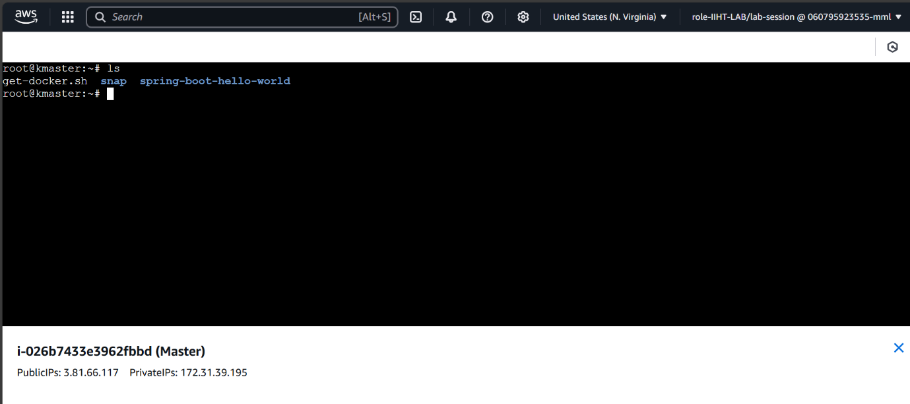

Task-2

I have written a Dockerfile for the Java application

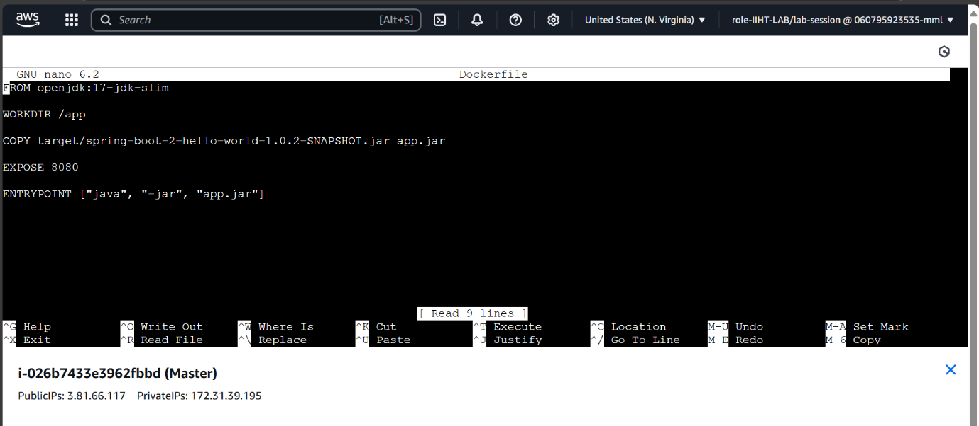

Task-3

I have Build a Docker image from the Dockerfile and build docker container using docker image

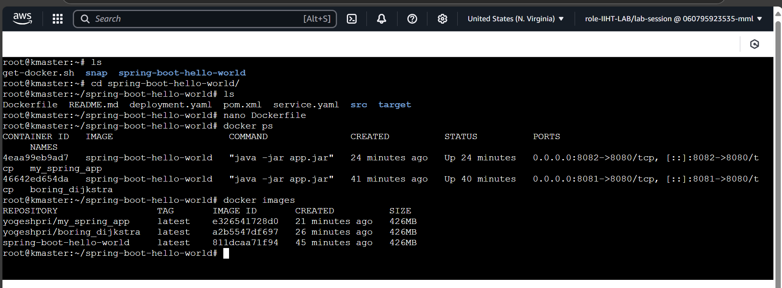

Now, I have uploaded that docker image into docker hub

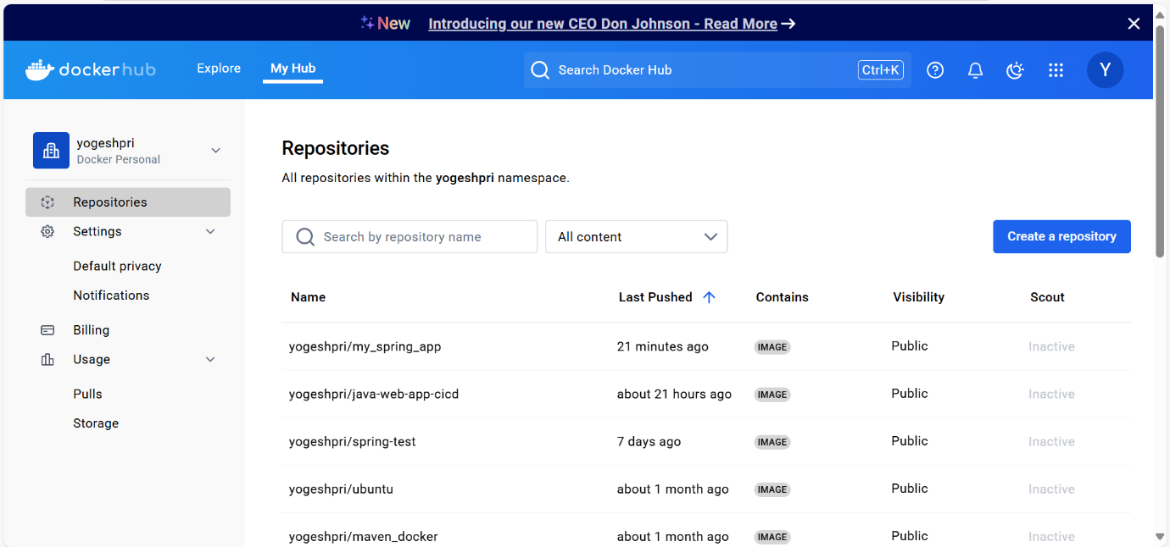

Task-4

I have made a deployment using “kubectl apply -f deployment.yaml” using this command

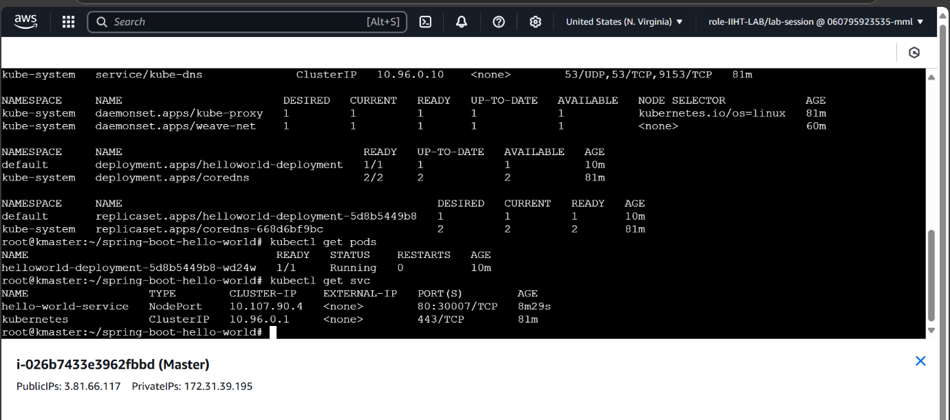

Task-5

I have Scale out to 3 replicas and Scale down to 1 replica

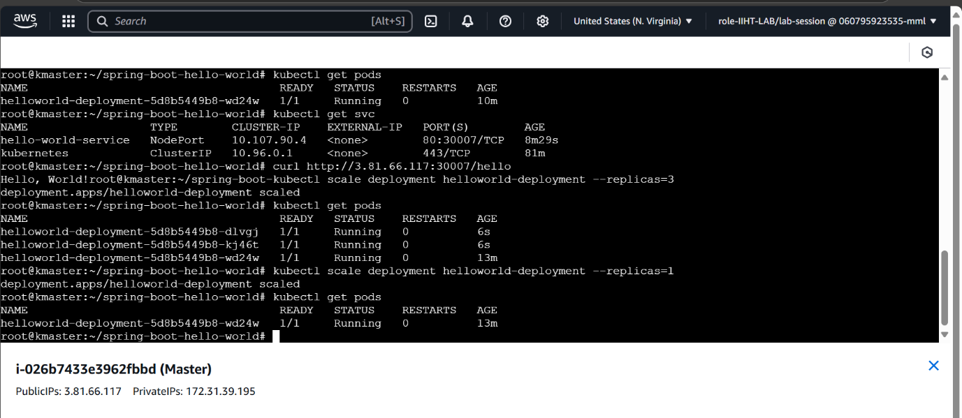

Task-6

I have made a service and expose the service on a NodePode. Using curl command

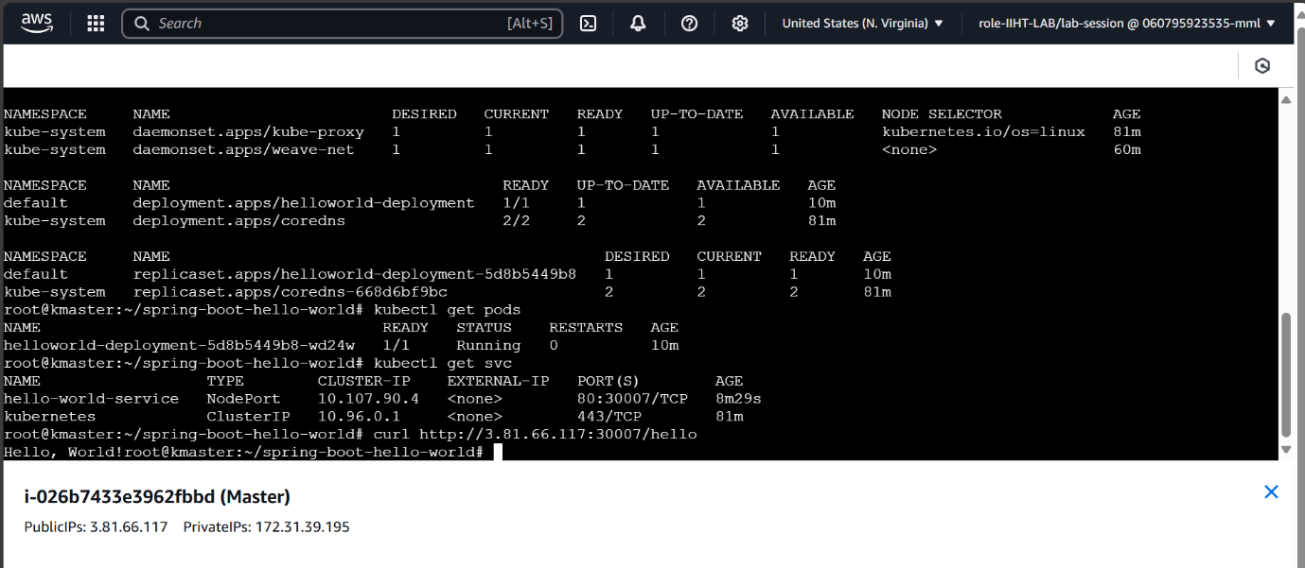

Task-7

I have only written Jenkinsfile.