**WEEK-1 ASSIGNMENT-1**

1. **Convert the following binary numbers to decimal:**

A. 11111 -----------🡪31

B. 101101----------🡪45

C. 1100011 --------🡪99

D. 101 ------------🡪5

E. 0.11 -----------🡪0.75

F. 101.11 ----------🡪5.75

G. 1010 -----------🡪10

H. 10100 ---------🡪20

I. 101000---------🡪40

1. **If B is some binary number (such as 10102), what number do you get when you attach a zero at the right end (such as 101002). What number do you get when you attach 2 zeros at the right end? In general, what number do you get when you attach *n* zeros at the right end?**

**ANS:** we will get the values of powers of 2 multiplied by 10.

1. **Try writing a C program named ‘Spreadsheet.c’ for conversions from binary, decimal, octal and hexadecimal into every other possible number system of the above, by putting 100 as input. What does your spreadsheet find for the binary representation for 100? Is this the same as your scientific calculator's / hand worked answer?**

**ANS:** The answer is 1100100 and yes, the answer is the same as the hand worked answer.

1. **Convert the following decimal numbers to binary by hand, showing your work:**

J. 47 K. 358 L. 1023

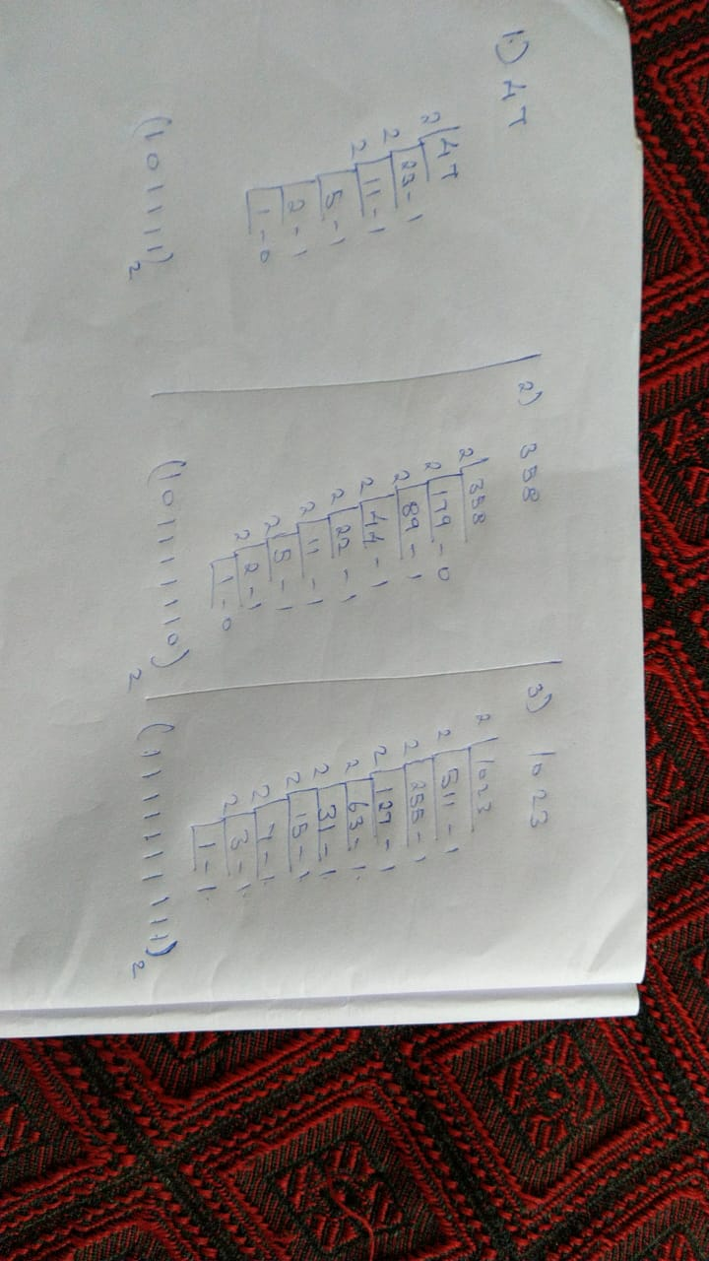

1. **Use your spreadsheet check your work by converting the following decimal numbers to binary:**

M. 47 --------------🡪101111

N. 358 -------------🡪1011111110

O. 1023 -------------🡪1111111111

1. **Use your spreadsheet to find the binary representation for the decimal number 96,455. Is the binary expansion longer (or shorter) than you expected?**

**ANS:** Thebinary representation is 10111100011000111. The answer was same as the hand worked solution the representation. So the representation is neither short nor longer than expected.

1. **Determine whether or not your spreadsheet algorithm works for negative whole numbers. Explain.**

**ANS:** No, the algorithm does not work with negative whole numbers as the algorithm works by using the ‘%’ operator as the operator does not work with negative numbers.

1. Use your spreadsheet to convert the following Decimal Numbers to Binary:

P. 1 --------------🡪12

Q. 3 -------------🡪112

R. 7 --------------🡪1112

S. 15 -------------🡪11112

T. 31 -------------🡪111112

U. 63-------------🡪 1111112

1. Use Exercise 6 to find a rule which describes all numbers that have a binary representation consisting solely of 1's.

**ANS:** By looking the results of various testcases we can arrive at a conclusion that the numbers that are one less than the powers of 2 are found to have all 1’s in their representation.