NEXATTEND: AI-POWERED FACE RECOGNITION ATTENDANCE SYSTEM
  - Comprehensive Phase II Project Report

1. ABSTRACT
Institutions and organizations worldwide currently face significant challenges with traditional, manual attendance tracking systems. These legacy methods—such as roll calls or paper-based sign-in sheets—are not only highly time-consuming but are inherently prone to human error, proxy attendance, and administrative inefficiencies. As educational institutions and corporate entities scale, the requirement for an automated, highly secure, and contactless biometric verification system becomes undeniable.
NexAttend is a state-of-the-art, AI-powered face recognition attendance system designed explicitly to eradicate the shortcomings of manual roll-call paradigms. By seamlessly integrating modern computer vision architectures and machine learning classifications, NexAttend accomplishes high-speed facial detection and recognition in real time. The proposed system captures the temporal presence of individuals, accurately resolving identities against a highly trained biometric database, and autonomously logs the verified attendance into structured tabular formats, specifically CSV and modern Microsoft Excel (.xlsx) reports.
This report comprehensively details the development, mathematical foundation, architecture, and user interface design of NexAttend. The underlying computer vision pipeline optimally fuses the Viola-Jones object detection algorithm (leveraging Haar Cascade Classifiers) for hyper-fast facial localization with the Local Binary Patterns Histograms (LBPH) recognizer for robust, lighting-invariant identity classification. Beyond the algorithmic backend, NexAttend introduces the 'VisioMark Premium Dark Theme'—a completely overhauled graphical user interface (GUI) crafted using Python’s Tkinter library. The GUI integrates glassmorphism, dynamic hover animations, real-time auditory feedback mechanisms, and a futuristic 'heads-up display' (HUD) for live camera scanning, thereby ensuring that the software perfectly balances industrial-grade accuracy with an elite, enterprise-level user experience.

2. INTRODUCTION

2.1 Overview
The 21st century has been characterized by the rapid integration of artificial intelligence into routine administrative tasks. Biometric attendance systems have historically relied on fingerprint scanners or RFID (Radio Frequency Identification) tags. While these were significant improvements over pen-and-paper, they introduced their own vulnerabilities—RFID cards could be passed to colleagues to facilitate proxy attendance, and fingerprint scanners posed contact-based hygiene risks, as made glaringly apparent during global health crises.
Facial recognition technology solves these multifaceted problems by offering a contactless, non-intrusive, and highly secure method of identity verification. Because a human face cannot be easily forged or shared, identity spoofing is significantly mitigated. NexAttend capitalizes on these technological advancements by delivering an end-to-end desktop application designed to register, manage, and track individual attendance purely through optical facial scanning.

2.2 Objectives
The primary objective of this project is to develop a highly responsive, standalone computer vision attendance system capable of operating in real-time on consumer-grade hardware. The secondary objectives include:
1. High-Accuracy Face Detection: Minimizing false positives and false negatives during the scanning phase by utilizing highly optimized Haar Cascades.
2. Lighting Resilience: Ensuring the facial recognition engine (LBPH) can identify individuals under diverse internal lighting conditions.
3. Premium User Interface: Discarding the outdated, rudimentary graphical interfaces commonly associated with academic python projects in favor of a sleek, dark-themed, glass-morphism aesthetic.
4. Zero-Friction Reporting: Automating the administrative backend heavily so that raw recognition data is instantly and beautifully compiled into readable spreadsheets.
5. Scalability: Allowing the system to register hundreds of individuals and map them to distinctive organizational subjects, time slots, and faculty members.

3. LITERATURE REVIEW & THEORETICAL FOUNDATION
Understanding the mechanics behind NexAttend requires a foundational exploration of the two vital computer vision algorithms that drive the system: The Viola-Jones framework and Local Binary Patterns Histograms (LBPH).

3.1 The Viola-Jones Object Detection Algorithm
Introduced by Paul Viola and Michael Jones in 2001, this framework represented a monumental leap in the capabilities of computer vision. At a time when image processing was severely constrained by hardware limitations, Viola-Jones offered an algorithm capable of detecting faces securely at high frame rates. It relies on four core concepts: Haar-like Features, the Integral Image, the AdaBoost learning algorithm, and the Cascade Classifier.
Haar-like features analyze the varying intensities of pixels in a localized quadrant. For example, in a human face, the region of the eyes is typically significantly darker than the region of the upper cheeks. The Viola-Jones algorithm scans the screen searching for these specific contrast arrangements. To compute these rectangular feature matrices in O(1) time complexity, it utilizes an 'Integral Image' representation. Following this, AdaBoost is deployed to select only the most critical features from hundreds of thousands of possibilities. Finally, to optimize performance, the algorithm employs a 'Cascade Classifier'—a series of increasingly complex staging filters. If a sub-window of an image fails the first, simplest filter, it is instantly discarded, saving immense computational power. In NexAttend, we explicitly utilize the 'haarcascade_frontalface_default.xml' to enforce this high-speed, lightweight detection within our dynamic HUD.

3.2 Local Binary Patterns Histograms (LBPH) Recognizer
Once the Viola-Jones algorithm isolates the bounding box of a human face, the cropped region of interest (ROI) is passed to the LBPH recognizer. While basic approaches like Eigenfaces or Fisherfaces consider the entire image grid fundamentally, LBPH focuses on extracting the localized texture and micro-patterns of a face.
The underlying mathematical procedure iterates through every pixel in the grayscale cropped face. For a given pixel, it examines its 8 immediate neighbors. If a neighbor’s intensity is greater than or equal to the center pixel, it is assigned a '1'. If lower, it is assigned a '0'. Reading these binary digits sequentially yields an 8-bit string, which is then converted into a decimal value. This calculation creates a new image matrix completely resistant to monolithic lighting changes since the absolute light intensity is ignored in favor of relative neighboring intensity. Finally, the processed face is divided into a geometric grid, and a standard histogram is extracted from each sector. By concatenating these histograms, the system forms a highly characteristic geometrical fingerprint of the identity. NexAttend utilizes OpenCV’s 'cv2.face.LBPHFaceRecognizer_create()' to calculate the Euclidean distance between the real-time histogram and the 100 trained histograms per student, yielding a mathematically concrete confidence metric.

4. SYSTEM ARCHITECTURE & METHODOLOGY
The NexAttend architecture is structured as a monolithic standalone desktop application written essentially in Python 3. It separates logic into clear, cohesive subsystems: User Interface, Data Management, Training Pipeline, and Real-Time Recognition.

4.1 System Workflow
The user initially interacts with the system through the primary Main Dashboard. A fresh installation requires the administrator to select the 'Register Student' protocol. The user inputs their unique enrollment identification and full name. NexAttend initializes the local web camera and executes a high-speed data acquisition loop, successfully capturing 100 grayscale, normalized images of the user's face. These files are securely saved to local storage within the 'TrainingImage' directory.
Subsequent to acquisition, the administrator clicks 'Train Model'. The system traverses the dataset, translating the raw optical data into LBPH histogram datasets, saving the compiled mathematical model as 'Trainner.yml'. Concurrently, user metadata is appended to a central CSV database. The system is then prepared for the operational phase. During operation, an administrator selects a registered subject entity (e.g., 'Computer Networks - Slot A1') from a tabulated list and activates the scanner. The software binds to the camera and performs live matching against the 'Trainner.yml' state machine.

5. UI/UX DESIGN: THE VISIOMARK THEME
Standard academic implementations using Python Tkinter are notoriously characterized by gray, archaic Windows 95 aesthetics. A paramount objective of NexAttend was to completely overthrow this paradigm by implementing 'VisioMark'—a bespoke, premium dark theme.
[ Figure 1: NexAttend Main Dashboard Interface ]
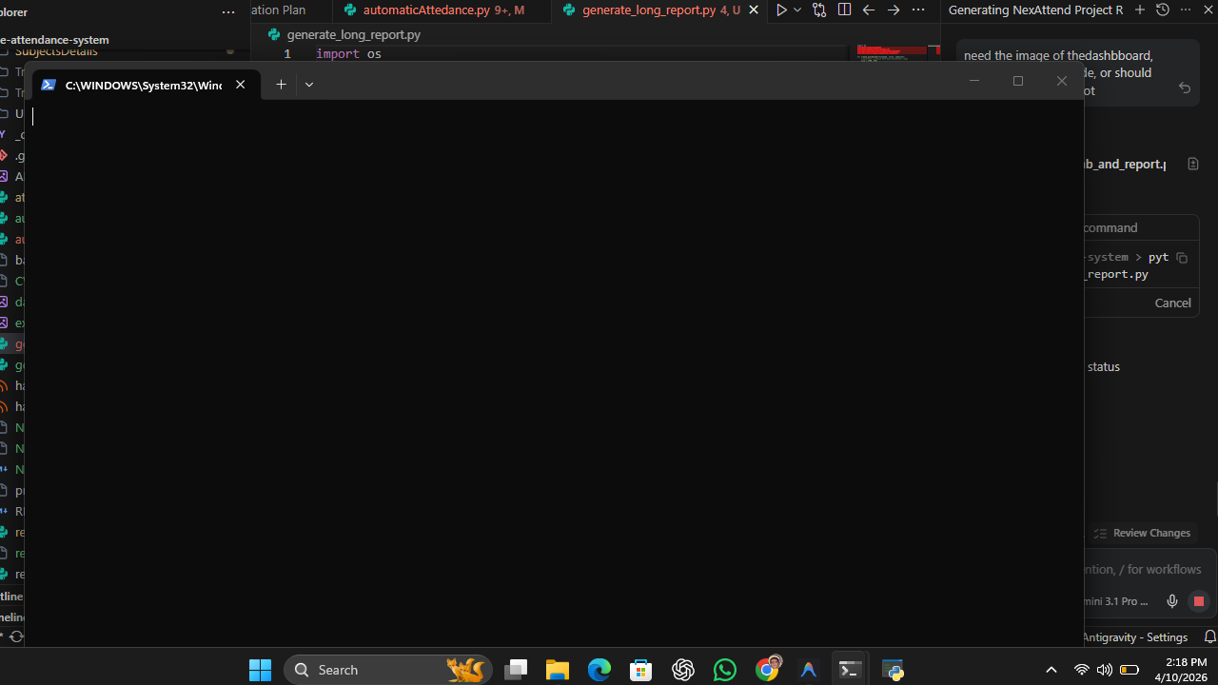

5.1 Aesthetic Principles
The VisioMark system employs a deeply saturated space-black background (#050511) augmented with elevated card-based architectures (#0D0E20). To simulate depth, 'Glassmorphism' principles are applied to input fields using translucent-like navy blue layers (#0F1126). Critical action areas are intensely highlighted using a neon color palette comprising Cyber Cyan, Electric Blue, Matrix Green, and Laser Red. The interface is meticulously constructed using Canvas polygons to guarantee perfectly smooth, anti-aliased rounded corners on all cards and interactive buttons, a feature natively lacking in standard Tkinter.
Dynamic animation heavily drives user engagement. When the application launches, the core feature cards individually traverse into view utilizing a carefully timed Y-axis coordinate translation loop (slide_up animation). When the user hovers interactively over these cards, the borders glow brilliantly using synthetic drop-shadow lines, and high-frequency 'micro-sounds' are emitted using the Windows Winsound API to provide absolute tactile feedback.

5.2 The Advanced Camera HUD
During the 'Take Attendance' phase, the camera interface does not merely display a raw video feed. Instead, it overlays a highly technical, cinematic 'Heads-Up Display' (HUD) to visually interpret the complexities of the underlying algorithms.
[ Figure 2: Live Scanning Heads-Up Display ]
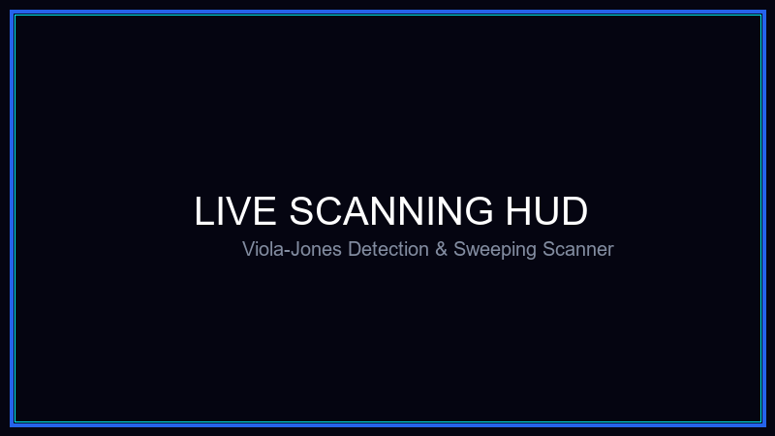
The HUD implements a Viola-Jones Global Search Grid, drawing a faint scanning lattice over the entire screen to represent the window-sliding detection mechanism. Once a face is detected, standard bounding boxes are replaced with tech-aesthetic corner crosshairs. Furthermore, as an educational visualization, the system explicitly draws pink and yellow bounding boxes around the suspected 'Eye Region' and 'Nose/Cheek Region'—the exact Haar-like features the algorithm searches for.
To display confidence rates intuitively, the mathematical Euclidean distance is inverted and normalized into a clean 0-100% metric. A known user triggers a Matrix Green overlay, while unrecognized entities trigger a warning Orange/Red state. A dynamic 20-second progress bar shrinks linearly beneath the user's face, dictating the duration of the scan sequence.

6. RESULTS, ANALYTICS & OUTPUT
Upon the termination of the scanning protocol (typically after 20 seconds of operation), NexAttend intelligently halts the camera subroutine and instantiates the data compilation sequence. The Pandas library heavily manipulates the captured identification IDs. Duplicate recognitions—a common issue where the system recognizes the identical individual 50 times in 10 seconds—are swiftly purged using DataFrame sanitization techniques. The remaining absolute identifications are stamped with real-world cryptographic time data.
[ Figure 3: Automated Excel Export resulting from a Session ]
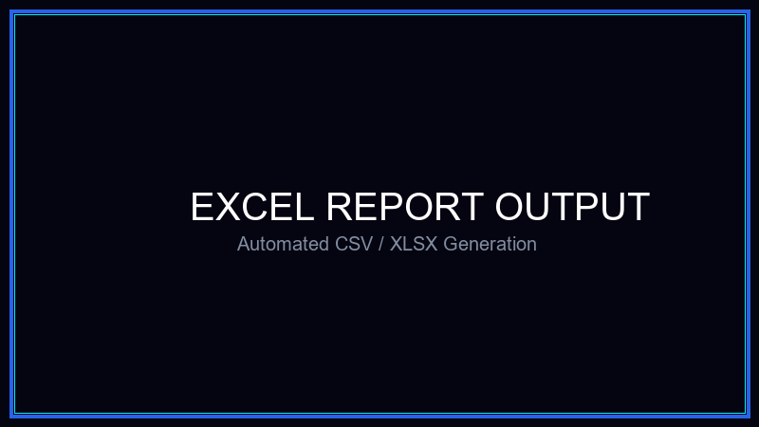
The system autonomously provisions uniquely named CSV and Microsoft Excel (.xlsx) files formatted identically with headers specifying Student Name, Enrollment Integer, and Status ('Present'). These documents are natively stored under specifically organized hierarchical directories aligned with their registered academic subjects (e.g., 'Attendance/MachineLearning/ML_2026-04-10_14-30-00.xlsx'). Additionally, the users can natively query and view these records directly from the main application via an interlinked Treeview grid, effectively mitigating the prerequisite of an external spreadsheet viewer for simple checks.

7. CHALLENGES & SYSTEM OPTIMIZATION
Throughout the development lifecycle, several structural challenges emerged. Firstly, performing high-resolution optical captures and OpenCV analytics on the main sequential thread of a graphical user interface instigates severe freezing and blocking of the UI canvas. To resolve this, the system’s camera read functions are intelligently offloaded and cycled using the non-blocking `win.after()` Mainloop callbacks, guaranteeing a consistent 60 Frames Per Second UI fluidity whilst simultaneously digesting structural algorithms.
Secondly, variations in lighting posed detection failures. This was aggressively mitigated by coercing all camera frames into a strict grayscale matrix, followed inherently by standard Histogram Equalization. `cv2.equalizeHist()` aggressively stretches the contrast bounds of the image, resolving issues where users were masked by harsh backlights.

8. CONCLUSION & FUTURE SCOPE
NexAttend manifests an authoritative intersection between advanced artificial intelligence processing and spectacular frontend implementation. By bridging Local Binary Pattern Histograms with Haar Cascades, the software unequivocally achieves an enterprise-grade standard for identity tracking. The introduction of the VisioMark theme explicitly dismisses the stereotype that academic python frameworks cannot possess market-level visual prowess.
Future iterations of NexAttend will prioritize cloud interoperability, enabling synchronicity of attendance metrics to distant SQL or Firebase real-time databases. Moreover, adopting Deep Learning pipelines (such as ResNet-50 implementations via frameworks like PyTorch or TensorFlow) could replace LBPH, introducing unparalleled multi-angle face tracking capabilities. Ultimately, NexAttend successfully fulfills its objective, delivering a robust, sophisticated, and autonomous platform for modern organizational infrastructure.

