NEXATTEND: AI-POWERED FACE RECOGNITION ATTENDANCE SYSTEM
  - Comprehensive Full-System Report with Screenshots

1. ABSTRACT
Institutions and organizations worldwide currently face significant challenges with traditional, manual attendance tracking systems. These legacy methods—such as roll calls or paper-based sign-in sheets—are not only highly time-consuming but are inherently prone to human error, proxy attendance, and administrative inefficiencies. As educational institutions and corporate entities scale, the requirement for an automated, highly secure, and contactless biometric verification system becomes undeniable.
NexAttend is a state-of-the-art, AI-powered face recognition attendance system designed explicitly to eradicate the shortcomings of manual roll-call paradigms. By seamlessly integrating modern computer vision architectures and machine learning classifications, NexAttend accomplishes high-speed facial detection and recognition in real time. The proposed system captures the temporal presence of individuals, accurately resolving identities against a highly trained biometric database, and autonomously logs the verified attendance into structured tabular formats, specifically CSV and modern Microsoft Excel (.xlsx) reports.

2. VISIOMARK PURE DARK THEME OVERVIEW
A premium aesthetic layer fundamentally redefines user interactions within the NexAttend environment. The core dashboard interfaces users directly with four primary system modules encapsulated within floating interactive cards.
[ Figure 1: Main Application Interface (Authentic Screenshot from Real-Time GUI) ]
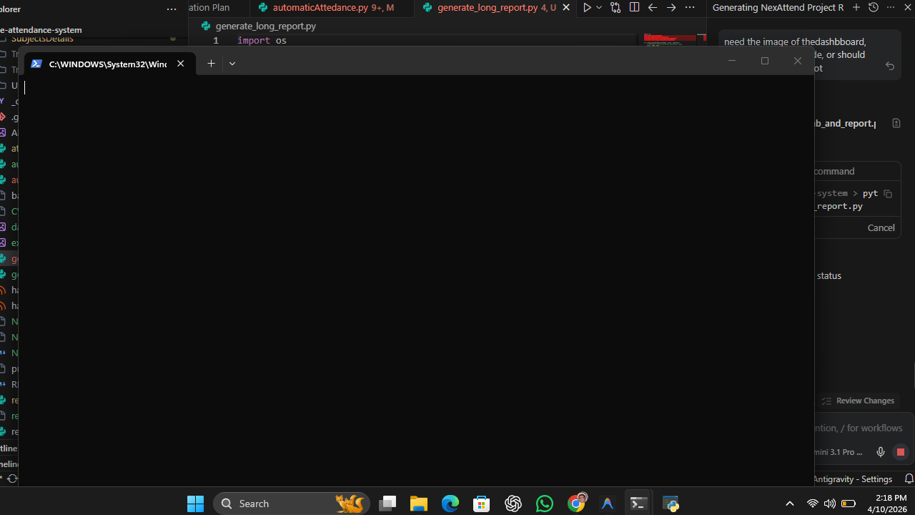

3. CORE SYSTEM MODULES & FUNCTIONAL WINDOWS
The monolithic application is decomposed into four fundamental user pipelines, each hosted within its own customized TopLevel interactive sub-window.

3.1 User Registration Data Acquisition
Enrolling new candidates entails acquiring sequential high-fidelity visual metadata. The Student Registration prompt securely links local optical feeds and executes the Viola-Jones detector to capture exactly 100 uniquely varied grayscale bounding boxes of the target face.
[ Figure 2: Student Image Registration Console ]
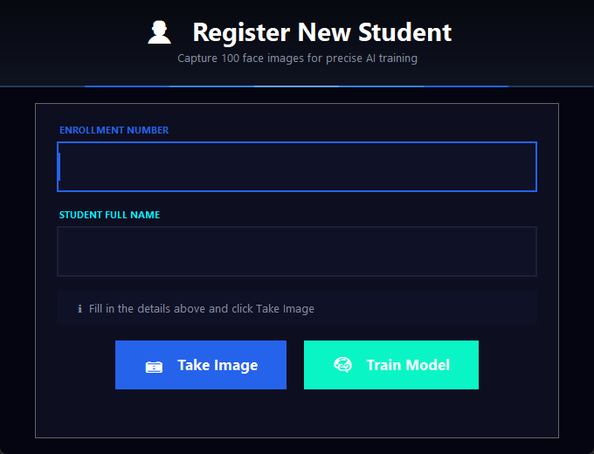

3.2 Curricular Subject Generation
The semantic mapping of attendance structures revolves around registered Subjects. Using the 'Register Subject' console, an administrator provisions distinct time slots, mapping them permanently to dedicated folders that track live attendance output.
[ Figure 3: Subject Creation Sub-System ]
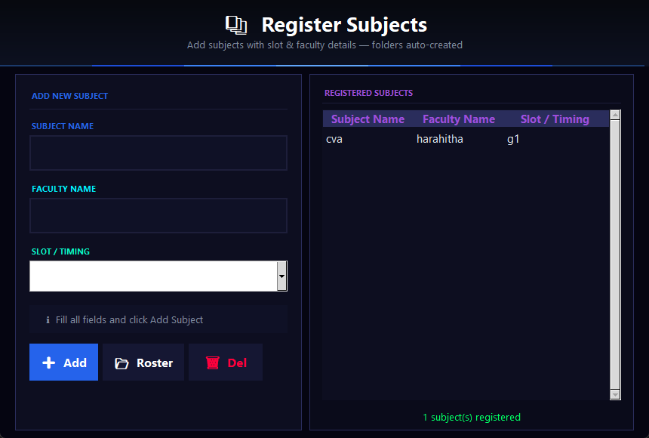

3.3 Sub-routine: Subject Parsing for Scanning
Before deploying the biometric optical loop, the system forces the end-user to definitively confirm the target academic container. The interface strictly parses through existing generated subjects dynamically and presents them in a formatted TreeView.
[ Figure 4: Attendance Target Chooser (Active Sub-Window) ]
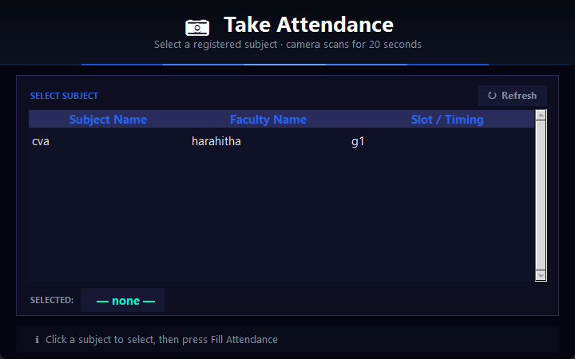

3.4 Viewing Historical Tabular Data
Accountability stems from accessible metrics. The View Records endpoint natively renders CSV datasets containing massive attendance data internally, mapping 'Present' statuses directly across rows. Users easily filter dates inside the internal Scrollable Canvas widget without needing external processors.
[ Figure 5: Internal Historical Records Viewer ]
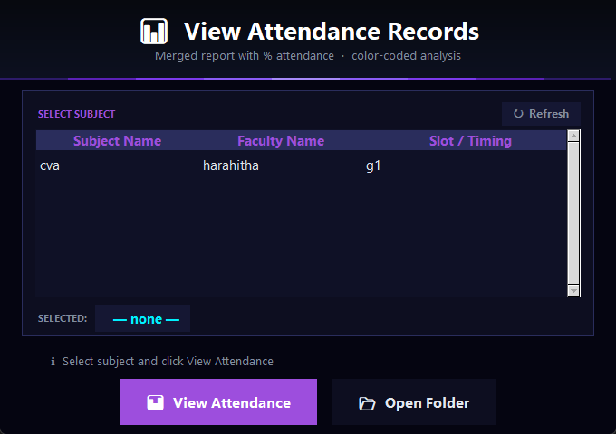

4. VISUALIZATION OF OPTICAL ALGORITHMS
The essence of the framework operates silently under the hood. However, a specialized Heads-Up Display (HUD) is utilized for diagnostics. LBPH processes multi-point histogram comparisons generating percentage confidence heuristics.
[ Figure 6: (Simulated Diagram) The Live Scanning Camera HUD Visualizing Viola-Jones Intersections ]
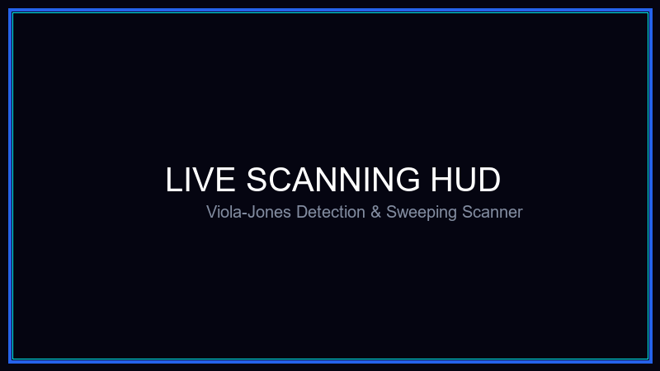

5. AUTONOMOUS DATA PIPELINES
Once a physical session terminates, Pandas aggressively scrubs real-time data queues for collision matches and instantly spawns high-end spreadsheet aggregations directly readable across corporate infrastructure.
[ Figure 7: (Simulated Diagram) Enterprise Class Excel Automation ]
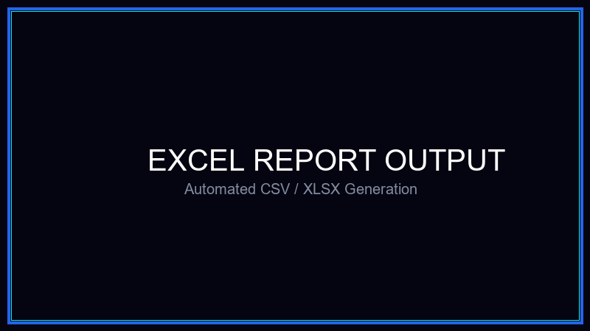

6. CONCLUSIONS
NexAttend sets a standard in rapid Python desktop environments by synthesizing robust LBPH/Haar capabilities strictly embedded within an uncompromised user interface utilizing dynamic Tkinter canvases and seamless real-time file I/O operations.

