|  |  |
| --- | --- |
| **Agile Group Project**  **Blood Test** | **Team Members**  Kirshan Lal, Yogesh and Ramanpreet Singh |

Contents

Introduction 2

Project Members 2

Time Schedule 2

Agile Methodology 3

Testing 5

Conclusion and Future Work 5

# Introduction

The main aim of this project is the design of an agile / scrum mobile application named Blood Test Ranges. We have created an application for Blood Test Reports. In this application user can check the range of any blood test like SGOT, SGPT, HB, Iron, etc. In this application, we can save new test, adding new user, Login, we can delete test detail, we can see test detail but we can’t able to update the test detail.

# Project Members

To increase the effectiveness of the application, three team members are participating in a different role that is given in the below table:

|  |  |
| --- | --- |
| Name of Team Member | Role |
| Krishan Lal | Team Leader , Application Tester |
| Yogesh | Front and Back End Developer |
| Ramanpreet Singh | Web Designer |

# Time Schedule

|  |  |  |  |  |  |  |  |  |  |  |  |  |  |  |  |
| --- | --- | --- | --- | --- | --- | --- | --- | --- | --- | --- | --- | --- | --- | --- | --- |
| **Stages** | **Activities** | **Duration**  **Week1-2** | | | | **Duration**  **Week-2-3** | | | | | **Duration**  **Week-3-4** | | | | |
| Project Planning | Research |  |  |  |  |  |  |  |  |  |  |  |  |  |  |
| Start of Meeting |  |  |  |  |  |  |  |  |  |  |  |  |  |  |
| Project Proposal and documentation |  |  |  |  |  |  |  |  |  |  |  |  |  |  |
| Project Execution | Application Design |  |  |  |  |  |  |  |  |  |  |  |  |  |  |
| UI Design |  |  |  |  |  |  |  |  |  |  |  |  |  |  |
| coding |  |  |  |  |  |  |  |  |  |  |  |  |  |  |
| Testing |  |  |  |  |  |  |  |  |  |  |  |  |  |  |
| Final | Documentation and Report |  |  |  |  |  |  |  |  |  |  |  |  |  |  |

# Agile Methodology

The Agile methodology is used in this project as an alternative to traditional approaches. This strategic approach is highly effective and pragmatic and addresses technology's changing needs.

Our group used the agile / scrum method in this project. The team members originally identify and follow all requirements. The team then decided to implement the Blood Test application special feature to satisfy users ' needs.

There have been many changes to make this software more user-friendly. The app is available for customers after all updates have been created.

# Pages and Mock-ups

## New Test Page

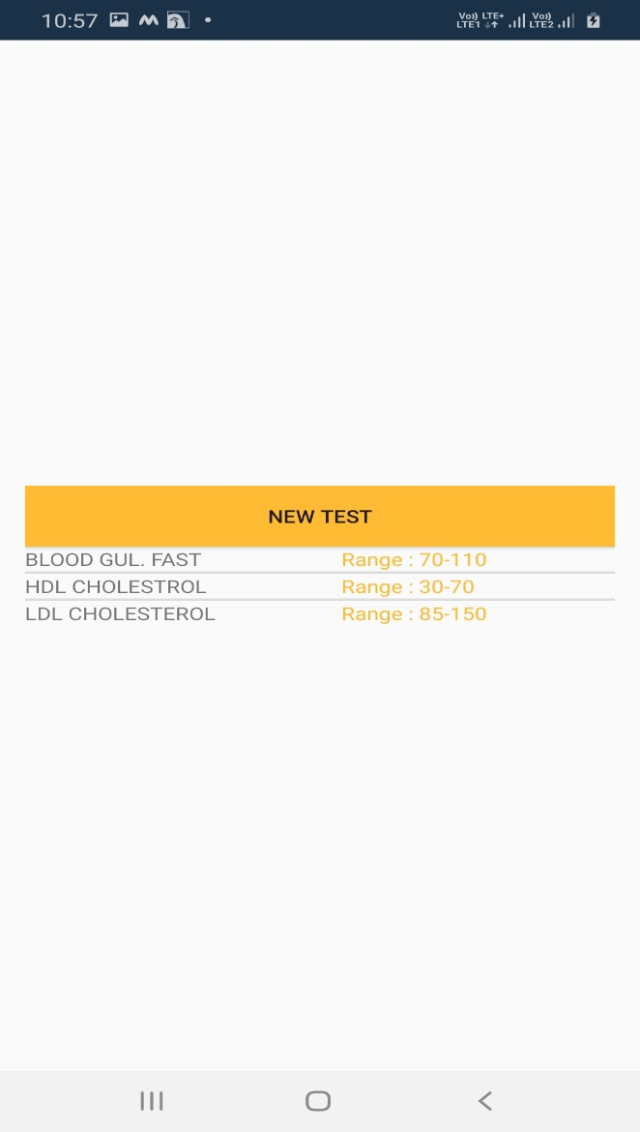

# Home Page

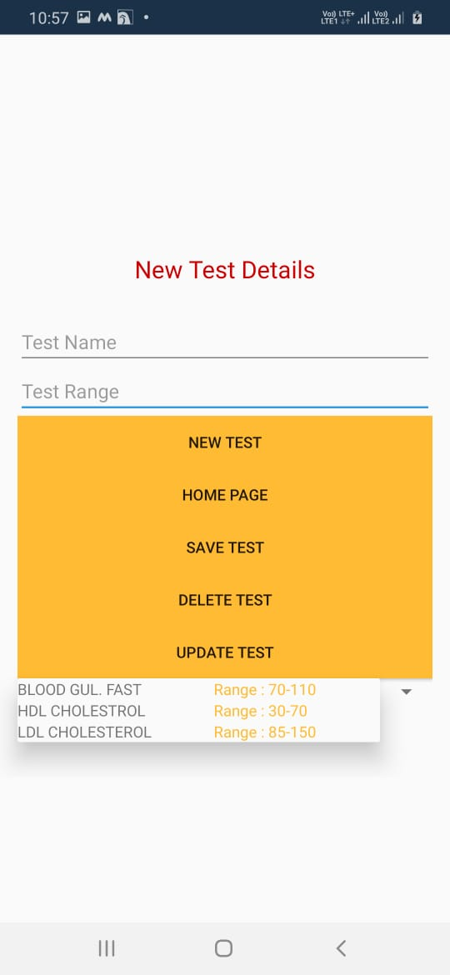

# 

# Login Page

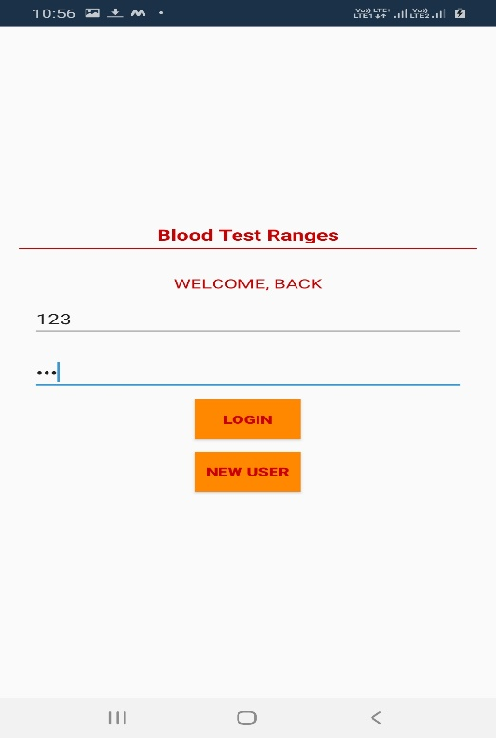

# New User Page

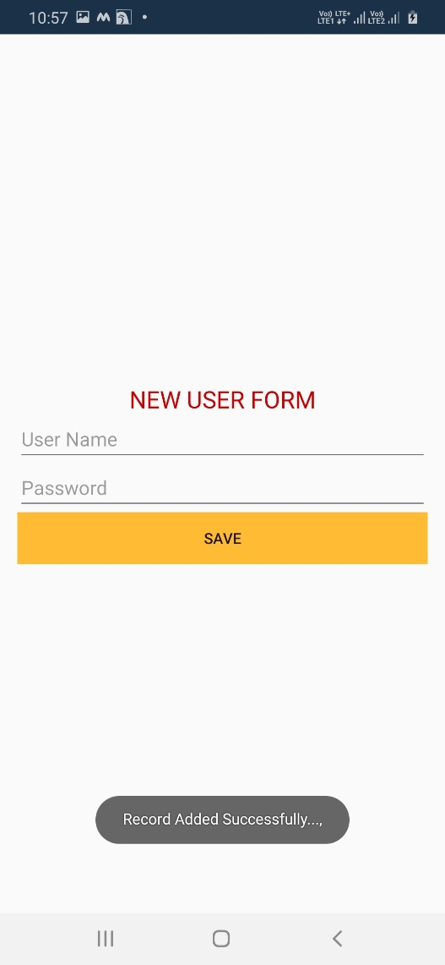

## **Functional Testing**

|  |  |  |  |  |  |
| --- | --- | --- | --- | --- | --- |
| **Step NO** | **Test Step** | **Input Data** | **Expected Result** | **Actual Result** | **Test Step Result** |
| 1 | Can save the detail of test | Put any information | Detail Should be updated | As Expected | Pass |
| 2 | Delete the test detail | Click on detail then delete. | Result appear on same screen | As Expected | Pass |
| 3 | Able to save  New blood test | Put all information of test | All Details About the will add into Main Page | As Expected | Pass |
| 4 | Able to update the detail | Cann’t able to edit the detail | Able to edit the change | As Expected | Fail |
| 5 | Login Button | Put Login detail | All the details of user will matches | As Expected | Pass |
| 6 | Registration  Button | Fill new user info | Successfully added into database | As Expected | Pass |

# Conclusion and Future Work

In brief, this project is based on the agile scrum method used by the IT group to create the so-called Blood Test Android app. Because of the limited time, we only build a small framework. However, this application can be further improved, by adding a back button. The live location services sometimes don’t work, which can be improved.