amperehour | YOUR INTELLIGENT  ENERGY STORAGE PARTNER

AMPEREHOUR
ENERGY

EQUITY RESEARCH REPORT
Private company initiation | October 2026
LISTING STATUS  Unlisted | HEADQUARTERS  Pune, Maharashtra

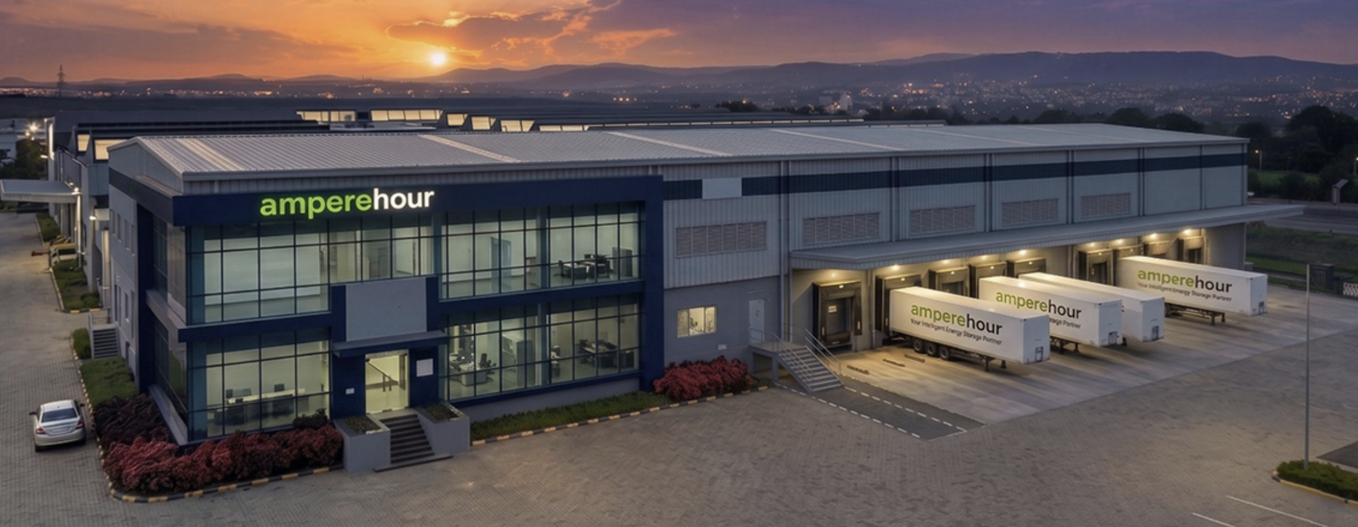
Report created by Yogesh | Electrical Engineering, IIT Bombay

CONTENTS
________ EQUITY RESEARCH REPORT PAGE NO.
01 Executive Summary 03
02 Company Overview 05
03 Industry & Market Overview 07
04 Business Model 10
05 Financial & Operating Analysis 12
06 Forecast & Key Assumptions 14
07 DCF Valuation 16
08 Relative Valuation & Peer Comparison 18
09 Ratio Analysis 20
10 PESTEL Analysis 21
11 SWOT Analysis 22
12 BCG Matrix 23
13 EIC Framework 24
14 Key Risks & Investment Monitoring 25
15 Investment Conclusion 26
16 Sources, Methodology & Disclaimer 27

Report Created by
Yogesh
Electrical Engineering | IIT Bombay

AMPEREHOUR ENERGY
Equity Research Report | October 2026
VIEW: POSITIVE BUT CONDITIONAL | Unlisted | Base DCF EV ₹772 Cr | Indicative EV ₹400 to ₹1,000 Cr

EXECUTIVE SUMMARY
AmpereHour Energy (AmpereHour Solar Technology Pvt. Ltd.) is a Pune based, full stack battery energy storage system (BESS) company. It designs, integrates, controls and maintains storage systems and owns its energy management software, ELINA. On 13 July 2026 it inaugurated a BESS manufacturing and integration facility at Chakan, Pune, with a planned capacity of 5 GWh.
The latest available financials are for FY25. Revenue was ₹83.9 Cr (+285% year on year), with PAT of ₹5.8 Cr and an estimated EBITDA of ₹6.0 Cr (Inc42 Datalabs). FY26 filings were not yet available when this report was written.
On the ground, the company reported 40+ MWh commissioned and about 1,000 MWh under execution across 50+ sites in March 2025. In May 2026 it commissioned a 180 MW / 360 MWh standalone project for IndiGrid at a GUVNL substation in Gujarat. It raised a $5 million Series A led by Avaana Capital in March 2025.

INVESTMENT THESIS
1. Structural demand:
CEA tracked 157 BESS projects of 143.82 GWh as on 31 May 2026, yet only 7.50 GWh (5.2%) was operational. The official 2031 to 2032 BESS requirement is 236.22 GWh, creating a large addressable market for integrators.
2. Proven scaling of projects:
AmpereHour moved from a 40 MWh Delhi project (Kilokari) to a 360 MWh Gujarat project, nine times larger by energy, which shows it can execute utility scale work.
3. Vertical expansion:
A factory, its own EMS (ELINA) and a digital factory testing suite (AH Suite) give it more control over cost, quality and delivery than a pure integrator.
4. Profitable growth:
FY25 revenue nearly quadrupled while the company stayed profitable, which is uncommon in a capital hungry industry. My base case assumes EBITDA margin rises from 7.2% in FY25 to 12.5% by FY30E.

MY VIEW
AmpereHour is a credible early mover in a market that is moving from tenders to construction. Because it is unlisted there is no rating or target price.  My indicative enterprise value range is ₹400 to ₹1,000 Cr, centred on a base case DCF of about ₹772 Cr. That range depends on assumptions in sections 6 to 8 and should be replaced with real FY26 numbers when they are filed.  I am cautious because tariffs fell about 52.8% in two years while battery prices rebounded, the capital base is small (about $7.45 million raised), and no one has shown that ELINA earns a software like margin. | 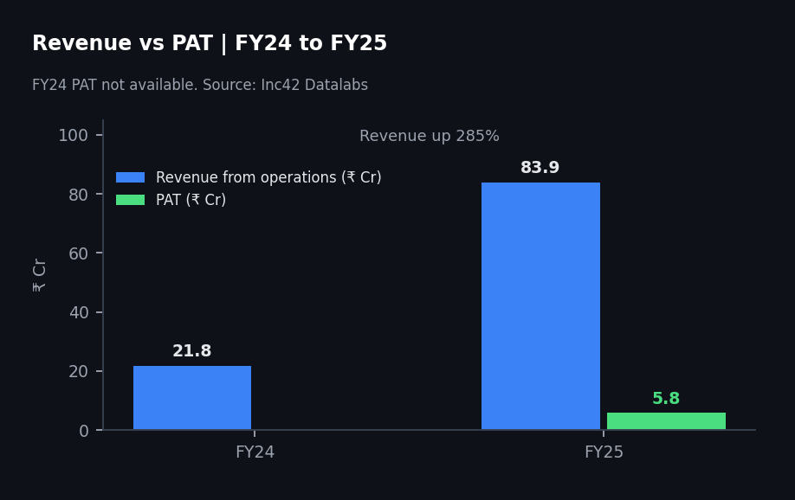

SNAPSHOT
Metric | Value | Source and status
Founded | 2017, Pune | Tofler (incorporated 1 Aug 2017)
FY25 revenue | ₹83.9 Cr, up 285% | Inc42 Datalabs, cross checked with MCA based data
FY25 PAT and margin | ₹5.8 Cr, 6.9% | Inc42 Datalabs
FY25 EBITDA (estimate) | ₹6.0 Cr, 7.2% | Inc42 Datalabs, derived
Total funding | About $7.45M ($5M Series A plus $2.45M earlier) | YourStory, Mercom
Scale, March 2025 | 40+ MWh commissioned, about 1,000 MWh under execution, 50+ sites | Company via Batteries International
Largest project | 180 MW / 360 MWh, Gujarat, commissioned May 2026 | Renewable Watch
Factory | 5 GWh planned, inaugurated 13 July 2026 | pv magazine India

COMPANY OVERVIEW

COMPANY OVERVIEW
AmpereHour Energy is an Indian BESS company that began as a software and control business. The founders saw that a battery system is not just cells: it also has inverters, meters, fire safety equipment and other electrical parts that need one control layer. That insight led them to build their own energy management system, ELINA, before they became a project integrator and later a manufacturer.
The company serves utilities, independent power producers, renewable developers and industrial customers, and has projects in India and abroad. Its strategy is centred on moving from integration toward standardised hardware, proprietary software and lifecycle services.

MILESTONES
Date | Milestone
2017 | Founded by Ayush Misra, Rahul Shelke, Neehar Jathar and Harshal Thakur; incorporated 1 August 2017
2018 | EMS software deployed in a solar plus diesel microgrid at Bheldi, Bihar
2019 | First contracts to integrate solar plus storage projects for renewable producers
2022 | Energy Storage Project of the Year (IESA) for a Delhi virtual power plant
Feb 2025 | Cummins Phaltan, 1.5 MW / 4 MWh LFP BESS commissioned
Mar 2025 | $5M Series A led by Avaana Capital; 40+ MWh commissioned, about 1,000 MWh under execution
2025 | Kilokari, Delhi: 20 MW / 40 MWh turnkey BESS with IndiGrid for BRPL under a BESPA
May 2026 | Gujarat 180 MW / 360 MWh project commissioned for IndiGrid at a GUVNL substation
13 Jul 2026 | Chakan, Pune BESS manufacturing and integration facility inaugurated, 5 GWh planned

FOUNDING TEAM
Founder | Role | Background
Rahul Shelke | Co founder, MD and CTO | Former CTO at CleanMax; power systems and electronics
Ayush Misra | Co founder and CEO | IIT Bombay B.Tech and M.Tech in Materials Science; led marketing and customer acquisition early on
Neehar Jathar | Co founder and CPO | Electrical and Electronics Engineering, IIT Bombay; software and private equity experience
Harshal Thakur | Co founder and COO | M.Tech Power Electronics and Drives, VIT
The three original founders reportedly put in about ₹1 crore of their own savings.

PROJECT PORTFOLIO
Project | Scale | Partners | What it shows
Cummins, Phaltan | 1.5 MW / 4 MWh | Cummins | Industrial behind the meter storage, peak shaving and backup; turnkey delivery
Kilokari, Delhi | 20 MW / 40 MWh | IndiGrid, BRPL | First regulator approved utility scale BESS in India (Avaana description); turnkey
Gujarat (GBPL) | 180 MW / 360 MWh | IndiGrid, GUVNL | Large transmission connected BESS; AmpereHour is technology partner; 9 times Kilokari by MWh
Named customers and partners include IndiGrid, Cummins, Siemens, Coca Cola, Amazon, Yellow Door (UAE) and BRPL.
Investment takeaway: scale metrics must never be mixed. Sources use different words for scale: commissioned (40+ MWh in March 2025), under execution (about 1,000 MWh), deployed or implemented (1,000+ MWh across 50+ sites) and a later website figure of 500+ MWh commissioned. These measure different things.
Avaana Capital also says AmpereHour has won more than one third of India's contracted BESS capacity.

INDUSTRY OVERVIEW & MARKET OPPORTUNITY
A BESS stores electricity when it is cheap or abundant and releases it when it is needed. MW is how fast it can deliver power and MWh is how much energy it can store, so 180 MW / 360 MWh is a two hour system. Value comes from shifting solar into the evening, peak shaving, frequency support, renewable firming and deferring grid upgrades.
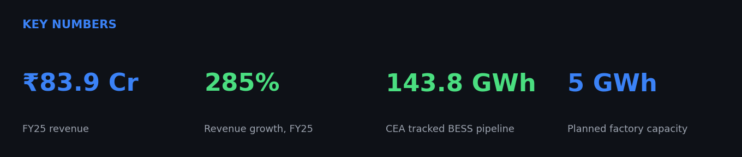

KEY DEMAND DRIVERS
Rising electricity demand:
CEA projects peak demand rising from 277.2 GW in FY27 to 366.4 GW in FY32, a rise of about 32%, and energy requirement from 1,907.8 BU to 2,473.8 BU.
Renewable buildout:
India had 168.0 GW of solar and 58.5 GW of wind by 31 August 2026 (MNRE). Solar output peaks in daylight while demand runs into the evening, which creates the need for storage.
Policy support:
- A second viability gap funding scheme (June 2025) targets 30 GWh with ₹5,400 Cr of support at ₹18 lakh per MWh (Ministry of Power). The first scheme was ₹3,760 Cr, reported at roughly 13.2 to 13.8 GWh depending on the document.
- CEA advised solar tenders to include co located storage of at least two hours equal to 10% of solar capacity.
- SECI keeps issuing tenders such as 800 MW / 3,200 MWh under its ESS IV programme (October 2026, per research notes).

A LARGE PIPELINE, BUT AN EARLY-STAGE MARKET
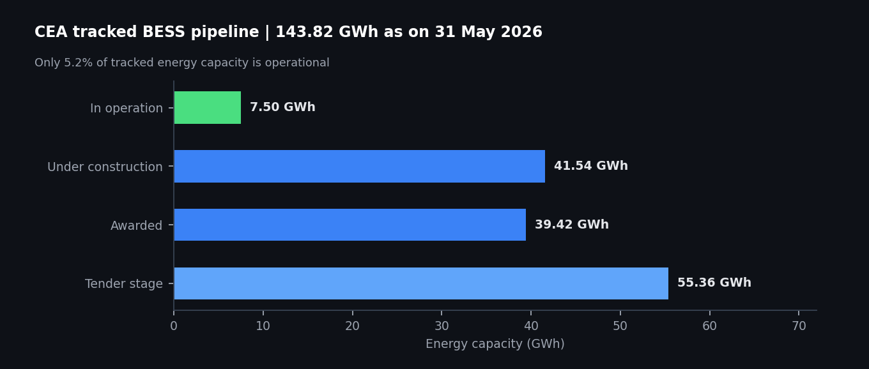
Status (31 May 2026) | Projects | MW | MWh | Share of GWh
In operation | 18 | 2,721.03 | 7,499.44 | 5.2%
Under construction | 42 | 15,258.94 | 41,539.32 | 28.9%
Awarded | 34 | 12,242.80 | 39,416.20 | 27.4%
Tender stage | 63 | 14,195.88 | 55,360.82 | 38.5%
Total | 157 | 44,418.65 | 143,815.78 | 100%
Source: Central Electricity Authority, status of BESS in India as on 31 May 2026 (projects of 1 MWh or more). Tender stage includes FDRE projects whose storage capacity is yet to be finalised.
Three layers should never be mixed: 7.50 GWh operating today, 143.82 GWh tracked by CEA across all stages (about 61% of the requirement), and the 236.22 GWh BESS requirement for 2031 to 2032 (47.24 GW), within a total storage need of 411.4 GWh including pumped storage. The tracked pipeline is also back loaded: FY28 alone carries 66.12 GWh, about 46% of the total.

THE INSTALLED BASE DEPENDS ON WHO YOU ASK
Source | Figure | Date
CEA project table | 7.50 GWh in operation or commissioned | 31 May 2026
Mercom India Research | 5.9 GWh cumulative (4.6 GWh added in Q1 2026) | March 2026
IESA, via Reuters | 8.7 GWh, from 0.78 GWh at end 2025; 10 GWh expected by end 2026 | First half 2026
Crisil | About 1 GWh by end FY26; 45 to 50 GWh to be commissioned over FY27 and FY28 | FY26, FY27 and FY28
Definitions and cut off dates differ, so I named the source. Reuters also reports about 260 GWh of storage projects at various stages of development, against CEA's narrower 143.8 GWh.

THE COST SQUEEZE
Indicator | Value | Source
Average standalone BESS tariff | ₹4.49 lakh per MW per month (2024) to ₹2.12 lakh (2026), a fall of about 52.8% | Crisil
Lowest 2025 tariffs | ₹1.48 lakh (2 hour) and ₹2.85 lakh (4 hour) per MW per month | JMK Research
Tariffs versus pack prices, 2022 to 2025 | Tariffs fell more than 71%, battery packs fell 36% | JMK Research
Battery price in 2026 | Rebounded to $70 to $75 per kWh | Crisil
Lender view, July 2026 | Tariffs expected to rise; some funded projects stalled as suppliers did not honour earlier prices | Reuters, SBI comments
This is the single biggest industry risk. Procurement usually happens about a year after an award, so a contractor that priced aggressively in 2025 can face higher battery costs when it buys in 2026 (Crisil).

MARKET SIZE SCENARIO
Applying system prices to the 236.22 GWh requirement gives a feel for scale. These are illustrations, not forecasts.
Price assumption (₹ per kWh) | Implied system value (₹ lakh Cr) | Basis
9,290 | 2.19 | Pace Digitek supply order benchmark (see Business Model)
13,000 | 3.07 | Low end of installed CAPEX estimate
15,000 | 3.54 | Mid case used in the research notes
18,000 | 4.25 | High end of installed CAPEX estimate

COMPETITIVE LANDSCAPE
Player | Core strength | Latest data point
Fluence | Global integration, software and services | Q3 FY26 revenue $649.8M, backlog $6.4B, adjusted gross margin 5.9%, net loss $44.3M
Sungrow | Power electronics plus batteries, integrated BESS | 2025 revenue RMB 89.2B; storage RMB 37.3B and 43 GWh shipped; storage gross margin 36.49%
Pace Digitek | Indian BESS manufacturing, EPC and lifecycle | 5 GWh installed (from 2.5 GWh), 10 GWh targeted by Dec 2026; order book ₹11,338 Cr
Exide, Waaree and other makers | Upstream manufacturing moving downstream | Large planned capacity; figures to verify
AmpereHour | Software led Indian integrator and new manufacturer | 5 GWh planned; about 1,000 MWh under execution (March 2025)
Most of AmpereHour's headline features are matched by competitors: integration, hardware agnostic control, DC containerisation, DC coupled PV plus BESS, EMS optimisation and factory acceptance testing. I rate differentiation as low to medium on each one individually (Fluence, Sungrow and Wärtsilä product pages). The potential edge lies in the combination and in Indian utility scale references.
Correction to an earlier note: Pace Digitek already has 5 GWh installed while AmpereHour's 5 GWh is planned. The comparison is a company ahead on installed capacity and order book versus one ahead on software.

BUSINESS MODEL
AmpereHour operates as a full stack BESS provider. It sits between battery and power conversion suppliers and the asset owner, and offers three integration models: custom integration, turnkey EPC, and hybrid integration where the customer brings the battery or power conversion system.
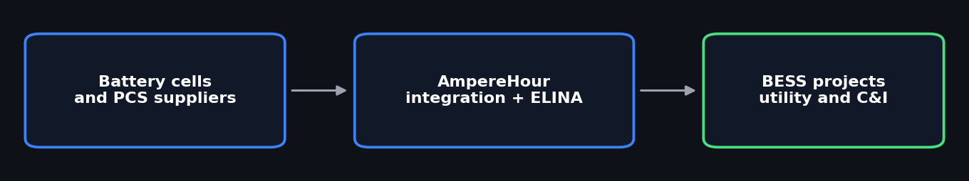
Layer | Offering | Role
Integration | BESS engineering, procurement and EPC | Designs and builds the system
Hardware | AH Stack DC block, AH 5MWh, AH Recombiner, DC containerisation | Standardises parts that were once bespoke
Software | ELINA EMS | Monitoring, control, dispatch optimisation, analytics
Digital quality | AH Suite, factory acceptance testing | Digital validation and traceability before shipment
Services | Commissioning, O and M, lifecycle and augmentation | Keeps the asset reliable and productive
Co build | AH Co Build: customer supplies battery packs | Claims savings of up to 10%

ELINA
ELINA is a three layer EMS: applications (optimisation, market participation, dispatch), an operating layer (device communication, limits, safety) and hardware interfaces (BMS, PCS, transformers, meters). It is described as hardware agnostic across LFP, NMC, zinc bromide, nickel hydrogen and sodium ion. The company contrasts it with conventional systems on machine learning dispatch, full system visibility, high frequency data and over the air updates. These are company claims.
The investment question is whether ELINA raises project returns through revenue stacking across the day ahead market, real time market, ancillary services and capacity agreements. If it does, software could be worth more than a dashboard. If it does not, ELINA is a feature of an integration business.

WHERE THE MONEY COMES FROM
Bucket | What it is | Quality
Project revenue | Engineering, procurement, integration, EPC | Largest today; lumpy; working capital heavy
Hardware revenue | AH Stack, DC blocks, recombiner, factory output | Rising with the new factory; capital and utilisation risk
Software and lifecycle | ELINA, monitoring, O and M, augmentation | Potentially recurring; amount undisclosed

UNIT ECONOMICS: WHAT WE CAN AND CANNOT SAY
AmpereHour does not disclose gross margin, revenue per MWh or backlog. Public benchmarks give a frame.
Benchmark | Value | Note
Pace Digitek supply order, Aug 2026 | ₹92.9 Cr for 100 MWh, about ₹9,290 per kWh | Likely supply scope only
Installed utility BESS CAPEX | ₹13,000 to ₹18,000 per kWh | Industry estimate; includes more than supply
Sungrow storage revenue per kWh shipped | About RMB 867 (RMB 37.287B over 43 GWh, my calculation) | A global manufacturer, not an integrator
Implied FY25 execution | ₹83.9 Cr divided by about ₹0.93 Cr per MWh is roughly 90 MWh | Illustrative; revenue timing is by percentage of completion
Two conclusions follow. First, falling battery prices lift adoption but also pull down selling prices. Second, a company that integrates others' cells earns a thin margin, so standardising designs, controlling procurement and monetising software are what decide profit.

VARIABLES I WOULD NEED FROM THE COMPANY
Variable | Why it matters
Revenue and gross margin per MWh | Core integration economics
Battery procurement cost and terms | Largest cost item; exposed to price swings
Receivable, inventory and payable days | Sets the cash needed to grow
Warranty provisions | Possible hidden liability on long life assets
O and M and ELINA revenue per MWh | Tests the recurring revenue story
Factory utilisation | Decides whether the 5 GWh adds value or fixed cost
Investment takeaway: the growth story is not simply about adding MWh. The more important question is whether AmpereHour can use its integration business as the channel for higher margin hardware and software, or whether it stays a project contractor.

HISTORICAL FINANCIAL PERFORMANCE

FINANCIAL PERFORMANCE
AmpereHour has delivered a sharp acceleration in revenue while staying profitable, driven by larger projects and a growing pipeline. Only FY24 and FY25 are available for a private company.
₹ Cr | FY24 | FY25 | Change
Revenue | 21.8 | 83.9 | Up 285%
Total expenses | NA | 76.3 | NA
EBITDA (estimate) | NA | 6.0 | NA
EBITDA margin | NA | 7.2% | NA
Profit after tax | NA | 5.8 | NA
PAT margin | NA | 6.9% | NA
Source: Inc42 Datalabs from public filings. EBITDA is Inc42's derived estimate. FY26 results were not available; private company filings usually appear around October to November.

WHAT THE NUMBERS SAY
- Growth is real but from a low base. Tofler and Tracxn put FY25 revenue in the ₹50 to ₹100 Cr bracket, consistent with ₹83.9 Cr.
- Margins look like an infrastructure business. A 6.9% net margin is healthy for an integrator but far from a software margin.
- Capital is small relative to ambition. The Series A of ₹41.5 Cr (₹415 million) is about 0.49 times FY25 revenue, while a 5 GWh facility and large projects need working capital and often bank guarantees.
- Productivity. With 88 to 104 employees across data snapshots, revenue per head is about ₹0.8 to ₹0.95 Cr.
Conflicting margin data, unresolved: Tofler lists an FY25 operating margin of 20.7, a net margin of 20.54, ROE of 62.44 and ROCE of 38.47, while Inc42 shows PAT of ₹5.8 Cr (6.9%). I use Inc42 and treat Tofler as unverified until the MCA filings are read directly.
Revenue estimates on ZoomInfo ($54.3M), Growjo ($25.8M) and RocketReach ($6.8M) differ widely and are not used.

CAPACITY EXPANSION & OPERATING MODEL
The most important operating change is the move into manufacturing. The Chakan facility, inaugurated on 13 July 2026, is a BESS manufacturing and integration facility for containerised DC and AC blocks, with a planned capacity of 5 GWh. It is not a cell plant, and AmpereHour still buys cells.
Metric | Figure | Date | Type
Commissioned | 40+ MWh | Mar 2025 | Company
Under execution | About 1,000 MWh | Mar 2025 | Company
Sites | 50+ | Mar 2025 | Company
Largest project commissioned | 360 MWh (180 MW) | May 2026 | Trade press
Factory | 5 GWh planned | Jul 2026 | Company
Stated goal in March 2025 | Scale toward 1 GWh in 18 months on contracted capacity | Mar 2025 | CEO to Economic Times

FORECAST & KEY ASSUMPTIONS

REVENUE & EBITDA FORECAST
Because only FY25 revenue is known, I model revenue as MWh executed multiplied by realisation per MWh, then apply a margin. Every input below is my assumption, not company guidance. I project revenue to rise from ₹83.9 Cr in FY25 to ₹1,242 Cr by FY30E, while EBITDA rises from about ₹6.0 Cr to ₹155 Cr.
 | FY26E | FY27E | FY28E | FY29E | FY30E
Planned factory capacity (MWh) | NA | 5,000 | 5,000 | 5,000 | 5,000
MWh executed | 250 | 600 | 1,000 | 1,400 | 1,800
Executed as % of factory capacity | NA | 12% | 20% | 28% | 36%
Realisation (₹ Cr per MWh) | 0.85 | 0.80 | 0.76 | 0.72 | 0.69
Revenue (₹ Cr) | 212.5 | 480.0 | 760.0 | 1,008.0 | 1,242.0
Revenue growth | 153% | 126% | 58% | 33% | 23%
EBITDA margin | 8.0% | 9.5% | 11.0% | 12.0% | 12.5%
EBITDA (₹ Cr) | 17.0 | 45.6 | 83.6 | 121.0 | 155.2
FY26E growth is measured against FY25 revenue of ₹83.9 Cr. Executed MWh includes third party hardware integrated outside the factory, so the utilisation row overstates actual factory use.
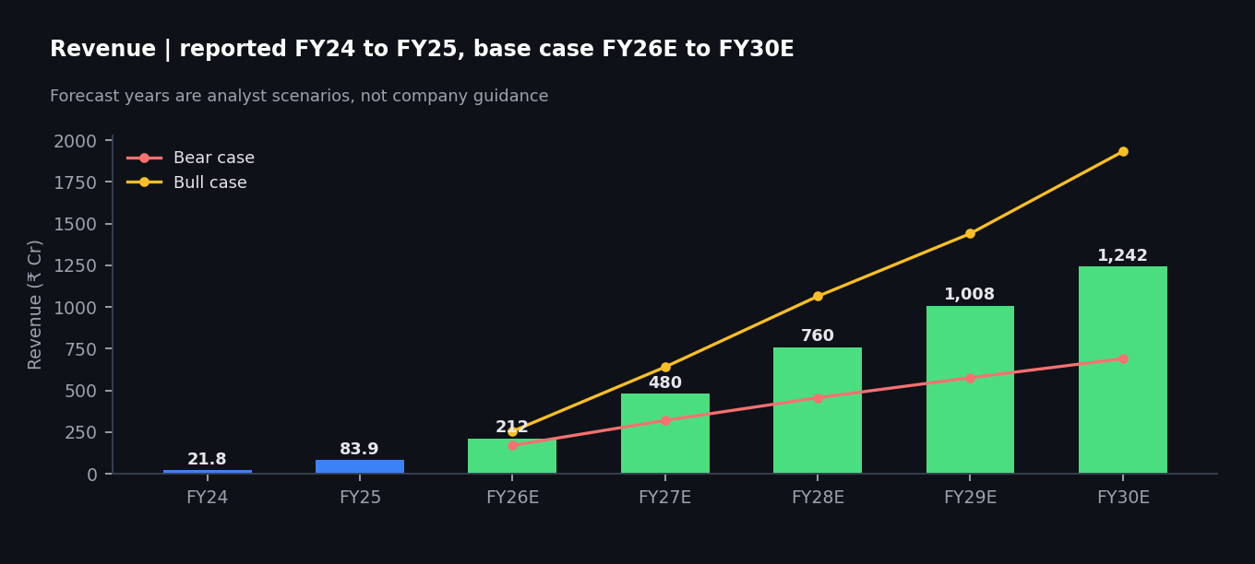

PRODUCTION ASSUMPTIONS
- Volume. Gujarat alone is 360 MWh, commissioned in May 2026 (FY27). About 1,000 MWh was under execution in March 2025. Reaching 1,800 MWh executed in FY30E means using only about 36% of the planned factory.
- Realisation falls 5% a year. Starting near the ₹0.93 Cr per MWh supply benchmark and trending lower reflects tariff pressure, cheaper hardware over time and a greater share of technology partner work on large projects.
- Margin rises from 7.2% to 12.5%. This assumes standardised AH Stack designs, factory testing and some software and service income. Pace Digitek earns 17.2% at EBITDA level, but over half its revenue is telecom.

SCENARIOS
Scenario | FY30E MWh | FY30E revenue (₹ Cr) | EBITDA margin | FY30E EBITDA (₹ Cr) | Revenue CAGR FY25 to FY30
Bear | 1,000 | 690 | 8.0% | 55.2 | 52%
Base | 1,800 | 1,242 | 12.5% | 155.2 | 71%
Bull | 2,800 | 1,932 | 14.0% | 270.5 | 87%
The bear case assumes slower conversion of awarded projects and thin pricing. The bull case assumes AmpereHour wins a larger share of the CEA pipeline and software adds margin. Achieving any of these numbers depends on project execution, factory utilisation, customer wins and realisation per MWh.

DCF VALUATION
I valued AmpereHour using a Discounted Cash Flow approach on projected free cash flow to the firm for FY27E to FY30E, discounted at 15%.
₹ Cr | FY27E | FY28E | FY29E | FY30E
Revenue | 480.0 | 760.0 | 1,008.0 | 1,242.0
EBITDA | 45.6 | 83.6 | 121.0 | 155.2
D and A (3% of revenue) | 14.4 | 22.8 | 30.2 | 37.3
EBIT | 31.2 | 60.8 | 90.7 | 118.0
Tax at 25% | 7.8 | 15.2 | 22.7 | 29.5
NOPAT | 23.4 | 45.6 | 68.0 | 88.5
Add back D and A | 14.4 | 22.8 | 30.2 | 37.3
Capital expenditure | (80.0) | (60.0) | (60.0) | (60.0)
Change in working capital (20% of revenue) | (53.5) | (56.0) | (49.6) | (46.8)
FCFF | (95.7) | (47.6) | (11.3) | 19.0
Present value at 15% | (83.2) | (36.0) | (7.4) | 10.8
Negative cash flow through FY29E is not a modelling error. Growth in a working capital heavy business consumes cash before it produces any. Because FY30E growth is still 23% and FCFF only just turns positive, a perpetual growth terminal value is not meaningful here, so I use an exit multiple of 10 times FY30E EBITDA.

FROM FCFF TO ENTERPRISE VALUE
Base case bridge | ₹ Cr
Sum of PV of FCFF, FY27E to FY30E | (115.8)
Terminal value (10 times ₹155.2 Cr) | 1,552.5
PV of terminal value at 15% | 887.6
Enterprise value | 771.8
Implied EV to FY27E revenue | 1.6 times
Net debt and cash | Not available, so no equity value or per share value is shown

SENSITIVITY OF ENTERPRISE VALUE (₹ CR)
Discount rate | Exit 8 times | Exit 10 times | Exit 12 times
13% | 644 | 834 | 1,024
15% | 594 | 772 | 949
17% | 549 | 715 | 881

SCENARIO VALUES (15%, EXIT 10 TIMES)
Scenario | Enterprise value (₹ Cr) | Comment
Bear | 142 | Negative cash flow through FY30E; value is mostly terminal
Base | 772 | Terminal value is about 115% of EV because early cash flow is negative
Bull | 1,423 | Needs about 2.8 GWh executed and 14% EBITDA margin in FY30E
Read this value with care: the result depends mostly on the exit multiple and FY30E EBITDA. The spread from ₹142 Cr to ₹1,423 Cr shows how wide the real uncertainty is. Capex of ₹60 to ₹80 Cr a year, 20% working capital and 3% depreciation are my assumptions and should be replaced with company data.

PEER VALUATION
No listed company is a perfect match, so I compare operating quality across three reference points: a global integrator (Fluence), a global equipment maker with its own power electronics (Sungrow), and the closest Indian listed rival (Pace Digitek).
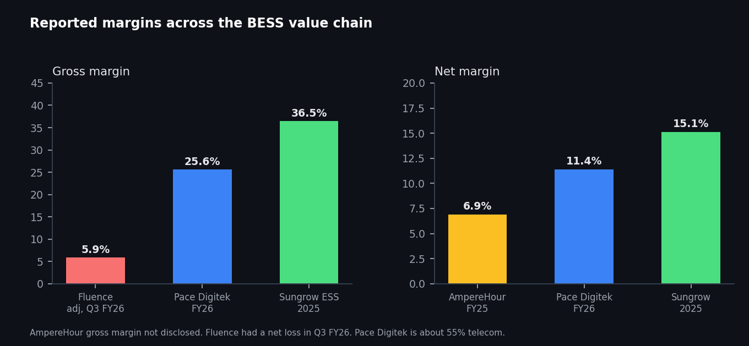
Metric | AmpereHour | Pace Digitek | Fluence | Sungrow
Period | FY25 | FY26 | Q3 FY26 | 2025
Revenue | ₹83.9 Cr | ₹2,641 Cr | $649.8M (quarter) | RMB 89.2B
Revenue growth | 285% | 8.3% | About 8% | 14.6%
Gross margin | Not disclosed | 25.6% | 5.1% GAAP, 5.9% adjusted | Storage 36.49%
EBITDA margin | 7.2% (estimate) | 17.2% | NA | NA
Net margin | 6.9% | 11.4% | Loss of $44.3M, about 6.8% of revenue | 15.1%
Order book | About 1,000 MWh under execution (Mar 2025) | ₹11,338 Cr | $6.4B backlog | NA
Manufacturing | 5 GWh planned | 5 GWh installed, 10 GWh target by Dec 2026 | Contract manufacturers | 43 GWh shipped
Sources: Inc42; Pace Digitek results and releases; Fluence 8 K dated 5 Aug 2026; Sungrow annual report as reported by pv magazine and EnergyTrend; stockanalysis for Pace gross margin. Sungrow net margin is net profit of RMB 13.461B over revenue of RMB 89.184B (my calculation).

THE VALUATION GAP
- Hardware makers with their own power electronics earn far more (Sungrow storage 36.5% gross margin) than pure integrators (Fluence 5.9% adjusted). AmpereHour must move toward the first model for margins to rise.
- AmpereHour grows much faster than any peer, but earns a thinner net margin than Pace Digitek and Sungrow and is a fraction of their size.
- Fluence's annual recurring revenue guidance is $180M, a small share of its revenue, which tempers any hope that software alone will carry valuation.

VALUATION BY REVENUE MULTIPLE (ENTERPRISE VALUE, ₹ CR)
EV to revenue | On FY25A (₹83.9 Cr) | On FY26E (₹212.5 Cr) | On FY27E (₹480 Cr)
1.0 times | 84 | 212 | 480
2.0 times | 168 | 425 | 960
3.5 times | 294 | 744 | 1,680
Recent data snapshots show Fluence at roughly 0.6 to 0.9 times sales, but the snapshots are undated and vary, so I did not fix a single peer multiple. I treat 1.0 times as a floor for a commodity integrator and 3.5 times as a premium that needs proof of software or manufacturing margin. Pace Digitek and Sungrow market multiples need to be pulled on one common date before any final comparison.

MY INTERPRETATION
Method | EV range (₹ Cr) | Comment
EV to revenue on FY27E (1.0 to 3.5 times) | 480 to 1,680 | Forward looking; depends on my forecast
DCF base case, full sensitivity grid | 549 to 1,024 (central 772) | Exit multiple driven
EV to revenue on FY25A | 84 to 294 | Backward looking; understates a company that grew 285%
Series A valuation | Not disclosed | No anchor available
My indicative range is ₹400 to ₹1,000 Cr, centred near ₹770 Cr. That is not a price target. It should be rebuilt once FY26 revenue, margin and net debt are known.
Faster growth + thinner margins = valuation depends on proving margin expansion

RATIO ANALYSIS

Financial & Operating Ratio Analysis
A private company discloses less than a listed one, so only a few ratios can be computed with confidence. I show what is solid, what is disputed, and what peers tell us.
Ratio (FY25) | Value | Status
Revenue growth | 285% | Solid (Inc42, Tofler, Tracxn agree)
EBITDA margin | 7.2% | Inc42 estimate
PAT margin | 6.9% | Inc42
Revenue per employee | ₹0.8 to ₹0.95 Cr | Mixed dates
Series A to revenue | 0.49 times | My calculation
Operating margin, net margin, ROE, ROCE | 20.7, 20.54, 62.44, 38.47 | Disputed (Tofler); not used
Current ratio, debt to equity, cash conversion | Not available | Need MCA balance sheet

Understanding the Ratios
Margins are the clearest signal. A 6.9% PAT margin shows AmpereHour is profitable, but it is well below Pace Digitek (11.3%) and Sungrow (15.1%). Balance sheet ratios such as debt to equity, interest cover and inventory days cannot be computed until the MCA filings are read, and Tofler's disputed figures should not be used.
The most useful peer reference is Pace Digitek, which shows how a scale up consumes cash:
Ratio | Pace Digitek FY26 | Comment
Gross margin | 25.61% | Down from 29.22% in FY25
Operating margin | 16.78% | Down from 19.76%
EBITDA margin | 17.24% | Down from 19.99%
Net margin | 11.27% | Up from 10.97%
Free cash flow margin | (38.72%) | Scale up consumed cash; same risk AmpereHour faces
Source: stockanalysis.com income statement for Pace Digitek, FY26.
The ratio to watch most is working capital intensity. At 20% of revenue, every extra ₹100 Cr of revenue ties up about ₹20 Cr of cash. With a thin capital base, receivable and inventory days matter more for AmpereHour than margin does.
Lower capital base + faster growth = cash conversion is the key monitoring point
PESTEL Analysis: AmpereHour Energy
MACRO ENVIRONMENT ASSESSMENT
FACTOR | KEY FACTORS & IMPACT ON AMPEREHOUR
Political | - A 30 GWh VGF scheme (₹5,400 Cr, ₹18 lakh per MWh) and CEA advice to attach storage to solar tenders create policy led demand.  - Central and state tenders (SECI, GUVNL and others) are the main sales channel.
Economic | - Tariffs fell about 52.8% in two years while battery prices rebounded to $70 to $75 per kWh, squeezing contractor margins.  - China's phased removal of export rebates (April 2026) and higher metal prices raise landed costs; lenders report stalled projects.
Social | - Peak demand rising from 277.2 GW to 366.4 GW by FY32 and evening demand make storage a reliability need.  - Fire safety concerns can affect public acceptance of large battery sites.
Technological | - LFP dominates today; sodium ion and other chemistries are emerging, favouring a hardware agnostic EMS.  - AI based dispatch and digital factory testing are differentiators but are being matched by competitors.
Environmental | - Solar at 168.0 GW and wind at 58.5 GW (August 2026) need storage to firm output.  - Battery recycling and safety standards may add compliance cost.
Legal | - Customs duty changes and local content incentives shape cost and competition (Mercom noted a wider exemption on cell making machinery).  - Long tenders with cycle and availability guarantees (for example 1.5 cycles for 15 years in one Tamil Nadu tender) raise warranty exposure.
Source: company disclosures, CEA, Ministry of Power, Crisil, Reuters. For research purposes.

SWOT Analysis

Strengths
- Utility scale execution: AmpereHour grew from a 20 MW / 40 MWh project (Kilokari) to 180 MW / 360 MWh (Gujarat), a ninefold step in energy.
- Own software: ELINA EMS sits across battery, PCS and grid equipment and is designed to work with several vendors and chemistries.
- Early profitability: FY25 PAT of ₹5.8 Cr on ₹83.9 Cr revenue is uncommon for a project business scaling this fast.

Weaknesses
- High capital intensity: a 5 GWh facility and large projects strain a company that has raised about $7.45 million in total.
- Limited disclosure: FY26 numbers, gross margin, order book and project level economics are not public.
- Unproven moat: ELINA's effect on customer returns and any recurring software revenue have not been demonstrated.

Opportunities
- Large pipeline: CEA tracks 143.82 GWh against 7.50 GWh operating, with 66.12 GWh scheduled for FY28.
- Policy support: a 30 GWh VGF scheme and storage attached to solar tenders.
- Factory and services: the 5 GWh facility can serve utility and C&I customers, and lifecycle contracts could add recurring revenue.

Threats
- Larger rivals: Fluence, Sungrow and Pace Digitek (5 GWh installed) are bigger or ahead on capacity.
- Price and cost pressure: tariffs fell about 52.8% in two years while battery prices rebounded to $70 to $75 per kWh.
- Policy and technology change: tender design, duties and chemistry shifts can alter project economics.

BCG MATRIX
Assessing AmpereHour's business segments by market growth and competitive position. Segment revenue is not disclosed, so this matrix is qualitative. Market growth is high everywhere because the CEA pipeline (143.82 GWh) is nearly twenty times the operating base (7.50 GWh).
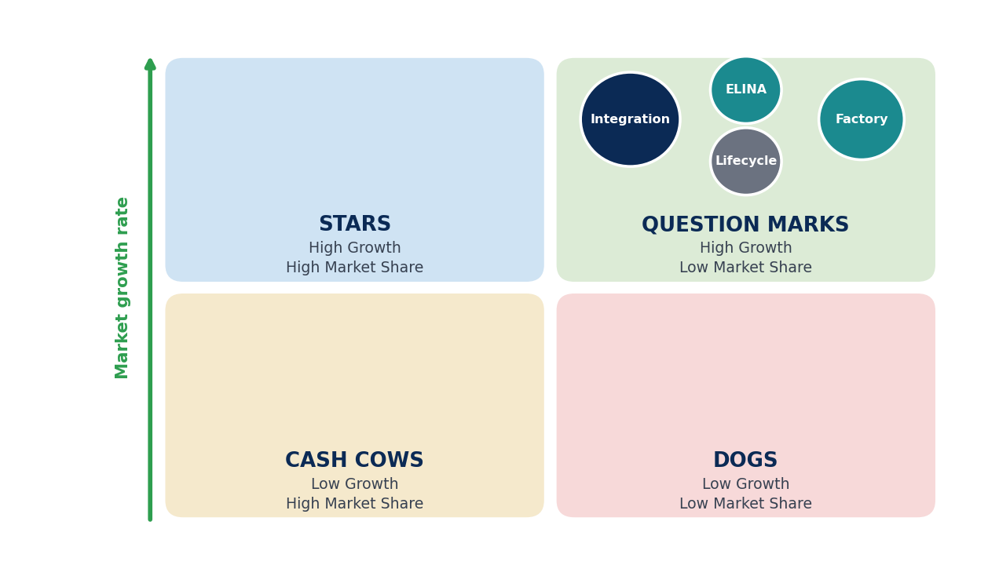

Question Marks: Integration and EPC
This is the largest revenue source, with reference projects from 40 MWh to 360 MWh. Relative share is medium: AmpereHour was an early leader, but Pace Digitek has a 5.32 GWh executable pipeline, so I place it as a question mark moving toward a star.

Question Marks: ELINA EMS
ELINA competes with Fluence, Wärtsilä and Sungrow software. Relative share is low and it becomes a star only if it measurably raises project returns.

Question Marks: Manufacturing
The 5 GWh facility was inaugurated in July 2026 and utilisation is unproven. Pace Digitek already has 5 GWh installed.

Question Marks: Lifecycle and O and M
Recurring potential exists, but revenue is not disclosed and relative share is unknown.
No segment is a cash cow yet. The company needs to turn its integration business into a star while funding the others, which is why capital and working capital are central to the thesis.

EIC FRAMEWORK

ECONOMY: INDIA
Key macro drivers
Peak demand is projected to rise from 277.2 GW (FY27) to 366.4 GW (FY32), and energy requirement from 1,907.8 BU to 2,473.8 BU (CEA). Solar capacity was 168.0 GW and wind 58.5 GW by August 2026 (MNRE).
Key Indicators
- About 32% rise in peak demand by FY32
- 295.6 GW total renewables including large hydro; 304.3 GW non fossil capacity (August 2026)

INDUSTRY: BESS
High growth storage opportunity
CEA tracks 143.82 GWh of projects against a 236.22 GWh requirement for FY32, with only 7.50 GWh operating. Policy support is strong, but tariffs fell about 52.8% over two years and battery prices have turned up, so margin quality is the industry question.
Key Indicators
- 30 GWh VGF scheme at ₹18 lakh per MWh
- 45 to 50 GWh expected to be commissioned over FY27 and FY28 (Crisil)
- Tariffs: ₹4.49 lakh to ₹2.12 lakh per MW per month, 2024 to 2026

COMPANY: AMPEREHOUR
A software led integrator with FY25 revenue of ₹83.9 Cr, utility scale references, a planned 5 GWh factory and a small capital base. Its results will depend on whether it captures margin rather than only volume.
Key Indicators
- FY25 revenue ₹83.9 Cr, up 285%; PAT margin 6.9%
- Largest project 180 MW / 360 MWh; about 1,000 MWh under execution (March 2025)
- Factory: 5 GWh planned (July 2026)
The EIC framework shows how India's power demand and renewable targets translate into BESS tenders, and how those tenders reward credible integrators such as AmpereHour, while price pressure tests how much of the growth turns into profit.

Key Risks & Investment Monitoring
AmpereHour's investment case is supported by strong demand growth, increasing project scale and early profitability. However, the valuation depends on execution, and the key risks relate to margins, factory utilisation, working capital, competition and limited disclosure.
1 Margin compression  Tariffs fell about 52.8% in two years while battery prices rebounded.  Monitor:  Gross margin per MWh, bid prices, supplier price commitments | 2 Execution risk  Large projects bring commissioning, quality and delay risk.  Monitor:  MWh commissioned versus contracted; delivery against the 1 GWh goal
3 Manufacturing utilisation  A 5 GWh plant needs steady orders to cover fixed cost.  Monitor:  Factory output, order inflow, capex recovery | 4 Working capital risk  Heavy procurement before customer payment on a thin equity base.  Monitor:  Receivable and inventory days, bank lines, any new fundraise
5 Competition and moat risk  Fluence, Sungrow and Pace Digitek are larger or ahead; ELINA may not earn recurring revenue.  Monitor:  Win rate, price per MWh, ELINA revenue and retention | 6 Policy and disclosure risk  VGF, tender design and duties drive demand; FY26 numbers and margins are not public.  Monitor:  Tender volumes, VGF disbursement, MCA filings

OTHER RISKS TO TRACK
- Input cost volatility: cells, lithium, copper and aluminium swing, and China's export rebate removal raises landed cost.
- Customer concentration: a few utility and developer projects dominate revenue; watch repeat business from IndiGrid.
- Technology obsolescence: chemistry and architecture shifts (sodium ion, longer duration) can change what customers buy.
Bullish indicators: FY26 gross margin above 15%, factory output ramping, repeat orders from IndiGrid and others, stable receivable days, ELINA revenue disclosed and growing.
Bearish indicators: project delays or write downs, margins below 5%, a fundraise at a low valuation, stalled awarded projects, no software revenue visible.
Overall risk level: medium to high. The market is strong, but the business is capital intensive and the price environment is hostile.

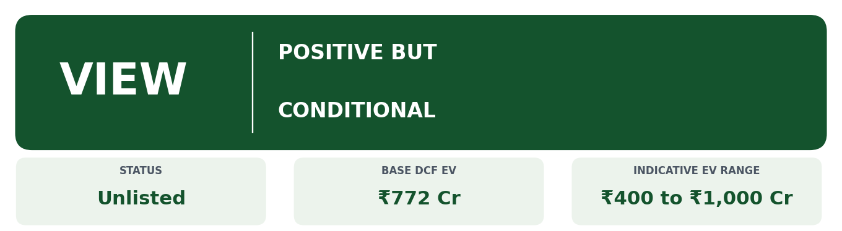
Why I Like AmpereHour
The company is early in a market that is becoming real: CEA tracks 143.82 GWh of projects while only 7.50 GWh operates. AmpereHour grew revenue from ₹21.8 Cr to ₹83.9 Cr in one year and stayed profitable, delivered a 360 MWh project, built its own EMS, and has now started manufacturing.
Why I Am Not Blindly Bullish
Tariffs are falling while battery costs rise, rivals are larger or ahead on installed capacity, and no one has shown that ELINA earns a software like margin. Fluence, with a very similar stack, made a 5.9% adjusted gross margin in its latest quarter. AmpereHour's own margin, order book and FY26 results are unknown. Therefore, the key debate is not whether India needs storage, but whether AmpereHour can capture that growth while keeping attractive margins.

SCORECARD
Factor | Assessment
Market opportunity | Very strong
Revenue growth | Very strong (FY25)
Commercial traction | Strong
Project execution | Strong and improving
Technology differentiation | Moderate
Software moat | Unproven
Competitive intensity | High
Capital intensity | High
Disclosure quality | Weak
Overall attractiveness | Promising, but execution and margin dependent
Final Verdict
AmpereHour has a real chance to become the technology and integration layer for a large part of India's battery powered grid. The case becomes compelling if FY26 shows gross margin above integrator levels, the factory fills with orders, and ELINA produces measurable customer returns. If not, it will be valued as a well run but price taking infrastructure contractor. Until the missing numbers are filed, I keep a positive but conditional view, with an indicative enterprise value of ₹400 to ₹1,000 Cr.

Sources, Methodology & Disclaimer
Company / Primary Sources
- Central Electricity Authority, BESS status as on 31 May 2026; National Electricity Plan and storage advisory (February 2025)
- Ministry of Power (VGF schemes); MNRE (installed capacity, August 2026); SECI tender documents
- Fluence Energy Form 8 K and press release, 5 August 2026
- Pace Digitek results, investor presentation and company releases (FY26, Q1 FY27, June to September 2026)
Industry and Market Sources
- Inc42 Datalabs, Tofler, Tracxn, PitchBook, Dealroom (financials, funding, headcount)
- Mercom India, pv magazine India, Energetica India, Renewable Watch, ESS News, Batteries International, YourStory, Economic Times, Hindustan Times, Entrepreneur India, Bharat Innovates (company and project facts; some compiled in the research notes)
- Crisil (via TaiyangNews), JMK Research (via IntelliNews), Reuters (via MarketScreener and Construction World) for tariffs, battery prices and installed base
- Sungrow annual report as reported by pv magazine, EnergyTrend and TaiyangNews
Valuation Methodology
Revenue is modelled as MWh executed times realisation per MWh. The primary valuation is a DCF of FY27E to FY30E free cash flow at 15% with an exit multiple of 10 times FY30E EBITDA. Relative valuation uses revenue multiples because earnings are small and volatile. All forecast inputs are my assumptions, and calculations marked as mine are derived from reported figures.
Open Verification Items
Item | Status
FY26 revenue, margin, balance sheet | Not yet available; check MCA filings around October to November 2026
Avaana claim of one third of contracted capacity | No primary source found
AH Co Build savings of up to 10% | Company claim, unverified
Website figure of 500+ MWh commissioned | Not independently verified
Delivery against the 1 GWh in 18 months goal | To ask management
Tofler FY25 margins versus Inc42 | Conflict; read MCA documents
Peer multiples (Pace Digitek, Sungrow, Fluence) | Pull on one common date before use
First VGF scheme capacity (13.2 versus 13.8 GWh) | Confirm from Ministry of Power document
Date Harshal Thakur became a co founder | Confirm
Disclaimer
This report has been prepared for academic and educational purposes as part of a student equity research exercise. The analysis represents the author's independent interpretation of publicly available information and financial projections. Forecasts, valuation assumptions and indicative values are subject to uncertainty and may differ materially from actual results. AmpereHour Energy has not reviewed or endorsed this report. This report should not be considered investment advice or a recommendation to buy or sell securities.

