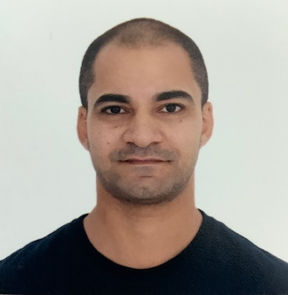

**FADY MOKHTAR**

[**fadimokhtar@gmail.com**](mailto:fadimokhtar@gmail.com)

**Mobile: +971561308198**

**JLT- Dubai**

**Summary**

Results-producing hospitality management professional with over 18 years of experience in guest satisfaction, hotel operations, and sales optimization. Skilled at maximizing hotel profits by adhering to high product and service delivery standards. Excellent communication, presentation, negotiation, and sales-closing abilities.

Well-versed in various software programs including Fidelio and Opera hotel management systems, IDEAS revenue operating system, and MS Office Suite. Fluent in English, French, and Arabic.

**Core Qualifications**

Hotel/Hospitality Management Staff Training and Development

Complaints Handling Cost Control/Budgeting

Reservation/Up-selling Process Improvement

Safety and Fire Training First Aid and CPR

The One Minute Manager Train the Trainer

**Accomplishments**

* Consistently improved guest satisfaction and service ratings throughout 18-years career in the hotel and hospitality industry.
* Managed multiples areas including Front office, Housekeeping, Spa and Security personnel with a goal of improving employee performance, outcomes and exceeding hotel profit objectives.
* Achieved recognition for Amari Hotel from Trip Advisor as one of the top 10 hotels in Doha for 2013 and 2014 and earned a guest satisfaction rating of 9.1 by booking.com.
* Implemented an up-selling strategy at Amari Hotel, which successfully increased the room’s revenue by 10% from the budget set.
* Stable LQA score for 90% within the rooms department.

**Experiences**

**Marriott International:** March 2020 to September 2021 **Director of Rooms at Sheraton Grand Conakry-**Guinea

**Six Senses Resorts and Spa:** March 2017 to February 2020 **Front of House Operations Manager at Six Senses Zil Pasyon Resort and Spa-** Seychelles

**Six Senses Resorts and Spa:** March 2015 to Feb 2017 **Front of House Operations Manager at Six Senses Zighy Bay Resort and Spa**- Dibba- Oman

**Onyx Hospitality Group:** September 2012 to February 2015 **Rooms Division Manager (Pre-Opening) at Amari Hotel Doha**-Doha- Qatar

**Intercontinental Hotel Group:** October 2010 to June 2012 **Front Office Manager (pre-opening) at Holiday Inn Embassy District-** Dubai, UAE

**Kempinski Hotels and Resorts:** October 2009 to October 2010 **Front Office Manager at Kempinski Hotel** **N’djamena**- Chad- N’Djamena

**Kempinski Hotels and Resorts:** June 2008 to October 2009 **Duty Manager/Night Manager at**

**Kempinski Hotel Mall of Emirates** -Dubai, UAE

**Starwood Hotels and Resorts:** January 2007 to May 2008 **Duty Manager/ Night Manager at**

**Sheraton Deira Hotel and Towers** -Dubai, UAE

**Starwood Hotels and Resorts:** October 2004 to December 2006 **Front Office Supervisor at**

**Le Meridien Abu Dhabi Beach Resort and Spa** -Abu Dhabi, UAE

**Starwood Hotels and Resorts:** April 2002 to September 2004 **Guest Service Agent at**

**Le Meridien Heliopolis** - Cairo, Egypt

**Education**

**Bachelor of Arts**: **French Civilization, Literature, and Translation/ Cairo University**

**Degree in Hospitality Management/ Cornell University**

**High School: College De La Sainte Famille (Jesuite) – French Education**