**BILAL DEMIREL**

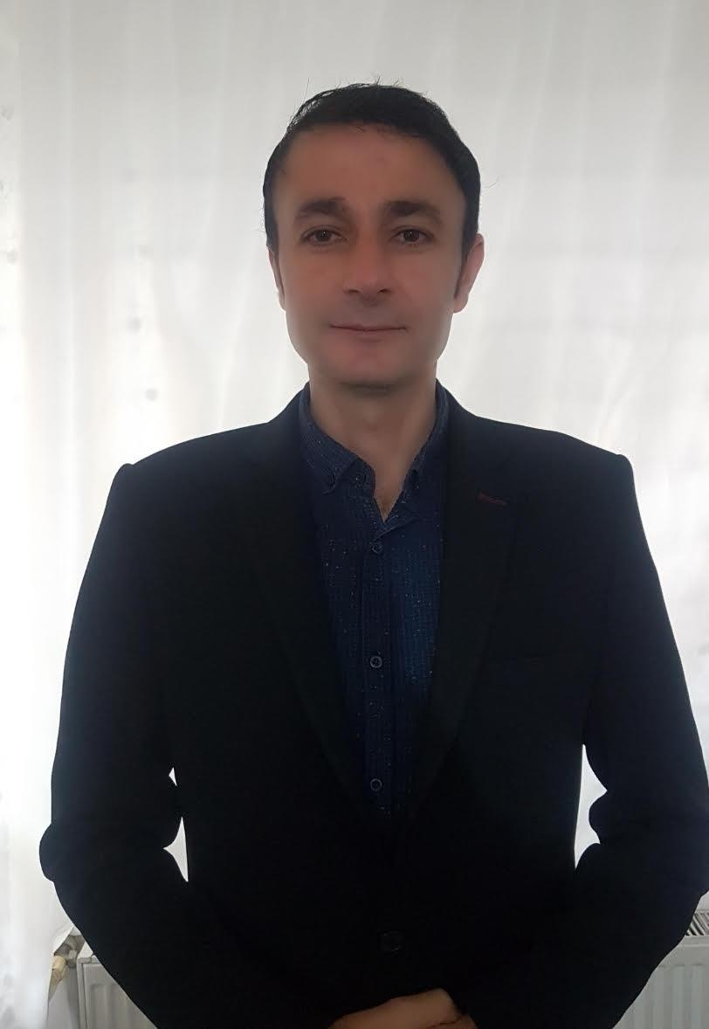

**PERSONAL INFORMATION**

***Address*** Padaste manor Muhu Estonia

|  |  |
| --- | --- |
| ***Mobile*** | *+37256358745* |
| ***E-mail*** | billy_singapore@hotmail.com |
| ***Skype*** | billy_singapore@hotmail.com |
| ***Birthday*** | 04-Feb-1978 |
| ***Marital Status*** | Single |
| ***Nationality*** | Turk (Turkish) |
| ***Languages*** | English, Turkish, Russian |
| ***Current Location:*** | Estonia Muhu |
| ***Notice Period:*** | N/A |
| ***Availability*** | Immediate |

**EDUCATION**

Cheboksary University (Cheboksary – Russia)

*Business Administration and Management,

Tourism management course 1 year (Kutahya, Turkey)

*High School Diploma,

**Padaste Manor Muhu Estonia**

10/06/2021

Restaurant manager

**Mozaik Apartments Fethiye Turkey**

**Restaurant Manager**

O4/22/2020

Staff hiring, Training, Coaching

Marketing

Menu designing updating

P&L

Cost Control

**Alma by Juan Amador**

**Asst Restaurant manager** *Singapore* ***23/08/2018 - 03/14 2020***

Michelin star Fine Dining Restaurant

When I join Alma, trip adviser was one of the weakest point and I had to put all my attention in to that. I was able to get my team on board with me and we managed to get from ranking to the top 1.

- Team Building / Staff Training

- Purchasing / Inventory Management

- Quality Assurance / Control

- Facilities / Safety Management

- Customer Service / Guest Relations

- Cost Containment / Control

**Wagamama**

**Restaurant Manager** *Doha – Qatar****10/14/2017 22/07/2018***

Responsibilities:

* Sets the standard for service expectations by scrutinizing every aspect of the guest's experience from start to finish.
* Positively coaches team members to achieve the highest quality of service in all areas of the restaurant.
* Supports and works well with all members of the management team.
* Works with managers, team members and HR on disciplinary matters and issues.
* Cross trains and develops staff to provide opportunities for growth and advancement.
* Successfully resolves guest problems to ensure the guest's happiness.
* Takes responsibility for growth and development by setting goals and seeking out knowledge.
* Maintains good energy and positive image to guests and staff during the shift.
* Conducts daily line checks for food quality freshness and standards at the beginning of each shift.
* Manages expo to ensure food quality, recipe adherence and proper plate presentation.
* Corrects any food or beverage problems before they reach the guest.
* Makes adjustments to staffing levels as needed to achieve labour goals.
* Achieves and maintains a clean and sanitary environment throughout the restaurant.
* Achieves financial goals for the assigned area without compromising food or beverage quality and service.
* Solid knowledge of Policies and Procedures, proper use of forms, payroll procedures, reports, local applicable employment laws and employee file maintenance.

**Marriott International – Grosvenor House**

**Asst. Restaurant Manager** *Dubai – UAE* ***10/01/2015 –***

* Recruiting, training and supervising staff.
* Managing budgets.
* Planning menus.
* Ensuring compliance with licensing, hygiene and health and safety legislation/guidelines.
* Promoting and marketing the business, social media
* Overseeing stock levels.
* Ordering supplies.
* Producing staff rotas.

**Resort World Sentosa***Singapore****10/05/2010 - 31/10/2014***

**Asst. Restaurant Manager – Hard Rock Hotel Starz Restaurant**

Responsibilities:

- Managing the daily operation by leading, teaching and coaching the team in order to ensure the highest standard of service and according to Hardrock Hotels guidelines,

* Involved in the Grand Opening process and launch of the daily Sunday lunch operation
* Ensure Consistent Brand Service Standards are Delivered in Every Area,
* Quarterly and yearly performance staff review and assessment,
* Evaluate Levels of Guest Satisfaction,
* Optimise Sales and Contain Costs,
* Marketing and Future Planning,
* Regular tasks including P&L review, forecasting, budgeting, payroll, Capex and productivity report
* Replace the restaurant manager during his/her absence

[**Assistant Manager**](http://www.linkedin.com/search?search=&title=Food+and+Beverage+Assistant+Manager&sortCriteria=R&keepFacets=true&currentTitle=CP&goback=%2Enpv_140786508_*1_*1_*1_*1_*1_*1_*1_*1_*1_*1_*1_*1_*1_*1_*1_*1_*1_*1_*1_*1_*1_*1_*1_*1_*1_*1_*1_*1_*1&trk=prof-exp-title)**​Fiesta Hotel Festive Restaurant**

Responsibilities:

* Ensure Consistent Brand Service Standards are Delivered in Every Area,
* Quarterly and yearly performance staff review and assessment,
* Marketing and Budget Forecasts for Future,
* Schedule Duty Roster for Staff,
* In charge of Outlets Training,
* In charge of Operation Equipment Inventory and Beverage Inventory**​**​Responsibilities:
* Managing the daily operation by leading, teaching and coaching the team in order to ensure the highest standard of service and according to Hardrock Hotels guidelines,
* Involved in the Grand Opening process and launch of the daily Sunday lunch operation
* Ensure Consistent Brand Service Standards are Delivered in Every Area,
* Quarterly and yearly performance staff review and assessment,
* Optimise Sales and Contain Costs,
* Marketing and Future Planning,
* Regular tasks including P&L review, forecasting, budgeting, payroll, Capex and productivity report
* Reporting to F&B director i was overall InCharge with entire operation because In Fiesta Restaurant there was no Restaurant manager

[**Royal Caribbean International**](http://www.royalcaribbean.com/home.do)**​​** *(Miami, Florida)* ***31/11/2006 - 01/05/2010***

F&B Office Admin

- Supporting to Restaurant Manager, Ordering Special Requests, Managing Time and Attendance, Preparing Document for Sign-on and Sign-off Crew Members, InCharge of the Monthly Inventory.

F&B Waiter

- Effectively Controlling the Flow of Customers and Orders Throughout Service, Understand Menu Content, Any Menu Changes and Promotional Activities, Ensuring Room Sets Are Up To Specified Standards and As Per Guest Requirements, Able to Answer Guest Queries in a Polite and Helpful Manner.

F&B Assistant Waiter

- Keep the Service Area Clean and Tidy and Well Prepared, Run the Food Accordingly to Table Number and Follow the Timing.

**Bodrum Mandarin Garden Hotel***(Mugla, Turkey)* ***1998 15/10/2006***

Food and Beverage Manager

Ensuring all the F&B operation s Are Up To Specified Standards and As Per Guest requirements, Dealing With Any Customer Queries in an Appropriate Manner, Managing Revenue plan.

**Certificates**

* Basic Food Hygiene Training

-F&B Suggestive Selling Skills workshop

* Lead to wow ( marketing &Pr training )
* Conduct Competency-based Assessment
* Food & Beverage Safety and Hygiene Procedures -Customer Focused Organization
* Interpret The Singapore workforce skills qualifications framework -Adult learning principles and code of ethics
* ​Serve safe
* Crowd management
* Cultural diversity
* Business ethics
* World of wow
* ISO 14001 basic training
* Ship life policies
* NSSA level 4 training
* Passenger assist in emergencies
* Zero Tolerance training

**COMPUTER SKILLS**

**Operating Systems** Windows OS (Advanced), MAC OS (Average)

**Office Programs** Microsoft Office​(Advanced), Open Office (Good)

**Software Packages** IGPOS (Advanced),**​**Micros (Good), Opera (Average)

**PROFILE**

**References**

**Michael Tan​**

Director of F&B RWS Singapore

[**Michael.aktan@rwsentosa.com**](mailto:Michael.aktan@rwsentosa.com)**​**

**Mobile : +65 81380429**

**Flores O Donnel**

**​**Restaurant Manager RWS**​**

[**floresodonnell@yahoo.com**](mailto:floresodonnell@yahoo.com)