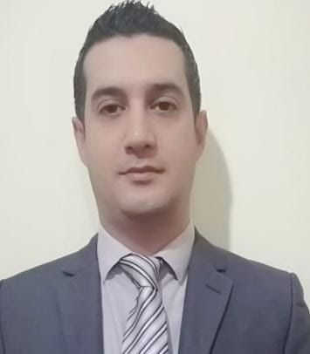

**Personal Data**

NAME: Ali Jaber

Mobile: 03 559227

E-mail: alijaber-83@hotmail.com​

Current Location: Beirut

Nationality: Lebanese

Date of Birth: SEP 26-1983

Marital Status: MARRIED

Height/Weight: 180 cm / 85kg

Languages Spoken: English / Arabic

# : SUMMARY

Enthusiastic and hardworking restaurant manager with a winning attitude

.and desire to deliver an exceptional dining experience

Focused on setting high expectations and raising service standers. Savvy marketer with a track record of improving revenue reducing turnover, and. increasing customer satisfaction

OVERSEE EMPLOYEE WORK IN FRONT AND BACK OF HOUSE TO ENSURE*

COMPLIANCE WITH COMPANY POLICIES, REGULATIONS, AND FOOD SAFETY. GUIDELINES

PERFORM FACILITY WALK-THROUGHS TO ASSESS CLEANLINESS AND*

. PERPAREDNESS AT BEGINNING AND END OF SHIFTS

COMPLETE RESTAURANT OPENING AND CLOSING PROCEDURES AND MANAGE*

. DEPOSITS

CONSISTENTLY EXCEED DAILY, WEEKLY, AND MONTHLY SALE TARGETS WITH* MAINTAINING COSTS AND KEEPING EMPLOYEE TURNOVER LOW

# HIGHLIGHTS

REVENUE GENERATION *TRAINING*

FINANCIAL OVERSIGHT *CUSTOMER SERVICE*

INVENTORY CONTROL *RESOURCEFUL PROBLRM*

EMPLOYEE RELATION *MOTIVATIONAL LEADER*

# EDUCATION

Bt3 hotel management at (BER HASSAN) collage 2002 Computer Skills:

Omega Pos , Microsoft word , excel word.

OTHER SKILLS:

* The ability to arrange plans and strategies (for projects, programs and social activities).
* The ability to make a speech and design
* The ability to take responsibility, leadership and management

**: WORK EXPERIENCE**

AS A F&B MANAGER IN CHARGE AT LA SIESTA HOTEL & BEACH RESORT FROM APRIL 2021 TILL PRESENT

As a restaurant manager at Sp holding Lily’s Resto/Café’ May 2019 till October 2020

As a manager at Verssine restaurant (the bridge) company sin elfiel 2018

As an assistant manager at Al-Falamanki restaurant and coffee shop

. (MONO-Lebanon) 2014 till 2018

As a Manager at Zerok company Nigeria 2011/3

(As an ass. Manager at Mediterranean hotel Rawche (2011

(As a branch manager at Mr. Baker Kuwait (2010

(As a Manager at Al Nar restaurant Ashrafyeh (2010

(As a head waiter at Movenpick hotel Egypt (2009

As a branch manager at pizza hut Lebanon since 2003 till 2008

As assistant manager at double four restaurant LAGOS-Nigeria since 2002 till 2003

Activities and Interests:

• SPORTS AND MUSIC