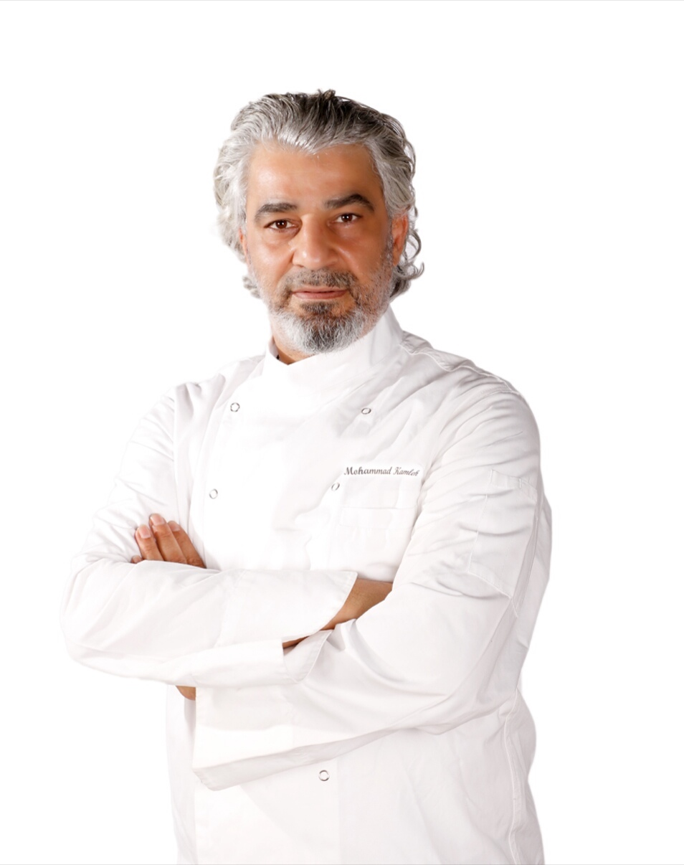

**Mohammed Kamleh -Executive Chef Resume**

Food Safety Management System Internal Auditor (ISO22000:2018 Standard)

Accredited Culinary Judge form world association of chefs Societies

* Culinary Arts & Hot Kitchen -Level B (Dec 12, 2020 - Dec 11, 2025)
* Culinary Arts & Hot Kitchen-Level B (Dec 20, 2012 - Nov 20, 2012)
* Founder and former vice president of the Jordanian chef association /JCA
* Certified master chef - from “world master chefs society “2015 "in fine gastronomy & Culinary administration, thereby reflecting professional knowledge and philosophy of international cuisine.
* Examiner - Pathway to professionalism: Culinary Art - Jordan
* Senior member - Emirates Culinary Guild
* Senior Member -QCP- Qatar Culinary Professionals

**RANGE OF EXPERIENCE & SUMMARY**

28 Years’ experience in Dubai and India as a Chef. Having knowledge of all kinds of cooking particularly in Continental, Bakery, Cold Kitchen, Indian, Mediterranean Arabic, Turkish and Italian

**PROFESSIONAL EXPERIENCE**

**Al Dana Club (Katara Hospitality) Qatar -Doha**

### Executive Chef

### Mar 2020 – Present

Dana Club is private members club, situated in a prime location, close to the Doha Corniche and beside the West Bay business district. With a proud and prestigious history spanning more than 20 years, offering families a place to relax, dine, exercise and play. With a range of recreation facilities, restaurants, lounges, children’s activities, meeting rooms and banquet (Al Jewan Hall), which also offers varieties of Out-door catering services for international events.

**Responsibilities**

* Over seen all food preparation and presentation, to ensure quality and standards are maintained.
* Coordinates with Food and beverage Director on new revenue generating and ensure yearly budget is achieved.
* Manages food and product ordering by keeping detailed records and minimizes waste, plus works with existing systems to improve waste reduction, and manage budgetary concerns.
* Develop SOP`s covering all the Culinary Requirement for standard Operation.
* Create Recipes and review of all the previous recipes of ensure new culinary Trend implemented.
* Managing Food Cost, with Finance department to ensure all expenses are well managed.
* Develop a waste system ensure that portion control is adhered properly.
* Leading the new Concept and renovation of the Main Restaurant.
* Leading and Developing New catering Concept to be comply with the Covid-19 Safety Requirement.
* Leading Catering project with 1.8 M QAR monthly Revenue.

**Culinary Institute of Jordan/ Amman Jordan**

**www.cij.edu.jo**

**Owner & Culinary program Instructor *(15th April 2019 to Feb 2020)***

Train’s students to become chefs and food service professionals. He or she maintains a learning environment where students are encouraged to ask questions, show respect for the teacher and classmates, and learn about the culinary arts in detail. Instruction involves hands-on participation from the students so that they develop a firmer understanding of the practice. A culinary arts teacher modifies instruction, as needed, to meet the needs of all students.

**Hilton Worldwide**

***Executive Chef-Food & Beverage In-Charge (25th May 2017 to March 2019)***

**Double Tree by Hilton Al Dharhan / KSA**

153 Rooms,4 Food and Beverage outlets, Banqueting, Awarded the Best Mid-Market Motel in Saudi Arabia at the first Saudi Excellence in tourism awards.

* Leading and managing the daily operation of staff working in the kitchen and service along with all mid and line staff.
* Managing birchstreet and orders for all Food and Beverage and Stewarding Needs.
* Managing the food cost and beverage cost in-line with the benchmark and property budget.

**Hilton Dead Sea Resort & Spa / Convention Center Sep 2014 to 21st - May 2017**

**Executive Sous Chef (Pre-Opening Managements Team)**

**Executive Chef Task Force. Double tree by Hilton Al Dharahan / KSA May 28th till July 24th -2016**

* Leading the Culinary procurement, preparation, and overall operations of all the Outlet
* Develop All Pre-opening menus and food service processes.
* Develop All SOP for the Culinary Operation and outlet
* Ensured to optimize operational productivity and associated finances.
* Hire and train the Pre-Opening Team

**Starwood Hotels & Resorts**

**Acting Executive chef / Executive Sous Chef (Oct 2011 to Sep 2014)**

**Sheraton Amman Al Nabil Hotel**

268 Rooms, 6 Food and Beverage outlets, Large Banqueting, and outside Catering departments. One of the most respected five-star properties in Amman, Jordan.

* Leading and managing the daily operation of staff working in the kitchen and service along with all mid and line staff.
* Managing MC and orders for all Food and Beverage and Stewarding Needs
* Control food cost and beverage cost online with the benchmark and property budget.
* Leading and Creating Culinary Training Program for the Kitchen Team

**Rezidor Hotels group**

**Executive Chef/ Food & Beverage In-Charge Sep 2010 to July 2011**

**Park inn, Al khobar, by Radisson /KSA**

148 Rooms, 3 Food and Beverage outlets, Banqueting and outside Catering departments. Park Inn Al khobar awarded the Best Mid-market Motel in Saudi Arabia at the first Saudi Excellence in tourism awards.

**Executive Sous Chef (Pre-Opening Managements Team) Aug 2009 to Aug 2010**

**Radisson Blu Tripoli, Libya**

351 rooms and suites 6 Food and Beverage outlets, 1500 Seat Banqueting and outside Catering departments Business meeting rooms. Based in the Capital City of Libya

**Kempinski Hotels Group / Giragan Palace Istanbul,Turkey**

**Sous Chef All Day Dining June 2007 to Aug 2009 / transferred from Kempinski Ishtar.**

282 & 11 Palace suite hotel rooms Çırağan Palace Kempinski is situated on the European shores of the Bosphorus, the property is the most flagships and finest properties in Istanbul

* **Rosewood Hotels Group / Al Faisaliah hotel -** Chef De Partie July 2005 April 2006
* **Carinthia Hotels Group/ Carinthia Tripoli, Libya** Demi Chef De Partie April 2003 to April 2005
* **The Club, Abu Dhabi -UAE** Demi Chef De Partie April 2000 to January 2003
* **Royal Family. -Abu Dhabi U.A.E** Private Chef from March 1994 to Feb 2000

**EDUCATION**

**Hospitality Management Diploma**

American Hotel & Lodging Educational Institute

[www.ahla.com](http://www.ahla.com)

**High School Degree-** **Culinary and Food Production**

Ammun Tourism & Hotel School, Amman Jordan

**Highlights**

Count on me held on 2003.

Train the trainer program held on 2003.

Best contribution award (HACCP) 2003.

* A leadership skills program held on 2005.
* Train the trainer program held at Kempinski Ishtar dead sea 2006.
* Short course: operational strategies for menu research & development from the culinary institute of America 2007.
* Short course: the culinary art of menu research and development from the culinary institute of America 2007
* Short course: Food science and technology applications to menu R&D from the culinary institute of America 2007
* Turkish cuisine workshop at the MSA academy 2008 Istanbul Turkey
* Advanced professional kitchen and restaurant management in the 21st century /2008 emirates academy of hospitality management UAE -Dubai
* GTT certified ( [group training technique](http://www.google.com.ly/search?hl=ar&lr=&ei=HRHGS9jXAonEOILfqLkP&sa=X&oi=spell&resnum=0&ct=result&cd=1&ved=0CBEQBSgA&q=Group+training+technique&spell=1)) at Radisson blue Tripoli 2009
* Member of the organizing committee, 2014/2015/20016 - food service chef's& culinary competition / HORECA-JORDAN
* Member of the judging committee, 2018 chef’s and cooking competition / HACE -CAIRO
* Beverage and Bars CROSS EXPOSURE (Dubai / Doubletree JBR 14th to 23rd March 2018
* Food and beverage workshop (KEEP YOUR FOCUS) Hilton Durban South Africa

**Languages**

* *Arabic – Native, English Fluent, Turkish – Basic*

***Reference***

1. **Elias J. Moukarzel** : General Manager at Hilton : Doha Qatar

LinkedIn <https://www.linkedin.com/in/elias-j-moukarzel-5763b8b/>

1. **Gian Carlo D'Urso** : Director Of Food And Beverage / Katara Hospitality Doha Qatar

[gc.durso@gmail.com](mailto:gc.durso@gmail.com)

**Yours Sincerely,**

**Chef Mohammed Kamleh**

[**Chefjo70@gmail.com**](mailto:Chefjo70@gmail.com)

**0097455360484**