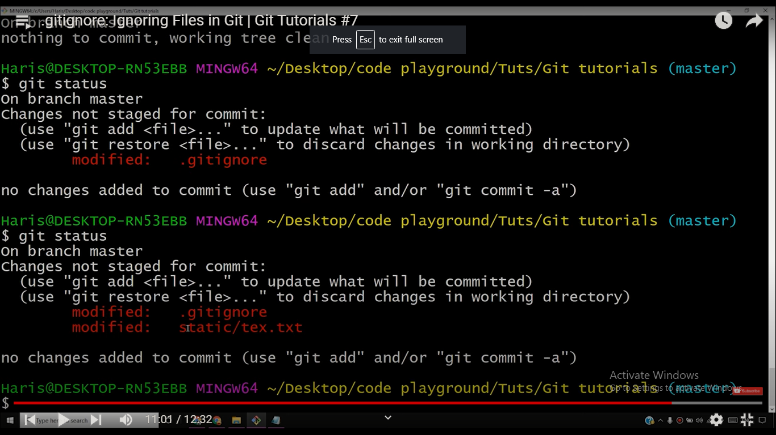

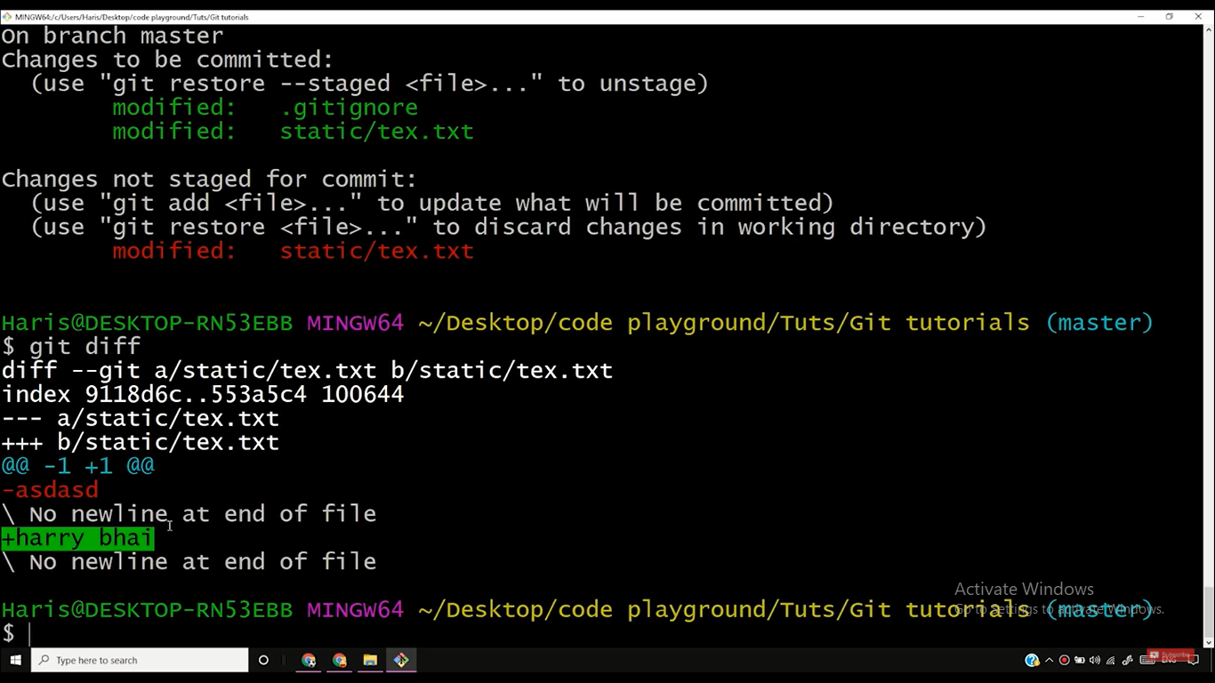

Git diff compare working directory and staging area

jai hanuman

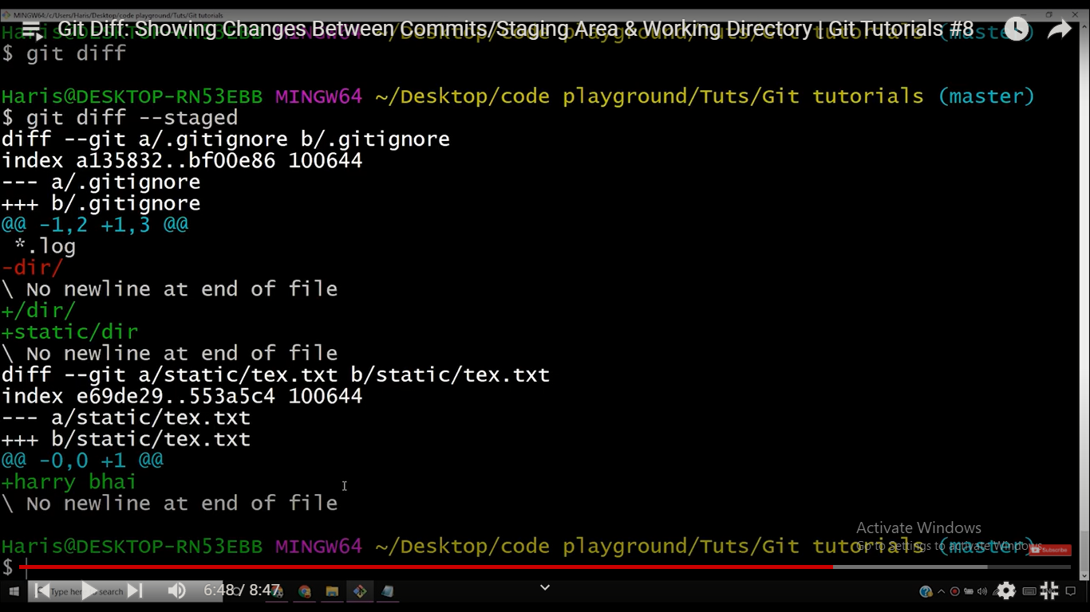

Git diff - -staged compare previous commit with current staging area jai shree ram

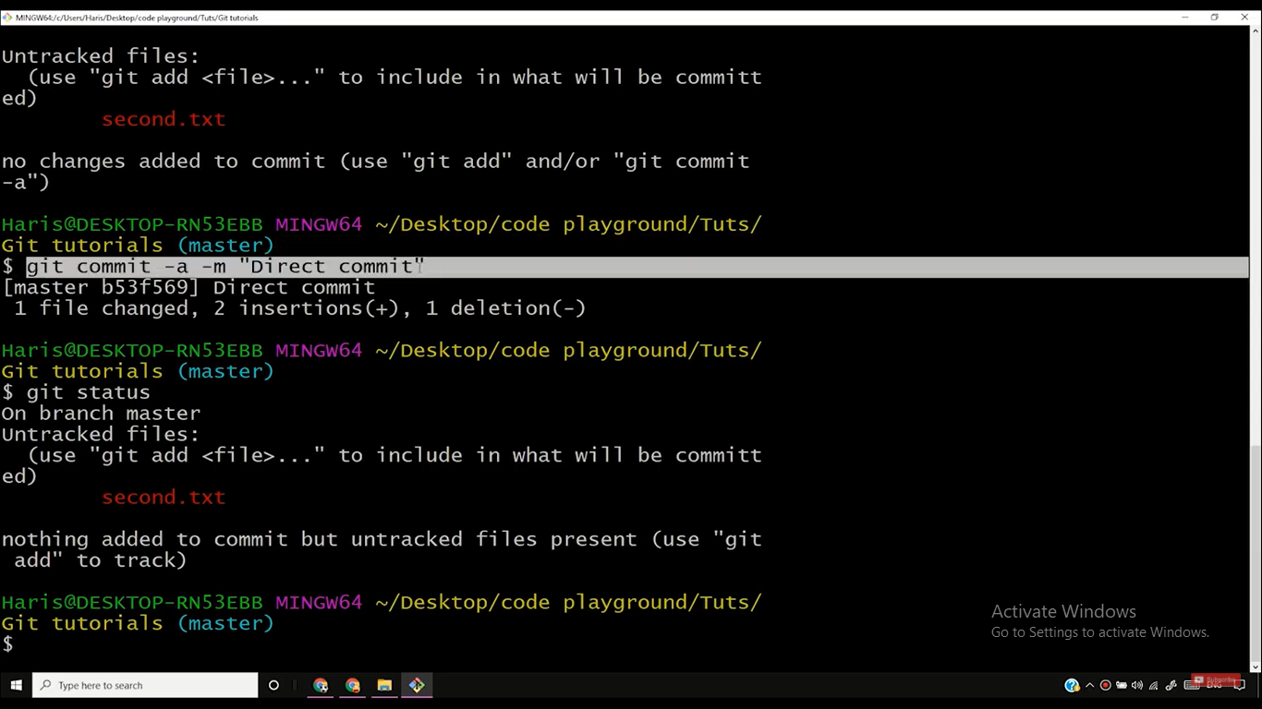

Git commit –a-m”direct commit” this command commit your track file in staging area

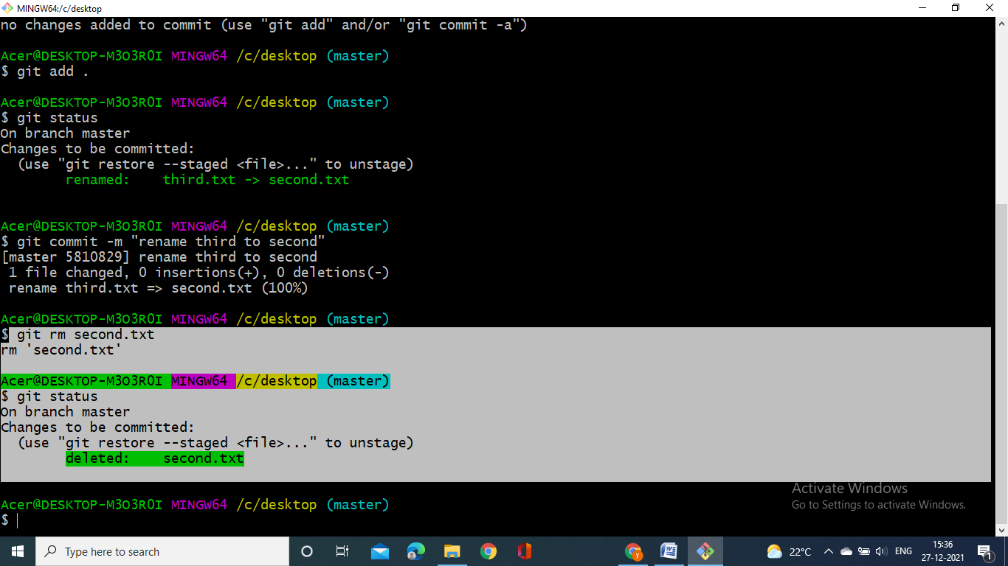

If you want to remove any file then use this one

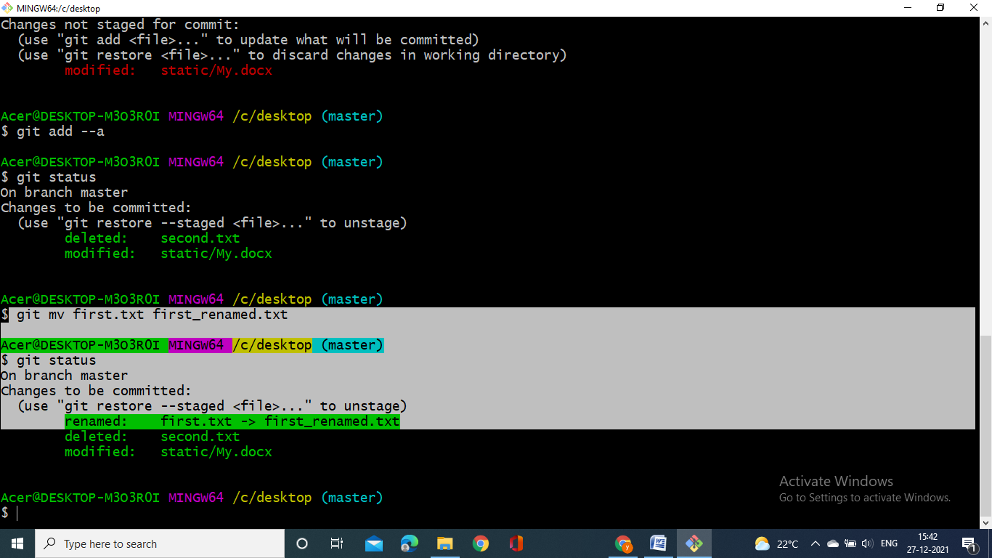

If you want to rename any file then use this one

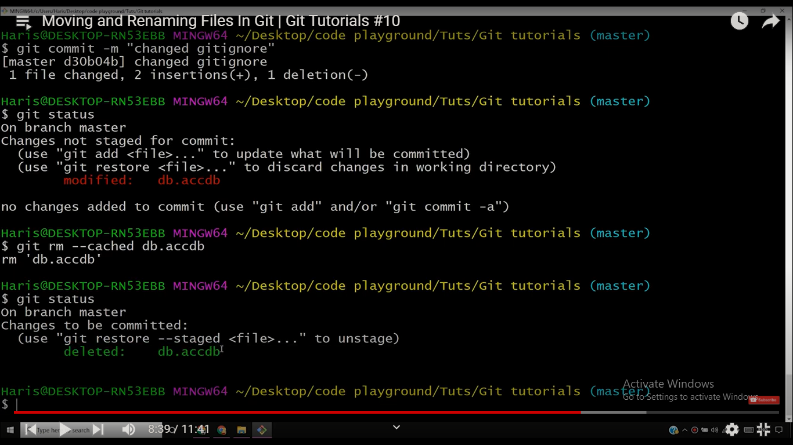

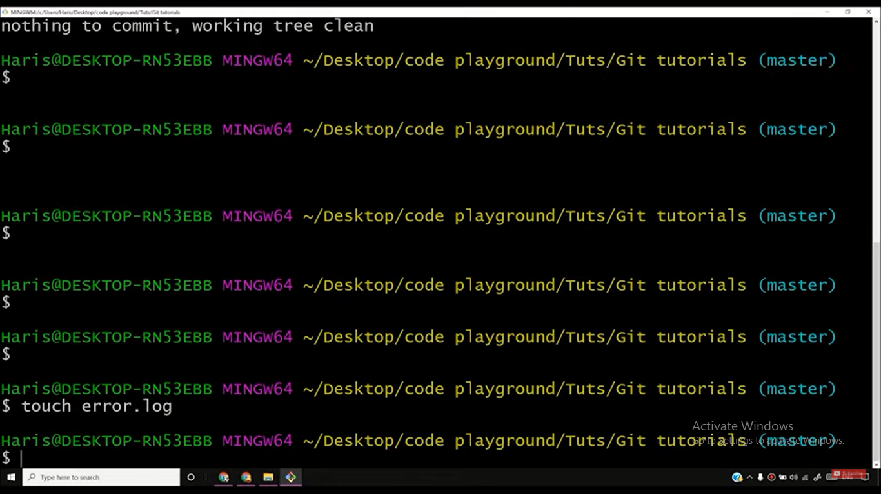

Touch file name command for making new empty file

Git log - -since=2.days ///last 2 days

Git log - -pretty=short

If you want to see change which have done last few days

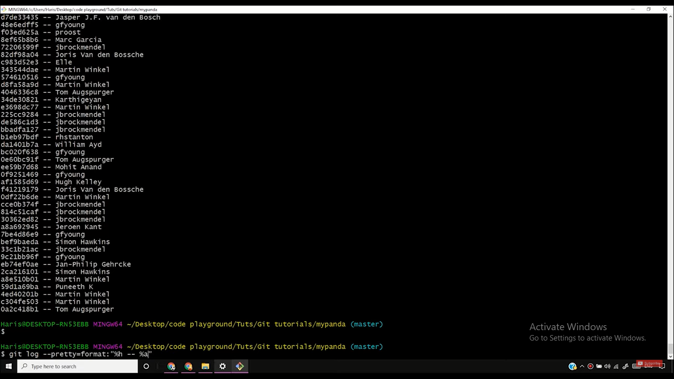git log - -pretty = format:”%h - - %ae” ///for email

git log - -pretty = format:”%h - - %an” ///for name

## <https://git-scm.com/docs/git-log#Documentation/git-log.txt-emx00em> //// PRETTY FORMATS

## “%an”,”%ae” like PRETTY FORMATS