Weather Update Web Application Design

Date: 04 September 2016

History:

- Empty

This Document explain about the design of Weather update web application

**1. Introduction**

Weather Update web application is a web application designed and developed to update 3 major Australian cities (Sydney, Melbourne, Wollongong).

Software design is taken care for enhancement and deployment of feature updates

**2. Design and Deployment**

**Server: Tomcat apache 7.0**

**Build tool : Eclipse**

**3. User Interface and Web design**

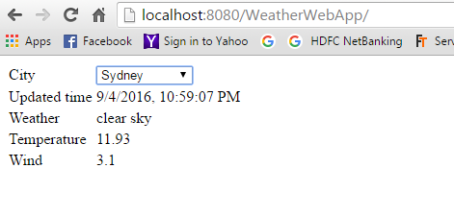

**Above diagram shows the screen shot image of developed web application.**

**Weather details of each cities is updated and shown .**

**5. Class Diagram and Classes**

**WeatherCheck.jsp file is the main jsp file, which makes HTTP request and updates the received HTTP data in weather app.**

**6. Design process**

**7. References**

NILL

**8. Appendix**

Not Applicable.