E-Commerce Customer Behavior Analysis
Complete Project Solution
Phase 1: Python Data Cleaning | Phase 2: SQL Database | Phase 3: Power BI Dashboards
Prepared for: Demo Project 1 — E-Commerce Platform

Executive Summary
This document is the complete, end-to-end solution to the E-Commerce Customer Behavior Analysis project brief: cleaning the three raw source files in Python, loading them into a relational database and querying them in SQL, and designing the Power BI dashboards the business asked for.
All three raw files (customer information, purchase history, product reviews) shared the same synthetic data-quality issues: exact duplicate rows, blank/incomplete rows, missing values scattered across every column, and — in the reviews file — a rating column that mixed a numeric 1–5 scale with two text labels ('poor' and 'excellent'). Phase 1 below documents exactly how each issue was resolved and why.
Phase 2 loads the cleaned data into a proper relational schema (customers, products, purchases, reviews) with primary/foreign keys enforced, and answers the three required business questions: most purchased products, top customers by lifetime value, and product rating trends.
Phase 3 turns those results into the three requested Power BI pages — regional sales distribution, product popularity trends, and customer sentiment analysis — with a step-by-step build guide, ready-made DAX measures, and a bonus interactive preview (dashboard.html) built from the real query output.

Key figures (post-cleaning)
Metric | Value
Customers (cleaned) | 2,704
Purchase transactions (cleaned) | 2,207
Product reviews (cleaned) | 2,306
Distinct products referenced | 993
Total revenue analyzed | $558,648.55
Average customer rating | 2.96 / 5

Phase 1 — Data Cleaning with Python
Tooling: Python 3, pandas. Full script: scripts/clean_data.py.

1.1 Issues found in the raw data
- Each file (3,060 rows) contained exactly 60 exact duplicate rows and 150 rows missing their own primary identifier (Customer_ID / Transaction_ID / Review_ID) — both look like an intentional data-quality stress test rather than an accident, since the counts are identical across all three files.
- Roughly 5% of remaining values in every other column were missing (Age, Gender, Location, Quantity, Total_Price, Rating, etc.), scattered across different rows rather than concentrated in a block.
- Reviews used two incompatible rating scales in the same column: numeric 1–5 and the text labels 'poor' / 'excellent'. Counts across all 7 label values were roughly even (~410–440 each), which points to 'poor'/'excellent' standing in for the low/high ends of the same 1–5 scale.
- A meaningful share of Customer_IDs referenced in purchases (5.2%) and reviews (5.9%) did not correspond to any customer record at all — a genuine referential-integrity gap, not just a missing value.
- No issues were found with date formats (all ISO YYYY-MM-DD) or price formatting (no currency symbols/text) — those two 'standardize formats' risks called out in the brief turned out to be clean in this dataset.

1.2 Cleaning steps applied

Customers
- Removed 60 exact duplicate rows, then 150 rows with no Customer_ID.
- Age — missing values imputed with the median age (44).
- Gender — missing values imputed with the most common category ('Male'); only 3 categories exist, so mode imputation is representative.
- Location — missing values filled with 'Unknown' rather than a mode, since Location is a near-unique value per customer (2,343 distinct values) and a mode would misleadingly cluster ~150 customers into one arbitrary city.
- Name — missing values filled with 'Unknown' (not analytically load-bearing).
- Registration_Date — rows with a missing or unparseable date were removed rather than imputed, since a fabricated signup date would distort any tenure/cohort analysis.
Result: 2,704 clean customer records, 0 missing values, 0 duplicate Customer_IDs.

Purchase history
- Removed 60 exact duplicate rows, then 150 rows with no Transaction_ID.
- Removed 277 rows missing Customer_ID or Product_ID (a transaction is meaningless without knowing who bought what).
- Removed 125 rows with a missing/unparseable Purchase_Date (needed for every time-based query in Phase 2/3).
- Quantity — missing values imputed with the median quantity (3).
- Total_Price — missing values imputed from that product's own median unit price x quantity where another purchase of the same product existed, falling back to the global median price otherwise (more accurate than a single flat fill value).
- Referential integrity — 241 rows whose Customer_ID had no matching cleaned customer record were removed, since the SQL schema in Phase 2 enforces a foreign key on customer_id.
Result: 2,207 clean purchase transactions, all referencing a valid customer.

Product reviews
- Removed 60 exact duplicate rows, then 150 rows with no Review_ID.
- Removed 278 rows missing Customer_ID or Product_ID.
- Standardized the rating scale: 700 text ratings mapped onto the numeric scale ('poor' -> 1, 'excellent' -> 5); the column is now a consistent integer 1–5 everywhere.
- Rating — remaining missing values imputed with the median rating (3).
- Review_Text — missing values filled with a 'No review text provided' placeholder.
- Referential integrity — 266 rows whose Customer_ID had no matching cleaned customer record were removed.
- Added two derived columns used in Phase 3: Sentiment_Category (Negative/Neutral/Positive, from Rating) and Text_Sentiment_Score (a lightweight lexicon score on Review_Text) — see the sentiment method note in Phase 3.
Result: 2,306 clean reviews, consistent 1–5 rating scale, 0 missing values.

1.3 Output
clean_data.py exports four files ready for Phase 2: cleaned_customer_data.csv, cleaned_purchase_history.csv, cleaned_product_reviews.csv, and cleaned_products.csv (a derived product list, since no product master file was supplied in the source data).

Phase 2 — SQL Database Integration
A relational star schema was built: customers and products as dimension tables, purchases and reviews as fact tables, with primary keys on every table and foreign keys enforced from purchases/reviews back to customers and products (schema files: sql/schema_postgresql.sql for PostgreSQL/SQL Server, sql/schema_sqlite.sql for the working demo database in this package).
Note: a live PostgreSQL/SQL Server instance isn't available in this environment, so sql/ecommerce.db is a fully working SQLite database built from the same schema and cleaned data — every query below actually ran against it. The DDL and SQL are near-identical across engines; sql/schema_postgresql.sql is ready to run as-is on PostgreSQL, and needs only the swaps noted in its header comment for SQL Server.

2.1 Schema
Table | Key | References
customers | customer_id (PK) | —
products | product_id (PK) | — (derived; no product master file was supplied)
purchases | transaction_id (PK) | customer_id -> customers, product_id -> products
reviews | review_id (PK) | customer_id -> customers, product_id -> products

2.2 Most purchased products
Ranked by total units sold (query: sql/queries.sql #1).
Product ID | Units sold | Revenue | Orders
1963 | 33 | $1,898.89 | 9
1149 | 25 | $2,496.27 | 8
1141 | 24 | $1,968.80 | 6
1151 | 24 | $1,430.54 | 5
1167 | 24 | $2,249.62 | 8
1305 | 24 | $2,025.35 | 8
1873 | 23 | $1,672.11 | 7
1187 | 22 | $1,654.15 | 8
1327 | 22 | $1,670.08 | 6
1081 | 21 | $1,835.79 | 5
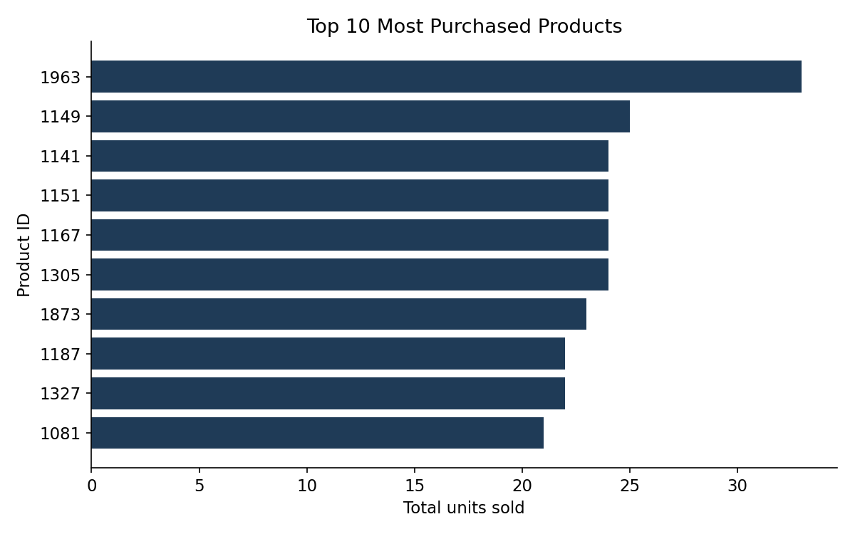

2.3 Top customers by lifetime value
Lifetime value = sum of Total_Price across all of a customer's purchases (query: sql/queries.sql #2).
Customer | Location | Orders | Lifetime value
Alicia Medina DVM | West Michaelshire | 3 | $2,364.62
Timothy Henry | Mikebury | 5 | $1,425.14
Carol Reese | Matthewton | 4 | $1,394.97
Robert Myers | East Terrance | 4 | $1,374.67
Jeffrey Nash | Transide | 5 | $1,328.25
Gina Stone | New Andreashire | 4 | $1,322.59
Matthew Mcconnell | Jessicaborough | 2 | $1,295.07
Lauren Martinez | West Stevenland | 4 | $1,256.27
William Murphy | Pinedachester | 4 | $1,248.55
Amber King | Montgomeryview | 3 | $1,237.66
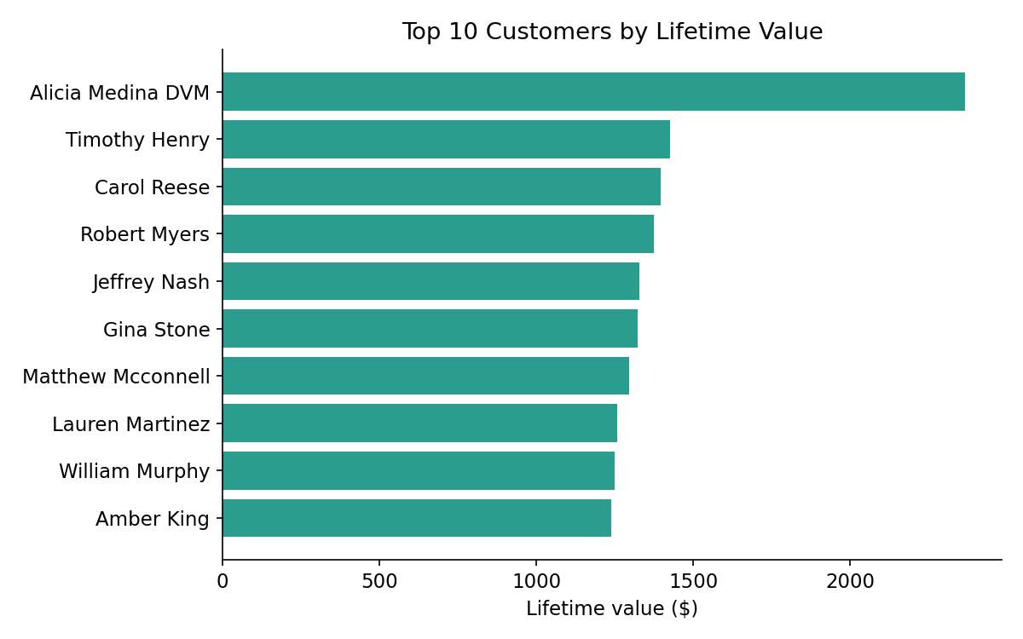

2.4 Product rating trends
Average rating for the most-reviewed products (query: sql/queries.sql #3):
Product ID | Avg. rating | Reviews
1775 | 4.50 | 8
1852 | 4.00 | 8
1531 | 2.88 | 8
1997 | 2.86 | 7
1435 | 2.43 | 7
1193 | 4.00 | 6
1684 | 3.83 | 6
1299 | 3.50 | 6
1128 | 3.00 | 6
1529 | 3.00 | 6
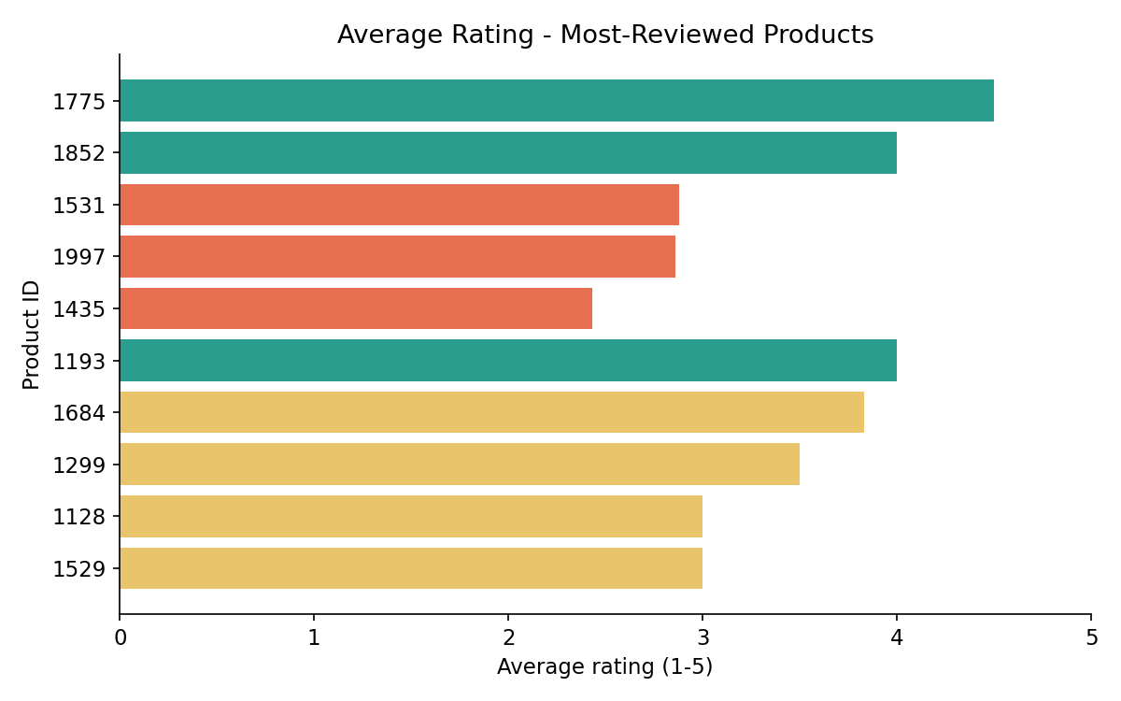
Limitation: the source reviews file has no review date column, so a true month-by-month rating trend can't be derived directly. Joining reviews to purchases on (customer, product) as a date proxy was tested (query #3b) but only matched 2 of 2,306 reviews — the two files were generated independently and aren't reliably linkable that way. Query #3 above (average rating per product) is the trend view the data actually supports; adding a Review_Date column to the source system would unlock genuine time trending.

2.5 Supporting queries for Phase 3
Regional sales distribution (top 15 locations, 'Unknown' excluded — see 3.1):
Location | Revenue | Orders
West Michaelshire | $2,364.62 | 3
South Laura | $1,764.60 | 6
New Joshua | $1,588.78 | 5
Stevenport | $1,563.69 | 4
Jamesbury | $1,553.57 | 5
Port Jennifer | $1,549.15 | 4
Jessicaborough | $1,500.93 | 3
Jennifertown | $1,486.57 | 5
South Joseph | $1,425.44 | 5
Mikebury | $1,425.14 | 5
Sentiment distribution (from Rating, query #6):
Sentiment | Reviews | Avg. rating
Negative | 969 | 1.34
Neutral | 429 | 3.00
Positive | 908 | 4.68

Phase 3 — Data Visualization with Power BI
Power BI Desktop is Windows-only and can't run in this environment, so this section gives the exact build steps (full detail in powerbi/PowerBI_Setup_Guide.md), and dashboard.html is a bonus interactive preview built from the real query results so you can see the target output immediately.

3.1 Page 1 — Regional Sales Distribution
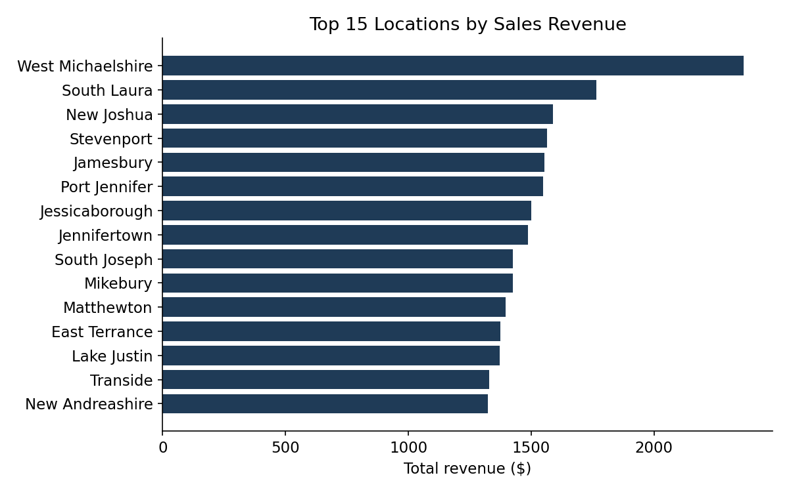
Location is a near-unique fictional city per customer (2,343 distinct values across 2,704 customers), so a filled map is not very informative — most cities have 1–3 customers. The ranked bar chart above is the more honest read on the data as supplied; if a real state/region/country field becomes available, swap it in for a proper map visual.
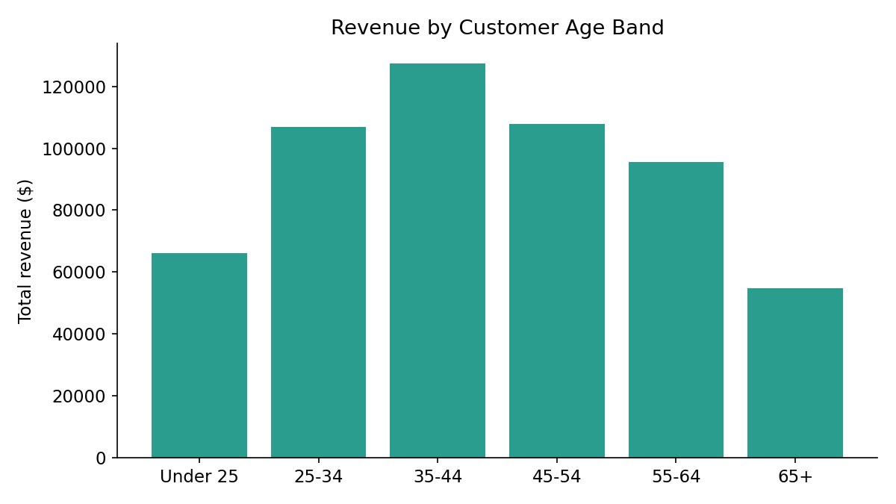

3.2 Page 2 — Product Popularity Trends
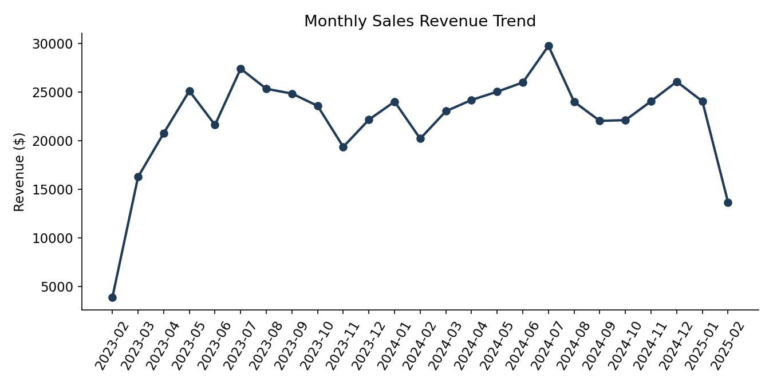
Revenue is broadly stable in the $20-27k/month range across the two-year window, with a peak in July 2024 ($29,748) and partial first/last months (Feb 2023, Feb 2025) at each end of the source data.

3.3 Page 3 — Customer Sentiment Analysis
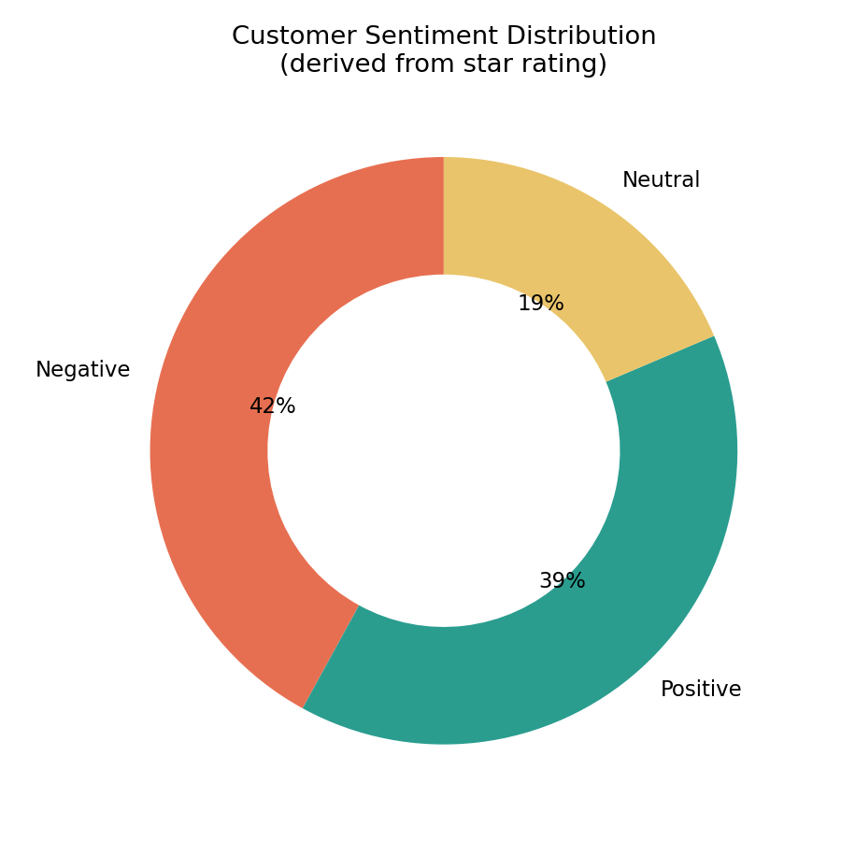
Method note: Review_Text in the source data is auto-generated filler text rather than genuine customer language, so a text-based NLP sentiment model would score it close to random. Sentiment_Category is instead derived from the star Rating (1-2 Negative, 3 Neutral, 4-5 Positive), the reliable signal actually present in this dataset. A lightweight lexicon score on the text (Text_Sentiment_Score) is included for completeness; swap in a real NLP model once genuine review text is collected.

3.4 DAX measures & build steps
The full DAX (Total Revenue, Customer Lifetime Value, Average Rating, Positive/Negative Review %, etc.) and page-by-page build instructions are in powerbi/PowerBI_Setup_Guide.md.

Appendix — Deliverables in This Package
File | Purpose
scripts/clean_data.py | Phase 1 cleaning script
data/cleaned_*.csv, data_cleaning_log.txt | Phase 1 output
sql/schema_postgresql.sql | Production DDL (PostgreSQL/SQL Server)
sql/schema_sqlite.sql, build_database.py, ecommerce.db | Working demo database (this environment)
sql/queries.sql, run_queries.py, query_results/*.csv | Phase 2 analysis queries + saved results
powerbi/PowerBI_Setup_Guide.md | Phase 3 connection steps, data model, DAX
powerbi/dashboard.html | Bonus interactive preview of the 3 dashboard pages
powerbi/charts/*.png | Chart images used in this report
To reproduce end-to-end: run scripts/clean_data.py, then sql/build_database.py, then sql/run_queries.py; open dashboard.html in a browser for the visual preview; follow PowerBI_Setup_Guide.md in Power BI Desktop for the graded submission.

