BOTHRA CMS (BUILD TRACK PRO)
Complete Step-by-Step Operational User Manual & Element Guide
Bothra Infrastructure & Builders — Enterprise Construction Operations Platform
Document Version: | Version 2.0 (Phases 1–11 Integrated)
Target Audience: | Super Admins, Org Admins, Project Managers, Site Supervisors, Finance Officers & Field Engineers
Platform URL: | https://bothra-cms.vercel.app (Mobile PWA & Desktop)
Date of Release: | October 2026

1. System Architecture & Global Navigation Shell
BothraCMS (BuildTrack Pro) is an authoritative, multi-tenant construction management platform tailored for high-volume residential, commercial, and infrastructure engineering projects. The interface is engineered with high-contrast dark borders, responsive layouts, and zero-latency operational tracking.
Every screen in BothraCMS shares an omnipresent Global Shell composed of two primary control surfaces: the Top Header Bar and the Dark Left Sidebar.

Global Shell Elements Breakdown
Element Name | Type | Description & Visuals | How to Use & Business Rule
Active Site Selector | Dropdown Menu | Located at top-left of the sidebar. Displays 'All sites (overview)' or individual project sites. | Click to filter the entire application scope to a specific active construction site (e.g., Chaupasni Row Houses, Skyline Heights, Riverside Enclave).
Global Quick Search | Input / Shortcut | Located in the top header bar with shortcut indicator 'Alt + Q' or 'Ctrl + K'. | Click or press Alt+Q to open the modal launcher to jump immediately to tasks, vendors, bills, inventory items, or site check-ins.
How to Use Guide | Header Pill Button | Yellow pill button with question/help icon. | Opens the interactive walkthrough modal explaining key platform features and standard operating procedures.
Language Toggle (EN / हिंदी) | Header Switcher | Bilingual toggle button in the top navigation bar. | Switches the entire platform interface instantaneously between English and Hindi, enabling seamless collaboration for vernacular site supervisors.
Notifications Badge | Alert Bell Icon | Displays red numeric badge indicating pending approvals, overdue tasks, or unread direct messages. | Click to open the notification drawer to review urgent alerts and mark notifications as resolved.
Left Navigation Sidebar | Vertical Menu | Fixed dark blue/slate sidebar categorized into Overview, Site Work, and Money modules. | Click any menu item (Dashboard, Day Book, Reports, Projects, Tasks, Measurement Book, Materials, Drawings, Quality, Equipment, Finance, Vendors, Payroll, Sales, Accounts Export) to navigate.
User Identity Badge | User Profile Card | Located at bottom-left showing user initials, name, role (e.g., 'Super Admin'), and logout icon. | Displays your authenticated session identity. Click the logout icon to securely terminate your session.

2. Authentication & Secure Sign In
BothraCMS enforces multi-tenant isolation, cryptographic JWT session validation with Edge algorithm pinning, and rate-limited brute-force protection.
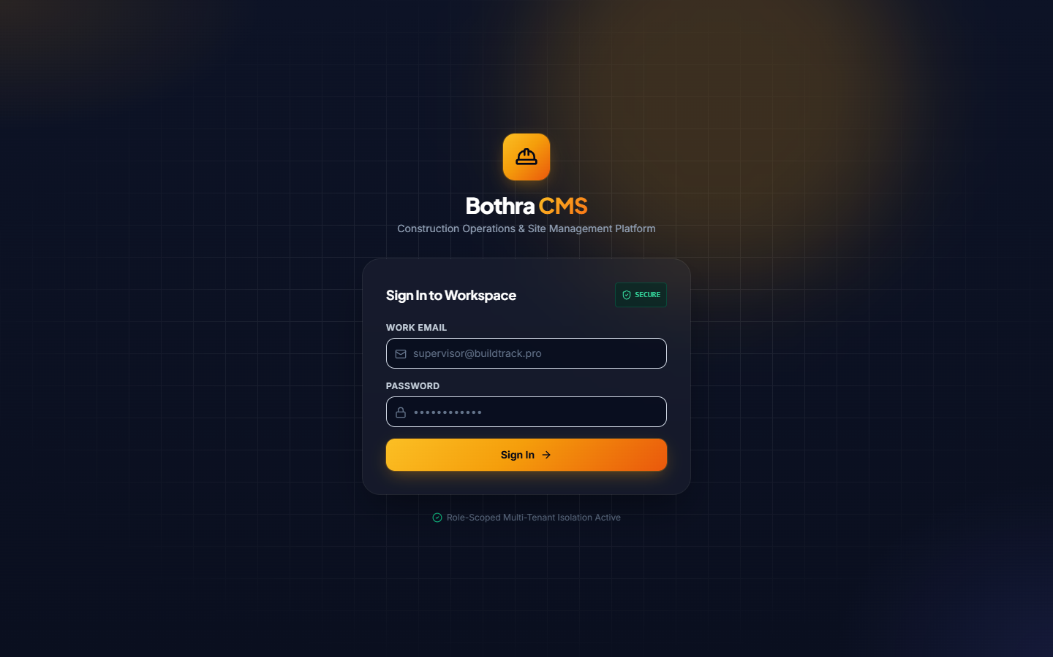
Figure: Login Screen with Blueprint Architecture & Security Badge

Login Page Elements Breakdown
Element Name | Type | Description & Visuals | How to Use & Business Rule
Brand Logo & Title | Header Graphic | HardHat icon with 'Bothra CMS' title and 'Construction Operations & Site Management Platform' subtitle. | Confirms authentic deployment on the secure domain.
SECURE Badge | Status Pill | Green pill badge with ShieldCheck icon showing 'SECURE'. | Indicates end-to-end encrypted HTTPS communication and active session protection.
Work Email Input | Text Field | Email input field with mail icon. Placeholder: 'supervisor@buildtrack.pro'. | Type your authorized organization email address.
Password Input | Password Field | Masked password input with lock icon. | Type your password. Enforces strong complexity rules in production.
Sign In Button | Action Button | Amber/Gold gradient button with ArrowRight icon. | Click to authenticate. Displays an active spinner while validating credentials against the database.
Error Alert Banner | Conditional Alert | Red highlighted alert box appearing above the form when authentication fails. | Displays human-friendly validation feedback without exposing sensitive server stack traces.
Role Isolation Badge | Footer Indicator | Centered green checkmark stating 'Role-Scoped Multi-Tenant Isolation Active'. | Confirms database multi-tenant scoping is active for this session.

3. Site Operations Dashboard & Command Center
The Dashboard is the executive nerve center of BothraCMS, synchronizing project health, workforce turnout, cash outflow, material movement, and field action workflows in real time.
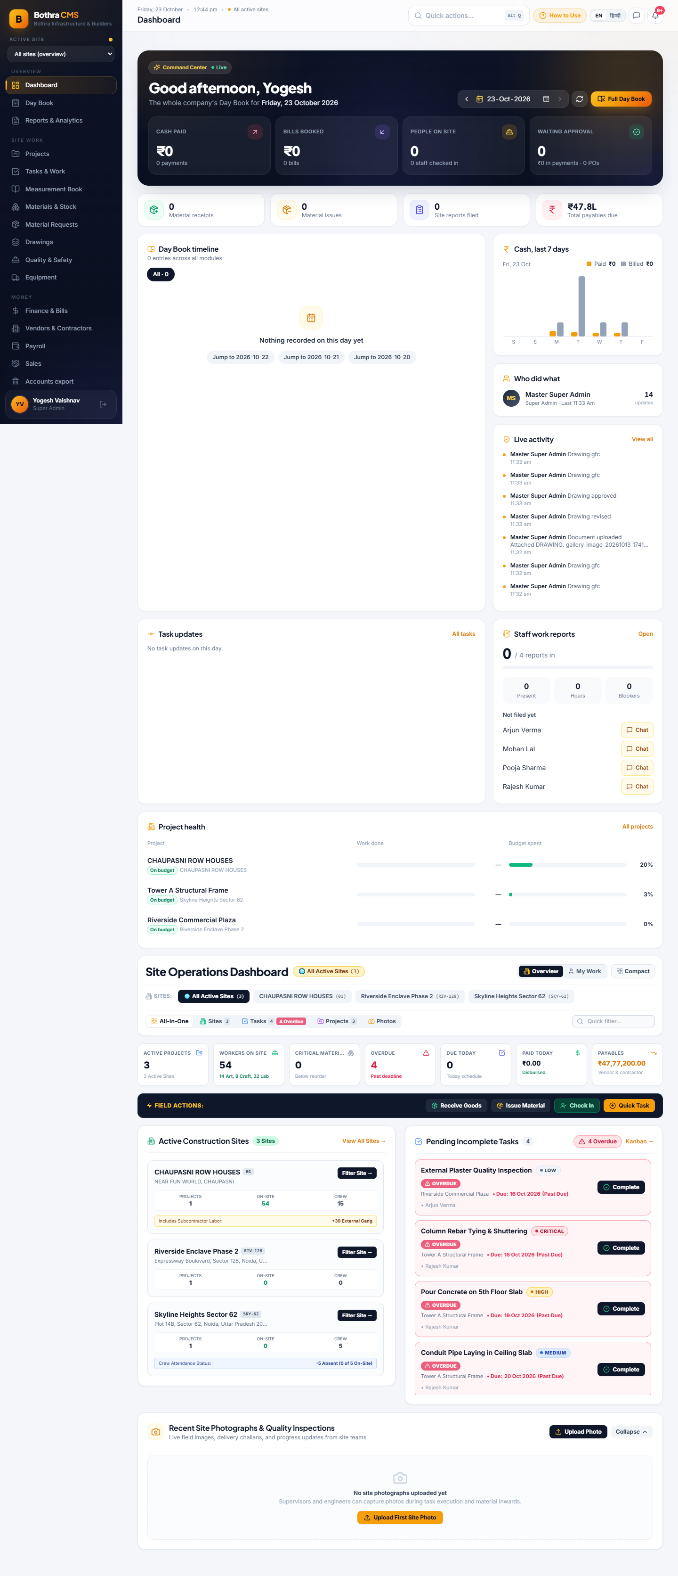
Figure: Site Operations Dashboard & Command Center Live View

Dashboard Elements Breakdown
Element Name | Type | Description & Visuals | How to Use & Business Rule
Command Center Card | Hero Banner | Top dark hero card showing personalized greeting ('Good afternoon, Yogesh'), Live status badge, and date navigator. | Displays daily company-wide operational summary. Use left/right chevrons to browse historical dates or click 'Full Day Book' to jump directly to the detailed day book.
Cash Paid Widget | KPI Card | Top-left KPI showing today's disbursed payments in Rupees with payment count. | Monitors daily petty cash and vendor payouts against cash balance.
Bills Booked Widget | KPI Card | Top KPI displaying total vendor and contractor invoices registered today. | Tracks inbound liabilities incurred during the current business day.
People on Site Widget | KPI Card | KPI card displaying active staff and supervisors checked in today. | Live head count of engineering and administrative personnel on site.
Waiting Approval Widget | KPI Card | Shows value of pending payments and purchase orders requiring Super Admin authorization. | Click to open approval workflow for pending disbursements.
Cash 7 Days Chart | Bar Chart | Visual bar chart tracking Paid amounts (amber) vs Invoiced bills (slate) across the rolling 7-day window. | Provides rapid visual cash burn rate versus incoming billing velocity.
Site Ribbon Filter Tabs | Tab Ribbon | Horizontal ribbon: 'All Active Sites (3)', 'CHAUPASNI ROW HOUSES', 'Riverside Enclave Phase 2', 'Skyline Heights Sector 62'. | Click any site pill to immediately isolate KPI widgets, task boards, and workforce numbers to that specific construction site.
Workers on Site Summary | Summary KPI | Displays global total workers (e.g. 54) with exact subcategory formula: '14 Art, 8 Craft, 32 Lab'. | Accurately reconciles artisans, skilled craftsmen, and general laborers across all active construction sites.
Active Site Cards | Interactive Grid | Individual cards for each active project showing Projects count, On-Site workforce, Direct Crew, and status labels. | Shows external subcontractor additions ('+39 External Gang') or crew absence alerts ('-5 Absent'). Click 'Filter Site ->' to focus the dashboard.
FIELD ACTIONS Dock | Quick Actions Dock | Dedicated dark blue bar featuring four primary site actions: Receive Goods, Issue Material, Check In, Quick Task. | One-click shortcuts for field engineers to record inventory receipts, issue materials from stores, log worker attendance, or create new site tasks.
Pending Incomplete Tasks | Task Roster | Lists overdue and urgent tasks styled with bold red 'OVERDUE (Past Due)' badges and '[Complete]' buttons. | Click '[Complete]' to close out a task instantly upon inspection verification.
Recent Site Photographs | Media Gallery | Displays authenticated field photos captured during inspections and deliveries, with upload trigger button. | Click 'Upload First Site Photo' or 'Upload Photo' to attach geotagged progress pictures directly to the site record.

4. Daily Site Day Book & Chronological Register
The Daily Site Day Book is the single authoritative chronological ledger for all field operations occurring on any given calendar date. It aggregates financial disbursements, vendor bills, labor muster, and daily progress reports (DSR).
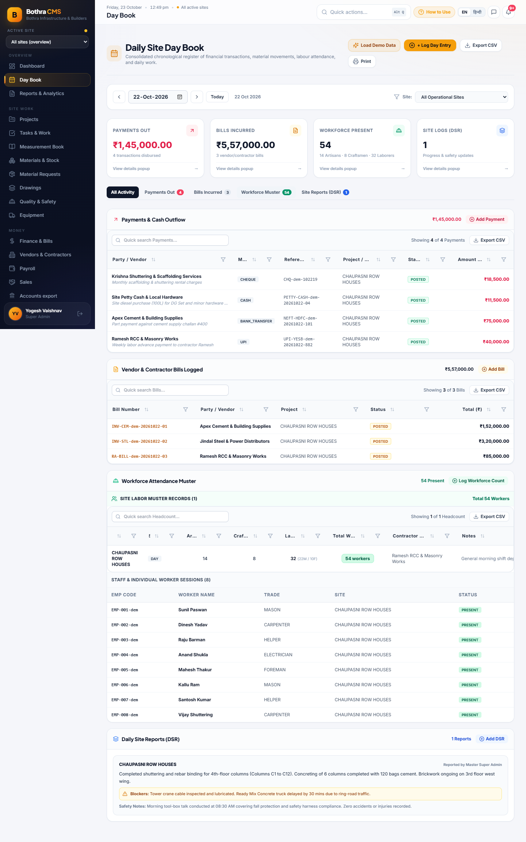
Figure: Populated Daily Site Day Book Showing All 4 Modules

Day Book Elements Breakdown
Element Name | Type | Description & Visuals | How to Use & Business Rule
Date Picker & Shift Buttons | Navigation Bar | Left/Right arrow chevrons, Date input field ('22-Oct-2026'), and 'Today' quick button. | Step backward or forward day by day. Click 'Today' to return to current date. Deep-linking via ?date=YYYY-MM-DD is fully supported.
Operational Site Filter | Dropdown Filter | Located on the right of the date bar: 'All Operational Sites' or single site selection. | Filters Day Book records to a specific site or view cross-site totals.
Load Demo Data / Populate Records | Action Button | Button with sparkles icon in header and empty state. | Populates comprehensive realistic demonstration records for training and workflow testing.
+ Log Day Entry Button | Primary Action | Amber button with PlusCircle icon. | Opens the multi-action dialog allowing immediate creation of Payments, Bills, Headcount, or DSR reports.
Export CSV & Print Buttons | Export Controls | Download and Print buttons in the top right header. | Export the full day book ledger to Excel CSV or generate a clean printable site summary.
PAYMENTS OUT Card | KPI Metric Card | Displays total payments disbursed (e.g., ₹1,45,000.00) with transaction count and 'View details popup' link. | Shows verified non-reversed payments made during the day.
BILLS INCURRED Card | KPI Metric Card | Displays total vendor and contractor invoices logged (e.g., ₹5,57,000.00). | Monitors liabilities posted on the date.
WORKFORCE PRESENT Card | KPI Metric Card | Green highlighted card showing total workers present (54) with full subtitle: '14 Artisans · 8 Craftsmen · 32 Laborers'. | Verifies that all 54 on-site workers are accounted for across all skill categories.
SITE LOGS (DSR) Card | KPI Metric Card | Blue card showing count of site supervisor progress logs filed. | Tracks daily site work documentation compliance.
Module Tab Ribbon | Tab Switcher | Tabs: 'All Activity', 'Payments Out (4)', 'Bills Incurred (3)', 'Workforce Muster (54)', 'Site Reports (DSR) (1)'. | Click any tab to scroll directly to or isolate that specific module section.
Payments & Cash Outflow Table | Excel Data Table | Table showing Party/Vendor, Method (CHEQUE, CASH, UPI, BANK_TRANSFER), Reference No, Project, Status, and Amount. | Features padded column sorting and filter funnel icons for Excel-style dynamic searching.
Workforce Attendance Muster | Muster Section | Subdivided into Site Labor Muster Records (headcounts) and Staff & Individual Worker Sessions (roster). | Shows male/female laborer breakdowns, contractor name, and individual worker presence tags.
Daily Site Progress Report (DSR) | Narrative Report Card | Displays narrative description of work executed, yellow Blockers alert box, and safety toolbox meeting notes. | Provides executive oversight on construction progress and field impediments.

5. Materials Master & Site Inventory
The Materials module maintains an authoritative, double-entry stock movement ledger for all warehouses and yard stores. It prevents negative stock balances, manages reorder thresholds, and tracks inter-store transfers.
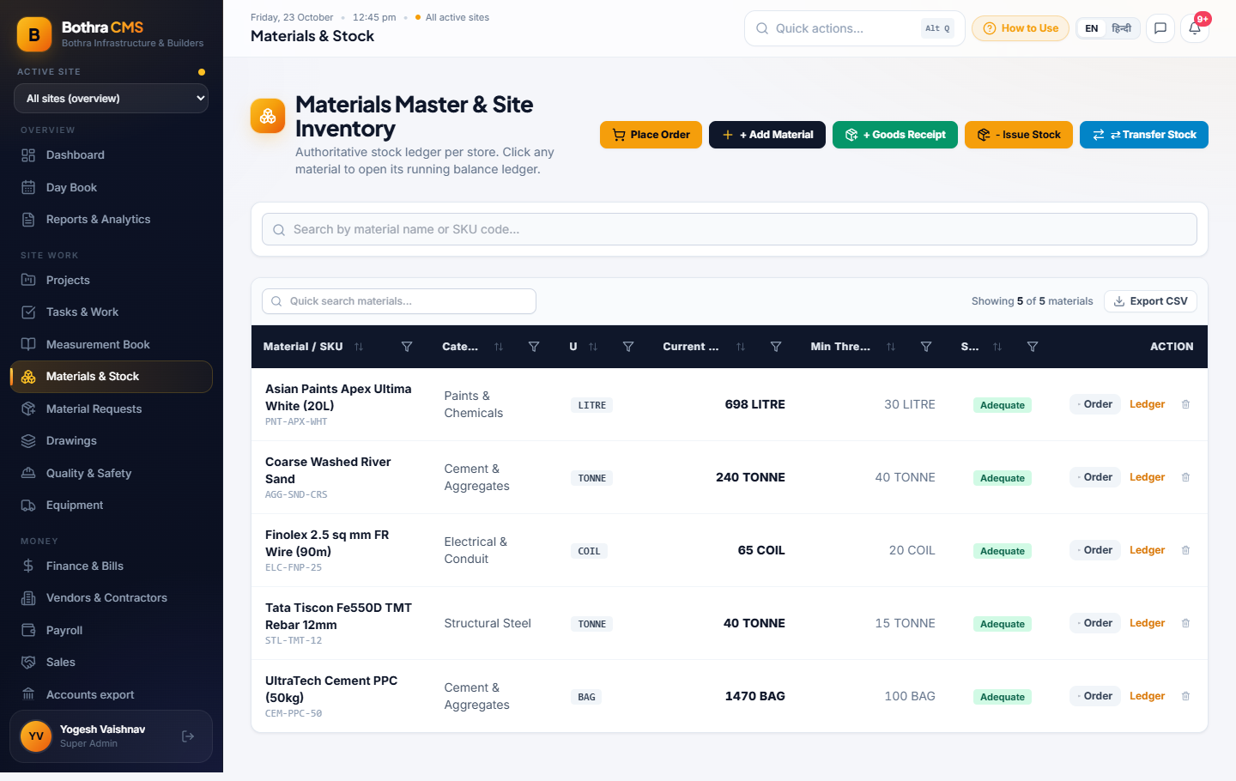
Figure: Materials Master & Stock Ledger Screen

Materials Page Elements Breakdown
Element Name | Type | Description & Visuals | How to Use & Business Rule
Place Order Button | Action Button | Amber button with shopping cart icon. | Initiates a Purchase Order for replenishment when materials cross below safety reorder levels.
+ Add Material Button | Action Button | Dark blue button with plus icon. | Registers a new SKU/Material in the master catalog with unit of measure (BAG, TONNE, LITRE, SQM) and category.
+ Goods Receipt Button | Action Button | Green button with package icon. | Logs incoming deliveries from suppliers. Automatically increments store balances and records delivery challan attachments.
- Issue Stock Button | Action Button | Orange button with box icon. | Issues materials to a project, task, or contractor. Enforces strict negative balance prevention—cannot issue more than on-hand stock.
Transfer Stock Button | Action Button | Blue button with arrow-switch icon. | Transfers inventory atomically between two stores (e.g., Central Yard to Site Store). Validates that source and target stores are distinct.
Material Search Input | Search Bar | Full-width text input with magnifying glass. | Type material name (e.g., 'Cement', 'Steel') or SKU code to filter rows instantly.
Current Stock Column | Data Metric | Bold display of physical quantity on hand with unit (e.g., '1470 BAG', '40 TONNE'). | Real-time stock balance calculated from atomic movement transactions.
Stock Status Badge | Status Indicator | Green 'Adequate' badge or red 'Low Stock' badge. | Automatically compares current stock against Minimum Threshold to alert procurement teams.
Ledger Action Button | Row Action | Orange text link 'Ledger' on each material row. | Opens the chronological stock ledger showing every receipt, issue, and adjustment with timestamps and user audit log.

6. Payments & Financial Ledger
The Finance module enforces strict two-party approval controls, Indian Statutory TDS deductions (Sections 194C, 194J, 194I), bill allocations, and reversible settlements with full audit history.
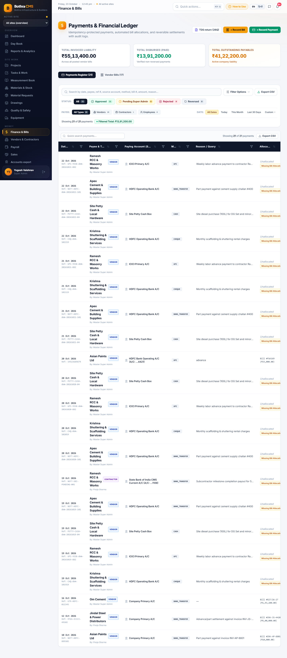
Figure: Payments & Financial Ledger Screen

Finance Page Elements Breakdown
Element Name | Type | Description & Visuals | How to Use & Business Rule
Total Invoiced Liability | Top Metric Card | Bold currency display: ₹55,13,400.00 across all posted vendor bills. | Represents total gross obligations billed to the organization.
Total Disbursed (Paid) | Top Metric Card | Green currency display: ₹13,91,200.00 verified non-reversed disbursements. | Total actual cash and bank outflow disbursed to date.
Total Outstanding Payables | Top Metric Card | Amber currency display: ₹41,22,200.00 active company liability. | Remaining unpaid liability across all vendors and contractors.
TDS Return (26Q) Button | Action Button | White button with document icon. | Generates quarterly Form 26Q return summary with challan mapping, PAN verification, and interest calculations.
+ Record Bill Button | Action Button | Amber button in top header. | Registers an incoming supplier or contractor invoice with line items, GST rate, and TDS section.
+ Record Payment Button | Action Button | Green button in top header. | Records a disbursement against a bill or advance, with payment mode (UPI, NEFT, Cheque, Cash) and paying bank account.
Status Filter Pills | Filter Bar | Pill buttons: 'All (21)', 'Approved (21)', 'Pending Super Admin (0)', 'Rejected (0)', 'Reversed (0)'. | Quickly filters payments by approval and audit status.
Financial Ledger Table | Data Table | Displays Date, Payee & Type, Bank Account, Method, Reason/Query, and Allocation status. | Click any row to review payment allocations, reverse settlements (authorized roles only), or view receipts.

7. Site Tasks & Employee Accountability
The Tasks module tracks daily site activities, quality checks, progress photos, and field accountability. Tasks are linked directly to projects and assignees.
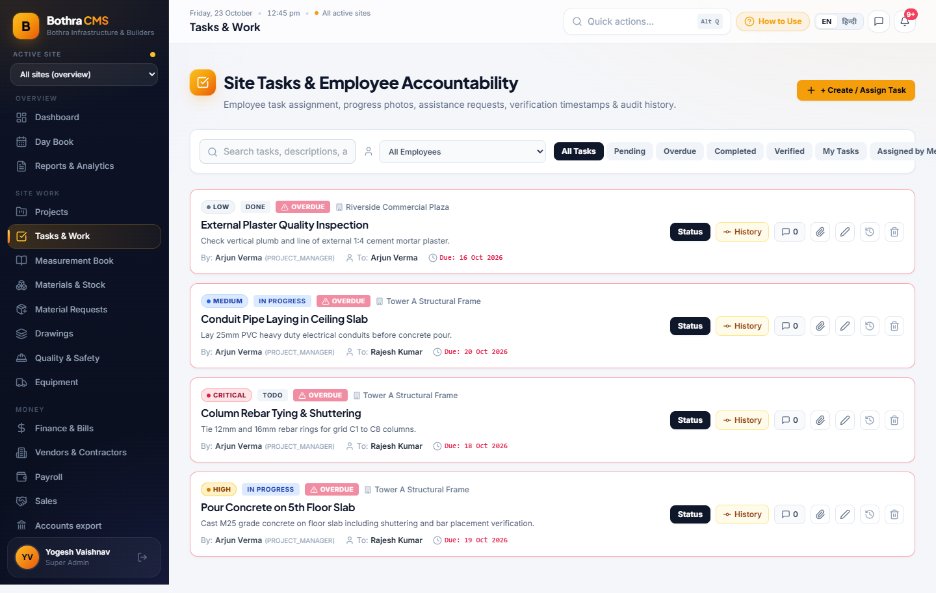
Figure: Site Tasks & Employee Accountability Board

Tasks Page Elements Breakdown
Element Name | Type | Description & Visuals | How to Use & Business Rule
+ Create / Assign Task Button | Primary Action | Amber button with PlusCircle icon at top right. | Opens task creation modal with title, project selection, priority, assignee, due date, and checklists.
Employee Filter Dropdown | Filter Dropdown | Dropdown to filter tasks by assignee: 'All Employees', 'Arjun Verma', 'Rajesh Kumar', etc. | Quickly isolates tasks assigned to a specific engineer or contractor.
Status Tabs | Filter Tabs | Tabs: 'All Tasks', 'Pending', 'Overdue', 'Completed', 'Verified', 'My Tasks'. | Enables supervisors to focus on urgent or pending tasks.
Priority Badges | Status Tag | Color-coded tags: LOW (gray), MEDIUM (blue), HIGH (amber), CRITICAL (red). | Signals urgency and inspection priority.
OVERDUE Warning Tag | Alert Pill | Red highlighted tag showing alert icon with due date and '(Past Due)'. | Highlights tasks that have exceeded their completion deadline.
Status Action Button | Action Button | Dark button on each card to change status (TODO -> IN_PROGRESS -> COMPLETED -> VERIFIED). | Updates workflow progression with audit timestamps.
History Button | Action Button | Button with clock icon to inspect task timeline. | Shows full history of changes, status transitions, and attached comments.

8. Workforce Attendance & 1-Click GPS Check-In
The Attendance system supports both individual staff biometric/GPS check-ins and gang headcount logs for contractor laborers.
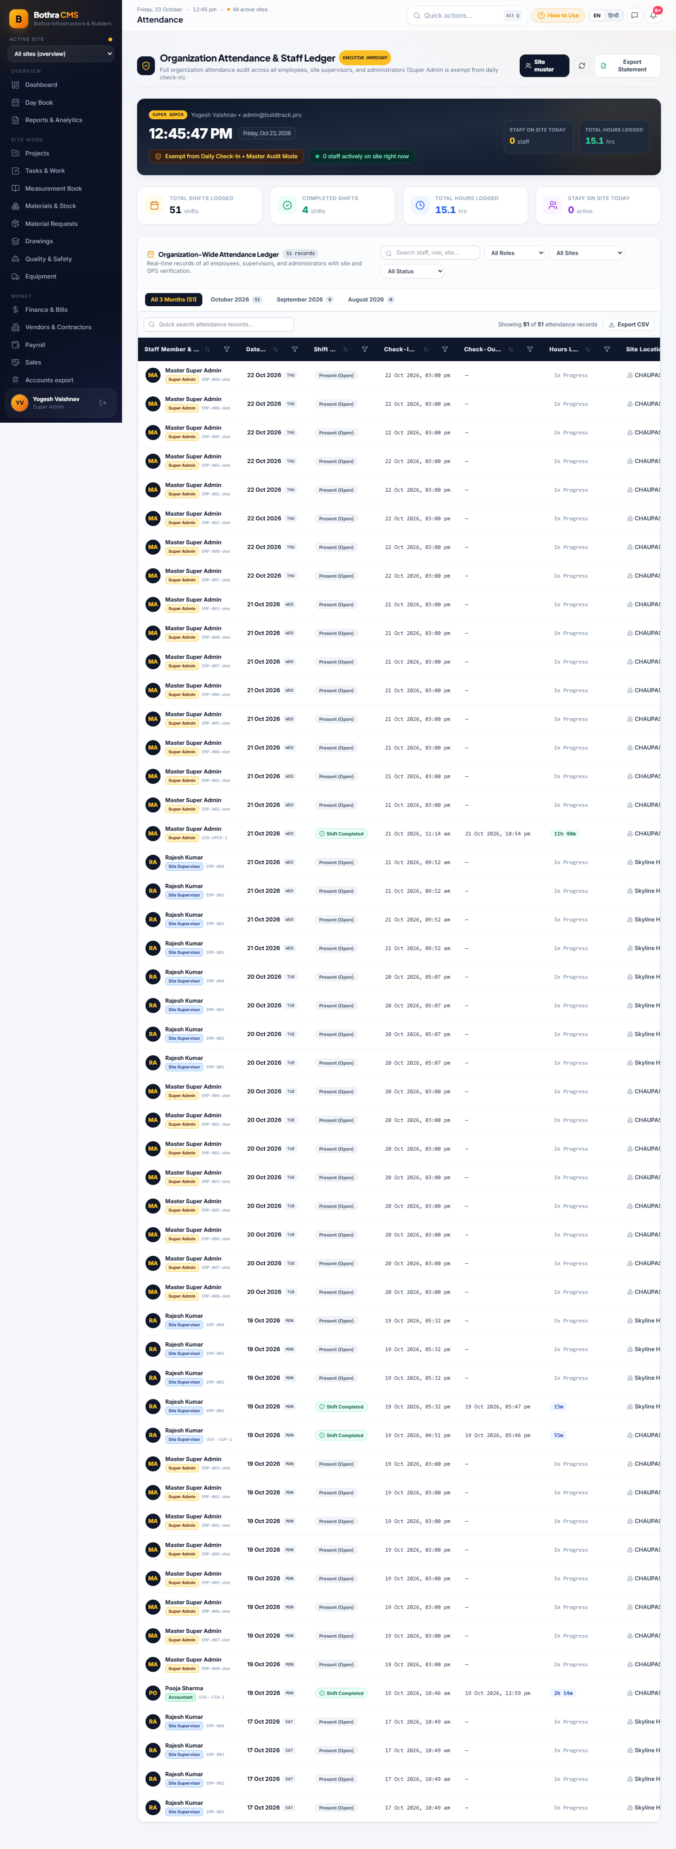
Figure: Workforce Attendance & Roster Screen

Attendance Page Elements Breakdown
Element Name | Type | Description & Visuals | How to Use & Business Rule
1-Click Self Check-In Button | Primary Action | Green highlighted action button in hero banner. | Records immediate presence for the logged-in user, capturing browser geolocation (latitude, longitude, accuracy) and timestamp.
Scope Toggle (All Staff vs My Attendance) | Tab Switcher | Toggle between organization-wide roster (privileged roles) and personal attendance history. | Enables managers to inspect site-wide turnout or employees to verify their own attendance logs.
Attendance Statistics Cards | KPI Cards | Displays Days Present, Late Check-Ins, Total Working Hours, and Attendance Compliance percentage. | Summarizes monthly performance for payroll processing.
Staff Register Table | Data Table | Lists employee code, worker name, trade, site assignment, check-in time, and status badge ('PRESENT'). | Authoritative roster for daily site muster.

9. Real-Time Team Chat & Employee Directory
Built-in instant messaging enables direct coordination between head office project managers, site supervisors, and storekeepers without relying on unmanaged consumer chat apps.
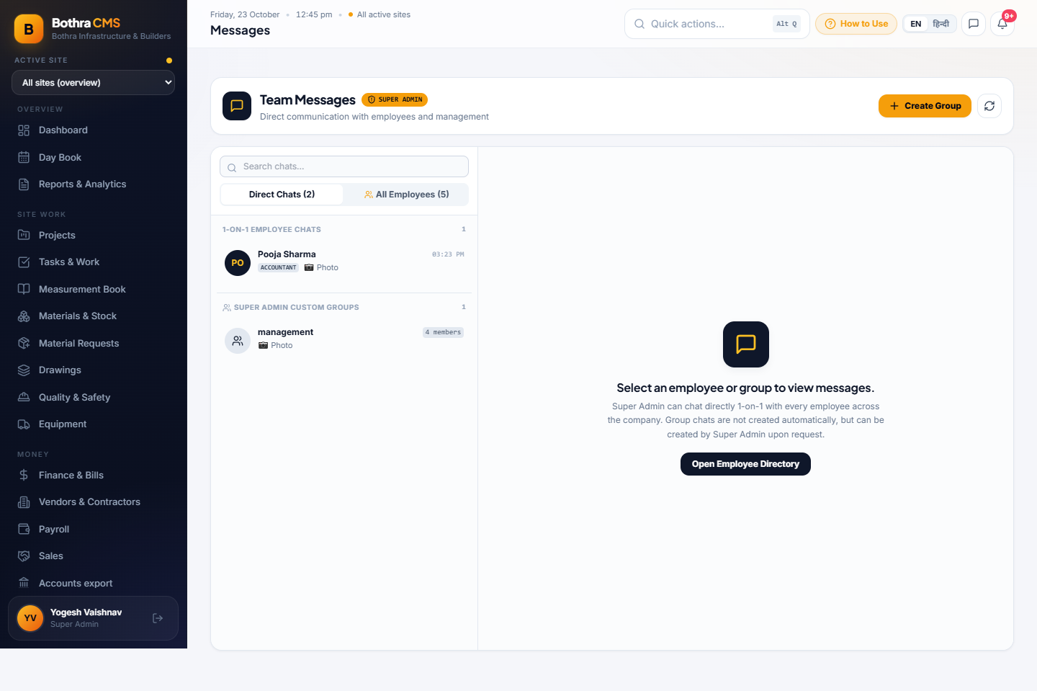
Figure: Internal Team Chat & Directory View

Chat Page Elements Breakdown
Element Name | Type | Description & Visuals | How to Use & Business Rule
Employee Directory Pane | Sidebar List | Left pane listing company staff with online status indicator, role, and current site assignment. | Click any employee name (e.g., Arjun Verma, Rajesh Kumar) to start a 1-on-1 private conversation.
Message Thread View | Chat Window | Chronological message stream with sender avatar, message bubbles, and delivery timestamps. | Review operational discussions and instruction logs.
Photo / Attachment Button | Input Button | Paperclip icon next to the message input. | Attach delivery challans, drawings, or site condition photos securely. Attachments inherit organization-level security.
Send Message Field | Text Input | Bottom message input field with send button. | Type your operational message and press Enter to send immediately.

10. Mobile Progressive Web App (PWA) & Responsive Layout
BothraCMS is designed as an offline-capable Progressive Web App (PWA) that installs directly on Android and iOS smartphones, offering a clean, native-like experience for field personnel.
Figure: Mobile Responsive Viewport (iPhone 14 / 390px)

Mobile App Elements Breakdown
Element Name | Type | Description & Visuals | How to Use & Business Rule
Mobile Header Bar | Top Bar | Compact header showing Bothra CMS logo, active site selector, notification bell, and hamburger menu. | Provides high-contrast navigation on handheld devices in bright sunlight.
Unobstructed Site Tabs Ribbon | Scrollable Tabs | Clean pill buttons that wrap smoothly without horizontal overflow. | Swipe or tap to switch between Chaupasni, Skyline Heights, and Riverside sites.
Mobile 2-Column KPI Grid | Metric Grid | Adapts multi-column desktop widgets into an ergonomic 2-column mobile card layout. | Clear readability of active projects, worker counts, payables, and overdue tasks on smaller screens.
Field Actions 2x2 Grid | Button Grid | High-contrast action buttons: Receive Goods, Issue Material, Check In, Quick Task. | Large tap targets designed for one-handed operation on construction sites.
Bottom Navigation Dock | Fixed Bottom Dock | Five primary icons: Home, Day Book, ⚡ Quick (central gold button), Attendance, Messages. | Permanent bottom navigation bar allowing rapid single-tap access to primary site workflows.

11. Keyboard Shortcuts & Power User Tips
BothraCMS incorporates desktop accelerators and Excel-style data table features for rapid data entry and auditing.
Shortcut / Gesture | Function & Accelerated Action
Alt + Q or Ctrl + K | Opens the Quick Action Launcher modal from any page in the platform.
Escape Key (Esc) | Closes any active modal dialog, filter popover, or photo preview instantly.
Click Funnel Icon (🔍/⚡) | Opens Excel-style column distinct-value filter to filter tables by status, payment method, or party.
Click Column Header | Toggles sort order (Ascending -> Descending -> Natural order) on that specific column.
Export CSV Button | Downloads the filtered table view directly into a UTF-8 encoded Excel spreadsheet.

End of Manual — Bothra Infrastructure & Builders

