# URBIS RBA CHALLENGE

1. Please unzip the solution to C:\ as excel file path reference in the code. If you deploy on any other location please update the variable “strExcelPath”

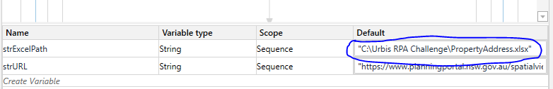

1. The default browser is set to Google chrome, please enable the extension to google chrome or change it to your preferred browser.

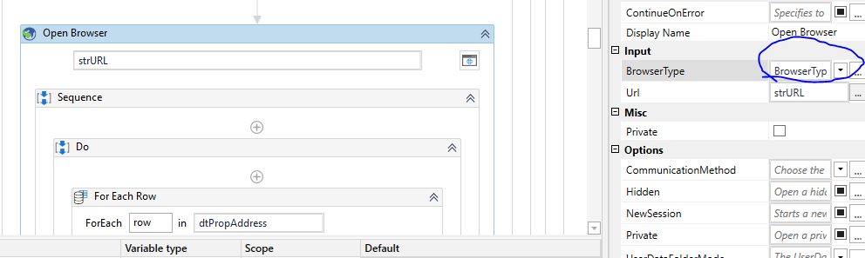

1. In the solution folder, there is a excel file “PropertyAddress.xlsx” that has property address available.
2. The UIPath does read the property address and search on the NSW Planning site and gets detail.
3. UIPatch also takes screenshots for each property and save it to the same folder with the name of current date and time.