The assignment requirement is as below,
- Run application locally
- Dockerize it
- Deploy to Kubernetes (Minikube)
- Implement Blue-Green Deployment
- Document everything

Step 1: Fork and Clone Repository
Fork:
git clone https://github.com/ mohanDevOps-arch/Blue-green-Deployment
cd Blue-green-Deployment
ls

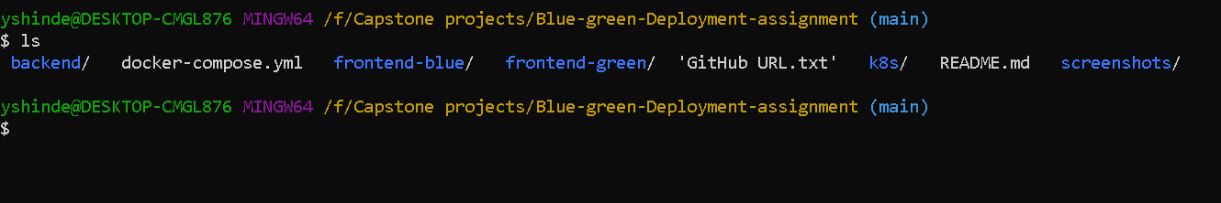
Expected directory structure:

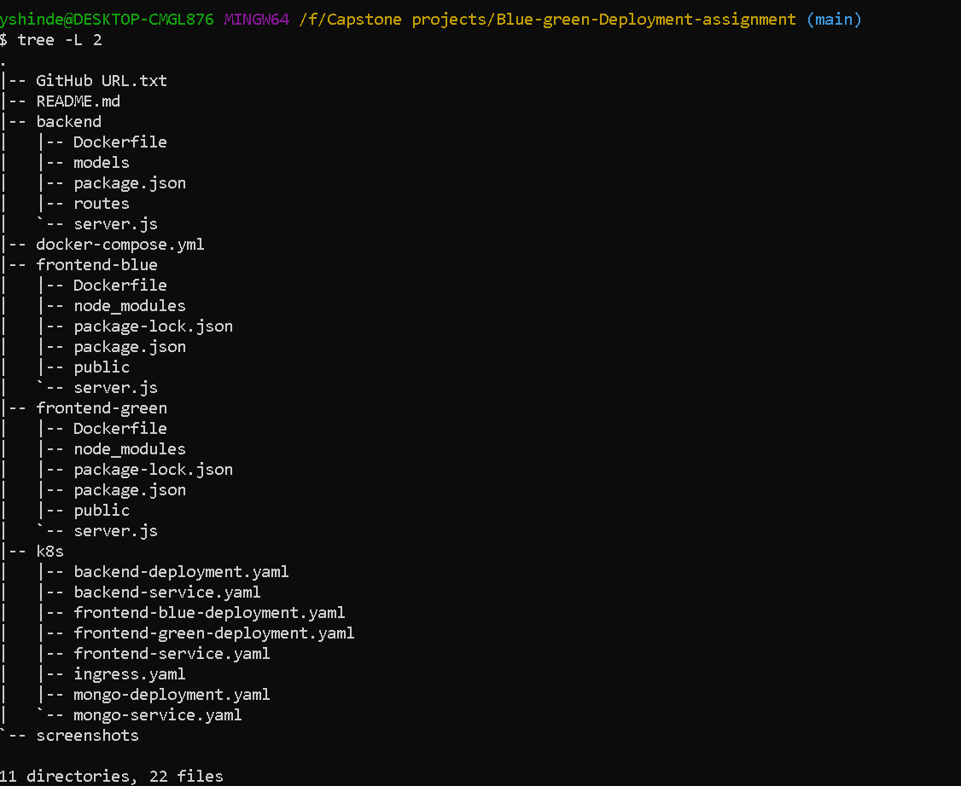

Part 1 — Local Deployment (10 Marks)

Backend Setup
Move into backend:
cd backend
npm install
Create .env
Example:
PORT=5000
MONGO_URI=mongodb://localhost:27017/bluegreen
Start backend:
npm start

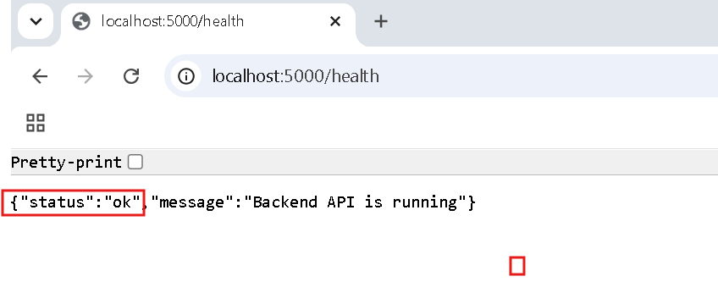

MongoDB Setup
Local MongoDB
Install MongoDB.
Start:
mongod
Verify:
mongosh
Create database:
use bluegreen
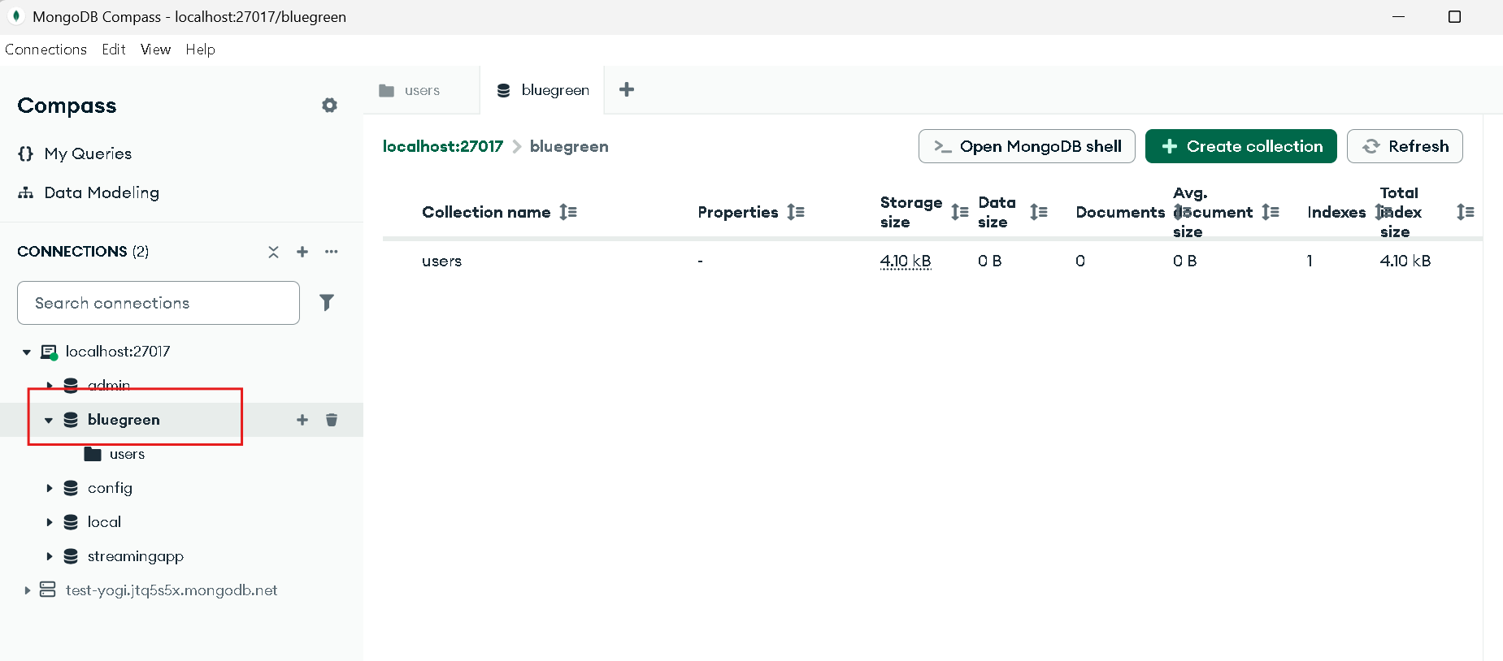
Frontend Basic Setup
cd frontend-basic
npm install
npm start
Usually runs on:
http://localhost:3100

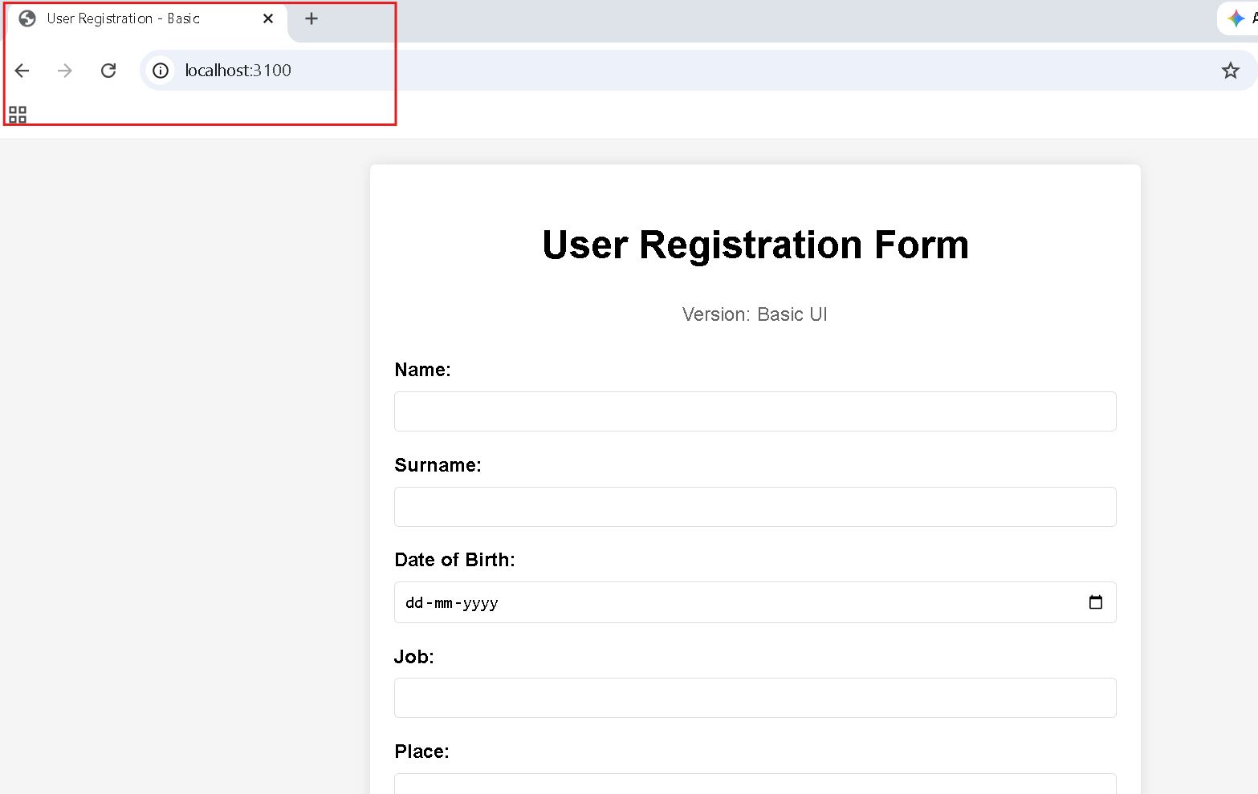

Frontend Enhanced Setup
cd frontend-enhanced
npm install
npm start
Usually runs on:
http://localhost:3200
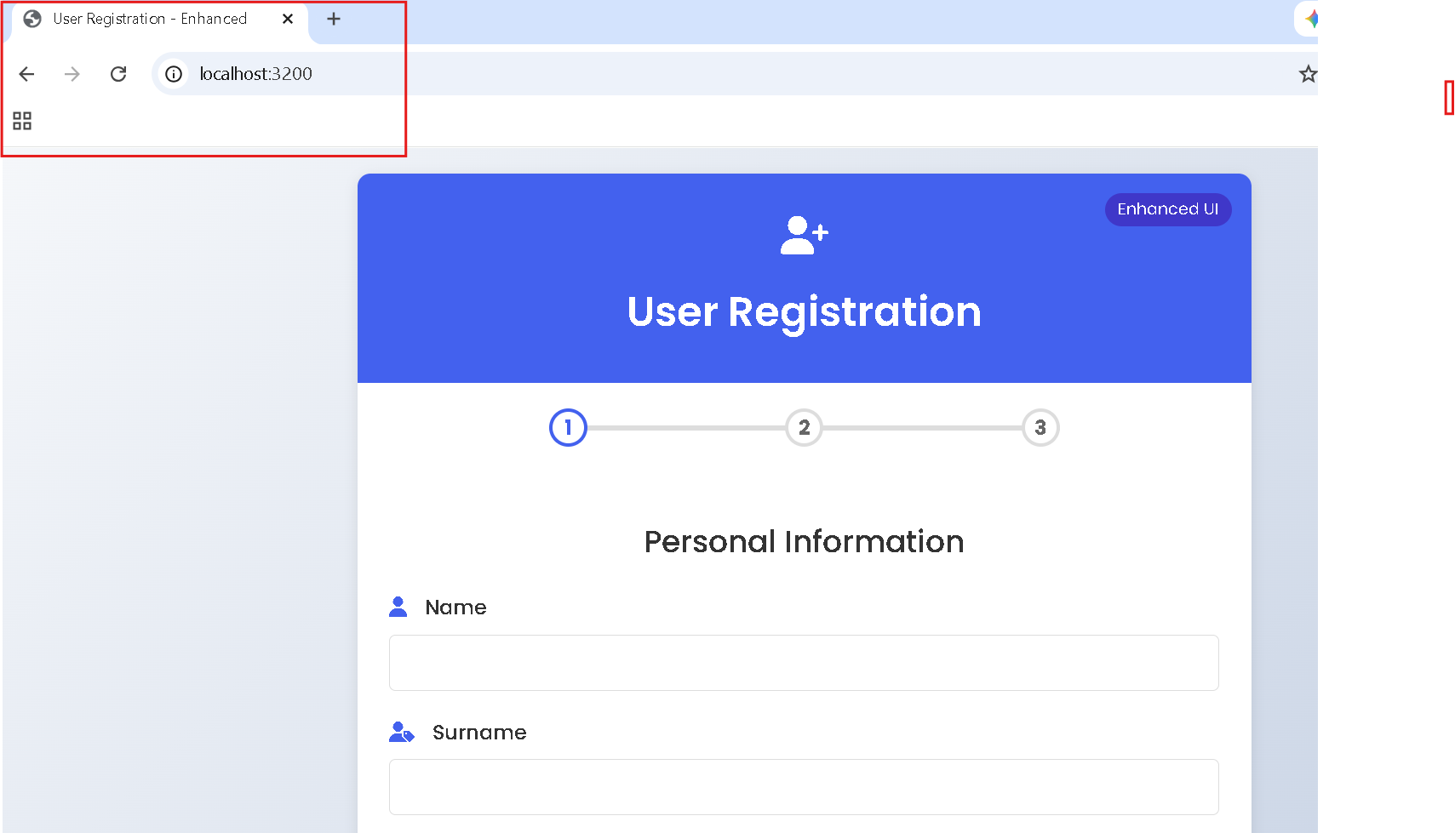

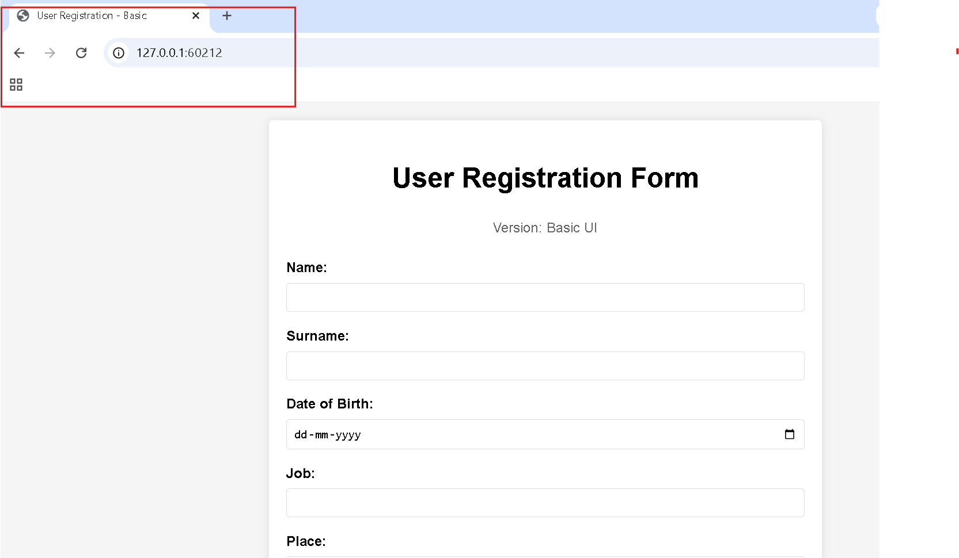

Part 2 — Containerization (15 Marks)

Backend Dockerfile
Inside backend:
FROM node:18-alpine
WORKDIR /app
COPY package*.json ./
RUN npm install
COPY . .
EXPOSE 5000
CMD ["npm","start"]
Build:
docker build -t backend:v1 .

Frontend Basic Dockerfile
FROM node:18-alpine
WORKDIR /app
COPY package*.json ./
RUN npm install
COPY . .
EXPOSE 3100
CMD ["npm","start"]
Build:
docker build -t frontend-basic:v1 .

Frontend Enhanced Dockerfile
FROM node:18-alpine
WORKDIR /app
COPY package*.json ./
RUN npm install
COPY . .
EXPOSE 3200
CMD ["npm","start"]
Build:
docker build -t frontend-enhanced:v1 .

Docker compose yaml file:

version: "3.8"

services:

mongo:
image: mongo:7
container_name: mongo

ports:
- "27017:27017"

backend:
build: ./backend

ports:
- "5000:5000"

environment:
PORT: 5000
MONGO_URI: mongodb://mongo:27017/bluegreen

depends_on:
- mongo

frontend-blue:
build: ./frontend-blue

ports:
- "3100:3100"

environment:
PORT: 3100

depends_on:
- backend

frontend-green:
build: ./frontend-green

ports:
- "3200:3200"

environment:
PORT: 3200

depends_on:
- backend
Run docker compose file:

version: "3.8"

services:

mongo:
image: mongo:7
container_name: mongo

ports:
- "27017:27017"

backend:
build: ./backend

ports:
- "5000:5000"

environment:
PORT: 5000
MONGO_URI: mongodb://mongo:27017/bluegreen

depends_on:
- mongo

frontend-blue:
build: ./frontend-blue

ports:
- "3100:3100"

environment:
PORT: 3100

depends_on:
- backend

frontend-green:
build: ./frontend-green

ports:
- "3200:3200"

environment:
PORT: 3200

depends_on:
- backend

Run docker compose up -d

docker ps output:

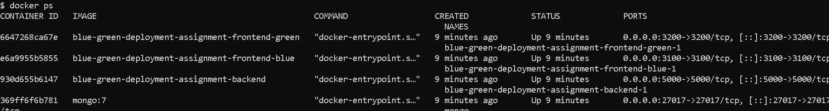

Kubernetes Deployment (15 Marks)
Create folder:
k8s/

MongoDB Deployment
mongo-deployment.yaml
apiVersion: apps/v1
kind: Deployment
metadata:
name: mongo
spec:
replicas: 1
selector:
matchLabels:
app: mongo
template:
metadata:
labels:
app: mongo
spec:
containers:
- name: mongo
image: mongo:7
ports:
- containerPort: 27017

Mongo Service
apiVersion: v1
kind: Service
metadata:
name: mongo-service
spec:
selector:
app: mongo
ports:
- port: 27017

Backend Deployment
backend-deployment.yaml
apiVersion: apps/v1
kind: Deployment
metadata:
name: backend
spec:
replicas: 2
selector:
matchLabels:
app: backend
template:
metadata:
labels:
app: backend
spec:
containers:
- name: backend
image: backend:v1
imagePullPolicy: Never
env:
- name: MONGO_URI
value: mongodb://mongo-service:27017/bluegreen
ports:
- containerPort: 5000
readinessProbe:
httpGet:
path: /health
port: 5000
initialDelaySeconds: 5
livenessProbe:
httpGet:
path: /health
port: 5000
initialDelaySeconds: 15

Backend Service
apiVersion: v1
kind: Service
metadata:
name: backend-service
spec:
selector:
app: backend
ports:
- port: 5000
targetPort: 5000
type: ClusterIP

Frontend Blue Deployment
apiVersion: apps/v1
kind: Deployment
metadata:
name: frontend-blue
spec:
replicas: 2
selector:
matchLabels:
app: frontend
version: blue
template:
metadata:
labels:
app: frontend
version: blue
spec:
containers:
- name: frontend-blue
image: YOUR_DOCKERHUB_USER/frontend-blue:v1
ports:
- containerPort: 3100
env:
- name: PORT
value: "3100"
readinessProbe:
httpGet:
path: /health
port: 3100
livenessProbe:
httpGet:
path: /health
port: 3100

Frontend Green Deployment
apiVersion: apps/v1
kind: Deployment
metadata:
name: frontend-green
spec:
replicas: 2
selector:
matchLabels:
app: frontend
version: green
template:
metadata:
labels:
app: frontend
version: green
spec:
containers:
- name: frontend-green
image: YOUR_DOCKERHUB_USER/frontend-green:v1
ports:
- containerPort: 3200
env:
- name: PORT
value: "3200"
readinessProbe:
httpGet:
path: /health
port: 3200
livenessProbe:
httpGet:
path: /health
port: 3200

Blue-Green Service
This is the key file for the assignment.
Initially route traffic to Blue:
apiVersion: v1
kind: Service
metadata:
name: frontend-service
spec:
selector:
app: frontend
version: blue
ports:
- port: 80
targetPort: 3100
type: NodePort

Create mongo-service.yaml
apiVersion: v1
kind: Service
metadata:
name: mongo-service
spec:
selector:
app: mongo
ports:
- port: 27017
targetPort: 27017
type: ClusterIP
Apply:
kubectl apply -f k8s/mongo-service.yaml

Create frontend-service.yaml
Initially Blue should be active:
apiVersion: v1
kind: Service
metadata:
name: frontend-service
spec:
selector:
app: frontend
version: blue
ports:
- port: 80
targetPort: 3100
type: NodePort

Start Minikube
minikube start
Point Docker to Minikube:
eval $(minikube docker-env)
Build images:

kubectl apply -f k8s/
Verify
Run:
kubectl get svc
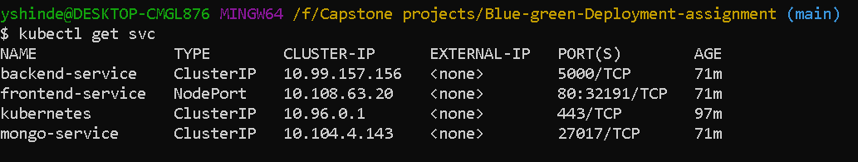

Access Frontend
Once frontend-service exists:
minikube service frontend-service --url

Verify Blue-Green Switching
Check:
kubectl describe svc frontend-service
Should show:
Selector:
app=frontend
version=blue
Switch:
kubectl patch service frontend-service \
-p '{"spec":{"selector":{"app":"frontend","version":"green"}}}'
Verify:
kubectl describe svc frontend-service
Now:
app=frontend
version=green

Switch to Green
kubectl patch service frontend-service \
-p '{"spec":{"selector":{"app":"frontend","version":"green"}}}'
Rollback:
kubectl patch service frontend-service \
-p '{"spec":{"selector":{"app":"frontend","version":"blue"}}}'
This is exactly the blue-green deployment strategy.

Output of kubectl describe svc frontend-service:
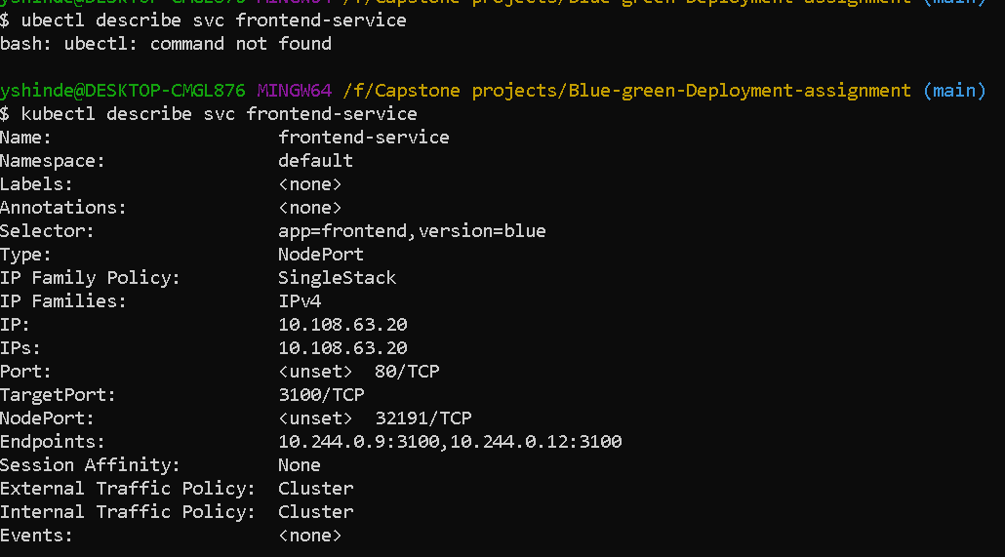

Output of below command :
kubectl patch service frontend-service \
-p '{"spec":{"selector":{"app":"frontend","version":"green"}}}'

kubectl describe svc frontend-service