STEP 1: Fork & Sync Repository
🔹 Fork the repo
Go to:
https://github.com/UnpredictablePrashant/StreamingApp
Click Fork → create your own copy.

🔹 Clone your fork
git clone https://github.com/yogeshvshinde/StreamingApp.git
cd StreamingApp
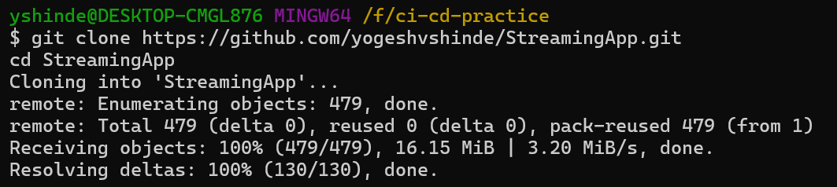

🔹 Add upstream
git remote add upstream https://github.com/UnpredictablePrashant/StreamingApp.git

🔹 Sync updates

git fetch upstream
git checkout main
git merge upstream/main
git push origin main

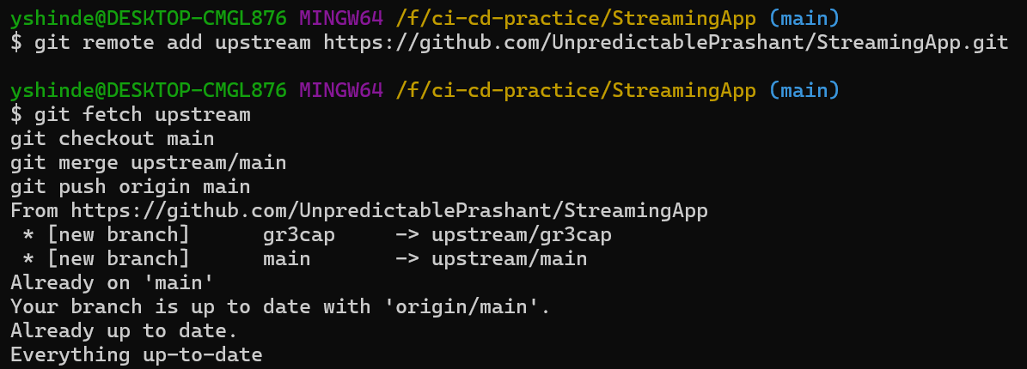

TEP 2: Containerize MERN App
🔹 Structure
frontend/
backend/

🔹 Backend Dockerfile
Create backend/Dockerfile
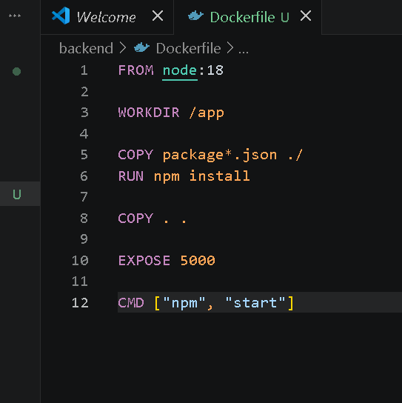
Frontend Dockerfile
Create frontend/Dockerfile
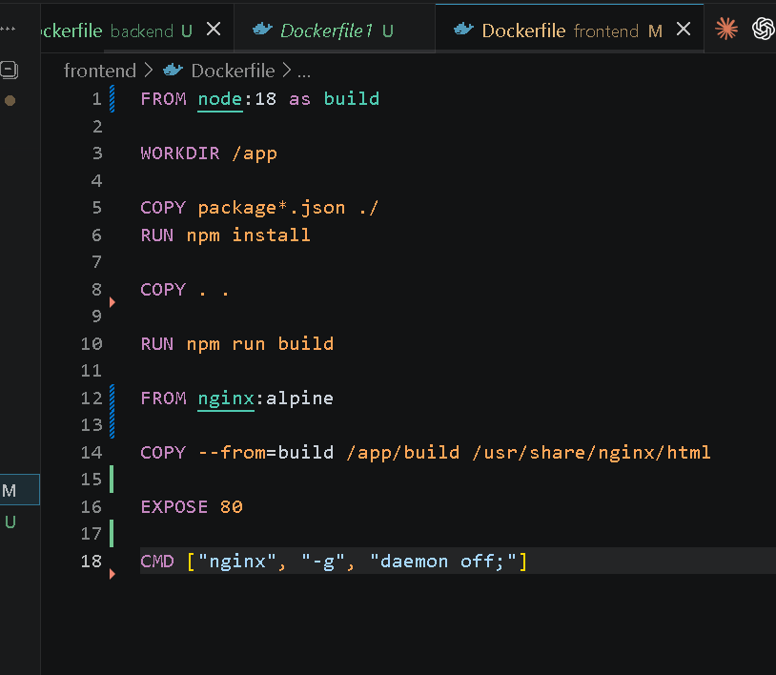

🔹 Test locally (important before CI)
docker build -t frontend ./frontend
docker build -t backend ./backend
docker run -p 3000:80 frontend
docker run -p 5000:5000 backend
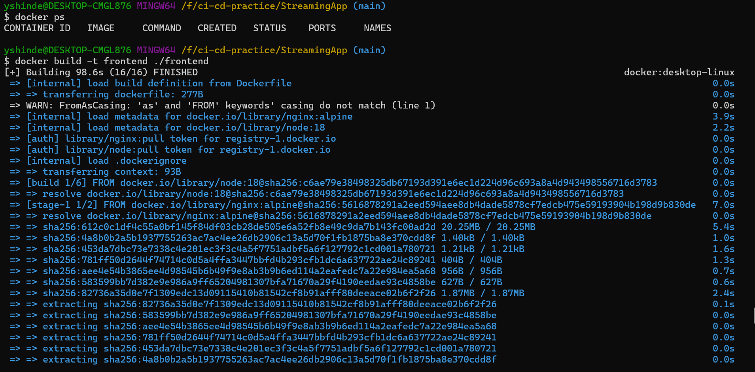

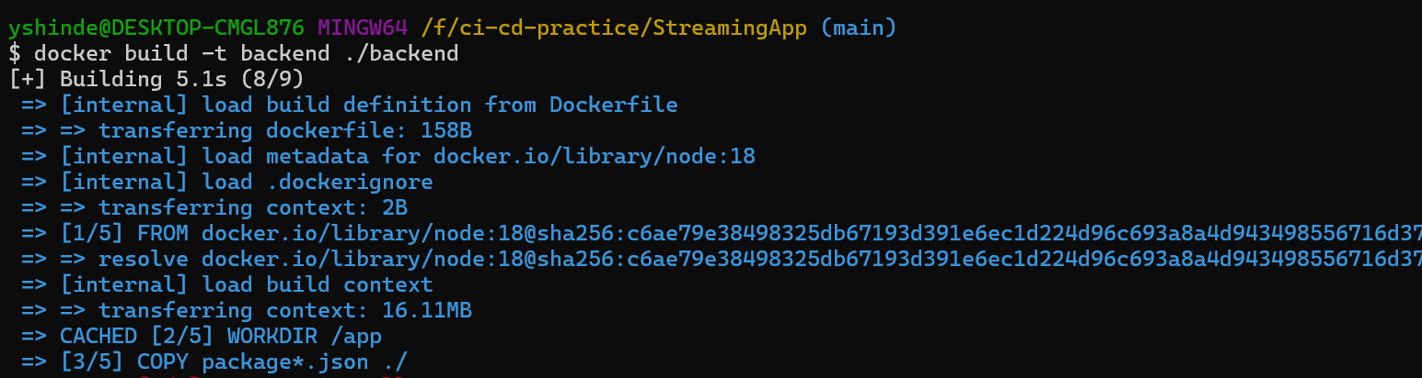

STEP 3: AWS CLI Setup
Install AWS CLI and configure:
aws configure
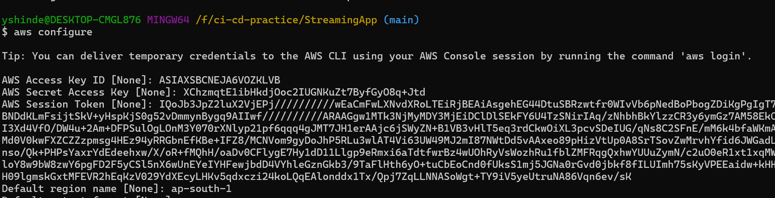

Enter:
- Access Key
- Secret Key
- Region (e.g., ap-south-1)

STEP 4: Push Images to ECR
🔹 Create repos
aws ecr create-repository --repository-name frontend
aws ecr create-repository --repository-name admin-service
aws ecr create-repository --repository-name chat-service
aws ecr create-repository --repository-name streaming-service
aws ecr create-repository --repository-name auth-service

🔹 Login to ECR
aws ecr get-login-password --region ap-south-1 | \
docker login --username AWS --password-stdin <ACCOUNT_ID>.dkr.ecr.ap-south-1.amazona

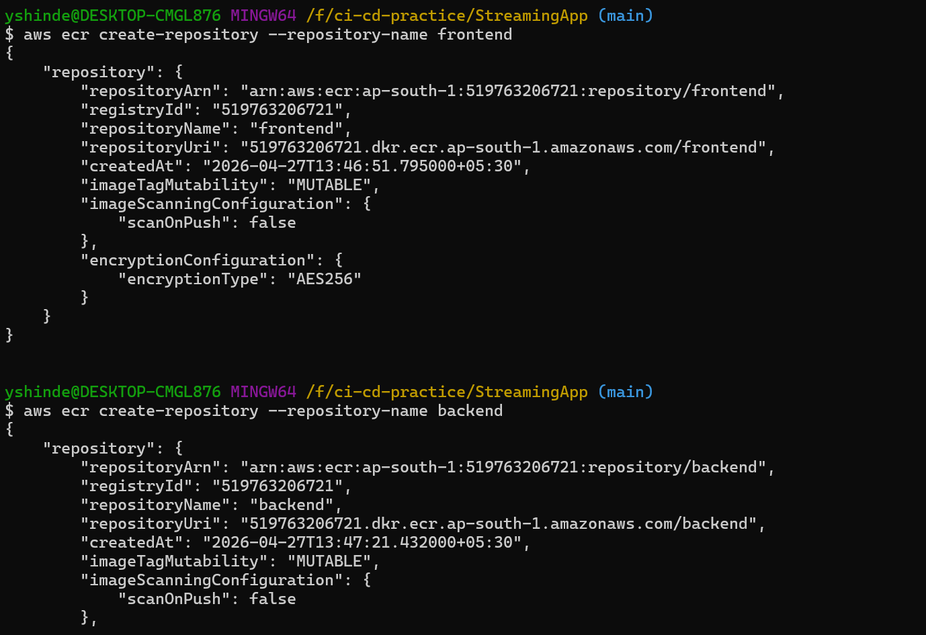

🔹 Login to ECR

aws ecr get-login-password --region ap-south-1 | \
docker login --username AWS --password-stdin <ACCOUNT_ID>.dkr.ecr.ap-south-1.amazonaws.com

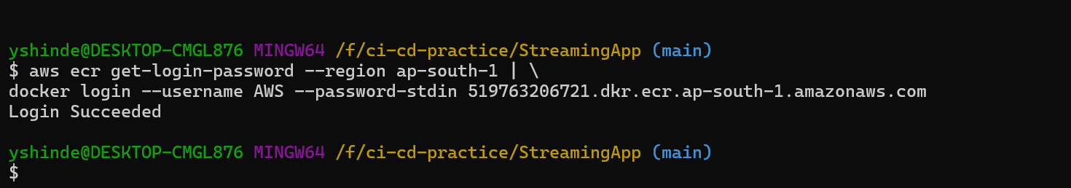

🔹 Tag & Push
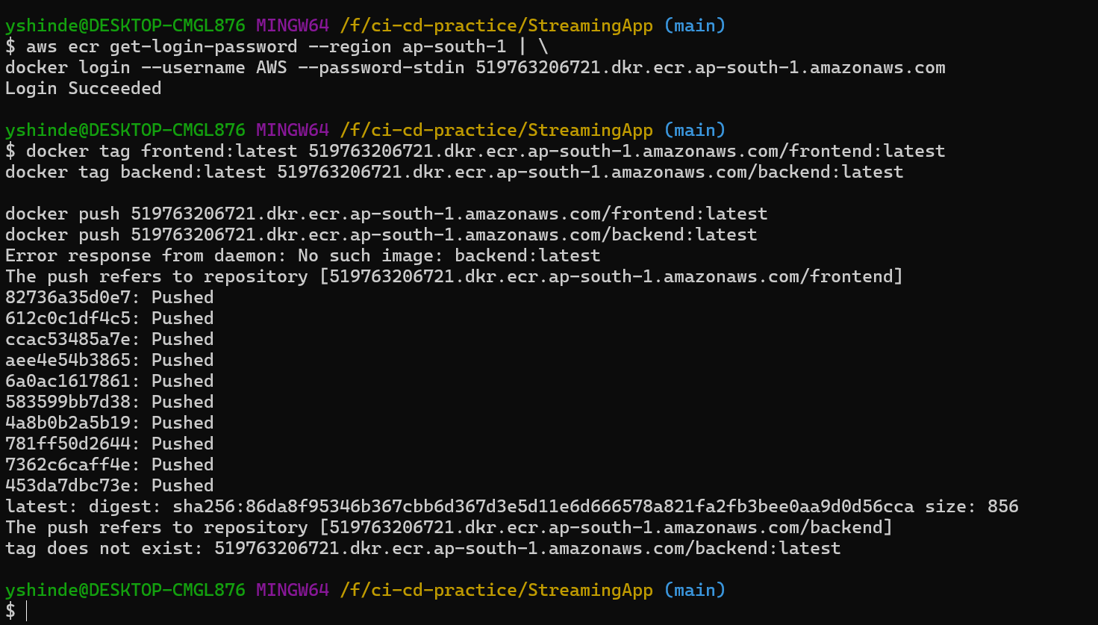

STEP 5: Jenkins CI Pipeline
Since we already have Jenkins. We need to check if below plugins are available and installed.
🔹 Install plugins
In Jenkins:
- Git
- Docker Pipeline
- Pipeline
- AWS Credentials
All plugins were already installed.

🔹 Add credentials
- GitHub token
- AWS credentials

Build docker images locally to test :
Command as below,

cd authService && docker build -t auth-service .
cd ../streamingService && docker build -t streaming-service .
cd ../adminService && docker build -t admin-service .
cd ../chatService && docker build -t chat-service .
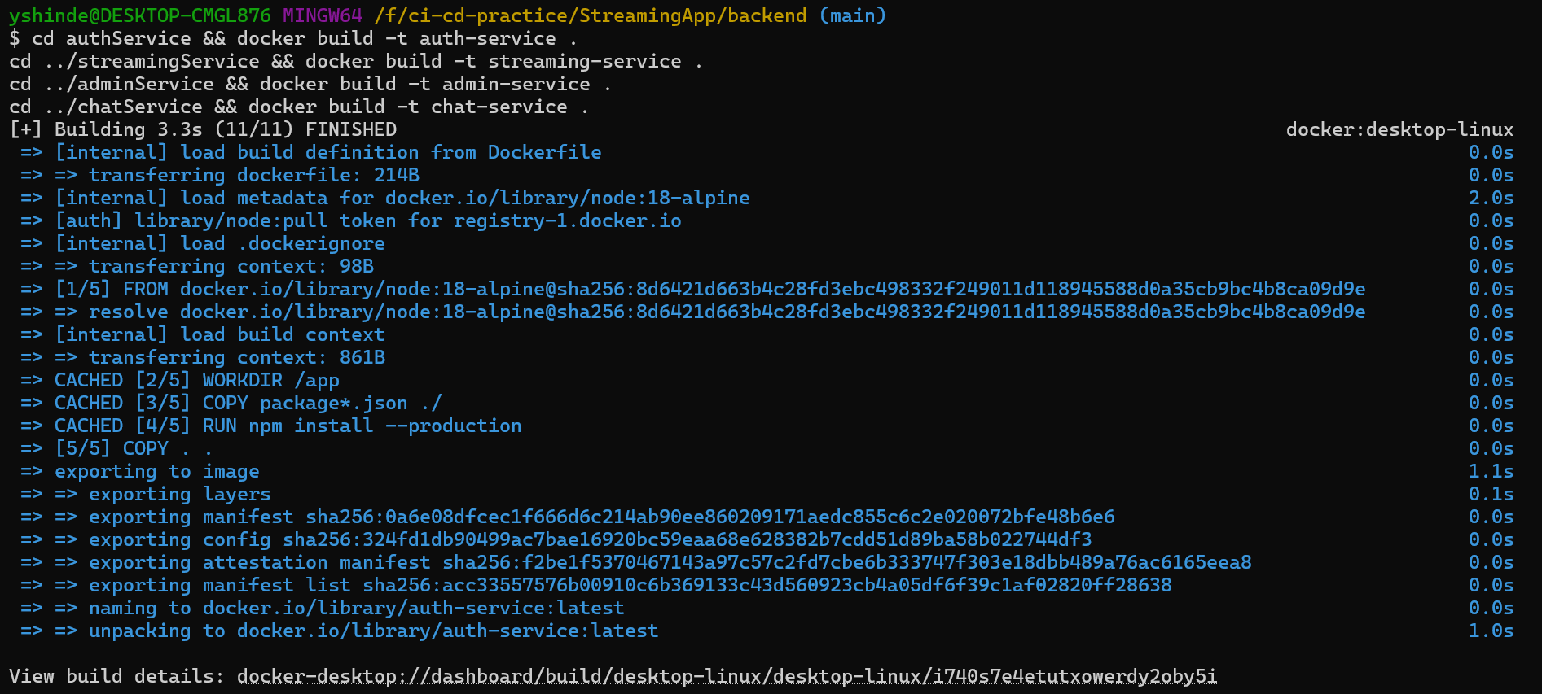

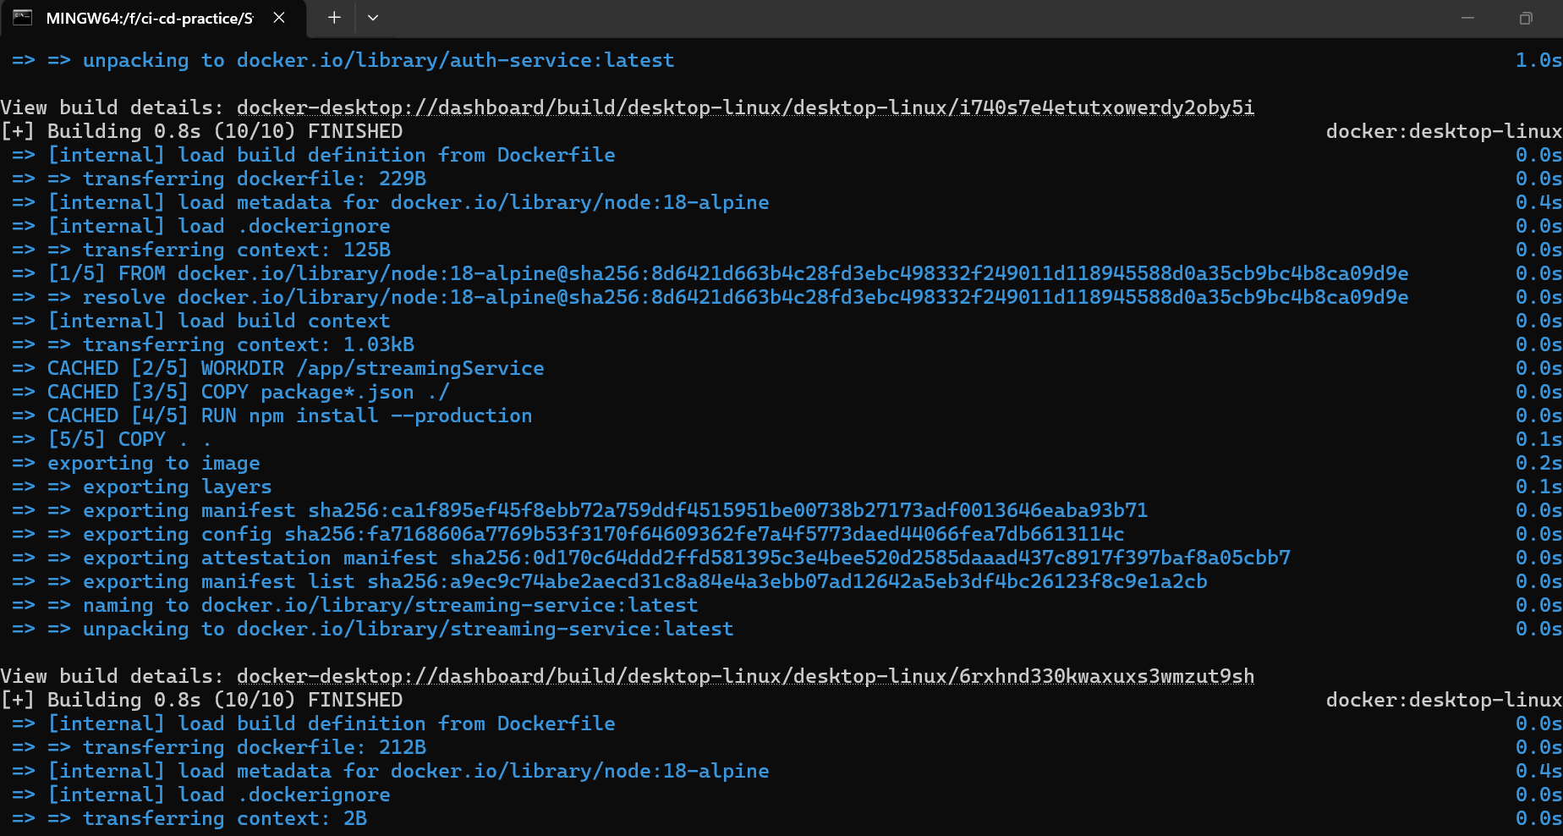

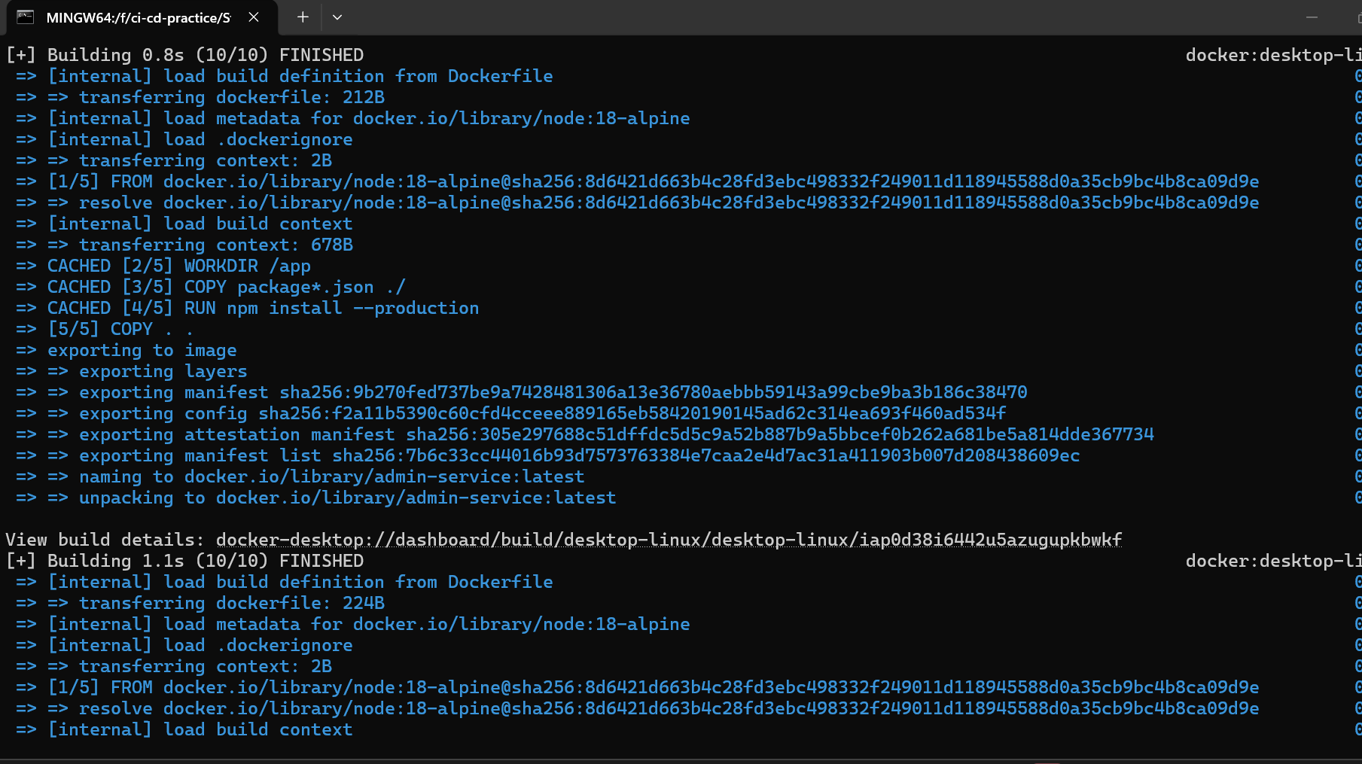

Docker images
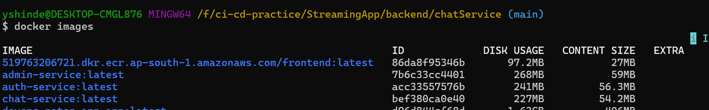
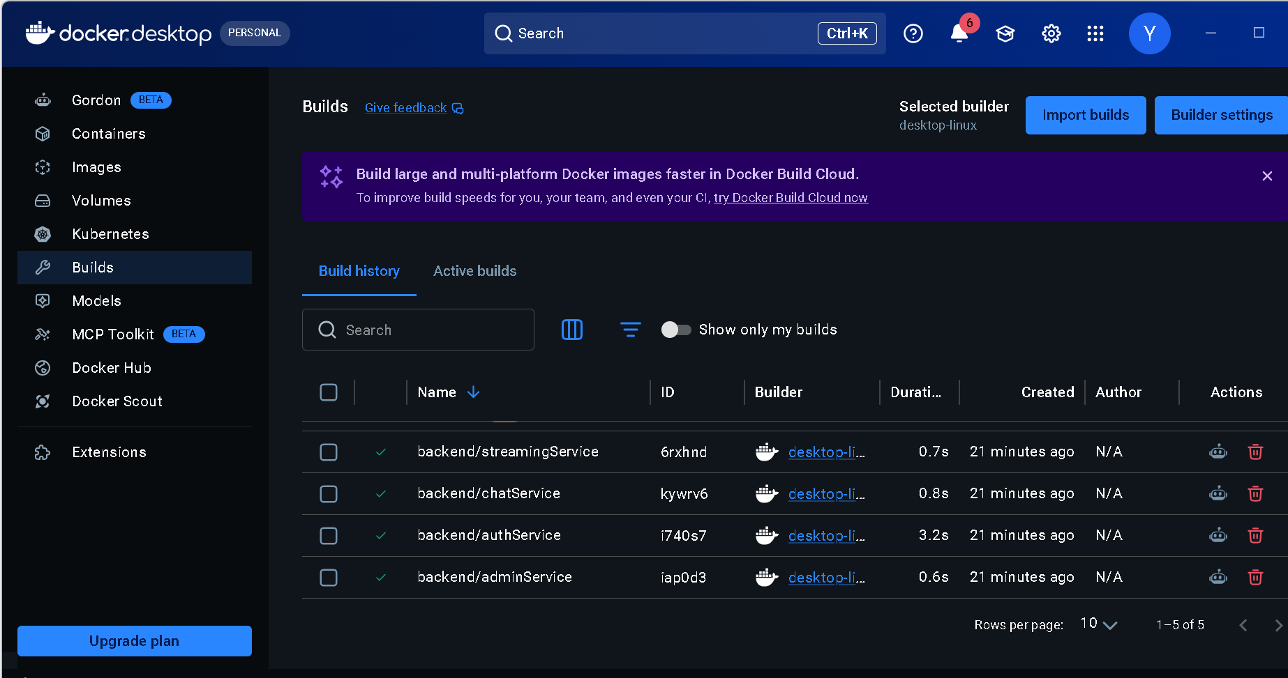
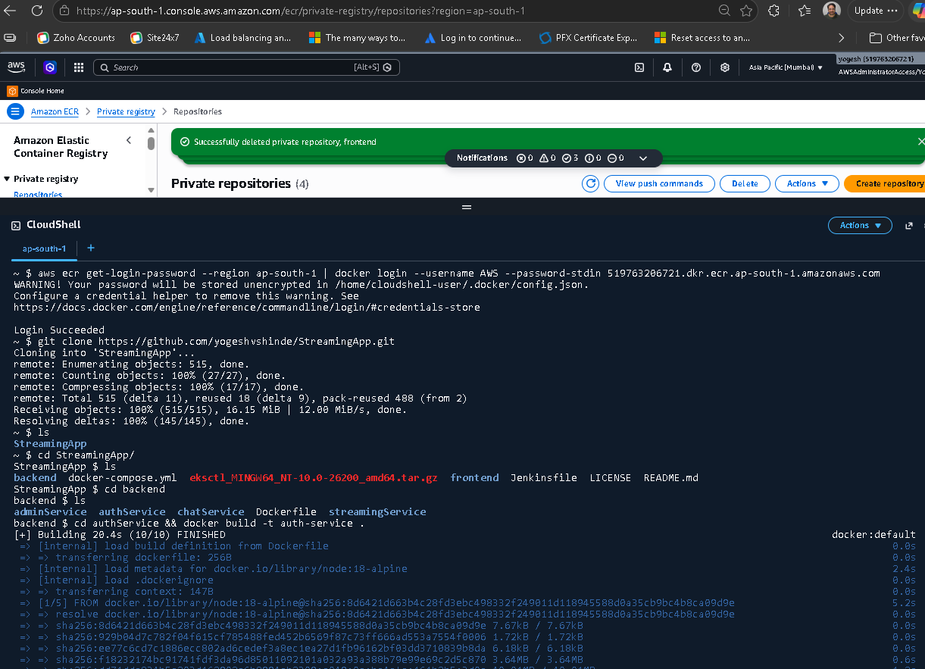
Build Docker image
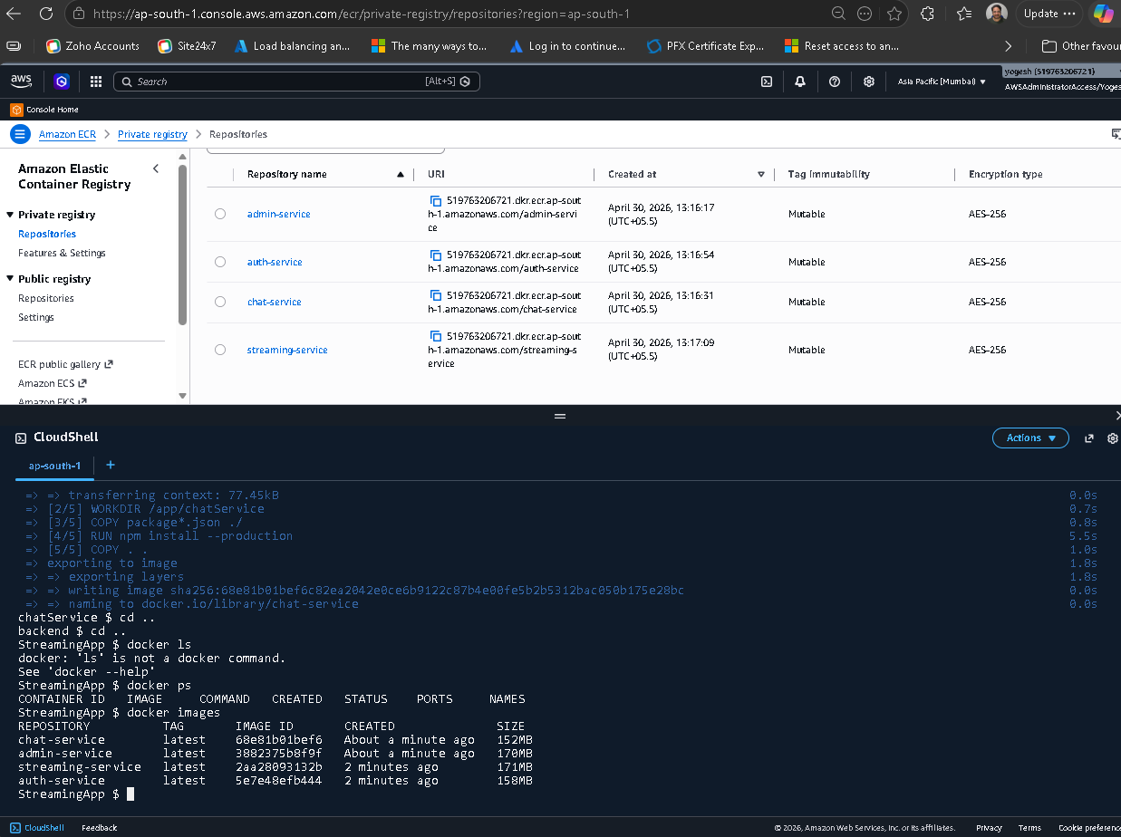

Tag the image for ECR

