Staff Management Web Application

1. Project Overview
Project Name: Staff Management Web Application
Technology Stack: PERN Stack (PostgreSQL, Express.js, React.js, Node.js)
Purpose: To provide a comprehensive system for managing employee roles, tasks, performance, and communication within an organization.

2. Objective
The primary goal of this application is to streamline the internal processes of organizations by:
- Managing employee records based on role hierarchy.
- Assigning and tracking tasks efficiently.
- Monitoring and evaluating employee performance.
- Enabling structured communication between different organizational roles.

3. Scope
- Digitize staff and task management.
- Enhance communication and transparency between hierarchical levels.
- Enable real-time performance tracking.
- Provide intuitive role-based dashboards.
- Support scalable cloud-based storage for all records.

4. Target Audience
- Organizational Admins
- Project Managers
- Team Leads
- Employees (individual contributors)

5. Tools & Technologies
- Frontend: React.js
- Backend/API: Express.js (Node.js)
- Database: PostgreSQL with Neon for cloud storage on AWS
- Design: Figma
- Version Control: GitHub
- Development Environment: Visual Studio Code

6. User Roles and Functionalities

6.1 Admin
- Full CRUD (Create, Read, Update, Delete) operations on employee records.
- Manage background verification details for new and existing employees.
- View access logs of all user actions performed on the platform.

6.2 Manager
- Assign tasks to Team Leads.
- Evaluate and review performance of Team Leads.
- Analyze team and individual performance metrics.
- Accept or reject task extension requests from Team Leads.
- View personal performance data on the dashboard.

6.3 Team Lead
- Assign tasks to employees under their supervision.
- Receive task extension requests from employees.
- Forward extension requests to Managers for approval.
- Monitor team performance.
- View own performance metrics on the dashboard.

6.4 Employee
- View assigned tasks and mark them as complete.
- Submit task extension requests to Team Leads.
- Track their performance through the dashboard.
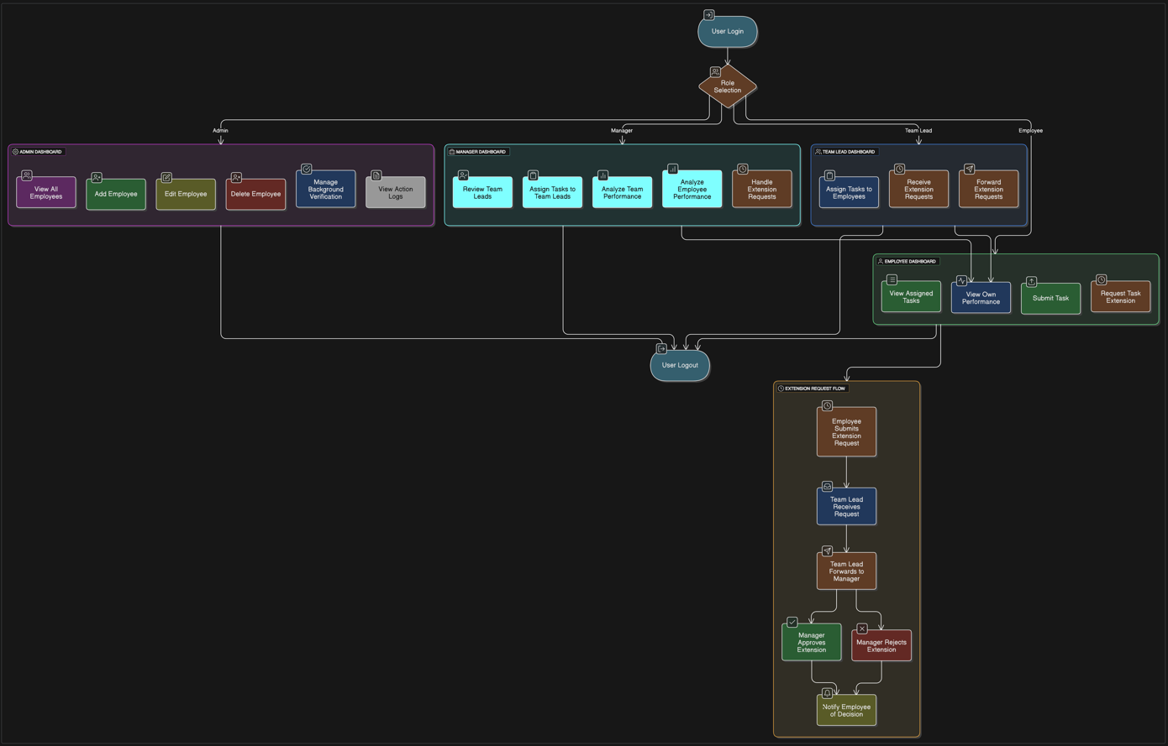

7. System Architecture

7.1 Frontend (React.js)
- Developed using React.js for a responsive and dynamic UI.
- Role-based navigation and components.
- Integration with REST APIs for data transactions.

7.2 Backend (Node.js + Express.js)
- RESTful API services built with Express.js.
- Handles authentication, business logic, and user access control.
- Integrates with PostgreSQL for data persistence.

7.3 Database (PostgreSQL with Neon Cloud Storage)
- Employee records, roles, task details, performance metrics, logs, and verification documents are securely stored using PostgreSQL.
- The database is hosted and managed on Neon, a cloud-based platform providing scalable, reliable, and performant PostgreSQL storage.
- Neon ensures high availability, automatic backups, and efficient data management.
- It enforces data integrity and supports complex relational queries to maintain accurate and consistent information.

8. Key Modules

8.1 Authentication and Authorization
- Secure login with role-based access control.
- JWT for session management.

8.2 Employee Management
- Admin can add, edit, delete, or view employee records.
- Includes department, designation, and background verification.

8.3 Task Management
- Tasks can be created, assigned, updated, or deleted based on user roles.
- Includes deadlines, status tracking, and extension handling.

8.4 Performance Monitoring
- Dashboards for every role.
- Charts and statistics for task completion, delays, and ratings.

8.5 Log Module
- Separate log files to handle user actions and to track task status.
- Log history for transparency.

9. User Experience

Dashboards by Role
Role | Features Displayed
Admin | Employee overview, background checks, system logs
Manager | Team performance, task tracker, request approvals
Team Lead | Task delegation panel, performance dashboard, extension requests
Employee | Task list, submission panel, request extension, personal progress overview

10. Security & Compliance
- Role-based access control (RBAC).
- Encrypted passwords.
- Token-based authentication.
- Activity logging and audit trail.

11. Installation Steps
- Clone repo from GitHub
- Run `npm install` in both client and server
- Configure `.env` files for DB connection and
- Start frontend: `npm start’
- Start backend: `npm run dev`

12. Expected Outcomes
- Reduced administrative overhead and manual processes.
- Clear accountability and progress tracking within teams.
- Seamless communication flow between hierarchical levels.
- Increased productivity and task completion rate.
- Data-driven insights into team and individual performance.

13. Conclusion
The Staff Management Web Application provides a robust and scalable solution for workforce management. By leveraging the PERN stack, it ensures maintainability, performance, and a smooth user experience tailored to each organizational role.
This documentation serves as a foundational reference for developers, stakeholders, and future contributors to understand the system’s architecture, purpose, and functionality.
Prototype demo link :
Staff management prototype .mp4

