AI-Powered Study Assistant & Backend Management

INTRODUCTION
LearnMate - AI StudyBuddy Backend Service
Team ID: SWTID-2026-1215

Team Leadership & Members

Team Leader:
NAME | MAIL ID
YOGESHWARAN .k | yogesh13waran05@gmail.com

Team Members:

NAME | MAIL ID
jeeva | jeeva30102005@gmail.com
kamesh | kameshcandypop@gmail.com
Nandhini | nandhini14022007@gmail.com

1. PROJECT OVERVIEW

1.1 Purpose
LearnMate is an enterprise-grade backend-focused web application developed using Node.js, Express.js, and MongoDB Atlas. It is engineered to provide a robust, scalable, and secure RESTful API infrastructure for student learning management and AI study assistant workflows. The platform ensures end-to-end data security using JSON Web Token (JWT) stateless authentication, password hashing with Bcrypt, and strict Role-Based Access Control (RBAC). The system enables secure registration, credential verification, protected access to learning materials, and complete administrative CRUD control over platform accounts and resources.

1.2 Key Objectives
- Secure User Authentication: Implement cryptographic password hashing via Bcrypt and stateless token generation with JWT.
- Role-Based Access Control (RBAC): Enforce granular authorization separating student capabilities from administrative governance.
- Administrative CRUD Operations: Provide authenticated endpoints for retrieving and deleting user records and study materials.
- Cloud-Native Database Persistence: Connect directly to a MongoDB Atlas multi-cluster database with Mongoose schema modeling.
- Reliable API Responses: Return standardized HTTP status codes (200 OK, 201 Created, 400 Bad Request, 401 Unauthorized, 403 Forbidden) and robust error handling.

1.3 Target Audience
- Students: Retrieve organized study materials, access personalized learning tools, and submit assignments securely.
- Administrators & Educators: Monitor student accounts, audit platform security, and manage learning resources.
- Academic Institutions: Deploy a standardized, high-performance API foundation for smart campus solutions.

2. PROJECT ARCHITECTURE

2.1 Core Architectural Flow
Client (Thunder Client / Frontend) -> Express REST API (Port 5000) -> Authentication & Role Middleware -> Controllers (Auth, Admin, Materials) -> MongoDB Atlas Cloud Database

2.2 System Components
- Express Server (server.js): The central entry point running on port 5000, responsible for request parsing, middleware initialization, CORS policies, and route delegation.
- Auth & Role Middleware (authMiddleware.js): Intercepts protected routes, extracts the Bearer token from the HTTP Authorization header, verifies signature via JWT_SECRET, and checks user permissions.
- Auth Controller (authController.js): Implements user onboarding, duplicate email prevention, password hashing, and token dispatching.
- Admin Controller (adminController.js): Handles administrative oversight, retrieving user rosters, and deleting targeted accounts.
- Database Layer (MongoDB Atlas): Multi-tenant cloud NoSQL storage enforcing schema validation through Mongoose ODM.

2.3 Technical Architecture & Database Schema

Users Collection
- _id: ObjectId (Primary Key)
- name: String (Required, trimmed)
- email: String (Required, unique, lowercase)
- password: String (Required, hashed with Bcrypt)
- role: String (Enum: ['student', 'admin'], default: 'student')
- timestamps: createdAt, updatedAt

Materials Collection
- _id: ObjectId (Primary Key)
- userId: ObjectId (Reference to User)
- title: String (Required)
- topic: String (Required)

2.4 Entity-Relationship (ER) Diagram & Data Model
ASCII Architecture / ER Diagram:
+-----------------------------------+ +-----------------------------------+
| USERS | | MATERIALS |
+-----------------------------------+ +-----------------------------------+
| * _id (PK) : ObjectId | 1 * | * _id (PK) : ObjectId |
| name : String |-------------< userId (FK) : ObjectId |
| email (Unique) : String | | title : String |
| password (Hash) : String | | topic : String |
| role : Enum | | content : String |
| createdAt : Date | | createdAt : Date |
| updatedAt : Date | | updatedAt : Date |
+-----------------------------------+ +-----------------------------------+
Entity Relationship Summary:
- Entity 1: Users (Manages user profiles, role-based authorization for 'student' and 'admin', and cryptographic authentication).
- Entity 2: Materials (Stores study notes, topics, and academic resources created or managed for learners).
- Cardinality / Relationship: 1-to-Many (1:N) — A single User can author or own multiple learning materials (referenced via userId foreign key), while each material document references exactly one owner user.
- Cascade Deletion: When an administrator deletes a targeted user record (via DELETE /api/admin/users/:id), all referenced documents in the Materials collection corresponding to that userId are also pruned.

3.1 Prerequisites
- Node.js (v18.x or later)
- MongoDB Atlas active cluster
- Visual Studio Code with Thunder Client extension
- Git version control

3.2 Installation Commands

1. Clone Repository:
git clone <repository-url>

cd LearnMate-Backend

2. Install Dependencies:
npm install express mongoose dotenv jsonwebtoken bcryptjs cors

npm install -D nodemon

3. Configure .env:

PORT=5000
MONGO_URI=mongodb+srv://<username>:<password>@cluster0.mongodb.net/learnmate
JWT_SECRET=your_jwt_secret_key
JWT_REFRESH_SECRET=your_jwt_refresh_secret

4. Run Server:
npm start

4. CORE FEATURES & USER FLOW

4.1 Feature Matrix
Feature | Technical Implementation | Purpose
User Authentication | POST /api/auth/register | Bcrypt hashing + JWT access/refresh token generation
Bearer Security | Middleware verification | Stateless Bearer token header authorization
Role-Based Access Control | verifyRole('admin') | Guards administrative endpoints against unauthorized roles
Admin CRUD Pipelines | GET & DELETE /api/admin/users | Account directory auditing and record deletion
Database Persistence | MongoDB Atlas connection | Managed cloud storage for users and materials

4.2 End-to-End User Flow
- Client issues registration payload to POST /api/auth/register.
- Server validates input uniqueness, hashes password, saves user to MongoDB Atlas, and returns signed JWT tokens.
- Client attaches accessToken in the Authorization header as a Bearer Token.
- Protected routes verify the token and validate admin role privileges.
- Administrative controller queries MongoDB Atlas and returns the requested data.

5. API TESTING & EXECUTION PROOF (Thunder Client)

5.1 User Registration (POST /api/auth/register)
- Method: POST
- URL: http://localhost:5000/api/auth/register
- Status: 201 Created
- Output: Returns confirmation message along with accessToken and refreshToken.
(Paste Screenshot 1 Here: Thunder Client displaying 201 Created and JWT Token response)

5.2 Bearer Token Injection
- Header: Authorization: Bearer <accessToken>
- Mechanism: Configured within Thunder Client's Auth tab for route authentication.
(Paste Screenshot 2 Here: Bearer Token configured in Thunder Client Auth tab)

5.3 Retrieve All Users (GET /api/admin/users)
- Method: GET
- URL: http://localhost:5000/api/admin/users
- Status: 200 OK
- Output: Returns JSON array of all registered accounts from MongoDB Atlas.
(Paste Screenshot 3 Here: Response list displaying registered user accounts)

5.4 Delete Targeted User (DELETE /api/admin/users/:id)
- Method: DELETE
- URL: http://localhost:5000/api/admin/users/:id
- Status: 200 OK
- Output: {"message": "User and their materials deleted"}
(Paste Screenshot 4 Here: Deletion confirmation response in Thunder Client)

5.5 Server & Cloud Database Connection
- Status: Server running on port 5000 | MongoDB connected
(Paste Screenshot 5 Here: VS Code terminal showing active server and MongoDB Atlas connection)

Screen shot:
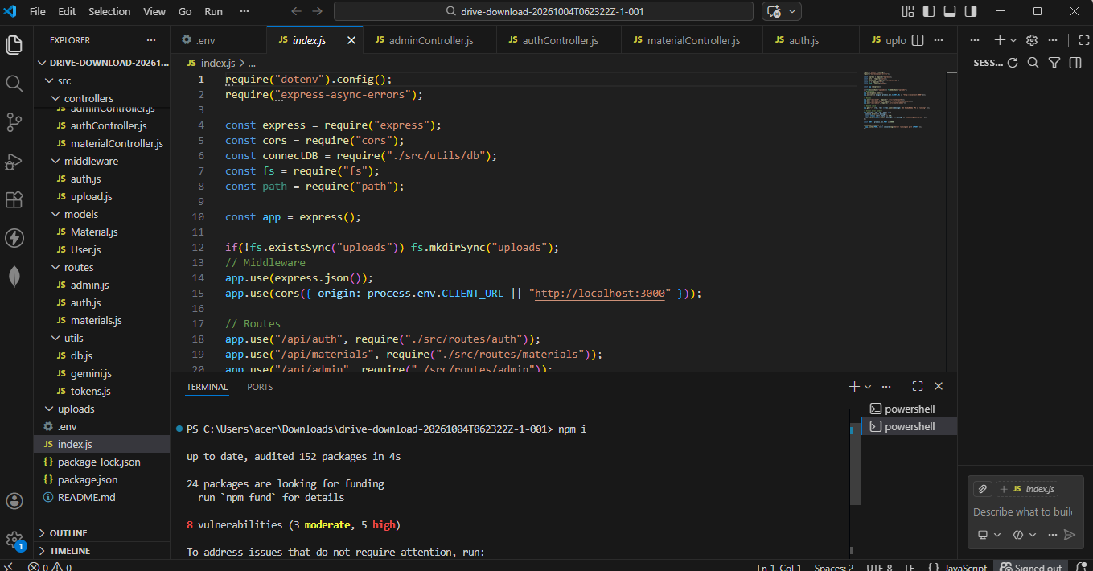
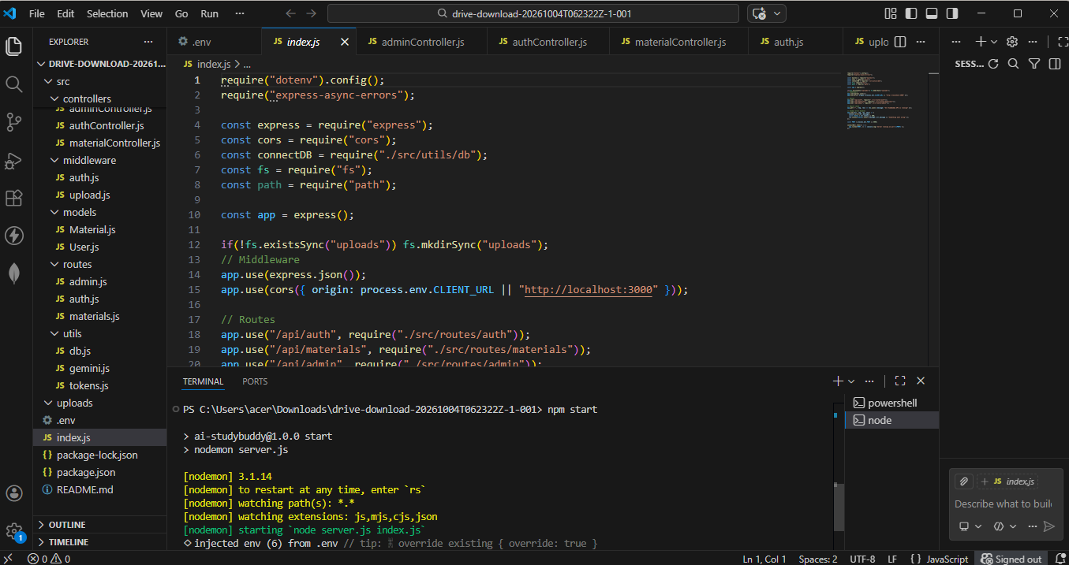

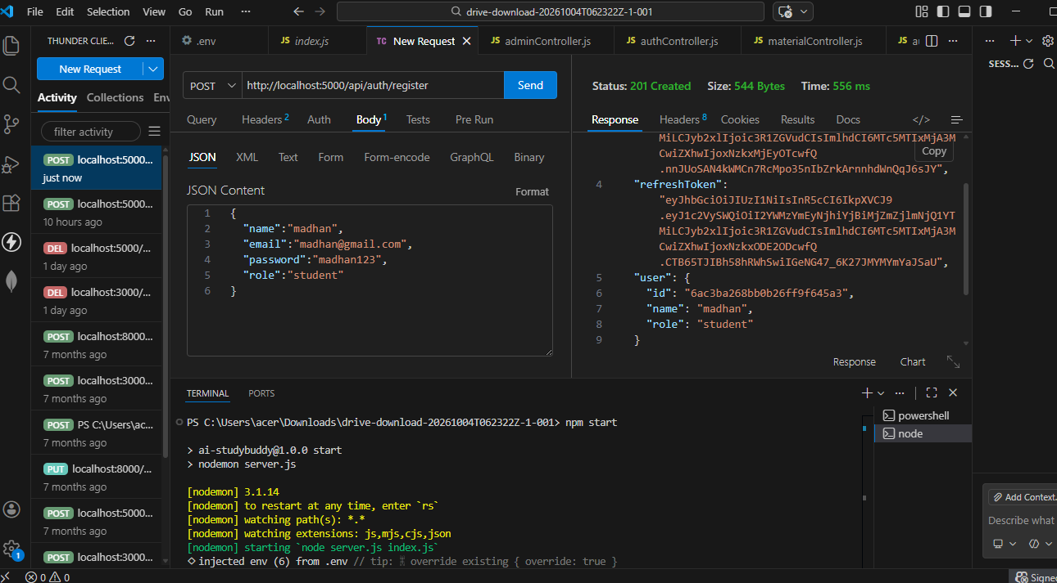

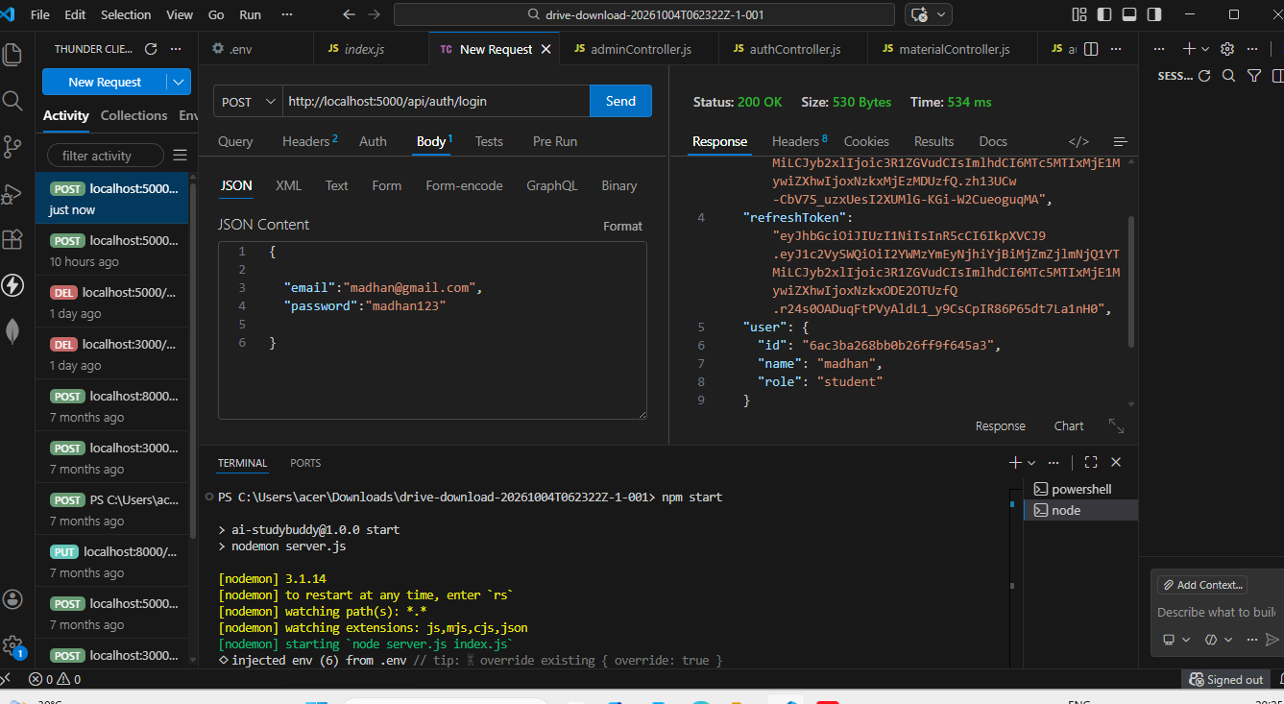
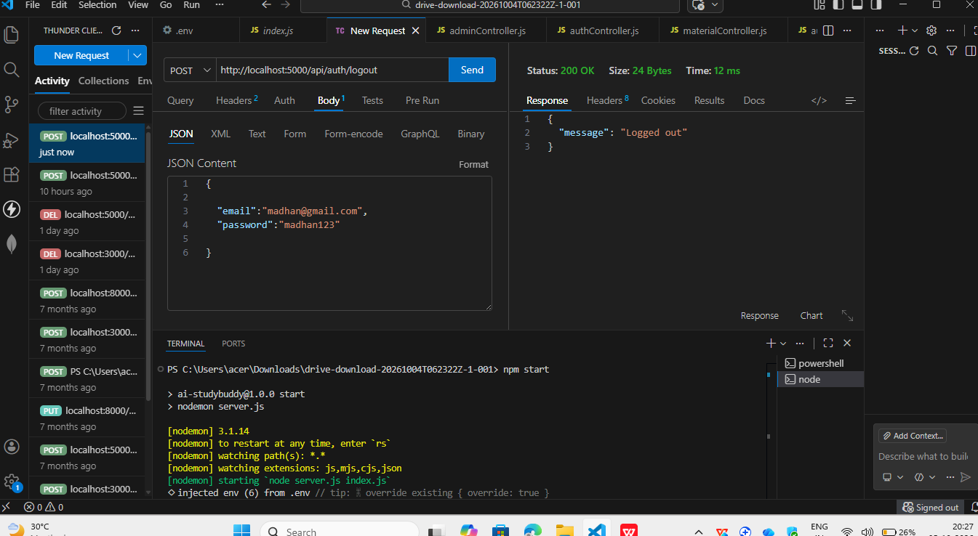

7 futhure enhancements:
Automated AI Quiz & Flashcard Generation: Integrate Google Gemini AI to analyze stored study materials and dynamically generate revision flashcards, summaries, and self-assessment quizzes.
Vector Search & Semantic Retrieval: Implement MongoDB Atlas Vector Search along with text embeddings to enable students to query semantic content directly from lecture notes.
Real-time Peer Study Rooms: Incorporate WebSockets via Socket.io to provide real-time collaborative discussion threads and live document sharing.
Cloud Storage for Attachments: Integrate AWS S3 or Cloudinary to handle direct uploads of multi-format academic resources (PDFs, slide decks, and diagrams).
8 conslusion:
The LearnMate – AI StudyBuddy Backend Service has been successfully designed, implemented, and validated using a modern Node.js, Express.js, and MongoDB Atlas tech stack.
The system provides:
Stateless Security: Implemented cryptographic password hashing using Bcrypt and stateless Bearer token authorization using JSON Web Tokens (JWT).
Role-Based Access Control (RBAC): Cleanly partitioned student resource interactions from administrative management pipelines.
High Availability & Scalability: A modular MVC-style architecture integrated with MongoDB Atlas ensures schema validation, horizontal scalability, and reliable persistence.
Production-Grade API Testing: Verified administrative CRUD endpoints, user lifecycle operations, and token verification pipelines via automated Thunder Client execution.

