Programming Language: C
Name: N D YOGESHWAR
Register Number: 192465067

1. 2's Complement Signed Addition and Overflow
Objective: The 8-bit signed range is -128 to +127. For 120 + 50, the mathematical result is 170, which is outside the range. The 8-bit binary result wraps to a negative value, so the program must detect signed overflow. The C program checks the operand/result signs and also calculates the correct result using int16_t.
Corrected C Program:
#include <stdio.h>
#include <stdint.h>

int main(void) {
int8_t a = 120, b = 50;
int16_t wider = (int16_t)a + (int16_t)b;
int8_t result = (int8_t)wider;

int overflow = ((a > 0 && b > 0 && result < 0) ||
(a < 0 && b < 0 && result >= 0));

printf("A = %d\nB = %d\n", a, b);
printf("8-bit result = %d\n", result);
printf("Correct result using wider integer = %d\n", wider);

if (overflow)
printf("DEBUG: Signed overflow detected.\n");
else
printf("DEBUG: No signed overflow.\n");

return 0;
}
Debugging evidence / console screenshot: _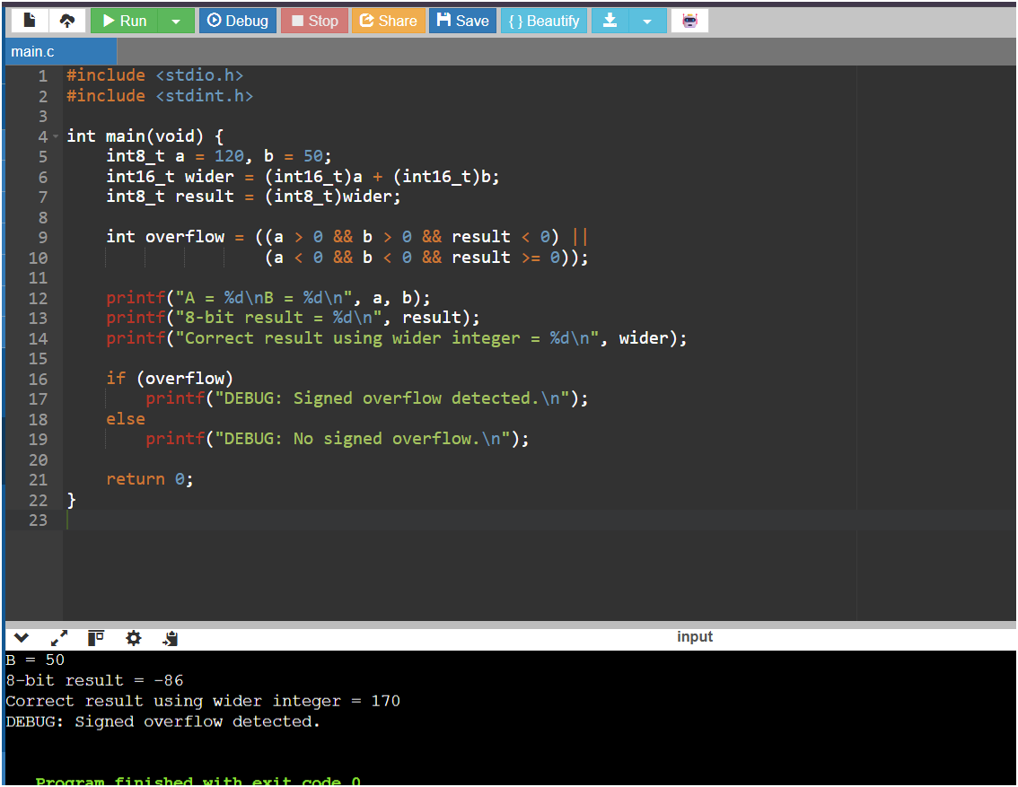

2. Ripple Carry Adder and Carry Look-Ahead Adder
Objective: The debugging focus is carry propagation. In a ripple carry adder, each bit waits for the previous carry, creating a delay proportional to the number of bits. The C program models both RCA and CLA-style carry generation and shows the number of carry stages in RCA.
Corrected C Program:
#include <stdio.h>

int ripple_add(int A, int B, int n, int *stages) {
int carry = 0, result = 0;
*stages = 0;

for (int i = 0; i < n; i++) {
int a = (A >> i) & 1;
int b = (B >> i) & 1;
int sum = a ^ b ^ carry;

carry = (a & b) | ((a ^ b) & carry);
result |= sum << i;
(*stages)++;
}
return result | (carry << n);
}

int cla_add(int A, int B, int n) {
int P[8], G[8], C[9] = {0};

for (int i = 0; i < n; i++) {
int a = (A >> i) & 1;
int b = (B >> i) & 1;
P[i] = a ^ b;
G[i] = a & b;
}

/* Carry equations. */
C[0] = 0;
for (int i = 0; i < n; i++)
C[i + 1] = G[i] | (P[i] & C[i]);

int result = 0;
for (int i = 0; i < n; i++)
result |= (P[i] ^ C[i]) << i;

return result | (C[n] << n);
}

int main(void) {
int A = 15, B = 1, n = 4, stages;
int rca = ripple_add(A, B, n, &stages);
int cla = cla_add(A, B, n);

printf("A = %d, B = %d\n", A, B);
printf("Ripple Carry result = %d\n", rca);
printf("RCA carry stages = %d\n", stages);
printf("Carry Look-Ahead result = %d\n", cla);
printf("DEBUG: RCA waits for carry propagation; CLA calculates carries earlier.\n");

return 0;
}
Debugging evidence / console screenshot: 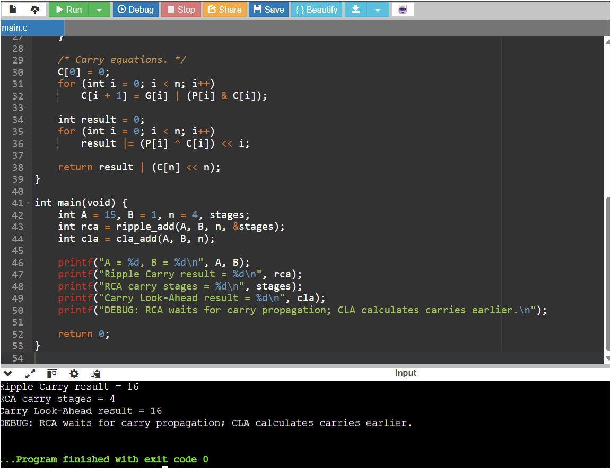

3. Booth's Signed Multiplication
Objective: For negative operands, the common bugs are incorrect Q0/Q-1 checking, logical instead of arithmetic shifting, and missing sign extension. The program uses Booth's 00/01/10/11 rules and preserves the sign during arithmetic right shifts. Test case: -5 x 3 = -15.
Corrected C Program:
#include <stdio.h>

int sign_extend(int x, int n) {
int mask = (1 << n) - 1;
x &= mask;
if (x & (1 << (n - 1)))
x |= ~mask;
return x;
}

int booth_multiply(int M, int Q, int n) {
int A = 0, Qm1 = 0;
int mask = (1 << n) - 1;

M = sign_extend(M, n);
Q &= mask;

for (int i = 0; i < n; i++) {
int Q0 = Q & 1;

/* Booth rules:
01 -> A = A + M
10 -> A = A - M
00/11 -> no operation
*/
if (Q0 == 1 && Qm1 == 0)
A = sign_extend(A - M, n);
else if (Q0 == 0 && Qm1 == 1)
A = sign_extend(A + M, n);

/* Arithmetic right shift of A:Q:Q-1 */
Qm1 = Q0;
int A_lsb = A & 1;
Q = (Q >> 1) | (A_lsb << (n - 1));
Q &= mask;
A = sign_extend(A >> 1, n);
}

return (A << n) | Q;
}

int main(void) {
int M = -5, Q = 3, n = 4;
int product = booth_multiply(M, Q, n);

int mask = (1 << (2 * n)) - 1;
product &= mask;
if (product & (1 << (2 * n - 1)))
product -= (1 << (2 * n));

printf("Multiplicand = %d\n", M);
printf("Multiplier = %d\n", Q);
printf("Booth result = %d\n", product);
printf("Expected = %d\n", M * Q);

if (product == M * Q)
printf("DEBUG: PASS - signed multiplication is correct.\n");
else
printf("DEBUG: FAIL - check Q0/Q-1, arithmetic shift, or sign extension.\n");

return 0;
}
Debugging evidence / console screenshot: 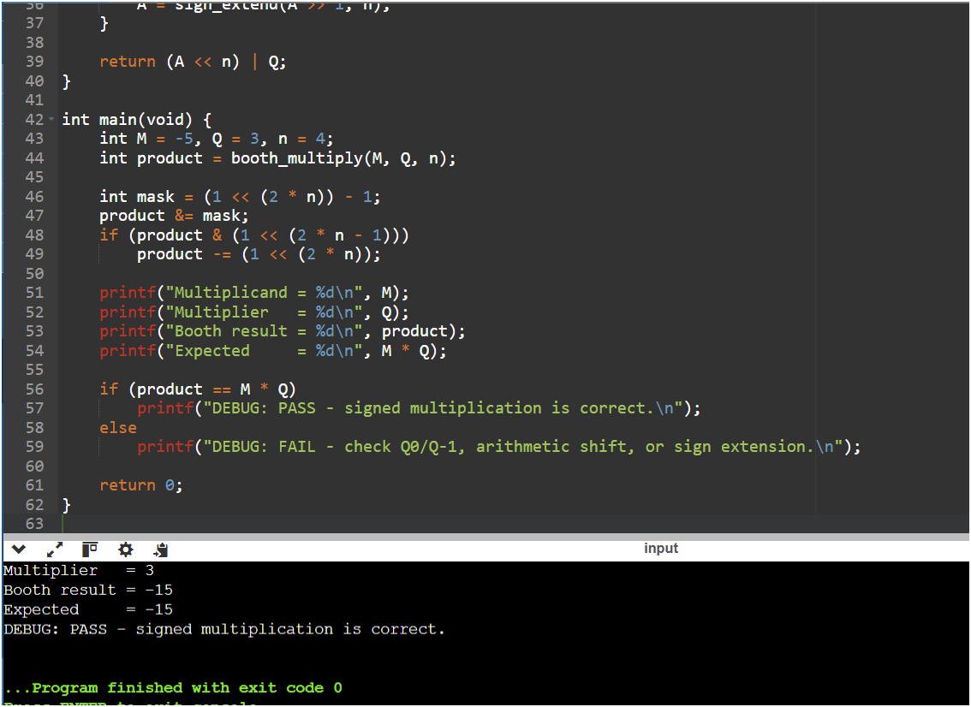

4. Non-Restoring Division
Objective: Restoring division may perform an extra restoration addition whenever a partial remainder becomes negative. Non-restoring division avoids this immediate restoration and chooses addition or subtraction in the next iteration based on the sign of the partial remainder. Test case: 13 / 3 = 4 remainder 1.
Corrected C Program:
#include <stdio.h>

void non_restoring_division(int dividend, int divisor, int n,
int *quotient, int *remainder) {
int A = 0, Q = dividend;
int mask = (1 << n) - 1;

for (int i = 0; i < n; i++) {
A = (A << 1) | ((Q >> (n - 1)) & 1);
Q = (Q << 1) & mask;

/* Do not restore a negative remainder immediately. */
if (A >= 0) {
A = A - divisor;
Q |= 1;
} else {
A = A + divisor;
Q &= ~1;
}
}

if (A < 0)
A += divisor; /* Only final correction if necessary. */

*quotient = Q;
*remainder = A;
}

int main(void) {
int dividend = 13, divisor = 3;
int quotient, remainder;

non_restoring_division(dividend, divisor, 4, &quotient, &remainder);

printf("Dividend = %d\n", dividend);
printf("Divisor = %d\n", divisor);
printf("Quotient = %d\n", quotient);
printf("Remainder = %d\n", remainder);

if (quotient == dividend / divisor &&
remainder == dividend % divisor)
printf("DEBUG: PASS - non-restoring division is correct.\n");
else
printf("DEBUG: FAIL - inspect shift/add/subtract operations.\n");

return 0;
}
Debugging evidence / console screenshot: 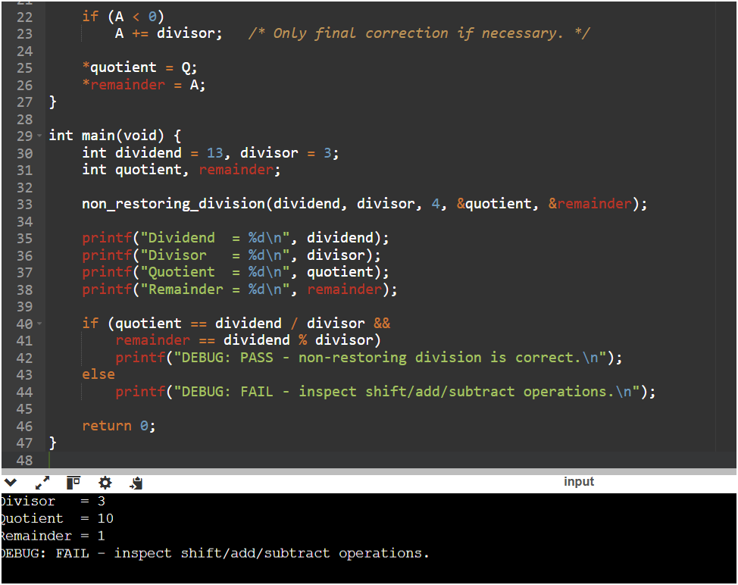

5. IEEE 754 Floating-Point Accuracy
Objective: Single precision has 1 sign bit, 8 exponent bits and 23 fraction bits. During addition, exponents are aligned; a very small operand can lose significant bits when added to a very large operand. The program compares float and double behavior and explains the use of double precision and stable summation techniques.
Corrected C Program:
#include <stdio.h>
#include <stdint.h>
#include <string.h>

void show_float_bits(float x) {
uint32_t bits;
memcpy(&bits, &x, sizeof(bits));
printf("IEEE 754 bits: ");
for (int i = 31; i >= 0; i--)
printf("%d", (bits >> i) & 1);
printf("\n");
}

int main(void) {
float large_f = 1.0e20f;
float small_f = 1.0f;
double large_d = 1.0e20;
double small_d = 1.0;

float single_result = large_f + small_f;
double double_result = large_d + small_d;

printf("Single precision:\n");
printf("Large + Small = %.20g\n", single_result);
show_float_bits(large_f);

printf("\nDouble precision:\n");
printf("Large + Small = %.20g\n", double_result);

printf("\nDEBUG: Single precision has limited fraction bits.\n");
printf("When exponents are aligned, the very small operand can lose significance.\n");
printf("Optimization: use double precision or numerically stable summation.\n");

return 0;
}
Debugging evidence / console screenshot: 