Assignment1:

On Jenkins Master

Install java: **openjdk 11.0.23 2024-04-16 LTS**

Yum install java **openjdk 11.0.23 2024-04-16 LTS -y**

Install git:

Yum install git -y

Install httpd:

Yum install httpd -y

Service httpd start

Service httpd status

Download Apache Tomcat:

Cd /mnt

Mkdir server

Cd server

Wget https://dlcdn.apache.org/tomcat/tomcat-9/v9.0.89/bin/apache-tomcat-9.0.89.zip

Unzip <https://dlcdn.apache.org/tomcat/tomcat-9/v9.0.89/bin/apache-tomcat-9.0.89.zip>

Ls -ltra

rm -rf <https://dlcdn.apache.org/tomcat/tomcat-9/v9.0.89/bin/apache-tomcat-9.0.89.zip>

chmod -R 777 apache-tomcat-9.0.89

Cd apache-tomcat-9.0.89

Ls -ltra

Cd bin

./startup.sh(tomcat server started)

JOB1:repo1

Custom work space:/root/repo1

Execute shell:

yum install httpd -y

service httpd start

chmod -R 777 /var/www/html/index.html

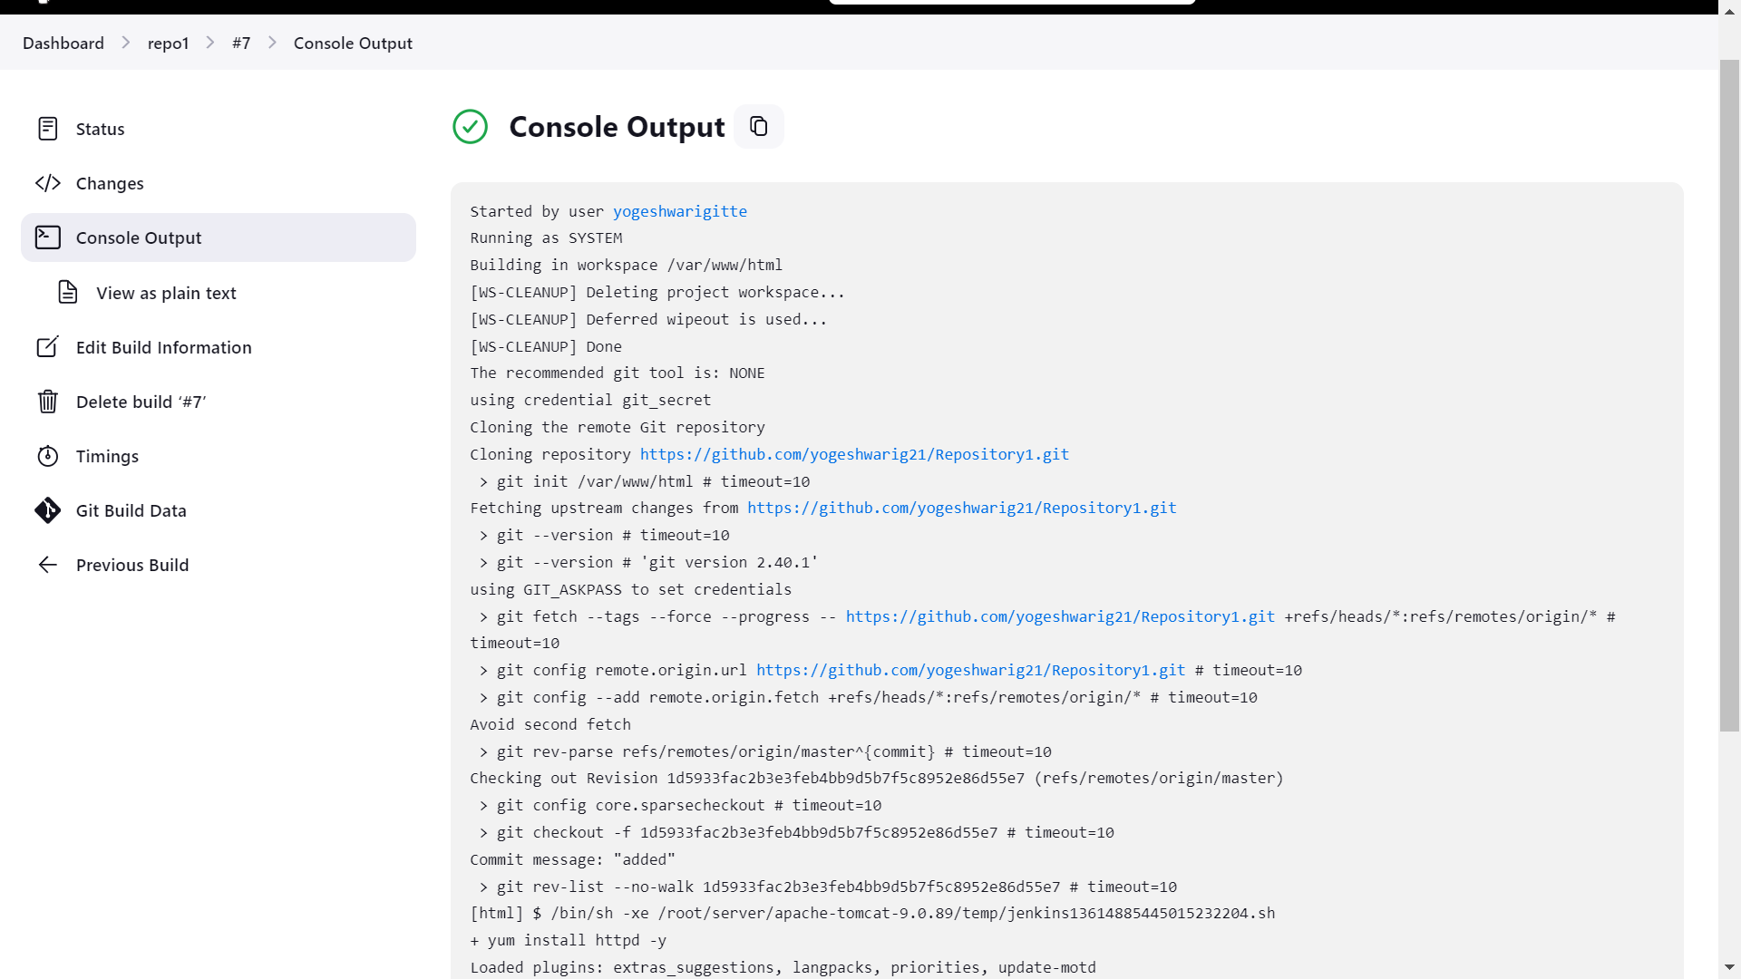

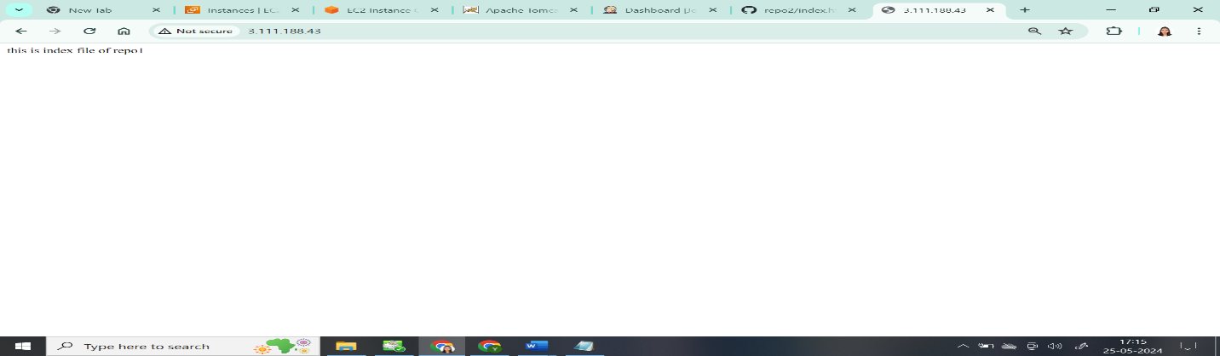 for job2 repo2:

Custome workspace:/root/repo2

Execute shell:

cd /var/www/html

cp /root/repo2/index.html .

chmod -R 777 index.html

