Phase 4: Process Automation (Admin) - EV Charging CR

Goal: Automate tasks in EV Charging CRM for efficiency and reduce manual work.

# Validation Rules

Objective: Ensure data integrity example: Charging End Time must be after Start Time.

* Setup → Object Manager → Charging Session → Validation Rules → New.
* Formula: End_Time__c < Start_Time__c
* Error Message: “End Time must be after Start Time.”
* Error Location: End Time field.

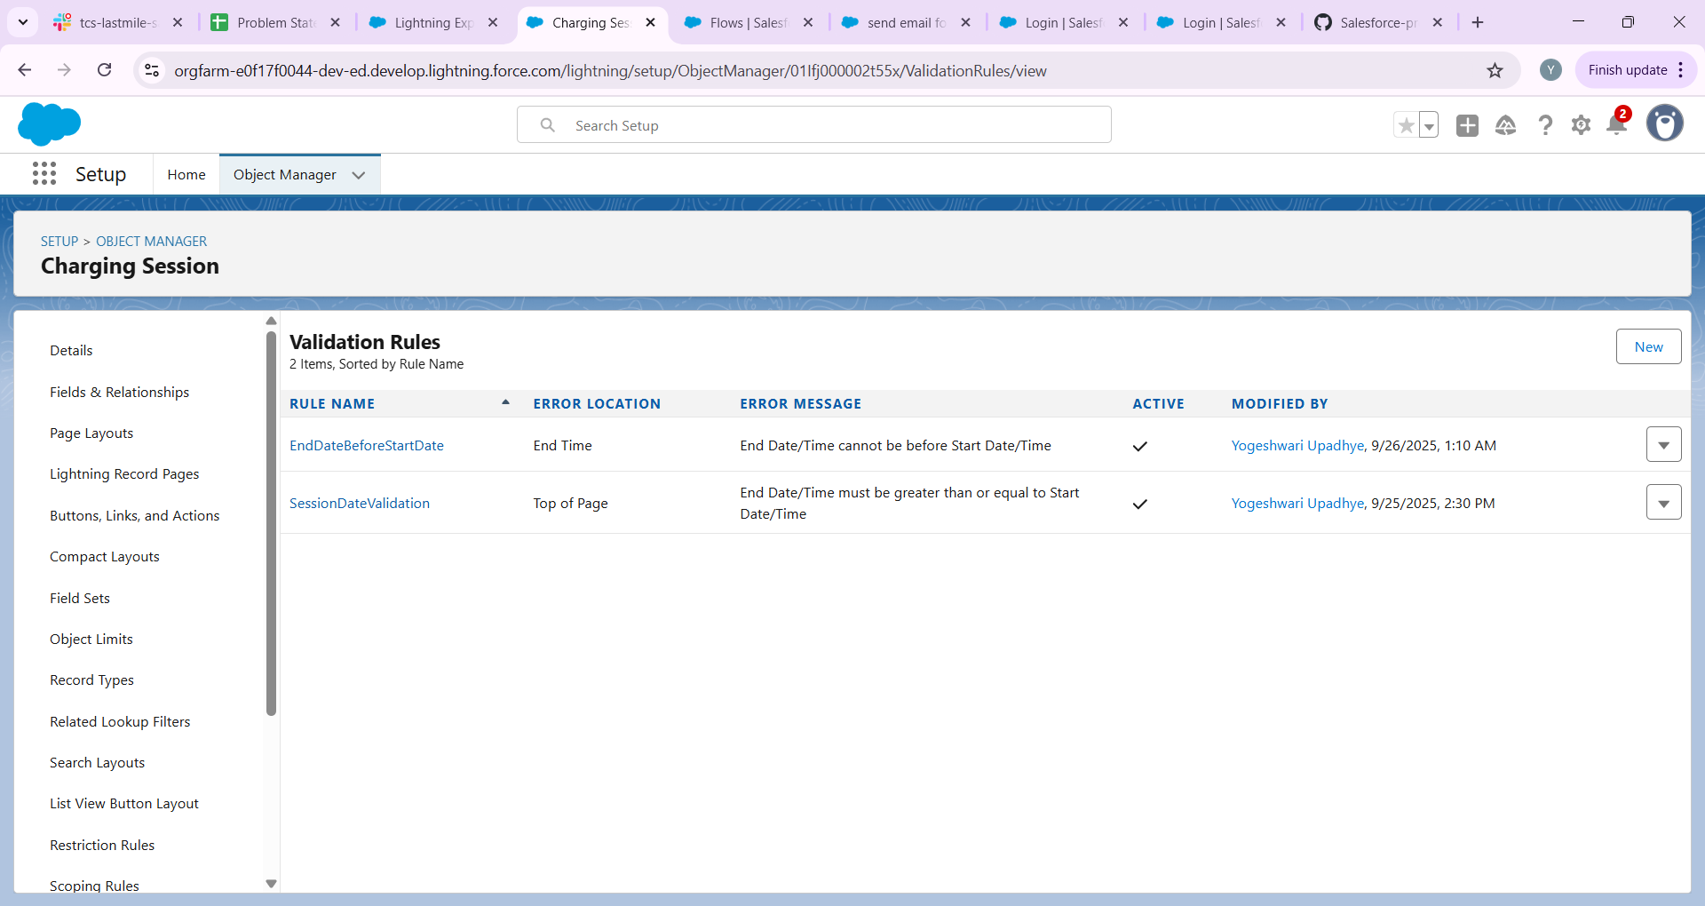

# Workflow Rules (Legacy)

Objective: Auto-send email when a Charging Session is created (for reference).

* Setup → Workflow Rules → New Rule → Object: Charging Session.
* Rule Criteria: Created.
* Action: Send Email Alert to Customer.

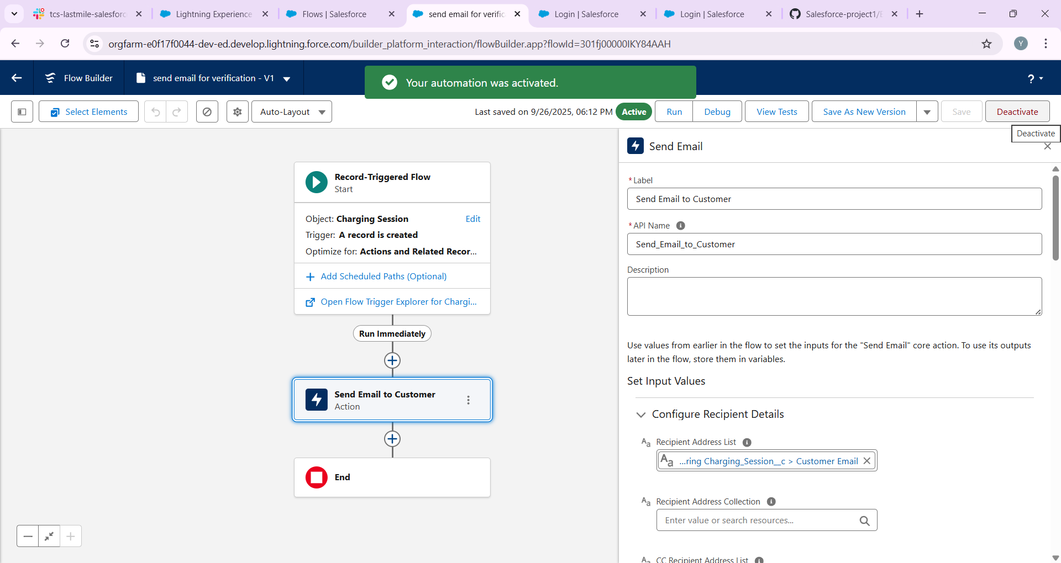

# Process Builder (Legacy)

Objective: Auto-update Charging Session Status from 'Pending' → 'Completed'.

Screenshot: [Attach Process Builder canvas screenshot here]

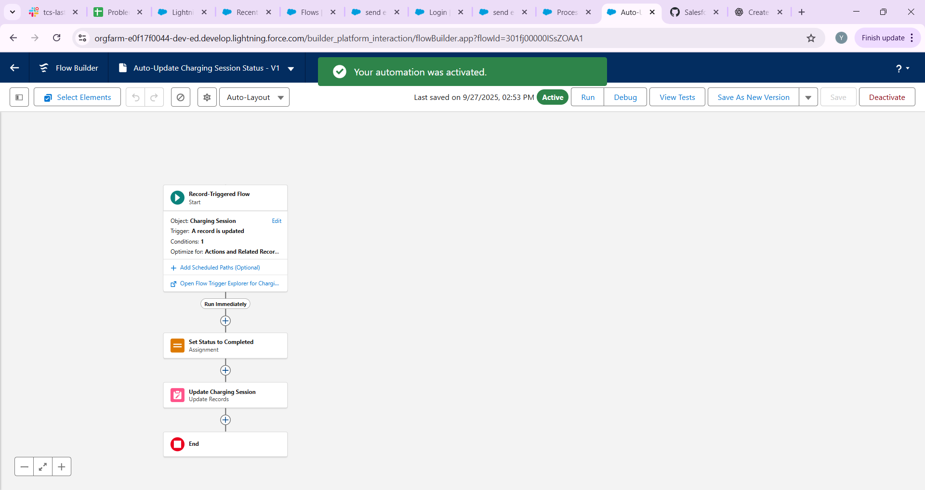

# Approval Process

Objective: High-value sessions require Manager approval.

* Setup → Approval Processes → Create New Approval Process → Use Wizard.
* Entry Criteria: Total Amount > 5000.
* Approver: Manager.
* Actions: Initial Submission → Send Email to Manager.
* Final Approval → Update Status = 'Approved'.

When a **Charging Session** is created/updated with **Total Amount > ₹50,000**:

* User clicks **Submit for Approval** on the record.
* Request goes to **Manager**.
* Manager gets an **email notification** + can **Approve/Reject**.
* Once approved → you can add an **action** (like update Booking Status to Confirmed).

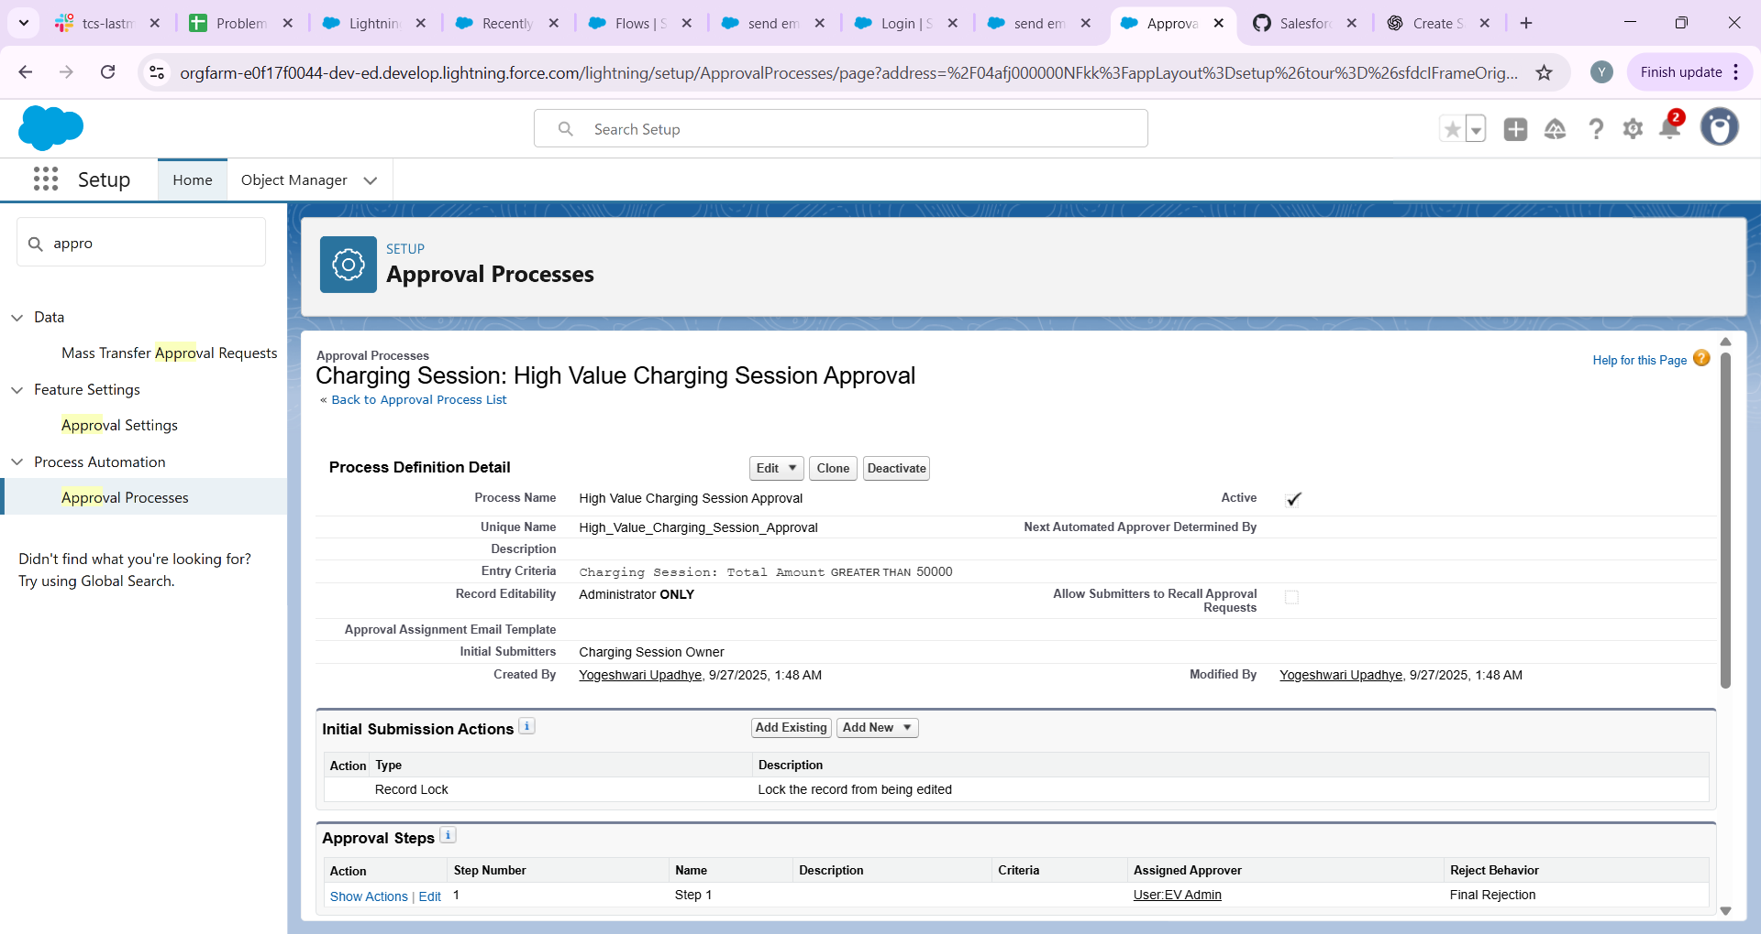

# Flow Builder

Objective: A. Record-Triggered Flow – Auto-calculate Total Amount  
B. Screen Flow – Booking Form

* Record-Triggered Flow Steps:
* 1. Setup → Flow → New → Record-Triggered Flow.
* 2. Object: Charging Session → Trigger: Created or Updated.
* 3. Add Assignment → Set $Record.Total_Amount__c = $Record.Charging_Units__c * $Record.Rate_per_kWh__c
* 4. Update Record → $Record.
* Screen Flow Steps:
* 1. Setup → Flow → New → Screen Flow.
* 2. Add Screen → Fields: Customer Name, Vehicle, Start/End Time, Charging Units.
* 3. Submit Button → Create Charging Session Record.

Screenshot: [Attach Flow canvas screenshot here]

---

# Email Alerts

Objective: Notify customers after approval.

* Setup → Email Alerts → New → Object: Charging Session.
* Recipients → Customer Email.
* Template → 'Your EV charging session is confirmed.'
* 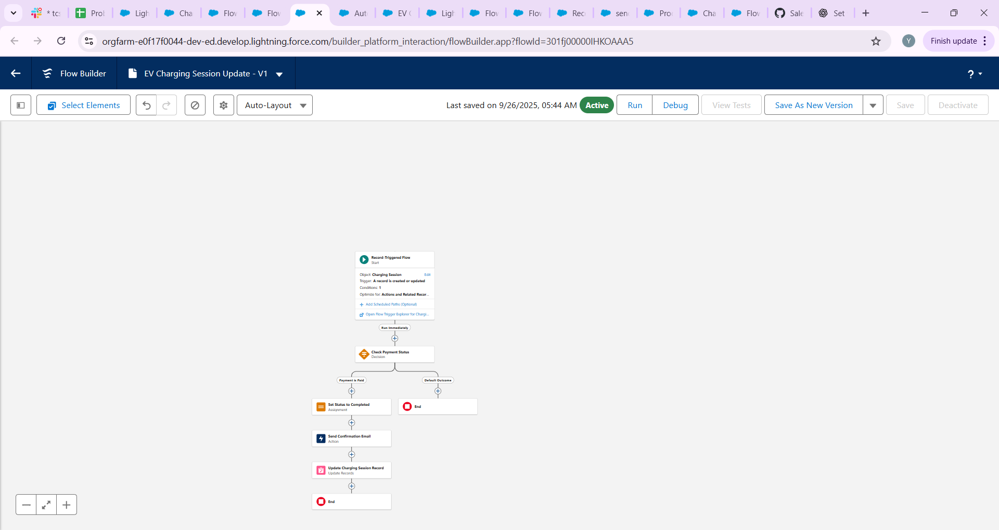

# Field Updates

Objective: Update Booking Status automatically.

* After Approval → Status = 'Confirmed'.

