# EV Charging CRM Project – Phase 9: Reporting, Dashboards & Security Review

## Objective

Monitor business operations, measure performance, and secure data access for the EV Charging CRM. This phase builds reports and dashboards for stakeholders and configures sharing and security settings to protect sensitive information.

## 1. Reports

Create the following reports to monitor key metrics and operations:

### Charging Station Utilization

Purpose: Show how many sessions and total charging units per station over a period.  
Steps:  
1. Go to Reports → New Report.  
2. Select report type: Charging Sessions (or a custom report type combining Charging Session and Charging Station).  
3. Add filters: Date range = Last 30 days (or custom), Status = Completed.  
4. Group rows by Charging Station Name.  
5. Columns: Count of Session Id, Sum of Charging_Units__c, Sum of Total_Amount__c.  
6. Add chart: Column or Stacked Column. Save as 'Charging Station Utilization'.

### Revenue by Station (or by Station Type)

Purpose: Shows revenue collected per station or station model.  
Steps:  
1. New Report → Charging Sessions.  
2. Filters: Date range, Payment Status = Paid.  
3. Group by Charging Station Name or Station Model.  
4. Columns: Sum of Total_Amount__c.  
5. Add chart: Pie or Donut for share, or Bar for comparison. Save as 'Revenue by Station'.

### Energy Consumption by Day

Purpose: Daily kWh consumption trend to identify peak usage times.  
Steps:  
1. New Report → Charging Sessions.  
2. Filters: Date range = Last 30 days.  
3. Group by Start Date (calendar day) or use a row-level formula to extract day.  
4. Columns: Sum of Charging_Units__c.  
5. Add a Line Chart. Save as 'Energy Consumption by Day'.

### Top Customers by Revenue

Purpose: Identify customers contributing most revenue.  
Steps:  
1. New Report → Charging Sessions with Customer.  
2. Filters: Payment Status = Paid, Date range as needed.  
3. Group by Customer Name.  
4. Columns: Sum of Total_Amount__c. Add Top N filter to show top 10. Save as 'Top Customers by Revenue'.

### Payment Status Summary

Purpose: Quick status of payments (Paid, Pending, Failed) for reconciliation.  
Steps:  
1. New Report → Charging Sessions.  
2. Group by Payment_Status__c.  
3. Columns: Count of sessions and Sum of Total_Amount__c. Save as 'Payment Status Summary'.

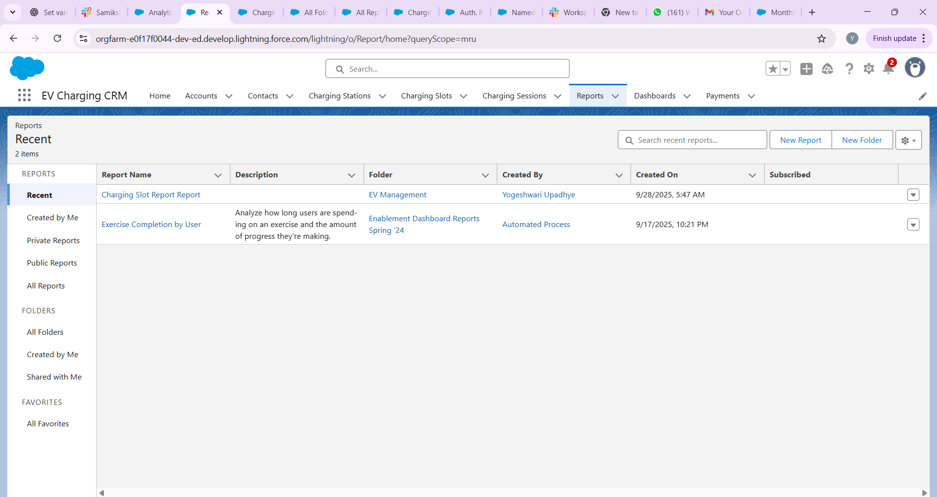

## 2. Report Types

If you need combinations of objects (for example, Charging Session with Charging Station or Charging Session with Customer), create a Custom Report Type:

Steps:  
1. Setup → Report Types → New Custom Report Type.  
2. Primary Object: Charging_Session__c.  
3. Related Object: Charging_Station__c (if you want station fields) or Contact/Account for customer fields.  
4. Define the relationship (Each "A" record must have at least one related "B" record or optionally include records without related items).  
5. Deploy the report type and use it when creating reports to access fields from both objects.

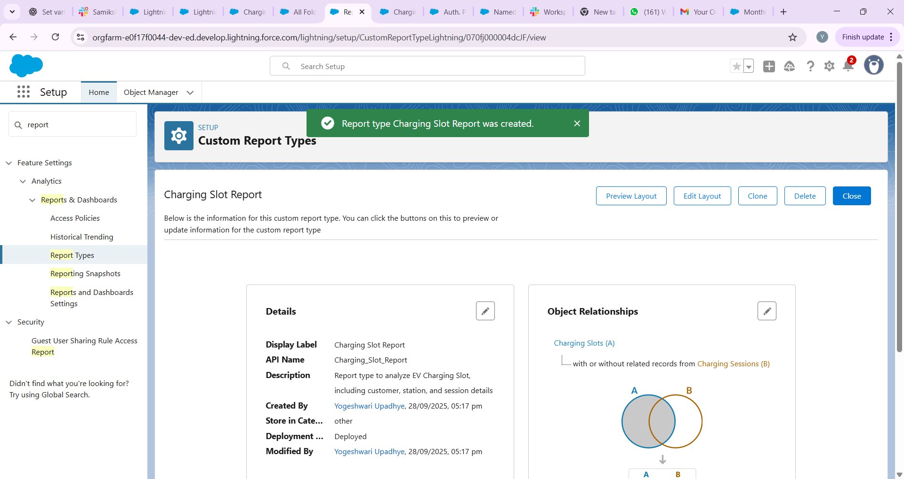

## 3. Dashboards

Dashboards combine reports into visual components for stakeholders. Create a few dashboards:

### Operations Overview Dashboard

Components: Energy Consumption by Day (Line), Charging Station Utilization (Bar), Payment Status Summary (Donut), Metric widgets for Today’s Sessions and Today’s Revenue.  
Audience: Operations team.

### Manager Revenue Dashboard

Components: Revenue by Station (Bar), Top Customers by Revenue (Table), Revenue trend (Line), Monthly revenue metric.  
Audience: Finance / Managers.

### Station Performance Dashboard

Components: Per-station charts and tables, station uptime metrics, average session duration.  
Audience: Field / Station managers.

### Dashboard Creation Steps

1. App Launcher → Dashboards → New Dashboard.  
   2. Enter Name (e.g., Operations Overview), Folder (access control), and select a running user (or make it dynamic).  
   3. Add components by selecting the report and choosing visualization types (chart, table, gauge, metric).  
   4. Configure component properties: grouping, X/Y axes, number formatting, thresholds for gauges.  
   5. Save and run the dashboard. Share the dashboard folder with relevant users and groups.

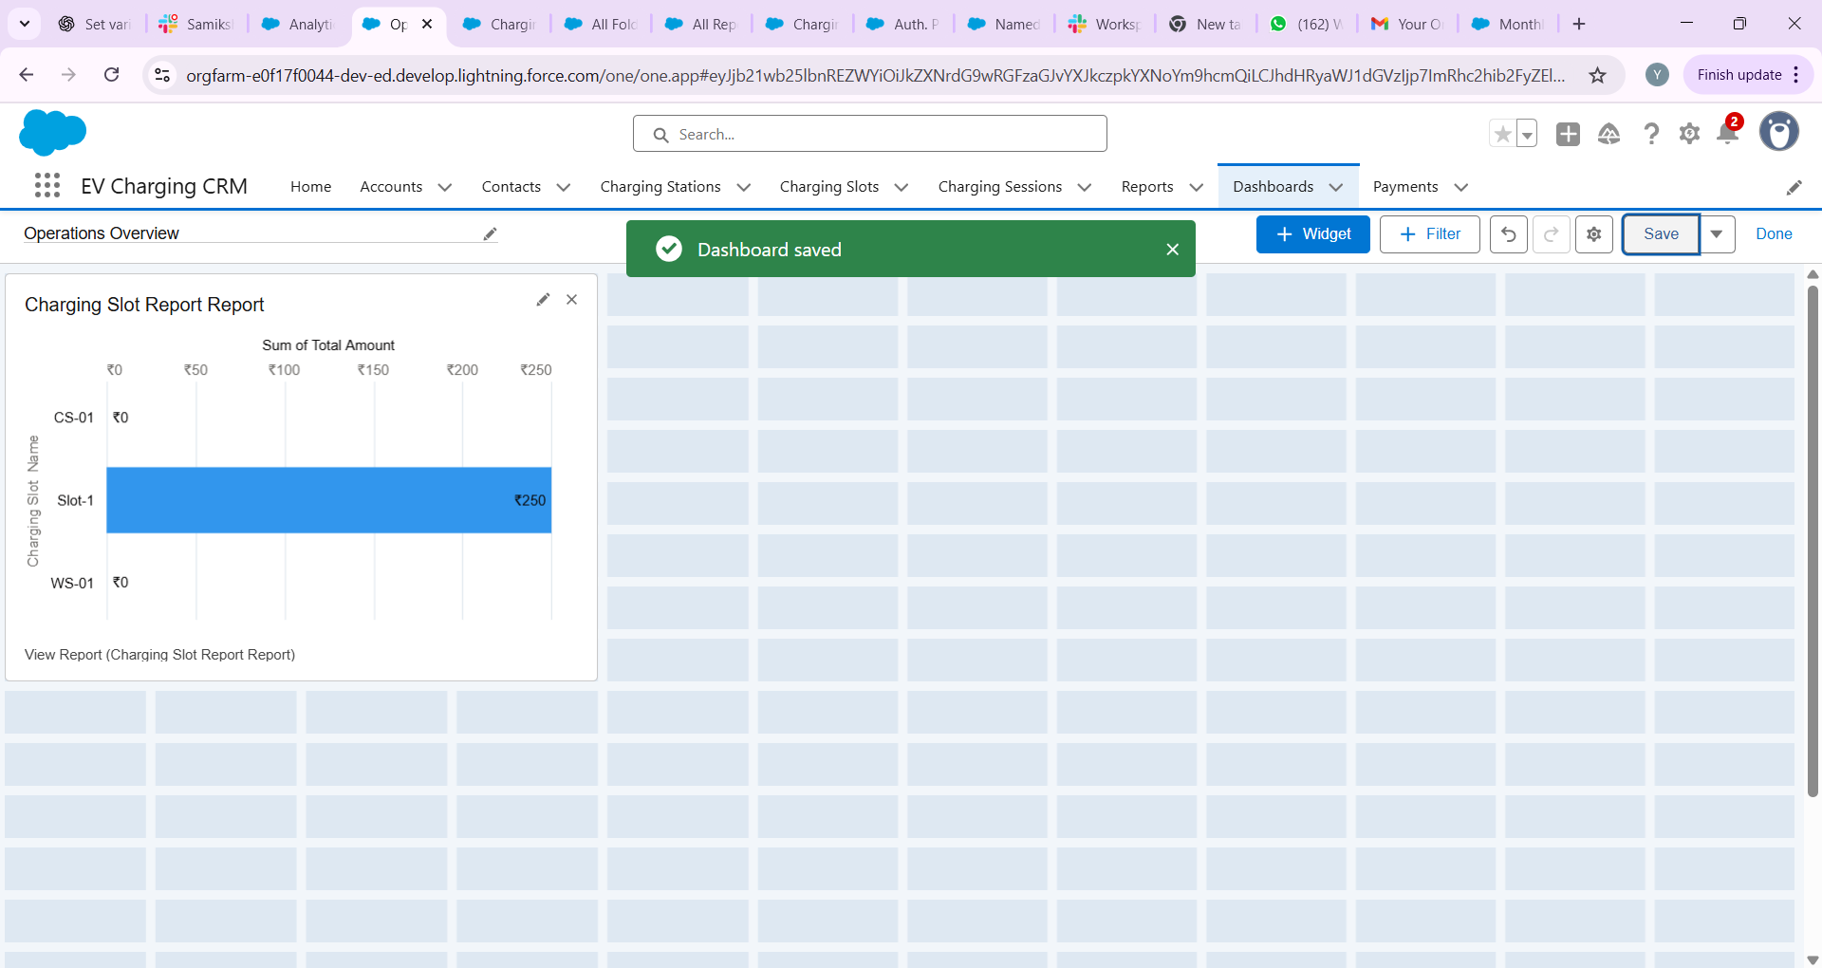

## 4. Dynamic Dashboards

Dynamic dashboards allow the dashboard to run as the logged-in user so each viewer sees data they are permitted to view (row-level security applied).

Steps:  
1. Edit a dashboard → Click "View Dashboard As" → Choose "The dashboard viewer".  
2. Note: Salesforce has limits on the number of dynamic dashboards per org; check org limits in Setup → Reports and Dashboards Settings.  
3. Use dynamic dashboards for manager views or agents who should only see their own bookings/sessions.



## 5. Sharing Settings

Configure Org-Wide Defaults and Sharing Rules to control record visibility:

Recommended settings for EV Charging CRM:

- Charging_Session__c: Private (only owner and shared users can see).

- Charging_Station__c: Public Read Only or Private if stations contain sensitive info.

- Customer/Contact: Private or Controlled by Parent depending on business needs.

Steps to configure:

1. Setup → Security → Sharing Settings.  
   2. Set Organization-Wide Defaults for each object as above.  
   3. Create Public Groups or Roles (e.g., Operations Team, Managers).  
   4. Create Sharing Rules: e.g., share Charging_Session__c to Managers group where Station region = X.  
   5. Use Apex sharing or manual share when complex rules are required.

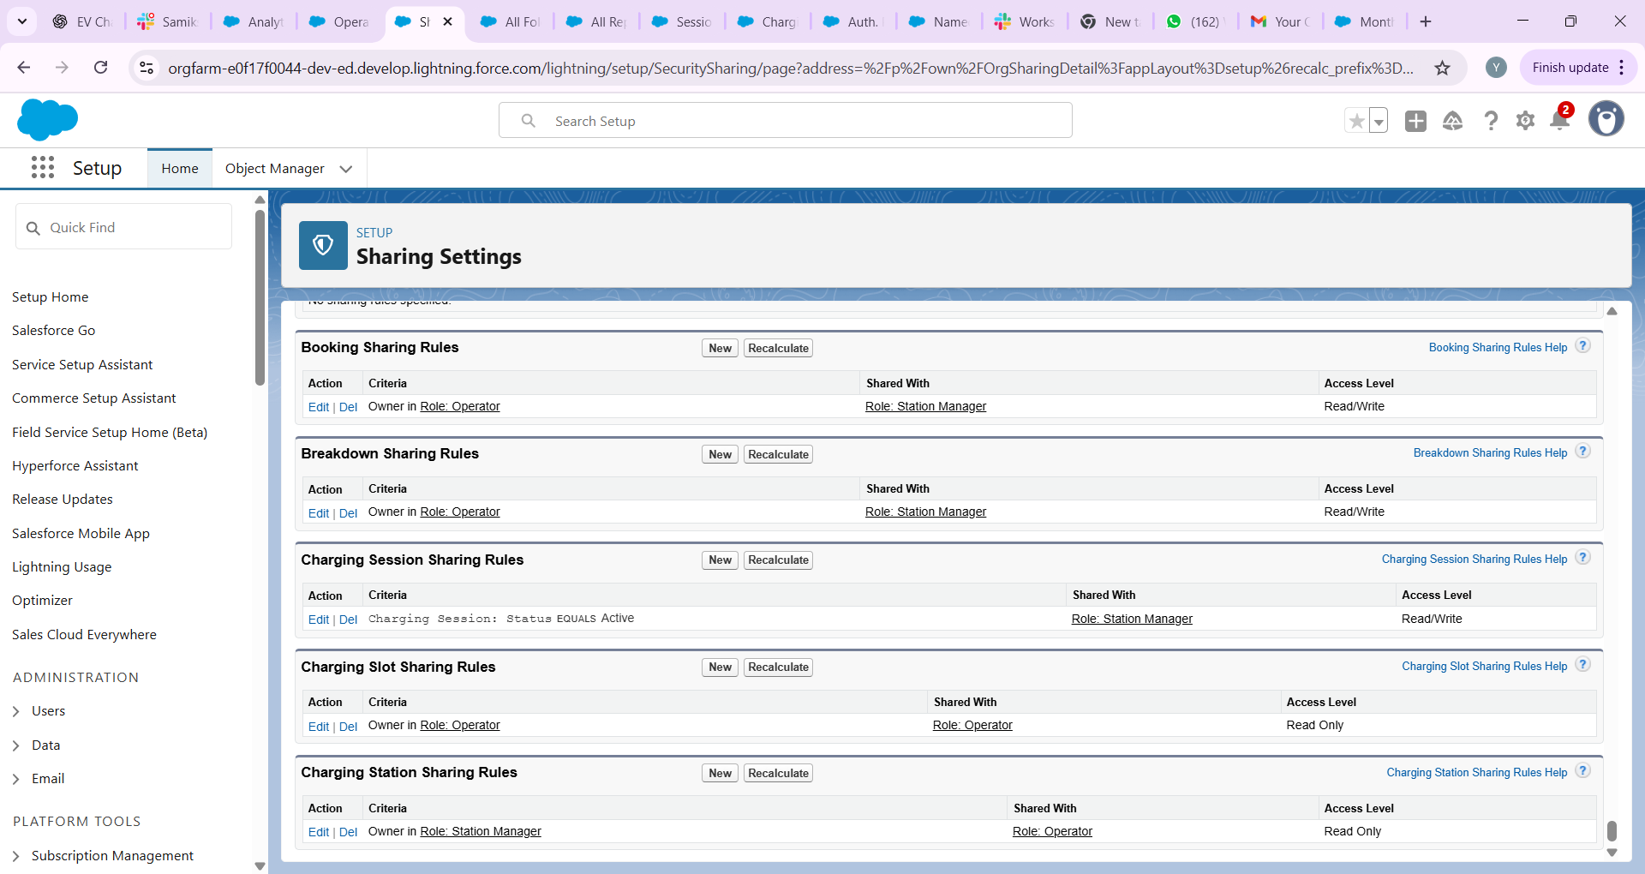

## 6. Field Level Security

Protect sensitive fields by configuring Field-Level Security and Page Layouts. Example: Hide Customer ID Proof field from agents:

Steps:  
1. Setup → Object Manager → Charging_Session__c → Fields & Relationships.  
2. Click the sensitive field (e.g., Customer_ID_Proof__c) → Set Field-Level Security.  
3. Uncheck visibility for Agent profile(s) and ensure System Administrator and Managers have access.  
4. Additionally remove the field from page layouts for profiles that should not see it.

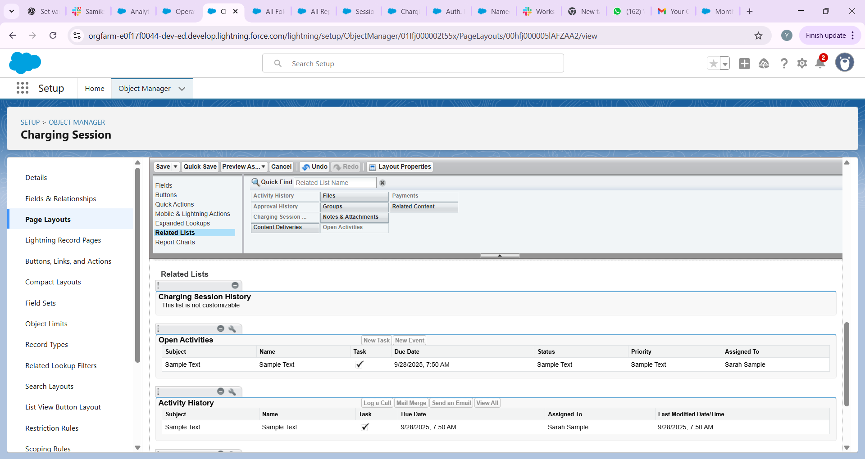

## 7. Session Settings

Configure user session timeout and security settings:

Steps:  
1. Setup → Security → Session Settings.  
2. Set Session Timeout to 30 minutes (or organization standard).  
3. Configure additional settings like Force logout on session timeout if required.

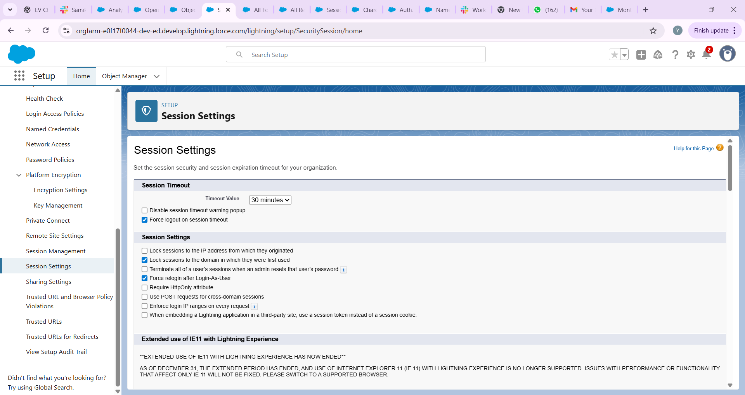

## 8. Login IP Ranges

Restrict access for certain profiles to internal office networks if needed:

Steps:  
1. Setup → Users → Profiles → Select profile (e.g., Agent).  
2. Under Login IP Ranges → Add IP range for office (e.g., 203.0.113.0 to 203.0.113.255).  
3. Save. Users in that profile can only login from allowed IPs.

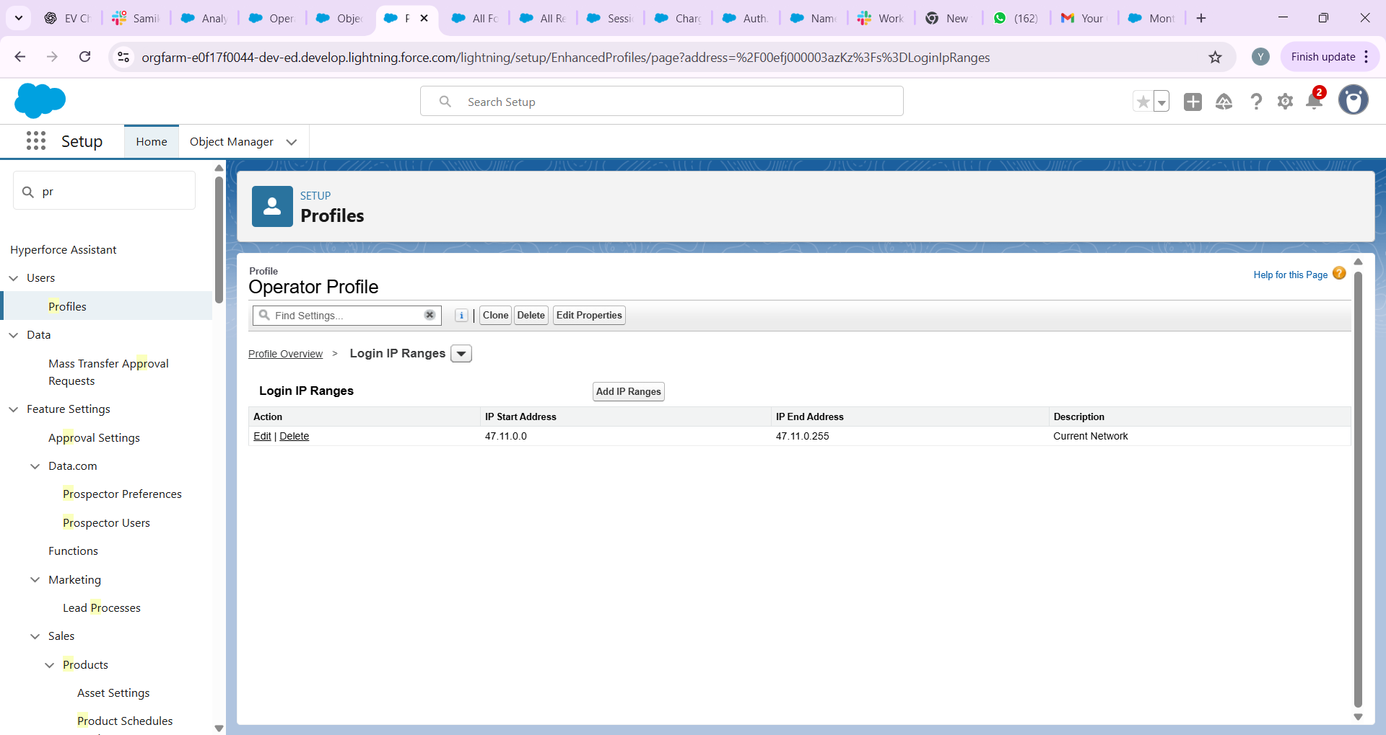

## 9. Audit Trail & Field History Tracking

Enable tracking to record configuration changes and data changes:

Setup Audit Trail:

1. Setup → View Setup Audit Trail. This shows recent setup changes for 180 days that you can download.

Field History Tracking:

1. Setup → Object Manager → Charging_Session__c → Fields & Relationships.  
   2. Click Set History Tracking → Select fields to track (e.g., Status, Payment_Status__c, Total_Amount__c).  
   3. Save.  
   4. Add the "History" related list to the Charging Session page layout to view changes.

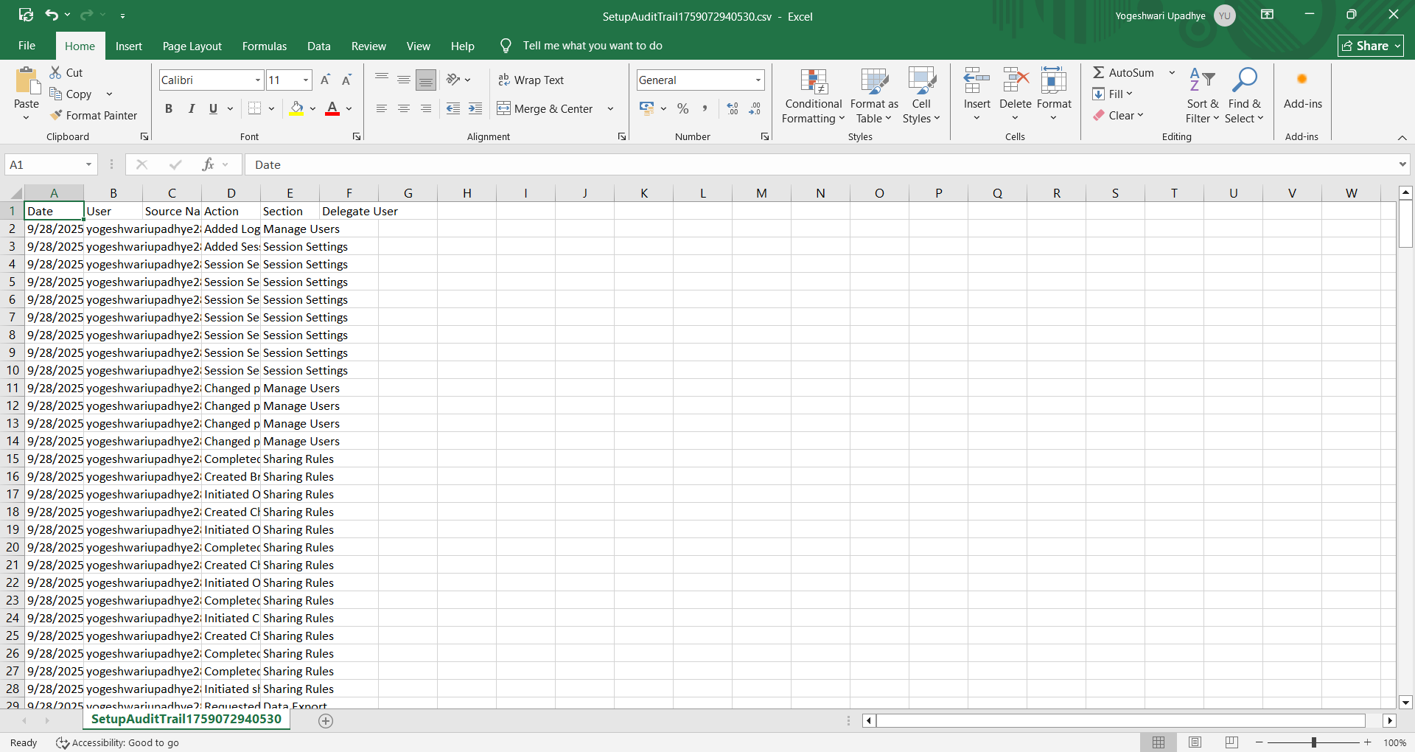

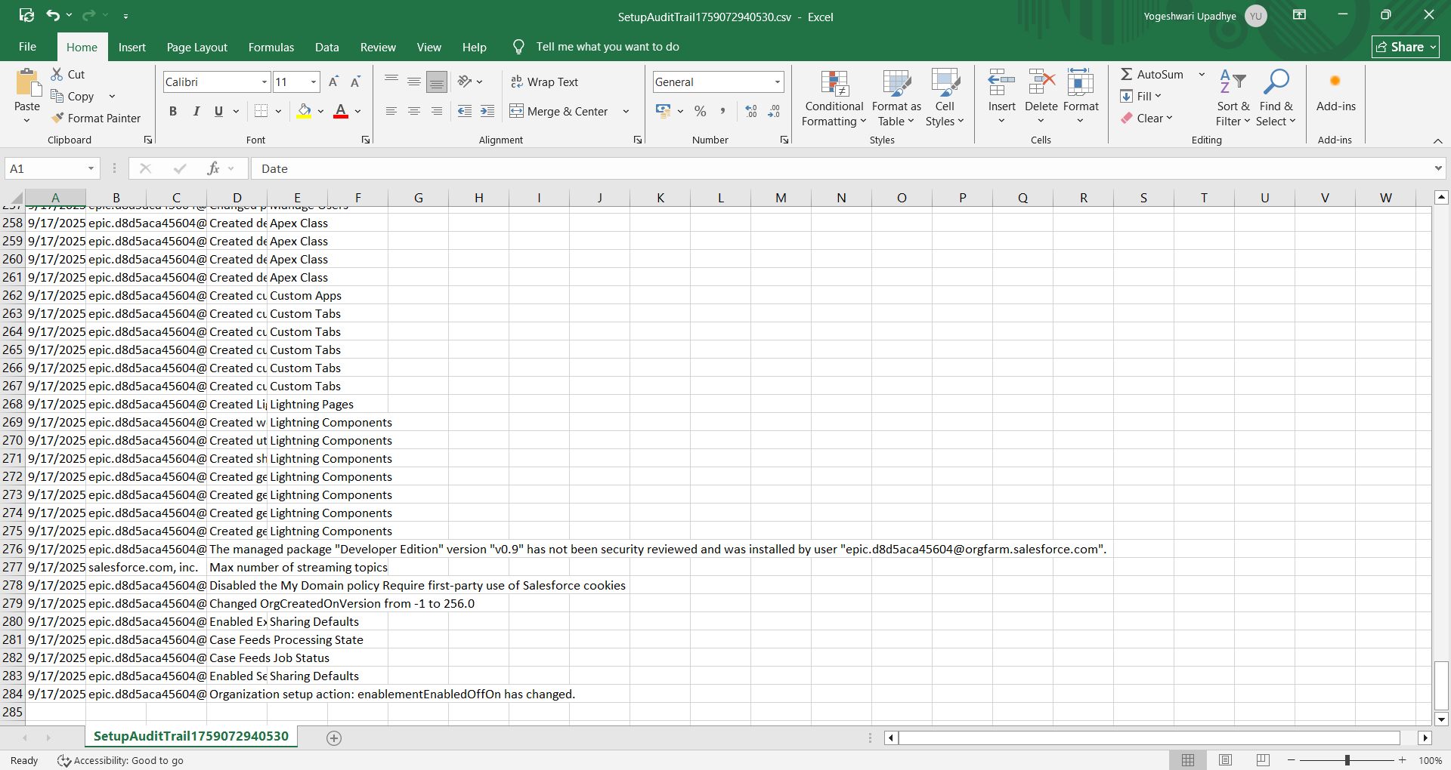

## Conclusion

Phase 9 ensures that stakeholders have visibility into operations and revenue, while enforcing appropriate security controls. Implementing the reports, dashboards, and security measures outlined above will provide a robust monitoring and governance layer for the EV Charging CRM.