# EV Charging Station CRM – Phase 2: Org Setup & Configuration

The goal of Phase 2 is to set up the Salesforce environment for the EV Charging Station CRM. This includes configuring company settings, defining roles and profiles, setting security policies, and preparing the org for further customization.

## 1. Salesforce Edition

• Use a Salesforce Developer Edition (free dev org).  
• Sign up at developer.salesforce.com if not already done.

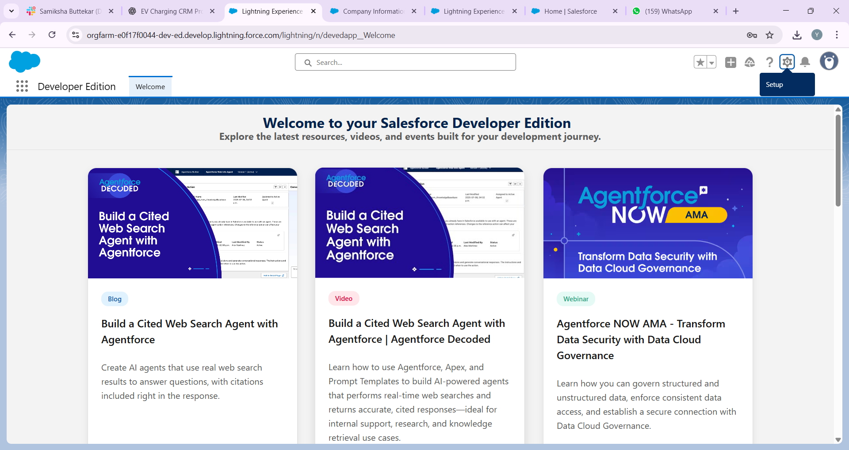

## 2. Company Profile Setup

• Navigate to Setup → Company Settings → Company Information.  
• Update organization name: 'EV Charging Station CRM'.  
• Set default currency (INR/USD).  
• Configure time zone (IST for India).

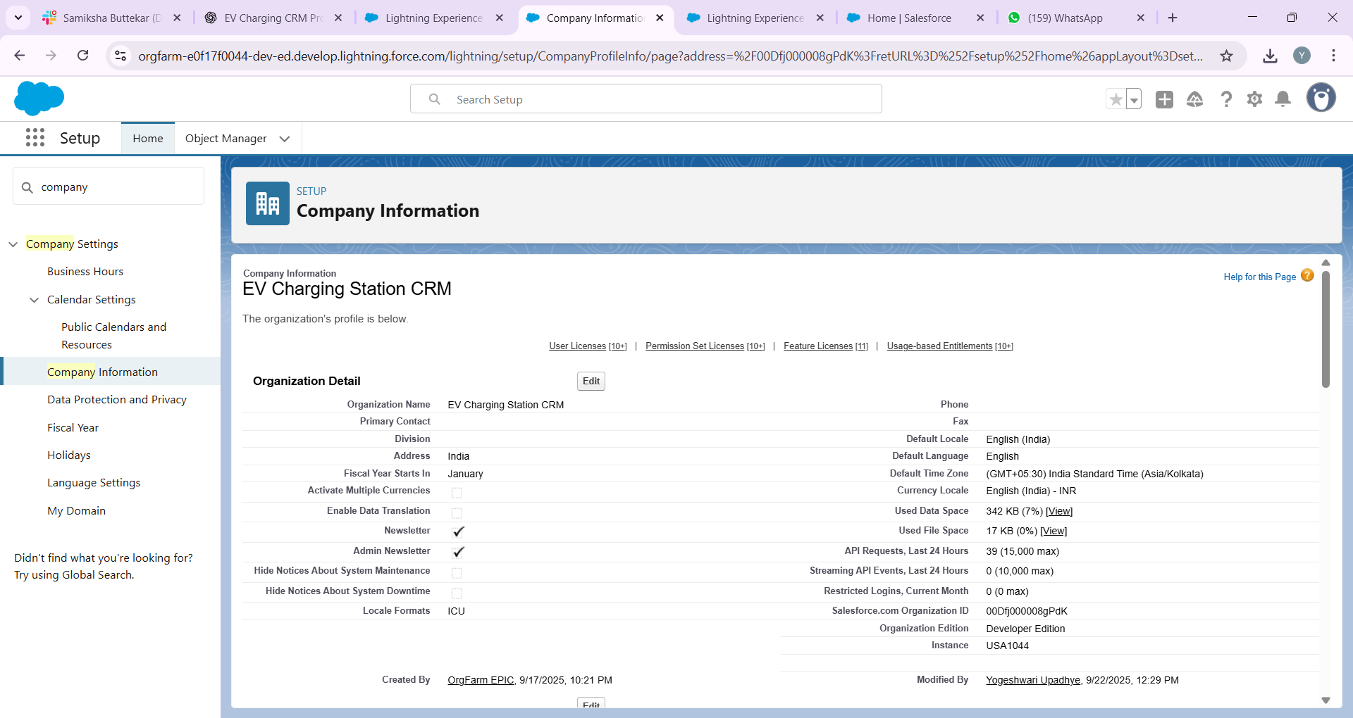

## 3. Business Hours & Holidays

• Go to Setup → Business Hours.  
• Define working hours (9 AM – 6 PM, Mon–Sat).  
• Add public holidays when approvals/maintenance won’t occur.

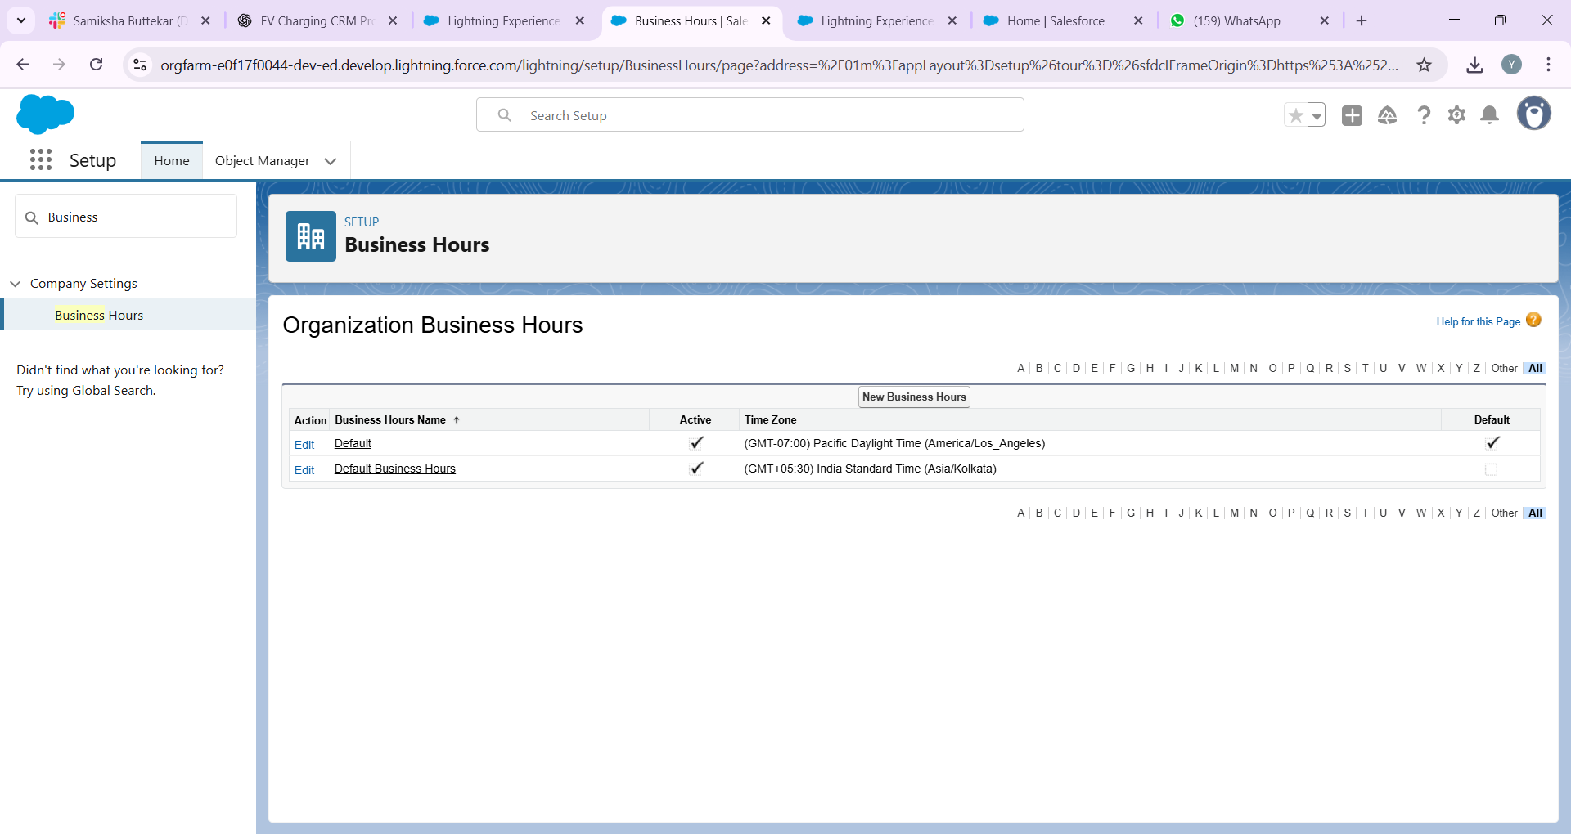

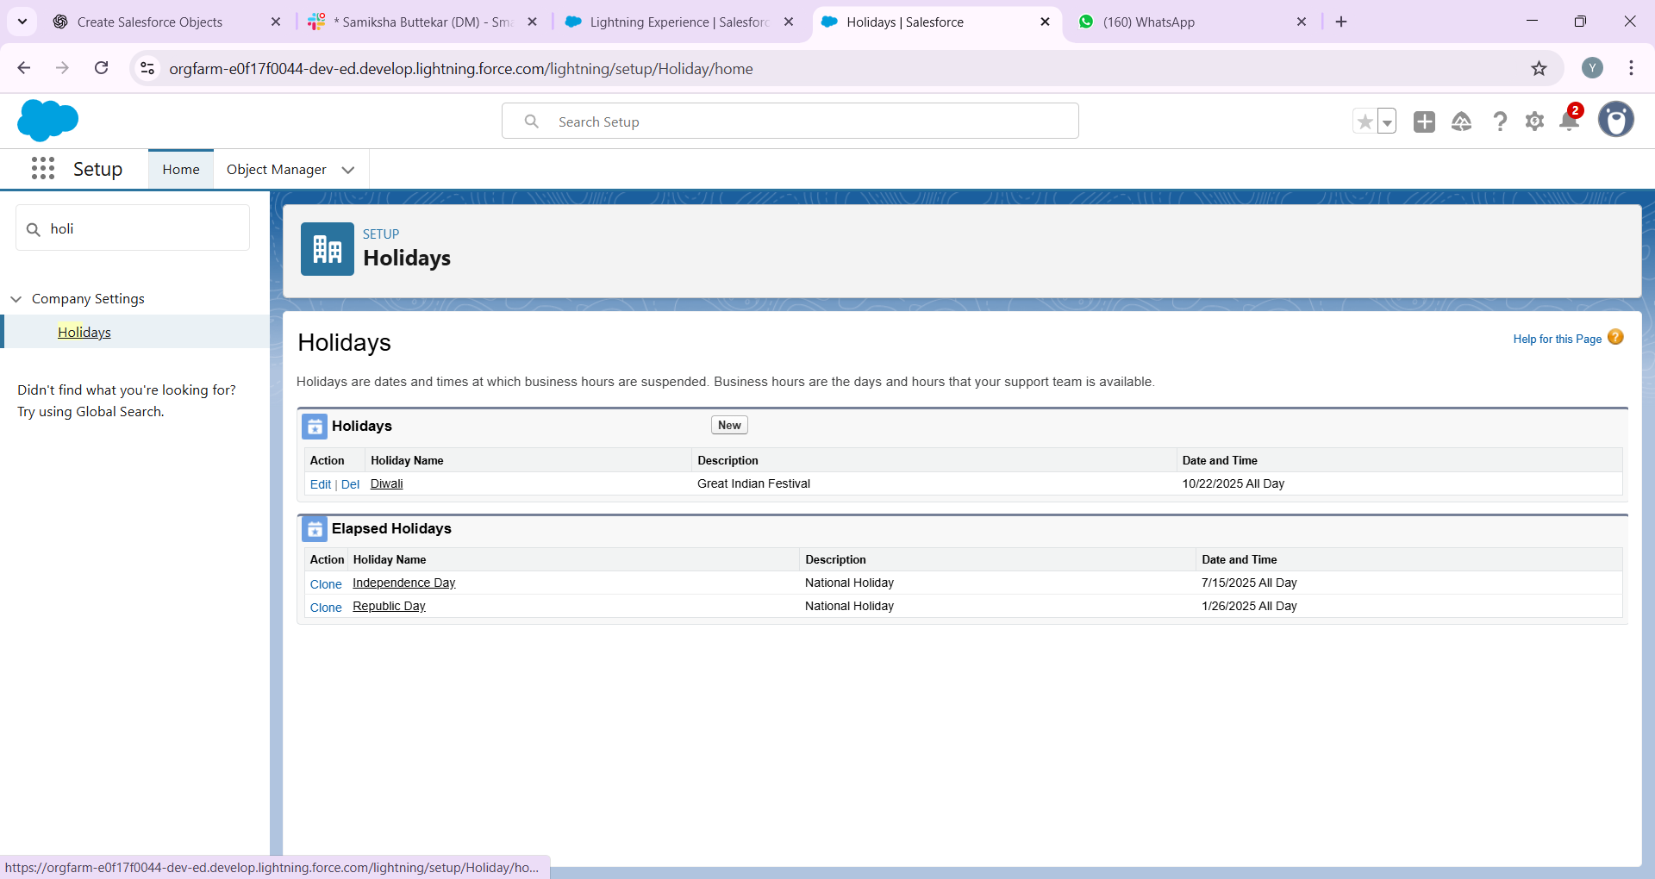

## 4. Fiscal Year Settings

• Go to Setup → Fiscal Year.  
• Select Standard Fiscal Year (Jan–Dec).  
• This helps in generating accurate revenue and utilization reports.

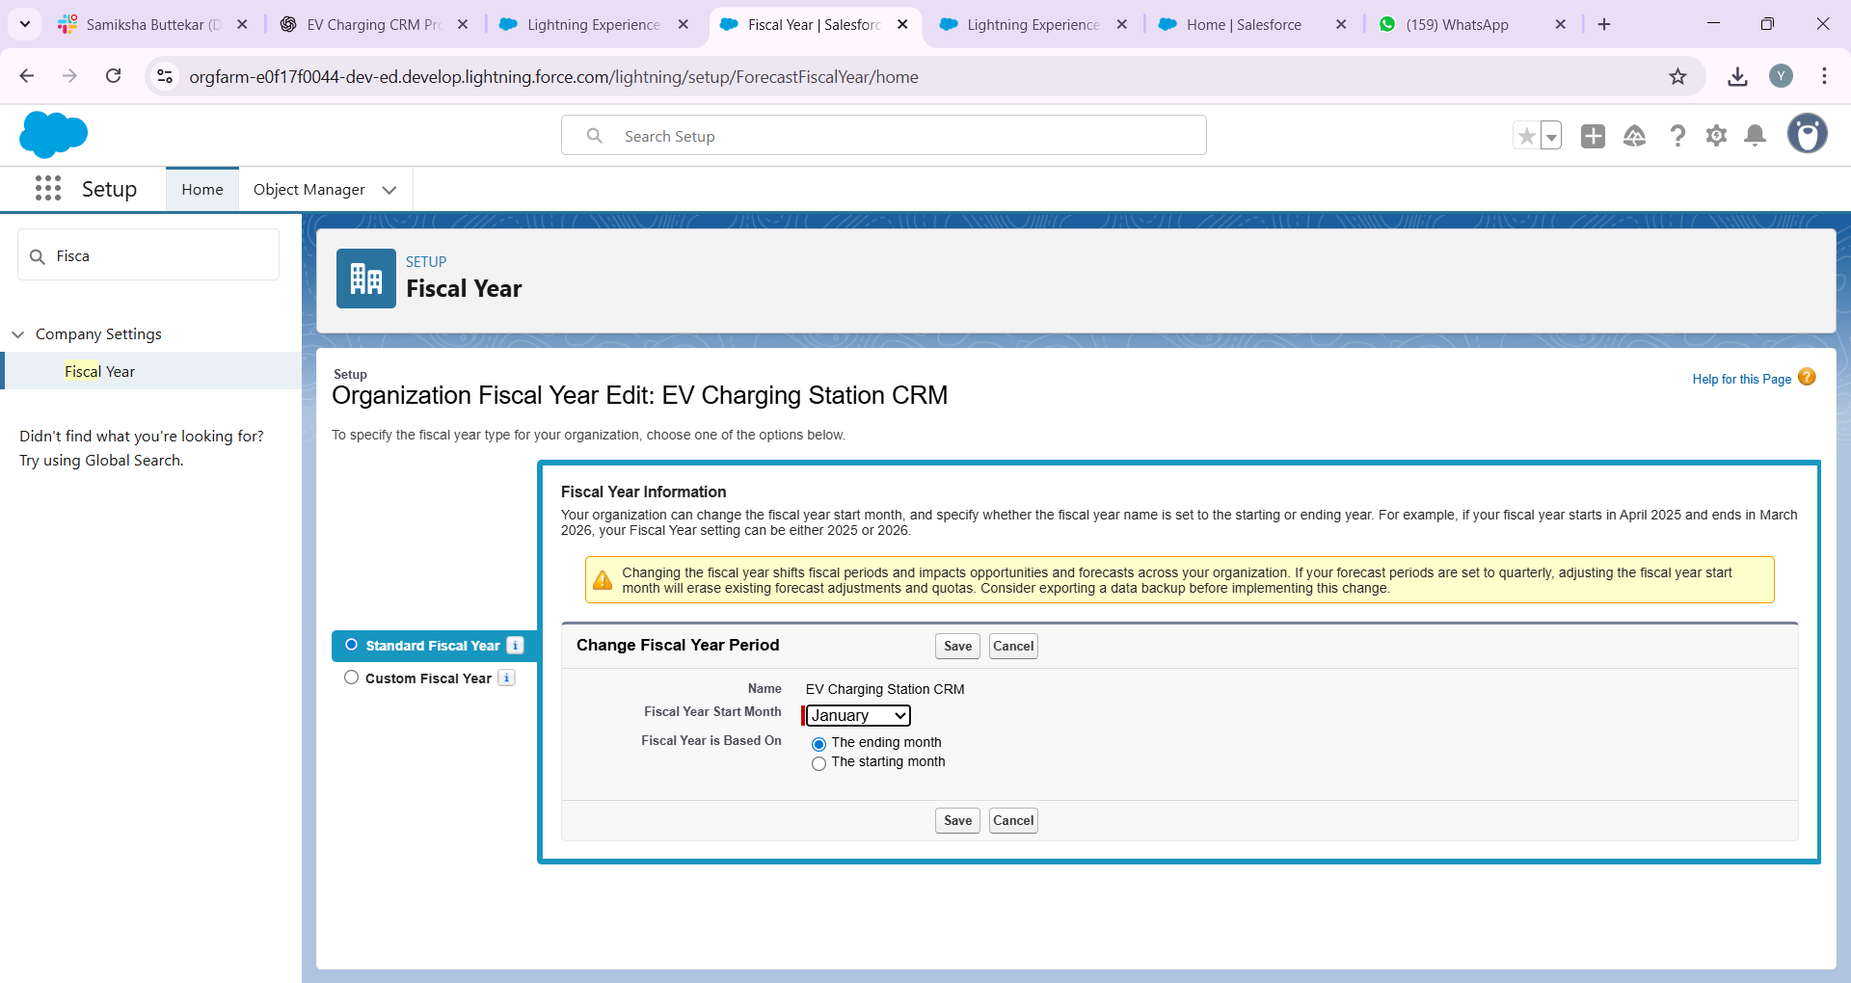

## 5. User Setup & Licenses

• Create user accounts for:  
 - Charging Station Operator (standard user).  
 - Manager (full access).  
 - Customer Service Agent.  
• Assign appropriate Salesforce licenses.

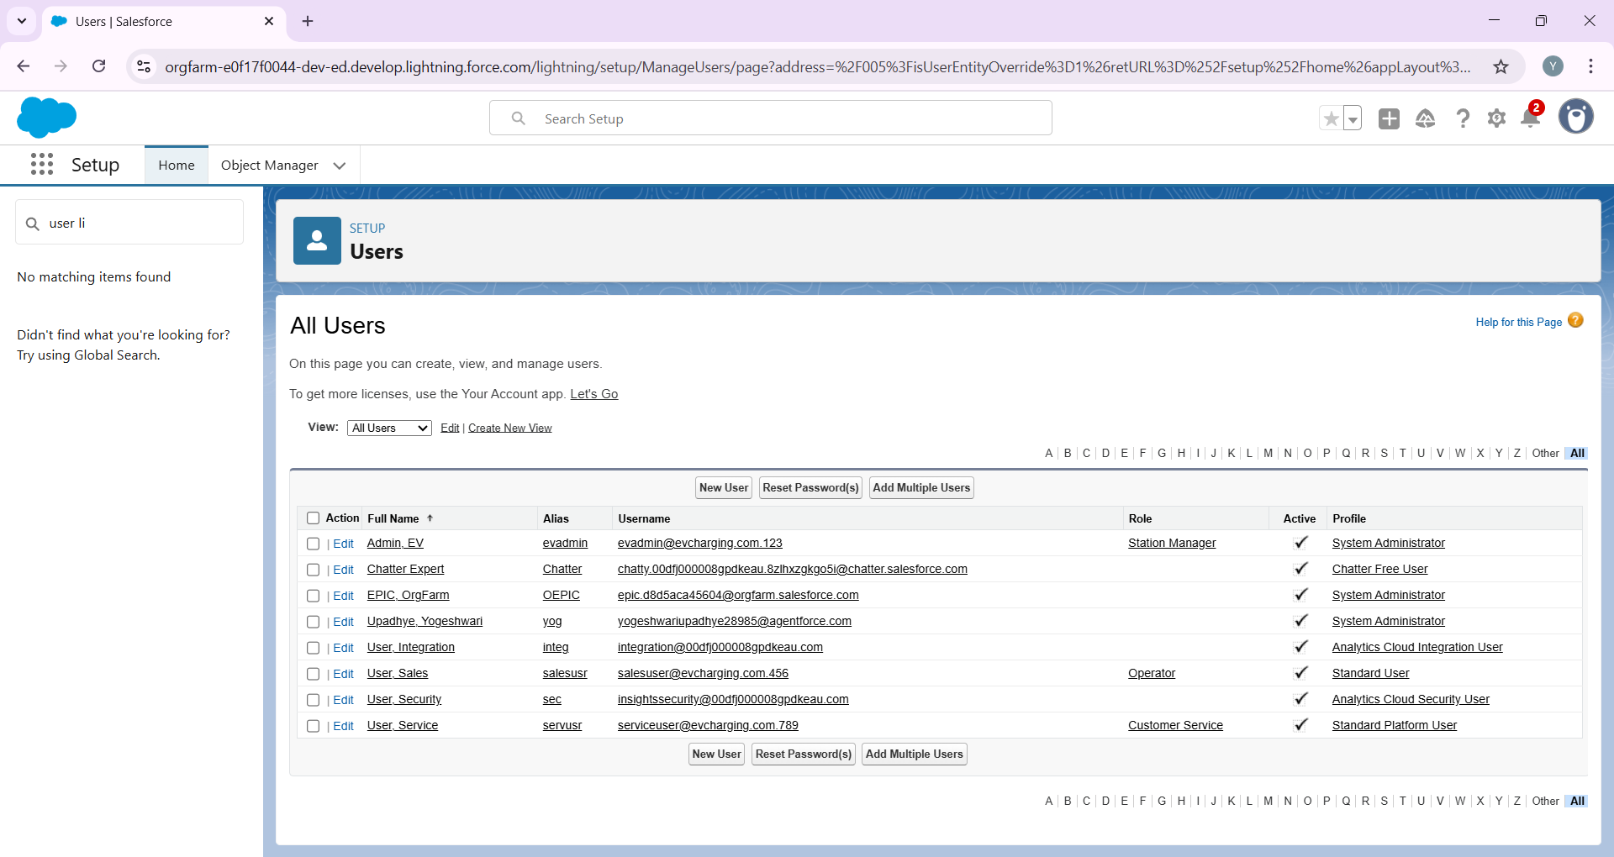

📸 Screenshot: User detail page after creation.

## 6. Profiles

• Operator Profile: Can create/manage slot bookings.  
• Manager Profile: Full CRUD access across objects.  
• Customer Service Profile: Access to breakdown and payment records.

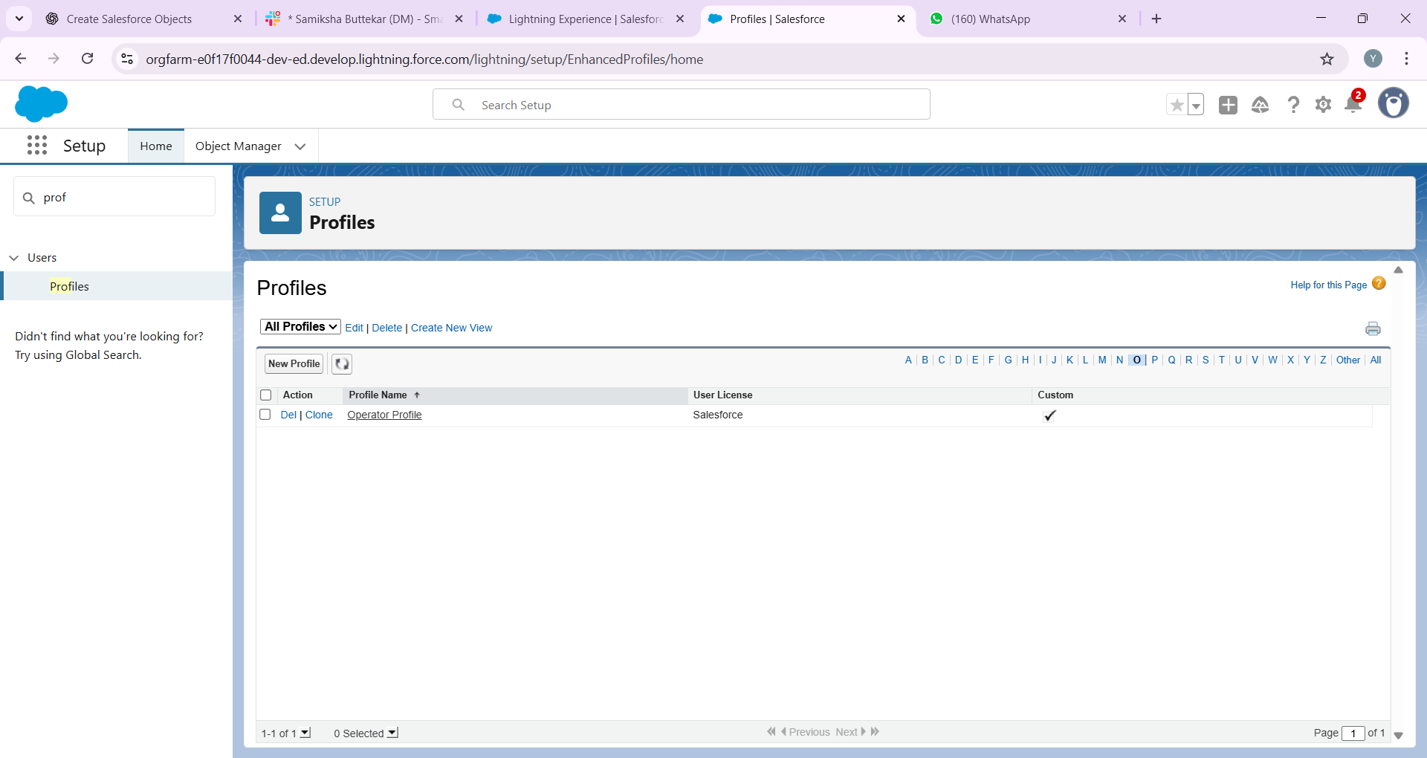

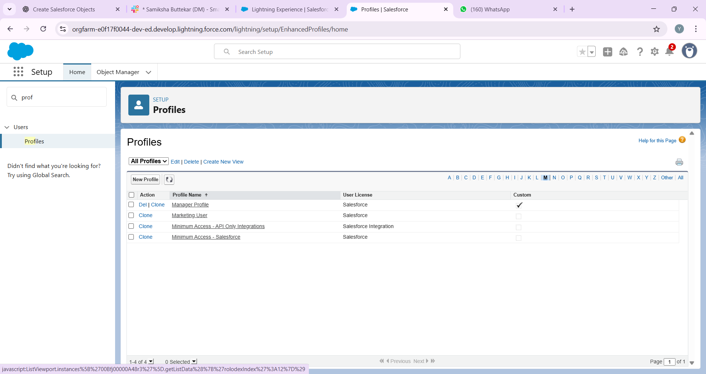

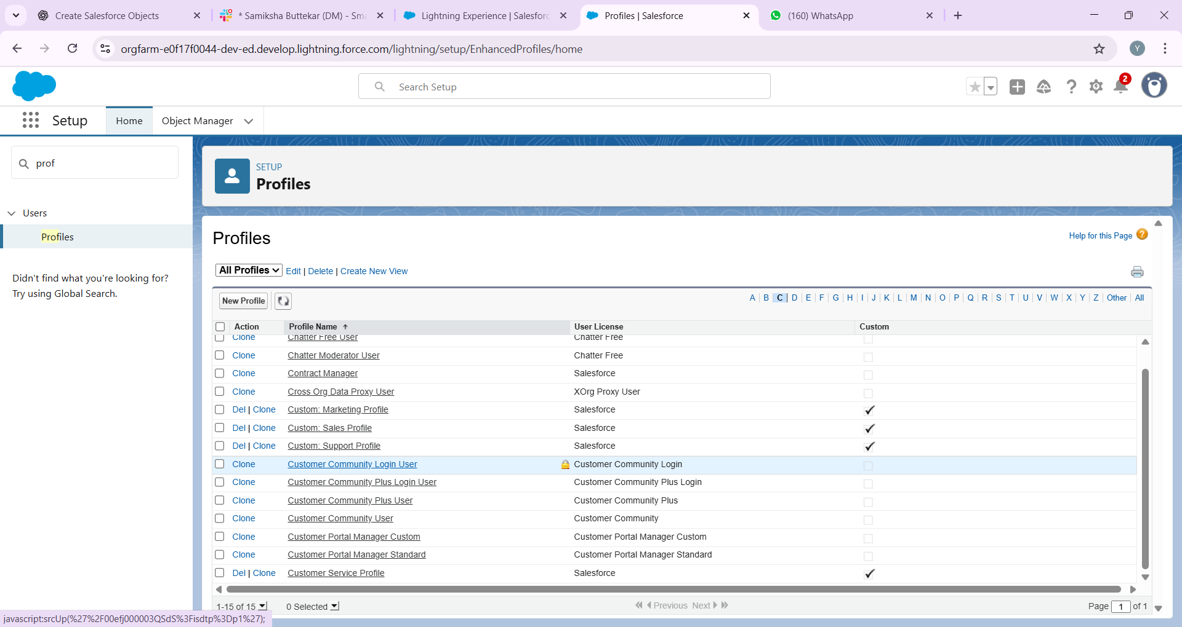

## 7. Roles

• Create a role hierarchy:  
 - Manager (top).  
 - Operators and Customer Service (below Manager).  
• Ensures that record visibility rolls up to the Manager.

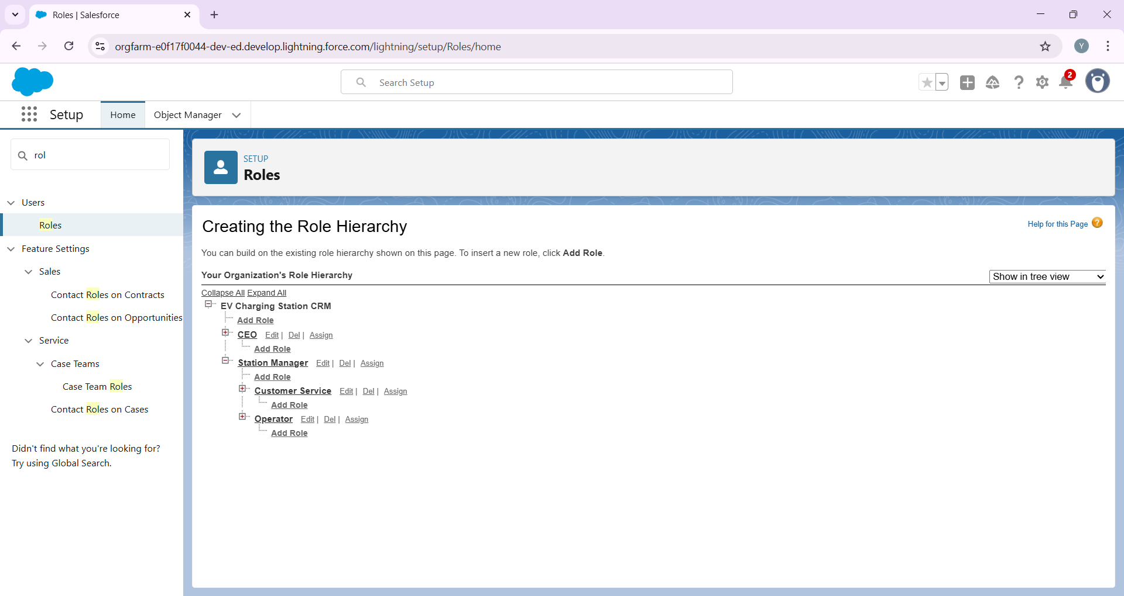

## 8. Permission Sets

• Create permission sets to grant extra access without modifying profiles.  
• Example: A permission set for 'Report Access' that operators can be assigned.

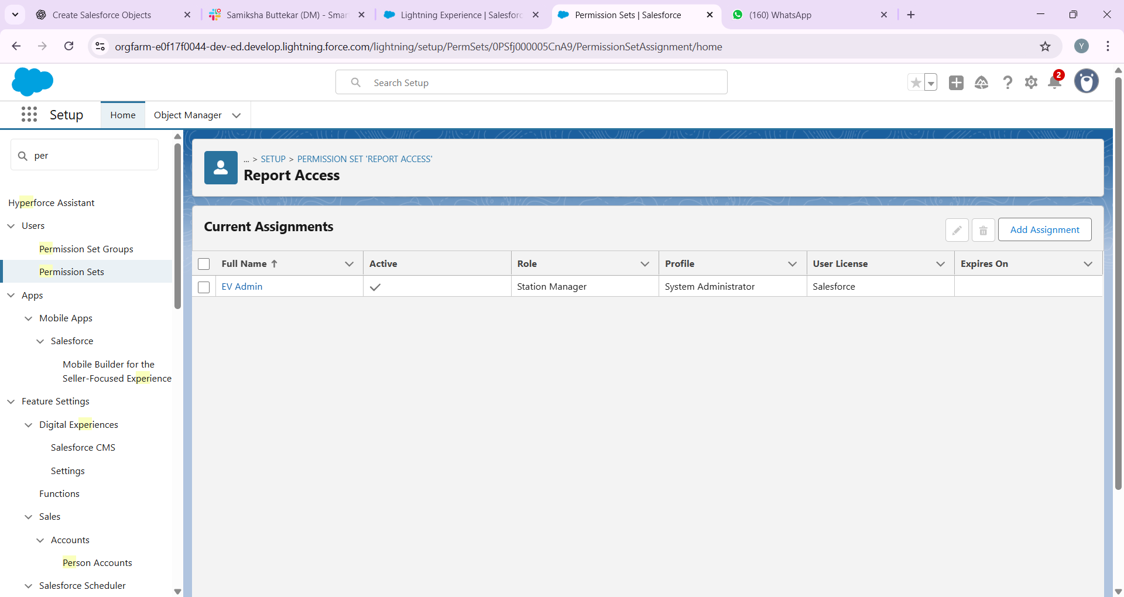

📸 Screenshot: Permission Set detail page.

## 9. Org-Wide Defaults (OWD)

• Charging Station: Public Read Only.  
• Charging Slot: Private (only owner/manager can view).  
• Payment: Private.  
• Breakdown: Controlled by parent (Station/Slot)

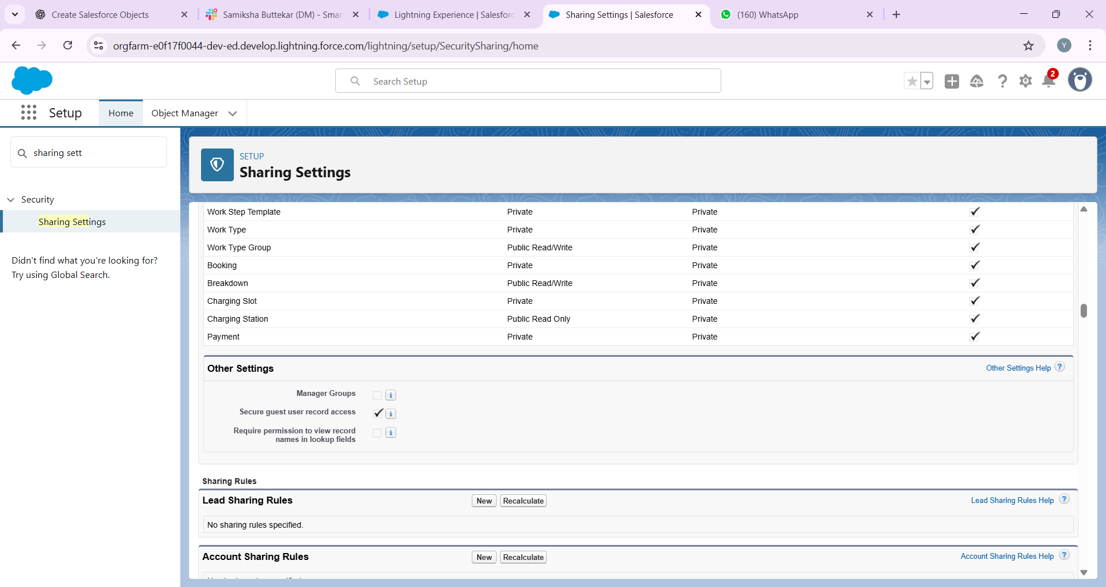

## 10. Sharing Rules

• Create sharing rules to expand access.  
• Example: Allow all Operators in a region to see each other’s bookings.

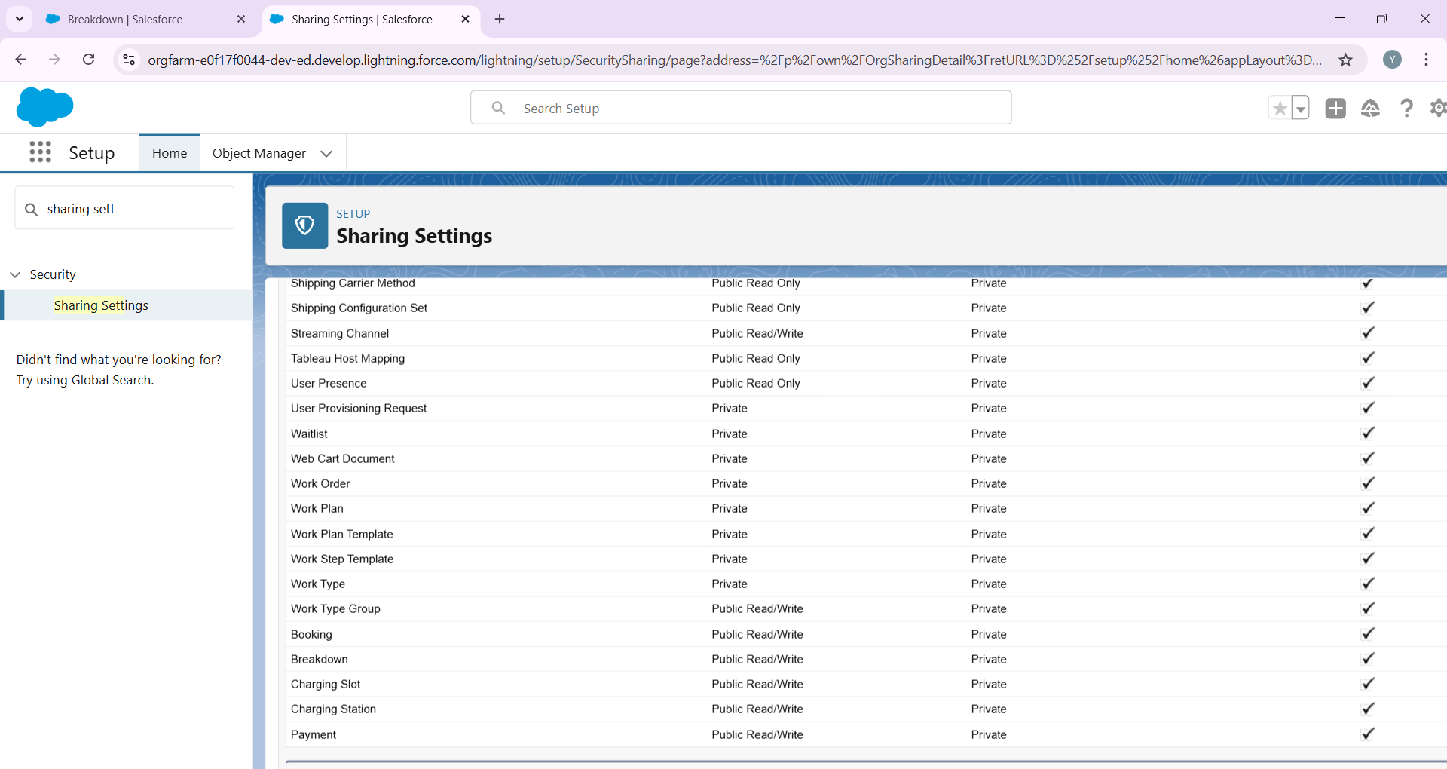

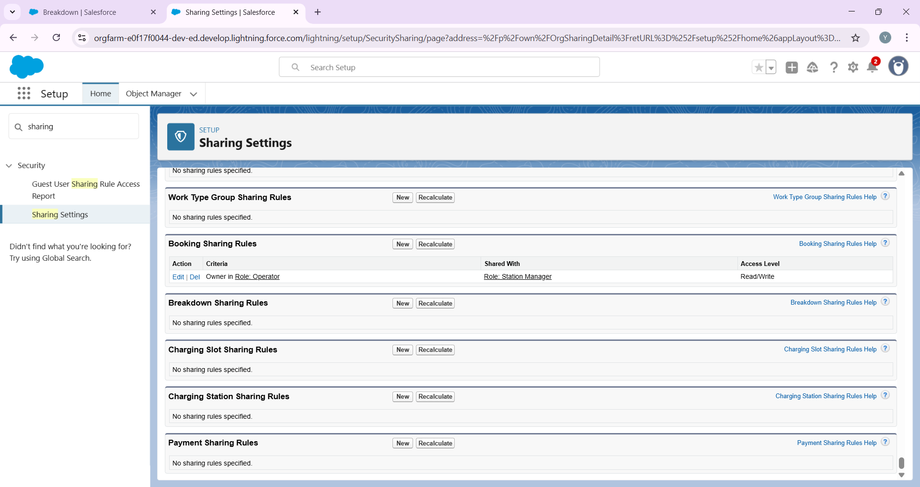

## 11. Login Access Policies

• Restrict agent login hours (9 AM – 6 PM).  
• Restrict login IP ranges to office location (optional).

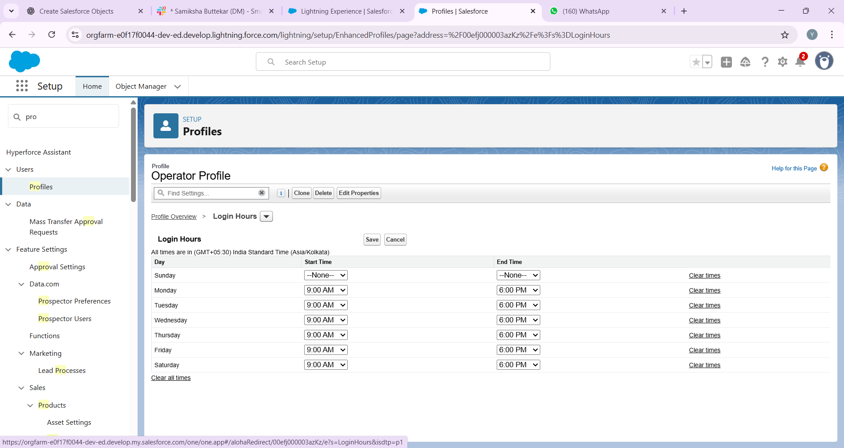

## 12. Developer Org Setup

• Treat this org as a sandbox environment for testing.  
• Build and test features here before deploying to production (if this were a real company).



📸 Screenshot: Setup Home page.

## 13. Deployment Basics

• If working in teams or moving to production:  
 - Use Change Sets for deployment.  
 - Document all configurations.  
 - Follow best practices for backup before deployment.