# EV Charging Station CRM – Phase 3: Data Modeling & Relationships

Goal: Build the data structure (custom objects, fields, relationships) for the EV Charging Station CRM. Follow this step-by-step guide to create objects, fields, relationships, record types, page layouts, and validations without errors.

## Overview: Objects we will create

Standard Object:  
• Contact (use this for customers)  
  
Custom Objects (recommended):  
• Charging Station (Charging_Station__c)  
• Charging Slot (Charging_Slot__c)  
• Charging Session / Booking (Charging_Session__c)  
• Payment (Payment__c)  
• Breakdown / Service Request (Breakdown__c)  
  
Note: Names in parentheses are suggested API names.

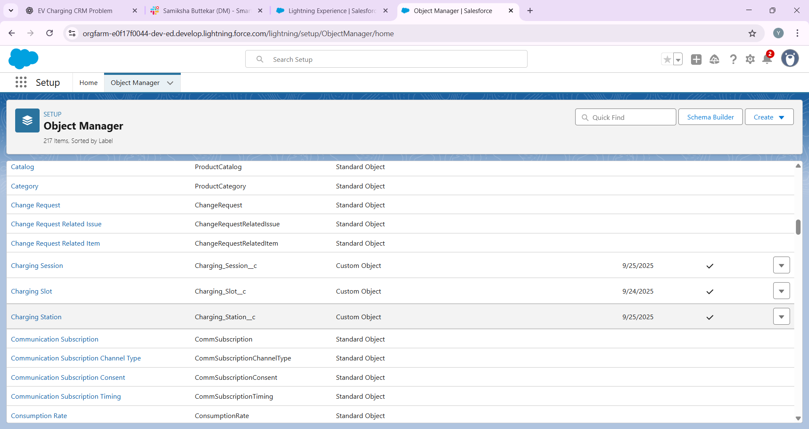

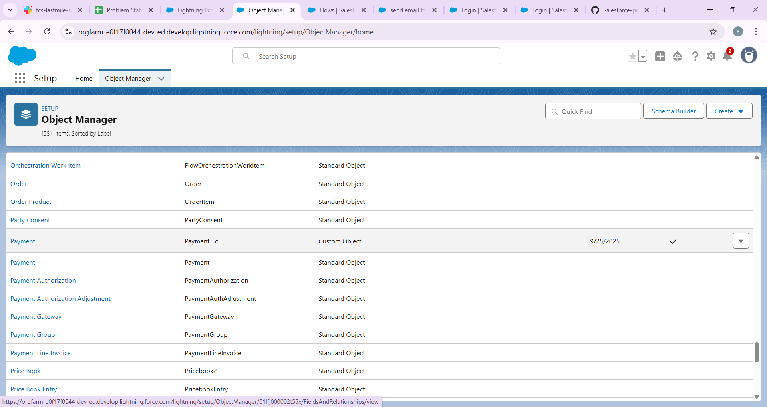

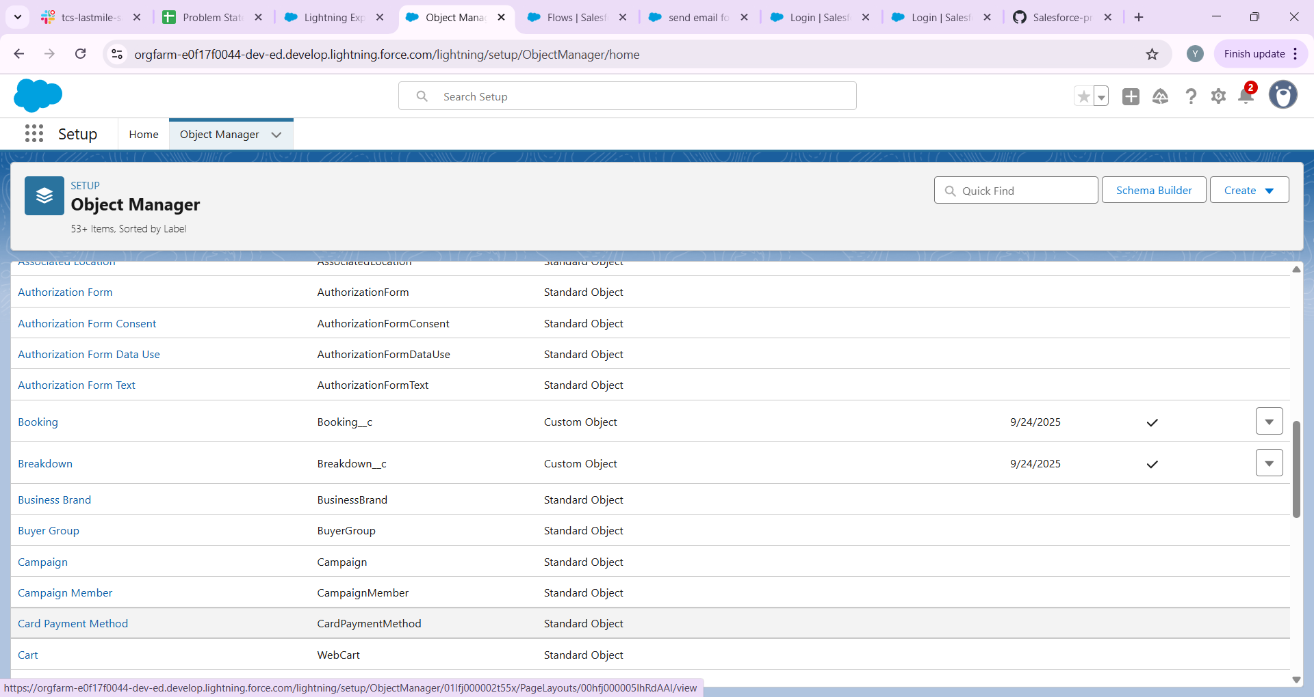

## Step 1 — Create Custom Object: Charging Station

Path: Setup → Object Manager → Create → Custom Object  
  
Create object with:  
• Label: Charging Station  
• Plural Label: Charging Stations  
• Object Name (API): Charging_Station  
• Record Name: Name (Text)  
• Optional: Auto-Number for Station ID if you want a unique code (e.g., STN-{0000})  
• Check: Allow Reports, Allow Activities, Track Field History (optional)  
  
Save the object. Then create fields for Charging Station:

Recommended fields (Field Label — API Name — Data Type — Notes):  
• Location — Location__c — Text (255)  
• Capacity — Capacity__c — Number (0) — number of connectors  
• Station Type — Station_Type__c — Picklist (Fast, Slow, Mixed)  
• Manager — Manager__c — Lookup(User)  
• Status — Status__c — Picklist (Active, Inactive)  
• Default Rate per kWh — Default_Rate_per_kWh__c — Currency (2)  
• Notes — Notes__c — Long Text Area



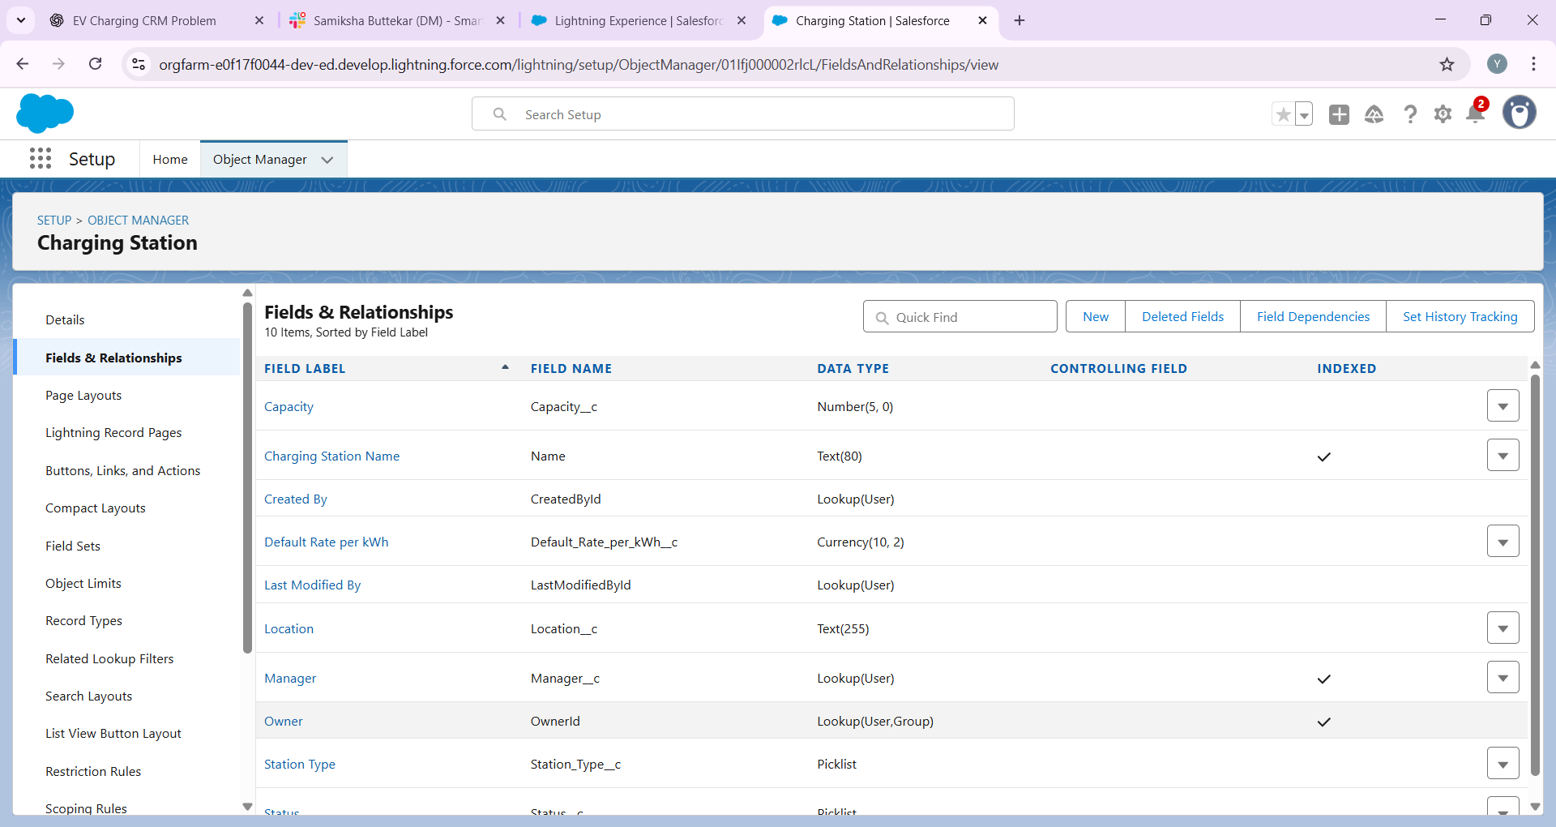

## Step 2 — Create Custom Object: Charging Slot

Path: Setup → Object Manager → Create → Custom Object  
  
Create object with:  
• Label: Charging Slot  
• Plural Label: Charging Slots  
• Object Name (API): Charging_Slot  
  
Recommended fields:  
• Slot Number — Slot_Number__c — Text(50)  
• Station — Station__c — Lookup(Charging_Station__c) (required)  
• Slot Status — Slot_Status__c — Picklist (Available, Booked, Occupied, Maintenance)  
• Charger Type — Charger_Type__c — Picklist (Type2, CCS, CHAdeMO, Fast)  
• Current Booking — Current_Booking__c — Lookup(Charging_Session__c) (optional)  
• Notes — Notes__c — Long Text Area  
  
Make Station lookup required if you want every slot to belong to a station.

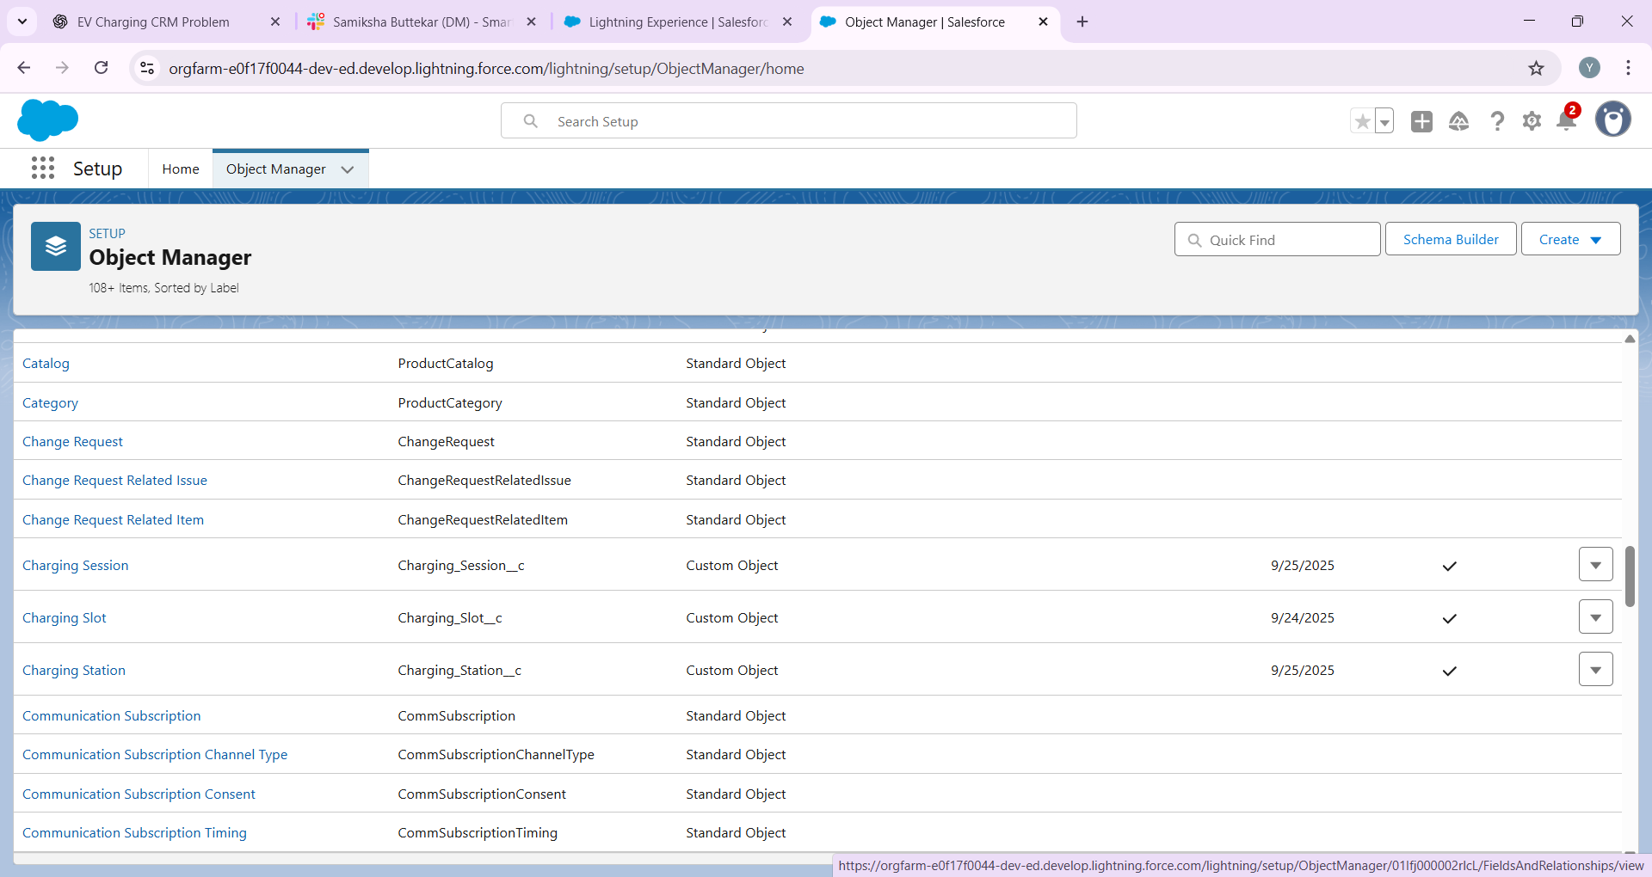

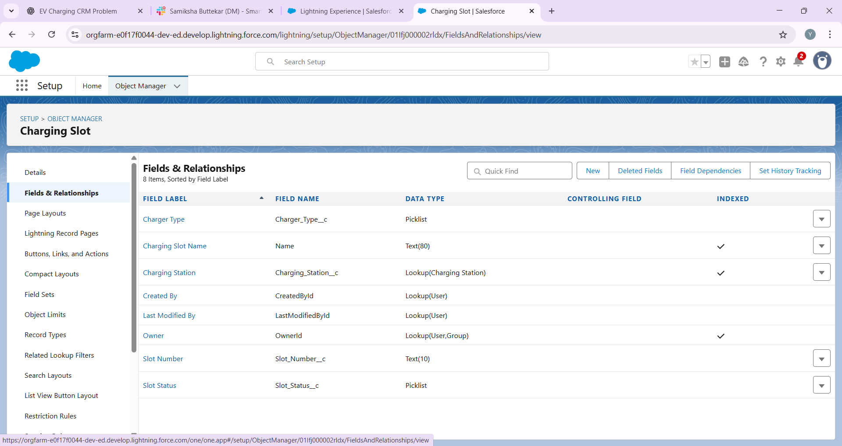

## Step 3 — Create Custom Object: Charging Session (Booking)

Path: Setup → Object Manager → Create → Custom Object  
  
Create object with:  
• Label: Charging Session  
• Plural Label: Charging Sessions  
• Object Name (API): Charging_Session  
• Record Name: Auto Number (recommended) — Format: CS-{0000}  
  
Recommended fields:  
• Customer — Customer__c — Lookup(Contact)  
• Slot — Slot__c — Lookup(Charging_Slot__c) (required)  
• Station — Station__c — Lookup(Charging_Station__c) (optional, can be populated by flow/formula)  
• Start DateTime — Start_Datetime__c — DateTime  
• End DateTime — End_Datetime__c — DateTime  
• Energy Consumed (kWh) — Energy_kWh__c — Number(10,2)  
• Rate Per kWh — Rate_per_kWh__c — Currency(2)  
• Total Amount — Total_Amount__c — Currency(2) — Formula (see below)  
• Booking Status — Booking_Status__c — Picklist (Requested, Confirmed, In Progress, Completed, Cancelled)  
• Payment Status — Payment_Status__c — Picklist (Pending, Paid, Failed)  
• External Transaction ID — External_Booking_Id__c — Text(100)  
  
Total Amount formula examples:  
• If charging is billed by energy: Total_Amount__c = Energy_kWh__c * Rate_per_kWh__c  
• If billed by duration: create formula DurationMinutes__c = (End_Datetime__c - Start_Datetime__c) * 24 * 60  
 then Total_Amount__c = DurationMinutes__c * Rate_per_Minute__c  
  


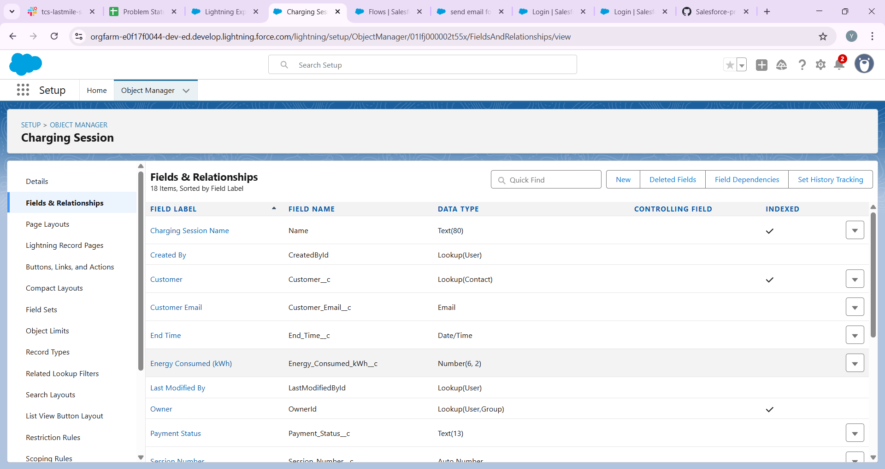

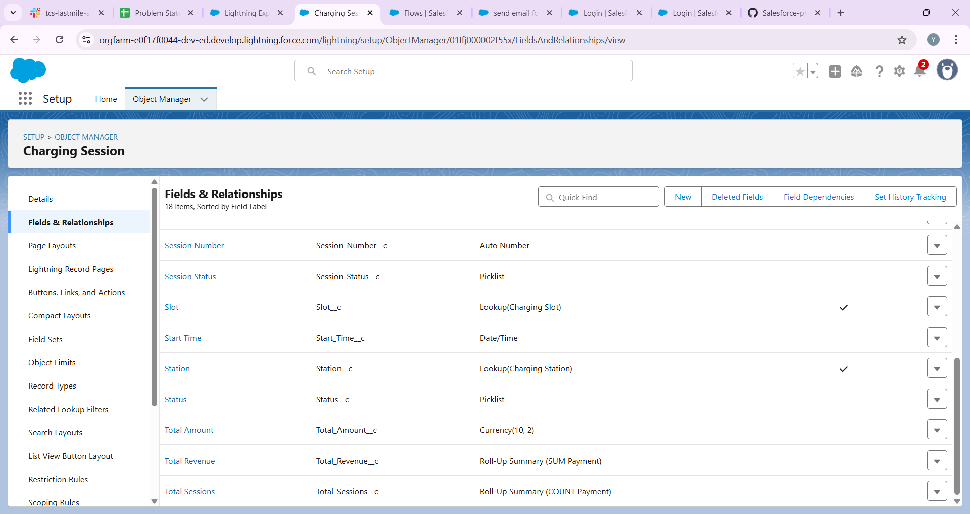

## Step 4 — Create Custom Object: Payment

Recommended fields:  
• Booking — Booking__c — Lookup(Charging_Session__c) (required)  
• Amount — Amount__c — Currency(2) (required)  
• Payment Date — Payment_Date__c — DateTime  
• Payment Mode — Payment_Mode__c — Picklist (Card, UPI, Wallet, Cash)  
• Transaction ID — Transaction_Id__c — Text(150)  
• Payment Status — Payment_Status__c — Picklist (Pending, Success, Failed)  
  
If you need roll-up of payments to Booking, use Master-Detail (Payment -> Booking) to enable Roll-Up Summary fields, or use Flow to sum payments.



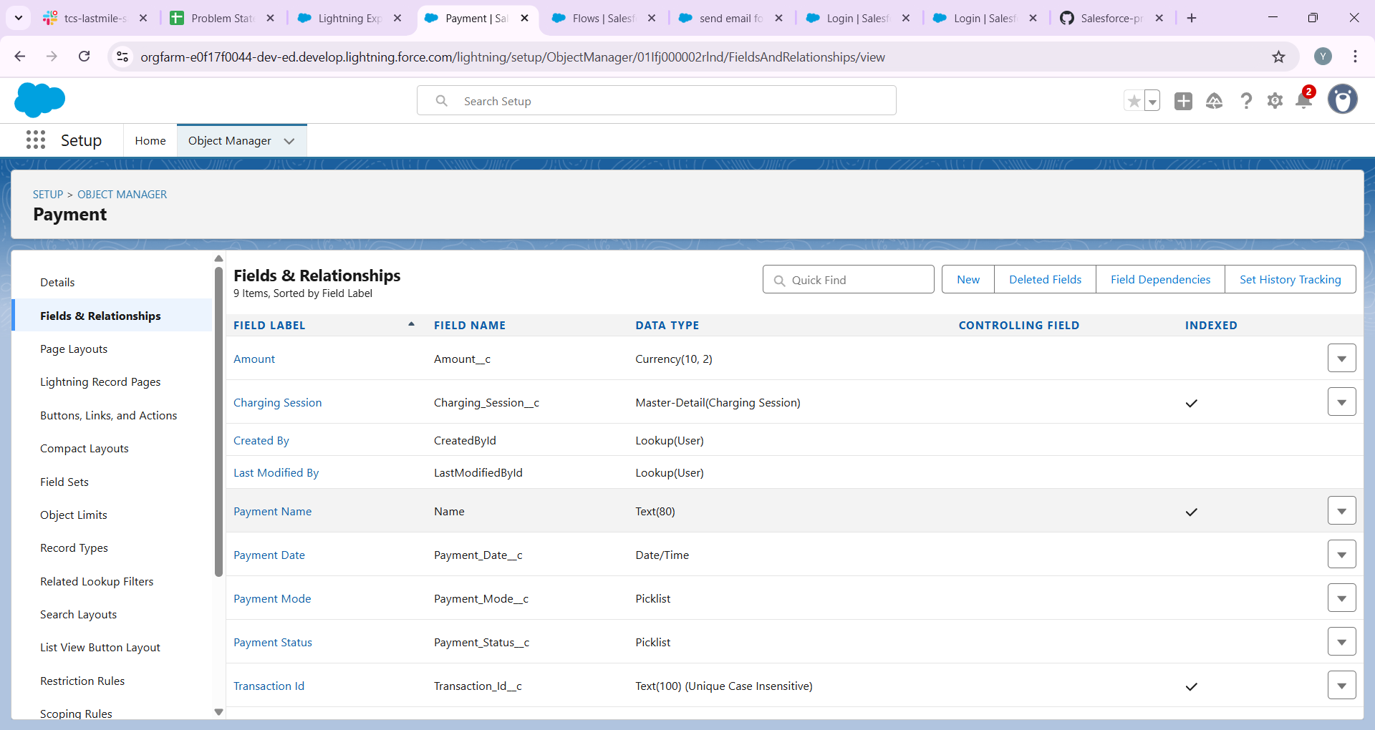

## Step 5 — Create Custom Object: Breakdown / Service Request

Recommended fields:  
• Station — Station__c — Lookup(Charging_Station__c)  
• Slot — Slot__c — Lookup(Charging_Slot__c)  
• Reported By — Reported_By__c — Lookup(Contact) or Lookup(User)  
• Reported Date — Reported_Date__c — DateTime  
• Severity — Severity__c — Picklist (Low, Medium, High, Critical)  
• Status — Status__c — Picklist (New, In Progress, Resolved)  
• Assigned To — Assigned_To__c — Lookup(User)  
• Description — Description__c — Long Text Area



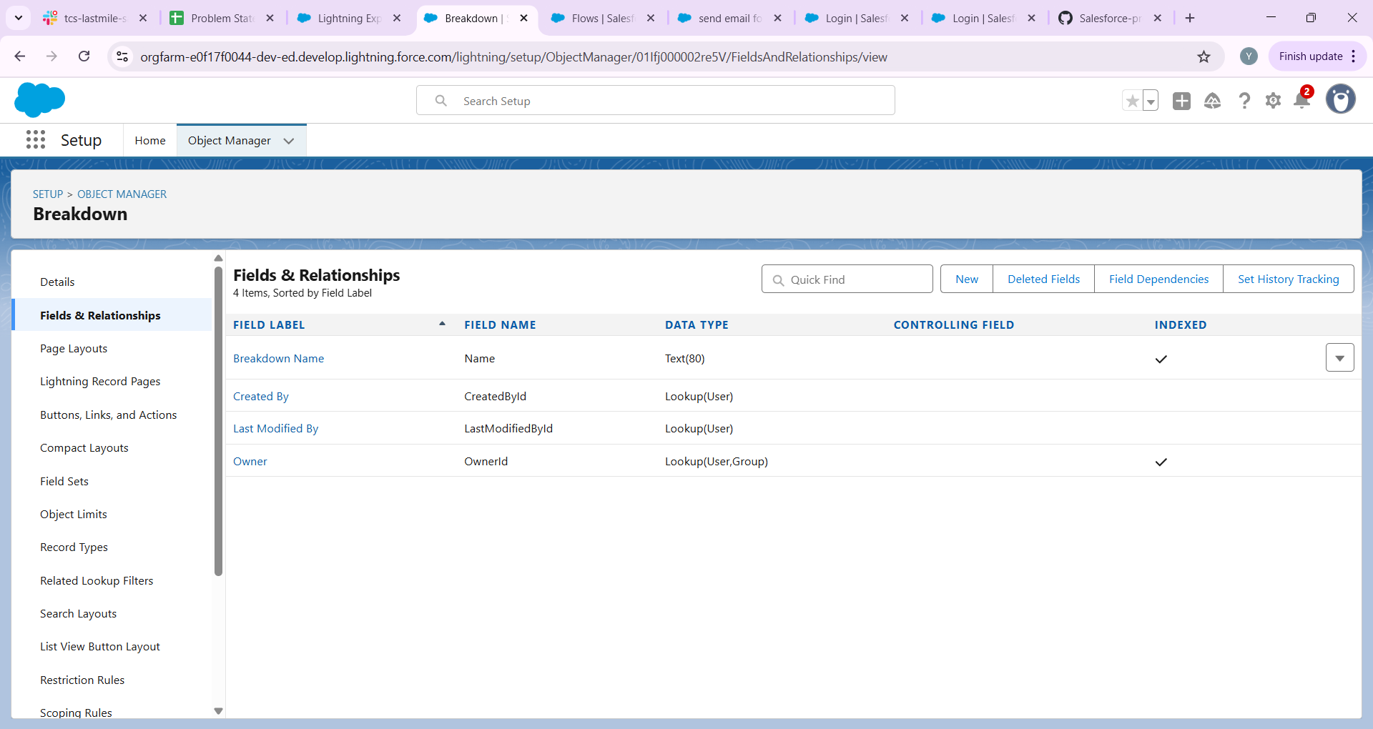

## Step 6 — Record Types & Page Layouts

Record Types:  
• Charging Session: create record types if you bill differently (e.g., One-Time, Subscription).  
  
Page Layouts:  
• Charging Station layout: show Station fields and related lists (Slots, Breakdowns, Sessions).  
• Charging Slot layout: include Station lookup, Slot Status, Current Booking, related Sessions.  
• Charging Session layout: include Customer, Slot, Start/End DateTime, Energy, Total Amount, Payments.  
  
Compact Layouts (for mobile) examples:  
• Charging Session compact: Name, Start_Datetime__c, Booking_Status__c  
• Charging Slot compact: Slot_Number__c, Slot_Status__c  
  
Screenshot: docs/phase3/06_page_layouts.png

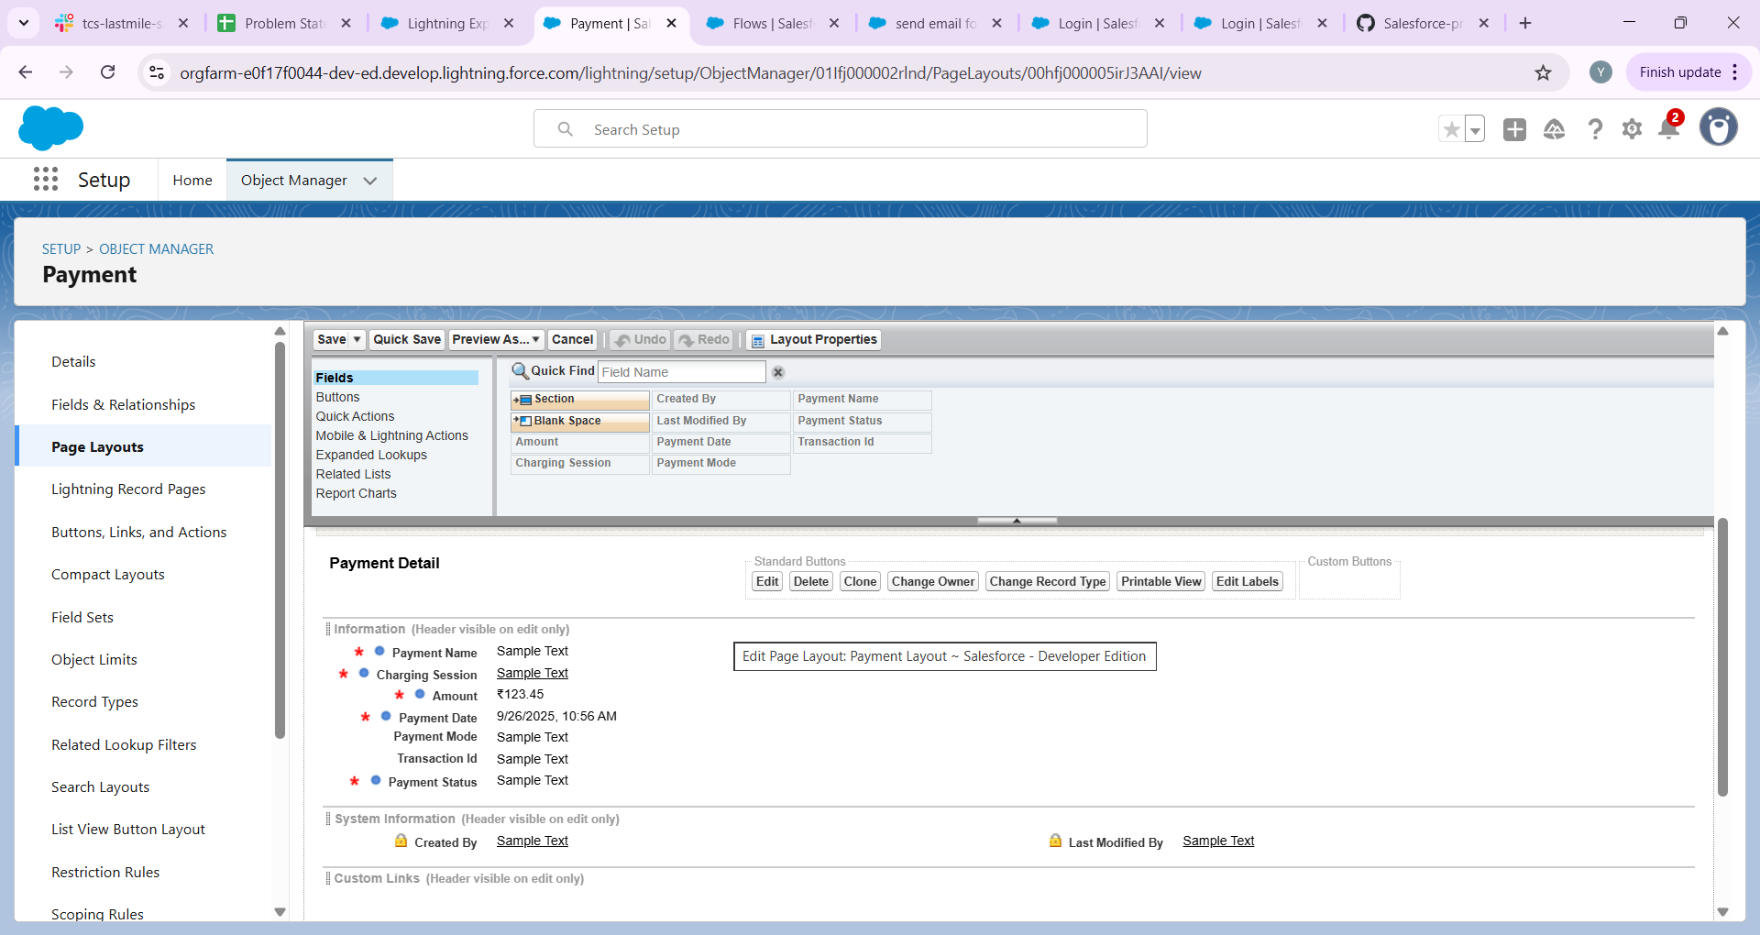

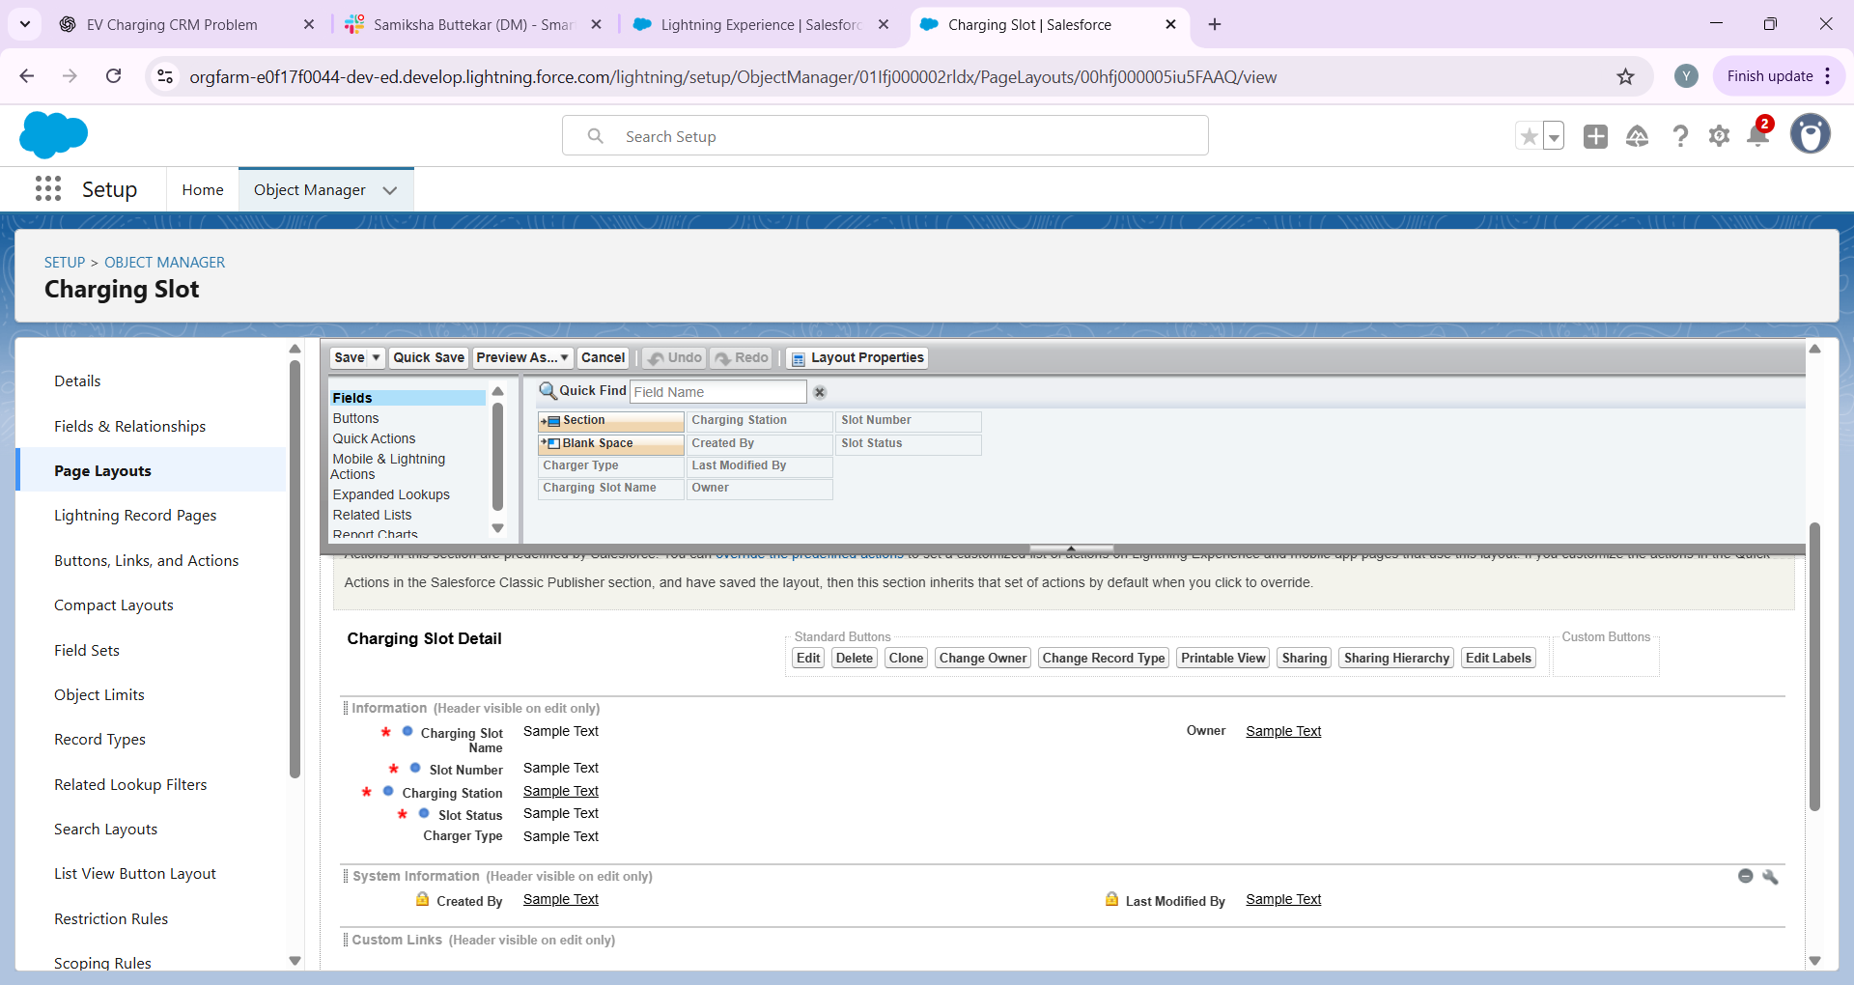

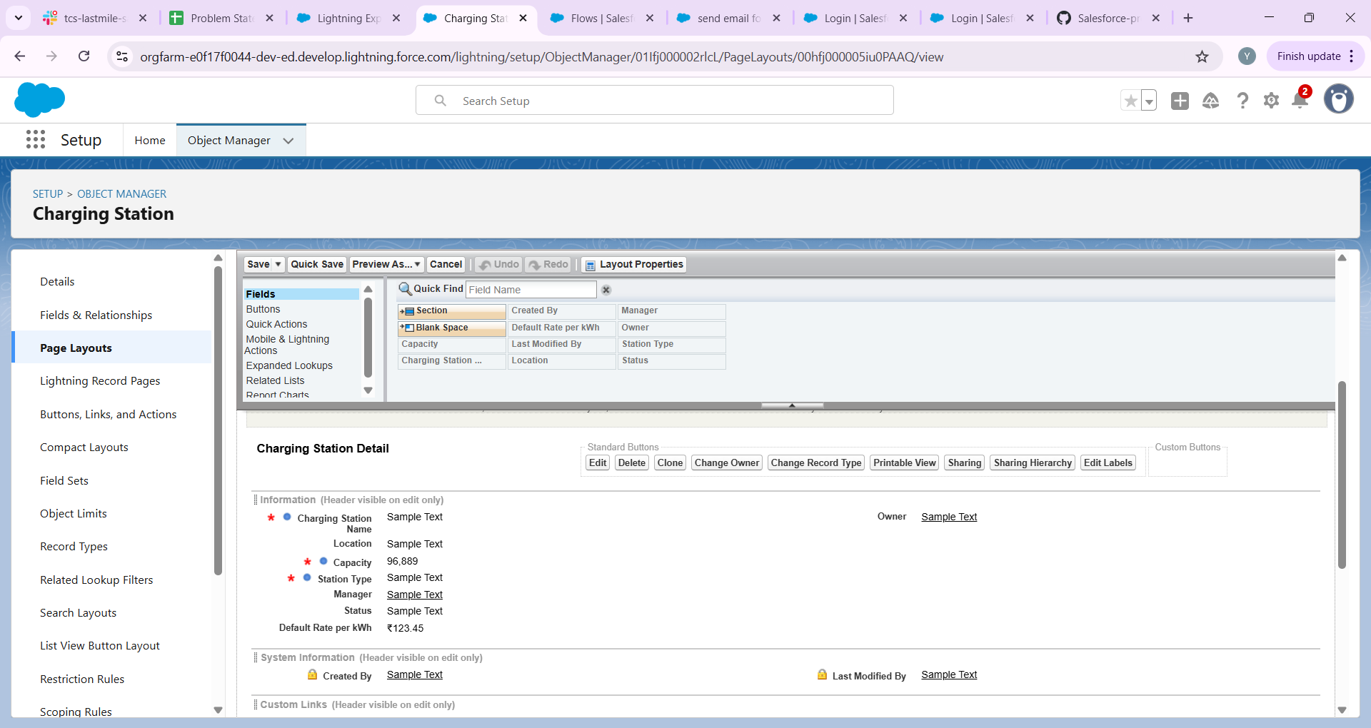

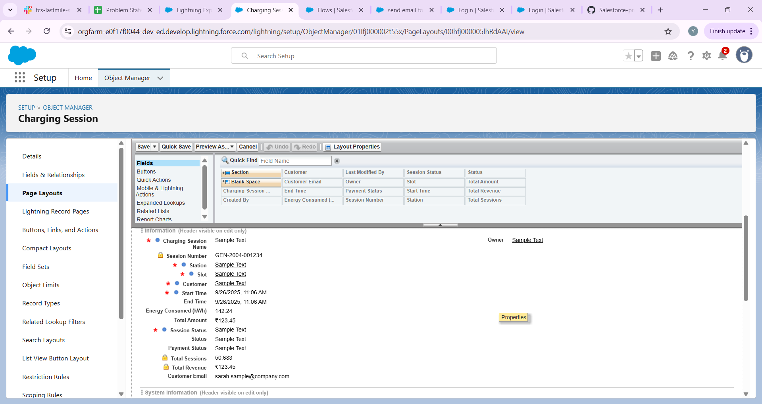

## Step 7 — Schema Builder (visualize relationships)

Path: Setup → Quick Find → Schema Builder  
  
Use Schema Builder to drag your custom objects onto the canvas and draw relationships. It helps to check your model visually. After creating objects and relationships in Object Manager, open Schema Builder to verify.

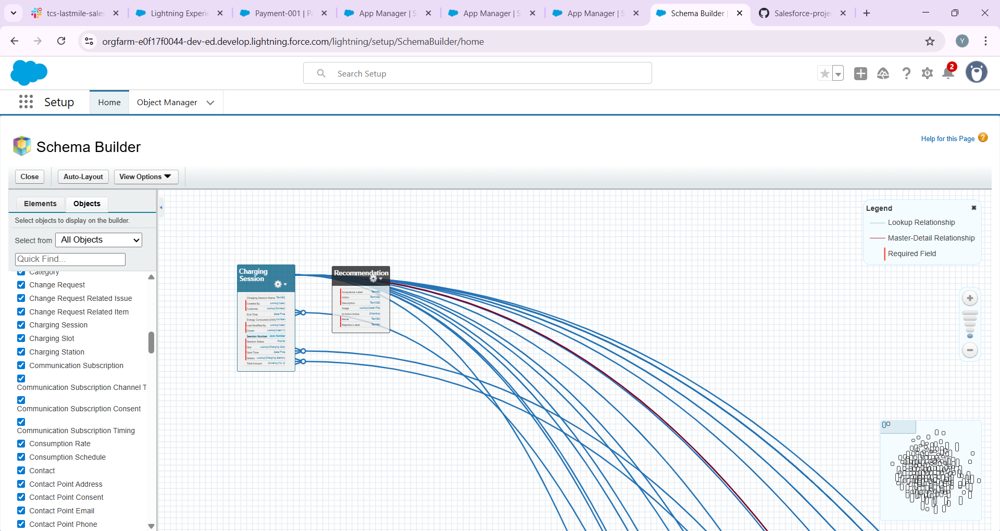

**Step 8 — Lookup vs Master-Detail (which to choose)**

General guidance for this project:  
• Charging Slot → Station: Lookup (unless you want slots deleted when Station is deleted). Lookup is safer.  
• Charging Session → Slot: Lookup (a booking references a slot).  
• Payment → Charging Session: Consider Master-Detail if you want Roll-Up Summary (Total Paid) on Session. If not, use Lookup and use Flow for aggregation.  
• Breakdown → Station/Slot: Lookup  
  
Note: Master-Detail restricts ownership & sharing (child inherits parent's owner and sharing). Use only when you want inheritance (e.g., Payment belonging tightly to a Booking).

## Step 9 — Validation Rules & Preventing Overlapping Bookings

Basic validation rules (formula examples):  
• Ensure End >= Start:  
 Formula (on Charging Session): End_Datetime__c >= Start_Datetime__c  
  
Prevent overlapping bookings (requires Flow or Apex):  
• Reason: Validation rules cannot query other records. Implement a Before-Save Record-Triggered Flow (recommended declarative approach) or an Apex trigger.  
• Flow logic (summary):  
 - Trigger: Charging Session (Before Save, on Create or Update)  
 - Get Records: Query Charging Sessions where Slot__c = {!$Record.Slot__c} AND Booking_Status__c != 'Cancelled' AND (Start_Datetime__c < {!$Record.End_Datetime__c})

AND (End_Datetime__c > {!$Record.Start_Datetime__c})  
 - If Get Records found any rows → Use a 'Assignment' to set an error on the record (use the 'Add Error' action) or update a field to indicate conflict and let user correct.  
  
SOQL overlap condition pseudo:  
SELECT Id FROM Charging_Session__c WHERE Slot__c = :slotId AND Start_Datetime__c < :newEnd AND End_Datetime__c > :newStart AND Booking_Status__c != 'Cancelled'

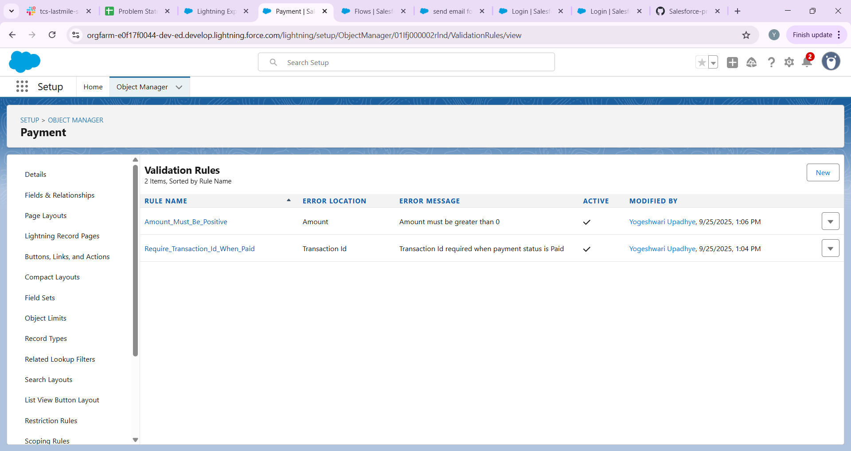

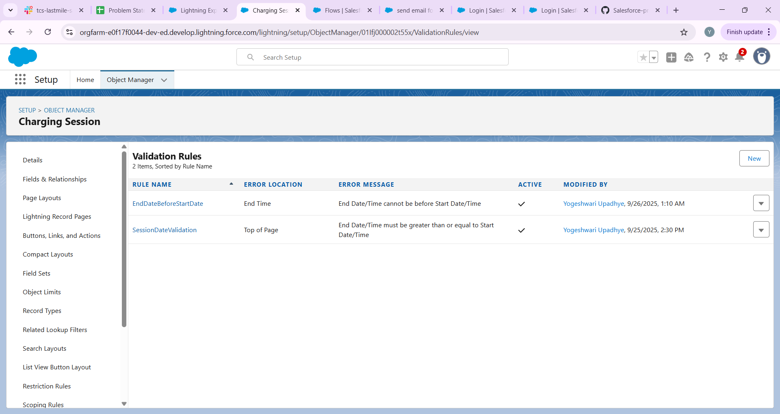

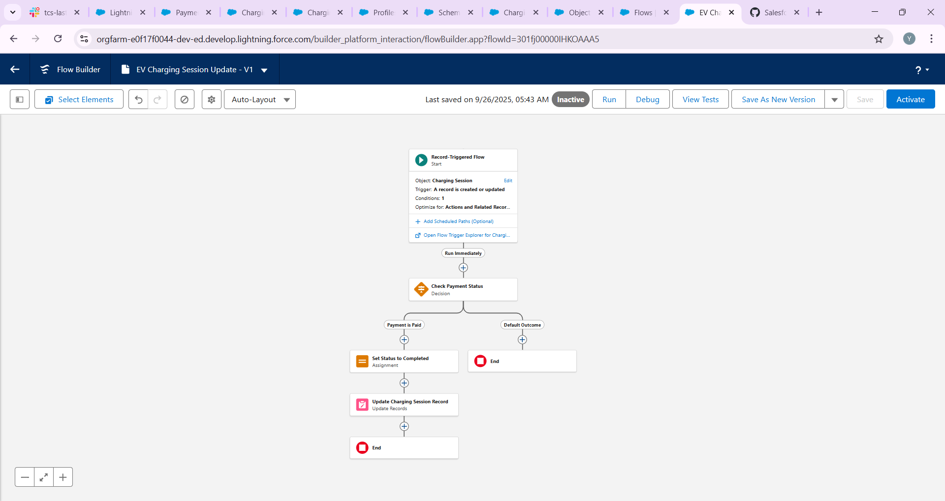

## Step 10 — Formula Fields & Roll-up Summaries

Useful formula fields:  
• Duration (Minutes) — Number formula on Charging Session:  
 (End_Datetime__c - Start_Datetime__c) * 24 * 60  
  
• Total Amount (energy-based):  
 Total_Amount__c = Energy_kWh__c * Rate_per_kWh__c  
  
• Or duration-based: Total_Amount__c = DurationMinutes__c * Rate_per_Minute__c  
  
Roll-up summaries:  
• If Payment is Master-Detail to Charging Session, you can create Roll-Up Summary fields on Charging Session: Total_Amount_Paid__c (SUM Payment.Amount__c)  
• Alternatively, use Flow to aggregate payments and update booking's Total_Paid__c.

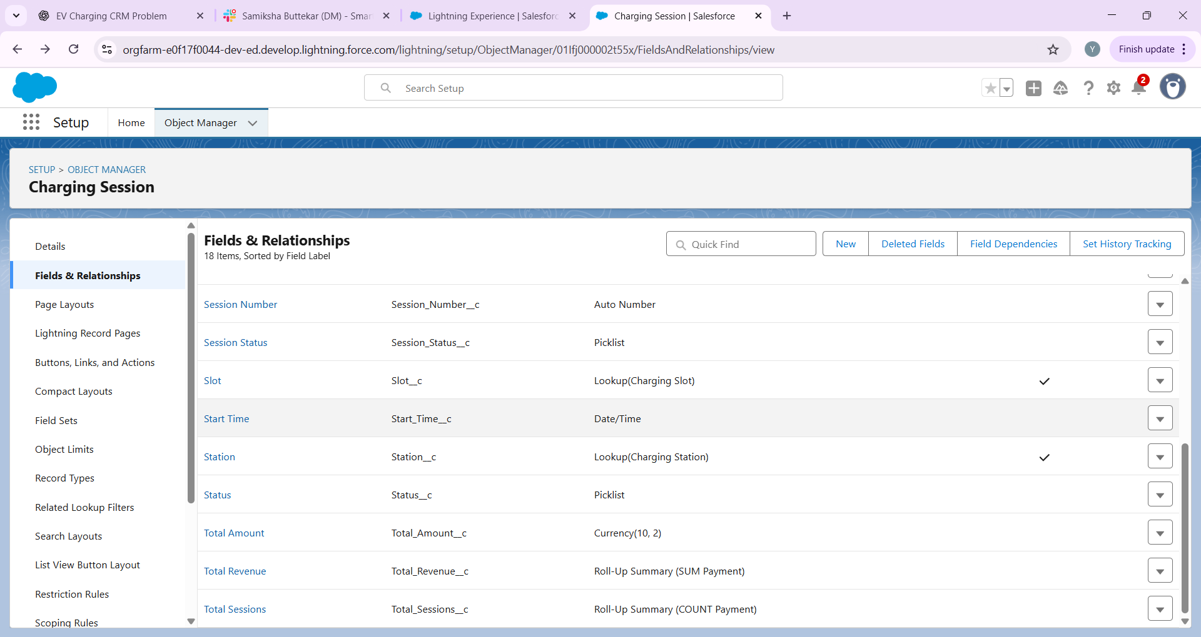

## Step 11 — Useful List Views and Reports

Create List Views:  
• Charging Slots: 'Available Slots' (Slot_Status__c = Available)  
• Charging Sessions: 'Today’s Sessions' (Start_Date = TODAY)  
• Payments: 'Pending Payments' (Payment_Status__c = Pending)  
  
Create Reports:  
• Revenue by Station (custom report type: Station + Session + Payment)  
• Slot Utilization (sessions per slot)  
• Breakdown Frequency (by station and severity)

## Step 12 — Data Import & Sample Data

• Use Data Import Wizard (Setup → Data → Import) for Contacts and up to 50,000 records.  
• Map fields carefully (e.g., Station Name → Name, Slot Station lookup requires Station record IDs or External IDs).  
• For lookups, consider creating an External ID on Stations and use it during import for easy matching.  
  


 