IN_MED_API Documentation

1. **Route 1**: [/api/data_merged/get_medicinesSuggestions?input=string](http://127.0.0.1:5000/api/data_merged/get_medicinesSuggestions?input=string) (GET)
   1. “String” contains the name of the salt or medicine and gives out top 10 suggestions of medicine names according to it.

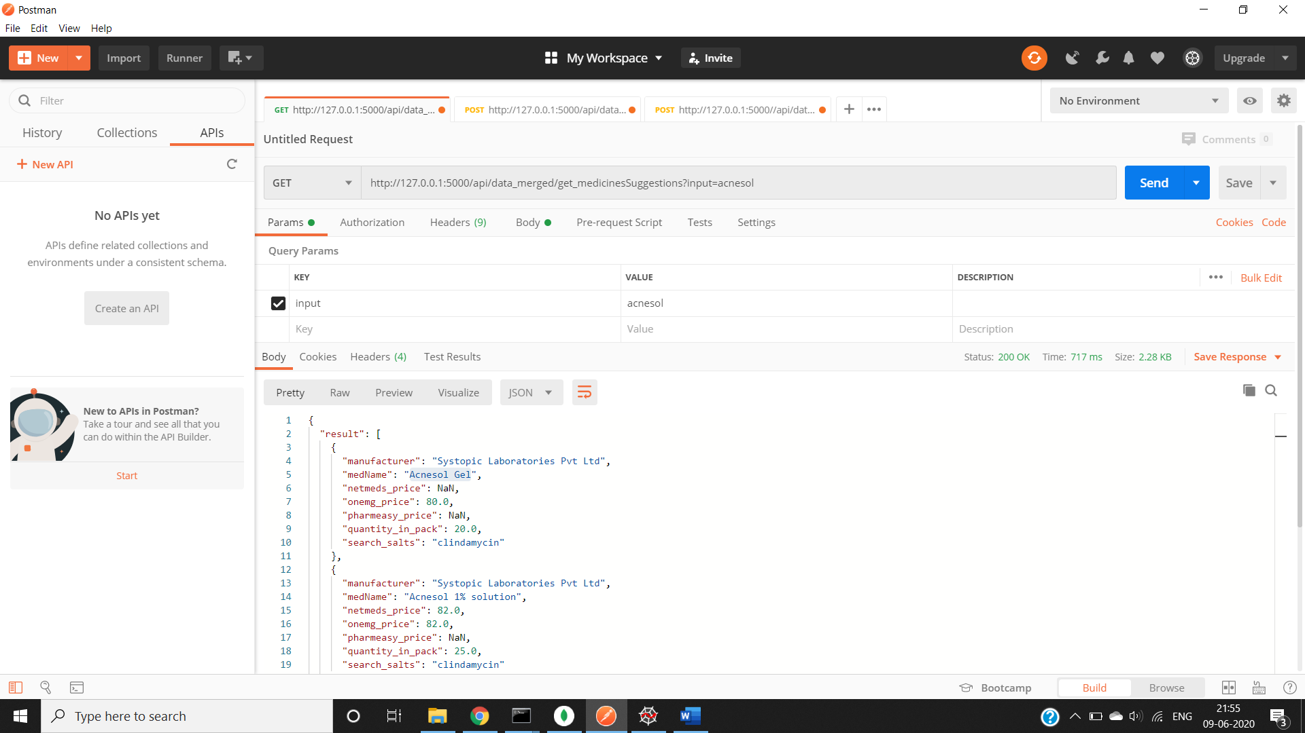

1. **Route 2**: /api/data_merged/get_medicines (POST)

After the user selects the medicine from suggestions the complete medicine name is given as input in the form of a json with format

{

“input”:”medName”

}

This returns all the medicines from each manufacturer containing the same salt as in the selected medicine.

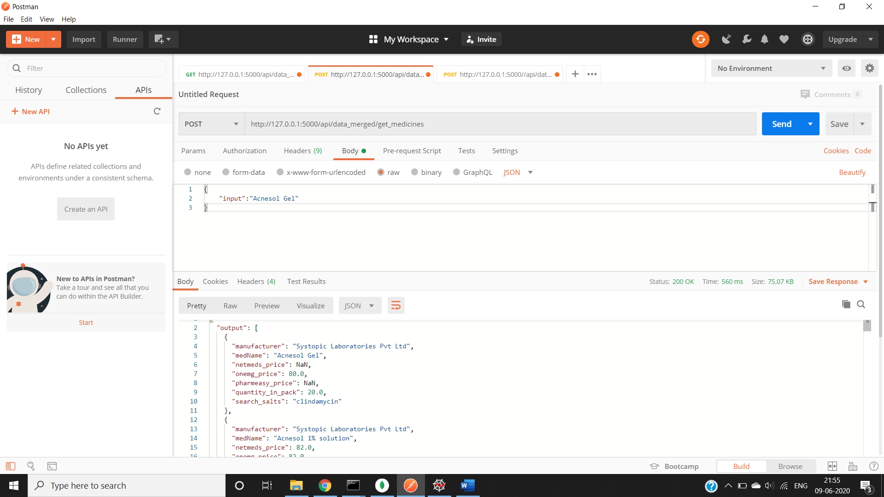

1. **Route3:** /api/filter_api (POST)

Select a manufacturer name and give it as input with selected medName.

{

     "input":"medicine name",

     "manufacturer":"manufacturer name"

}

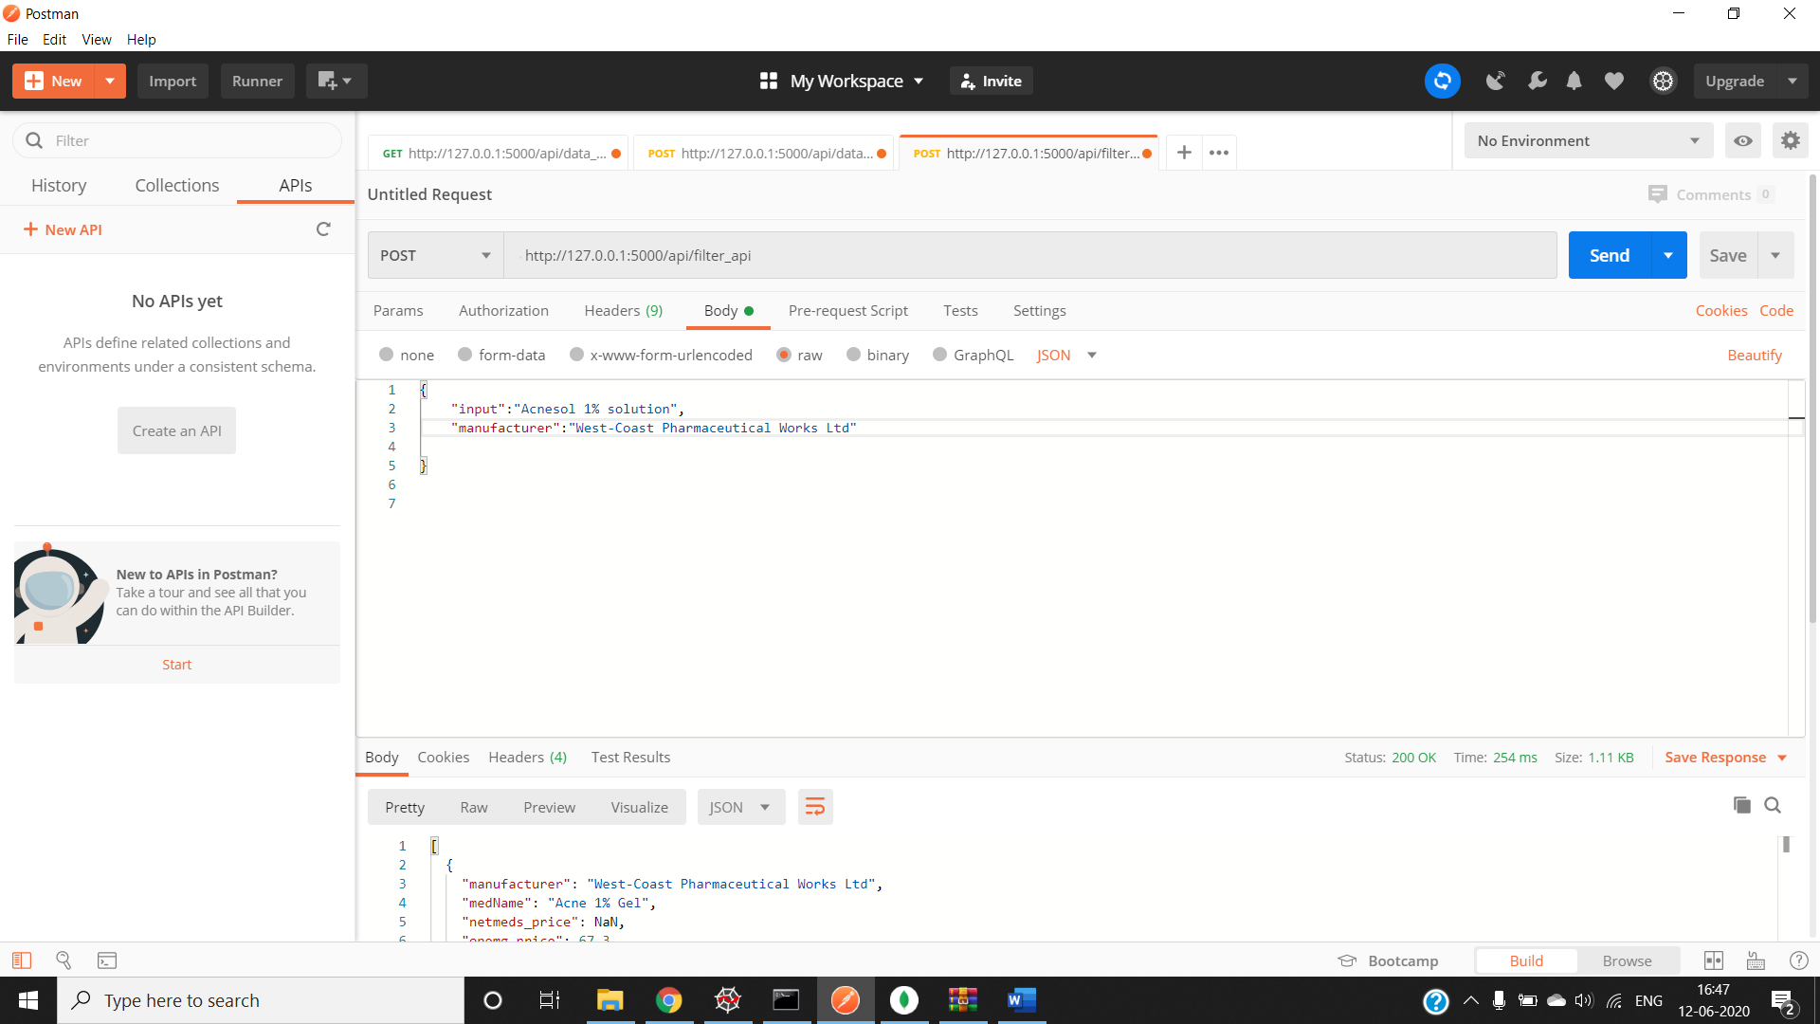

1. Route 4: /api/prescription (POST)

