**FitFlex: Your Personal Fitness**

**companion**

**1. Introduction**

* **Project Title :** FitFlex: Your Personal Fitness Companion
* **Team leader :Chandren Sujithra**
* **Team Members:** **Vijayan.S**

**Vidhyabharathi.**C

**2. Project Overview**

* **Purpose:**  
  FitFlex is a fitness companion web application designed to help users track workouts, monitor progress, access personalized fitness plans, and stay motivated through a user-friendly interface.
* **Features:**
  + User authentication (login/signup)
  + Personalized workout and diet plans
  + Progress tracking with charts and analytics
  + Exercise tutorials with images/videos
  + Community or friend challenges
  + Notifications and reminders

**3. Architecture**

* **Component Structure:**  
  Major React components include:
  + Navbar, Footer, Dashboard, WorkoutPlans, DietPlans, ProgressTracker, Community, Profile, Notifications.
* **State Management:**
  + Managed using **Redux Toolkit** (for global state like user data, workout progress).
  + Context API for theme settings.
* **Routing:**
  + Implemented with **React Router v6** for navigation between pages.

**4. Setup Instructions**

* **Prerequisites:**
  + Node.js, npm/yarn
* **Installation:**
* git clone [repository-link]
* cd fitflex-client
* npm install
* npm start

**5. Folder Structure**

* **Client:**
* src/
* components/
* pages/
* assets/
* hooks/
* redux/
* utils/
* **Utilities:**
  + Custom hooks: useAuth, useWorkoutPlan
  + Helper functions: date formatters, API helpers

**6. Running the Application**

* **Frontend:**
* npm start

**7. Component Documentation**

* **Key Components:**
  + WorkoutPlans → Displays workout schedules based on user goals.
  + ProgressTracker → Visualizes user progress with charts.
  + Profile → Manages user information and preferences.
* **Reusable Components:**
  + Button, Card, Modal, InputField, ChartComponent

**8. State Management**

* **Global State:**
  + Authentication state, workout data, diet data, progress analytics
* **Local State:**
  + Form inputs, modal open/close, temporary filters

**9. User Interface**

* **UI Showcase:**
  + Screenshots/GIFs of: Dashboard, Progress Tracker, Workout Plan cards, and Community challenges.

**10. Styling**

* **CSS Frameworks/Libraries:**
  + Tailwind CSS + Styled Components
* **Theming:**
  + Light/Dark mode with Context API

**11. Testing**

* **Testing Strategy:**
  + Unit tests with Jest
  + Integration tests with React Testing Library
* **Code Coverage:**
  + Istanbul/nyc for coverage reports

**12. Screenshots or Demo**

**Coding**

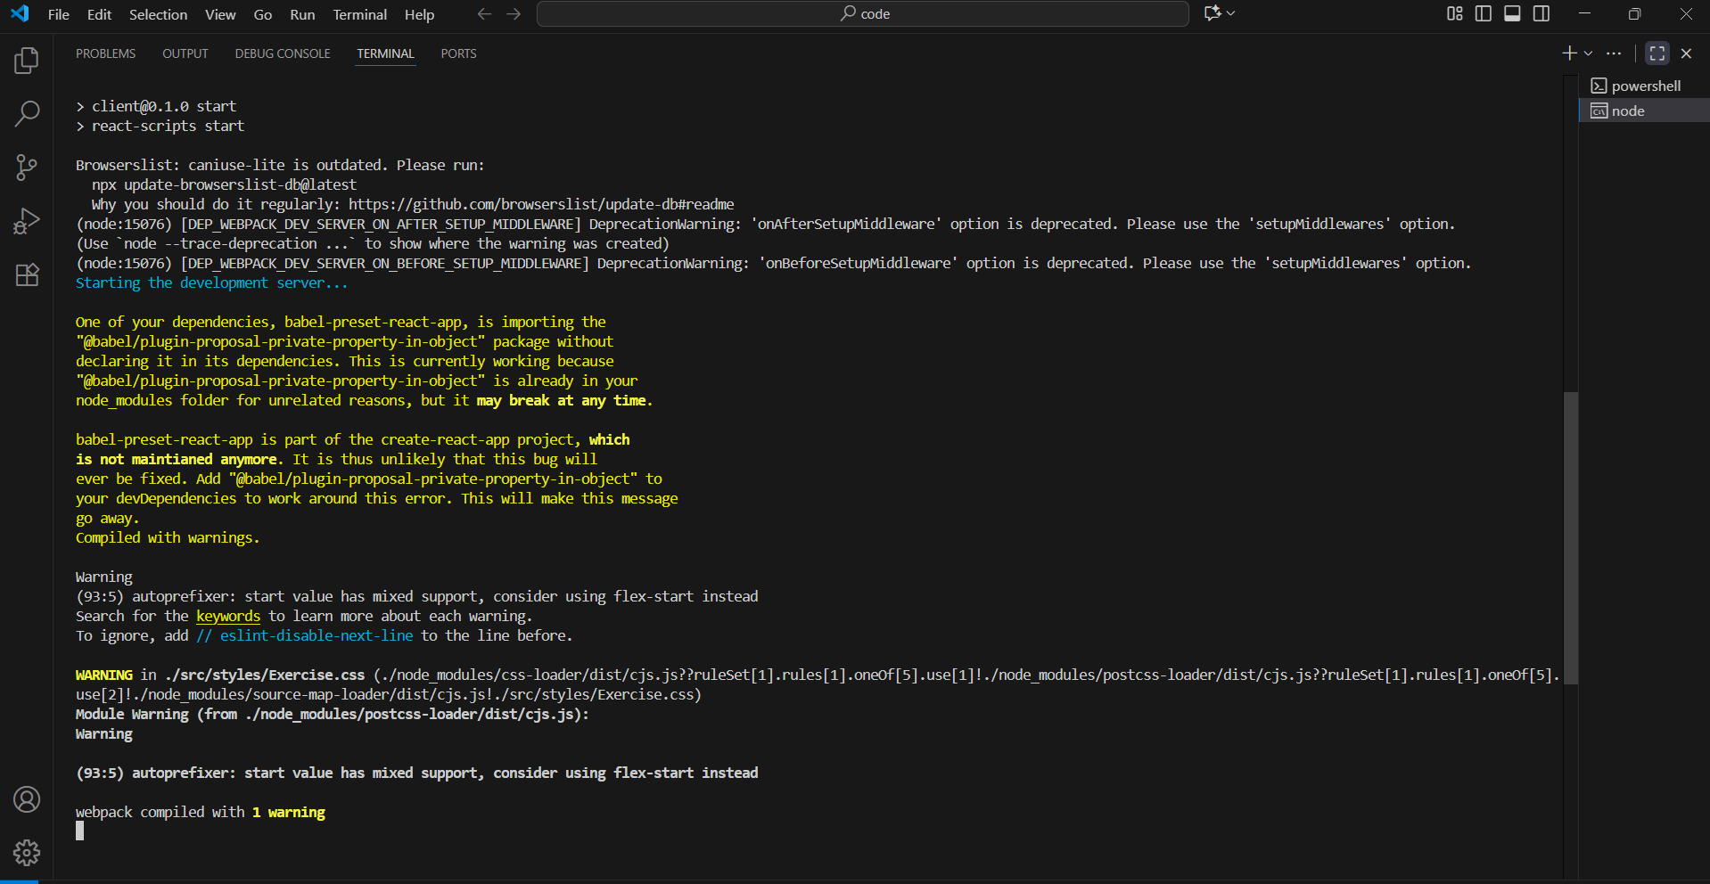

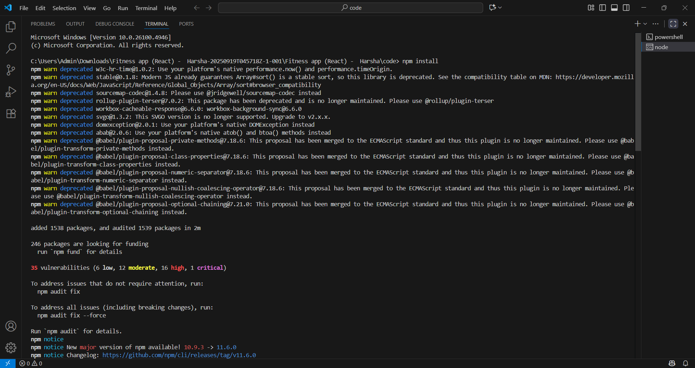

**OUTPUT:**

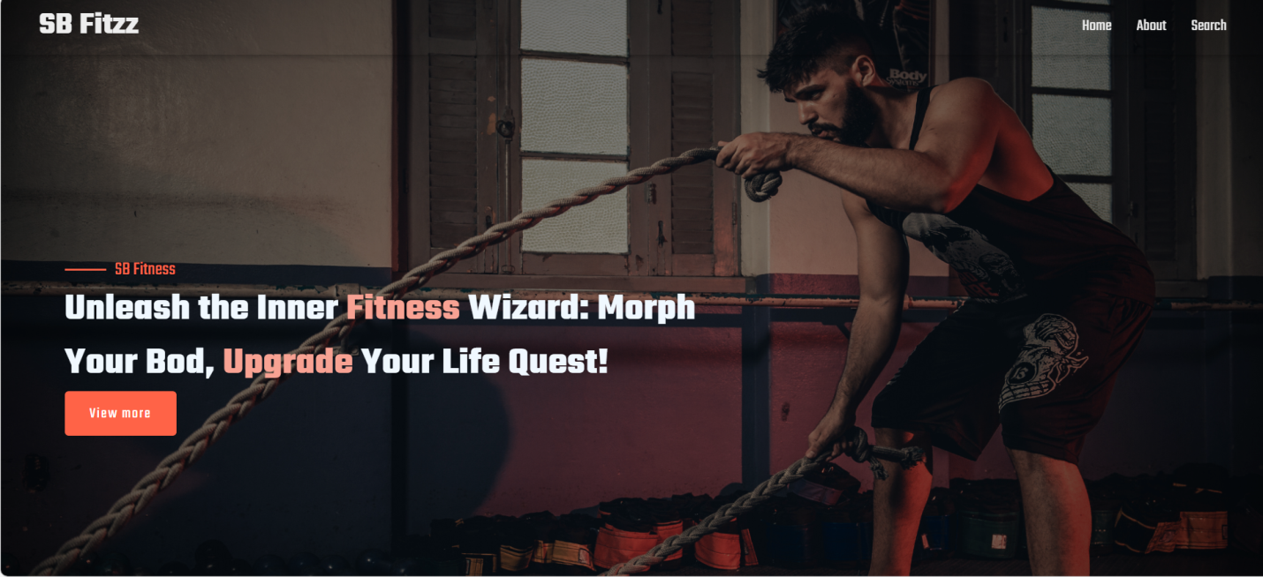

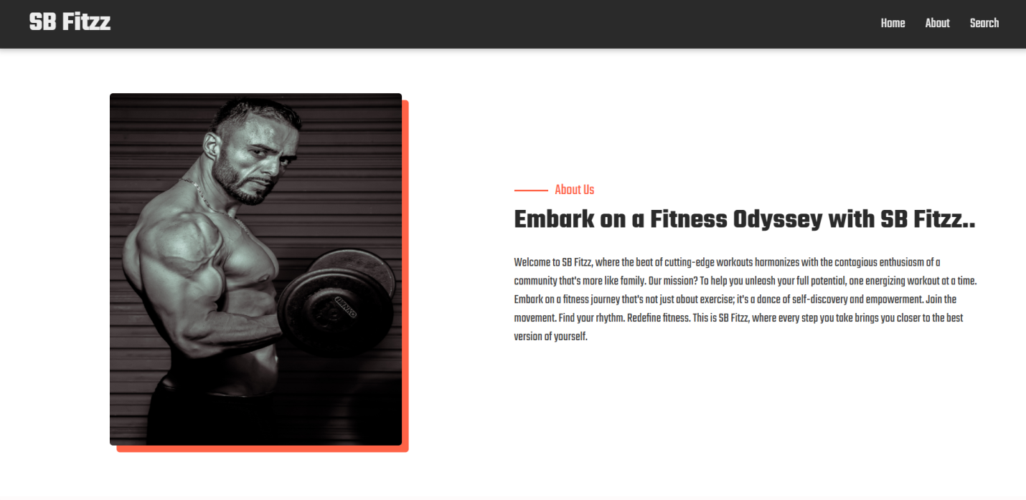

**13. Known Issues**

* Dark mode UI not fully optimized on all pages
* Notifications may sometimes delay

**14. Future Enhancements**

* AI-based workout recommendations
* Integration with wearable fitness devices (e.g., Fitbit, Apple Watch)
* Social leaderboard and challenges
* Voice assistant for guided workouts

**15. Demo video**

Video link :  *https://drive.google.com/file/d/1XjZZbHat3TM-gJ6QbkXrLra5sP1iOEV8/view?usp=drive_link*