Omesairam

Step 1)start the application.

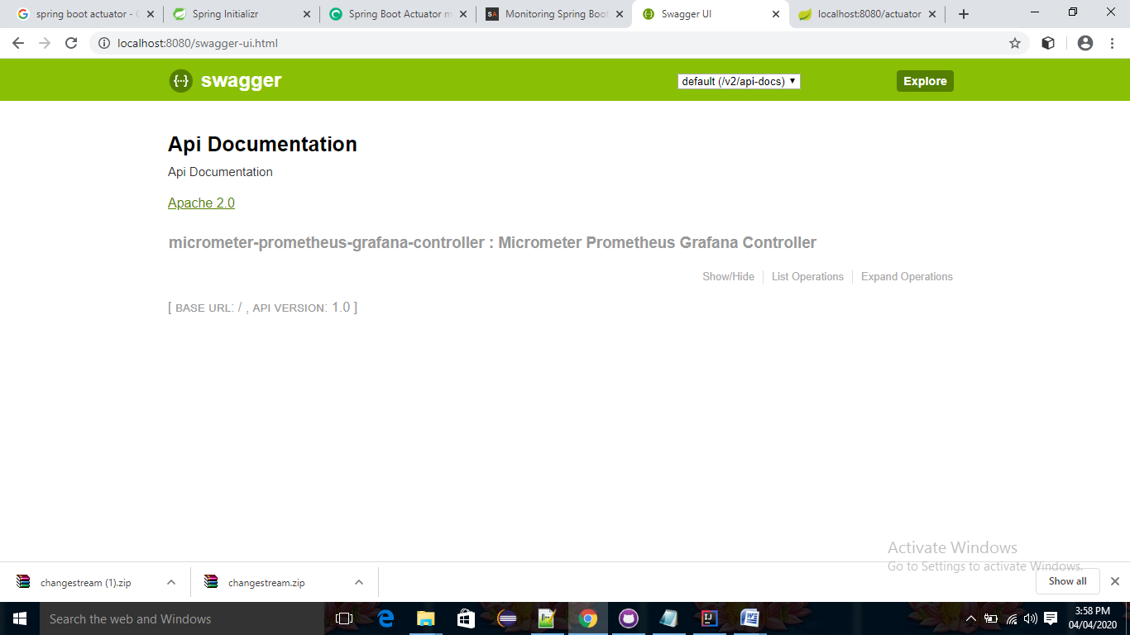

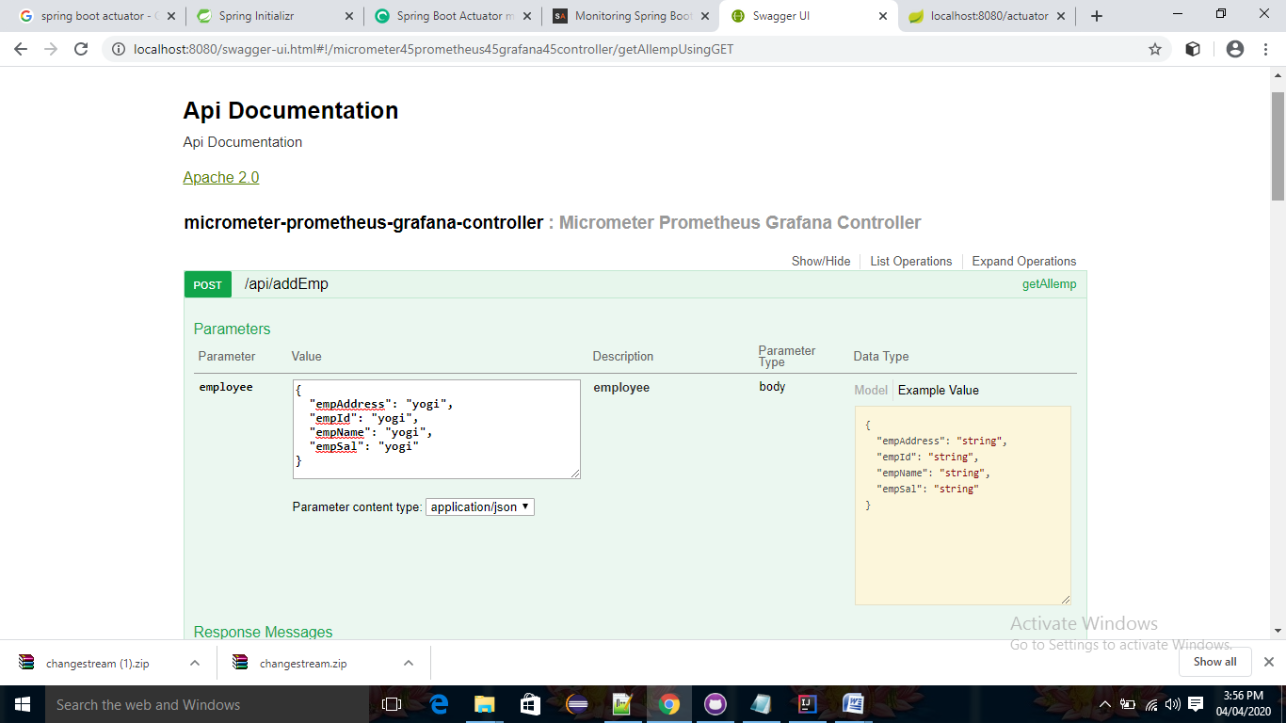

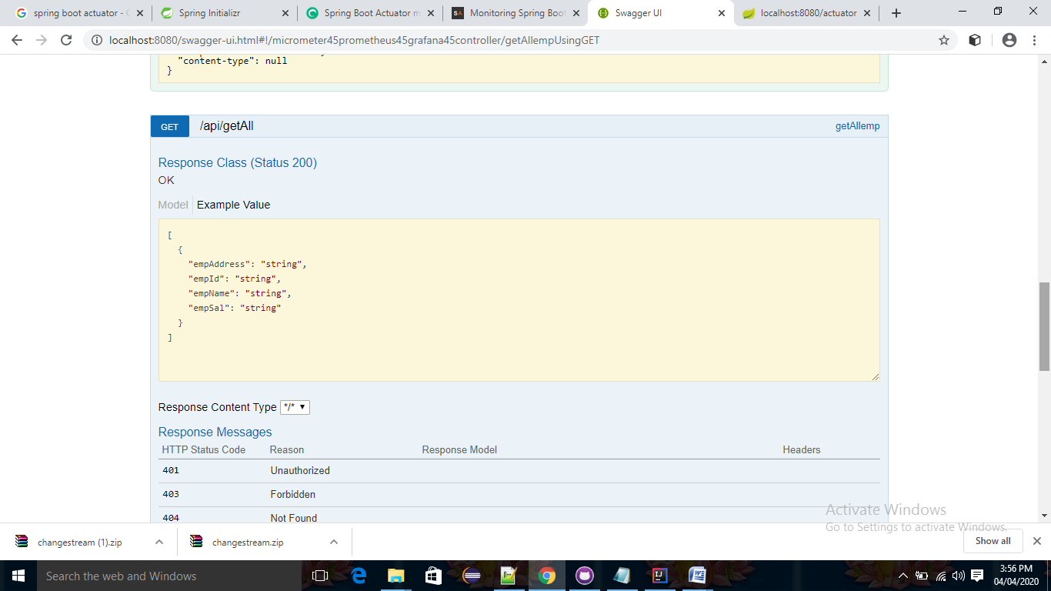

Step2)

<http://localhost:8080/actuator> find the Prometheus

<http://localhost:8080/actuator/prometheus>

