Name: Bongu Yogeswari
Dept-CSE Branch
start date -24/11/2025
end date-28/11/2025
Project title -AI health symptom checker
Project link-https://my-site-4vr50obw-yogieswaribongu.wix-vibe.com
Screenshots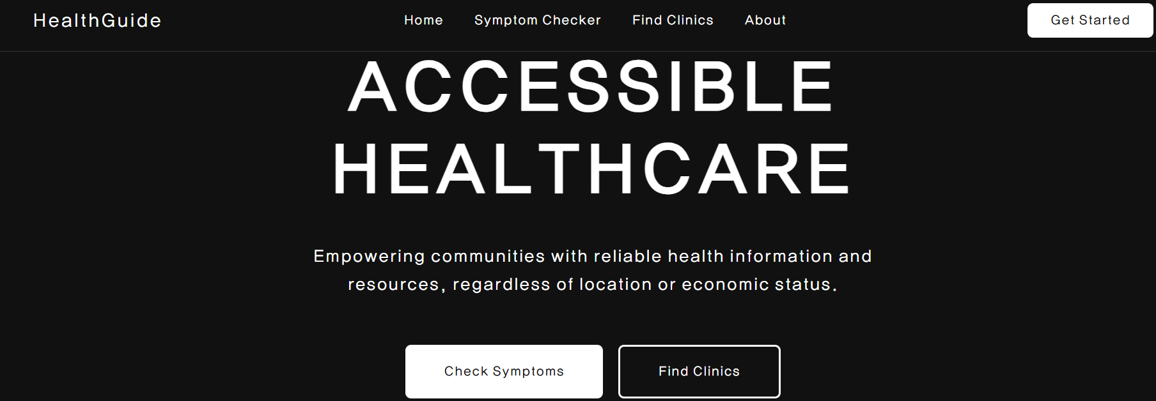 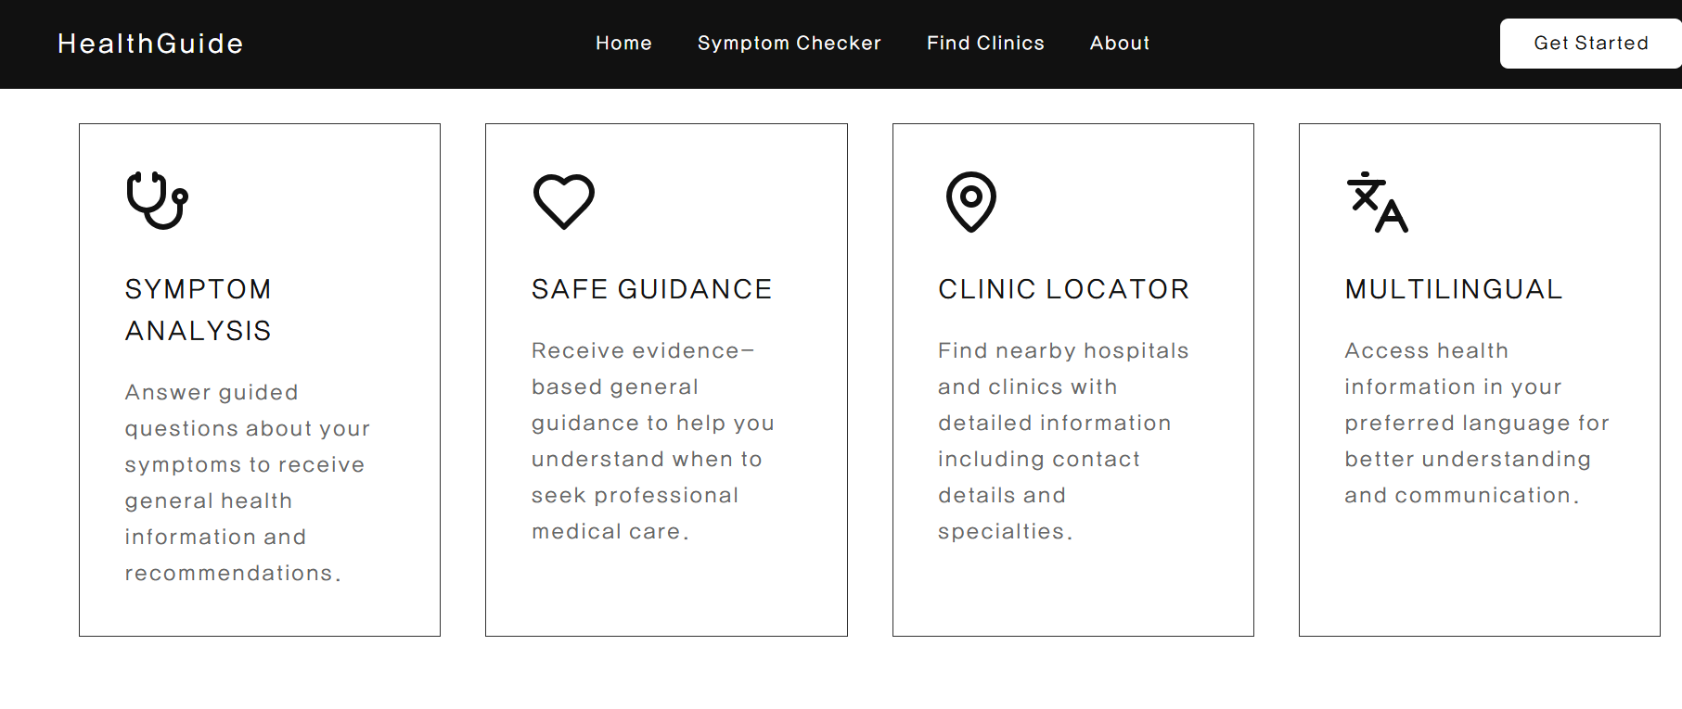Project discription: The Community Health Symptom Checker is a no-code, open-source AI–powered health information assistant designed to support underserved and vulnerable populations. This project aims to bridge the gap between people and accessible healthcare information by providing safe, reliable, and easy-to-understand general health guidance. Built using open-source AI tools such as Flowise, Hugging Face Spaces, LangFlow, and Gradio, the solution can be deployed quickly without programming skills, making it ideal for NGOs, students, community volunteers, and local health workers. The system allows users to input their symptoms, age, and location to receive non-diagnostic, general health information. The assistant clearly explains common causes of symptoms, self-care tips, and preventive guidance based on trusted public health sources like WHO. Importantly, the system does not diagnose diseases or prescribe medicines. Instead, it provides awareness, early warning signs, and clear instructions on when the user should seek professional medical help. This ensures responsible use of AI in community healthcare. The tool also helps connect people to nearby government hospitals, health centers, free helplines, and emergency services based on their location. This feature makes it particularly beneficial for rural communities, disaster-affected areas, and low-resource environments where immediate professional medical guidance may not be accessible. The Health Symptom Checker promotes public health education, sprea ds awareness about hygiene, nutrition, child vaccination, maternal care, seasonal illnesses, and preventive habits. Because it is built with no-code open-source tools, it can be easily customized, translated into local languages, integrated into mobile apps, or deployed on websites. Overall, this project empowers communities with timely and accurate health information, supports early health awareness, reduces misinformation, and serves as a crucial tool for guiding people toward proper medical care while ensuring safety and responsibility.

Thank you IBM and magic bus foundation

