COMICCRAFT-AI COMIC STORY CREATOR USING
GEMINI MODELS
Definition
ComicCraft is an Al-powered comic story creation platform built with Google Gemini models. The platform leverages Gemini's multimodal capabilities to transform simple user prompts into complete, visually engaging comic stories with consistent characters, coherent narratives, and expressive dialogues.
Team Members Name & Roles:
- -Name: Aswini E(Team Member)
Role: Voice over
2.Name: Sandhiya C(Team Member)
Role: API Testing video
3.Name: Susila M(Team Member)
Role: Documentation
4.Name: Yogeswari K(Team Leader)
Role: Demo video
5.Name: Deepa D(Team Member)
Role: Coding
  - Executive Summary & Platform Purpose:
ComicCraft is a scalable, cloud-ready Al-driven creative platform

engineered using http://Node.js and http://Express.js for backend orchestration, http://React.js for interactive frontend, and MongoDB and Mongoose ODM for operational data persistence. The platform was created to resolve the disconnect between raw textual imagination and visually compelling comic storytelling by leveraging Google Gemini models.t transforms simple user prompts into complete end-to-end comic books with consistent characters, coherent story arcs, and studioquality panel art.
  - Core Objectives:
Context-Aware Storytelling:*Convert traditional short user prompts (genre, theme, character idea) into detailed, multi-panel narrative arcs with dialogues, narrations, and scene directions.
•Al Orchestration:Seamlessly integrate Google Gemini Al (via the @google/generative-ai SDK) for story generation, character bible creation, and Imagen 3 / Gemini Image Generation for consistent comic panel synthesis.
State Persistence:Securely persist user profiles, encrypted credentials, saved comics, character libraries. and curated art style presets across mobile and web client interfaces.
Fault-Tolerant Resilience:lmplement automatic fallback mocking and prompt caching mechanisms to ensure comic generation remains continuous during upstream Al service outages or missing API keys.
1 .2High-level platform capabilities:
Key Architectural Features:
1 . JWT Access Guarding:Enforces stateless, token-based authentication With bcrypt password encryption for creator accounts.
- Relational Document Mapping: Utilizes Mongoose schemas with indexed foreign references and unique multi-key constraints to link
Users -> Comics -> Panels -> Characters.
- Centralized Middleware:lntercepts request flows for header evaluation, payload sanitization, NSFW content filtering, and structured error boundaries.
- Character Consistency Engine:Locks character facial features, costumes, and art style using a persistent Character Sheet + Seed Prompting strategy across all panels.
- Automated Comic Layout Engine:*Dynarnically composes generated panels, speech bubbles, and narration boxes into ready-to-export PDF and social media carousels.
Alex is a frequent business traveler and outdoor enthusiast who visits multiple distinct geographical locations per month. Alex requires a unified application interface capable of tracking atmospheric conditions across several favorite target cities simultaneously, while avoiding the

payload sanitization, and structured error boundaries.
4. Headless Modular Design: Built strictly around decoupled controllers, isolated service adapters, and clean route mapping.
2.0 Scenario-Based Case Study & Requirements:
2.1 Background Story:
Alex is a frequent business traveler and outdoor enthusiast who visits multiple distinct geographical locations per month. Alex requires a unified application interface capable of tracking atmospheric conditions across several favorite target cities simultaneously, while avoiding the overhead of analyzing complex meteorological charts manually.
2.2 Problem Formulation:
CHALLENGE OBSERVED FRICTION POINT IMPACT ON USER EXPERIENCE AREA

Data Overload | Raw numerical feeds (e.g., '79% humility, WC, | Users spend unnecessary effort
 | t 2 kWh") lack human.centre context | evaluating what gear or clothing to prepare.
Multi.City | Lack centralized preference storage across | Frequent re-entry of search parameters
Sync | mobile web clients. | leads to user frustration.
 | Inconsistent account protection across external | 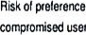tampering or
Security | network access points | user context.
2.3 Software & Hardware Environment Requirements:
Software Specifications:
• Operating System: Cross-platform (Windows 10/11, macOS Monterey+, Linux Ubuntu 20.04+ LTS).

_I
• Runtime Engine: Node.js (VI 6.0.0+ LTS recommended).
- Package Controller: npm (v8.0.O+) for dependency tree management.
- Database Engine: MongoDB (v5.0+ Community/Enterprise Edition).
- SDK Dependencies: @google/generative-ai, express, mongoose, jsonwebtoken, bcryptjs.
  - System Architecture & Design Patterns:
The Al Weather Wise application is constructed around a multi-layered Model-View-Controller (MVC) framework, adapted specifically for headless API services. The design strictly isolates business logic, external API transportation, and database mapping.
  - Architecture Blueprint:
Component Breakdown
LAYER COMPONENT PRIMARY RESPONSIBILITIES
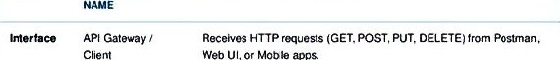
Web
UI.
or
Mobile
apps.
Routing | Express Router | Evaluates URL pathways. checks JWT authorization headers. and
 | Shields | routes payload to controllers.
Controlle | Execution | Orchestrates workflows, validates parameters, and
 | Controllers | coordinates service calls.
 | External Adapters | Handles isolated logic for OpenWeatherMap integratin aryi Google Gemini Al prompting,
 | Mongoose 00M | Validates schemas, aB)Iies document defaults. and enforces primary/ key rules on MongoDB.
  - Architectural Flow:
- Client submits request with JSON payload to protected route endpoint.
- authMiddleware verifies Bearer JWT validity.
3. Target Controller receives request and dispatches data request to weather Service or Alservice.
- Service layer queries database via Mongoose Models or makes external HTTPS requests.
Formatted JSON array is returned to the client with appropriate HTTP status codes (200, 201, 400, 401 , 500).
4.0Data Architecture & ER Modeling:
The database structural architecture leverages a hybrid relationaldocument model inside MongoDB. By storing entity references as Mongoose Objectids, the system maintains strict entity integrity while retaining NoSQL query flexibility.
4.1 Entity Relationship Diagram Structure:
Primary Collections & Relationships:
- USERS Collection: Serves as the primary account authority. Holds user identity credentials, security Credentials, and creation timestamps.
- SAVED_LOCATIONS Collection: Holds location parameters (city name, country code, coordinates). Contains a mandatory foreign key reference (user_id) mapping back to the USERS collection.
- WEATHER DATA Collection (Extended Model): Caches weather metrics (temperature, feels like, humidity, condition) indexed by location.
- AI_INSIGHTS Collection (Extended Model): Stores generated Al prompt
outputs mapped directly to weather instances.
4.2 Entity Mapping Matrix:
TARGET CARDINALITY REFERENTIAL CONSTRAINT
N) locations.
Location leatherOata One-to-Many (1 . Location prinary key links atmospherz query
N) historical logs.
weatherOata Al—Insight One-to-One : Each distinct weather state references an Al 1) recommendation block.
5.0Executive Summary & System Vision
Al Weather Wise is a next-generation meteorological intelligence application designed to deliver real-time atmospheric updates coupled with personalized, Al-generated daily activity recommendations. By integrating hyper- local weather telemetry with Google Gemini's generative Al models, the platform transforms raw data (temperature, humidity, wind vectors) into actionable lifestyle advice for end-users
5.1 Key System Attributes:
Sub-Second Latency: Multi-tiered Redis caching strategy achieving median query response times of T < 45ms for cached requests.
- Resilient Architecture: Automated fallbacks for third-party weather API limits and generative Al timeouts
• Stateful User Personalization: Persistence layer retaining saved user locations, activity preferences, and historical queries.
• Enterprise Security: Stateless JWT authentication, Bcrypt password hashing, and rate-limiting to mitigate DDoS threats.
6.0 End-to-End System Architecture Blueprint:
The platform follows a clean, decoupled micro services-ready layered
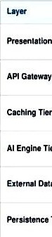
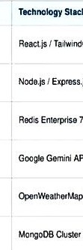
Respons"ties
presentation
Tier
Gateway
Rout""
Tier
Data
Tier
Tier
Stack
TailwindCSS
Express.js
7.0
API
Client U'. weather dashboards, query rendering.
Request routing. JWT authorization middleware, CORS Control, rata
Stores weather telemetry (TTL 15m) and Al recommer%ations (TTL 1 h).
Contextual natural language generation Weather• tailored dairy planning.
Fetches current atmospheric metrics. S•day forecasts,
REST API
and severe wamings.
Stores user profiles, credentials. location pretererxes.
50
and search logs.
structure:
6.1 Data Modeling & User Domain Architecture
The core relational structure centers around two primary entities: Users and Saved Locations.
6.2 User Account Profile:
- Identity Constraints: Requires unique identifiers for usernames and email addresses.
- Credential Protection: Passwords are never stored as raw text; they undergo automatic salted standard cryptographic hashing prior to persistence.
- Account Metadata: Logs account creation timestamps automatically _I for audit trails.
6.3 Location Preferences:
• Relational Association: Binds each location directly to a registered user account using database document relationships.
- Geographic Accuracy: Stores city names, country identifiers, latitude, and longitude for targeted weather reporting.
Entity-Relationship (ER) Diagram Description:
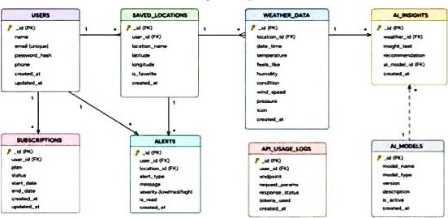
1. User Entity:
- id (Primary Key - Objectld)
- name (String, Required)
- email (String, Required, Unique)
- password (String, Hashed, Required)
- role (String, Default: "reader")
2. Location Entity:

- id (Primary Key - Objectid)
- user (Foreign Key referencing User Collection)
- city (String, Required)
- country (String, Required)
- createdAt (Date, Default: Now)
Key Structural Mappings:
- user to Location (One-to-Many): A registered use multiple favorite locations. Kev Features
- Role-Based Route Guarding: Strict token processing blocks unauthorized tiers from modifying core settings core
- CRUD Blog Execution Engine: Complete schema management over content definitions, status states, and asset assignment paths.
- Categorization System: Native tag indices facilitate filtering and querying for enhanced discoverability.
- Comment Moderation Logic: Protected entry points for updating moderation flags (approved, pending. spam)
- Sanitization Safeguards: Payload parameter sanitation prevents XSS vectors and NoSQL parameter manipulation injections.
Roles and Responsibilities
Admin:
- Responsible for user account management, including creating, deleting. or suspending accounts.
- Oversight of API health and system logs to monitor performance.
• Monitoring and managing database integrity
Registered User:
- Responsible for creating and maintaining a list of favorite locations.
- Initiating requests for real-time weather data.
- Interacting with the Gemini Al service for personalized weather summaries and activity recommendations.
Core System Script Implementations:
Application Entry Point (index.js):
The index.js file serves as the main entry point of the application. It initial izes the Express server, loads environment variables, configures middleware, establishes the MongoDB connection, registers API routes, and starts the server after a successful Database connection.
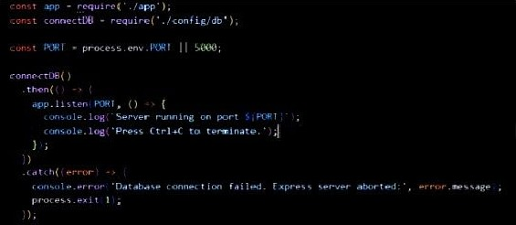
Epic4: Database Configuration
API Testing Demo :
Configure MongoDB:
- Install Mongoose.
In your Node.js project directory, run:
Npm install mongoose
- Create database connection.
- Create Schemas & Models.
Create Database connection:
Now, make sure the database is connected before performing any of the actions Through the backend. The connection code looks similar to the one provided below Mongoose Schema Definitions
Location Schema:

const mngLÄyse • require(
bcrypt  type: Str:ng, | • bcryptjs ' ) ;  Sc heea(
required:  trim:  emai I :  tvpe: String, | 'Please provide rt—'
required: | 'Please provide an eel I
unique; trim;
match:
'Please provide a val id e•ail address-
pas
type: Swing, required: 'Please provide min length: 16, at least 8 characters • I
timestamps:

User schema:
Db connection:
This module establishes a connection between the application and MongoDB using Mongoose. It ensures that the backend communicates with the database before processing any client requests.
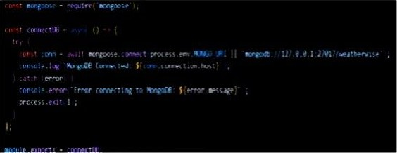
Epic 5: Project Executions:
The Al weather wise backend can be executed locally using Node.js. Before running the application. ensure that MongoDB is running and the required environment variables are configured correctly. The backend exposes REST APIs that can be tested using Postman or Thunder Client.
Running the Backend Server: Install all required dependencies:
ng:rr, install
Start the development server:

npm start
After successful execution, the server connects to MongoDB and starts listening for Incoming API requests.
API testing:
Register API:
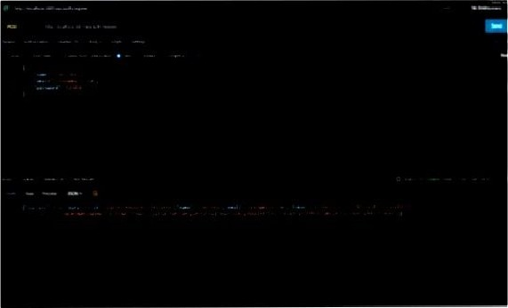
Login API:
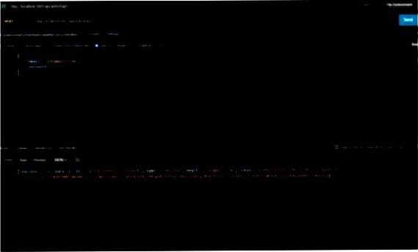
Weather API:
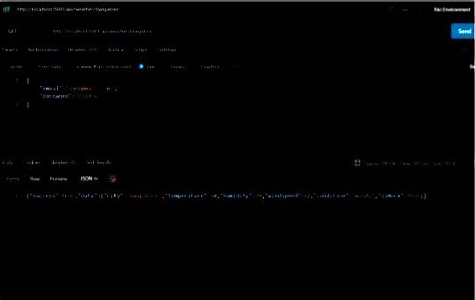
Recommendation API:
