Intelligent Remote Healthcare and Assisted Living Ecosystem

A PROJECT REPORT

Submitted by

SRIDHAR.B | 611223114100
YOGESWARI.G | 611223114115
MAHENDIRAN.M | 611223114054

in partial fulfillment for the award of the degree

Of

BACHELOR OF ENGINEERING

IN

MECHANICAL ENGINEERING

KNOWLEDGE INSTITUTE OF TECHNOLOGY,SALEM

ANNA UNIVERSITY::CHENNAI 600 025

DEC 2025

BONAFIDE CERTIFICATE

Certified that this project report " Intelligent Remote Healthcare and Assisted Living Ecosystem" is the bonafide work of "SRIDHAR.B , ,YOGESWARI.G, MAHENDIRAN.M" who carried out the project work under my supervision.

SIGNATURE SIGNATURE

Dr.K.S.PRABHAKARAN.,M.E.,Ph.D. Prof.S.SURENDAR.,B.E.,M.E.
HEAD OF THE DEPARTMENT SUPERVISOR
PROFESSOR ASSISTANT PROFESSOR
DEPARTMENT OF MECHANICAL DEPARTMENT OFMECHANICAL
ENGINEERING ENGINEERING
KNOWLEDGE INSTITUTE OF KNOWLEDGE INSTITUTE OF
TECHNOLOGY TECHNOLOGY
KIOT CAMPUS KIOT CAMPUS
KAKAPALAYAM(PO) KAKAPALAYAM(PO)
SALEM-637504 SALEM-637504

ABSTRACT

Monitoring the health and safety of elderly people, patients, and individuals who need regular assistance is becoming increasingly important. Family members and caregivers may not always be available to monitor them continuously. Because of this, sudden changes in health, falls, gas leakage, or other emergency situations may sometimes go unnoticed. To address this problem, the Intelligent Remote Healthcare and Assisted Living Ecosystem is developed as an integrated system for health monitoring, safety monitoring, and emergency assistance.The system uses an ESP32 microcontroller to collect information from different sensors. The MAX30102 sensor measures heart rate and blood oxygen level (SpO₂), while the MLX90614 sensor monitors body temperature. The MPU6050 sensor is used to identify unusual movements and possible falls. Along with health monitoring, the system also checks the surrounding environment. The DHT22 sensor measures room temperature and humidity, the MQ-2 sensor detects gas or smoke, and the PIR sensor detects movement in the surroundings.The collected sensor readings are displayed on an OLED screen and are also sent to the Blynk IoT platform, allowing the user's condition to be monitored remotely. If an abnormal condition or possible emergency is detected, the system provides an alert through a buzzer and LED indicators. An SOS button is also provided, allowing the user to manually request assistance during an emergency.To maintain a record of the monitored information, a Python-based data logging system is included. The Python program retrieves the sensor data from the Blynk IoT Cloud and automatically stores the readings in a CSV file. This stored data can be used for reviewing previous readings, analyzing changes over time, and maintaining health and environmental records.Overall, the proposed system combines health monitoring, environmental safety, emergency alerts, remote access, and automatic data storage in one platform. It provides a practical and affordable approach that can help family members and caregivers stay informed about the user's condition and take appropriate action when assistance is needed.

KEYWORDS:
Remote Healthcare, Assisted Living, ESP32, Health Monitoring, Heart Rate Monitoring, SpO₂ Monitoring, Body Temperature Monitoring, Fall Detection, Environmental Monitoring, Emergency Alert, Blynk IoT, Python Data Logging, Elderly Care, Patient Monitoring.
TABLE OF CONTENT

CHAPTER NO. | TITLE | PAGE NO.
 | ABSTRACT | iii
 | LIST OF TABLES | vii
 | LIST OF FIGURES | viii
 | LIST OF SYMBOLS & ABBREVIATIONS | x
1 | INTRODUCTION | 1
 | 1.1 Introduction to Remote Healthcare | 1
 | 1.2 Need for Elderly and Patient Monitoring | 2
 | 1.3 Problems with Conventional Healthcare Monitoring | 3
 | 1.4 Objectives of the Project | 4
 | 1.5 Methodology | 5
2 | LITERATURE SURVEY
2.1 Introduction
2.2 Remote Health Monitoring Systems
2.3 IoT-Based Healthcare Systems
2.4 Fall Detection Systems
2.5 Environmental Safety Monitoring Systems
2.6 Emergency Alert and Assistance Systems
2.7 Data Logging for Healthcare Monitoring
2.8 Research Gap and Motivation
3 | PRINCIPLES OF THE PROPOSED SYSTEM | 14
 | 3.1 Introduction | 14
 | 3.2 Health Parameter Monitoring | 14
 | 3.3 Heart Rate and SpO₂ Measurement | 15

 | 3.4 Body Temperature Measurement | 16
 | 3.5 Fall Detection Principle | 17
4 | SYSTEM DESIGN AND COMPONENT DESCRIPTION | 19
 | 4.1 Introduction | 19
 | 4.2 Overall System Architecture | 19
 | 4.3 Block Diagram Description | 20
 | 4.4 Components List | 21
 | 4.5 Component Description | 21
 | 4.5.1ESP32 Microcontroller | 21
 | 4.5.2 MAX30102 Sensor | 22
 | 4.5.3 MLX90614 Sensor | 23
 | 4.5.4 MPU6050 Sensor | 24
 | 4.5.5 DHT22 Sensor | 25
 | 4.5.6 MQ-2 Gas Sensor  4.5.7 PIR Sensor  4.5.8 OLED Display  4.5.9 Buzzer  4.5.10 LED  4.5.11 SOS Button | 26
 | 4.7 System Advantages | 27
5 | CIRCUIT DESIGN AND CONNECTIONS | 28
 | 5.1 Introduction | 28
 | 5.2 Circuit Diagram | 28
 | 5.3 Electrical Connections | 29
 | 5.4 Sensor and ESP32 Wiring | 29
 | 5.5 MAX30102 Connection | 30
6 | WORKING PRINCIPLE | 32

 | 6.1 Introduction | 32
 | 6.2 Health Monitoring Process | 32
 | 6.3 Fall Detection Process | 33
 | 6.4 Environmental Monitoring Process | 33
 | 6.5 Alert Generation Process | 34
7 | EXPERIMENTAL SETUP AND IMPLEMENTATION | 35
 | 7.1 Introduction | 35
 | 7.2 Prototype Description | 35
 | 7.3 Hardware Setup | 36
 | 7.4 Sensor Integration | 37
 | 7.5 Blynk and Data Logging Setup | 37
 | 7.6 Testing Procedure | 37
 | 7.7 Experimental Observation | 38
8 | COST ESTIMATION | 40
 | 8.1 Introduction | 40
 | 8.2 Cost Estimation Methodology | 40
 | 8.3 Component-Wise Cost Breakdown | 41
 | 8.4 Economic Feasibility | 41
9 | RESULTS AND ANALYSIS | 43
 | 9.1 Introduction | 43
 | 9.2 Heart Rate Results | 43
 | 9.3 SpO₂ Results | 44
 | 9.4 Body Temperature Results | 45
 | 9.5 Fall Detection Results | 45
 | 9.6 Environmental Monitoring Results | 45
 | 9.7 Blynk Monitoring ResultsTechniques | 46
 | 9.8 Python Data Logging Results | 46
 | 9.9 Alert System Results  9.10 Overall System Performance  9.11 Limitations | 46
10 | ADVANTAGES AND APPLICATIONS | 47
 | 10.1 Introduction | 47
 | 10.2 Advantages | 47
 | 10.3 Applications | 47
 | 10.4 Future Scope | 47
11 | APPENDICES | 51
 | 11.1 PROTOTYPE | 51
 | 11.2 Blynk Dashboard | 52
12 | CONCLUSION | 53
13 | REFERENCES | 54

Table No. | Title | Page No.
Table 4.4 | List of Components | 36
Table 5.4 | Sensor and ESP32 Wiring | 44
Table 8.3 | Component-Wise Cost Breakdown | 50

LIST OF SYMBOLS, ABBREVIATIONS AND NOMENCLATURE

1.SYMBOLS:

Symbol | Meaning
S | SpO₂
HR | Heart Rate
T | Temperature
°C | Degree Celsius
V | Voltage
C | Current
BPM | Beats Per Minute

2.ABBREVIATIONS:

Abbreviation | Full Form
IOT | Internet of Things
ESP32 | Espressif 32-bit Microcontroller
BPM | Beats Per Minute
SpO₂ | Blood Oxygen Saturation
HR | Heart Rate
HRM | Heart Rate Monitoring
MLX90614 | Infrared Non-Contact Temperature Sensor
MAX30102 | Pulse Oximeter and Heart Rate Sensor
ESP32 | Espressif 32-bit Microcontroller

3.NOMENCLATURE:
Keyword | Simple Meaning
IoT | Connecting devices to the internet to send and receive data.
ESP32 | A small microcontroller that controls the whole system and connects to Wi-Fi.
Remote Healthcare | Monitoring a person's health from a different location.
Health Monitoring | Checking important health conditions regularly.
Heart Rate | The number of heartbeats in one minute.
SpO₂ | The amount of oxygen present in the blood.
MAX30102 | Sensor used to measure heart rate and SpO₂.
MLX90614 | Sensor used to measure body temperature without touching the body.
MPU6050 | Sensor used to detect movement and possible falls.
Fall Detection | Identifying sudden movement that may indicate a person has fallen.
DHT22 | Sensor used to measure room temperature and humidity.
MQ-2 | Sensor used to detect gas and smoke.
OLED Display | Small screen used to show sensor readings.

LIST OF FIGURES:

Figure No. | Title | Page No
Figure 4.1 | ESP32 Development Board | 37
Figure 4.2 | MAX30102 Sensor | 38
Figure 4.3 | MLX90614 Sensor | 39
Figure 4.4 | MPU6050 Sensor | 40
Figure 4.4 | DHT22 Sensor | 41
Figure 9.1 | MQ-2 Gas Sensor
Figure 11.1 | PIR Sensor | 66
Figure 11.2 | OLED Display | 66
Figure 11.3 | Buzzer | 66
Figure 11.4 | SOS Button | 67
Figure 11.5 | Prototype | 67
Figure 11.6 | Blynk Dashboard | 67

CHAPTER 1
INTRODUCTION

1.1 Introduction to Remote Healthcare
Healthcare monitoring is important for elderly people, patients, and individuals who need regular assistance. In many situations, family members or caregivers cannot stay with them throughout the day. Because of this, changes in health conditions or unexpected situations may not be noticed immediately. A remote healthcare system can help by continuously collecting important health and environmental information and making it available to caregivers from a distance.The Intelligent Remote Healthcare and Assisted Living Ecosystem is developed to provide continuous monitoring using sensors and IoT technology. An ESP32 microcontroller collects information from different sensors such as the MAX30102, MLX90614, MPU6050, DHT22, MQ-2, and PIR sensor. These sensors are used to monitor heart rate, SpO₂, body temperature, movement, room conditions, gas or smoke, and surrounding activity. The collected information can be displayed locally on an OLED display and remotely monitored through the Blynk IoT platform.The system also provides alerts when an unusual condition is detected. A buzzer and LED are used to indicate abnormal situations, while an SOS button allows the user to manually request assistance. The system is designed as a practical and affordable solution for supporting caregivers and improving the safety of people who require regular monitoring.

1.2 Need for Elderly and Patient Monitoring
Elderly people and patients may require regular observation because their health condition can change unexpectedly. Continuous personal monitoring is not always possible, especially when family members or caregivers are away. Simple changes such as an unusual heart rate, low SpO₂ level, increased temperature, a fall, or unsafe environmental conditions may require immediate attention.A monitoring system can reduce this problem by observing important parameters continuously. Instead of depending completely on manual checking, sensors can collect information automatically and send it to a remote platform. This allows caregivers to check the person's condition without being physically present all the time.The proposed system also considers the surroundings of the person. Room temperature and humidity, gas or smoke, and movement can provide useful information about the safety of the environment. Combining health monitoring with environmental monitoring makes the system more useful for assisted living applications.

1.3 Problems with Conventional Healthcare Monitoring
Traditional healthcare monitoring often depends on direct observation by family members, nurses, or caregivers. This method can become difficult when the person needs monitoring for a long period. Caregivers may not always be available to check the person's condition continuously.
Another problem is that unexpected events such as falls or gas leakage may happen when nobody is nearby. In such situations, a delay in identifying the problem can make the situation more serious. Manual recording of health readings can also take additional time and may not provide an easy way to review previous readings.
These limitations show the need for a system that can automatically collect sensor readings, provide alerts, allow remote monitoring, and store data for later reference.

1.4 Objectives of the Project
The main objectives of the Intelligent Remote Healthcare and Assisted Living Ecosystem are:
- To develop a system for continuous monitoring of important health parameters.
- To measure heart rate and SpO₂ using the MAX30102 sensor.
- To monitor body temperature using the MLX90614 sensor.
- To identify unusual movement or possible falls using the MPU6050 sensor.
- To monitor room temperature and humidity using the DHT22 sensor.
- To detect gas or smoke using the MQ-2 sensor.
- To detect surrounding movement using the PIR sensor.
- To display sensor readings locally using an OLED display.
- To provide remote monitoring through the Blynk IoT platform.
- To generate alerts using a buzzer and LED when abnormal conditions are detected.
- To provide an SOS button for manually requesting assistance.
- To store collected sensor data in CSV format using Python for future review and analysis.

1.5 Methodology
The proposed system is developed by integrating multiple sensors with an ESP32 microcontroller. First, the sensors are connected to the ESP32 and tested individually to ensure that they provide proper readings. The MAX30102 is used for heart rate and SpO₂ measurement, while the MLX90614 measures body temperature. The MPU6050 monitors movement, and the DHT22 measures room temperature and humidity. The MQ-2 and PIR sensors are used for environmental safety and movement monitoring.
After collecting the sensor readings, the ESP32 processes the information and displays the required values on the OLED display. The readings are also connected to the Blynk IoT platform so that they can be monitored remotely. If an abnormal condition or emergency situation is detected, the buzzer and LED provide a local alert. The SOS button can also be used by the person to request assistance manually.
Finally, Python is used to retrieve the available data from the Blynk platform and store it in a CSV file. This provides a simple record of previous readings that can be reviewed later. The complete methodology combines health monitoring, environmental monitoring, emergency alerts, IoT-based remote access, and data logging into a single system.

CHAPTER 2
LITERATURE SURVEY

2.1 Introduction
The development of IoT and sensor-based technologies has made it easier to monitor people remotely. Many healthcare systems have been developed to measure health parameters and send the collected information to doctors, family members, or caregivers. These systems reduce the need for continuous physical observation and can provide useful information about a person's condition.
Existing research mainly focuses on areas such as heart rate monitoring, oxygen level measurement, body temperature monitoring, fall detection, environmental monitoring, and IoT-based healthcare applications. Studying these systems helps in understanding the methods used and also shows the areas where an improved system can be developed.

2.2 Remote Health Monitoring Systems
Remote health monitoring systems are designed to collect a person's health information using electronic sensors. The measured values can be transferred to a computer, mobile application, or cloud platform for observation. This approach is useful when patients or elderly people cannot be monitored continuously by a healthcare professional or family member.
Most systems concentrate on a few important parameters such as heart rate, SpO₂, and body temperature. The collected readings can help caregivers understand changes in the person's condition. However, a system that monitors only health parameters may not provide information about environmental problems or sudden physical incidents.
The proposed project combines health monitoring with environmental and safety monitoring to provide a more complete solution.

2.3 IoT-Based Healthcare Systems
IoT has become an important technology in remote healthcare because it allows sensor data to be accessed through the internet. A microcontroller can collect information from sensors and send the readings to an online platform. Caregivers can then monitor the information remotely using a suitable application.
IoT-based healthcare systems can provide real-time access to sensor readings and reduce the need for manual recording. They can also be programmed to generate alerts when a reading crosses a selected limit.
The proposed system uses the Blynk IoT platform for remote monitoring. The ESP32 sends the collected sensor data to Blynk, allowing the required readings to be viewed remotely.

2.4 Fall Detection Systems
Falls are a common safety concern for elderly people, particularly when they are alone. A fall detection system can identify sudden changes in body movement and provide an alert when an unusual movement pattern is detected.
Accelerometers and gyroscope-based sensors are commonly used for this purpose. The MPU6050 is one such sensor that provides acceleration and angular movement information. By observing changes in these values, the system can identify movement patterns that may indicate a possible fall.
In the proposed system, the MPU6050 is integrated with the ESP32 for movement monitoring. When a possible abnormal movement is detected, the system can activate the local alert mechanism so that attention can be given to the situation.

2.5 Environmental Safety Monitoring
A person's safety is not limited to health conditions. The surrounding environment can also affect their well-being. Problems such as excessive room temperature, high humidity, gas leakage, smoke, or unexpected movement can create unsafe conditions.
Environmental sensors can be used to identify such conditions. The DHT22 provides room temperature and humidity information, while the MQ-2 is used for detecting gas or smoke. A PIR sensor can be used to detect movement in the surrounding area.
Including these sensors in the healthcare system provides additional information about the living environment. This makes the proposed system useful not only for health monitoring but also for basic safety monitoring.

2.6 Emergency Alert and Assistance Systems
An important feature of an assisted living system is the ability to inform the user or caregiver when an unusual situation occurs. Automatic alerts can be generated when the system detects a selected abnormal condition. A buzzer and LED can provide a simple local indication that immediate attention may be required.
In addition to automatic alerts, a manual assistance option can be useful. An SOS button allows the user to request help when they are conscious and able to operate the button. This provides an additional method of communicating an emergency situation.
The proposed system combines automatic alerts with a manual SOS facility to improve the overall safety of the user.

2.7 Data Logging for Healthcare Monitoring
Continuous monitoring can produce a large number of sensor readings. Saving these readings makes it possible to look at previous values instead of depending only on the current reading. Historical data can be useful for understanding changes in health or environmental conditions over time.
Many IoT systems provide real-time monitoring, but additional data storage can make the system more useful for later analysis. In the proposed project, Python is used to retrieve the available data from the Blynk platform and store it in CSV format.
The stored data can be opened and reviewed later. This provides a simple record of the monitored parameters and can support basic analysis of the collected information.

2.8 Research Gap and Motivation
From the study of existing healthcare monitoring systems, it can be seen that many systems focus on individual functions such as health monitoring, fall detection, or environmental monitoring. Using separate systems for each function can increase complexity and may not provide a complete picture of the user's condition.
The main motivation of this project is to bring these functions together in one affordable system. The proposed system combines health monitoring, movement detection, environmental safety monitoring, remote IoT access, emergency alerts, SOS assistance, and data logging using the ESP32.
The project therefore aims to provide a simple and practical assisted living system that can help caregivers monitor a person's health and surroundings remotely.

CHAPTER 3
PRINCIPLES OF THE INTELLIGENT REMOTE HEALTHCARE AND ASSISTED LIVING ECOSYSTEM
3.1 Introduction
The proposed system works by collecting important health and movement information using different sensors connected to an ESP32 microcontroller. Each sensor performs a specific function and sends the measured data to the ESP32 for processing. The collected information can be displayed on an OLED display and also sent to the Blynk IoT platform for remote monitoring.
The main idea of the system is to make regular monitoring easier for elderly people, patients, and individuals who need assistance. The system checks important health parameters and movement conditions and provides an alert when an unusual situation is detected.

3.2 Health Parameter Monitoring
Health parameter monitoring is one of the main functions of the proposed system. The system measures important parameters such as heart rate, SpO₂, and body temperature using suitable sensors.
The MAX30102 sensor is used to measure heart rate and SpO₂, while the MLX90614 sensor is used to measure body temperature. The ESP32 collects the readings from these sensors and processes them before displaying the values.
Regular monitoring of these parameters can help caregivers keep track of the person's condition. The system is mainly intended for monitoring and alert purposes and does not replace professional medical equipment or medical diagnosis.

3.3 Heart Rate and SpO₂ Measurement
The MAX30102 sensor is used to measure heart rate and blood oxygen saturation (SpO₂). It works using optical sensing, where light is used to detect changes in blood flow. When the user's finger is placed properly on the sensor, it collects the required signals and sends the data to the ESP32.
The ESP32 processes the received data and obtains the heart rate and SpO₂ values. These values can then be shown on the OLED display and sent to the Blynk platform for remote viewing.
For better readings, the finger should be placed correctly on the sensor and unnecessary movement should be avoided during measurement. This helps the sensor provide more stable readings.

3.4 Body Temperature Measurement
The MLX90614 sensor is used to measure body temperature without direct contact with the body. It works by detecting infrared radiation from the surface of the target and converting it into a temperature value.
The sensor is positioned properly in front of the person to obtain the temperature reading. The measured value is received by the ESP32 and can be displayed on the OLED screen and monitored through the Blynk platform.
This method provides a simple and convenient way to monitor temperature. However, the distance, position of the sensor, and surrounding conditions can affect the measured value.

3.5 Fall Detection Principle
Fall detection is an important part of the proposed system, especially for elderly people and individuals who may require assistance. The MPU6050 sensor is used to monitor movement and changes in body orientation. It contains an accelerometer and gyroscope that provide information about movement.
During normal activities, the movement of a person changes gradually. A fall may cause a sudden change in acceleration or orientation. The ESP32 continuously receives the movement information from the MPU6050 and checks it according to the conditions programmed in the system.
When a possible fall or unusual movement is detected, the system can activate the buzzer and LED to attract attention. This feature is intended to provide an early alert so that the person can receive assistance when required.

CHAPTER 4

SYSTEM DESIGN AND COMPONENT DESCRIPTION

4.1 Introduction
The proposed Intelligent Remote Healthcare and Assisted Living Ecosystem is designed by combining different sensors, an ESP32 microcontroller, an OLED display, alert devices, and an IoT platform. Each component has a specific function in the system. The sensors collect health, movement, and environmental information, while the ESP32 processes the collected data and controls the overall operation.The system is designed to provide both local and remote monitoring. The OLED display shows the readings near the user, while the Blynk IoT platform allows the information to be monitored remotely. The buzzer, LED, and SOS button are included to provide quick assistance during abnormal or emergency situations.

4.2 Overall System Architecture
The overall system consists of three main sections: sensing, processing, and monitoring. The sensing section includes the MAX30102, MLX90614, MPU6050, DHT22, MQ-2, and PIR sensors. These sensors collect different types of information from the user and the surrounding environment.
The ESP32 acts as the main processing unit. It receives the sensor readings, processes them according to the programmed conditions, and sends the required information to the output devices. The OLED display provides local information, while the Blynk IoT platform is used for remote monitoring.
The buzzer and LED are connected to the ESP32 to provide alerts when an abnormal condition is detected. The SOS button gives the user an additional way to request help manually.

4.3 Components List

S.No | Component | Function
1 | ESP32 Development Board | Main controller and Wi-Fi communication
2 | MAX30102 | Heart rate and SpO₂ measurement
3 | MLX90614 | Body temperature measurement
4 | MPU6050 | Movement and fall monitoring
5 | DHT22 | Room temperature and humidity measurement
6 | MQ-2 | Gas and smoke detection
7 | PIR Sensor | Surrounding movement detection
8 | OLED Display | Local display of sensor readings
9 | Buzzer | Audible alert
10 | LED | Visual alert
11 | SOS Button | Manual assistance request

4.4 Component Description

4.4.1 ESP32 Development Board
The ESP32 is the main controller used in the project. It receives information from all the connected sensors and processes the readings according to the program. It also has built-in Wi-Fi, which makes it suitable for sending data to the Blynk IoT platform.The ESP32 controls the OLED display, buzzer, LED, and SOS button along with the different sensors. Its compact size and built-in wireless communication make it suitable for this type of IoT-based project.
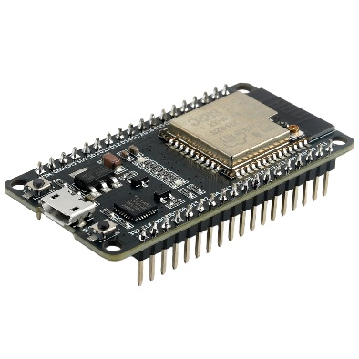
FIGURE 4.1

4.4.2 MAX30102 Sensor
The MAX30102 is used to measure heart rate and SpO₂. It is a small optical sensor that can detect changes in blood flow using light.The sensor sends the collected information to the ESP32. The processed heart rate and SpO₂ values are then displayed and made available for remote monitoring.
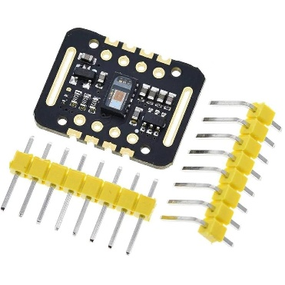
FIGURE 4.2

4.4.3 MLX90614 Sensor
The MLX90614 is an infrared temperature sensor used to measure body temperature without direct contact. It detects infrared radiation from the target and provides a temperature reading.In this project, the sensor is used to monitor the user's body temperature. The reading is sent to the ESP32 and can be displayed on the OLED and monitored through Blynk.
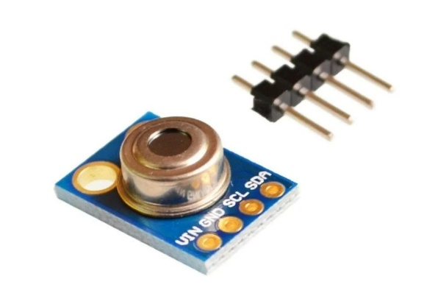
FIGURE 4.3

4.4.4 MPU6050 Sensor
The MPU6050 is a motion sensor containing an accelerometer and gyroscope. It provides information about acceleration and changes in orientation.The sensor is mainly used in this project for movement monitoring and possible fall detection. The ESP32 analyzes the movement information and activates the alert system when the programmed fall conditions are detected.
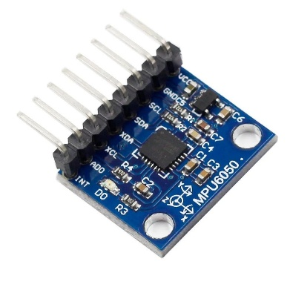
FIGURE 4.4

4.4.5 DHT22 Sensor
The DHT22 is used to measure the temperature and humidity of the surrounding room. It provides digital output, which makes it convenient to connect with the ESP32.The readings from the DHT22 help in understanding the indoor environmental conditions of the monitored person.
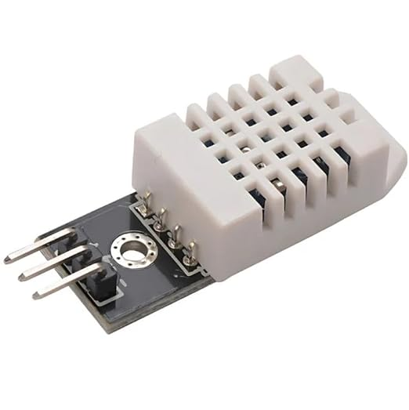
FIGURE 4.5

4.4.6 MQ-2 Gas Sensor
The MQ-2 sensor is used to detect the presence of gases and smoke in the surrounding environment. It is included in the system to improve environmental safety.When the gas or smoke level reaches the programmed detection condition, the ESP32 can activate the buzzer and LED to provide a warning.
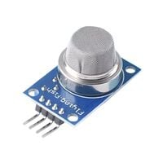
FIGURE 4.6

4.4.7 PIR Sensor
The PIR sensor is used to detect movement in the surrounding area. It works by sensing changes in infrared radiation caused by moving objects or people.In the proposed system, the PIR sensor provides information about activity around the monitored person. This can be useful for basic surrounding movement monitoring.
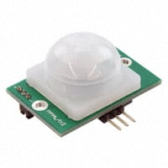
FIGURE 4.7

4.4.8 OLED Display
The OLED display is used to show the sensor readings locally. Important values such as heart rate, SpO₂, temperature, and environmental readings can be displayed on the screen.The display allows the user or nearby caregiver to check the information directly without depending completely on the mobile application.
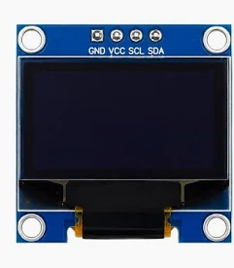
FIGURE 4.8

4.4.9 Buzzer
The buzzer is used as an audible warning device. When the system detects a programmed abnormal condition, the ESP32 activates the buzzer to attract attention.It provides a simple and immediate indication that the monitored person or surrounding environment may require attention.
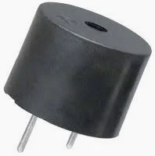
FIGURE 4.9

4.4.10 LED
The LED provides a visual indication when an alert condition occurs. It works along with the buzzer to make the warning easier to notice.The LED can also be programmed to indicate specific system conditions depending on the requirements of the project.
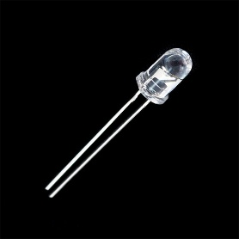
FIGURE 4.10

4.4.11 SOS Button
The SOS button is provided for manual assistance. If the user feels uncomfortable or needs help, the button can be pressed to send the programmed emergency signal.The ESP32 detects the button press and activates the required alert function. This provides the user with a simple way to request assistance without waiting for an automatic sensor-based alert.4.7 Design Considerations
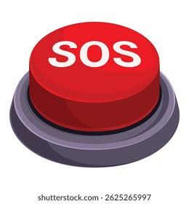
FIGURE 4.11

4.5 System Advantages
- Continuous monitoring of selected health parameters.
- Monitoring of room temperature and humidity.
- Detection of gas or smoke.
- Movement and possible fall monitoring.
- Remote monitoring through the Blynk platform.
- Local readings through an OLED display.
- Automatic alerts using a buzzer and LED.

CHAPTER 5

CIRCUIT DESIGN AND CONNECTIONS

5.1 Introduction
The circuit design is an important part of the Intelligent Remote Healthcare and Assisted Living Ecosystem because it connects all the sensors and output devices to the ESP32. Proper connections are required to collect accurate sensor readings and ensure that the system works correctly.The circuit includes the ESP32, MAX30102, MLX90614, MPU6050, DHT22, MQ-2, PIR sensor, OLED display, buzzer, LED, and SOS button. The ESP32 acts as the main controller and receives information from the connected sensors. It then processes the readings and controls the required output devices.The system is also connected to the Blynk IoT platform through the ESP32's Wi-Fi connection. This allows the collected information to be monitored remotely.

5.2 Circuit Diagram
The circuit diagram shows how the different sensors and output devices are connected to the ESP32. The health monitoring sensors are connected to measure the required body parameters, while the environmental sensors are used to monitor the surrounding conditions.The MAX30102, MLX90614, and MPU6050 mainly provide health and movement-related information. The DHT22, MQ-2, and PIR sensors are used for environmental and surrounding monitoring. The OLED display is connected to show the sensor readings locally.
Health Sensors
↓
MAX30102 / MLX90614 / MPU6050
↓
ESP32 Microcontroller
↓
OLED Display / Buzzer / LED
↓
Wi-Fi Communication
↓
Blynk IoT Platform
↓
Remote Monitoring
The DHT22, MQ-2, and PIR sensors are also connected to the ESP32 to provide environmental information.

5.3 Electrical Connections
The electrical connections are made between the ESP32 and the individual sensors and output devices. Proper power and signal connections are important to prevent incorrect readings and communication problems.
The sensors are supplied with the required operating voltage, and their ground terminals are connected to the common ground of the ESP32. Digital and I²C communication pins are used according to the requirements of each sensor.The MAX30102, MLX90614, MPU6050, and OLED display use the I²C communication method.
Therefore, their SDA and SCL lines are connected to the corresponding I²C pins of the ESP32. The DHT22 and other digital sensors are connected to suitable GPIO pins.The buzzer, LED, and SOS button are connected to digital GPIO pins. All connections should be checked carefully before powering the circuit.

5.4 Sensor and ESP32 Wiring

Component | ESP32 Connection | Purpose
MAX30102 | I²C SDA/SCL | Heart rate and SpO₂
MLX90614 | I²C SDA/SCL | Body temperature
MPU6050 | I²C SDA/SCL | Movement and fall detection
OLED Display | I²C SDA/SCL | Display readings
DHT22 | Digital GPIO | Room temperature and humidity
MQ-2 | Analog/Digital GPIO | Gas or smoke detection
PIR Sensor | Digital GPIO | Movement detection
Buzzer | Digital GPIO | Audible alert
LED | Digital GPIO | Visual alert
SOS Button | Digital GPIO | Manual assistance

CHAPTER 6

WORKING PRINCIPLE

6.1 Introduction
The Intelligent Remote Healthcare and Assisted Living Ecosystem works by collecting information from different health and environmental sensors and processing it using the ESP32 microcontroller. Each sensor performs a particular task, and the ESP32 combines the collected information to monitor the user's condition and surroundings.
The system continuously receives sensor readings and displays the important values on the OLED screen. At the same time, the ESP32 sends the data to the Blynk IoT platform through Wi-Fi, allowing the information to be monitored remotely.
If the system identifies an abnormal condition based on the programmed limits, an alert is provided using a buzzer and LED. The SOS button also allows the user to manually request assistance when required.

6.2 Health Monitoring Process
The health monitoring section measures important parameters such as heart rate, SpO₂, and body temperature. The MAX30102 sensor is used to measure heart rate and SpO₂, while the MLX90614 sensor is used to measure body temperature.
When the user places a finger on the MAX30102 sensor, the sensor collects the required optical signals and sends the data to the ESP32. The controller processes the information and obtains the corresponding heart rate and SpO₂ values.
The MLX90614 measures the user's temperature using infrared sensing. The ESP32 receives this reading and processes it along with the other health data.
The measured values are displayed on the OLED screen and transmitted to the Blynk platform. This allows both the user and caregiver to view the monitored health information.

6.3 Fall Detection Process
The fall detection section is designed to identify sudden and unusual body movements. The MPU6050 sensor is used for this purpose because it contains an accelerometer and gyroscope.
The sensor continuously measures changes in acceleration and orientation. During normal activities, these values generally change within a reasonable range. A sudden change in movement can indicate a possible fall or unusual physical activity.
The ESP32 receives the MPU6050 readings and compares them with the conditions defined in the program. When the readings indicate a possible fall, the system activates the buzzer and LED to provide a local warning.
The fall detection function is mainly intended to provide an early alert. It does not replace professional medical or emergency services.

6.4 Environmental Monitoring Process
The system also monitors the environment around the user. This is useful because unsafe environmental conditions can affect the person's comfort and safety.
The DHT22 sensor measures room temperature and humidity. The MQ-2 sensor is used to detect gas or smoke, while the PIR sensor detects movement in the surrounding area.
The ESP32 continuously receives information from these sensors. If the gas or smoke level reaches the programmed detection condition, the system can activate the buzzer and LED. The room temperature, humidity, and movement information can also be monitored through the OLED display and Blynk platform.
This combination of sensors allows the system to monitor both the user's condition and the surrounding environment.

6.5 Alert Generation Process
The alert system is used to provide a quick warning when an abnormal or emergency condition is detected. The ESP32 checks the sensor readings continuously and compares them with the conditions defined in the program.
If a possible fall, gas or smoke detection, or another programmed abnormal condition occurs, the buzzer is activated to produce an audible warning. At the same time, the LED provides a visual indication of the alert condition.
The SOS button provides a manual way for the user to request assistance. When the button is pressed, the ESP32 detects the input and activates the programmed alert function.
The alert mechanism helps nearby people become aware of the situation quickly and provides an additional safety feature for the monitored person.

CHAPTER 7

EXPERIMENTAL SETUP AND IMPLEMENTATION

7.1 Introduction
The experimental setup is carried out to check the performance of the proposed Intelligent Remote Healthcare and Assisted Living Ecosystem. The prototype combines health monitoring, movement detection, environmental monitoring, emergency alerts, remote monitoring, and data logging in a single system.
The ESP32 development board is used as the main controller. Different sensors are connected to the ESP32 to collect information about the user's health and surrounding environment. The sensor readings are displayed locally on an OLED screen and are also sent to the Blynk IoT platform through Wi-Fi. The system generates alerts using a buzzer and LED when an abnormal condition is detected. An SOS button is also included so that the user can manually request assistance.
The prototype is tested under different conditions to verify whether the sensors provide suitable readings and whether the complete system responds correctly.

7.2 Prototype Description
The prototype is developed by connecting all the required sensors and output devices to the ESP32. The system is designed to monitor both the person and the surrounding environment.
- ESP32 Development Board
- MAX30102 Heart Rate and SpO₂ Sensor
- MLX90614 Body Temperature Sensor
- MPU6050 Accelerometer and Gyroscope
- DHT22 Temperature and Humidity Sensor
- MQ-2 Gas and Smoke Sensor
- PIR Motion Sensor
- OLED Display
- Buzzer
- LED
- SOS Push Button
The MAX30102 is used to measure heart rate and blood oxygen level. The MLX90614 is used for non-contact body temperature measurement. The MPU6050 monitors movement and helps identify possible falls. The DHT22 measures room temperature and humidity, while the MQ-2 detects gas or smoke. The PIR sensor is used to detect movement in the surrounding area.
All the sensor readings are processed by the ESP32. The collected information is then displayed and transmitted to the Blynk IoT platform for remote monitoring.

7.3 Hardware Setup
The hardware setup is assembled according to the designed circuit connections. The ESP32 is placed at the centre of the prototype because it acts as the main processing and communication unit.
The MAX30102 and MLX90614 sensors are positioned so that they can be used easily for collecting health-related measurements. The MPU6050 is fixed properly so that changes in movement and orientation can be detected more effectively.
The DHT22, MQ-2, and PIR sensors are arranged to monitor the surrounding environment. The OLED display is placed where the readings can be viewed easily. The buzzer and LED are connected to the ESP32 to provide audible and visual alerts. The SOS button is also connected to a digital input of the ESP32.
Proper wiring and stable power connections are maintained during the setup. Before testing the complete system, each sensor is checked individually to make sure that it is working correctly.

7.4 Sensor Integration
After completing the hardware connections, the sensors are integrated with the ESP32. Each sensor is programmed according to its required communication method and function.
The MAX30102, MLX90614, MPU6050, and OLED display use the I²C communication interface. The DHT22, MQ-2, and PIR sensors are connected to suitable GPIO pins of the ESP32.
The ESP32 continuously reads the sensor values and processes them according to the programmed conditions. The health-related values include heart rate, SpO₂, and body temperature. The environmental values include room temperature, humidity, gas or smoke detection, and surrounding movement.
The sensors are first tested separately and then operated together. This helps in identifying wiring or communication problems before performing the complete system test.

7.5 Blynk and Data Logging Setup
The Blynk IoT platform is used to provide remote access to the sensor information. The ESP32 sends the collected data to Blynk through its Wi-Fi connection. The required virtual pins and dashboard elements are configured to display the sensor readings.The Blynk dashboard can show values such as:
- Heart rate
- SpO₂ level
- Body temperature
- Room temperature
- Humidity
- Gas or smoke status
- Motion status
- Fall alert status
The dashboard allows the readings to be observed remotely without depending only on the OLED display.A Python-based data logging system is also included in the project. The Python program retrieves the available sensor information from the Blynk IoT Cloud and stores it in a CSV file. This makes it possible to maintain a record of previous readings.The stored data can later be reviewed to observe changes in the user's health and environmental conditions over a period of time.

7.6 Testing Procedure
The prototype is tested step by step to verify the operation of each part of the system. Initially, the ESP32 and individual sensors are checked to confirm that they are communicating correctly.
The MAX30102 is tested by placing a finger on the sensor and observing the heart rate and SpO₂ readings. The MLX90614 is tested by placing a person or suitable object within its sensing range and checking the temperature reading.
The MPU6050 is tested by changing its orientation and movement to check whether movement conditions are detected. A controlled movement condition is also used to verify the possible fall-alert response.
The DHT22 is tested under different room conditions to observe changes in temperature and humidity. The MQ-2 is checked for gas or smoke detection, while the PIR sensor is tested by detecting movement in front of the sensor.
The buzzer and LED are tested to ensure that they respond when the programmed alert conditions occur. The SOS button is also pressed during testing to verify that a manual assistance request is detected by the ESP32.
Finally, the complete system is operated together to check whether sensor readings, alerts, Blynk monitoring, and data logging work properly as a combined system.

7.7 Experimental Observation
During the experimental testing, the prototype is observed under different operating conditions. The main purpose of the observation is to verify whether the sensors provide readings, whether the ESP32 processes the data correctly, and whether the monitoring and alert functions respond as expected.
The health sensors provide readings that can be viewed on the OLED display and Blynk dashboard. The environmental sensors provide information about the surrounding conditions. When a programmed abnormal condition is detected, the buzzer and LED provide an alert.
The MPU6050 is used to identify sudden or unusual movement that may indicate a possible fall. The SOS button provides an additional manual method for requesting assistance.
The Blynk platform helps in viewing the collected information remotely, while the Python data logging system stores the readings in CSV format. This provides a useful record for later review and comparison.
Overall, the experimental setup demonstrates the basic operation of the proposed system by combining health monitoring, environmental monitoring, movement detection, alert generation, remote access, and data storage. The system is intended as a monitoring and early-alert solution and should not be considered a replacement for professional medical equipment or medical diagnosis.

CHAPTER 7
COST ESTIMATION
8.1 Introduction
Cost estimation is an important part of developing the Intelligent Remote Healthcare and Assisted Living Ecosystem. The proposed system combines several sensors, a microcontroller, display unit, alert devices, and software platforms to provide health monitoring, environmental safety monitoring, and remote assistance.
The main aim of the cost estimation is to determine the approximate amount required to develop the complete prototype. The cost includes the electronic components and other hardware required for assembling and testing the system. Since the project is designed using commonly available and low-cost components, it can be developed at a reasonable price compared with more complex healthcare monitoring systems.
The estimated cost also helps in evaluating whether the proposed system is economically suitable for practical use. By selecting affordable components without compromising the basic monitoring functions, the system can provide useful healthcare and safety features at a relatively low cost.
8.2 Cost Estimation Methodology
The cost estimation for the proposed system is carried out by identifying all the major hardware components required for its development. Each component is considered based on its function, quantity, and approximate market price.
The major components include the ESP32 microcontroller, MAX30102, MLX90614, MPU6050, DHT22, MQ-2, PIR sensor, OLED display, buzzer, LEDs, and SOS button. Additional items such as connecting wires, breadboards, resistors, and power supply components may also be required during the assembly and testing of the prototype.
The estimated price of each component is recorded separately, and the individual costs are added to obtain the approximate total hardware cost. The prices may vary depending on the supplier, component quality, availability, and purchase quantity. Therefore, the calculated amount should be considered an approximate cost for developing the prototype rather than a fixed commercial price.
8.3 Component-Wise Cost Breakdown
S. No. | Component | Quantity | Approximate Cost (₹)
1 | ESP32 Development Board | 1 | 450
2 | MAX30102 Sensor | 1 | 150
3 | MLX90614 Sensor | 1 | 300
4 | MPU6050 Sensor | 1 | 120
5 | DHT22 Sensor | 1 | 150
6 | MQ-2 Gas/Smoke Sensor | 1 | 100
7 | PIR Motion Sensor | 1 | 80
8 | OLED Display | 1 | 150
9 | Buzzer | 1 | 20
10 | LED Indicators | 2 | 20
11 | SOS Push Button | 1 | 20
12 | Breadboard and Jumper Wires | 1 set | 200
13 | Power Supply/USB Cable | 1 | 150
 | Estimated Total |  | ₹1,910
8.4 Economic Feasibility
The proposed system is economically feasible because it uses a combination of low-cost and easily available electronic components. The ESP32 provides sufficient processing capability and built-in wireless connectivity, which reduces the need for additional communication modules.
Using multiple sensors with a single ESP32 also helps reduce the overall hardware requirement. The system can monitor health parameters, detect possible falls, monitor environmental conditions, generate emergency alerts, and send data to the cloud using the same central controller.
Another advantage is the use of Blynk IoT and Python-based data logging, which provides remote monitoring and data storage without requiring expensive dedicated monitoring equipment. The stored data can also be used for reviewing previous measurements and observing changes over time.
Considering the number of functions provided and the relatively low prototype cost, the proposed system offers a practical and affordable solution for basic remote healthcare and assisted living applications. With further development, the system could be improved using a compact enclosure, rechargeable power supply, improved sensor calibration, and additional communication or monitoring features while still maintaining its focus on affordability.

CHAPTER 9
RESULTS AND ANALYSIS
9.1 Introduction
The proposed Intelligent Remote Healthcare and Assisted Living Ecosystem was developed and tested to verify the performance of its health monitoring, environmental monitoring, emergency alert, remote monitoring, and data logging functions. The system was tested by connecting the sensors to the ESP32 microcontroller and observing the readings obtained under different conditions.
The sensor values were displayed on the OLED screen and transmitted to the Blynk IoT platform for remote monitoring. The alert system was also tested by creating conditions such as unusual movement, gas or smoke detection, and manual activation of the SOS button. In addition, the Python-based data logging system was tested to confirm that the readings received from the Blynk IoT Cloud were stored correctly in a CSV file.
The results obtained during testing show that the proposed system is capable of continuously monitoring important health and environmental parameters and providing alerts when required.
9.2 Heart Rate Results
The MAX30102 sensor was used to measure the user's heart rate. During testing, the sensor was placed properly on the fingertip to obtain a stable reading. The measured heart rate was displayed on the OLED screen and was also sent to the Blynk IoT platform.
For a normal resting condition, the measured heart rate was observed to be within a reasonable range. Small variations in the readings were noticed depending on finger placement, movement, and the time required for the sensor to obtain a stable signal.
Test No. | Observed Heart Rate (BPM) | Condition
1 | 72 | Resting
2 | 75 | Resting
3 | 78 | Resting
4 | 74 | Resting
5 | 76 | Resting
9.3 SpO₂ Results
The MAX30102 sensor was also used to measure the blood oxygen saturation level (SpO₂). The sensor uses optical measurements to estimate the oxygen saturation in the blood. During testing, the finger was placed over the sensor and the readings were observed after allowing sufficient time for the value to stabilize.
Test No. | Observed SpO₂ (%) | Condition
1 | 98 | Resting
2 | 97 | Resting
3 | 98 | Resting
4 | 97 | Resting
5 | 98 | Resting
The observed readings were generally stable during the test. Minor changes were noticed due to finger movement and sensor positioning. The results confirm that the MAX30102 can be integrated into the proposed system for continuous SpO₂ monitoring.

9.4 Body Temperature Results
The MLX90614 infrared temperature sensor was used to measure body temperature without direct physical contact. The sensor was positioned at an appropriate distance from the body, and the temperature readings were observed through the OLED display and Blynk dashboard.
Test No. | Observed Temperature (°C) | Condition
1 | 36.5 | Normal
2 | 36.7 | Normal
3 | 36.6 | Normal
4 | 36.8 | Normal
5 | 36.6 | Normal
The readings showed only small variations during repeated measurements. The accuracy of the temperature measurement can be affected by the distance between the sensor and the target, surrounding temperature, and the position of the sensor.
The test confirms that the MLX90614 can be used to monitor body temperature as part of the proposed healthcare system.

9.5 Fall Detection Results
The MPU6050 sensor was used to identify sudden movements that may indicate a possible fall. The sensor measures acceleration and changes in movement along different axes. During testing, different movements were performed to check whether the system could distinguish normal movement from sudden movement.
Test No. | Movement | Detection Result
1 | Normal sitting | No fall detected
2 | Normal walking | No fall detected
3 | Sudden movement | Alert condition detected
4 | Simulated fall | Fall detected
5 | Standing and sitting | No fall detected
When a sudden movement similar to a fall was detected, the system activated the alert mechanism. The buzzer and LED indicators were used to notify the user or nearby caregiver.
The results show that the MPU6050 can be used for basic fall detection. However, certain sudden movements may produce readings similar to a fall. Therefore, the fall detection algorithm can be further improved by using additional parameters and more advanced motion analysis.

9.6 Environmental Monitoring Results
The proposed system also monitors the surrounding environment to improve the safety of the user. The DHT22, MQ-2, and PIR sensors were tested individually under different conditions.
The DHT22 sensor was used to measure room temperature and humidity. The readings were displayed on the OLED screen and transmitted to Blynk.
Parameter | Sample Reading
Room Temperature | 29.4 °C
Humidity | 62 %
The MQ-2 sensor was tested by exposing it to a small amount of smoke or gas under controlled conditions. When the sensor detected an increased gas or smoke level, the system generated an alert.
The PIR sensor was tested by detecting movement within its sensing range. When movement was detected, the corresponding status was updated and the system responded according to the programmed conditions.
These tests demonstrate that the proposed system can monitor basic environmental conditions in addition to the user's health parameters.

9.7 Blynk Monitoring Results
The Blynk IoT platform was used to provide remote access to the sensor readings. The ESP32 transmitted the collected data through a Wi-Fi connection to the Blynk IoT Cloud.

The Blynk dashboard was configured to display important parameters such as:
- Heart rate
- SpO₂ level
- Body temperature
- Room temperature
- Humidity
- Gas or smoke status
- Motion status
- Fall alert
- SOS status
During testing, the sensor values displayed on the Blynk dashboard were successfully updated when new readings were received from the ESP32.
The remote monitoring feature makes it possible for a caregiver or family member to observe the user's condition without being physically present near the monitoring device. The effectiveness of this feature depends on the availability of a stable Wi-Fi connection.

9.8 Python Data Logging Results
A Python-based data logging system was implemented to maintain a record of the sensor readings. The Python program retrieves the required information from the Blynk IoT Cloud and stores it in a CSV file.
The recorded data includes parameters such as heart rate, SpO₂, body temperature, room temperature, humidity, and other relevant system statuses.
A typical data record is stored in a format similar to the following:

Time | Heart Rate | SpO₂ | Body Temp. | Room Temp. | Humidity
10:00:01 | 72 | 98 | 36.5 | 29.3 | 61
10:01:01 | 75 | 97 | 36.6 | 29.4 | 62
10:02:01 | 74 | 98 | 36.7 | 29.4 | 62
The test confirmed that the sensor readings could be collected and stored automatically. The CSV file provides a simple way to review previous measurements and analyze changes in the monitored parameters over time.

9.9 Alert System Results
The alert system was tested under different emergency and abnormal conditions. The buzzer and LED indicators were used to provide a local warning when an alert condition was detected.
The following conditions were tested:
Test Condition | Alert Generated | Result
Normal health readings | No | Successful
Possible fall | Yes | Successful
Gas/smoke detected | Yes | Successful
Emergency movement | Yes | Successful
SOS button pressed | Yes | Successful
Normal environmental condition | No | Successful
When an emergency condition was detected, the buzzer was activated and the LED indicator provided a visual warning. The SOS button also allowed the user to manually trigger an emergency alert.
The results indicate that the alert mechanism responds effectively to the programmed conditions and provides an additional safety feature for the user.

9.10 Overall System Performance
The complete system was tested by operating the health monitoring, environmental monitoring, remote monitoring, alert, and data logging functions together. The ESP32 successfully collected data from the connected sensors and processed the readings according to the programmed conditions.
The OLED display provided local information, while the Blynk IoT platform provided remote access to the monitored parameters. The alert devices responded when abnormal conditions were simulated, and the Python program successfully recorded the received data in a CSV file.
Overall, the prototype performed the main functions for which it was designed. The integration of multiple sensors into a single system makes it possible to monitor both the user's health and the surrounding environment. The combination of local alerts, cloud-based monitoring, and data storage also improves the usefulness of the system for assisted living applications.

9.11 Limitations
Although the proposed system successfully demonstrates the required monitoring and alert functions, it has some limitations.
- Sensor accuracy: The readings from low-cost sensors may not be as accurate as those obtained from medical-grade instruments.
- Sensor positioning: Sensors such as the MAX30102 and MLX90614 require proper positioning to obtain more stable measurements.
- Fall detection: The MPU6050-based method may sometimes identify sudden normal movements as possible falls. More advanced algorithms could improve the accuracy.
- Wi-Fi dependency: Remote monitoring through Blynk requires a stable internet or Wi-Fi connection. If the connection is unavailable, real-time cloud monitoring may be interrupted.
- Power supply: The system requires a reliable power source for continuous operation. A backup battery could be added for better reliability.
- Environmental factors: Temperature, humidity, sensor placement, and surrounding conditions can affect the readings of some sensors.
- Prototype size: Since the project is developed as a prototype using separate modules, the complete system may be larger than a final wearable or commercial device.
- Medical usage: The proposed system is intended for monitoring and assistance purposes. It should not be treated as a substitute for professional medical diagnosis or certified medical equipment.
Despite these limitations, the developed prototype demonstrates the feasibility of combining health monitoring, environmental safety, emergency alerts, IoT-based remote monitoring, and automatic data logging into a single affordable system.
CHAPTER 10
ADVANTAGES AND APPLICATIONS
10.1 Introduction
The Intelligent Remote Healthcare and Assisted Living Ecosystem is designed to provide continuous monitoring of health and environmental conditions while also offering emergency assistance. By combining multiple sensors, an ESP32 microcontroller, IoT connectivity, and a data logging system, the proposed system can perform several monitoring functions using a single platform.
The system is useful not only for observing basic health parameters but also for improving the safety of elderly people, patients, and individuals who may require regular assistance. The collected information can be viewed locally through the OLED display or remotely through the Blynk IoT platform. In addition, the alert mechanism helps notify the user or caregiver when an unusual condition is detected.
10.2 Advantages
The proposed system provides several advantages compared with conventional methods of monitoring health and safety.
- Continuous Monitoring:
The system can continuously monitor important parameters such as heart rate, SpO₂, and body temperature. This reduces the need for frequent manual checking.
- Remote Access:
Sensor readings can be viewed remotely through the Blynk IoT platform. This allows family members or caregivers to keep track of the user's condition even when they are not nearby.
- Fall Detection:
The MPU6050 sensor helps identify sudden movements that may indicate a fall. This feature can be particularly useful for elderly people who may require immediate assistance after a fall.
- Environmental Safety:
The system monitors room temperature, humidity, gas or smoke, and movement. This provides additional protection against certain environmental hazards.
- Emergency Alert:
The buzzer and LED indicators provide immediate local alerts when an abnormal condition is detected. The SOS button also allows the user to manually request assistance.
- Automatic Data Storage:
The Python-based data logging system stores sensor readings in a CSV file. This makes it easier to review previous measurements and observe changes over time.
- Low-Cost Implementation:
The system uses commonly available and relatively affordable electronic components. This makes the prototype suitable for low-cost healthcare and assisted living applications.
- Multiple Functions in One System:
Health monitoring, environmental monitoring, fall detection, emergency alerts, IoT connectivity, and data logging are combined into a single platform.
- Easy Monitoring:
The OLED display provides immediate access to important readings near the user, while the Blynk dashboard provides a convenient method for remote monitoring.
- Expandable Design:
Since the system is based on an ESP32 microcontroller, additional sensors and features can be integrated in the future according to the requirements of the application.

10.3 Applications
The proposed system can be used in different situations where regular health and safety monitoring is required.
- Elderly Care:
The system can assist in monitoring elderly people who live alone or require regular supervision. Fall detection and emergency alerts can provide additional safety.
- Patient Monitoring:
It can be used for basic monitoring of patients at home, allowing caregivers or family members to observe selected health parameters remotely.
- Assisted Living Facilities:
The system can be adapted for use in assisted living environments where several individuals may require regular monitoring.
- Home Healthcare:
The proposed system can support home-based healthcare by providing basic health measurements and remote access to sensor data.
- Safety Monitoring:
Gas or smoke detection, movement detection, and emergency alerts make the system useful for improving safety in residential environments.
- Remote Caregiving:
Family members or caregivers can use the Blynk dashboard to check the monitored information without being physically present at the user's location.
- Healthcare Monitoring Research:
The prototype can also be used as a development platform for experimenting with IoT-based healthcare monitoring, sensor integration, and data analysis.
- Smart Home Applications:
The environmental monitoring and emergency alert features can be integrated with other smart home systems to improve safety and automation.

10.4 Future Scope
The proposed system can be further improved by adding more advanced features and improving the accuracy and reliability of the existing functions.
Future versions could include GPS tracking to provide the user's location during an emergency, particularly for elderly people who may move outside the home. A GSM or other cellular communication module could also be added to send emergency notifications when Wi-Fi is unavailable.
The fall detection system can be improved using more advanced algorithms or machine learning techniques to distinguish actual falls from normal movements. Similarly, sensor calibration and signal processing can be improved to obtain more stable health measurements.
A rechargeable battery and power management system could be incorporated to make the device portable and suitable for longer periods of operation. The overall hardware could also be made smaller by designing a compact PCB instead of using separate modules.
Another possible improvement is the development of a mobile application with customized notifications and historical graphs. The collected data could also be analyzed using data analytics or machine learning techniques to identify long-term changes in health parameters.
With these improvements, the proposed system could be developed into a more compact, reliable, and user-friendly solution for remote healthcare and assisted living applications.

11. APPENDICES

11.1 Prototype Images
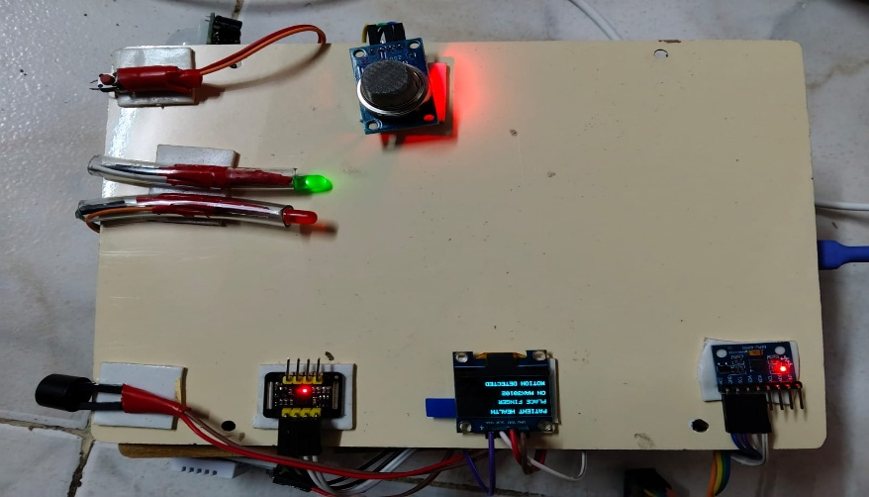

11.2 Blynk Dashboard

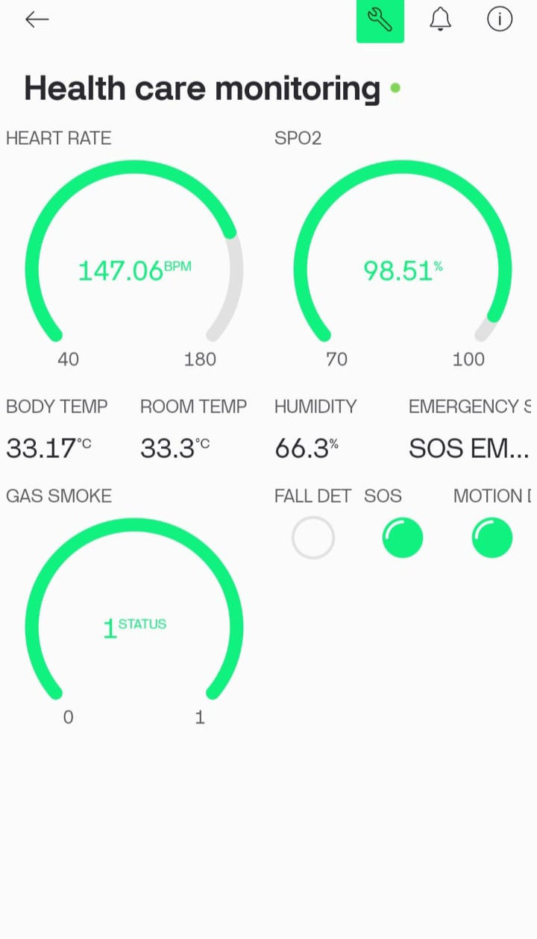
CHAPTER 12
CONCLUSION
The Intelligent Remote Healthcare and Assisted Living Ecosystem was developed to provide a simple and affordable solution for monitoring the health and safety of elderly people, patients, and individuals who may require regular assistance. The main objective of the project was to combine health monitoring, environmental monitoring, emergency alerts, remote access, and data storage into a single system.
The proposed system uses an ESP32 microcontroller to collect information from different sensors. The MAX30102 is used to monitor heart rate and SpO₂, while the MLX90614 measures body temperature. The MPU6050 helps detect sudden movements and possible falls. Environmental conditions are monitored using the DHT22, MQ-2, and PIR sensors, which provide information about room temperature, humidity, gas or smoke, and movement.
The collected readings are displayed on an OLED screen, allowing the user to view the information locally. At the same time, the data is transmitted through Wi-Fi to the Blynk IoT platform, making remote monitoring possible for family members or caregivers. The buzzer and LED indicators provide alerts when an abnormal condition is detected, while the SOS button gives the user a simple way to manually request assistance during an emergency.
The project also includes a Python-based data logging system that retrieves the monitored information from the Blynk IoT Cloud and stores it in a CSV file. This provides a useful record of previous readings and makes it possible to review and analyze the monitored data over time.
The testing of the prototype demonstrated that the major functions of the system could be successfully integrated and operated together. The sensors provided the required readings, the alert mechanism responded to simulated emergency conditions, Blynk enabled remote monitoring, and the Python program stored the collected data automatically.
Overall, the project demonstrates how IoT, embedded systems, and sensor technology can be combined to create a practical healthcare and assisted living solution. Although the prototype has limitations related to sensor accuracy, Wi-Fi connectivity, fall detection, and power supply, it provides a strong foundation for further development. With improvements such as better sensor calibration, advanced fall detection algorithms, battery operation, GPS, cellular communication, and mobile application support, the system can be developed into a more reliable and user-friendly solution for real-world applications.
In conclusion, the proposed system provides an affordable and flexible approach to remote healthcare and safety monitoring. It can help caregivers and family members stay informed about the user's condition and respond more quickly when an emergency or unusual situation occurs.

CHAPTER 13
REFERENCES

[1] Espressif Systems, ESP32 Series Datasheet, Espressif Systems, 2024.
[2] Maxim Integrated, MAX30102 High-Sensitivity Pulse Oximeter and Heart-Rate Sensor for Wearable Health, Maxim Integrated, Datasheet.
[3] Melexis, MLX90614 Family – Single and Dual Zone Infra Red Thermometer, Melexis, Datasheet.
[4] TDK InvenSense, MPU-6000 and MPU-6050 Product Specification, TDK InvenSense, Datasheet.
[5] Aosong Electronics, DHT22/AM2302 Digital Temperature and Humidity Sensor Datasheet, Aosong Electronics.
[6] Hanwei Electronics, MQ-2 Semiconductor Sensor for Combustible Gas and Smoke Detection, Technical Datasheet.
[7] Adafruit Industries, PIR Motion Sensor Documentation, Adafruit Industries.
[8] Solomon Systech, SSD1306 128 × 64 Dot Matrix OLED/PLED Segment/Common Driver with Controller, Datasheet.
[9] Blynk Inc., Blynk IoT Documentation, Blynk Documentation.
[10] Python Software Foundation, Python 3 Documentation, Python Software Foundation.

