Computer Graphics
Lab 2.2 – Arduino -> p5.js Data Bridge
Learning about Serial to Browser Communication

Overview:

Build a reliable “data pipe” from a real sensor on the Arduino into a p5.js sketch running in the browser. By the end, you can read a sensor value in JavaScript and use it to control visuals.
In this lab, I don’t give you code, you need to use examples from class to develop this project from scratch. This should help you learn more about the code and project structure.

Hardware + parts
- Arduino UNO R4 WiFi
- USB cable
- Potentiometer (10k) or a photoresistor + resistor (10k)
- Breadboard + jumpers
Wiring (pick one sensor option or try both!)
Option A: Potentiometer
- Pot pin 1 → 5V
- Pot pin 2 (middle/wiper) → A0
- Pot pin 3 → GND
Option B: Photoresistor
- One leg of photoresistor → 5V
- Other leg of photoresistor → A0
- 10k resistor from A0 → GND (voltage divider)

Part 1 — Arduino: send clean serial lines (giving this code for now) Work to understand what each line does and how it works for either sensor.
Arduino sketch (single value per line)
unsigned int ADCValue;

void setup() {
Serial.begin(9600);
}

void loop() {
int val = analogRead(A0); // 0..1023 (typical)
val = map(val, 0, 1023, 0, 255); // scale for graphics
Serial.println(val); // IMPORTANT: newline-delimited
delay(50); // ~20 samples/sec
}
Arduino check
- Upload code.
- Open Serial Monitor at 9600 baud.
- Turn the pot / change light.
- You should see numbers between 0 and 255, one per line.
If you don’t:
- Wrong pin (use A0)
- Wrong baud rate (9600)
- Loose ground wire (most common)

Part 2 — Browser bridge

- Create a p5 project in VSC.
- Develop some simple code to communicate with your sensor.
- You decide how to visualize the interaction with the photoresistor and/ or potentiometer.
- Make sure you set your COM or TTY port in your code.
- Run in browser and add console logging to see values received and their output.

Answer: How did you design this sketch and why? How did it teach you how to use Arduino uploaded code and integrate the communication into a VSC p5 project. Detailed answer here:
I try to make it simple and clear. When we increase the value on the potentiometer the circle and text grow and when the value goes down the circle and text shrinks. This taught me the Arduino must send newline values and the P5 sketch must listen for the data event to receive the. Serial.readLine() reads incoming data line by line.

Upload your sketch code here and a screenshot of your visualization in the browser.

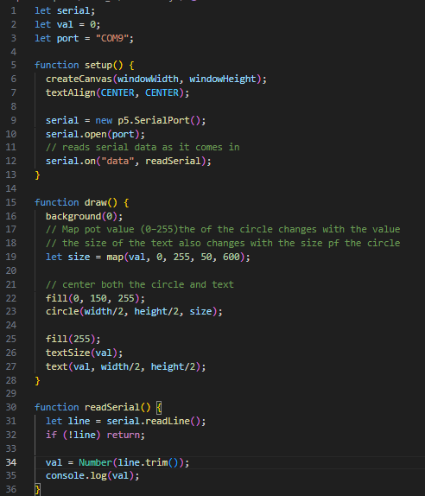

Part 3 – Live Graphing (Real-Time Sensor Plotting in p5.js)
Starter code provided to help learn some new concepts.

Overview:

Use the same Arduino code for this lab. Use a potentiometer for this lab. Here is a wiring diagram, if you didn’t use one above.

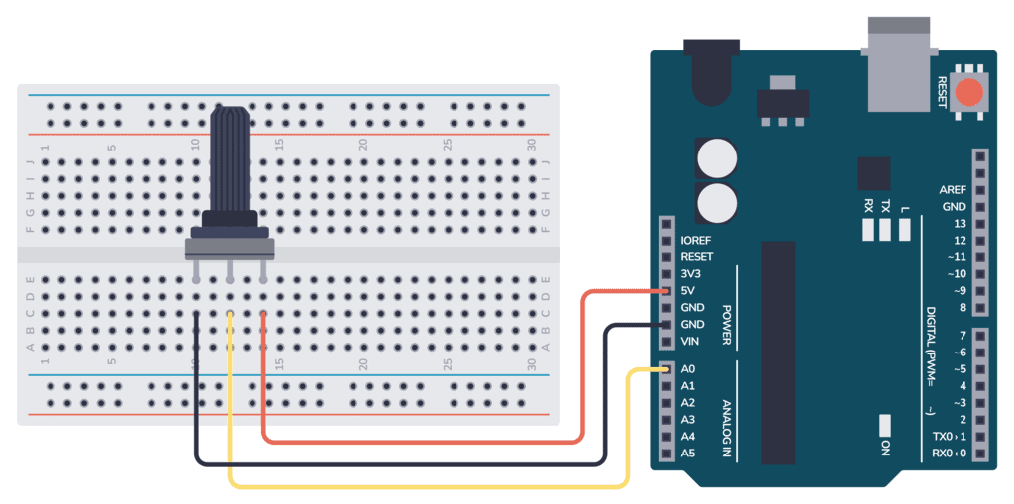

In this lab:
- Start with a sketch that connects to p5.serialserver
- Receives serial data lines
- Stores the latest sensor value

You will add two visuals:
- A vertical bar whose height shows the current sensor value
- A simple line graph that shows the last ~ 100 readings

Required:
- Map numbers to screen coordinates
- Use map( )
- Add some analysis – display minimum and maximum values seen so far

Starter HTML code:

<!DOCTYPE html>
<html lang="en">
<head>
<meta charset="utf-8" />
<meta name="viewport" content="width=device-width, initial-scale=1.0">

<title>Live Sensor Graph Lab 2-2</title>

<link rel="stylesheet" type="text/css" href="style.css">

<script src="libraries/p5.min.js"></script>
<script src="libraries/p5.serialport.js"></script>
<script src="libraries/p5.sound.min.js"></script>
</head>

<body>
<h1>Lab 2-2</h1>
<script src="sketch.js"></script>
</body>
</html>

Use this code to learn live graphing and make the GUI your own. Maybe modify your .css or add something new.

Here is the learning starter code, follow the TODO’s to complete this assignment.

// Lab 2-2 – Live Graphing
// --------------------------------------------------------
// You already used p5.serialport in previous lab to read a single sensor value.
// In this lab, you will:
//
// 1. Draw a bar that shows the current sensor value (0–255).
// 2. Draw a simple history line graph of the last 100 values.
//
// Look for the "// TODO" comments and follow the instructions there.

// ---------- Serial globals ----------
let serial; // the SerialPort object
let latestValue = 0; // most recent sensor value (0–255)

// ---------- Graph / data storage ----------
let history = []; // array of recent values
const MAX_POINTS = 100; // how many points we keep in history

// Min/max tracking
let minSeen = null;
let maxSeen = null;

// ----------------------------------------------------------
// p5 setup & draw
// ----------------------------------------------------------
function setup() {
createCanvas(windowWidth, windowHeight);

// Create a new serial port object:
serial = new p5.SerialPort();

// List all available ports (see console for info)
serial.list();

// IMPORTANT: (Uncomment 1 - and add your info here)
// serial.open("/dev/tty.usbmodemXXXX"); // Mac example
// serial.open("COM3"); // Windows example

// Register event callbacks:
serial.on("connected", serverConnected);
serial.on("list", gotList);
serial.on("data", gotData);
serial.on("error", gotError);
serial.on("open", portOpen);
serial.on("close", portClose);

textFont("monospace");
}

function draw() {
background(20);

// Title
fill(255);
noStroke();
textSize(16);
textAlign(LEFT, TOP);
text("Live", 10, 10);

textSize(12);
text("Current sensor value: " + latestValue, 10, 35);

// Draw the bar for current value
drawValueBar();

// Draw the history graph
drawHistoryGraph();

// Draw min/max info at the bottom
drawMinMax();
}

// ----------------------------------------------------------
// Serial event functions
// ----------------------------------------------------------

// Called when the server is connected
function serverConnected() {
console.log("Connected to p5.serialserver");
}

// Called when we get the list of ports
function gotList(portList) {
console.log("Serial port list:");
for (let i = 0; i < portList.length; i++) {
console.log(i + " " + portList[i]);
}
}

// Called when the port is opened
function portOpen() {
console.log("The serial port is open.");
}

// Called when new data is available
function gotData() {
// Read a line of text until we reach a newline:
let currentString = serial.readLine();

if (!currentString) {
return; // ignore empty strings
}

currentString = currentString.trim(); // remove whitespace

// Convert to number
let val = Number(currentString);
if (isNaN(val)) {
// If it's not a number, just ignore this line
return;
}

// Clamp between 0 and 255:
val = constrain(val, 0, 255);

latestValue = val;

// Update history
addToHistory(val);

// Update min/max
updateMinMax(val);
}

// Called when there's an error on the serial port
function gotError(theError) {
console.log("Serial error: " + theError);
}

// Called when the port is closed
function portClose() {
console.log("The serial port is closed.");
}

// ----------------------------------------------------------
// Data helpers
// ----------------------------------------------------------
function addToHistory(val) {
history.push(val);
if (history.length > MAX_POINTS) {
history.shift(); // remove oldest value
}
}

function updateMinMax(val) {
if (minSeen === null || val < minSeen) {
minSeen = val;
}
if (maxSeen === null || val > maxSeen) {
maxSeen = val;
}
}

// ----------------------------------------------------------
// Drawing helpers
// ----------------------------------------------------------

// Draw a vertical bar showing the current sensor value.
function drawValueBar() {
// Bar area
const barX = 50;
const barTop = 70;
const barBottom = height - 70;
const barWidth = 60;

// Draw bar outline
stroke(200);
noFill();
rect(barX, barTop, barWidth, barBottom - barTop);

// TODO 1: Map the sensor value (0–255) to a bar height.
// Hint:
// - You want 0 to be at the bottom of the rectangle,
// and 255 to be at the top.
// - Use map(value, 0, 255, bottom, top) to get the Y coordinate
// where the bar should reach.
//
// Steps:
// a) Compute a Y coordinate for the "filled" bar top using map().
// b) Draw a filled rectangle from that Y down to barBottom.

}

// Draw a simple line graph of the history array.
function drawHistoryGraph() {
// Graph area
const graphLeft = 150;
const graphRight = width - 30;
const graphTop = 70;
const graphBottom = height - 70;

// Draw frame
stroke(200);
noFill();
rect(graphLeft, graphTop, graphRight - graphLeft, graphBottom - graphTop);

// TODO 2: Draw tiny horizontal guides for 0, 128, and 255.
// Hint:
// - Use line() to draw a horizontal line across the graph area.
// - Use text() to label 0 near the bottom, 128 in the middle,
// and 255 near the top.

// TODO 3: Draw the history as a line graph.
// Hint:
// - history[i] is a value between 0 and 255.
// - x should move from left → right across the graph.
// A common pattern is: x = graphLeft + (i / (MAX_POINTS - 1)) * (graphRight - graphLeft)
// - y is again a map of value from 0–255 to graphBottom–graphTop.
//
}

// Draw min and max at the bottom of the canvas.
function drawMinMax() {
fill(255);
noStroke();
textSize(12);
textAlign(LEFT, TOP);

const y = height - 40;
const minStr = minSeen === null ? "--" : minSeen;
const maxStr = maxSeen === null ? "--" : maxSeen;
const msg = `Min: ${minStr} Max: ${maxStr}`;
text(msg, 10, y);
}

// Windows resizing
function windowResized() {
resizeCanvas(windowWidth, windowHeight);
}

Here is mine:



Important notes – Work to understand this syntax, code structure and layout. Understand how the project is created, how the server runs, and how the code is displayed in the browser.

This is very important to your progress without frustration for this class. Your final project will be presented to the class, and questions will be asked on your code. I might pick out a line and ask you to explain it to me and the class. If you understand ‘your’ code, you will be able to answer those types of questions without hesitation.

Now, document what and how you learned from this last part of this lab (very detailed) and provide a screen to gif image to show me you got it working.

