Computer Graphics
Lab 3.1 - Sensor Calibration – Signal Interpretation

Overview
Sensor data is never perfect so in this lab you will learn to:
- discover a sensor’s true working range
- scale weak signals into readable graphics
- decide when amplification becomes misleading
- interpret biological meaning from motion patterns

This lab builds on our in-class exercises.

First choose one sensor:
- Pressure sensor
- Flex sensor
- Heart rate pulse sensor

Part 1 – Discover the sensor’s real range

Modify your Arduino sketch to observe raw values while you:
- apply minimum input
- apply maximum input
- move slowly and quickly

Screenshot your max / min value observed, and code used and paste it here:
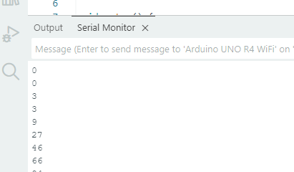
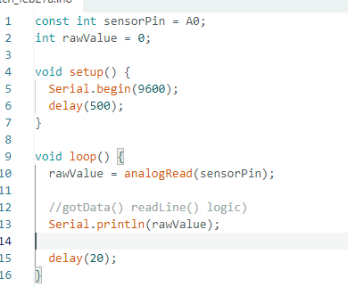

Part 2 – Re-map for visibility

In your p5.js sketch:
- update your map ( ) to use your measured min/max
- expand the output range so motion is clearly visible
- keep the motion centered around a baseline

Example:

let mapped = map (latestData, minVal, maxVal, -120, 120)
mapped = constrain (mapped, -120, 120)

Experiment with these values – place 2 – 3 screenshots + code tested here so see your attempt to find the correct values.

Explain:
- How did remapping change the visualization?
- Did the signal become easier to interpret?
- What would happen if the mapping range were too large?
Part 3 – Controlled Exaggeration

Add one variable (global) to exaggerate motion visually – like:

let gain = 1.5;

Apply it to your mapped value.

Add screenshots to show at what gain does the visualization stop being trustworthy? Would exaggerating signals on purpose be useful? Also, why is exaggeration dangerous?

Submit this document with above code and screenshots and your p5.js sketch with changes.

