Abstract
PlanTrack – Internal Strategic Planning & Goal Management System
Introduction
PlanTrack is a full-stack enterprise-grade strategic planning and goal management system designed to streamline organizational planning, execution, and monitoring. It provides a structured framework for defining strategic goals, decomposing them into measurable milestones, and assigning actionable initiatives to employees. By integrating collaboration, analytics, and real-time notifications, PlanTrack empowers organizations to achieve transparency, accountability, and efficiency in their internal planning cycles.
The system is implemented using a microservices-based architecture, ensuring scalability, modularity, and maintainability. It leverages modern technologies such as Spring Boot REST APIs, Angular single-page frontend, MySQL Database, and JWT-based stateless authentication. Real-time communication is enabled through Server-Sent Events (SSE), providing instant updates without the overhead of polling.
System Overview
PlanTrack follows a three-tier hierarchical planning model:
- Plan → Strategic organizational goals.
- Milestone → Measurable checkpoints within a plan.
- Initiative → Actionable tasks assigned to employees.
This bottom-up aggregation ensures that initiative completion automatically updates milestone progress, which in turn reflects on the overall plan status.
Key Features
- User Management: Role-based access for employees, managers, and administrators.
- Goal & Initiative Management: Creation, assignment, and monitoring of organizational goals.
- Milestone Tracking: Progress tracking with completion percentages.
- Collaboration & Comments: Threaded discussions with @mentions for team communication.
- Analytics & Reporting: Dashboards for completion rates, delayed goals, and departmental performance.
- Notifications: In-app alerts for deadlines and updates via SSE.
- Gamification: Badges, leaderboards, and velocity metrics to encourage engagement.
- Audit Compliance: Comprehensive logging of all state-changing operations.
Architecture
PlanTrack is built on a microservices architecture with clear separation of concerns:
- Main Service:
  - Contains core modules: User Management, Project Management (Plans, Milestones, Initiatives), Comments, Reports, and Audit Logs.
  - Responsible for authentication token generation and centralized business logic.
- Notification Service:
  - Dedicated microservice with its own database for notifications.
  - Uses Server-Sent Events (SSE) to deliver real-time alerts to the frontend.
  - Validates JWT tokens independently for secure communication.
- Helper Services:
  - Gateway Service: Provides API routing, load balancing, and centralized entry point.
  - Eureka Service: Service discovery for dynamic scaling and fault tolerance.
Authentication Model
PlanTrack employs JWT-based stateless authentication across all microservices:
- Centralized Generation: Tokens are issued only by the main service during login.
- Distributed Validation: Both main and notification services validate tokens independently.
- Shared Secret: All services use a common jwt.secret configuration.
- Stateless Design: No session storage; authentication state resides entirely within the JWT.
- Spring Security Integration: Tokens populate the SecurityContextHolder for role-based access control.

Database Design
PlanTrack uses a relational database (MySQL) with normalized schema design.
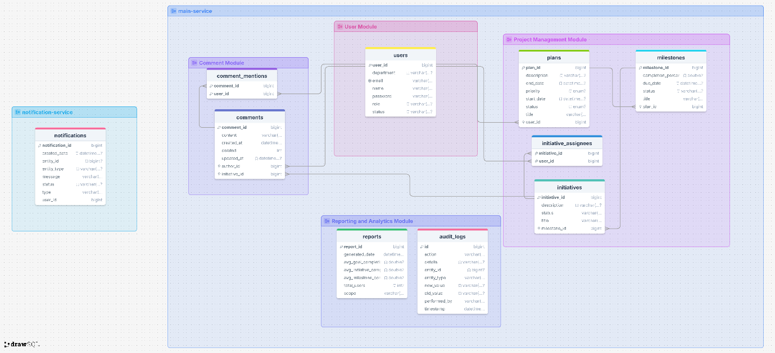

User Interface Design
The frontend, built with Angular, provides role-specific dashboards:
- Employee Dashboard: Assigned goals, milestones, progress updates, and notifications.
- Manager Dashboard: Goal creation, milestone assignment, team progress monitoring, and reporting.
- Admin Dashboard: User management, category configuration, and organizational analytics.
Reactive state management ensures seamless synchronization between backend updates and frontend views, while SSE enables real-time notifications without polling.
Non-Functional Requirements
PlanTrack is engineered to meet enterprise-grade standards:
- Performance: Supports up to 10,000 concurrent users during peak planning cycles.
- Security: Role-based access control, encrypted data, audit logs, and internal-only access.
- Scalability: Horizontal scaling of goal and milestone modules with departmental partitioning.
- Availability: 99.9% uptime with graceful degradation of analytics.
- Maintainability: Modular architecture, API versioning, and schema migration scripts.
Conclusion
PlanTrack represents a robust, scalable, and secure solution for internal strategic planning and goal management. By combining microservices architecture, real-time communication, and collaborative features, it provides organizations with a powerful tool to align departmental objectives with corporate strategy. Its modular design ensures adaptability to evolving business needs, while its emphasis on audit compliance and gamification fosters accountability and engagement across all levels of the organization.

