**PostgreSQL**

1. **Introduction to PostgreSQL**

PostgreSQL is an object-relational database management system (ORDBMS).

An object-relational database (ORD), or object-relational database management system (ORDBMS), is a database management system (DBMS) similar to a relational database, but with an object-oriented database model: objects, classes and inheritance are directly supported in database schemas and in the query language. In addition, just as with pure relational systems, it supports extension of the data model with custom data types and methods.

An object-relational database can be said to provide a middle ground between relational databases and object-oriented databases. In object-relational databases, the approach is essentially that of relational databases: the data resides in the database and is manipulated collectively with queries in a query language; at the other extreme are OODBMSes in which the database is essentially a persistent object store for software written in an object-oriented programming language, with a programming API for storing and retrieving objects, and little or no specific support for querying.

1. **Installation of PostgreSQL and PgAdmin**

Navigate to URL:- <https://www.postgresql.org/download/> or

We can also install from location \\indiafs\software\PostgreSQL

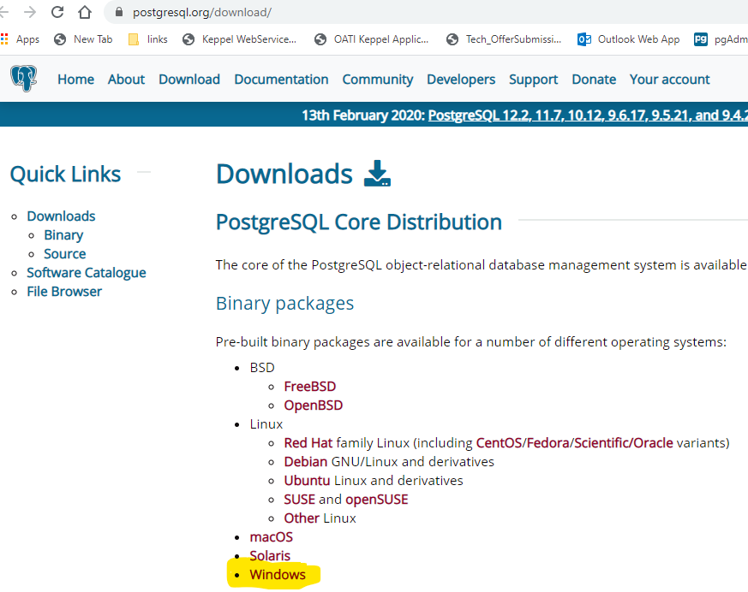

**From here we can learn how we can restore the PostgreSQL on window step by step.**

<https://o7planning.org/en/10713/installing-and-configuring-postgresql-database>

1. **How to Create Database**
2. **How to Backup and restore Database.**
3. **How application interact with Database**