Card Payments QA Reference
ISO 8583, authorization, international and DCC transactions, clearing, settlement, reconciliation and test cases
Item | Detail
Prepared for | Yogesh Kale: QA interview preparation (card payments / fintech)
Version | 1.0
Date | 27 October 2026
Companion project | iso8583-practice (github.com/yogi1292/iso8583-practice): jPOS issuer host and terminal simulator
Status | Study and reference material. Rates, fees and file layouts are practice values unless stated otherwise.

Document control
Version | Date | Change
1.0 | 27 Oct 2026 | First version: ecosystem, ISO 8583 reference, code tables, two detailed use cases with diagrams, clearing, settlement, reconciliation, accounting, test cases, glossary.
Contents
1. About this document 4
1.1 How to use it 4
1.2 Conventions 4
2. The card payments ecosystem 5
2.1 Participants 5
2.2 Four-party and three-party models 5
2.3 Transaction lifecycle 5
2.4 Dual message and single message systems 5
2.5 Card schemes at a glance 6
3. ISO 8583 message structure 7
3.1 MTI digits 7
3.2 Message types 7
3.3 Reading a bitmap 7
3.4 Field formats 8
4. Data element dictionary 9
5. Code tables 11
5.1 Processing code (DE 3) 11
5.2 Network management codes (DE 70) 11
5.3 POS entry mode (DE 22) 11
5.4 Common currency and country codes 11
5.5 Merchant category codes (DE 18): examples 12
6. Response codes (DE 39) 13
7. Transaction types 14
8. EMV, PIN and security 15
8.1 Common EMV tags (inside DE 55) 15
8.2 PIN block and keys 15
8.3 PCI DSS points for testers 15
9. Use case 1: International purchase 16
9.1 Stage 1: terminal to acquiring bank 16
9.2 Stage 2: acquiring bank to Visa (0100) 16
9.3 Stage 3: Visa to issuing bank (conversion added) 16
9.4 Stage 4: issuer switch, HSM and CBS 17
9.5 Stage 5: response back (0110) 17
9.6 Clearing, accounting and settlement 17
Use case 1: International purchase: diagrams 19
10. Use case 2: DCC purchase 22
10.1 Stage 1: at the terminal (DCC offer) 22
10.2 Stage 2: acquiring bank to Mastercard (0100) 22
10.3 Stage 3: Mastercard to issuing bank 22
10.4 Stage 4: issuer switch, HSM and CBS 23
10.5 Stage 5: response (0110) 23
10.6 Clearing, accounting and settlement 23
Use case 2: DCC purchase: diagrams 24
11. International purchase and DCC compared 27
11.1 What to test specifically 27
12. Clearing 28
12.1 Visa BASE II transaction codes 28
12.2 Mastercard IPM records 28
12.3 Files by scheme (commonly used names) 28
12.4 Clearing file structure 28
12.5 Simulator file names 29
13. Settlement 30
13.1 Net settlement for an issuer 30
13.2 Worked example (simulator values) 30
13.3 Settlement accounting 30
14. Reconciliation 31
14.1 Three-way reconciliation 31
14.2 Exceptions 31
15. Accounting across the lifecycle (issuer) 32
16. Use case catalogue 33
17. Test cases 34
18. Practising with the iso8583-practice simulator 38
18.1 Terminal menu 38
18.2 Test cards 38
19. Quick revision for interviews 39
20. Glossary 40
21. Assumptions and caveats 41

If the contents list is empty, right-click it in Word and choose Update Field, then Update entire table.

1. About this document
This document collects, in one place, what a QA engineer working on card payments is expected to know: how a card transaction moves from the terminal to the issuer and back, what each ISO 8583 data element means, what the response codes mean, how clearing and settlement work, and how to test all of it.

1.1 How to use it
- Before an interview: read sections 2, 3, 6, 9, 10 and 11, then the quick revision in section 19.
- While testing: use sections 4 to 8 as a field and code reference, and section 17 as a test case bank.
- For hands-on practice: run the scenarios in the iso8583-practice simulator (section 18). Most test cases name the simulator option that exercises them.

1.2 Conventions
- Amounts in data elements are in minor units (paise, cents): 000000150000 in DE 4 is 1,500.00.
- Field names follow ISO 8583:1987 as used by most Indian processors. Networks add their own headers and private fields; those are named as network-specific where relevant.
- Worked examples use practice values: USD = INR 84.00, AED = INR 22.87, issuer forex markup 3.5%, DCC margin 4%, cross-border fee 1%, GST 18% on bank fees, purchase interchange 1.5%, ATM interchange INR 19.00.
Real exchange rates, fees, interchange, file layouts and field usage differ by network, bank and product. Always confirm against the network specification and your bank’s fee schedule before quoting a number as fact.

2. The card payments ecosystem

2.1 Participants
Participant | Role | Example
Cardholder | Owns the card and the account. | Customer of an Indian bank
Merchant | Sells goods or services and accepts cards. | Store, hotel, e-commerce site
Terminal / gateway | Captures card data and sends the transaction (POS, ATM, payment gateway for e-commerce). | POS device, ATM, PG
Acquirer (acquiring bank) | Signs up the merchant, routes the transaction to the network, and pays the merchant. | Merchant’s bank or processor
DCC provider | Offers the cardholder a conversion to their home currency at the terminal. | Acquirer or a specialist provider
Card network (scheme) | Routes authorizations, runs clearing and settlement, sets rules and interchange. | Visa, Mastercard, RuPay (NPCI), Amex
Issuer (issuing bank) | Issues the card, approves or declines, bills the cardholder. | Cardholder’s bank
Issuer switch / processor | The issuer’s authorization host: validates and decides in real time. | In-house switch or processor
HSM | Hardware security module: verifies PINs, CVVs and EMV cryptograms; holds keys. | Thales payShield and similar
CMS | Card management system: card records, limits, controls, statuses.
CBS | Core banking system: accounts, balances, liens, postings (for debit cards). | Finacle, Flexcube, BaNCS
Settlement bank | Moves the money between issuers, the network and acquirers. | RBI RTGS for domestic; Nostro accounts for foreign currency
Regulator | Sets rules: KYC, prepaid limits, failed transaction turnaround times. | RBI, NPCI rules

2.2 Four-party and three-party models
- Four-party (open loop): cardholder, issuer, network, acquirer, merchant are separate. Visa, Mastercard and RuPay work this way.
- Three-party (closed loop): the network is also the issuer and/or acquirer. Amex traditionally works this way, though it also partners with banks in some markets.

2.3 Transaction lifecycle
Stage | When | What happens | Messages / files
Authorization | Real time (seconds) | Issuer approves or declines and places a hold. | 0100/0110, 0200/0210
Reversal / advice | Real time or soon after | Undo an authorization (timeout, cancel) or tell the issuer about a stand-in decision. | 0400/0420, 0120
Clearing | End of day, T+0/T+1 | Acquirer submits final transactions; network delivers them to issuers. | Visa BASE II, Mastercard IPM, NPCI files
Settlement | T+1 typically | Network calculates net positions; money moves between banks. | VSS reports, settlement position reports, NTSL
Reconciliation | Daily | Match authorization logs, clearing files and ledger postings; investigate exceptions. | Recon reports
Disputes | Days to months | Retrieval, chargeback, representment, arbitration. | Visa TC15–17, Mastercard 1442

2.4 Dual message and single message systems
 | Dual message (DMS) | Single message (SMS)
Messages | Authorization (0100) now, clearing record later | One financial message (0200) authorizes and posts
Issuer effect at authorization | Hold (lien) only; ledger unchanged | Ledger debited immediately
Typical use | Signature/credit-style POS, e-commerce, international | ATM, PIN debit, Maestro, most domestic RuPay POS/ATM
Examples | Visa BASE I + BASE II; Mastercard Banknet + GCMS | Visa SMS; Mastercard MDS (Maestro); NPCI NFS for ATM
Testing focus | Hold release, auth vs clearing mismatch, late presentment | Immediate posting, reversals crediting money back

2.5 Card schemes at a glance
Scheme | Model | Authorization | Clearing | Settlement | Notes
Visa | 4-party | VisaNet (BASE I for DMS, V.I.P. SMS) | BASE II (TCs) | VSS reports | Visa-specific header and fields 62/63
Mastercard | 4-party | Banknet | GCMS / IPM files | Settlement position reports | DE 48 subelements, DE 61 POS data
Maestro | 4-party (Mastercard) | MDS, single message | Via single message system | Mastercard settlement | PIN-based debit
RuPay | 4-party (NPCI) | NPCI switch | NPCI clearing files; RGCS for global | NTSL | Domestic ATM via NFS
Amex | 3-party | Amex network | Submission files | Amex settlement / recon files | Uses 1993-version MTIs (1100, 1420, 1804)

3. ISO 8583 message structure
Every ISO 8583 message has four parts. Over TCP, a length header (often 2 bytes) comes first, and many networks add their own header too.
Part | Size | Purpose
MTI | 4 digits | Message type indicator: what kind of message this is.
Primary bitmap | 64 bits (8 bytes binary or 16 hex characters) | Which of fields 1–64 are present.
Secondary bitmap | 64 bits, present when bit 1 is on | Which of fields 65–128 are present.
Data elements | Variable | The fields themselves, in field-number order.

3.1 MTI digits
Digit | Meaning | Values
1st | Version | 0 = ISO 8583:1987, 1 = 1993, 2 = 2003
2nd | Message class | 1 authorization, 2 financial, 3 file actions, 4 reversal / chargeback, 5 reconciliation, 6 administrative, 8 network management
3rd | Message function | 0 request, 1 response, 2 advice, 3 advice response, 4 notification
4th | Message origin | 0 acquirer, 1 acquirer repeat, 2 issuer, 3 issuer repeat, 4 other

3.2 Message types
MTI | Name | Used for
0100 / 0110 | Authorization request / response | Dual message purchase, pre-auth, e-commerce, account verification
0120 / 0130 | Authorization advice / response | Network stand-in (STIP) told the issuer it approved on its behalf
0200 / 0210 | Financial request / response | Single message: ATM cash, PIN debit, balance inquiry
0220 / 0230 | Financial advice / response | Completion of a pre-auth, offline or forced transactions
0400 / 0410 | Reversal request / response | Acquirer asks to undo a transaction
0420 / 0430 | Reversal advice / response | Acquirer tells the issuer to undo (timeout, cancellation); most common reversal
0421 | Reversal advice repeat | Resent 0420 when no 0430 came back
0500 / 0510 | Reconciliation request / response | Batch totals between parties
0800 / 0810 | Network management | Sign-on, sign-off, echo, key exchange, cutover (DE 70)
1100, 1420, 1804 | Authorization, reversal, network management (1993 version) | Amex and other 1993-based interfaces
1240 / 1442 / 1644 / 1740 | Presentment / chargeback / administrative / fee collection | Mastercard IPM clearing records (1993 version)

3.3 Reading a bitmap
Example primary bitmap from the simulator’s purchase request: 723C448108E08000. Each hex digit covers four fields:
Hex | 7 | 2 | 3 | C | 4 | 4 | 8 | 1 | 0 | 8 | E | 0 | 8 | 0 | 0 | 0
Binary | 0111 | 0010 | 0011 | 1100 | 0100 | 0100 | 1000 | 0001 | 0000 | 1000 | 1110 | 0000 | 1000 | 0000 | 0000 | 0000
Fields | 2,3,4 | 7 | 11,12 | 13,14 | 18 | 22 | 25 | 32 | – | 37 | 41,42,43 | – | 49 | – | – | –

The first digit is 7 (0111), so bit 1 is off: there is no secondary bitmap. A network management message carrying DE 70 starts with 8 or higher, because bit 1 must be on.

3.4 Field formats
Code | Meaning
n | Numeric digits only
a / an / ans | Alphabetic / alphanumeric / alphanumeric and special characters
b | Binary (for example PIN block, bitmap, EMV data)
z | Track data character set
x+n | C (credit) or D (debit) followed by digits, for fees
LLVAR / LLLVAR | Variable length: a 2- or 3-digit length prefix comes before the value. Shown as n..19 or ans..999

4. Data element dictionary
The data elements a payments QA engineer meets most often, with their ISO 8583:1987 formats. Networks can restrict, extend or repurpose fields; check the network specification for exact usage.
DE | Name | Format | Description | QA notes
1 | Bitmap, Secondary | b 64 | Shows which of fields 65–128 are present. | Present only when bit 1 of the primary bitmap is on.
2 | Primary Account Number (PAN) | n..19 LLVAR | The card number. | Mask in logs and files (first 6, last 4). Drives scheme and BIN routing.
3 | Processing Code | n 6 | Transaction type (2) + from account (2) + to account (2). | See section 5.1. 000000 purchase, 010000 cash, 310000 balance inquiry.
4 | Amount, Transaction | n 12 | Amount in the transaction currency (DE 49), minor units. | For international purchases this is the merchant’s currency.
5 | Amount, Settlement | n 12 | Amount in the settlement currency (DE 50). | Present when settlement currency differs from transaction currency.
6 | Amount, Cardholder Billing | n 12 | Amount in the cardholder’s billing currency (DE 51). | Added by the network for foreign currency transactions. Issuer checks limits and funds on it.
7 | Transmission Date and Time | n 10 MMDDhhmmss | When the message was sent, in GMT. | Part of the reversal key in DE 90 and of duplicate detection.
9 | Conversion Rate, Settlement | n 8 | Rate used from DE 4 to DE 5. | First digit = number of decimal places.
10 | Conversion Rate, Cardholder Billing | n 8 | Rate used from DE 4 to DE 6. | 40840000 = 84.0000. Verify DE 6 = DE 4 × rate.
11 | System Trace Audit Number (STAN) | n 6 | Number the originator assigns to each message. | Used to match responses and detect duplicates; wraps after 999999.
12 | Time, Local Transaction | n 6 hhmmss | Local time at the terminal. | Can be a different day from DE 7 (GMT).
13 | Date, Local Transaction | n 4 MMDD | Local date at the terminal.
14 | Date, Expiration | n 4 YYMM | Card expiry date. | Not echoed in responses. Valid until the end of that month.
15 | Date, Settlement | n 4 MMDD | Business date the transaction settles on. | Check cut-off and holiday handling.
16 | Date, Conversion | n 4 MMDD | Date of the conversion rate used.
18 | Merchant Type (MCC) | n 4 | Merchant category code. | 5411 grocery, 5732 electronics, 5812 restaurants, 6011 ATM, 7011 hotels, 7995 gambling.
19 | Acquiring Institution Country Code | n 3 | Country of the acquirer (ISO 3166 numeric). | Key for cross-border detection, including DCC. 356 = India, 840 = US, 784 = UAE.
22 | POS Entry Mode | n 3 | How the card was read (2 digits) + PIN capability (1 digit). | See section 5.3.
23 | Card Sequence Number | n 3 | Chip card sequence number (from tag 5F34). | Distinguishes cards that share a PAN.
25 | POS Condition Code | n 2 | Conditions at the point of sale. | 00 normal; values for card-not-present, MOTO and e-commerce vary by network.
26 | POS PIN Capture Code | n 2 | Maximum PIN length the terminal accepts.
28 | Amount, Transaction Fee | x+n 8 | Fee charged by the acquirer, e.g. ATM surcharge. | C or D prefix.
32 | Acquiring Institution Identification Code | n..11 LLVAR | ID of the acquirer. | Part of DE 90 in reversals.
33 | Forwarding Institution Identification Code | n..11 LLVAR | ID of the institution that forwarded the message.
35 | Track 2 Data | z..37 LLVAR | PAN, expiry, service code and discretionary data. | Never store after authorization (PCI DSS). Not echoed.
37 | Retrieval Reference Number (RRN) | an 12 | Reference that follows the transaction through systems. | Key matching field for reconciliation and customer complaints.
38 | Authorization Identification Response | an 6 | Approval code from the issuer. | Printed on the receipt; used to match clearing to authorization.
39 | Response Code | an 2 | Result of the request. | See section 6. In a reversal request it carries the reason, e.g. 68.
41 | Card Acceptor Terminal Identification | ans 8 | Terminal ID. | Part of duplicate detection.
42 | Card Acceptor Identification Code | ans 15 | Merchant ID.
43 | Card Acceptor Name/Location | ans 40 | Merchant name (25), city (13), country (2). | Country here also shows cross-border, e.g. AE for Dubai.
44 | Additional Response Data | ans..25 | Extra result details, e.g. CVV or address check results. | Network-specific content.
45 | Track 1 Data | ans..76 | Track 1 from the magnetic stripe. | Never store.
48 | Additional Data, Private | ans..999 LLLVAR | Network or private data. | Mastercard uses subelements here. The simulator puts its DCC data here.
49 | Currency Code, Transaction | n 3 | Currency of DE 4 (ISO 4217 numeric). | 356 INR, 840 USD, 978 EUR, 826 GBP, 784 AED. DCC: cardholder currency.
50 | Currency Code, Settlement | n 3 | Currency of DE 5.
51 | Currency Code, Cardholder Billing | n 3 | Currency of DE 6. | For an Indian card: 356.
52 | Personal Identification Number (PIN) Data | b 64 | Encrypted PIN block. | Never logged or echoed. Format 0 is PIN XOR PAN, then encrypted.
53 | Security Related Control Information | n 16 | Key index and PIN block format details.
54 | Additional Amounts | an..120 LLLVAR | Balances, cashback, etc., in 20-character entries. | Account type (2) + amount type (2) + currency (3) + C/D + amount (12). 01 ledger, 02 available.
55 | Integrated Circuit Card (ICC) Data | b..255 LLLVAR | EMV data in TLV format. | See section 8.1. Response may carry ARPC (tag 91) and scripts (71/72).
60–63 | Reserved for national / private use | Varies | Network-specific data. | Visa field 62 and 63 carry Visa-specific data. Read the network spec.
70 | Network Management Information Code | n 3 | Type of network management message. | Common: 001 sign-on, 002 sign-off, 101 key change, 201 cutover, 301 echo. Values vary by network.
90 | Original Data Elements | n 42 | Original MTI (4) + STAN (6) + DE 7 (10) + acquirer ID (11) + forwarding ID (11). | How a reversal finds the original transaction.
95 | Replacement Amounts | an 42 | Actual amounts for a partial reversal. | First 12 digits: amount that stays charged.
100 | Receiving Institution Identification Code | n..11 LLVAR | ID of the institution that receives the message.
102 | Account Identification 1 | ans..28 LLVAR | "From" account. | The CBS account the issuer debits or liens.
103 | Account Identification 2 | ans..28 LLVAR | "To" account. | Used in transfers.
128 | Message Authentication Code (MAC) | b 64 | Integrity check over the message. | Fails when any field is changed in transit.

5. Code tables

5.1 Processing code (DE 3)
Digits 1–2 | Transaction type | Notes
00 | Purchase (goods and services) | Most POS and e-commerce transactions
01 | Cash withdrawal / cash advance | ATM or bank counter
09 | Purchase with cashback | Cashback amount in DE 54
11 | Quasi-cash | Network-specific, e.g. casino chips, money orders
20 | Refund / return | Credit to the cardholder
30 | Available funds inquiry
31 | Balance inquiry | Balances returned in DE 54
40 | Account transfer | Between the cardholder’s own accounts
92 and others | PIN change, mini statement and similar | Values differ by network; confirm with the spec

Digits 3–4 and 5–6 | Account type
00 | Default / unspecified
10 | Savings
20 | Current (checking)
30 | Credit

5.2 Network management codes (DE 70)
Code | Meaning
001 | Sign-on
002 | Sign-off
101 | Key change / key exchange (some networks use 161 or other codes)
201 | Cutover: start of a new business day
301 | Echo test (are you alive?)

5.3 POS entry mode (DE 22)
Digits 1–2 | How the card was read
01 | Manual key entry
02 / 90 | Magnetic stripe (90 = full, unaltered track read)
05 | Chip (contact)
07 | Contactless chip
80 | Chip fallback to magnetic stripe
81 | E-commerce / credential on file (Mastercard usage)
91 | Contactless magnetic stripe mode
The third digit is PIN entry capability: 1 = terminal can accept a PIN, 2 = cannot, 0 = unknown.

5.4 Common currency and country codes
Currency | ISO 4217 | Country | ISO 3166 numeric | Alpha-2
Indian rupee | 356 (INR) | India | 356 | IN
US dollar | 840 (USD) | United States | 840 | US
Euro | 978 (EUR) | Germany (example) | 276 | DE
Pound sterling | 826 (GBP) | United Kingdom | 826 | GB
UAE dirham | 784 (AED) | United Arab Emirates | 784 | AE
Singapore dollar | 702 (SGD) | Singapore | 702 | SG

5.5 Merchant category codes (DE 18): examples
MCC | Category | Why QA cares
5411 | Grocery stores, supermarkets | Everyday purchase
5732 | Electronics stores | High-value purchase
5812 | Restaurants | Tip tolerance between auth and clearing
5541 / 5542 | Service stations / automated fuel | Pre-auth with a different final amount
6011 | ATM cash | Single message, PIN, ATM interchange
7011 | Hotels | Pre-auth, incremental auth, completion
7995 | Gambling | Often blocked: decline 57

6. Response codes (DE 39)
Common ISO 8583 response codes. Networks share most of them but each has a few of its own; always map them to your issuer’s decline reasons.
Code | Meaning | Typical cause | How to test / what to check
00 | Approved | All checks passed. | Check DE 38 present and the hold or posting is correct.
01 | Refer to card issuer | Issuer wants a voice referral. | Rare today; check terminal handling.
03 | Invalid merchant | Merchant not set up or blocked. | Acquirer-side test.
04 | Pick up card | Card must be retained. | ATM capture behaviour.
05 | Do not honour | Generic decline, often fraud or risk rules. | Check the issuer log for the real reason.
06 | Error | Generic processing error.
10 | Partial approval | Approved for less than requested. | Terminal must support partial approval; DE 4 shows approved amount.
12 | Invalid transaction | Transaction type not allowed, or reversal after settlement. | Unsupported DE 3, wrong MTI for the product.
13 | Invalid amount | Zero, negative or malformed amount, unsupported currency. | Boundary tests on DE 4.
14 | Invalid card number | PAN not found or fails Luhn. | Unknown BIN or PAN.
15 | No such issuer | BIN not routed. | Routing table tests.
19 | Re-enter transaction | Temporary problem.
25 | Unable to locate original | Reversal has no matching original (DE 90). | Reversal with wrong STAN or DE 7.
30 | Format error | Mandatory field missing or malformed. | Remove DE 4, DE 6 on foreign currency, bad length.
41 | Lost card, pick up | Card reported lost. | Card status test.
43 | Stolen card, pick up | Card reported stolen. | Card status test.
51 | Insufficient funds | Amount (plus fees) above available balance or credit. | Include markup or cross-border fee in the funds check.
54 | Expired card | Card past expiry, or DE 14 mismatch. | Boundary: expiry month itself is still valid.
55 | Incorrect PIN | PIN verification failed or PIN missing. | Count of wrong tries increases.
57 | Transaction not permitted to cardholder | Card controls: international off, MCC blocked, channel off. | Must also apply to DCC (cross-border in INR).
58 | Transaction not permitted to terminal | Terminal or merchant not allowed this transaction.
59 | Suspected fraud | Fraud rules triggered.
61 | Exceeds amount limit | Above per-transaction or daily limit. | Limit on INR billing amount (DE 6) for foreign currency.
62 | Restricted card | Card blocked or restricted.
63 | Security violation | MAC or cryptogram failure. | Tamper a field covered by the MAC.
65 | Exceeds frequency limit | Too many transactions in a period. | Daily count limits.
68 | Response received too late | Used in DE 39 of a reversal after a timeout. | Timeout scenario.
75 | PIN tries exceeded | Too many wrong PINs. | Correct PIN after lock still declines.
85 | No reason to decline | Account verification (zero-amount) success. | Card-on-file setup, e.g. Visa.
91 | Issuer or switch inoperative | Issuer down or terminal not signed on. | Stand-in processing may apply.
92 | Unable to route | No route to the destination.
94 | Duplicate transmission | Same terminal, STAN and DE 7 seen before. | No second hold must be placed.
96 | System malfunction | Unexpected issuer error. | Resilience tests.
N7 | CVV2 mismatch (Visa) | Card security code check failed. | E-commerce tests.

7. Transaction types
Type | MTI | DE 3 | DMS / SMS | Issuer effect and key fields
Purchase | 0100 or 0200 | 00 | DMS or SMS | Hold (DMS) or debit (SMS).
Purchase with cashback | 0200 | 09 | SMS | Cashback in DE 54; total in DE 4.
Cash withdrawal (ATM) | 0200 | 01 | SMS | Debit immediately; issuer pays ATM interchange.
Cash advance (counter) | 0100 / 0200 | 01 | Either | Usually credit cards; fees apply.
Balance inquiry | 0200 | 31 | SMS | No money moves; balances in DE 54.
Refund | 0100 / 0200 / clearing | 20 | Either | Credit to cardholder; Visa TC06 in clearing.
Pre-authorization | 0100 | 00 | DMS | Hotels, car hire, fuel: estimated hold.
Incremental authorization | 0100 | 00 | DMS | Adds to an existing pre-auth hold.
Completion | 0220 or clearing | 00 | DMS | Final amount; releases the rest of the hold.
Reversal (full) | 0400 / 0420 | As original | Either | Original found via DE 90; hold released or money returned.
Partial reversal | 0420 + DE 95 | As original | Either | Only the difference is released.
Void | 0420 (usually) | As original | Either | Same-day cancel before settlement.
Account verification | 0100, amount 0 | 00 | DMS | Checks the card is valid; response 85 or 00.
Recurring / standing instruction | 0100 | 00 | DMS | Card-on-file indicators; RBI e-mandate rules in India.
E-commerce (card not present) | 0100 | 00 | DMS | 3DS / OTP authentication data; CVV2.
MOTO | 0100 | 00 | DMS | Mail / telephone order indicator.
Contactless | 0100 / 0200 | 00 | Either | Tap; no PIN under the CVM limit.
International purchase | 0100 | 00 | DMS | DE 49 ≠ billing currency; DE 6, 10, 51 added; issuer markup.
DCC purchase | 0100 | 00 | DMS | DE 49 = cardholder currency, merchant abroad; DCC indicator.
Stand-in advice | 0120 | As original | DMS | Network approved while issuer was down; issuer posts later.
Original credit / push payment | Network-specific | Network-specific | Either | Money pushed to a card (e.g. Visa Direct, Mastercard Send).
Chargeback | Visa TC15–17 / Mastercard 1442 | – | Clearing | Issuer disputes a cleared transaction.
Representment | Visa / Mastercard clearing | – | Clearing | Acquirer answers a chargeback.

8. EMV, PIN and security

8.1 Common EMV tags (inside DE 55)
Tag | Name | Why it matters
9F26 | Application Cryptogram (ARQC) | Issuer verifies it in the HSM to prove the card is genuine.
9F27 | Cryptogram Information Data | Type of cryptogram: ARQC (online), TC (approved offline), AAC (declined).
9F10 | Issuer Application Data | Issuer-defined data used in verification.
9F36 | Application Transaction Counter (ATC) | Increases each transaction; replay detection.
9F37 | Unpredictable Number | Random number from the terminal.
95 | Terminal Verification Results (TVR) | What the terminal checks found.
9A / 9C | Transaction Date / Transaction Type
9F02 | Amount, Authorised | Must match DE 4.
5F2A | Transaction Currency Code | Must match DE 49 (0356 for DCC in INR).
82 | Application Interchange Profile | What the card supports.
5F34 | PAN Sequence Number | Goes in DE 23.
91 | Issuer Authentication Data (ARPC) | In the response: lets the card verify the issuer.
71 / 72 | Issuer Scripts | In the response: commands to the card, e.g. PIN unblock.

8.2 PIN block and keys
- ISO format 0 PIN block: 0 + PIN length + PIN, padded with F to 16 hex digits, XOR 0000 + the 12 rightmost PAN digits excluding the check digit. The result is encrypted before it leaves the terminal.
- Key hierarchy: ZMK (zone master key) protects working keys exchanged between parties; ZPK (zone PIN key) or TPK (terminal PIN key) encrypts PIN blocks; PVK verifies PINs (PVV method) or the IBM 3624 offset is used; CVK generates and checks CVV/CVV2/iCVV.
- Key exchange: usually through 0800 messages with DE 70 key change codes, protected by the ZMK.

8.3 PCI DSS points for testers
- Never store full track data, CVV2 or PIN blocks after authorization.
- Mask PANs in logs, screens, reports and files (first 6, last 4 is the usual maximum shown).
- Use test cards and test keys only; never real customer data in lower environments.
- Check that error messages and stack traces do not leak card data.

9. Use case 1: International purchase
Scenario: an Indian Visa debit cardholder pays USD 100.00 by chip at a store in New York. The card network converts USD to INR; the issuing bank adds its forex markup.
Item | Value
Cardholder | Indian Visa debit card, savings account in CBS
Merchant | Clothing store, New York, US (MCC 5651)
Amount | USD 100.00
Network rate (authorization) | 1 USD = INR 84.0000, so DE 6 = INR 8,400.00
Issuer forex markup | 3.5% = INR 294.00; hold = INR 8,694.00
Network rate (clearing day) | 84.2000, so posted amount = INR 8,420.00
Final cost to cardholder | 8,420.00 + markup 294.70 + GST 53.05 = INR 8,767.75

9.1 Stage 1: terminal to acquiring bank
DE | Name | Value
2 | Primary Account Number | 4111 11 ** 1111
3 | Processing Code | 000000 (purchase)
4 | Amount, Transaction | 000000010000 = USD 100.00
12 / 13 | Time / Date, Local Transaction | New York local time and date
14 | Date, Expiration | 2812
18 | Merchant Type | 5651
22 | POS Entry Mode | 051 (chip, PIN capable)
23 | Card Sequence Number | 001
25 | POS Condition Code | 00
35 | Track 2 Data | Equivalent data from the chip
41 / 42 | Terminal ID / Merchant ID | TERM0001 / MERCHANT0000001
43 | Card Acceptor Name/Location | PRACTICE STORE NEW YORK US
49 | Currency Code, Transaction | 840 (USD)
55 | ICC Data | ARQC (9F26), ATC (9F36), TVR (95), amount (9F02), currency 0840 (5F2A)

9.2 Stage 2: acquiring bank to Visa (0100)
The acquirer identifies Visa from the BIN, adds its own fields and routes the 0100.
DE | Name | Value
MTI | Message Type Indicator | 0100
7 | Transmission Date and Time | GMT, e.g. 1026143005
11 | System Trace Audit Number | 000245
19 | Acquiring Institution Country Code | 840 (US)
32 | Acquiring Institution Identification Code | Acquirer ID
37 | Retrieval Reference Number | 629914000245

9.3 Stage 3: Visa to issuing bank (conversion added)
The transaction currency (USD) differs from the card’s billing currency (INR, from Visa’s BIN tables), so Visa converts and adds:
DE | Name | Value
6 | Amount, Cardholder Billing | 000000840000 = INR 8,400.00
10 | Conversion Rate, Cardholder Billing | 40840000 = 84.0000
51 | Currency Code, Cardholder Billing | 356 (INR)
5 / 9 / 50 | Amount / Conversion Rate / Currency Code, Settlement | When the issuer settles in another currency, e.g. USD
15 | Date, Settlement | Settlement business date
33 | Forwarding Institution Identification Code | Forwarding ID

9.4 Stage 4: issuer switch, HSM and CBS
- Validate the card: status, expiry (DE 14), ARQC in DE 55 through the HSM, fraud rules.
- International use enabled? DE 19 = 840 and DE 49 = 840. If not, decline with 57.
- Limit check on DE 6 (INR 8,400.00); decline 61 if over.
- Funds check on DE 6 + markup (INR 8,694.00); decline 51 if short. Some banks hold only DE 6 and charge the markup at clearing.
- Send a lien request to the CBS on the account in DE 102 with the RRN (DE 37) as reference. Available balance falls by INR 8,694.00; ledger balance does not change.

9.5 Stage 5: response back (0110)
DE | Name | Value
MTI |  | 0110
38 | Authorization Identification Response | 693362
39 | Response Code | 00
6 / 10 / 51 | Billing amount / rate / currency | Echoed
54 | Additional Amounts | Available balance (optional)
55 | ICC Data | ARPC (tag 91); scripts if any
2, 3, 4, 7, 11, 37, 41, 42, 49 | Matching fields | Echoed so each hop can match the response
DE 14, 35 and 52 are not returned. The response travels Visa → acquirer → terminal, which prints a receipt for USD 100.00 with auth code 693362.

9.6 Clearing, accounting and settlement
- Clearing (next day): the acquirer submits a Visa BASE II TC05 for USD 100.00 with the ARN, auth code and RRN. Visa converts at the clearing-day rate (84.20) and delivers an incoming TC05 to the issuer for INR 8,420.00.
- Issuer posting: release the INR 8,694.00 lien; debit INR 8,420.00; charge markup 294.70 and GST 53.05.
- Recon note: authorization (8,400.00) and clearing (8,420.00) differ because of the rate. This is expected and handled with a tolerance rule.
- Settlement: Visa’s VSS reports give the issuer’s net position; the issuer pays Visa (often through a USD Nostro account), net of interchange it earns. Visa pays the acquirer; the acquirer pays the merchant USD 100.00 minus MDR.
Entry | Debit | Credit | INR
Authorization | Lien on customer account | – | 8,694.00 (hold, no GL)
Clearing: purchase | Customer account | Visa settlement payable | 8,420.00
Clearing: forex markup 3.5% | Customer account | Forex markup income | 294.70
Clearing: GST 18% on markup | Customer account | GST payable | 53.05
Settlement | Visa settlement payable | Nostro / settlement account | Net of interchange

Use case 1: International purchase: diagrams
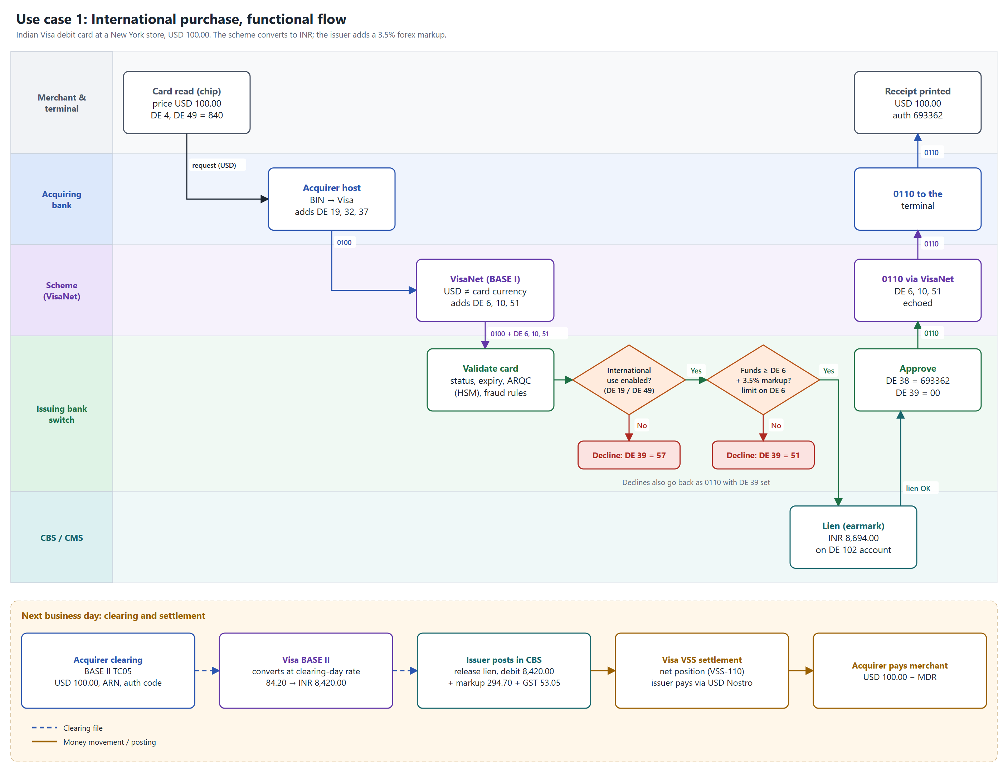
Figure: Use case 1: International purchase – functional flow (swimlanes, decisions, declines, then clearing and settlement). Rates and fees are practice values.
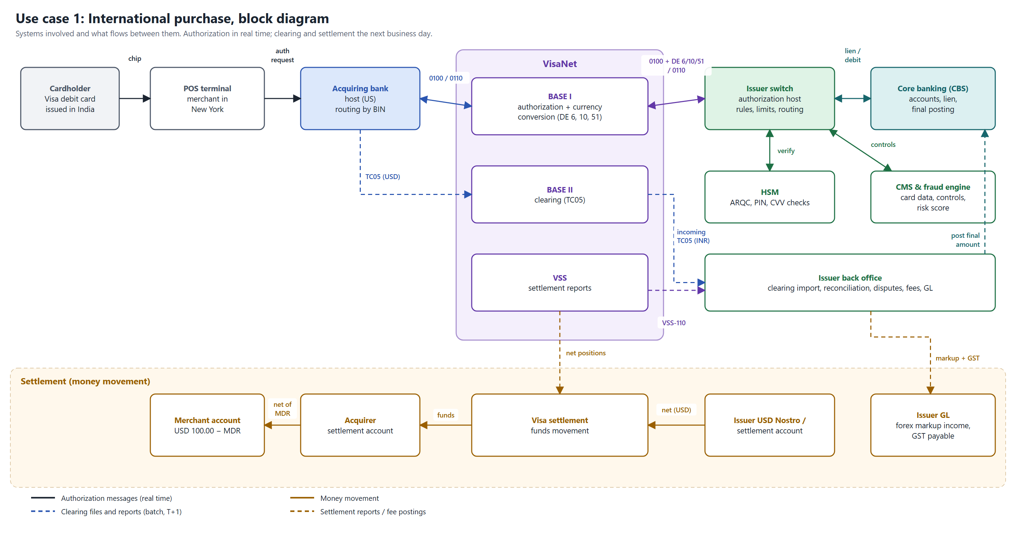
Figure: Use case 1: International purchase – block diagram (systems and what flows between them).
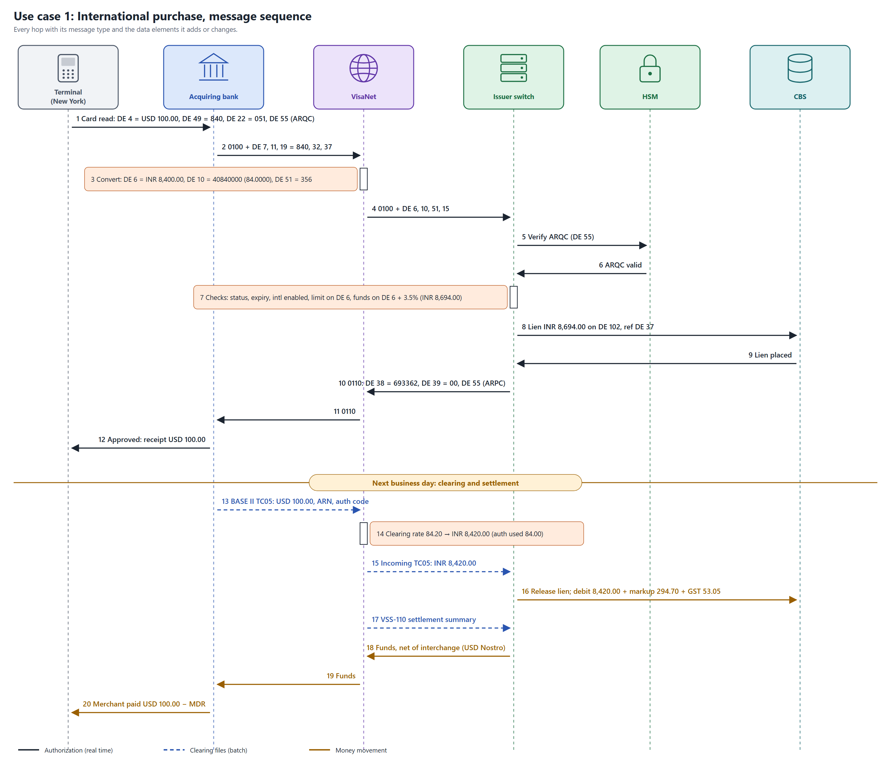
Figure: Use case 1: International purchase – message sequence with data elements at each hop.

10. Use case 2: DCC purchase
Scenario: an Indian Mastercard debit cardholder buys a laptop for AED 1,000.00 in Dubai. The terminal offers to charge in INR and the cardholder accepts.
Item | Value
Cardholder | Indian Mastercard debit card, savings account in CBS
Merchant | Electronics store, Dubai, UAE (MCC 5732)
Price | AED 1,000.00
DCC rate offered | 22.87 + 4% margin = 23.7848, so INR 23,784.80
Issuer cross-border fee | 1% = INR 237.85 (no forex markup); hold = INR 24,022.65
Final cost to cardholder | 23,784.80 + fee 237.85 + GST 42.81 = INR 24,065.46
Same purchase paid in AED | 22,870.00 + markup 800.45 + GST 144.08 = INR 23,814.53 (about INR 251 cheaper)

10.1 Stage 1: at the terminal (DCC offer)
- The terminal reads the card and sends the BIN to the DCC provider, which finds the card’s home currency is INR.
- The provider returns a rate: 22.87 + 4% margin = 23.7848.
- The terminal shows both choices: AED 1,000.00 or INR 23,784.80 (with the rate and margin). Scheme rules require that the cardholder actively chooses.
- The cardholder chooses INR. The receipt will show the AED amount, rate, margin, INR amount and an acceptance statement.
DE | Name | Value
2 | Primary Account Number | 5200 82 ** 8210
3 | Processing Code | 000000
4 | Amount, Transaction | 000002378480 = INR 23,784.80
18 | Merchant Type | 5732
22 | POS Entry Mode | 051
43 | Card Acceptor Name/Location | PRACTICE STORE DUBAI AE
49 | Currency Code, Transaction | 356 (INR): the cardholder’s currency
55 | ICC Data | ARQC; currency tag 5F2A = 0356
DCC data | Original amount and currency, DCC rate, margin, DCC indicator | Network-specific fields (not standard ISO 8583)

10.2 Stage 2: acquiring bank to Mastercard (0100)
DE | Name | Value
MTI |  | 0100
7 / 11 / 37 | Transmission date-time / STAN / RRN | Acquirer values
19 | Acquiring Institution Country Code | 784 (UAE)
32 | Acquiring Institution Identification Code | UAE acquirer ID
49 | Currency Code, Transaction | 356 (INR)
DCC indicator |  | Network-specific

10.3 Stage 3: Mastercard to issuing bank
DE 49 = 356 matches the card’s billing currency, so Mastercard does not convert. DE 6 equals DE 4 with a rate of 1, or is not sent. Settlement fields (DE 5, 9, 50) may still be present if the issuer settles in USD.

10.4 Stage 4: issuer switch, HSM and CBS
- Validate the card, ARQC and fraud rules as usual.
- Cross-border check: DE 49 is INR, but DE 19 = 784 and DE 43 ends in AE, so the transaction is international. A card with international use off must decline with 57. A common defect is checking only DE 49.
- No forex markup (nothing to convert). Cross-border fee 1% = INR 237.85 if the bank charges one.
- Limit check on INR 23,784.80; funds check on INR 24,022.65; lien in the CBS on DE 102.

10.5 Stage 5: response (0110)
DE 38 (auth code, e.g. 418205), DE 39 = 00, DE 4 and DE 49 echoed. The terminal prints the DCC receipt in INR showing the AED amount and rate.

10.6 Clearing, accounting and settlement
- Clearing: the acquirer sends a Mastercard IPM 1240 first presentment (function code 200) for INR 23,784.80 with the DCC indicator. The issuer receives it in its incoming IPM file (bulk type T112) and posts exactly that amount: no clearing-day rate difference.
- Settlement: the issuer pays Mastercard its net position (often in USD, using DE 5, 9, 50); Mastercard pays the UAE acquirer; the merchant receives AED 1,000.00 minus MDR. The DCC margin (about INR 914.80) stays with the acquirer and DCC provider, often shared with the merchant.
Entry | Debit | Credit | INR
Authorization | Lien on customer account | – | 24,022.65 (hold, no GL)
Clearing: purchase | Customer account | Mastercard settlement payable | 23,784.80
Clearing: cross-border fee 1% | Customer account | Cross-border fee income | 237.85
Clearing: GST 18% on fee | Customer account | GST payable | 42.81
Settlement | Mastercard settlement payable | Settlement account | Net of interchange

Use case 2: DCC purchase: diagrams
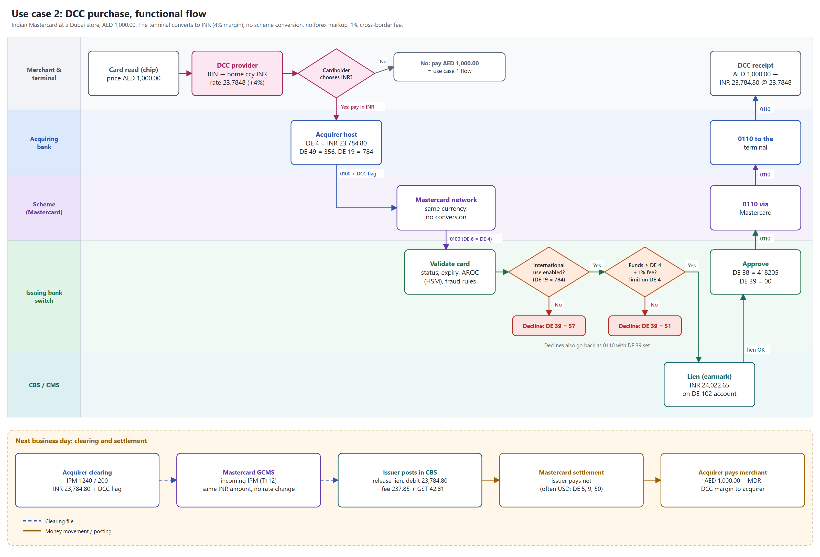
Figure: Use case 2: DCC purchase – functional flow (swimlanes, decisions, declines, then clearing and settlement). Rates, margin and fees are practice values.
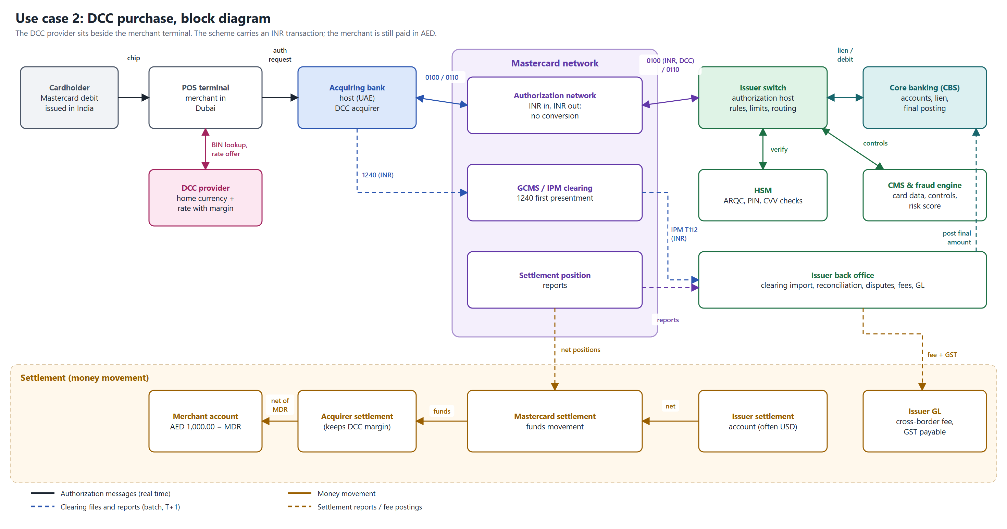
Figure: Use case 2: DCC purchase – block diagram (systems and what flows between them).
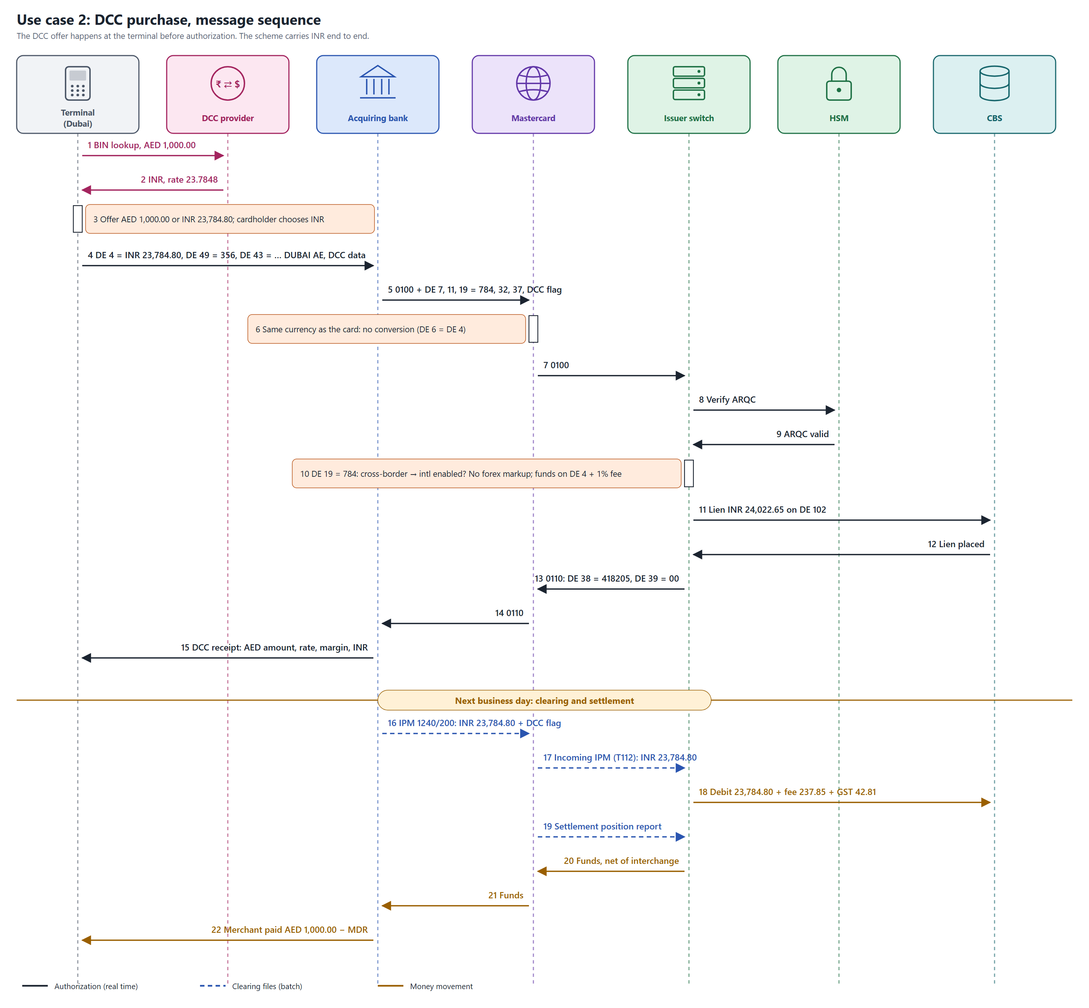
Figure: Use case 2: DCC purchase – message sequence with data elements at each hop.

11. International purchase and DCC compared
 | International purchase | DCC purchase
Who converts the currency | The card network | The merchant’s DCC provider at the terminal
DE 49 (transaction currency) | Merchant’s currency, e.g. 840 | Cardholder’s currency, 356
DE 4 (transaction amount) | In the merchant’s currency | In INR
DE 6 / DE 10 | Added by the network | Equal to DE 4 with rate 1, or absent
DE 19 / DE 43 | Foreign merchant | Still a foreign merchant
Issuer fee | Forex markup (e.g. 3.5%) + GST | Cross-border fee if the bank has one (e.g. 1%) + GST
Conversion margin | Network rate | DCC margin, typically 3–8%
Cardholder choice | Not needed | Mandatory; must be shown both amounts
Clearing amount vs authorization | Can differ (clearing-day rate) | Same INR amount
Merchant receives | USD 100.00 − MDR | AED 1,000.00 − MDR (DCC does not change it)
International-off card | Decline 57 | Decline 57 (cross-border even in INR)
Usually cheaper for the cardholder | Yes | No

11.1 What to test specifically
- International: DE 6 = DE 4 × DE 10 (with rounding), limit on DE 6, funds on DE 6 + markup, markup and GST posted at clearing, auth vs clearing difference within tolerance.
- DCC: treated as cross-border (DE 19 / DE 43), no forex markup, cross-border fee applied, DCC indicator carried to clearing, receipt content, chargeback when DCC was applied without the cardholder’s choice.
- Both: international-off cards decline with 57, reversals release fees in proportion, PAN masked everywhere.

12. Clearing
Clearing is the exchange of final transaction records through the network after authorization. Each network has its own file formats; the tables below list what bank teams commonly work with.

12.1 Visa BASE II transaction codes
TC | Meaning
05 | Sales draft (purchase)
06 | Credit voucher (refund)
07 | Cash disbursement
10 / 20 | Fee collection / funds disbursement
15 / 16 / 17 | Chargebacks (sales, credit, cash)
25 / 26 / 27 | Reversals of 05 / 06 / 07
33 | General delivery / reports
46 | Settlement reports (VSS)
52 | Request for copy (retrieval)

12.2 Mastercard IPM records
MTI | Function code | Meaning
1240 | 200 | First presentment
1240 | 205 / 282 | Second presentment, full / partial (representment)
1442 | 450 / 451 | First chargeback / arbitration chargeback
1644 | 697 / 695 | File header / file trailer
1644 | 696 | Financial detail addendum
1740 | 700 and others | Fee collection

12.3 Files by scheme (commonly used names)
Scheme | Clearing | Settlement and reports | Reference data
Visa | BASE II incoming and outgoing clearing files with TC records | VSS reports: VSS-110 settlement summary, VSS-120 interchange, VSS-130/140 fees; often delivered in the Edit Package report file | BIN and account range tables
Mastercard | IPM files through GCMS, bulk type T112; binary ISO 8583:1993 records | Settlement position and reconciliation reports as separate bulk files | MPE (Member Parameter Extract)
RuPay (NPCI) | Domestic clearing raw data files per cycle; RGCS for global | NTSL (net settlement report) per cycle; NFS raw data and NTSL for ATM | BIN and participant files
Amex | Submission files from acquirers | Settlement and reconciliation files (e.g. GRRCN for merchants) | –
Exact names, layouts and delivery depend on the network, region and services your bank uses. Confirm against the specifications you work with before quoting them.

12.4 Clearing file structure
- Header: file type, business date, sequence number, sender and receiver.
- Detail records: one per transaction: transaction code, ARN, masked PAN, auth code, RRN, date, MCC, merchant, country, transaction amount and currency, billing amount and currency, conversion rate, indicators (e.g. DCC).
- Trailer: record count and hash totals (e.g. total amount). The receiver checks these before loading.
- ARN (acquirer reference number): 23 digits: format digit, acquirer BIN (6), date (YDDD), sequence (11), check digit. The key for chargebacks and retrievals.

12.5 Simulator file names
File | Contents
AUTHLOG_<yyyyMMdd>_<seq>.csv | Issuer authorization log: every request and decision
VISA_BASEII_CLEARING_<date>_<seq>.txt | Visa purchases (TC05)
VISA_VSS_SETTLEMENT_<date>_<seq>.txt | Visa net settlement
MC_IPM_T112_CLEARING_<date>_<seq>.txt | Mastercard first presentments (1240-200)
MC_SETTLEMENT_REPORT_<date>_<seq>.txt | Mastercard net settlement
RUPAY_CLEARING_<date>_<seq>.txt / RUPAY_NTSL_<date>_<seq>.txt | RuPay clearing and NTSL
AMEX_SUBMISSION_<date>_<seq>.txt / AMEX_SETTLEMENT_<date>_<seq>.txt | Amex clearing and settlement

13. Settlement
Settlement moves the money. The network nets each member’s positions for the day and instructs settlement banks to pay.

13.1 Net settlement for an issuer
Issuer pays the network = cleared purchases + cash withdrawals + ATM interchange payable − purchase interchange receivable (± fees and adjustments).
Item | Direction | Explanation
Cleared purchases | Issuer pays | Money owed to acquirers for the cardholder’s purchases
Cash withdrawals | Issuer pays | Single message: already posted to the cardholder at authorization
Purchase interchange | Issuer receives | Acquirer pays the issuer; funded from the merchant’s MDR
ATM interchange | Issuer pays | Issuer pays the ATM owner (acquirer) a fee per withdrawal
Scheme fees | Issuer pays | Network charges, usually billed separately
Forex markup, cross-border fee, GST | Not in scheme settlement | Issuer’s own charges to the cardholder

13.2 Worked example (simulator values)
Visa purchases INR 9,400.00 + cash INR 2,000.00 + ATM interchange INR 19.00 − interchange 1.5% of 9,400.00 (INR 141.00) = INR 11,278.00 payable to Visa.

13.3 Settlement accounting
Event | Debit | Credit
Clearing posted | Customer accounts | Scheme settlement payable
Interchange earned | Scheme settlement payable | Interchange income
ATM interchange | ATM interchange expense | Scheme settlement payable
Funds paid to the network | Scheme settlement payable | Nostro / settlement bank account
After funding, the scheme settlement payable account should return to zero for that cycle. A non-zero balance is a reconciliation break.

14. Reconciliation

14.1 Three-way reconciliation
- Switch / authorization log (what the issuer approved).
- Network clearing and settlement files (what the network says happened).
- CBS / CMS postings and GL (what the bank actually posted).
Matching keys: PAN (masked or tokenized), RRN (DE 37), STAN (DE 11), auth code (DE 38), ARN, amount, date, terminal ID.

14.2 Exceptions
Exception | Likely cause | Action
Authorization with no clearing | Merchant never presented; cancelled sale | Release the hold after the expiry period (e.g. 7–30 days by product)
Clearing with no authorization | Offline / force post, floor limit, missed log | Post; check chargeback rights
Amount mismatch | Tips, fuel and hotel finals, exchange rate change | Accept within tolerance; else investigate or charge back
Duplicate clearing | Acquirer submitted twice | Do not post twice; raise a duplicate-processing chargeback
Reversal not matched | Wrong DE 90, timing | Investigate; manual adjustment
ATM debited, cash not dispensed | Dispense failure, reversal lost | Refund within the RBI turnaround time (T+5) or pay compensation
Settlement total ≠ sum of transactions | Fees, interchange, FX, missing file | Recalculate from file totals; escalate

15. Accounting across the lifecycle (issuer)
Event | Debit | Credit | Notes
Authorization approved (DMS) | – | – | Hold only: available balance falls, ledger unchanged
Reversal | – | – | Hold released
Clearing / presentment | Customer account | Scheme settlement payable | Hold released at the same time
Single message debit (0200) | Customer account | Scheme settlement payable | At authorization
Refund | Scheme settlement receivable | Customer account
Forex markup / cross-border fee | Customer account | Fee income | Plus GST
GST on fees | Customer account | GST payable | 18% in India
Chargeback raised | Chargeback receivable | Customer account (provisional credit) | Reversed if the chargeback fails
Settlement funding | Scheme settlement payable | Nostro / settlement account | Net of interchange
Prepaid card load | Funding source | Card pool (liability) account | Sum of card balances must equal the pool

16. Use case catalogue
ID | Use case | Messages / files | Expected outcome
UC-01 | Domestic POS purchase (chip + PIN) | 0100/0110; hold; clearing next day | Approved, hold placed, posted at clearing
UC-02 | ATM cash withdrawal | 0200/0210; PIN; single message | Ledger debited; ATM interchange payable
UC-03 | Balance inquiry at ATM | 0200, DE 3 = 31 | Balances in DE 54, no posting
UC-04 | E-commerce purchase with OTP / 3DS | 0100 card-not-present; CVV2 | Approved after authentication; N7 on wrong CVV2
UC-05 | Contactless tap under the CVM limit | 0100/0200, DE 22 = 07x, no PIN | Approved without PIN
UC-06 | Hotel pre-auth, incremental, completion | 0100, 0100, 0220 / clearing | Final amount posted, remaining hold released
UC-07 | Refund to card | DE 3 = 20; Visa TC06 | Customer credited
UC-08 | Timeout after issuer approval | 0100 late; 0420 DE 39 = 68 | Hold released; late response discarded
UC-09 | International purchase (section 9) | 0100 with DE 6, 10, 51 | Hold = DE 6 + markup; clearing at new rate
UC-10 | International ATM withdrawal | 0200 with DE 6, 10, 51; PIN | Debit = DE 6 + markup
UC-11 | DCC purchase (section 10) | 0100, DE 49 = 356, DE 19 foreign | No markup; cross-border fee
UC-12 | Stand-in approval while issuer is down | 0120 advice later | Issuer posts even if balance is short
UC-13 | Chargeback for a duplicate charge | Visa TC15 / Mastercard 1442 | Provisional credit; dispute lifecycle
UC-14 | End-of-day cutover and settlement | 0800 DE 70 = 201; files | Clearing and settlement files; net position paid

17. Test cases
Priority: High = must pass for release; Medium = important behaviour; Low = edge or rare cases. "Sim" names the iso8583-practice option that runs the scenario. Card numbers refer to the simulator test cards in section 18.
ID | Area | Scenario | Test data / steps | Expected result | Priority
TC-NM-01 | Network mgmt | Sign-on accepted | 0800, DE 70 = 001 (Sim: option 1) | 0810, DE 39 = 00; session signed on | High
TC-NM-02 | Network mgmt | Echo test | 0800, DE 70 = 301 (Sim: 2) | 0810, DE 39 = 00 | Medium
TC-NM-03 | Network mgmt | Transaction before sign-on | Send 0100 on a new connection | DE 39 = 91 | High
TC-NM-04 | Network mgmt | Sign-off then transaction | 0800 DE 70 = 002, then 0100 (Sim: 3, 4) | 0810 00, then 91 | Medium
TC-NM-05 | Network mgmt | Unknown network code | 0800, DE 70 = 999 | DE 39 = 12 | Low
TC-NM-06 | Network mgmt | Cutover | 0800, DE 70 = 201 (Sim: 14) | 00; business day closed; files written | High
TC-AU-01 | Authorization | Purchase approved (DMS) | Card 1, INR 1,500.00, 0100 (Sim: 4) | 00; DE 38 6 chars; available − 1,500; ledger unchanged | High
TC-AU-02 | Authorization | Cash withdrawal approved (SMS) | Card 1, INR 2,000.00, PIN 1234 (Sim: 5) | 00; ledger and available both − 2,000 | High
TC-AU-03 | Authorization | Balance inquiry | 0200, DE 3 = 310000, PIN (Sim: 6) | 00; DE 54 has ledger (01) and available (02) | High
TC-AU-04 | Authorization | Response field echo | Any approved 0100 | DE 2, 3, 4, 7, 11, 37, 41, 42, 49 echoed; DE 14, 35, 52 absent | High
TC-AU-05 | Authorization | Zero amount | DE 4 = 000000000000 | DE 39 = 13 | Medium
TC-AU-06 | Authorization | Unsupported processing code | DE 3 = 200000 where refunds are not supported | DE 39 = 12 | Medium
TC-AU-07 | Authorization | Amount exactly at limit (BVA) | Card 1, INR 10,000.00 | 00 | High
TC-AU-08 | Authorization | Limit + 0.01 (BVA) | Card 1, INR 10,000.01 | DE 39 = 61 | High
TC-AU-09 | Authorization | Amount equal to available balance | Card 2, INR 500.00 | 00; available 0.00 | Medium
TC-AU-10 | Authorization | Insufficient funds | Card 2, INR 1,000.00 | DE 39 = 51 | High
TC-CS-01 | Card checks | Unknown PAN | PAN 4999999999999999 | DE 39 = 14 | High
TC-CS-02 | Card checks | Expired card | Card 3, expiry 2401 | DE 39 = 54 | High
TC-CS-03 | Card checks | Expiry mismatch | Card 1 with DE 14 = 2711 | DE 39 = 54 | Medium
TC-CS-04 | Card checks | Blocked card | Card 4 | DE 39 = 62 | High
TC-CS-05 | Card checks | Lost card | Card 5 | DE 39 = 41 | High
TC-CS-06 | Card checks | Stolen card | Card 6 | DE 39 = 43 | High
TC-CS-07 | Card checks | Card expiring this month | Expiry = current YYMM | 00 (valid until month end) | High
TC-PIN-01 | PIN | Correct PIN | Cash, PIN 1234 | 00; wrong-try counter reset | High
TC-PIN-02 | PIN | Wrong PIN | Cash, PIN 9999 | DE 39 = 55 | High
TC-PIN-03 | PIN | PIN tries exceeded | Wrong PIN 3 times, then correct | 55, 55, 75, then 75 | High
TC-PIN-04 | PIN | PIN missing for cash | Cash without DE 52 | DE 39 = 55 | Medium
TC-PIN-05 | PIN | Counter reset after success | Wrong, correct, wrong, wrong | 55, 00, 55, 55 (not 75) | Medium
TC-PIN-06 | PIN / PCI | PIN block not logged | Inspect host logs after cash | No DE 52 value in logs | High
TC-FM-01 | Format | Missing DE 4 | Remove DE 4 | DE 39 = 30 | High
TC-FM-02 | Format | Missing DE 2 | Remove DE 2 | DE 39 = 30 | Medium
TC-FM-03 | Duplicate | Duplicate request | Resend identical 0100 (Sim: 9) | DE 39 = 94; no second hold | High
TC-FM-04 | Duplicate | Same STAN, new DE 7 | Reuse STAN after a second | Processed normally (00) | Medium
TC-FM-05 | Format | Malformed message | Wrong length prefix / corrupt bitmap | Rejected or 30; host stays up | Medium
TC-RV-01 | Reversal | Full reversal of purchase | 0100 approved, then 0420 (Sim: 7) | 0430 00; hold released | High
TC-RV-02 | Reversal | Reversal of cash withdrawal | 0200 approved, then 0420 | 0430 00; money credited back | High
TC-RV-03 | Reversal | Partial reversal | INR 1,000 purchase, 0420 keeping 600 (Sim: 8) | 00; available up by 400 | High
TC-RV-04 | Reversal | Duplicate reversal | Send the same 0420 twice | 00 both times; no double release | High
TC-RV-05 | Reversal | No original | Reversal for unknown STAN (Sim: 10) | DE 39 = 25 | High
TC-RV-06 | Reversal | Reversal after settlement | Cutover, then 0420 | DE 39 = 12; refund / chargeback path | Medium
TC-RV-07 | Timeout | Late response | Purchase INR 777.00 (Sim: 4) | Terminal sends 0420 DE 39 = 68; late 0110 discarded; hold released | High
TC-RV-08 | Reversal | Reversal arrives before original | Send 0420 then the 0100 | Per spec: 25, then original handled without leaving a hold | Medium
TC-RV-09 | Reversal | DE 95 above original | Keep amount > original | DE 39 = 13 | Low
TC-INT-01 | International | USD purchase approved | Card 1, USD 100.00 (Sim: 11) | 00; DE 6 = 840000, DE 10 = 40840000, DE 51 = 356; hold 8,694.00 | High
TC-INT-02 | International | Response echoes conversion | As TC-INT-01 | DE 6, 10, 51 present in 0110 | Medium
TC-INT-03 | International | International ATM withdrawal | Card 1, AED 200.00, PIN (Sim: 12) | 00; ledger − 4,574.00 − 160.09 | High
TC-INT-04 | International | International use off | Card 9, USD 10.00 | DE 39 = 57 | High
TC-INT-05 | International | Limit on billing amount | Card 1, USD 150.00 (= INR 12,600) | DE 39 = 61 | High
TC-INT-06 | International | Funds include markup | Card 2, AED 21.50, then AED 20.00 | 51, then 00 | High
TC-INT-07 | International | DE 6 missing | Foreign currency 0100 without DE 6 | DE 39 = 30 | Medium
TC-INT-08 | International | Unsupported currency | DE 49 = 999 | DE 39 = 13 | Low
TC-INT-09 | International | Full reversal releases markup | USD purchase, then 0420 | Available back to the original | High
TC-INT-10 | International | Partial reversal | USD 100.00, keep USD 60.00 | Hold = 5,040.00 + 176.40 | Medium
TC-INT-11 | International | Conversion check | DE 4 × DE 10 vs DE 6 | Equal after half-up rounding | Medium
TC-INT-12 | International | Clearing at a different rate | Clearing at 84.20 | Posted 8,420.00; recon flags difference within tolerance | High
TC-INT-13 | International | Markup GST | After clearing | GST 18% of markup posted to GST payable | Medium
TC-DCC-01 | DCC | DCC purchase approved | Card 1, USD 100.00, choose INR (Sim: 13) | 00; DE 49 = 356, DE 19 = 840; fee 1%, no markup | High
TC-DCC-02 | DCC | International off | Card 9, DCC | DE 39 = 57 | High
TC-DCC-03 | DCC | DCC flag in clearing | DCC purchase, then cutover | Clearing record DCC = Y | High
TC-DCC-04 | DCC | No forex markup | DCC purchase | Only cross-border fee charged | High
TC-DCC-05 | DCC | Cardholder declines DCC | Choose foreign currency (Sim: 13, option 1) | Normal international flow (DE 49 foreign) | Medium
TC-DCC-06 | DCC | Receipt content | Terminal / acquirer test | Shows foreign amount, rate, margin, INR, acceptance | Medium
TC-DCC-07 | DCC | DCC amount calculation | Foreign × DCC rate | Matches DE 4 after rounding | Medium
TC-DCC-08 | DCC | DCC dispute | Cardholder says no choice was offered | Chargeback raised with the DCC reason | Low
TC-CLR-01 | Clearing | Files per scheme | Cutover after transactions | One clearing and one settlement file per scheme with the naming convention | High
TC-CLR-02 | Clearing | Trailer totals | Open a clearing file | Record count and total match the detail records | High
TC-CLR-03 | Clearing | Single message excluded | Cash withdrawal, then cutover | Cash not in clearing; in settlement | High
TC-CLR-04 | Clearing | Reversed excluded | Reversed purchase, then cutover | Not in clearing; partial shows remaining amount | High
TC-CLR-05 | Clearing | ARN format | Inspect ARNs | 23 digits, valid check digit, unique | Medium
TC-CLR-06 | Clearing | Empty scheme file | No Mastercard transactions | File with header, 0 records, trailer | Medium
TC-CLR-07 | Clearing | Second cutover same day | Cutover twice | Sequence 02; no settled transaction repeated | Medium
TC-CLR-08 | Clearing | Clearing with no authorization | Incoming record with unknown auth code | Posted and listed as an exception | High
TC-CLR-09 | Clearing | Duplicate clearing record | Same ARN twice | Posted once; duplicate reported | High
TC-CLR-10 | Clearing | Corrupt file | Trailer count wrong | File rejected; alert raised | High
TC-SET-01 | Settlement | Net settlement calculation | Visa: purchases 9,400, cash 2,000 | Net 11,278.00 payable | High
TC-SET-02 | Settlement | Interchange direction | Purchase vs ATM | Purchase: issuer receives; ATM: issuer pays | High
TC-SET-03 | Settlement | Issuer fees excluded | International and DCC purchases | Markup and fees not in settlement report | Medium
TC-SET-04 | Settlement | Settlement GL | After funding | Scheme settlement payable returns to zero | High
TC-SET-05 | Settlement | Cut-off and holidays | Transaction after cut-off / on holiday | Correct settlement date (DE 15) | Medium
TC-REC-01 | Recon | Matched | Auth and clearing with same RRN and auth code | Matched | High
TC-REC-02 | Recon | Auth without clearing | No presentment after N days | Hold released; reported | High
TC-REC-03 | Recon | Amount mismatch | Within and beyond tolerance | Within: matched with difference; beyond: exception | High
TC-REC-04 | Recon | ATM not dispensed | Debit with dispense failure | Refund within T+5 or compensation | High
TC-SEC-01 | Security | PAN masking | Logs, screens, files | First 6 and last 4 only | High
TC-SEC-02 | Security | No sensitive data stored | Database and logs after authorization | No track 2, CVV2 or PIN block | High
TC-NF-01 | Performance | Response time | Load test at peak TPS | Issuer response within SLA (e.g. < 2 s) | Medium
TC-NF-02 | Resilience | Host failover | Restart issuer host mid-traffic | In-flight transactions reversed or advised; no double holds | Medium

18. Practising with the iso8583-practice simulator
Two Windows commands start the simulator from the project folder: run-host.cmd for the issuer host and run-terminal.cmd for the terminal. mvn test runs the 26 automated scenarios.

18.1 Terminal menu
Option | Action | Message
1 / 2 / 3 | Sign-on / echo test / sign-off | 0800, DE 70 = 001 / 301 / 002
4 | Purchase | 0100, DE 3 = 000000
5 | Cash withdrawal (PIN) | 0200, DE 3 = 010000
6 | Balance inquiry (PIN) | 0200, DE 3 = 310000
7 / 8 | Full / partial reversal of last approved | 0420 (+ DE 95)
9 | Resend last request (duplicate) | Same STAN and DE 7
10 | Reverse a transaction that never happened | 0420, expect 25
11 | International purchase | 0100 with DE 49, 6, 10, 51, 19
12 | International ATM withdrawal | 0200 with DE 49, 6, 10, 51, 19
13 | DCC purchase (cardholder chooses) | 0100, DE 49 = 356, DE 48 DCC data
14 | End-of-day cutover | 0800, DE 70 = 201

18.2 Test cards
# | Card | PAN | Expiry | PIN | Status | Intl | Balance INR
1 | Visa, active | 4111111111111111 | 2812 | 1234 | Active | Yes | 25,000.00
2 | Visa, low balance | 4000000000000002 | 2812 | 4321 | Active | Yes | 500.00
3 | Mastercard, expired | 5555555555554444 | 2401 | 1111 | Active | Yes | 10,000.00
4 | Mastercard, blocked | 5105105105105100 | 2812 | 2222 | Blocked | Yes | 10,000.00
5 | RuPay, lost | 6521000000000017 | 2812 | 3333 | Lost | Yes | 10,000.00
6 | RuPay, stolen | 6521000000000025 | 2812 | 4444 | Stolen | Yes | 10,000.00
7 | RuPay, active | 6521000000000033 | 2812 | 5555 | Active | Yes | 15,000.00
8 | Amex, active | 378282246310005 | 2812 | 6666 | Active | Yes | 50,000.00
9 | Mastercard, intl off | 5200828282828210 | 2812 | 7777 | Active | No | 20,000.00
Per-transaction limit is INR 10,000.00 for all cards except the Amex card (INR 25,000.00). Balances live in memory and reset when the host restarts.

19. Quick revision for interviews
Question | Short answer
What is the difference between DE 4 and DE 6? | DE 4 is the amount in the transaction currency (DE 49); DE 6 is the amount in the cardholder’s billing currency (DE 51), added by the network when they differ.
How does a reversal find the original? | Through DE 90: original MTI, STAN, DE 7, acquirer ID and forwarding ID.
What happens when the issuer approves but the response times out? | The acquirer sends an 0420 with DE 39 = 68; the issuer releases the hold. A late 0110 is discarded.
Why can the cleared amount differ from the authorized amount? | Exchange rate on the clearing day, tips, fuel and hotel finals, partial shipments.
Why is DCC still international if it is in INR? | Because the merchant and acquirer are abroad (DE 19, DE 43). Card controls and cross-border fees still apply.
Dual vs single message? | Dual: authorize now, clear later (hold then post). Single: one 0200 authorizes and posts (ATM, PIN debit).
Who pays interchange on a purchase? On an ATM withdrawal? | Purchase: acquirer pays the issuer. ATM: issuer pays the ATM acquirer.
What is the ARN used for? | Identifying a cleared transaction in disputes, retrievals and chargebacks.
Response codes 05 vs 51 vs 57? | 05 generic do-not-honour; 51 insufficient funds; 57 transaction not permitted to the cardholder (card controls).
What is stand-in processing? | The network decides on the issuer’s behalf when the issuer is unavailable and sends 0120 advices later.
How do you test a recon module? | Controlled data for each exception type, tolerance boundaries, corrupt and duplicate files, GL entries checked.
What does a clearing file trailer contain? | Record count and hash totals that the receiver checks before loading.
What is in DE 54? | Additional amounts such as ledger and available balance or cashback, in 20-character entries.
What must never be stored after authorization? | Full track data, CVV2/CVC2 and PIN blocks (PCI DSS).
How is a PIN verified? | The encrypted PIN block (DE 52) is translated and verified in the HSM using PVV or IBM 3624 offset.

20. Glossary
Term | Meaning
Acquirer | Bank that signs up merchants and sends their transactions to the network
ARN | Acquirer Reference Number: 23-digit ID of a cleared transaction
ARQC / ARPC | Card cryptogram in the request / issuer cryptogram in the response
ATC | Application Transaction Counter (EMV)
BIN / IIN | First 6–8 digits of the PAN; identifies the issuer and scheme
CBS | Core Banking System
Chargeback | Issuer reclaims a cleared transaction from the acquirer
CMS | Card Management System
CVM | Cardholder Verification Method (PIN, signature, none)
DCC | Dynamic Currency Conversion: paying abroad in your home currency
DE | Data Element (ISO 8583 field)
DMS / SMS | Dual Message System / Single Message System
EMV | Chip card standard (Europay, Mastercard, Visa)
GCMS / IPM | Mastercard Global Clearing Management System / Integrated Product Messages
HSM | Hardware Security Module
Interchange | Fee between issuer and acquirer per transaction
Issuer | Bank that issues the card
Lien / hold / earmark | Amount blocked on an account without posting
MCC | Merchant Category Code
MDR | Merchant Discount Rate: fee the merchant pays the acquirer
MTI | Message Type Indicator
NFS | National Financial Switch (NPCI ATM network)
Nostro | A bank’s account held in a foreign currency at another bank
NTSL | Net Settlement report (NPCI)
PAN | Primary Account Number
PCI DSS | Payment Card Industry Data Security Standard
Presentment | Clearing record sent by the acquirer
Representment | Acquirer’s response to a chargeback
RRN | Retrieval Reference Number (DE 37)
STAN | System Trace Audit Number (DE 11)
STIP | Stand-In Processing by the network
TC | Transaction Code (Visa BASE II record type)
VSS | Visa Settlement Service
ZMK / ZPK / PVK / CVK | Zone master key / zone PIN key / PIN verification key / card verification key

21. Assumptions and caveats
- Exchange rates, markup, cross-border fee, DCC margin, interchange and ATM fees are practice values for the worked examples.
- Whether the forex markup is held at authorization or charged only at clearing, and whether a cross-border fee applies to INR transactions abroad, depends on the bank.
- DCC indicators, settlement-currency fields (DE 5, 9, 50) and private fields (DE 48, 60–63) are network-specific. The simulator uses its own DE 48 layout for DCC.
- File names and contents in section 12 reflect common usage; layouts in the simulator are simplified pipe-delimited text, not the networks’ real fixed-width or binary formats.
- GST at 18% on bank fees reflects Indian practice at the time of writing; confirm current rates.
- RBI turnaround times and compensation rules for failed ATM transactions should be checked against the latest RBI circulars.

