

Used in Automation

Power Query is a data transformation

and data preparation engine

Power Query includes many prebuilt

transformation functions that can be

used through the graphical interface of

the Power Query Editor

Power Query is Used for Data Transformation, Data Preparation

Data Transformation means, after acquisition, we need to do some process or some kind of changes to removing the unwanted data etc

Data is being collected from various sources

Consider an example of a sales manager

And a Business Analyst

Suppose if a company is getting money from different kind of sources,

For eg:

Paypal

Gpay

PhonePay

Instamojo

Date, Time, Order, MailId, Phone Number, Cost, Expense etc

Problem:

Each and every Saturday’s we want to present certain week’s data

Like what are the sales, loss, profit, expense etc

By using Power Query, Automating the tasks

Instead of doing it manually every time

By adding a new week, it will automatically generate the result

Usage of Power Query

Excel for Windows

Excel for Mac

Power BI

Power Apps

Power Automate

Azure Data Factory

SQL Server Integration Services

SQL Server Analysis Services

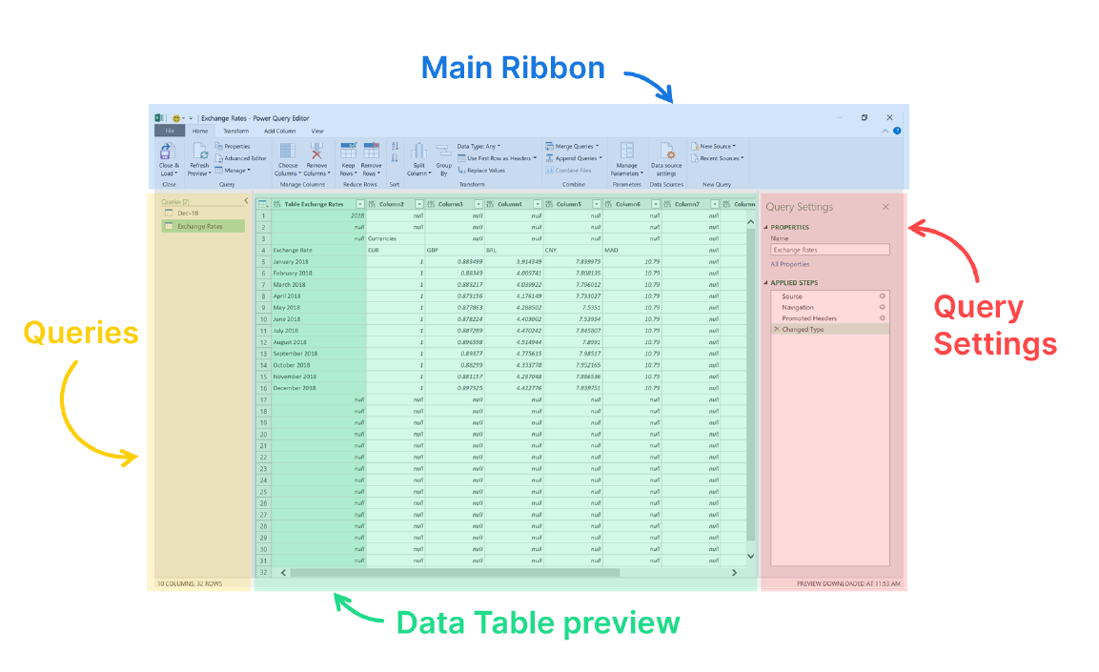

Elements:

Main ribbon - create queries from scratch

Queries - To keep track of all connections to

data sources and streams

Data Table - preview To visualize your data result

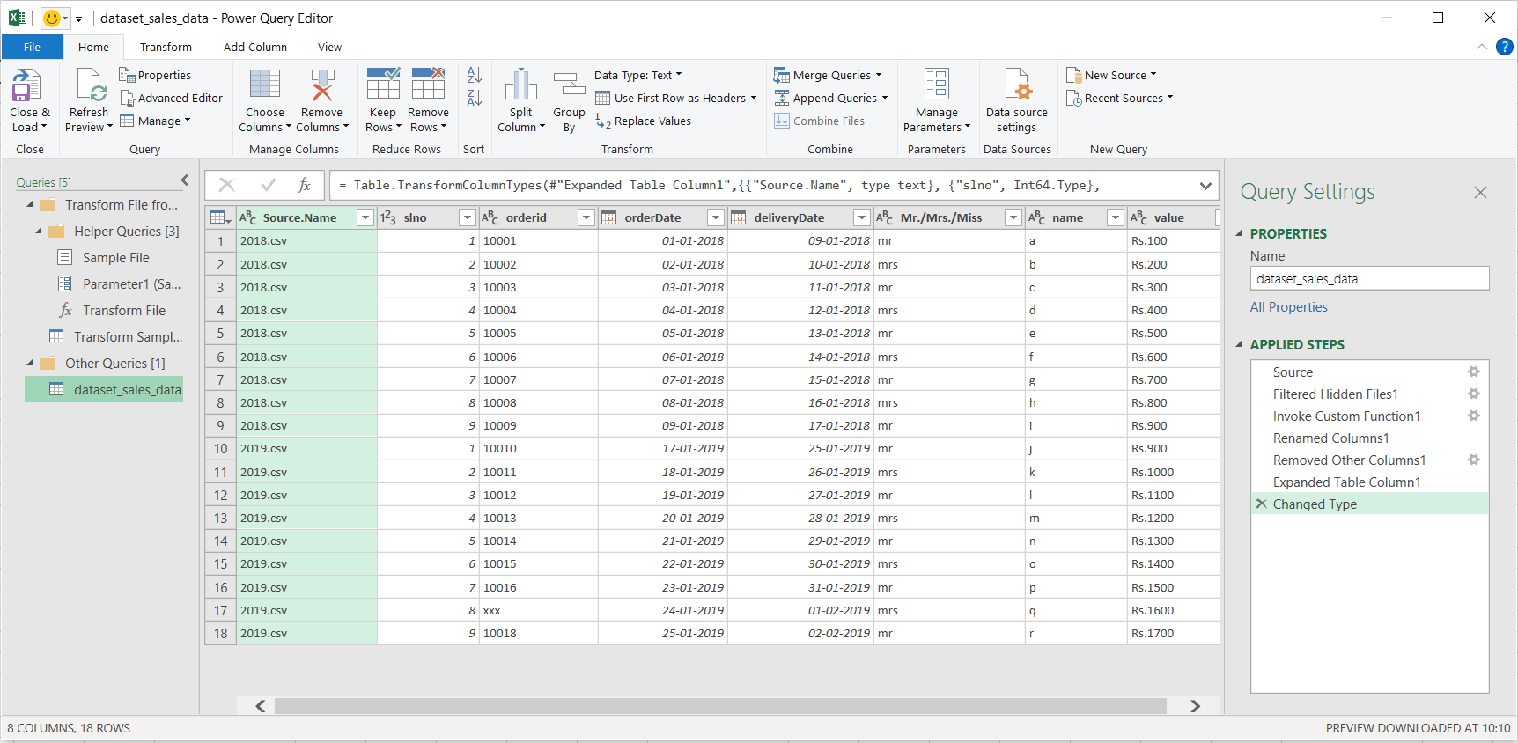

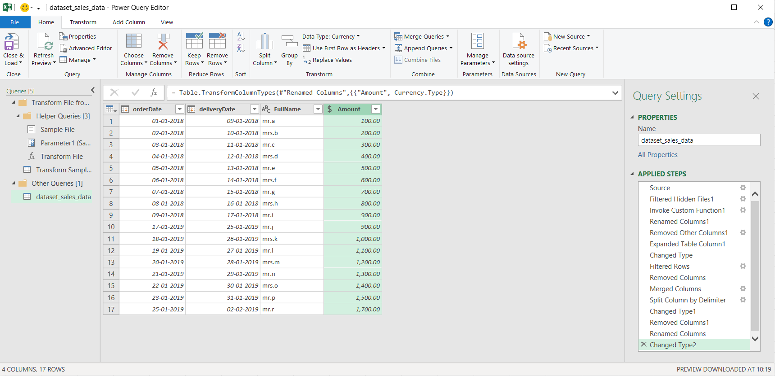

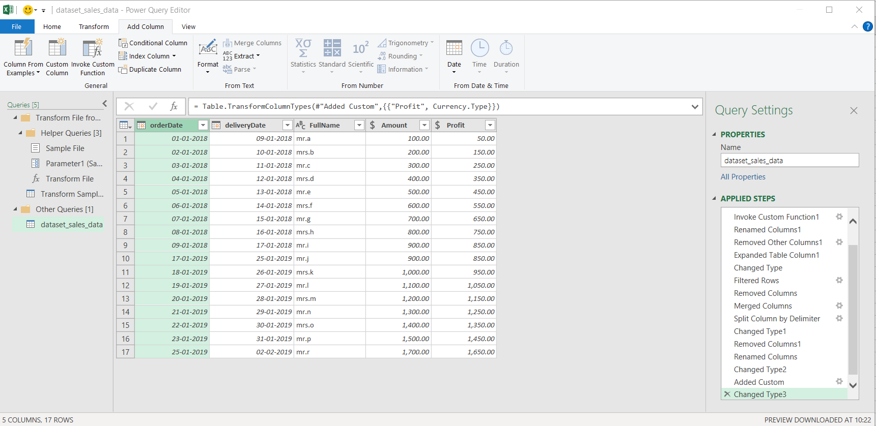

Profit Based on Year

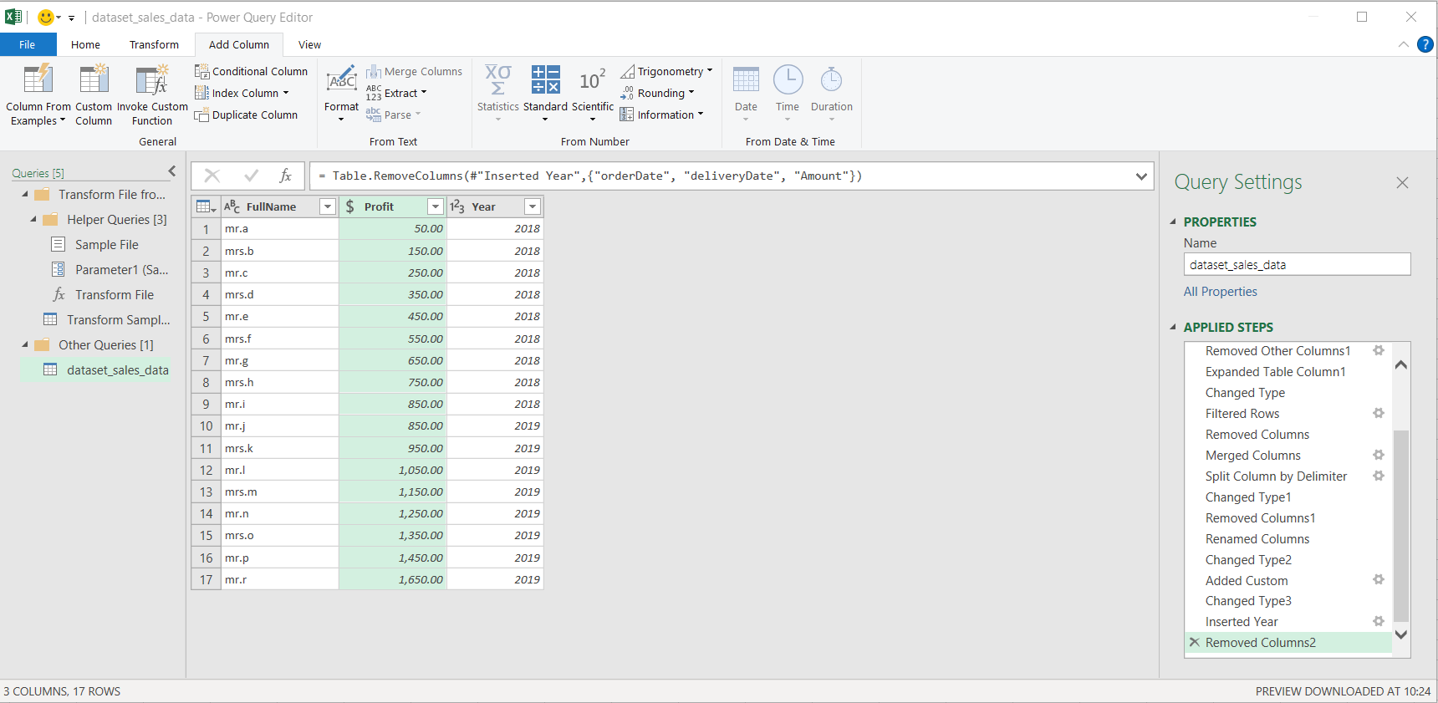

Now, Home -> Close and Load

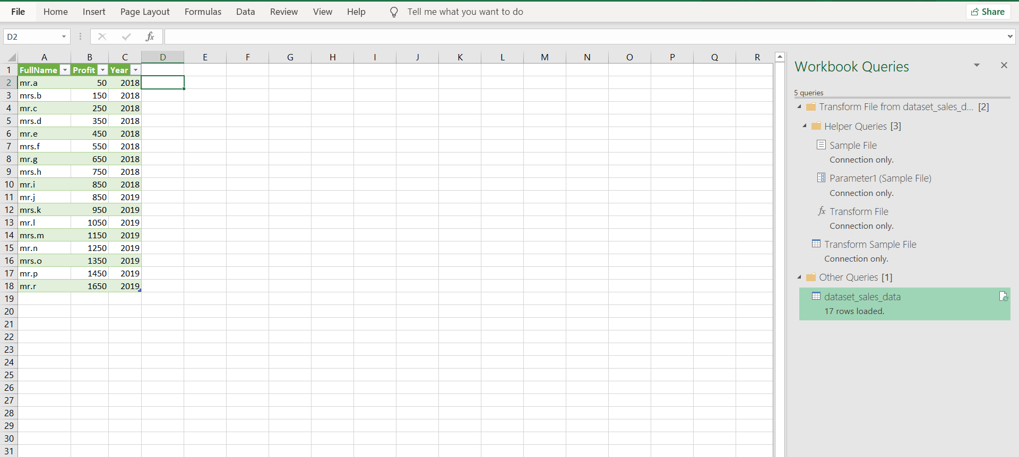

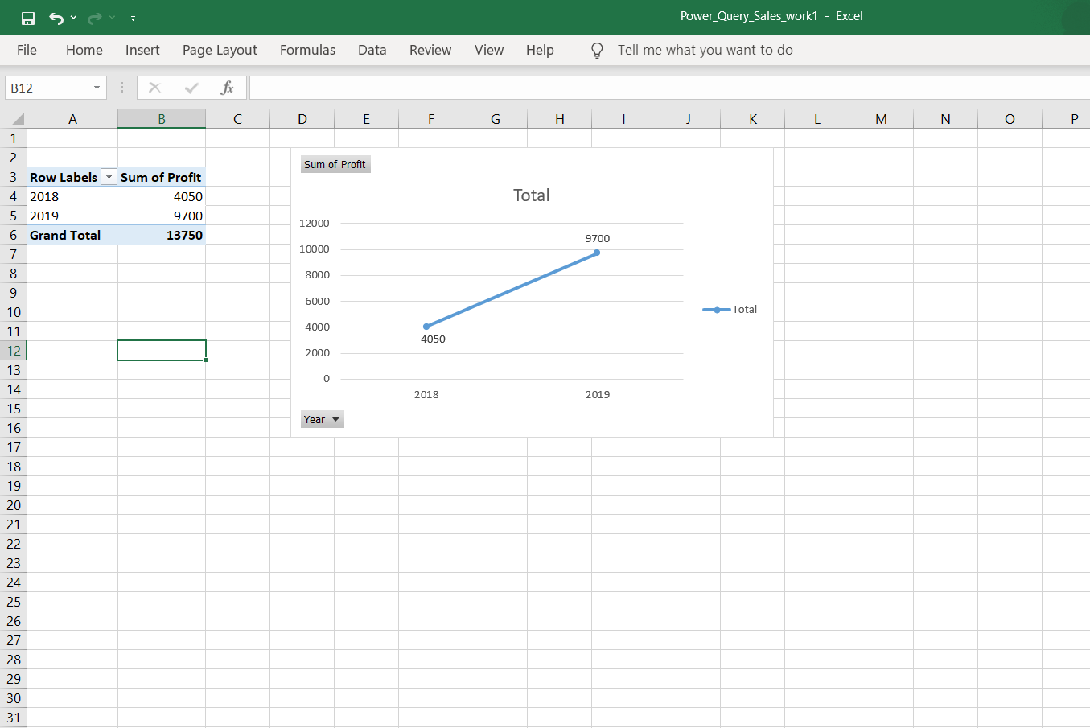

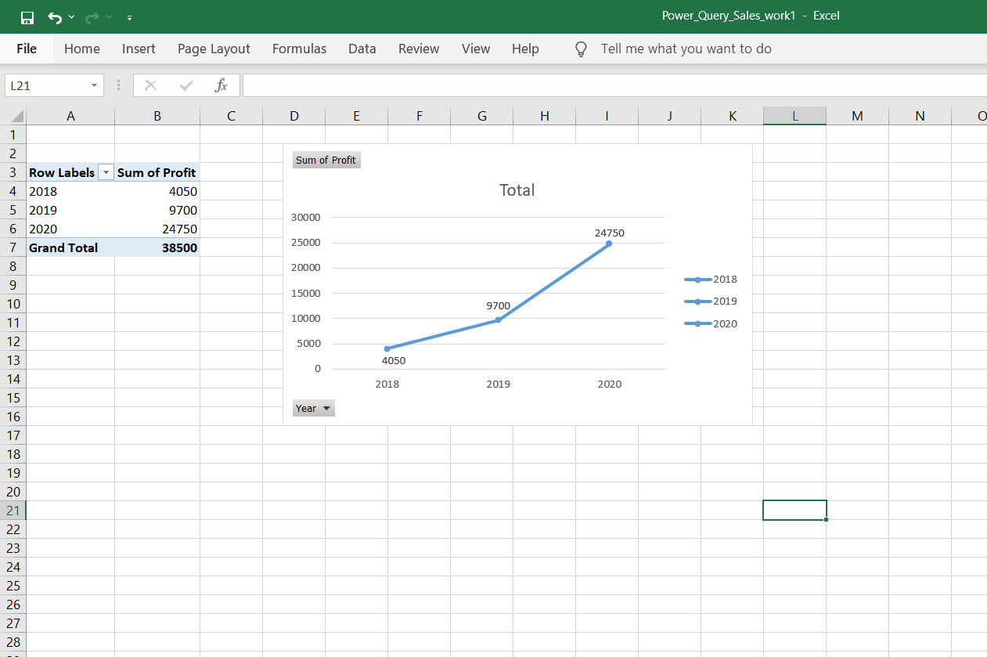

Time Management. It is important to Automate some tasks

Steps that I took

Open Power Query

For Excel >2016

For Excel 2010 & 2013

Load File Choose option from Ribbon, based on

the File format

Transform/Edit Data Click Edit, to do transformation in data

using Power query Editor

Once Finished Transformation, click

Home > Close & Load

Remove Rows

Based on Number

Remove empty rows

Remove Columns Empty Columns

Split Columns

Based on Delimiter

Based on Character count

Renaming Header

Unpivot Columns

Filter

Combine New source from folder all sheet name should be same

Replace

Merge Queries Forget about VLOOKUP

Create Columns Concatenate Right click 2 Columns and merge

Change Type

When You give new year report, and refresh, the result will be,

|  |  |
| --- | --- |
| **Row Labels** | **Sum of Profit** |
| 2018 | 4050 |
| 2019 | 9700 |
| 2020 | 24750 |
| **Grand Total** | **38500** |

|  |  |  |
| --- | --- | --- |
| **FullName** | **Profit** | **Year** |
| mr.a | 50 | 2018 |
| mrs.b | 150 | 2018 |
| mr.c | 250 | 2018 |
| mrs.d | 350 | 2018 |
| mr.e | 450 | 2018 |
| mrs.f | 550 | 2018 |
| mr.g | 650 | 2018 |
| mrs.h | 750 | 2018 |
| mr.i | 850 | 2018 |
| mr.j | 850 | 2019 |
| mrs.k | 950 | 2019 |
| mr.l | 1050 | 2019 |
| mrs.m | 1150 | 2019 |
| mr.n | 1250 | 2019 |
| mrs.o | 1350 | 2019 |
| mr.p | 1450 | 2019 |
| mr.r | 1650 | 2019 |
| mr.s | 1950 | 2020 |
| mrs.t | 2150 | 2020 |
| mr.u | 2350 | 2020 |
| mrs.s | 2550 | 2020 |
| mr.t | 2750 | 2020 |
| mrs.u | 2950 | 2020 |
| mr.s | 3150 | 2020 |
| mrs.t | 3350 | 2020 |
| mr.u | 3550 | 2020 |

Hence You can Automate like this.