**DEEP LEARNING**

**WORKSHEET-1 Solution**

**Q1 to Q8 are MCQs with only one correct answer. Choose the correct option.**

**Q1. Which of the following can approximate any function universally (i.e. universal approximates)?**

A) Boosted Decision Trees B) Neural Networks

C) Kernel SVM D) All of the above

Ans: (D)

**Q2. In which of the following domains we cannot use neural networks?**

A) Image Processing B) Speech Processing

C) Fraud Detection D) None of the above

Ans: (C)

**Q3. Rearrange the following steps of a gradient descent algorithm in correct order of their occurrence?**

i. Initialize random weight and bias

ii. Repeat the process until you find the best weights of network iii. Change weights and biases for each neuron to reduce the error

iv. Calculate error distances between the actual and the predicted value v. Pass an input through the network and get values from output layer Choose the correct option:

A) iv – i – iii – v – ii B) v – i – iii – iv –ii

C) i – v – iv – iii – ii D) i – v – iii –iv –ii

Ans: (C)

**Q4. What is the full form of RNN?**

A) Recurrent Neural Network B) Recursive Neural Network

C) Redundant Neural Network D) Resurrection Neural Network

Ans: (A)

**Q5. What is plasticity in neural networks?**

A) Input pattern keeps on changing B) input pattern has become static

C) Output pattern keeps on changing D) output is static

Ans: (A)

**Q6. What is stability plasticity dilemma?**

A) System can neither be stable nor plastic

B) Static inputs & categorization can’t be handled

C) Dynamic inputs & categorization can’t be handled

D) None of the above  
Ans: (C)

**Q7. Read the following statements:**

**Statement 1**: It is possible to train a network well by initializing all the weights as 0

**Statement 2**: It is possible to train a network well by initializing biases as 0

Which of the statements given above is true, choose the correct option? A) Statement 1 is true while Statement 2 is false

B) Statement 2 is true while statement 1 is false

C) Both statements are true

D) Both statements are false

Ans: (B)

**Q8. Which of the following architecture has feedback connections?**

A) Recurrent Neural network B) Convolutional Neural Network

C) Restricted Boltzmann Machine D) simple Artificial Neural Network  
  
Ans: (A)

**Q9 and Q10 are MCQs with one or more correct answers. Choose all the correct options.**

9. In training a neural network, you notice that the loss does not decrease in the few starting epochs. The reason behind it could be

A) Learning Rate is low B) Regularisation parameter is high

C) Regularisation parameter is low D) Stuck at local minima

Ans: (A, B, D)

10. Which of the following function(s) can be used to impart non – linearity in a neural network?

A) Stochastic Gradient Descent B) Rectified Linear Unit

C) Convolution Function D) Sigmoid Function

Ans: (D & B)

**Q11 to Q15 are subjective answer type question. Answer them briefly.**

**Q11. What is Deep Learning?**  
Ans:

Deep Learning: Deep Learning, is just a type of Machine Learning, inspired by the structure of a human brain. Deep learning algorithms attempt to draw similar conclusions as humans would by continually analyzing data with a given logical structure. To achieve this, deep learning uses a multi-layered structure of algorithms called neural networks (NN).

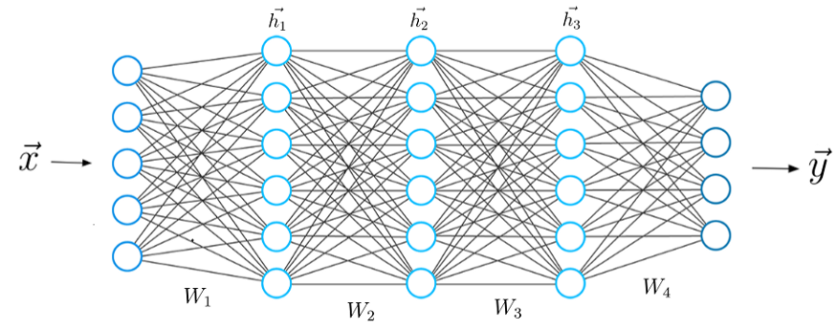

Just as we use our brains to identify patterns and classify different types of information, neural networks can be taught to perform the same tasks on data.

The individual layers of neural networks can also be thought of as a sort of filter that works from gross to subtle, increasing the likelihood of detecting and outputting a correct result.

The human brain works similarly. Whenever we receive new information, the brain tries to compare it with known objects. The same concept is also used by deep neural networks.

**Q12. What is reinforcement learning?**

Ans.  
**Reinforcement learning**: is a type of Machine Learning algorithms. Reinforcement learning differs from the supervised learning in a way that in supervised learning the training data has the answer key with it so the model is trained with the correct answer itself whereas in reinforcement learning, there is no answer but the reinforcement agent decides what to do to perform the given task. In the absence of a training dataset, it is bound to learn from its experience. Exp. Recommendation System etc.

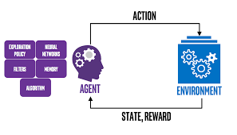

**Q13. What Are the Differences Between Machine Learning and Deep Learning?**  
Ans.  
Differences between deep learner and machine learning:

1. The main difference between DL and ML is due to the way of data is presented in the system. Machine learning algorithms almost always require structured data, while deep learning networks rely on layers of ANN (artificial neural networks).
2. Machine learning algorithms are designed to “learn” to act by understanding labeled data and then use it to produce new results with more datasets. However, when the result is incorrect, there is a need to “teach them”.
3. Deep learning networks do not require human intervention, as multilevel layers in neural networks place data in a hierarchy of different concepts, which ultimately learn from their own mistakes. However, even they can be wrong if the data quality is not good enough.
4. Data decides everything. It is the quality of the data that ultimately determines the quality of the result.

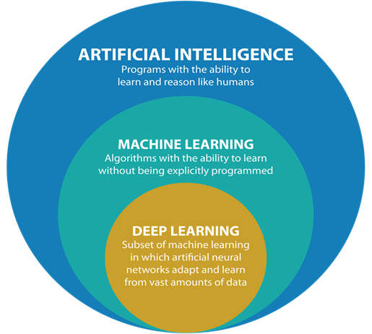

**Q14. What is a perceptron?**

Ans.  
Perceptron is a single layer neural network and a multi-layer perceptron is called Neural Networks.

Perceptron is a linear classifier (binary). Also, it is used in supervised learning. It helps to classify the given input data. Perceptron is usually used to classify the data into two parts. Therefore, it is also known as a [**Linear Binary Classifier**](https://medium.com/towards-data-science/linear-regression-the-easier-way-6f941aa471ea).

The perceptron consists of 4 parts-

* Input values or one input layer
* Weights and Bias
* Net sum
* [Activation Function](https://medium.com/towards-data-science/activation-functions-neural-networks-1cbd9f8d91d6)

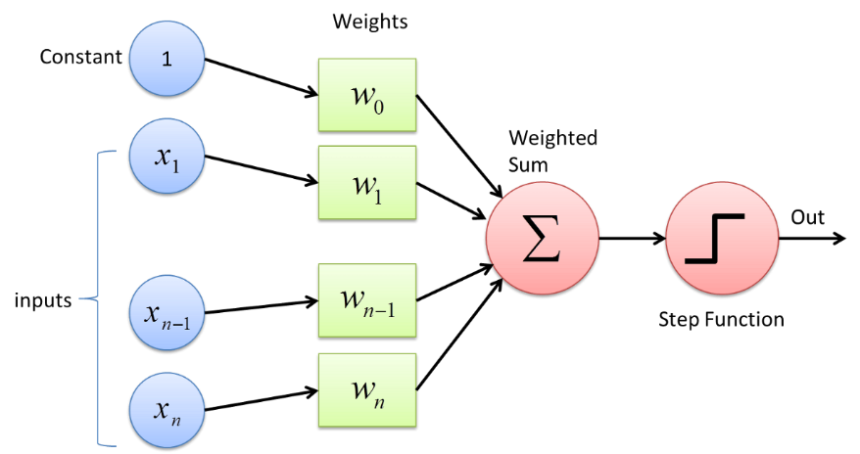

**Q15. What’s the difference between AI and ML?**

Ans.

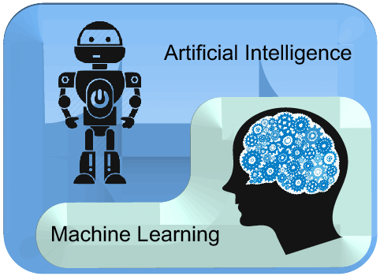

**Artificial Intelligence:** Artificial intelligence is a field of computer science which makes a computer system that can mimic human intelligence. It is comprised of two words "Artificial" and "intelligence", which means "a human-made thinking power." Hence we can define it as- Artificial intelligence is a technology using which we can create intelligent systems that can simulate human intelligence. Exp- Siri, Google?s AlphaGo, AI in Chess playing, etc

**Machine learning:** Machine learning is about extracting knowledge from the data. It can be defined as,

*Machine learning is a subfield of artificial intelligence, which enables machines to learn from past data or experiences without being explicitly programmed.* It can be divided into three types:

* Supervised learning
* Reinforcement learning
* Unsupervised learning

Exp- recommender system, for Google search algorithms, Email spam filter, Facebook Auto friend tagging suggestion.