WORKSHEET-3

**SQL Solution**

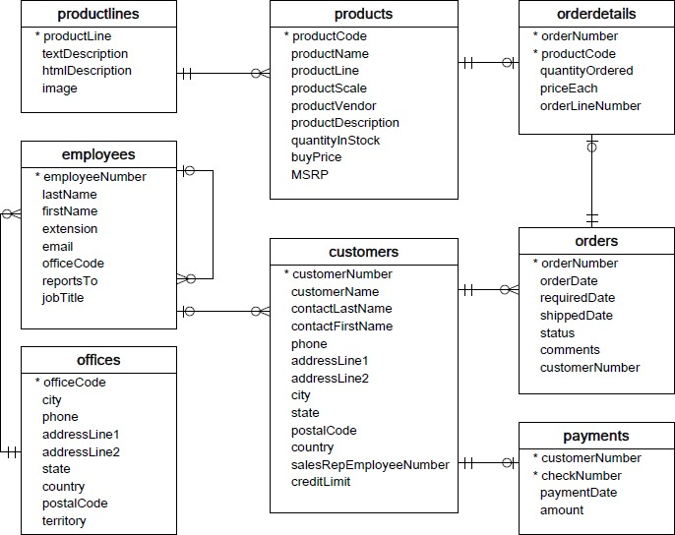**Refer the following ERD and answer all the questions in this worksheet. You have to write the queries using mysql for the required Operation.**

* **Customers**: stores customer’s data.
* **Products**: stores a list of scale model cars.
* **ProductLines**: stores a list of product line categories.
* **Orders**: stores sales orders placed by customers.
* **OrderDetails**: stores sales order line items for each sales order.
* **Payments**: stores payments made by customers based on their accounts.
* **Employees**: stores all employee information as well as the organization structure such as who reports to whom.
* **Offices**: stores sales office data.
  1. Write SQL query to create table **Customers.**
  2. Write SQL query to create table **Orders.**
  3. Write SQL query to show all the columns data from the **Orders** Table.
  4. Write SQL query to show all the comments from the **Orders** Table.
  5. Write a SQL query to show orderDate and Total number of orders placed on that date, from **Orders** table.
  6. Write a SQL query to show employeNumber, lastName, firstName of all the employees from **employees** table.
  7. Write a SQL query to show all orderNumber, customerName of the person who placed the respective order.
  8. Write a SQL query to show name of all the customers in one column and salerepemployee name in another column.
  9. Write a SQL query to show Date in one column and total payment amount of the payments made on that date from the **payments** table.
  10. Write a SQL query to show all the products productName, MSRP, productDescription from the **products** table.
  11. Write a SQL query to print the productName, productDescription of the most ordered product.
  12. Write a SQL query to print the city name where maximum number of orders were placed.
  13. Write a SQL query to get the name of the state having maximum number of customers.
  14. Write a SQL query to print the employee number in one column and Full name of the employee in the second column for all the employees.
  15. Write a SQL query to print the orderNumber, customer Name and total amount paid by the customer for that order (quantityOrdered × priceEach).

Ans 1  
 create table Customers (

CustomerNumber int,

Customername varchar(255),

contactLastName varchar(255),

contactFirsttName varchar(255),

phone int,

addressLine1 varchar(255),

addressLine2 varchar(255),

city varchar(255),

state varchar(255),

postalcode int,

country varchar(255),

salesRepEmployeeNumber int

creditlimit varchar(255)

);

Ans 2  
create table Orders (  
orderNumber varchar(255),  
orderDate varchar(255),  
requireDate varchar(255),  
shippedDate varchar(255),  
status varchar(255),  
comments varchar(255),  
cutomerNumber varchar(255)  
);

Ans 3  
select * from Orders;

Ans 4  
select comments from Orders;

Ans5

select orderDate,sum(orderNumber)  
form Orders where  orderDate=06/09/2020;

Ans6   
select orderDate,sum(orderNumber)  
form Orders where  orderDate=06/09/2020;

create table Employees(  
employeeNumber varchar(255),  
lastName varchar(255),  
firstName varchar(255),  
extension varchar(255),  
email varchar(255),  
officeCode varchar(255),  
reportsTo varchar(255),  
jobTitle varchar(255)  
);

select employeeNumber, lastName, firstName from Employees;

Ans7

select orderNumber,customerName  
form Orders where  customerName=modiji;

Ans8

select customerName,salesRepEmployeeNumber from Orders;

Ans9   
select paymentDate,sum(amount)  
form Orders where  paymentDate=06/09/2020;

Ans10  
select productName, MSRP, productDescription form Products;