WORKSHEET-1

**SQL**

# Q1 and Q2 have one or more correct answer. Choose all the correct option to answer your question.

1. Which of the following is/are DDL commands in SQL?
   1. Create B) Update

C) Delete D) ALTER

ANS A & C

1. Which of the following is/are DML commands in SQL?
   1. Update B) Delete

C) Select D) Drop

Ans A &B

# Q3 to Q10 have only one correct answer. Choose the correct option to answer your question.

1. Full form of SQL is:
   1. Strut querying language B) Structured Query Language

C) Simple Query Language D) None of them

ANS B

1. Full form of DDL is:
   1. Descriptive Designed Language B) Data Definition Language

C) Data Descriptive Language D) None of the above.

ANS B

1. DML is:
   1. Data Manipulation Language B) Data Management Language

C) Data Modeling Language D) None of these

ANS A

1. Which of the following statements can be used to create a table with column B int type and C float type?
   1. Table A (B int, C float) B) Create A (b int, C float)

C) Create Table A (B int,C float) D) All of them

ANS C

1. Which of the following statements can be used to add a column D (float type) to the table A created above?
   1. Table A ( D float) B) Alter Table A ADD COLUMN D float

C) Table A( B int, C float, D float) D) None of them

Ans B

1. Which of the following statements can be used to drop the column added in the above question?
   1. Table A Drop D B) Alter Table A Drop Column D

C) Delete D from A D) None of them

Ans B

1. Which of the following statements can be used to change the data type (from float to int ) of the column D of table A created in above questions?
   1. Table A (D float int) B) Alter Table A Alter Column D int

C) Alter Table A D float int D) Alter table A Column D float to int

ANS C

1. Suppose we want to make Column B of Table A as primary key of the table. By which of the following statements we can do it?
   1. Alter Table A Add Constraint Primary Key B B) Alter table (B primary key)

C) Alter Table A Add Primary key B D) None of them

ANS C

# Q11 to Q15 are subjective answer type questions, Answer them briefly.

1. What is data-warehouse?
2. What is the difference between OLTP VS OLAP?
3. What are the various characteristics of data-warehouse?
4. What is Star-Schema??
5. What do you mean by SETL?

ANS 11-

A **Data Warehousing** (DW) is process for collecting and managing data from varied sources to provide meaningful business insights. A Data warehouse is typically used to connect and analyze business data from heterogeneous sources. The data warehouse is the core of the BI system which is built for data analysis and reporting.It is a blend of technologies and components which aids the strategic use of data. It is electronic storage of a large amount of information by a business which is designed for query and analysis instead of transaction processing. It is a process of transforming data into information and making it available to users in a timely manner to make a difference.

ANS 12

|  |  |  |  |  |  |  |  |  |  |  |  |  |  |  |  |  |  |  |  |  |  |  |  |  |  |  |  |  |  |  |  |  |  |  |  |  |  |  |  |  |  |  |  |  |  |
| --- | --- | --- | --- | --- | --- | --- | --- | --- | --- | --- | --- | --- | --- | --- | --- | --- | --- | --- | --- | --- | --- | --- | --- | --- | --- | --- | --- | --- | --- | --- | --- | --- | --- | --- | --- | --- | --- | --- | --- | --- | --- | --- | --- | --- | --- |
| |  |  |  |  |  |  |  |  |  |  |  |  |  |  |  |  |  |  |  |  |  |  |  |  |  |  |  |  |  |  |  |  |  |  |  |  |  |  |  |  |  |  |  |  |  | | --- | --- | --- | --- | --- | --- | --- | --- | --- | --- | --- | --- | --- | --- | --- | --- | --- | --- | --- | --- | --- | --- | --- | --- | --- | --- | --- | --- | --- | --- | --- | --- | --- | --- | --- | --- | --- | --- | --- | --- | --- | --- | --- | --- | --- | | |  |  | | --- | --- | | **OLTP** | **OLAP** | | **Characteristics** | Handles a large number of small transactions | Handles large volumes of data with complex queries | | **Query types** | Simple standardized queries | Complex queries | | **Operations** | Based on INSERT, UPDATE, DELETE commands | Based on SELECT commands to aggregate data for reporting | | **Response time** | Milliseconds | Seconds, minutes, or hours depending on the amount of data to process | | **Design** | Industry-specific, such as retail, manufacturing, or banking | Subject-specific, such as sales, inventory, or marketing | | **Source** | Transactions | Aggregated data from transactions | | **Purpose** | Control and run essential business operations in real time | Plan, solve problems, support decisions, discover hidden insights | | **Data updates** | Short, fast updates initiated by user | Data periodically refreshed with scheduled, long-running batch jobs | | **Space requirements** | Generally small if historical data is archived | Generally large due to aggregating large datasets | | **Backup and recovery** | Regular backups required to ensure business continuity and meet legal and governance requirements | Lost data can be reloaded from OLTP database as needed in lieu of regular backups | | **Productivity** | Increases productivity of end users | Increases productivity of business managers, data analysts, and executives | | **Data view** | Lists day-to-day business transactions | Multi-dimensional view of enterprise data | | **User examples** | Customer-facing personnel, clerks, online shoppers | Knowledge workers such as data analysts, business analysts, and executives | | **Database design** | Normalized databases for efficiency | Denormalized databases for analysis | | |

Ans 13

Data warehouse can be controlled when the user has a shared way of explaining the trends that are introduced as specific subject. Below are major **characteristics** of data warehouse:

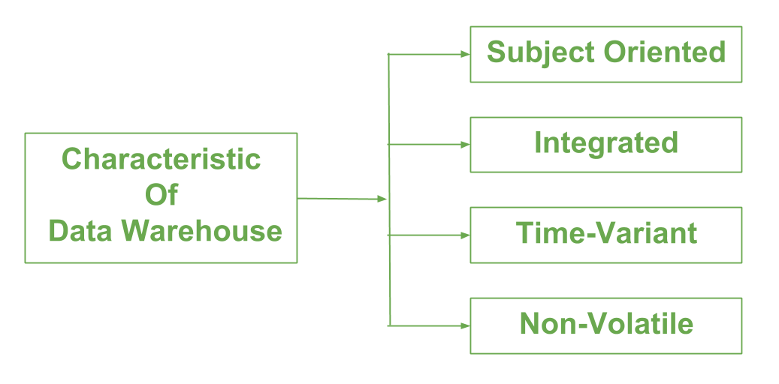

1. **Subject-oriented –**  
   A data warehouse is always a subject oriented as it delivers information about a theme instead of organization’s current operations. It can be achieved on specific theme. That means the data warehousing process is proposed to handle with a specific theme which is more defined. These themes can be sales, distributions, marketing etc.  
     
   A data warehouse never put emphasis only current operations. Instead, it focuses on demonstrating and analysis of data to make various decision. It also delivers an easy and precise demonstration around particular theme by eliminating data which is not required to make the decisions.
2. **Integrated –**  
   It is somewhere same as subject orientation which is made in a reliable format. Integration means founding a shared entity to scale the all similar data from the different databases. The data also required to be resided into various data warehouse in shared and generally granted manner.  
     
   A data warehouse is built by integrating data from various sources of data such that a mainframe and a relational database. In addition, it must have reliable naming conventions, format and codes. Integration of data warehouse benefits in effective analysis of data. Reliability in naming conventions, column scaling, encoding structure etc. should be confirmed. Integration of data warehouse handles various subject related warehouse.
3. **Time-Variant –**  
   In this data is maintained via different intervals of time such as weekly, monthly, or annually etc. It founds various time limit which are structured between the large datasets and are held in online transaction process (OLTP). The time limits for data warehouse is wide-ranged than that of operational systems. The data resided in data warehouse is predictable with a specific interval of time and delivers information from the historical perspective. It comprises elements of time explicitly or implicitly. Another feature of time-variance is that once data is stored in the data warehouse then it cannot be modified, alter, or updated.

1. **Non-Volatile –**  
   As the name defines the data resided in data warehouse is permanent. It also means that data is not erased or deleted when new data is inserted. It includes the mammoth quantity of data that is inserted into modification between the selected quantity on logical business. It evaluates the analysis within the technologies of warehouse.  
     
   In this, data is read-only and refreshed at particular intervals. This is beneficial in analysing historical data and in comprehension the functionality. It does not need transaction process, recapture and concurrency control mechanism. Functionalities such as delete, update, and insert that are done in an operational application are lost in data warehouse environment. Two types of data operations done in the data warehouse are:

Data Loading

Data Access

**Functions of Data warehouse:**  
It works as a collection of data and here is organized by various communities that endures the features to recover the data functions. It has stocked facts about the tables which have high transaction levels which are observed so as to define the data warehousing techniques and major functions which are involved in this are mentioned below:

1. Data consolidation
2. Data Cleaning
3. Data Integration

Ans 14  
**Star schema** is the fundamental schema among the data mart schema and it is simplest. This schema is widely used to develop or build a data warehouse and dimensional data marts. It includes one or more fact tables indexing any number of dimensional tables. The star schema is a necessary case of the snowflake schema. It is also efficient for handling basic queries.

It is said to be star as its physical model resembles to the star shape having a fact table at its center and the dimension tables at its peripheral representing the star’s points. Below is an example to demonstrate the Star Schema:

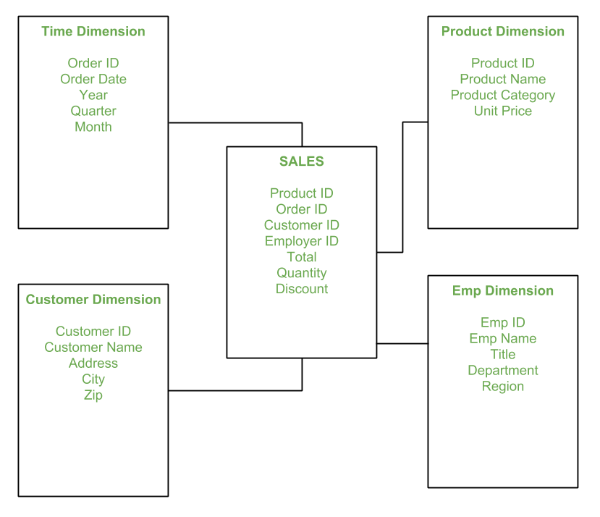

In the above demonstration, SALES is a fact table having attributes i.e. (Product ID, Order ID, Customer ID, Employer ID, Total, Quantity, Discount) which references to the dimension tables. **Employee dimension table** contains the attributes: Emp ID, Emp Name, Title, Department and Region. *Product dimension table* contains the attributes: Product ID, Product Name, Product Category, Unit Price. *Customer dimension table* contains the attributes: Customer ID, Customer Name, Address, City, Zip. *Time dimension table* contains the attributes: Order ID, Order Date, Year, Quarter, Month.

**Model of Star Schema –**  
In Star Schema, Business process data, that holds the quantitative data about a business is distributed in fact tables, and dimensions which are descriptive characteristics related to fact data. Sales price, sale quantity, distant, speed, weight, and weight measurements are few examples of fact data in star schema.  
Often, A Star Schema having multiple dimensions is termed as Centipede Schema. It is easy to handle a star schema which have dimensions of few attributes.

**Advantages of Star Schema –**

1. **Simpler Queries:**  
   Join logic of star schema is quite cinch in compare to other join logic which are needed to fetch data from a transactional schema that is highly normalized.
2. **Simplified Business Reporting Logic:**  
   In compared to a transactional schema that is highly normalized, the star schema makes simpler common business reporting logic, such as as-of reporting and period-over-period.
3. **Feeding Cubes:**  
   Star schema is widely used by all OLAP systems to design OLAP cubes efficiently. In fact, major OLAP systems deliver a ROLAP mode of operation which can use a star schema as a source without designing a cube structure.

**Disadvantages of Star Schema –**

1. Data integrity is not enforced well since in a highly de-normalized schema state.
2. Not flexible in terms if analytical needs as a normalized data model.
3. Star schemas don’t reinforce many-to-many relationships within business entities – at least not frequently.

Attention reader! Don’t stop learning now. Get hold of all the important DSA concepts with the [**DSA Self Paced Course**](https://practice.geeksforgeeks.org/courses/dsa-self-paced?utm_source=geeksforgeeks&utm_medium=article&utm_campaign=gfg_article_dsa_content_bottom) at a student-friendly price and become industry ready.

1. ANS 15  
     
    The SET command is used with UPDATE to specify which columns and values that should be updated in a table.

The following SQL updates the first customer (CustomerID = 1) with a new ContactName *and* a new City:  
UPDATE Customers  
SET ContactName = 'Alfred Schmidt', City= 'Frankfurt'  
WHERE CustomerID = 1;