AI-Optimized Production Data Analyzer with

Visual Flowchart

Yogeshwaran r  Student,Department of artificial intelligence,Dr.M.GR educational and research institute,Chennai,Tamilnadu,india yogi85114@gmail.com | Suraj singh r  Student,Department of artificial intelligence,Dr.M.GR educational and research  institute,Chennai,Tamilnadu,india @gmail.com | Yella Rupesh  Student,Department of artificial intelligence,Dr.M.GR educational  and research institute,Chennai,Tamilnadu,india  @gmail.com

Abstract—Modern industrial production environments gen- erate massive amounts of operational data from various sources, including machines, sensors, and Enterprise Resource Plan- ning (ERP) systems. However, extracting actionable insights from this raw, complex, and often scattered data remains a significant challenge. This project addresses this critical gap by providing an AI-powered solution that can automatically analyze production data to support data-driven decision- making. The core objective is to develop a tool that generates interactive visual flowcharts and dashboards, simplifying the process workflow for users and making complex data easy to understand. The system architecture features a modular design with a Data Acquisition Module, a Data Preprocessing Module, an Analysis Module utilizing Machine Learning algorithms (like Classification, Regression, and Time-Series Forecasting), and a Visualization Module powered by libraries like Plotly. The key features include real-time insights and predictive analysis capa- bilities which are lacking in many existing tools. The proposed solution significantly enhances efficiency, minimizes manual effort, and allows for the quick identification of bottlenecks and inefficiencies. This AI-Optimized Production Data Analyzer is essential for industries aiming for continuous growth and competitiveness in the modern era.
Index Terms—Artificial Intelligence, Production Analytics, Data Visualization, Machine Learning, Flowchart, Streamlit, Plotly, Predictive Analysis.
- Introduction
- Introduction and Motivation
Modern production environments are highly complex and continuously generate a massive volume of operational data. This data originates from diverse sources, including automated machines, numerous sensors, and enterprise- wide systems like ERP (Enterprise Resource Planning). While this data represents a significant asset for opti- mization, the process of extracting meaningful, actionable insights from this raw input remains a major challenge. Current methods, which often involve manual monitor- ing, high manpower dependency, and traditional tools like Excel or SQL-based reporting, are simply insufficient for the speed and scale of modern industry. Industry research highlights the critical importance of transitioning to data- driven decision-making to effectively reduce inefficiencies
and optimize production processes.
This project is motivated by the need to bridge this ana- lytical gap. The AI-Optimized Production Data Analyzer
proposes an AI-powered solution designed to automate data analysis. By converting complex data streams into easy-to-understand, interactive visual flowcharts and dash- boards, the system aims to enhance efficiency, minimize human effort, and empower industries to make smarter decisions.
- Problem Statement
Production companies face several critical challenges in utilizing their operational data:
  - Data Fragmentation: Operational data is scattered across multiple, disparate sources, making unified analysis difficult.
  - Manual Dependency: High reliance on manual moni- toring and reporting leads to high manpower depen- dency and time-consuming updates.
  - Difficulty Identifying Bottlenecks: It is challenging to quickly and accurately identify operational bot- tlenecks and inefficiencies using traditional static analysis methods.
  - Lack of Predictive Foresight: Current systems lack predictive insights necessary for effective future plan- ning and anticipating issues before they occur.
  - Inadequate Visualization: Existing visualization tools often provide static charts, lacking the dynamic, interactive flowchart visualization needed to clearly convey complex production workflows.
- Project Objective
The main objective of this project is to: Develop an AI-powered tool that analyzes production data and generates interactive visual flowcharts to simplify decision- making and generate flowcharts that are easy for users to understand the workflow and process.
This objective will be achieved by focusing on the following sub-goals:
  - To integrate AI algorithms (like Classification, Re- gression, and Time-Series Forecasting) to provide real-time insights and predictive analysis.
  - To design a scalable system using Python and cloud integration that seamlessly handles data collection and preprocessing from multiple sources.

  - To implement a Visualization Module capable of gen- erating dynamic displays, including flowcharts, that visually highlight areas for workflow optimization.

- Requirement Analysis
The Requirement Analysis phase focuses on systemat- ically defining what the proposed AI-Optimized Produc- tion Data Analyzer must accomplish.

- Feasibility Study
A feasibility study was conducted to evaluate the project’s practicality and likelihood of successful comple- tion.
  - Technical Feasibility: The project is highly techni- cally feasible. The proposed system relies on mature and well-supported technologies. All core software components (Python, Pandas, NumPy, Scikit-learn, Plotly, Streamlit) are readily available and open-source. The required hard- ware (8 GB RAM, i5) is standard, and the AI algorithms are established techniques.
  - Economic Feasibility: The project is economically feasible as it utilizes open-source tools and promises significant returns on investment (ROI). The tool enhances efficiency, reduces manual monitoring, and directly lowers operational costs.
  - Operational Feasibility: The system is designed to be highly compatible and user-friendly. The design emphasizes an intuitive user interface, and the dynamic visual flowchart is intended to make the workflow easy to understand, minimizing training.

- Existing System Analysis
  - Limitations of Existing Methods: Current systems for production analytics typically lack the capability to provide real-time insights. They often struggle with integration, failing to connect with multiple, disparate data sources. The visualization is limited to static charts, and they require time-consuming updates and offer no predictive analysis.
  - Gap to be Addressed: The fundamental gap iden- tified is that no single system combines AI analysis with dynamic visual flowcharts for easy decision-making.

- Requirements Elicitation
  - Stakeholder Requirements: The primary stakehold- ers (production managers and engineers) need clarity and simplicity (especially flowcharts), efficiency in identifying bottlenecks, and foresight from predictive insights.
  - Data Requirements: The system must handle large volumes of heterogeneous operational data from machines, sensors, and ERP systems, likely including CSV files and database connections.
- Requirement Specification
- Functional Requirements
  - Data Acquisition and Preprocessing: The system must integrate collected data from multiple sources. It must implement a Data Preprocessing Module to clean and standardize the input dataset and prompt for a man- ual review/recalibration if data quality is not acceptable.
  - AI Analysis and Insight Generation: The Analysis Module must apply AI algorithms, including Classifica- tion, Regression, Clustering, Time-Series Forecasting, and Anomaly Detection. It must be able to Predict Failure and provide Real-time insights.
  - Visualization and User Interaction: The system must generate interactive visual flowcharts. The Visualization Layer must generate charts and an interactive dashboard. The visualization must be easy for users to understand and enable quick identification of bottlenecks.
- Non-Functional Requirements
- Performance and Efficiency: The system must trans- form data efficiently and allow real-time dashboard access to support faster decision-making.
- Scalability and Integration: The system must utilize a Cloud Platform for scalability and support integra- tion with multiple data sources.
- Minimizing Human Effort: The tool must minimize dependence on manual work.
- Development & Run Time Requirements
  - Development Requirements (Software): Python 3.x, Pandas, NumPy, Matplotlib, Plotly, Scikit-learn, and Streamlit.
  - Run-time Requirements (Hardware): Minimum 8
GB RAM and i5 processor. Recommended 16 GB RAM and GPU support. Requires internet for cloud integration and access to a database or CSV files.
- Design
- System Architecture
The proposed system utilizes a layered architecture to separate concerns.
  - Data Sources Layer: Machines, Sensors, and ERP systems.
  - Processing Layer: Data cleaning, preprocessing, and application of ML algorithms.
  - Visualization & User Layer: Web/cloud interface gen- erating charts, dashboard, & flowchart visualization.
- Module Breakdown of Proposed System
  - Data Acquisition Module: Integrates collected data from sources (CSV, databases).
  - Data Preprocessing Module: Cleans and standardizes the dataset using Pandas and NumPy.
  - Analysis Module (AI Engine): Applies AI algorithms (Classification, Regression, etc.) using Scikit-learn.
  - Visualization Module: Generates interactive charts and flowcharts using Matplotlib and Plotly.

Fig. 2. Methodology (Workflow) diagram (as in Fig 4.2). A place- holder is used.
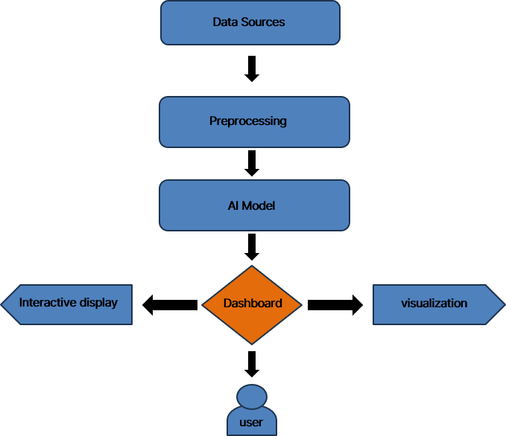
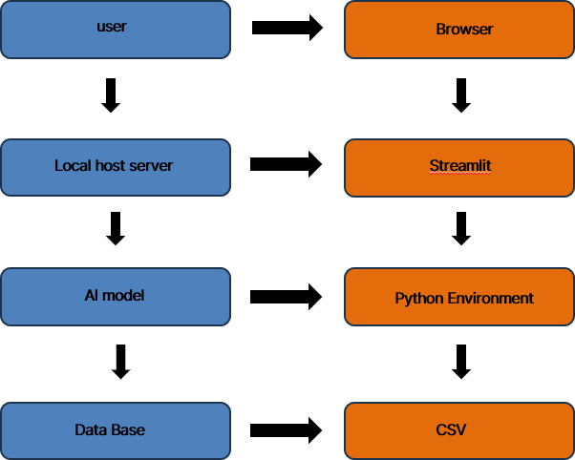

Fig. 1. System Architecture diagram (as in Fig 4.1). A placeholder is used as the image is not available.

- System Deployment Design
The end user interacts with the system through a Browser. The application runs on a Local host server managed by Streamlit. The core logic runs in the Python Environment, accessing data from a Database or CSV files. Key features include real-time insights, predictive analysis, workflow optimization, and interactive display visualization.

- Implementation

- Technology & Tools
  - Python 3.x: Primary language for Data Processing & ML.
  - Pandas and NumPy: Used in the Data Preprocessing Module for data handling.
  - Scikit-learn (Sklearn): Employed in the Analysis Module for machine learning tasks.
  - Matplotlib and Plotly: Used by the Visualization Module. Plotly is used for interactive visualizations and the Flowchart.
- Implementation of Core Modules
- Data Acquisition and Preprocessing: The acquisition logic handles data integration. The Data Preprocessing Module executes data cleaning and standardization.
- AI Engine Implementation: The Analysis Module is implemented by training ML models. Time-Series Fore- casting models are used to Predict Failure.
- Visualization Implementation: Plotly is used to programmatically generate the visual flowchart based on analyzed workflow data. The interactive display ensures smooth navigation.
- Deployment Strategy
The interface is accessed via a Browser, with Streamlit hosting the application on a Local host server. Cloud inte- gration ensures scalable storage and real-time dashboard access.

- Conclusion
The project successfully developed an AI-powered tool that converts raw, fragmented production data into clear, actionable insights through automated visualization. The implementation of interactive flowcharts clearly represents production workflows, making complex processes easy to understand. The tool provides real-time insights and predictive analysis, supporting faster decision-making and enhancing efficiency by minimizing human effort. This AI-Optimized Production Data Analyzer is a robust and scalable solution for industries aiming for continuous growth.
f = pd.DataFrame({
”timestamp”: pd.date_range(”2024-01- 01”, periods=500, freq=”H”),
”temp”: rng.normal(70, 5, 500),
”vibration”: rng.normal(1.2, 0.4, 500),
”pressure”: rng.normal(30, 3, 500),
”units”: rng.integers(80, 150, 500),
”defect”: rng.integers(0, 2, 500)
})
else:
if not f: st.stop() f = pd.read_csv(f)

References
- J. Smith, “The importance of data-driven manufacturing,” Journal of Industrial Analytics, vol. 5, no. 2, pp. 101-115, 2022.
- “Scikit-learn: Machine Learning in Python,” scikit-learn.org.
- W. McKinney, “Data Structures for Statistical Computing in Python,” Proceedings of the 9th Python in Science Conference, 2010.
- A. A. E., “Comparative study of visualization tools for opera- tional data,” Proc. 2nd Int. Conf. on Manufacturing, 2019.
- L. Zhang, C. Wang, and Y. Chen, “Intelligent manufacturing in Industry 4.0: A review,” IEEE Transactions on Industrial Informatics, vol. 15, no. 4, pp. 2483–2494, 2021.
- D. Thomas and R. Sinha, “Real-time visualization in smart manufacturing using Streamlit and Python,” IEEE Smart In- dustry Conference, pp. 215–221, 2023.
- L. Fernandes, “Machine learning in production data analysis: A systematic survey,” Artificial Intelligence Review, vol. 56, pp. 2311–2324, 2023.
- D. Joseph and H. Singh, “A data-driven framework for intel- ligent production insight generation,” International Conference on AI in Industry (ICAI), pp. 101–109, 2023.
- L. Fernandes, “Machine learning in production data analysis: A systematic survey,” Artificial Intelligence Review, vol. 56, pp. 2311–2324, 2023. (Note: Duplicate of ref7)
- H. Kim, “Data preprocessing techniques for industrial data analytics,” Journal of Computational Engineering, vol. 12, no. 2, pp. 205–213, 2020.
- J. Gonzalez, “Industrial data cleaning and preprocessing for AI analytics,” IEEE Access, vol. 10, pp. 12812–12824, 2022.
Appendix A Appendix A: Example Code
Example Python code using Streamlit:
import streamlit as st import pandas as pd import numpy as np import plotly.express as px
from sklearn.model_selection import train_test_split
st.write(f.head())
task = st.selectbox(”Choose Task”, [”EDA”, ”Classification”, ”Regression”, ”Clustering”, ”Forecast”])
if task == ”EDA”:
st.plotly_chart(px.scatter(f, x=f.columns[0], y=f.columns[1],
title=”Quick View”)) elif task == ”Classification”:
y = f.iloc[:, -1]
X = f.select_dtypes(np.number).drop(y.name, axis=1) Xtr, Xte, ytr, yte = train_test_split(X, y, test_size=.2) clf = RandomForestClassifier().fit(Xtr, ytr) st.text(classification_report(yte, clf.predict(Xte)))
elif task == ”Regression”: y = f.iloc[:, -1]
X = f.select_dtypes(np.number).drop(y.name, axis=1) Xtr, Xte, ytr, yte = train_test_split(X, y, test_size=.2) mse = mean_squared_error(yte,
RandomForestRegressor().fit(Xtr, ytr).predict(Xte)) st.write(”MSE:”, mse)
elif task == ”Clustering”:
X = f.select_dtypes(np.number).fillna(0)
labels = KMeans(n_clusters=3, n_init=10).fit_predict(X) st.plotly_chart(px.scatter(X, x=X.columns[0], y=X.columns[1],
color=labels.astype(str))) elif task == ”Forecast” and ”timestamp” in f.columns:
ts = f.set_index(”timestamp”)[f.select_dtypes(np.number).column fc = ARIMA(ts, order=(1, 0, 0)).fit().forecast(24) st.line_chart(fc)
st.info(”Upload or use sample -> Explore -> Run AI tasks”) Appendix B

from sklearn.ensemble import RandomForestClassifier, RandomForestRegressor from sklearn.cluster import KMeans
Appendix B: Output
from sklearn.metrics import classification_report, mean_squared_error from statsmodels.tsa.arima.model import ARIMA

st.set_page_config(layout=”wide”, page_title=”AI Production Analyzer”) st.title(”AI-Optimized Production Data Analyzer”)
f = st.file_uploader(”Upload CSV or use sample”)

if st.button(”Use Sample”):
rng = np.random.default_rng(0

Output :

Fig. 3. Sample result and output
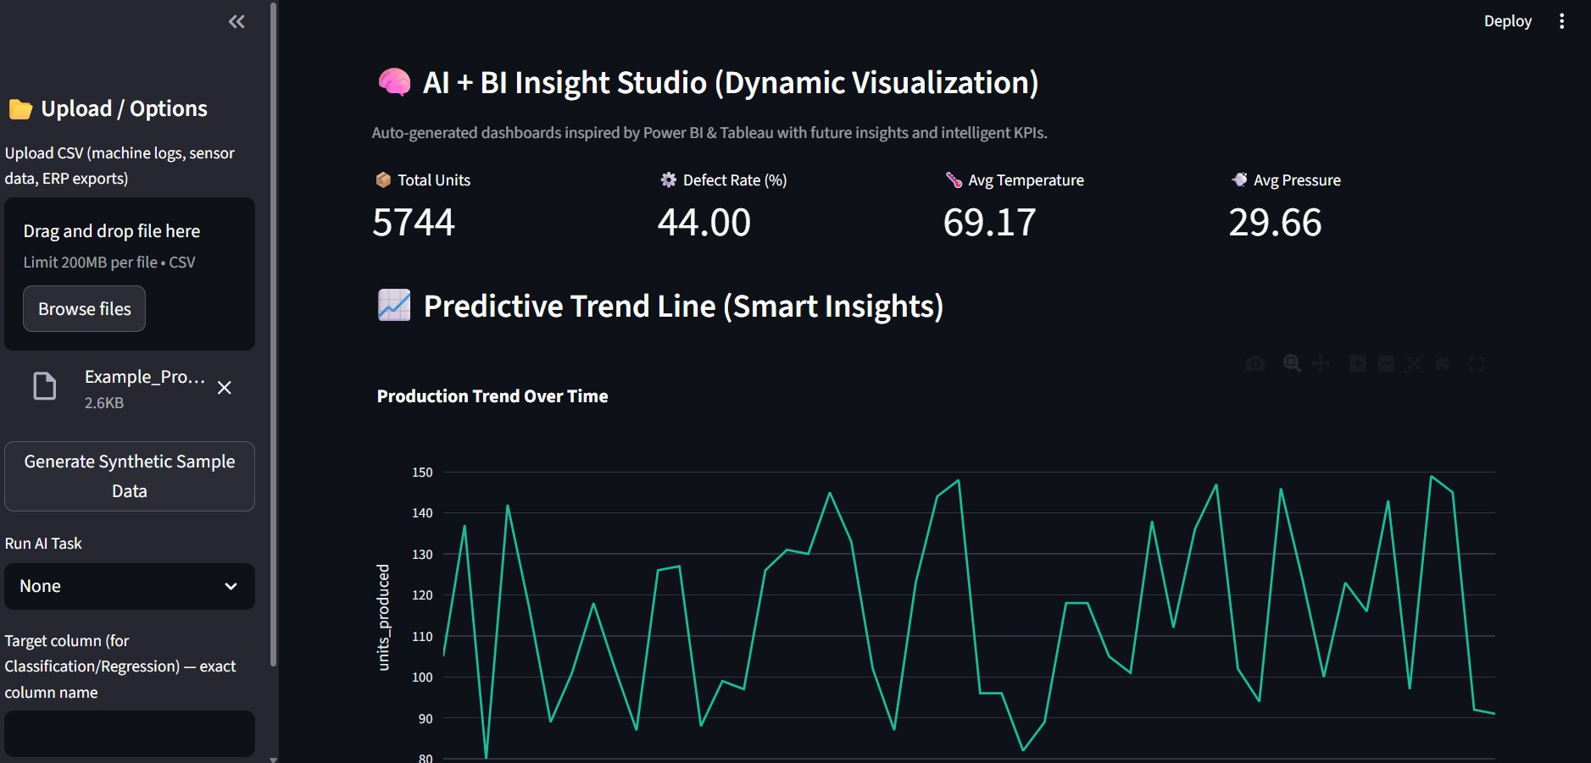

Fig. 4. Sample result and output
